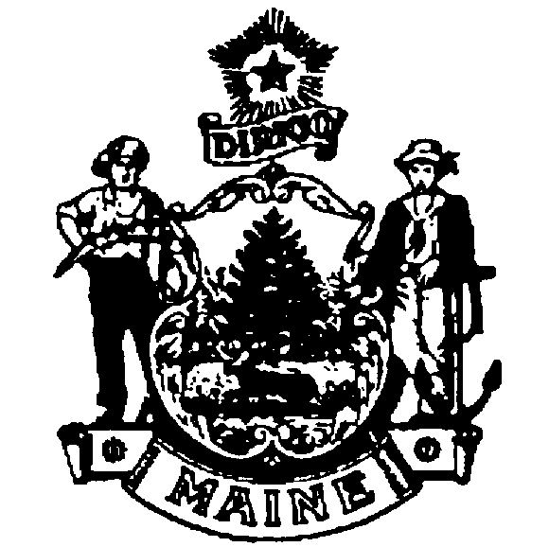
March 13, 2012
Jeffrey L. Timberlake, State Representative
House of Representatives
2 State House Station
Augusta, ME 04333-0002

RE: Development of Pesticide Notification Registry
Dear Representative Timberlake:
Thank you for your letter requesting that the Board of Pesticides Control (Board) consider expanding the coverage of the pesticide notification registry. At its February 24, 2012 meeting, the Board reviewed your letter and one submitted by Representative James F. Dill. After extensive discussion and review of the current notification requirements as well as the recent history of the pesticide notification registry concept, the Board reached consensus on recommending that the staff attempt to improve the awareness and operation of the current notification requirements before attempting to develop a new system. Board members cited the following reasons for supporting their position:
- The Board has considered a wide array of options since 2006 and studied the issue exhaustively. All of the alternatives to the current requirements currently have downsides and lack support from the regulated community. The issue of pesticide notification remains polarized and contentious. Consequently, the Board believes this may not be the best time to propose a new system.
- The current set of pesticide notification requirements is tailored to best suit different pesticide application sectors. The primary shortcoming to the current requirements is a lack of public awareness. Developing a registry won’t address that shortcoming; better publicity will.
- There is already an operational registry addressing non-agricultural, residential applications. The Board believes this application sector is best suited to the registry format. Agricultural applications are more predictable and better addressed through the “by request” option.
- While the registry format is attractive to individuals who wish to be notified, applicators cite a variety of obstacles and burdens to successful implementation of additional registry coverage. The Board believes a wide-scale registry unfairly shifts the majority of the burden to the applicator community. At present, members are more comfortable with an approach in which the burden is more equally shared.
- Applicators have complained about the complexity of the notification requirements. Adding another registry would exacerbate that concern.
The Board appreciates your interest in seeking a compromise on this contentious and challenging issue. We invite you to attend one of monthly meetings to further discuss the issue and the Board’s current thinking. The Board intends to re-evaluate its position in the coming years following attempts to improve operation of the current requirements. Please feel free to contact me directly if you wish to discuss the matter in person.

Sincerely,
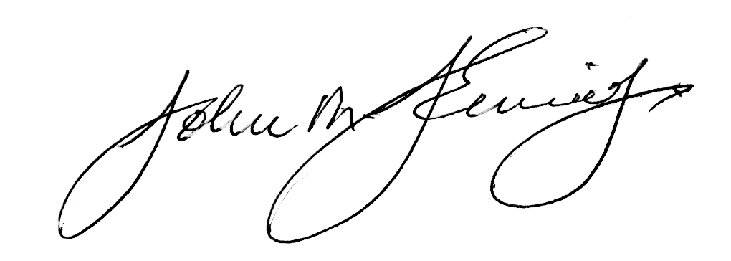
John Jemison, Chair
Maine Board of Pesticides Control

