Integrated Pest Management
School Toolkit –revised 2017

Integrated Pest Management
School Toolkit--revised 2017

Integrated Pest Management
School Toolkit-- revised 2017

Integrated Pest Management
School Toolkit-- revised 2017

Maine Integrated Pest Management School Toolkit

Everything You Need
for a Top-Notch IPM Program
in Compliance with
State Pesticide Regulations

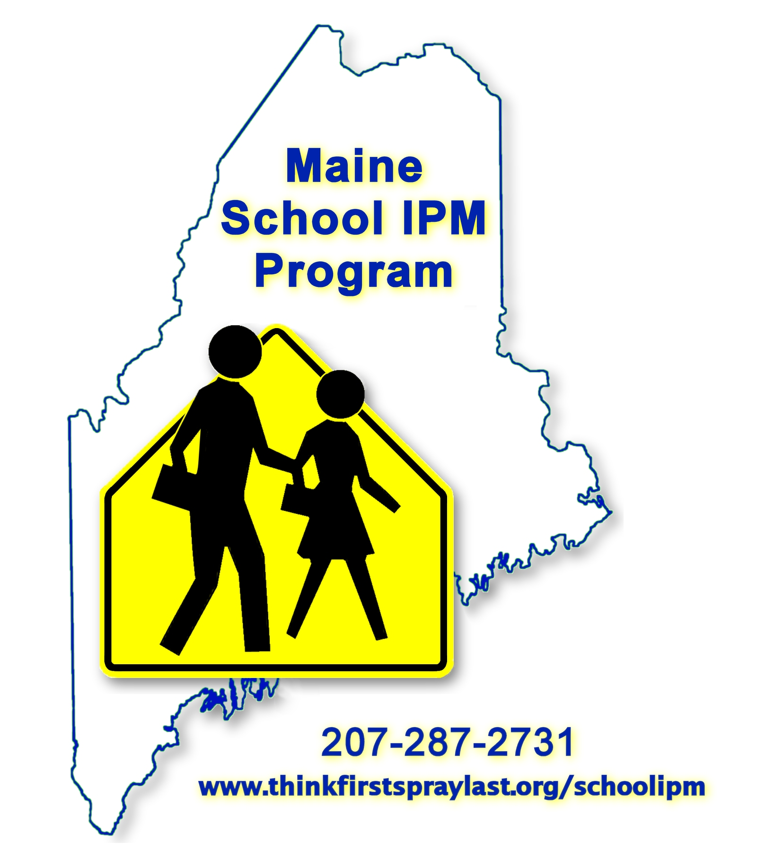

Revised 2017 Includes NEW Logbook and Notice Forms

