Maine
Volunteers in
Parks

Name: |  |  |  | Age: |  |  | Telephone:
If organization, name of group: |  |  |  |  |  | Number of people:
Mailing address:
E-mail address:

What are some of your objectives for working as a volunteer?

Is there a specific volunteer/intern project you would like to work on?

Which work environment do you prefer?

 | Indoor |  | Outdoor |  | Home |  | Combination |  | Doesn’t matter

Other, Please explain: _________________________________________________________________

What qualifications/skills/experience do you have that you could use in your volunteer work? Place the following numbers in the blanks preceding those skills.
1=Beginner 2=Intermediate 3=Advanced 4=Instructor

Outdoor Skills |  | Communication Skills |  | Research/Interpretation
 | Backpacking/Camping |  | Cartography/digitizing |  | Historical research
 | Canoeing/Kayaking |  | Computer |  | Environmental research
 | Carpentry |  | Communication, verbal |  | Historical interpretation
 | Chainsaw operation |  | Communication, written |  | Environmental interpretation
 | Equipment/Vehicle Repair |  | Coordinating volunteers
 | Gardening/Landscape |  | Data collection & organization
 | General cleanup |  | General office |  | Areas of knowledge in
 | General maintenance |  | Grant writing/fundraising |  | Natural Sciences:
 | Hand tools/power tools |  | Graphics or Illustration
 | Map/Compass |  | Journalism
 | Small boat operation |  | Photography
 | Trail construction |  | Public speaking
 | Trail layout |  | Typing/Word processing
 | Trail maintenance |  | Teaching |  | First aid certificate?
 |  |  | Working with people |  | Driver’s license?

Please provide additional information about your educational background and any specialized skills:

List your two most relevant volunteer or work experiences:

Approximately how many hours a week would you like to volunteer? ____________

How long do you picture yourself volunteering? One week? One month? One year? Indefinitely?
Please explain:

Specify what region of the State you would like to do volunteer work:

Housing: _____ I have lodging in the area
(check one) _____ I need lodging provided

How did you learn about the MVP program?

Please list (2) references related to your work, volunteer or educational experience:
Please include name, address, phone number and your relationship to the individual
1.
2.

Please feel free to include a resume or additional information with this application

Notice to Volunteer/Intern applicants: Volunteers and interns are not considered to be State Employees. The MVP program provides accident insurance for participants. There is no provision for Workers Compensation in this policy.

Signature |  | Date

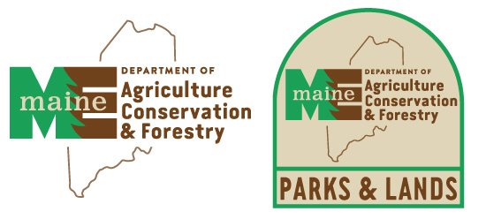
Please return this completed form to: The Manager of the State Park where you
want to volunteer.
See the linked listing of parks on the Volunteer webpage
https://www.maine.gov/dacf/parks/get_involved/volunteer.shtml

Rev: 2024-08-25

