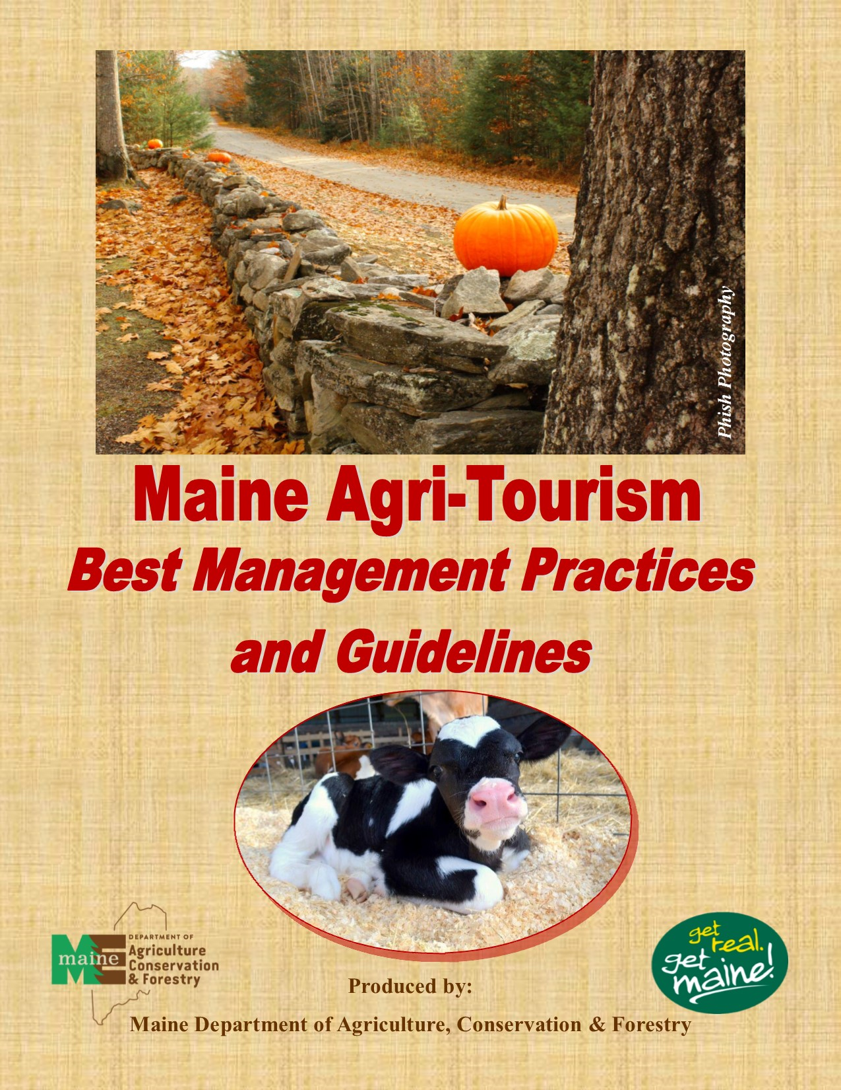

Maine Agritourism: Best Management Practices and Guidelines

Agricultural tourism, or agritourism, is a commercial enterprise at a working farm, farmers market, production facility, or local business creating experiences for visitors that generate income. Farms are selling not only a commodity or product, but rather an experience of how the product is being produced, where, and by whom. With over 2.5 million farms in the United States and Canada, about 50,000 of them are engaged in a significant way in farm direct marketing and agritourism.

Farm stands, u-pick operations, and farm bed and breakfasts are just a few of the agritourism investments that Maine farmers are making. There are also a variety of activities available across the state of Maine, with fairs, festivals, and on-farm events taking place throughout the year. The Maine Department of Agriculture, Conservation and Forestry’s get real. get Maine! website contains a listing of participating farms, upcoming events, and resources to learn more about agritourism.

Agritourism Examples:

- Agricultural food & craft shows
- Animal feeding opportunities
- Barn dances
- Birdwatching
- Educational Tours
- Floral arrangement classes
- Garden tours
- Historical displays
- Farm stands
- Pick your own operations

Is your farm or business interested in opening an agritourism enterprise? If so, there are several planning and legal considerations that you should assess before beginning this exciting business venture.

Planning Considerations

- Product Development: Assess your assets to evaluate potential new attractions that would enhance your operation to a visitor.
- What’s your Big Idea?: Describe the activity or experience you want to develop.

- Cost: Set your cost limits and admission fees.

- Marketing/Promotion: Determining your mission, goals and objectives, and identify your target audience.

Example:

Goal #1: To increase the number of visitors to Piscataquis County, Maine.

Objective #1: To design and develop tour itineraries for school groups, regional tourism offices, and motor coach companies.

Objective #2: To collaborate with area farms, farmers’ markets, farm bed and breakfasts, and agritourism sites to plan and promote regional events.

Identifying what other agritourism activities are currently available in your area is beneficial in helping your farm to diversify and offer new and unique experiences for visitors. Contact your regional chamber of commerce, or town office to learn about festivals, events, on-farm stores, Community Supported Agriculture (CSAs) farms, and other activities that farms offer, in order to promote these different experiences to tourists.

Brochures, posters, media campaigns, and website development are beneficial in creating awareness about agritourism and you should design and market them during development of the program. You should determine your budget before beginning your promotional efforts, as these costs can be significant. There are often agricultural websites and county/regional tourism offices that will post your events and on-farm activities free of charge. Once you are able to establish your farm as a worthwhile stop and reach a large audience of visitors, word-of-mouth advertising will begin and is the best form of free advertising and promotion.

The Department of Agriculture, Conservation and Forestry, local tourism bureaus, chambers of commerce, regional planning committees, and local and state agricultural organizations can offer assistance with marketing and promotional efforts.

Some helpful contacts are:
Maine Office of Tourism, Destination Development Specialist- Donna Moreland donna.moreland@maine.gov

Maine Motorcoach Network - https://visitmaine.com/maine-motorcoach-network/

- Facilities: In constructing and developing your agritourism business, you should consider parking areas, restrooms, access roads, and Americans with Disabilities Act (ADA) accessibility. You should plan and design parking and access to the property for motor coaches/buses if you would like to host large tour groups or host many tourists during peak tourism season. Parking, traffic, and managing visitors on site are vital to gaining repeat business, and to keeping neighbors and the town happy.

If offering meal service on site, you should have adequate table space available for visitors, as it will encourage them to stay, enjoy their meal, and explore more that the farm has to offer. You also need to read and understand building permits and codes if you wish to build commercial kitchens, processing facilities, and retail spaces.

Legal Considerations

- Regulations/Permits: You should familiarize yourself with agricultural food and safety laws, health permits, and fire and building codes before starting an agritourism operation. There may also be applicable local, county, state, or federal regulations that apply to your specific type of on-farm activities or events.

Depending on your type of agricultural operation, you may need to obtain a food license for their business. Commodities that are subject to licensing requirements include small grains, potatoes, dry beans; dairy; feed, seed, and fertilizer; meat and poultry; maple syrup; home food processor items; beverages; bakery items; and cider/juice.

To obtain copies of the applicable food license and permit applications, please visit the Department of Agriculture, Conservation and Forestry’s Quality Assurance & Regulations page at: http://www.maine.gov/dacf/qar/permits_and_licenses/application_forms.shtml

- Zoning: Call or meet with your local town zoning commission to determine what zoning ordinances your farm may have to comply with before investing time, money, and resources into an activity or event.

- Contracts/Waivers: When hosting events at your farm, it is important to have signed contracts with the visitors/participating organizations. Within the contract, the exact details of the event should be outlined, including timeframe for the event, number of attendees, what items are the responsibilities of the farm and what items the visitor is taking care of, down payments/deposits, and whether outside food or drink is permitted. Also, it is important to have a waiver of liability in case anything were to happen during the event or on the property of the farm.

You should use the waiver language contained in Title 7 Maine Revised Statutes Section 252 (3)

“Warning
Under Maine law, there is no liability for injury to a participant in an agritourism activity conducted at this agritourism location if such injury results from the inherent risks of the agritourism activity. Inherent risks of agritourism activities include, among others, risks of injury inherent to land, equipment and animals, as well as the potential for injury if you act in a negligent manner. You are assuming the risk of participating in this agritourism activity.”

- Liability Insurance: It is important for farms to talk with their insurance agents to determine the proper insurance policy and coverage amount. Typically, the policy that provides liability for the farm business does not extend to liability from other profit-making activities, such as agritourism.

- Incident Reports: If an accident or injury does occur on the farm, the farm owners or employees should complete an incident report as soon as possible. An incident report gives a thorough account of what happened without leaving out important facts or details. You should keep this report in your files so that you will have it readily available should a patron pursue a claim against the farm. Local police stations have copies of incident reports that may be used, as well as online resources to develop incident reports tailored to your farm. A sample form you may use is attached.

REPORTING PROCEDURE
• Forms should be readily available for all owners, managers, and employees to obtain and should be available at the front desk/office area, farm stand, in the company vehicle, tractor if conducting hay rides, or other areas that have a high risk of injury occurring.
• Staff member(s) who responded to or are involved in the incident/accident are responsible for filling out form(s).
• Reports must be completed as soon as possible after the event but no longer than 24 hours.
• Turn form into the on-site manager or appropriate staff member.

- Public Safety Plan: While it is impossible to ensure 100% safety on farms, reducing the risk of injury and maintaining a safe environment for visitors must be your first priority. The safety of both employees and patrons and guests must be considered when developing your agritourism business. It is important to have clear signage, as discussed in a later section, to inform all parties of the risks of on-farm machinery, livestock, ponds/water sources, and other potential sources of danger. If livestock are present on the farm, it is necessary to have signs that direct patrons to wash their hands upon touching the animals. Hand washing stations should be readily accessible and stocked at all times.

Several Maine farms and agritourism sites are in rural areas, where road access issues may arise during an emergency situation. It is important to meet with local emergency medical service personnel, such as the fire department and police officers, to determine the best route of access to the farm during an emergency. Training employees and staff in emergency protocols is also a key factor in managing these types of incidents, as well as having first aid/medical supplies and a list of emergency contacts readily accessible.

- Security: With merchandise for sale at many agritourism sites, the possibility of theft is real. Several farms have security cameras installed in areas where employees may not be able to view as easily or in orchards and fields where other on-farm activities are conducted. Some farms even utilize “dummy” cameras or post signs that the farm is under surveillance to discourage theft or other wrongdoing on the premises. These methods have proven to be successful in terms of managing inventory, incident reports, and potential liabilities.

- Photography/Videography Permits: Photographs that are taken at the farm can be a great way to promote your business and reach a variety of new visitors. However, often when professional photographers take these images, they are able to resell them at a higher price without the farm receiving any of the compensation. To prevent this from happening, you are encouraged to have photographers pay for a permit to take photos. This allows you to be able to receive a small fee for the use of the property, venues, and activities/events, while also allowing photographers to resell the images and promote Maine agriculture.

- Biosecurity: Many farms have animals that are an instrumental part of their agritourism sites, including petting zoos, horseback rides, and even some exotic animals on display. Farm biosecurity is a set of measures designed to protect a property from the entry and spread of pests and diseases. Protocols such as handwashing and sanitizer stations, posted signs to prevent visitors from touching the animals, and quarantining/removing sick animals from the property so they do not come in contact with visitors are necessary measures that you should implement. Contacting your state or local veterinarian is a good first step in developing your farm’s biosecurity plan.

Maine Department of Agriculture, Conservation and Forestry, State Veterinarian - Michele Walsh: 207-287-7615 or michele.walsh@maine.gov

United States Department of Agriculture: Animal and Plant Health Inspection Service offers a variety of resources in regards to animal welfare, exotic animals, disease emergency response/preparedness, and other helpful publications, forms, and guidance documents. https://www.aphis.usda.gov/aphis/ourfocus/animalwelfare/sa_publications

- Posted Rules/Signage: With multiple on-farm activities at the farm, it can be difficult to manage all visitors, especially during peak seasons and hours. It is helpful to have signs posted around the property that indicate rules for certain areas and activities, such as how many apples can be picked to constitute a “bushel”, no-petting of animals, no photography/videos, etc. When signs and farm rules are clearly visible, it mitigates potential problems and makes for a more enjoyable experience for both visitors and employees/managers. Providing brochures and additional handouts about why certain areas are off-limits or dangerous to customers is also beneficial, as many visitors do not realize the risks that exist on farms.

- To help protect yourself from liability, you should post warning signs that make it clear that visitors to your business are assuming the risk of participating in agritourism activities. Title 7 of the Maine Revised Statutes section 252 (2) provides the required language and size of the letters.

"WARNING
Under Maine law, there is no liability for injury to a participant in an agritourism activity conducted at this agritourism location if such injury results from the inherent risks of the agritourism activity. Inherent risks of agritourism activities include, among others, risks of injury inherent to land, equipment and animals, as well as the potential for injury if you act in a negligent manner. You are assuming the risk of participating in this agritourism activity."

The message on the sign must be in black letters at least one inch in height, and the sign or signs must be placed in a clearly visible location on or near the places where the agritourism professional conducts agritourism activities.

To order farm safety signs, visit: http://www.mysafetysign.com/farm-safety-signs

To learn more about identifying potential safety hazards on farms and how to address them, visit: http://safeagritourism.org/checklists/

Agritourism is growing in importance to Maine farmers, and in order to build a successful and worthwhile business, farms should be mindful of the potential obstacles they may face. When these considerations are made prior to development of the agritourism activities, it provides a proactive approach to help farms be at the forefront of this rapidly growing sector of agriculture.

If interested in being featured on the Maine Agri-Tourism Map, or for further questions about growing your agritourism business, please contact Melissa Macaluso at: 207-287-3228 or melissa.macaluso@maine.gov.

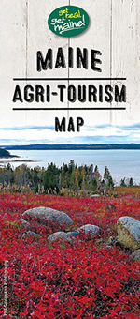

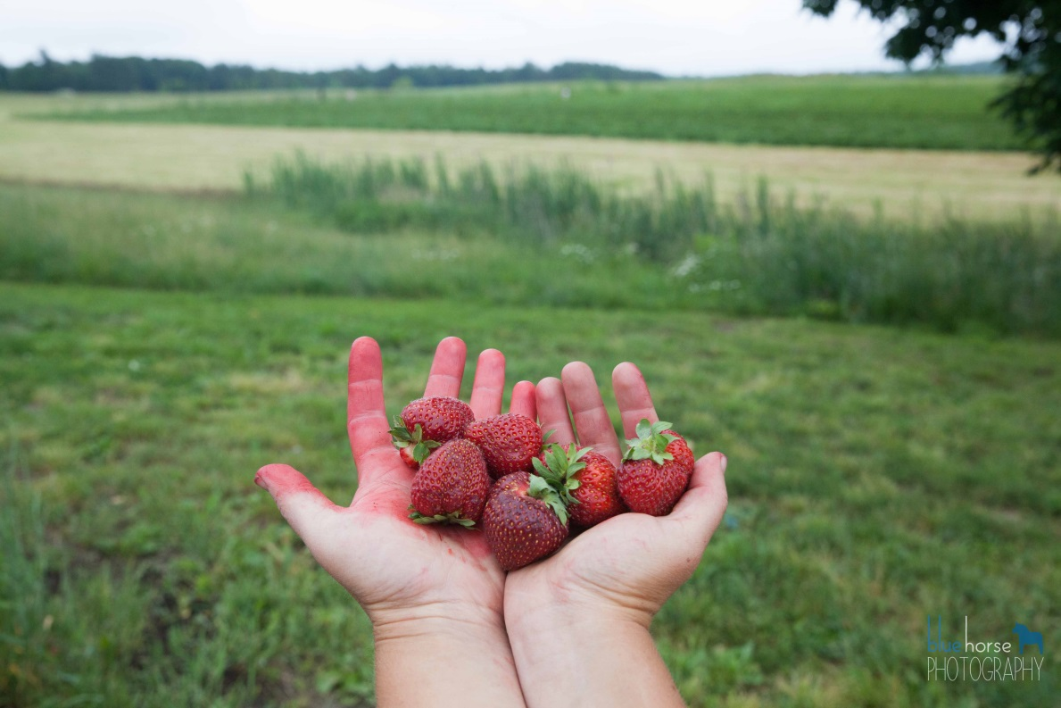
- SAMPLE -
FARM ACCIDENT/INCIDENT REPORT FORM
{Farm Name}
Date of incident: _______________ Time: ________ AM/PM
Weather conditions: __________________________________
Name of injured person: ____________________________________
Address: ________________________________________________
Phone Number(s): __________________________
Date of birth: ________ Male ______ Female _______
Description of injury: ____________________________________________________________________________________________________________________________________________________________
Details of incident: ________________________________________________________________________________________________________________________________________________________________________________________________________________________________________________________________________________________________________________________ ______________________________________________________________________________
Were there any witnesses? Yes ___ No ___
Name of witness(es): ______________________________ _______
Address of witness: _____________________________________________________________
Phone number(s): _______________________________________
Was a witness statement obtained? Yes ___ No ___
Was first aid administered at the farm? Yes ___ No____
If yes, describe actions taken: __________________________________________________________________________________________________________________________________________________________________________________________________________________________________________

Did injury require EMS/hospital visit? Yes ___ No _____
Name of hospital: _____________________________________________________
Hospital phone number: _________________________________________
Employee(s) investigating scene: ___________________________
Any corrective measures taken? __________________________________________________________________________________________________________________________________________________________________________________________________________________________________________
Any photographs taken? Yes ___ No ____
Signature of injured party
x____________________________________________________________________________ Date
*No medical attention was desired and/or required:
x ____________________________________________________________________________
Signature of injured party if medical attention declined Date
******************************************************************************
Name of person filling out report (printed) ___________________________________________
Signature
x____________________________________________________________________________ Date
Name of farm owner/manager (printed) _____________________________________________
Signature
x____________________________________________________________________________
Date

get real. get Maine! is the widely recognized Maine Department of Agriculture, Conservation and Forestry promotional effort that connects consumers and wholesale buyers to great food and farm products. Using the get real. get Maine! website, you can locate farms to visit in the area; shop for particular products; find any Maine farmers’ market and agricultural fairs throughout Maine; and obtain information on other events and resources to connect with Maine’s real farm, food and forest products!

Look to get real. get Maine! for searchable local listings of an increasing variety of products and services including fruits and vegetables, dairy, meats, specialty foods, unique farm and forest products, farm stands, and maple syrup just to name a few. get real. get Maine! instantly connects you to real Maine products and experiences.

For more information, visit us at www.getrealmaine.com

