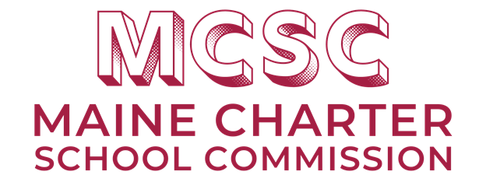

**Fund Request Form**

1. *Completed form must be submitted via Epicenter.*
2. *Form must be submitted at least* ***three weeks*** *prior to the January or June Commission Meeting date to be included on the agenda. Note: Commission Meetings are typically held on the 2nd Tuesday of each month.*

***Innovation Fund Information:*** *SY 2024-2025*

*The Maine Charter School Commission is pleased to offer Innovation Grants to applicants from Maine Charter Schools. The Commission has dedicated $40,000 in total to award to applicants in SY24-25. The grant funds are allocated on an annual basis and the total amount of funding will be determined annually by the Commission.*

***What is the Innovation Fund?***

*There are multiple goals for the funds, all to serve as innovations to increase student achievement, improve student opportunities, and enhance services to students. We encourage schools to work together, take risks, learn from failures, and celebrate successes. While we do not wish to stifle innovation, we must ensure that adequate planning - including ensuring the safety of students and evaluation of efforts - reveal that the innovations are forward moving.*

*A charter school may apply for up to $10,000 for a single project or multiple projects. If the school achieves successful program outcomes, they will share best practices and lessons learned with the other charter schools in Maine to encourage program replication.*

***Who may apply?***

*Any staff member of a public Maine Charter School may apply for up to $10,000, with application approval from the charter school’s Executive Director.*

***How do you apply?***

1. *Fill out the Innovation Fund Request Form (below) and submit it via Epicenter. The fund request form should be no more than 5 pages.*
2. *The form must be filled out at least three weeks before the Commission Meeting when it will be considered for approval.*
3. *The Commission will consider the request during scheduled business meetings in January and June and decide whether to issue the funds and, if approved, how much money to issue.*

***What types of innovation is the Commission interested in funding?***

*The following priorities are not required for Fund Request approval but are highly recommended. Applications that contain some or all of the below priorities have a greater chance of being approved by the Commission.*

* *Demonstrates rigorous learning along with high student engagement*
* *Will increase student achievement*
* *Program runs the full school year*
* *Program impacts at least three or more grade levels*
* *Proposal demonstrates collaboration with at least one other school - charter, district public, and/or higher education*
* *Proposed innovation is a new experience for students*
* *Schools have not been awarded Innovation Fund grants in the prior school year*

|  |  |
| --- | --- |
| Name of Requestor |  |
| Organization/School |  |
| Phone |  |
| Email |  |
| Signature |  |
| Date |  |
| Total Amount Requested |  |

**Please explain the proposed use of funds in detail:**

|  |
| --- |
|  |

**How will this proposal enhance the performance of your school?**

|  |
| --- |
|  |

**Please explain how this relates to your professional development and operation of the school:**

|  |
| --- |
|  |

**How will you measure the success of your innovation?**

|  |
| --- |
|  |

***Fill in as Appropriate:***

|  |  |
| --- | --- |
| Proposed Date of Activity |  |
| Duration |  |
| Location |  |
| Number of Participants |  |

*Please provide a breakdown of the Total Amount Requested. If you have received a proposal from a provider you* ***must*** *attach a copy to this request.*

|  |  |
| --- | --- |
| Registration Fee |  |
| Materials Fee |  |
| Venue Fee |  |
| Other (Please Explain) |  |
| Other (Please Explain) |  |
| Other (Please Explain) |  |
| Total Cost |  |