The ConnectME Authority



Detailed 2019-2021 Strategic Plan for Broadband Service in Maine

February 2019

Table of Contents

A Broadband Overview 3

Maine Goals and the Triennial Plan 5

Ubiquitous Connectivity 6

Vision and Objectives 9

Action Plan 10

# A Broadband Overview

In its simplest terms, “broadband” is a fast connection to the internet that is always on. Broadband infrastructure is an essential catalyst to drive community and economic goals across the state. It is revolutionizing the way people all over the world shop; conduct business; read; communicate; become educated; receive health care; and provide government services.

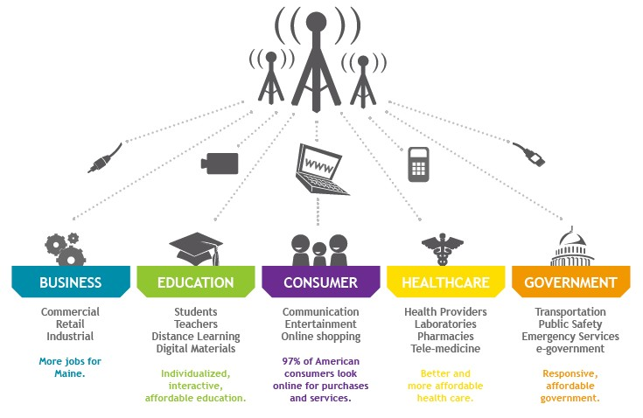

Nationally, residents and business alike rely more on broadband access every day. While usage is growing across the board, previously underrepresented groups are increasing their engagement. Families with lower household incomes are finding alternate paths for services, workforce training and healthcare.

Figure 1: Internet Use by Family Income [1]

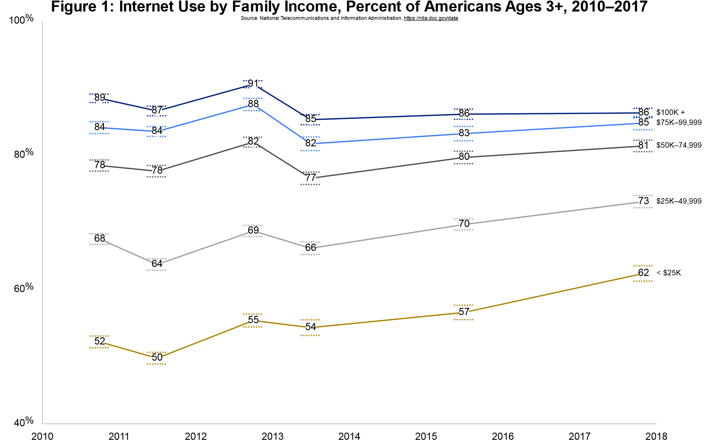

Seniors are finding ways to stay connected to family and reduce isolation with connectivity as well.

Figure 2: Internet Use by Age [2]

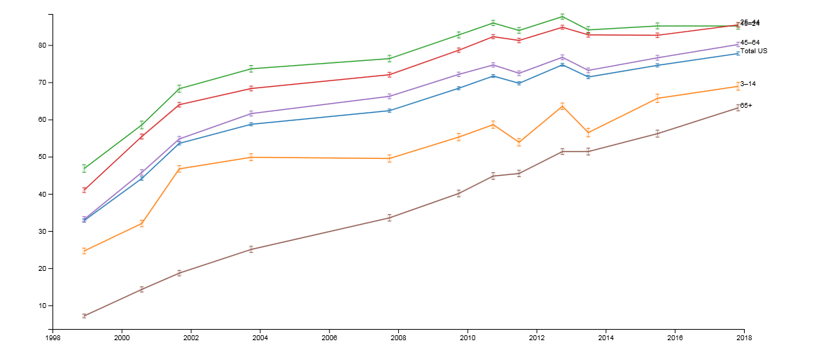

Accessible broadband includes not only available infrastructure, it also includes ensuring that there are affordable subscriptions to create access for all, improving digital literacy to enable people to optimize technology to achieve their goals and application development that makes services readily available.

*Digital Literacy and Inclusion*

Accessible, reliable, and affordable broadband service continues to be out of reach for millions of Americans and thousands of Mainers, many of whom live in low-income, rural households. This gap in adoption of high-speed internet and the lack of skills needed to use broadband-enabled tools in meaningful ways continue to be a lag on the Maine economy.

While much of the attention tends to focus on connecting homes to the internet, another serious concern is emerging… how to leverage the internet beyond the typical uses of email and streaming television content. Increasingly, homes that have internet may not be leveraging the full power of that connection and even more concerning, those that are just getting an internet connection, or the 1000s of homes that are still waiting for a connection, may not fully understand the capability and value of an internet connection.

Maine is fortunate to have The National Digital Equity Center (NDEC) based here. NDEC is committed to closing the Digital Divide in Maine and across the United States. In addition to advocating for Affordable Broadband, Affordable Equipment and Public Computer Access, NDEC is focused on creating digitally literate citizens across Maine and beyond, providing communities with the expertise to mobilize broadband technologies through digital inclusion and literacy efforts.

Four major areas of support are especially important in Maine:

* Aging in Place
* Tourism
* Small and Home Business Growth & Support
* Residential Resources

# Maine Goals and the Triennial Plan

The Maine Legislature has adopted the following goals related to broadband:[3]

* 1. *Broadband service be universally available in this State, including to all residential and business locations and community anchor institutions;*
  2. *There be secure, reliable, competitive and sustainable forward-looking infrastructure that can meet future broadband needs; and*
  3. *All residents, businesses and institutions in the State be able to take full advantage of the economic opportunities available through broadband service.*

The major policy means for achieving these goals is the ConnectME Authority, established as an independent state agency in 2006. The funding mechanism for the ConnectME Authority is a 0.25% surcharge on all communications, video and internet service bills which generates approximately $850,000 per year.

Over the past 12 years, the ConnectME Authority has awarded approximately $12 million in grants to 144 projects, increasing access to high-speed internet to 39,465 Maine households (no data is available on how many of these households has actually subscribed to high-speed internet). The ConnectME Authority has also leveraged more than $7 million in federal high-speed internet grants over the last 6 years. Additionally, ConnectME has started issuing Planning Grants and has issued 14 grants for a total of $451,000. These grants are critical to supporting communities as they determine their needs, assets and business models to move forward.

#### *Table 1: ConnectME Authority Infrastructure Grants*

|  |  |  |  |  |  |
| --- | --- | --- | --- | --- | --- |
| Grant Round | # of Grants | Grant Range in Thousands | Total Grants | Total Project Amount | Household Broadband Availability[4] |
| 1 | 6 | $38 - $370 | $739 K | $1.53 | 13,836 |
| 2 | 5 | $45 - $533 | $1.19 MM | $3.89 | 8,678 |
| 3 | 8 | $43 - $232 | $610 K | $1.23 | 4,227 |
| 4 | 22 | $23 - $114 | $788 K | $1.51 | 2,957 |
| 5 | 12 | $7- $191 | $1.09 MM | $1.66 | 1,545 |
| 6 | 23 | $5 - $242 | $1.55 MM | $2.34 | 2,296 |
| 7 | 23 | $23 - $284 | $2.08 MM | $3.16 | 2,049 |
| 8 | 15 | $6 - $144 | $1.02 MM | $1.69 | 1,034 |
| 9 | 8 | $12 - $186 | $749 K | $1.43 | 975 |
| 10 | 13 | $22-$199 | $1.31 MM | $2.26 | 1,043 |
| 11 | 7 | $22-$100 | $398K | $1.98 | 626 |
| 12 | 2 | $71-$185 | $255 K | $395K | 206 |
| **Total** | **144** | **$5 - $533** | **$12.16 MM** | **$23.91 MM** | **39,472** |

Table 2: ConnectME Authority Planning Grants

|  |  |  |
| --- | --- | --- |
| Round | # of Grants | Total Grants |
| 1 | 4 | $212K |
| 2 | 5 | $159K |
| 3 | 5 | $80K |
| **Total** | **14** | **$451K** |

# Ubiquitous Connectivity

Connectivity is becoming ubiquitous. 9 in 10 adults in the United States use the internet. (Pew Institute) Users expect seamless transitions between devices and locations and access to information and communication has become the standard. The Fiber Broadband Association estimates that worldwide bandwidth use roughly doubles every 2 years and Cisco estimates that we will have 12.9 connected devices per capita in 2021.

There is a growing percentage of internet users that use a smart phone as their primary connectivity[5]. Technologies like 5G will continue that progression. Fortunately, the infrastructure that will support 5G deployments also supports fixed broadband needs.

Figure 3: % of U.S. Adults Who Do Not Use Broadband at Home but Own Smartphones, by Age

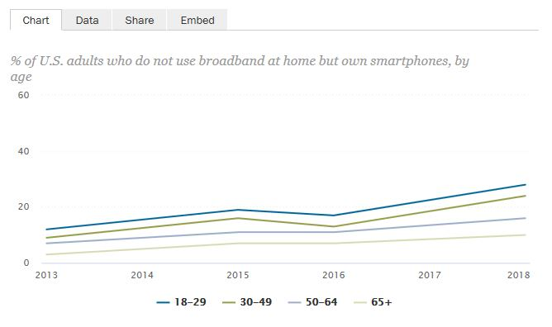

As the Internet of Things expands there are more opportunities for towns to connect and streamline experiences for residents and visitors. As Communities are looking to the future and determining what their version of Connected Communities will be, the private sector is focused on the revenue opportunities of Connected Communities as well.

Figure 4: The Connected Community [6]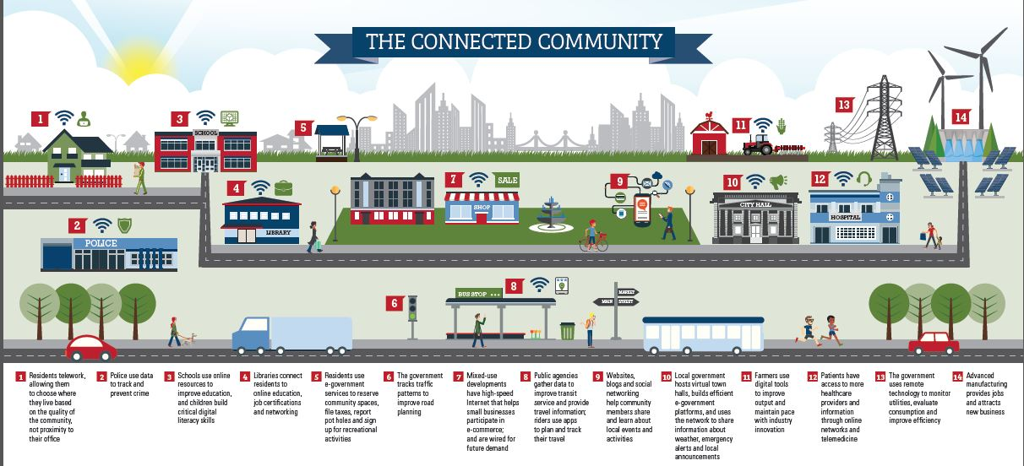

Residents are assessing the risk and convenience of connections and determining how engaged they choose to be. The State can play a leadership role in supporting community planning in this area.

Figure 5: Seven Major Themes on the Future of the Internet of Things and Connected Life [7]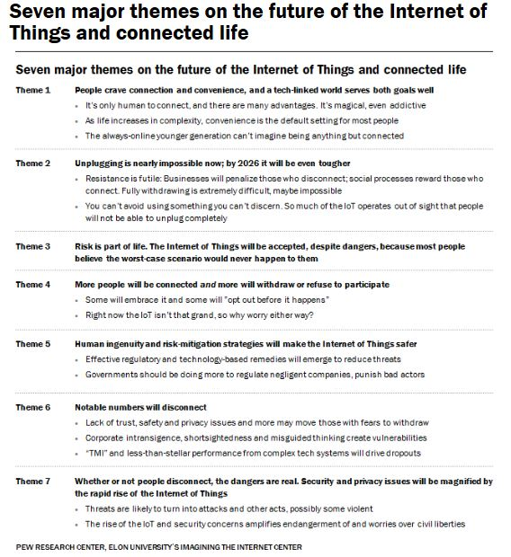

# Vision and Objectives

The vision of the ConnectME Authority Board for the State of Maine is that:

***Every Maine citizen, business, and institution will have access to and take advantage of high- quality broadband network services****.*

The ConnectME Authority Board currently defines effective broadband as 25 Mbps/3 Mbps – 25 megabits down and 3 megabits up. Areas that have available broadband speeds of at least 25 Mbps/3 Mbps are considered served. Areas without broadband speeds at a minimum of 25Mbps/3Mbps are considered unserved.

The ConnectME Authority is directed to prepare “a detailed, triennial strategic plan for broadband service … to further the goals and policies in section 9202-A.” The Legislature directs the ConnectME Authority to serve as the chief monitor of the state’s progress in meeting these goals and to set “objectives, targets, measures of performance, implementation strategies, timelines.”

The objectives of the Triennial Strategic Plan for broadband service for the State of Maine are:

* 1. ***To have 93% of Maine locations have available high-speed internet access by 2021;*** *i.e., access to basic internet service increase in Maine (defined as at least 25 Mbps up), as measured by the ConnectME Authority detailed mapping.*
  2. ***To increase the usage of high-speed internet by 2021 from 76% to 85%;*** *i.e., the proportion of Maine households that subscribe to high-speed internet (via cable, cell, or other means) increase from 76% in 2018 to 85% in 2021, as measured by the US Census. This requires addressing all aspects of digital inclusion: affordable internet, affordable equipment, digital literacy training, and public computer access.*
  3. ***To fully engage Maine business with the internet;*** *i.e., the proportion of Maine businesses that carry out marketing and online activities through their own website to 80% in 2021.*

It is the policy of the Connect ME Authority to be neutral about the technological means to achieve these goals – not to favor one technology over another in its planning or grant provision.

These objectives cannot be achieved without robust leadership, investment, and activity. The approach which follows recommends a partnership between Maine’s private and public sectors to achieve these objective

# Action Plan

The Broadband private sector investment model doesn’t work in rural Maine. The low population density and limited scale make it unprofitable for the private sector to expand their networks with private investment only.

The Statewide Action Plan is a community driven process. There are a number of business model options for the communities to leverage.  Regional Utilities are being established in a few areas in the state while municipally owned is less common. Additionally, Public/Private partnerships is an option to optimize the private sector investment while driving the expansion needed to grow the Maine economy.

This Statewide Broadband Action Plan (Action Plan) proposes that the state will contribute 25% of the total cost of the expansion needed for rural Maine. The remaining costs will come from the private sector, federal government and the local communities.

Our goal is to complete this program within 5 years of initial funding. The first-year funding will start the work in high impact communities and demonstrate to the other public and private partners that Maine is committed to supporting and growing our rural economy and encourage their investment.

The ConnectME Action Plan first builds a solid foundation from which to enable successful Public/Private partnerships by:

* Collaborating with the existing service providers to produce more accurate mapping of actual broadband speed availability by address;
* Redefines our definition of unserved to recognize the value of longer term investment;
* Sets long-term and intermediate goals to measure progress and success;
* Determines the overall cost to fill the gaps in availability, the ability of which has eluded us until now;
* Places our local communities firmly in the drivers seat to determine their own broadband destiny;
* Positions the State to support the local communities their effort to expand broadband;
* Distributes available subsidy dollars in a competitive and efficient manner;
* Holds the local communities accountable for the efficient deployment and use of public dollars;
* Leads a high-level effort, in collaboration with State leadership and our congressional delegation, to seek increased federal funding and private provider participation; and,
* Rewards those communities that are willing to lead, have the capacity to contribute funds and/or are willing to make broadband adoption commitments to convert what is currently an uneconomic investment, into a viable and sustainable solution.

## **Mapping**

The current ConnectME Authority Mapping relies upon the service provider submission of FCC Form 477 data, which by its definition, over-states availability geographically *(as an example, if a single address is served within the census block, the entire census block is considered served)* and reports the maximum advertised speed instead of the actual speeds available at a specific address.

With the cooperation of the service providers[8], we will revise the methodology to require address specific, actual speed available submissions to develop mapping with a much higher degree of accuracy. Providers who do not provide address specific actual speed availability data will not be eligible for subsidies.

We have defined unserved potential subscribers as those locations where the available service is less than 25Mbps/3Mbps. We will also select 100/10 as a preferred capability. These definitions will more closely align the Maine standards to the federal standards used by the FCC and other federal agencies and their funding programs. The current FCC standard considers service at 25Mbps/3Mbps as served.

Importantly, these definitions will be utilized to determine geographic areas eligible for implementation subsidies under this Action Plan, but do not necessarily define the capabilities to be deployed with the subsidized services.

## **Cost Estimates**

Using the geography defined in the steps above and industry deployment metrics for outside plant construction, we will determine high-level estimated costs to deploy service using the following architectures:

* Open-access dark fiber capable of providing service at 10Gbps symmetrical
* Expand existing cable TV hybrid/fiber infrastructure capable of providing service at speeds up to 1Gbps symmetrical

This effort will define the scale of the broadband challenge on a statewide basis in terms of the maximum total dollars required. It is important to note that we are not excluding deployment of twisted-pair copper DSL solutions and their associated costs; rather, we recognize the determination of costs for DSL solutions cannot easily be calculated without detailed knowledge of the actual method of construction of the existing copper, the condition of that network, and the gauge of the conductors, all of which is proprietary to the underlying service providers.

## *Preliminary Cost Estimates*

In the absence of accurate mapping, we have made a series of assumptions to develop preliminary cost estimates to guide our efforts.

* The total sphere of Addressed Road Miles per Maine E911, which includes most seasonal and private roads, is 35,162 miles. We use this mileage to define to total addressable road mileage.
* Our best estimate of the total road mileage served by hybrid fiber/coax infrastructure is 17,502 miles. We arrive at this amount by interpolation of the FCC Form 477 reporting data *(based on census blocks)* and reduce the amount by 10% to account for the inherent overstatement of availability using this data *(see Section 2.1 above).*
* As a result, roughly 50% of roadways in Maine, or 17,660 miles, is considered unserved or below the preferred capability level.

### *Open-Access Dark Fiber Cost Estimate*

We estimate the total cost to deploy a statewide open-access dark fiber network, designed to enable any service provider to be able to lease a fiber connection to any location would cost at least $1.6 billion dollars. Importantly, this cost estimate does not include the drop fiber cable from the street to the subscriber or any electronics to deliver a finished service, which would be the responsibility of the service providers. Further, it is unlikely any private provider would contribute capital dollars for construction of such a statewide network unless they were afforded a long period of exclusive use before permitting other service providers to utilize the infrastructure.

Operating and maintaining such a network, and gaining sufficient market share to achieve sustainability, would also be a challenge in the face of a viable competitive infrastructure such as the cable TV hybrid/fiber networks already deployed in the most densely populated areas across 50% of the roadway footprint.

### *Cost Estimate to Expand Cable Tv Hybrid Fiber/Coax Infrastructure*

We estimate the total cost to expand the existing cable TV hybrid fiber/coax infrastructure, already deployed in the most densely populated areas may cost at least $600 million dollars, or more than 60% less than a ubiquitous open-access dark fiber network.

Unlike the open-access dark fiber network discussed above, the service providers whose network is being expanded would contribute private funding and be fully responsible for the operation and maintenance of such a network. As such, sustainability would not be an ongoing concern.

As with any public/private partnership, determining the share of public or private funding is difficult to project with certainty. We can however, leverage the experience in New York where the New York State Broadband Program Office (NYBPO) is in the process of implementing the third phase of their three-phase reverse auction program to deploy high-speed broadband to the entire state.

**Figure 6: New York State Private Contribution Example**



Based on the New York program, we would expect private providers to contribute 20%-25% of the deployment costs.

### **Funding**

We believe the ideal method of sharing the funding is an equal allocation between the private provider and local, state and federal government, each contributing 25% of the funds. At the same time, we recognize many local communities may not have the capacity to fund at this level and also recognize we cannot count on the federal government to fill the gap. As a result, we anticipate the State share of funding to be 25% or as high as 75% without local or federal funding.

This cost sharing approach appropriately balances the funding capacity of each partner, encourages both local and state governments to seek the balance of funding elsewhere, and encourages public/private partnership solutions without relying solely on state government to bridge the gap.

## *Prioritize Areas Eligible to be Subsidized*

The statewide unserved areas will be subdivided by county and by municipality to enable each government entity within the State to understand the broadband capability within each of their borders. Municipalities will be eligible for subsidy and participation in the reverse auctions as well.

1. **Reverse Auction**

Our primary method for the award of subsidies will be a reverse auction, although we recognize the potential need to develop an alternative method should there be areas without qualified applicants.

A reverse auction is a type of [auction](https://en.wikipedia.org/wiki/Auction) in which the roles of buyer and seller are reversed. In an ordinary auction (also known as a “forward auction”), buyers compete to obtain goods or services by offering increasingly higher prices. In a reverse auction, the sellers compete to obtain business from the buyer and prices will typically decrease as the sellers underbid each other.   
  
In this instance, service providers will compete for subsidies with the subsidy awarded to the service provider willing to provide service with the least amount of subsidy. Properly administered, a reverse auction should result in the greatest capital efficiency.

The reverse auction will have some critical design elements that we will work with communities and providers to determine the most effective balance of weighting. At least two other reverse auction programs are in process for expansion of broadband service that can serve as a model for the State of Maine.

## *Provide Funding Leadership*

Success under this Action Plan will be defined by our ability to secure a combination of private funding (service provider investment) and public funding (local, state and federal), and will require a high level collaborative effort between State administrative and legislative leadership, and our congressional delegation.

We believe sufficient private funding is available from the service providers if sufficient subsidy funding is available to develop an overall economic investment on the part of the service providers. Securing sufficient pubic funding is clearly the most significant barrier to success.

### *Federal Funding*

To confront this challenge, we propose the appointment of a high-level special envoy with extensive broadband development experience that will have the authority to represent the administration and have access to State leadership, and whose sole purpose will be to lead the State of Maine efforts to secure federal funding in collaboration with our congressional delegation. This special envoy will focus in the following areas for the State of Maine:

* Build a relationship with the FCC to influence the direct federal broadband subsidy programs to maximize the State’s share of those dollars.
* Build relationships with the USDA Rural Development agency to maximize the federal dollars directed toward rural broadband expansion.
* Work with other executive departments of the Trump Administration to better coordinate programs that can direct funds from those budgets toward a greater level of funding for broadband expansion.

### *ConnectME Fund*

Currently funded by a ¼ of 1 percent assessment on Communications Service Provider State revenues, this funding source should be retained. We recognize this funding source is declining year-over-year as subscribers discontinue land-line based services and migrate to wireless services not assessed this fee. This source of funding should be devoted to administrative and project management expenses to govern this Action Plan and to continue funding Broadband Feasibility Studies at the municipal level to prepare communities for participation in the Action Plan.

### *Low Interest Loans*

Low interest loans may enhance the ability of private industry to participate in public/private partnerships that will expand broadband availability under this Action Plan. Collaboration with the Finance Authority of Maine (FAME) and Maine Technology Institute (MTI) will present an opportunity for the State to take a leadership position in assisting service providers to invest in these types of projects.

### *Local Funding*

A key design element of the reverse auction process is to award projects meeting goals at the lowest cost per unit of State investment. Local funding in addition to private funding will naturally be given preference, as the cost per unit will theoretically be lower with local government participation. Local funding may be in the form of local public funding, local private funding (non-service provider partner), business donations, and public or private donations.

## **Accountability**

Accountability must be a key component and should be required of any applicant receiving funds as a result of this Action Plan. Likewise, it will be important for the State to be accountable for properly and efficiently distributing funds.

### State of Maine Accountability

* Maintain mapping
* Develop and manage reverse auction process
* Collaborate with municipalities and service providers
* Present an annual progress report to legislature
* Educate stakeholders and constituents regarding the challenges and processes required to expand broadband availability

### Applicant Accountability

* Complete projects on-time and within budget
* Measure and report actual speeds provided, latency, etc., in conformance with FCC Connect America Fund standards
* Measure and report on adoption attainment compared to plan

## Goals

### *Five-Year Goal*

Within five years, 99%[9] of all potential subscriber locations statewide have access to at least one broadband provider with sufficient capacity needed for full participation in our society, democracy and economy, to enable civic and cultural participation, employment, lifelong learning, and access to essential services.

### 

### *Interim Goals*

**Figure 9: Interim Goals**



**Figure 10: Five-Year Goal Forecast**

### Actions Necessary to Reach 5-Year Goal

### *Funding Availability*

The greatest risk to achieving the five-year plan will be the availability of funding in the early years of the plan. Once projects are awarded, engineering, utility pole make-ready and network construction will require 12-18 month to complete. As a result, all project areas will need to be awarded no later than the beginning of the fourth year.

If sufficient funding is not available within the first two years, the schedule will necessarily be extended until such funding becomes available.

### *Additional ConnectME Authority Staffing*

The two current ConnectME staff positions will not be sufficient to achieve this aggressive five-year plan. We anticipate a requirement to augment the staff with either permanent employees or temporary contractors to manage the reverse auction process, assist the community applicants, govern the awards and ensure overall compliance with this Action Plan.

## *Review and Update Action Plan Annually*

With the rapid changes in broadband technology, application development, and bandwidth capacity requirements, we anticipate this Action Plan to be reviewed and updated on an annual basis.

1. https://www.ntia.doc.gov/data/digital-nation-data-explorer#sel=internetUser&demo=income&pc=prop&disp=chart
2. https://www.ntia.doc.gov/data/digital-nation-data-explorer#sel=internetUser&demo=age&pc=prop&disp=chart
3. Sec. 3. 35-A MRSA §9202-A, State broadband policy
4. Household Broadband availability is defined as those houses offered the option of acquiring broadband services from a provider and is also referred to as houses passed.
5. See <http://www.pewinternet.org/fact-sheet/internet-broadband/>
6. See <https://broadbandusa.ntia.doc.gov/sites/default/files/resource-files/bbusa_connected_community.pdf>
7. See <http://www.pewinternet.org/2017/06/06/the-internet-of-things-connectivity-binge-what-are-the-implications/pi_2017-06-06_future-of-connectivity_0-01/>
8. As of this writing, Consolidated Communications has entered into a non-disclosure agreement to provide address specific, actual speed availability and the other service providers we spoke with regarding this Action Plan have indicated a willingness to share their address specific data under similar non-disclosure agreements. This initiative is moving forward under ConnectME Authority guidance in parallel to this Action Plan and is not reliant upon this plan.
9. The 99% goal is based upon the assumption that the cost to reach the last 1% is exorbitant and will be much more reasonably served via satellite-based services.