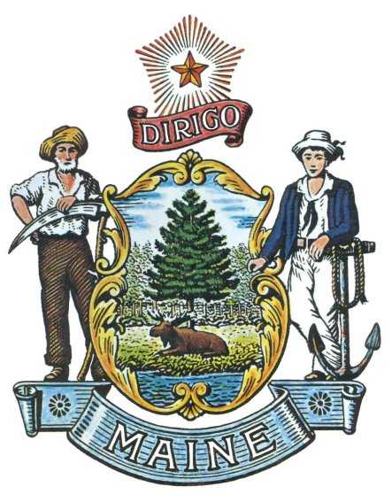

State of Maine

Environmentally Preferable Procurement Policy

The State of Maine has established a broad range of product procurement practices oriented toward the preservation of natural resources, the promotion of environmental sustainability, and the protection of the health and safety of employees, citizens, and visitors of the State.

The State remains dedicated to continuing environmentally preferable procurement: to purchase products and contract for services that have a reduced negative impact on human health and the natural environment in comparison to other products and services that serve similar purposes. To that end, the State shall carry on its efforts to seek ways to increase the acquisition of such products and services, to the extent feasible, balancing price, performance, availability, and safety.

The effective date of this policy is 5 November 2004.

Signed ___________________________________
Director, Division of Purchases

State of Maine

Environmentally Preferable Procurement Program

Pursuant to the State of Maine Environmentally Preferable Procurement (EPP) Policy, the State hereby establishes an EPP Program to reduce the environmental and health impacts associated with procurement, reduce costs where possible, and increase operational efficiency. Under the program, the State shall engage in multiple strategies, which will include:

- Establishing an EPP Team with membership from the Departments of Administrative and Financial Services and Environmental Protection. Work will include developing and communicating specific work plans that promote the State EPP Policy, researching new environmentally sustainable products, educating employees about emerging best-practices in EPP, periodically re-evaluating goals, practices, and the EPP Policy and Program, and developing and providing information for State agencies to help them identify, assess, and procure EPP products, when feasible;
- Considering several factors in making best value (as that term is defined at 5 M.R.S.A. § 1825-B(7)) determinations, including, but not limited to, fuel efficiency and use of alternative fuels, recycled content percentages, energy- and water-efficiency ratings, materials content, emissions, waste generation, toxicity, and recyclability;
- Seeking recognized certifications in determining the products that best reflect the policy;
- Increasing the selection of EPP products on State contracts and eliminating non-EPP product alternatives, when feasible;
- Working with vendors to learn about and promote EPP;
- Identifying EPP cost-saving opportunities through product life-cycle cost assessments and alternative procurement methods;
- Setting annual targets for increased EPP purchases and communicating those targets to State agencies;
- Continuing to offer municipalities and school districts the opportunity to benefit from various State of Maine contracts, including those involving EPP products;
- Identifying the most significant purchases made on an annual basis and taking steps to ensure that the products contain EPP criteria when feasible; and
- Incorporating EPP specifications into service contracts and grants.

