How to Register for an On-Site Health Screening
- Log on to https://wellstarme.org and select “Schedule Now”
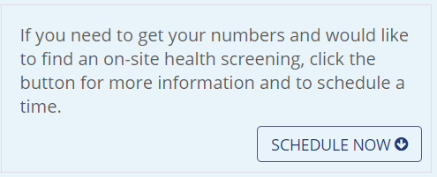

- The page will automatically scroll down to scheduling information. Returning users to the scheduling system may log in however it is not required.
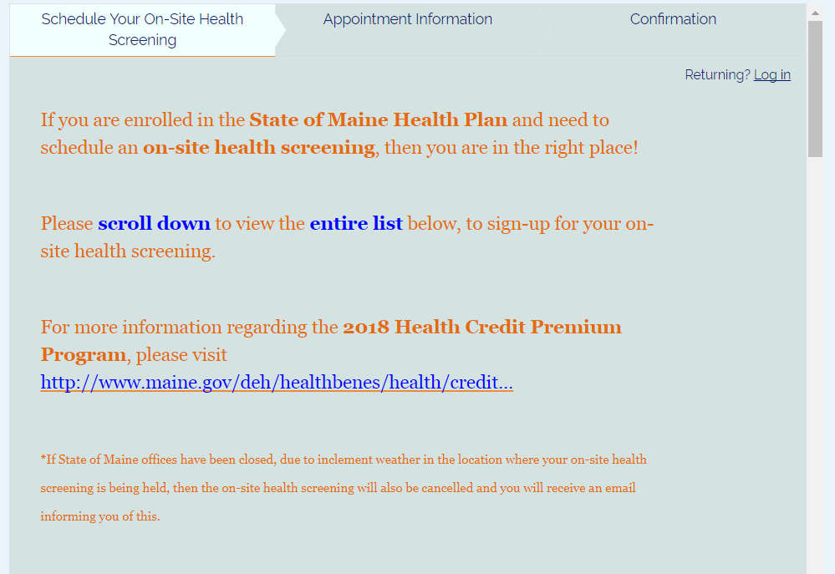

- Scroll down (within the page above) to view the screening locations.
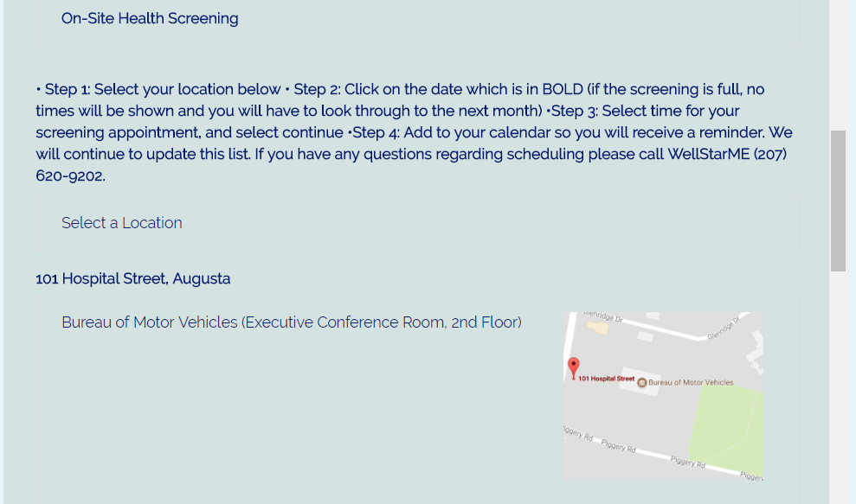

- The screening events are listed in order of street number. For a list by city or town, please visit http://www.maine.gov/deh/healthbenes/wellness/On-SiteHealthScreenings.html
- Select screening location by clicking in the map section:
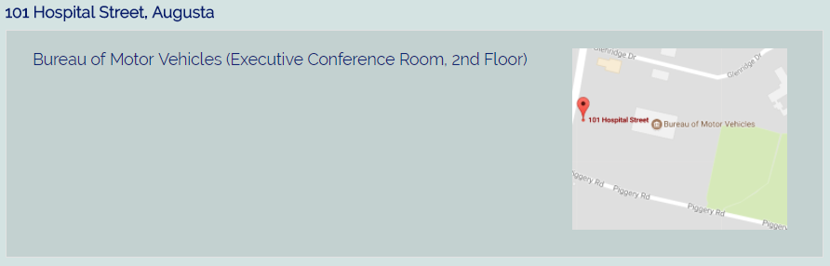

- The month and date will appear in the calendar. Select the date and the available screening appointments will appear:
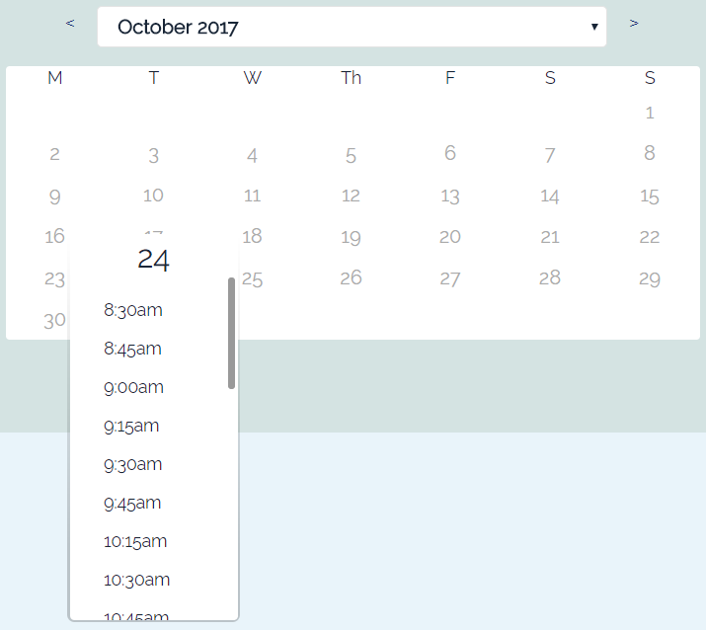

- Select the time and fill in all of your appointment information:
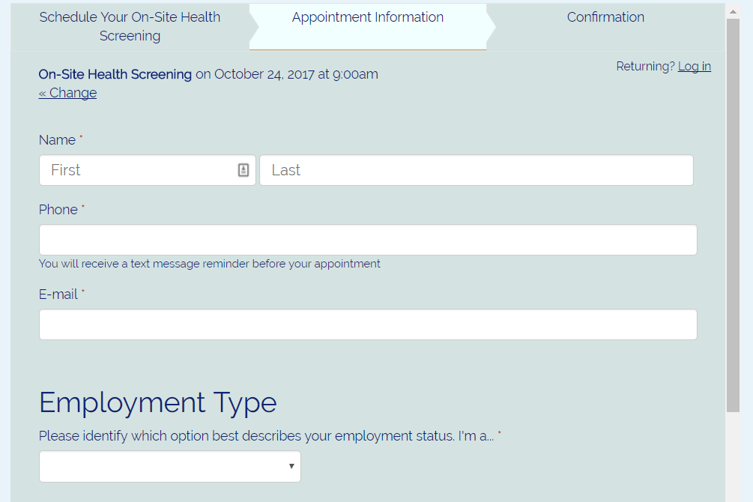

- Select “Complete Appointment”
