How to Verify Your Health Insurance Premium

- Go to www.Maine.gov/deh & select the Health & Benefits tab
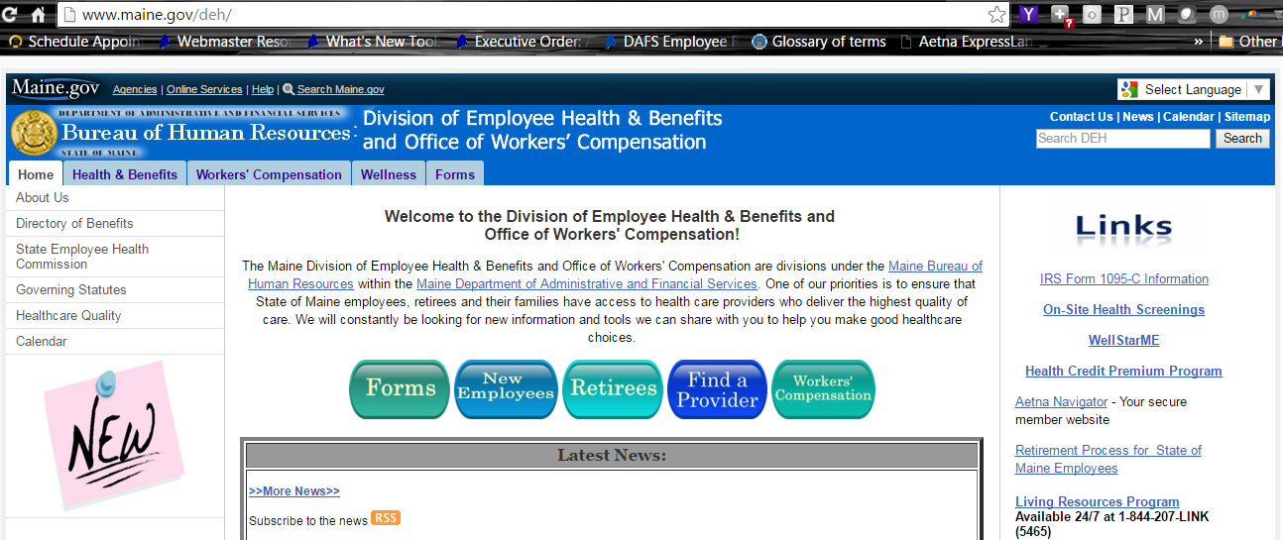

- Select Health Benefits
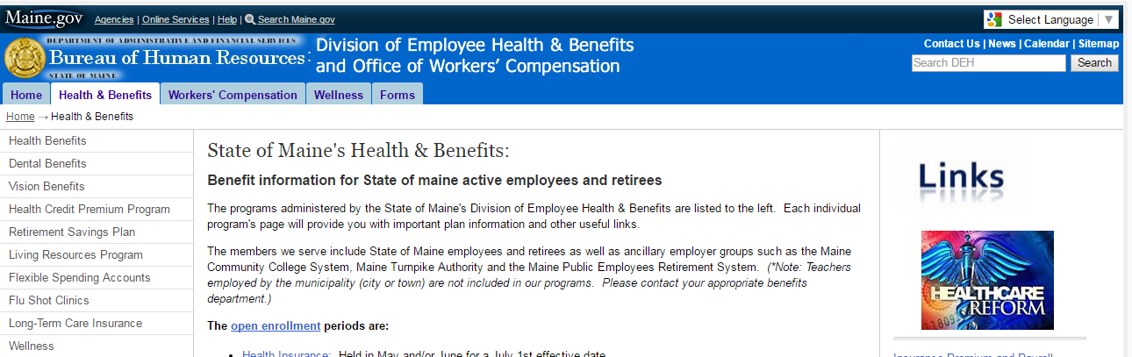

- Select Point of Service In-State Health Plan
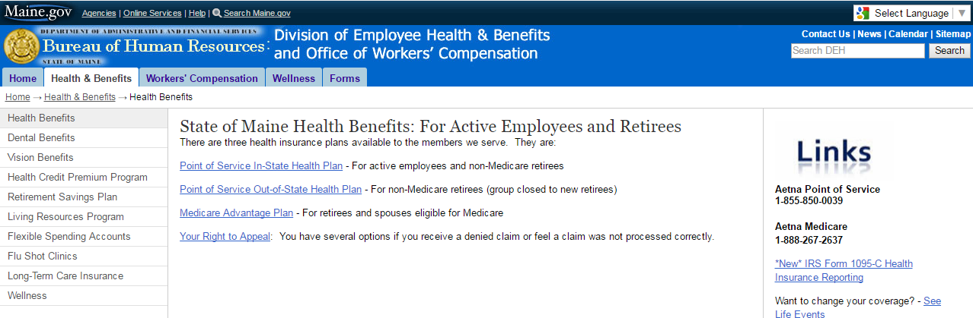

- Select Premium Rates
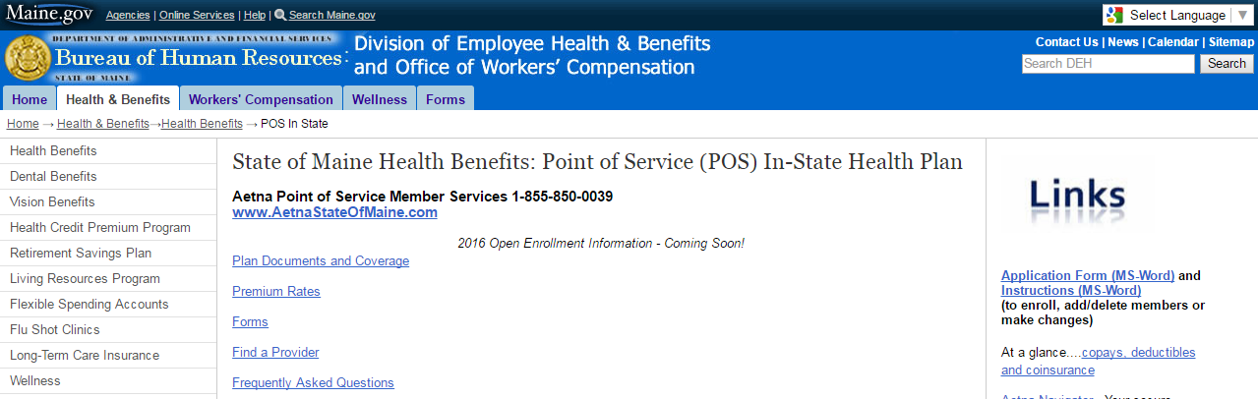

- Locate your salary & level of coverage. You’ll see the employee and employer share of the premium with and without the health premium credit applied.
