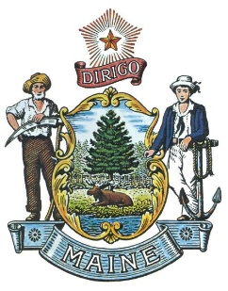

Automotive Right to Repair Working Group
Notice of Meeting

The Automotive Right to Repair Working Group (the “Working Group”) will hold a meeting at 2:00 p.m. on September 26, 2024 in Room 209 of the Cross Office Building at 111 Sewall Street, Augusta, Maine, 04333 and will also be available for public viewing via zoom https://mainestate.zoom.us/j/86814755190.
Pursuant to 2023 Resolves Chapter 171, the Attorney General is convening the Working Group to develop recommendations for legislation to establish an entity with rule-making and enforcement authority to adopt standards governing access to motor vehicle telematics systems and to otherwise implement and enforce the requirements of the Maine Revised Statutes, Title 29-A, section 1810. The Working Group will develop recommendations for legislation to establish an entity to ensure cyber-secure access to motor vehicle-generated data to owners and owner authorized independent repair facilities for maintenance, diagnostic and repair purposes.
The recommendations developed by the Working Group will address the entity’s ability to:
A. Identify and adopt relevant standards for implementing the requirements of Title
29-A, section 1810, including standards relating to access to vehicle telematics
systems;

B. Monitor motor vehicle manufacturer compliance with standards adopted by the
entity;

C. Develop and monitor policies for the evolving use and availability of data generated by the operations of motor vehicles;

D. Create policies for compliance with relevant laws, regulations, standards,
technologies and best practices related to motor vehicle data, with consideration given to privacy and cybersecurity concerns; and

E. Adopt rules necessary for implementation and enforcement of Title 29-A, section
1810 and to enforce the requirements of that law consistent with those rules.

On or before February 28, 2025, the Attorney General will submit to the joint
standing committee of the Legislature having jurisdiction over innovation, development,
economic advancement and business matters a report containing the findings and recommendations of the Working Group.

