**MaineDOT Public Mapviewer Right of Way Research Guide January 2019**

Locate MaineDOT Map Viewer on the MaineDOT web page by clicking on the tab...

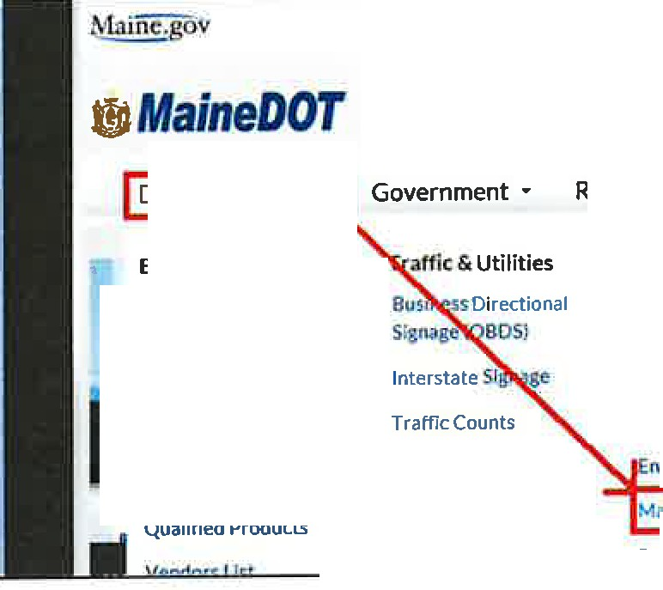

File Edrt View Fnurites Toots Help

MaindJOT Intranl!t(2) (! SYggi&ed Sitt-: • Free Hotmail MaineOOT Intrand

Doing Business •

Residents • Explore Mal

**Business** Opportunities

Consultants

Resources

Civil Rights/DBE

Contractors ADA Accessibility

Program

•

Ii Products, Vendors &

**Research**

Advertise Schedule

Labor Rates

Flagger Resources

nv;ronmentat Info

Utilities Mal110DOT Map Viewer

Permits

***Doing Business*** and selecting

***MaineDOT Map Viewer***

which is located within the Resources group.

Or the user can navigate to <http://www.maine.gov/mdot/mapviewer/> You can use any search engine and search *"mainedot mapviewer".*

This should bring you to a page that looks like this:

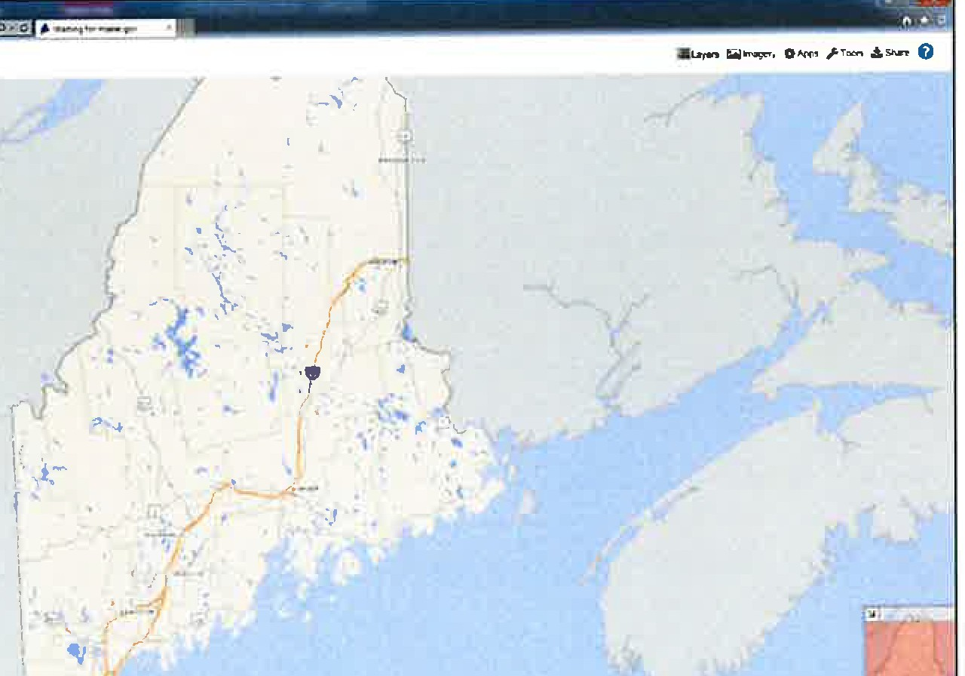

-**t1JIAfa/neDOT Public Map Viewer**

+

By default, only certain layers are turned on. For the user to see Right Of Way information the layers must be turned on.

|  |  |  |
| --- | --- | --- |
| - Maine DOT Pubhc Map Vie... X | / |  |
| I | |  |
| !§Layersl lrnagery 0Apps rTools .t.Shara ***0*** | | |

In the top right corner of the Map Viewer page click on Layers

Note that by default there are only 15 User Layers. To add the ROW layers, select the blue **'S'**

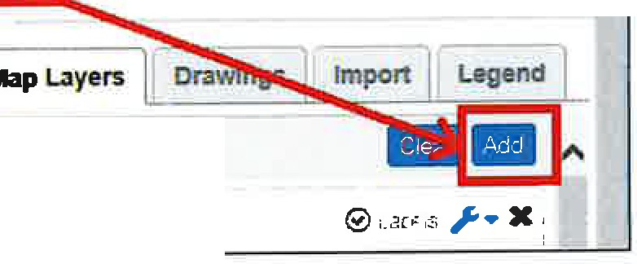

Layers :. Imagery **0Apps***rTods* .!,Share ***O* A**

**G** User Layers

0 Airports

button shown when the Layers tab is open.

Enter the word **"Right"** in the @earch for layers...!text

box.

LayersImagery**0App**r**s**Tools .!,Share ***0***

11

j **llap** Layers ]. Drawings Import

I

.. Legend ]

ADD USER LAYERS

- I Search for layers.

,,,,,,,VieY,ing Co1TV110n Layers: **48** Found

-

**I X**

Hlgnway atures

Bridges . AJI

Culverts - LMge

ShowAII

1

**X**

**xi**



The Layers list reduces to show the two choices for turning on Right of Way data.

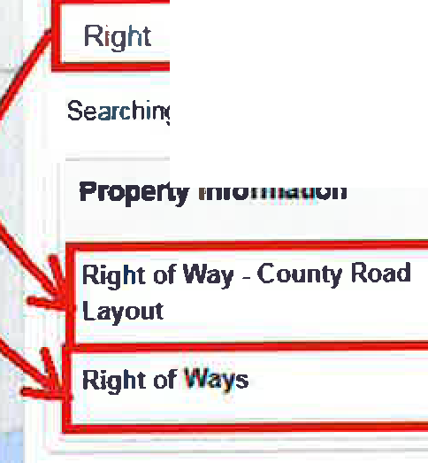

= Layers **l;il** Imagery **O** Apps Tools .!.Share **Q**

*J* **Map Layers** j **Drawings Import Legend** I

**ADD USER LAYERS**

**)C**

Searching Layers: **2 Found**

Clear Search

**0**

+

+

Select the+ sign to the right of both Right of Way layer names.

This will add each option to the User Layers.

* **Right of Way- County Layout** is a layer depicting County Commissioner's Road Layouts (green lines).
* **Right of Ways** is a layer depicting MaineDOT Right of Way maps (blue lines).

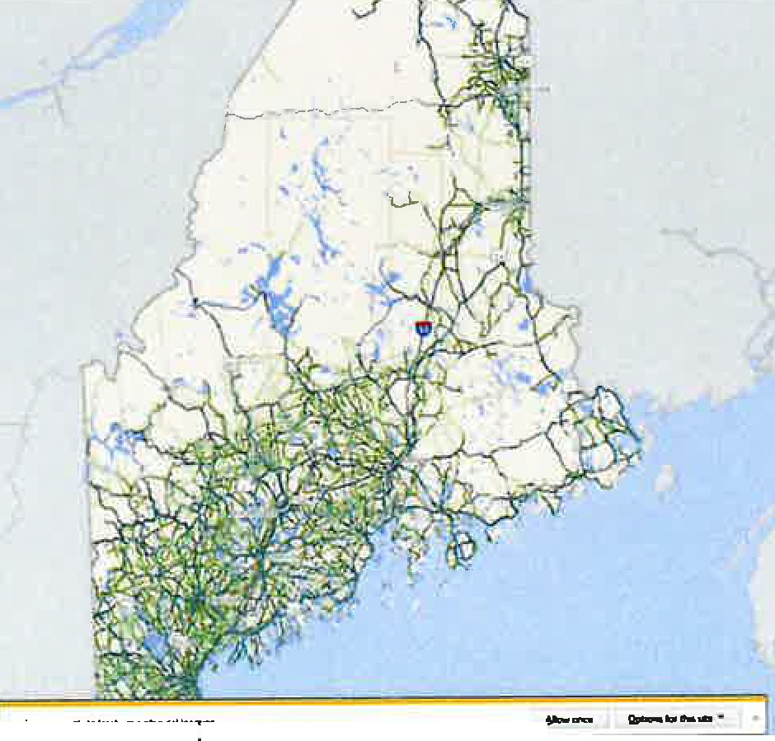

***i!:JMaineDOT***Public M.ap.Viewer

--

--

--

--

**ftlt0**

,.,

**AOO USER LAYDI**

w..,11.p1,,nllH

.

"

+

+

+

II

+

+

.

+

+

.

+

+

" ....

.

+

+

-­

, ..,..,,.... -

+

..-,;;;.--,

Select the blue **mm!**button in the top right side of screen.

J **Map** uyers I, Drawtngs

ADD USER LAYERS

Import

Legend

Riaht

The Check box to the left of the Layer name will toggle the layer display on and off

laye;s [;i}Imagery **O** Apps ***r*** Tools ,& Share

J Map Layers Drawings Import Legend

User Layers

**mam**

0 **Bridges** - **All**

**Right of Ways**

**Right of Way** - **County**

**Road Layout**

Click on the **Layers** tab and the drop-down list will minimize.

###### Search a location ...

Use the **"Search"** text box located in the upper left corner of the Map Viewer screen to zoom to the location of your project.

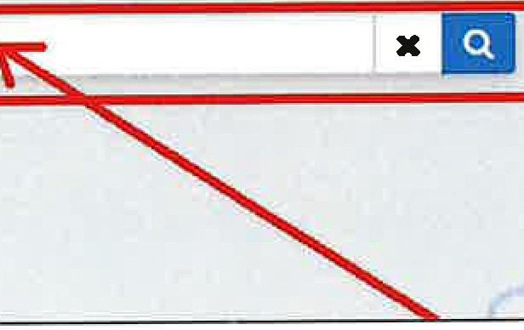

|  |  |  |  |  |  |  |
| --- | --- | --- | --- | --- | --- | --- |
| File | Edit |  | | | | |
| *I,* <http://www.maine.gov/mdo> | | | | "marr"',wer/ |
| View | Favorites | Tools | Help |  |
| * ***MaineDOT* Public Map Viewer**   Search | | | | | | |

Type the town name or address.

*Tip: For town search, start typing town name and then you can select the town dropdown with your mouse.*



**Bridges-**- **All** PORTER PORTER

PORTERCOVERED PORTERI.AKE STREAM PORTlANDWcSTBROOK I TER

**Towns Portage** Lake **Porter**

Portland

**xEI**

Port

**f* *MaineDOT* Public Map Vie**

File Edit View Favorites Tools Help

By default, the Town becomes highlighted in light blue. This highlighting can be removed by clicking the X just to the right of the search bar.

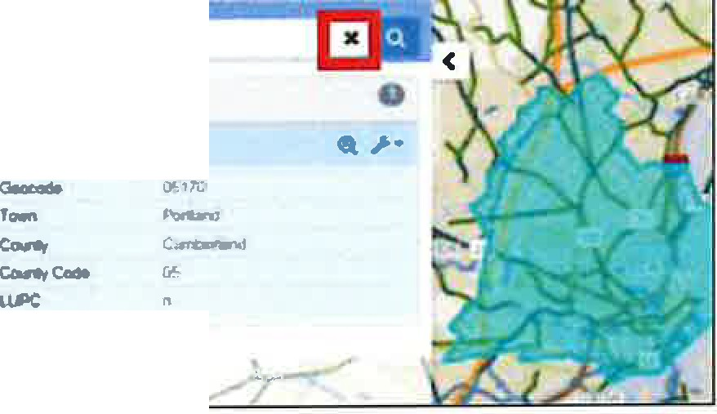

-,_

**lfc*MaineDOT* Public Map Viewer**

--

/

Search an address ...

Map Viewer requires the use of commas when entering an address. Use a comma between the street address and town.

*Example shown* 150 Preble Street. Portland



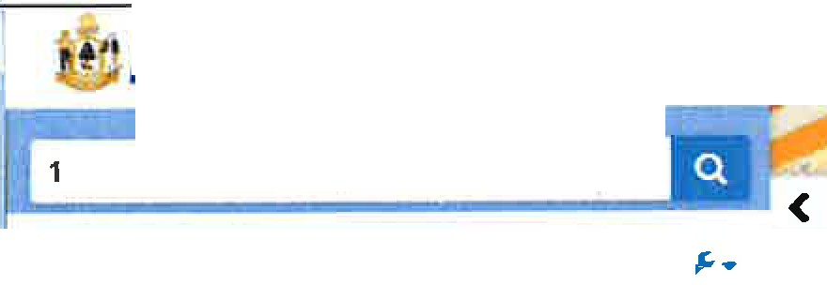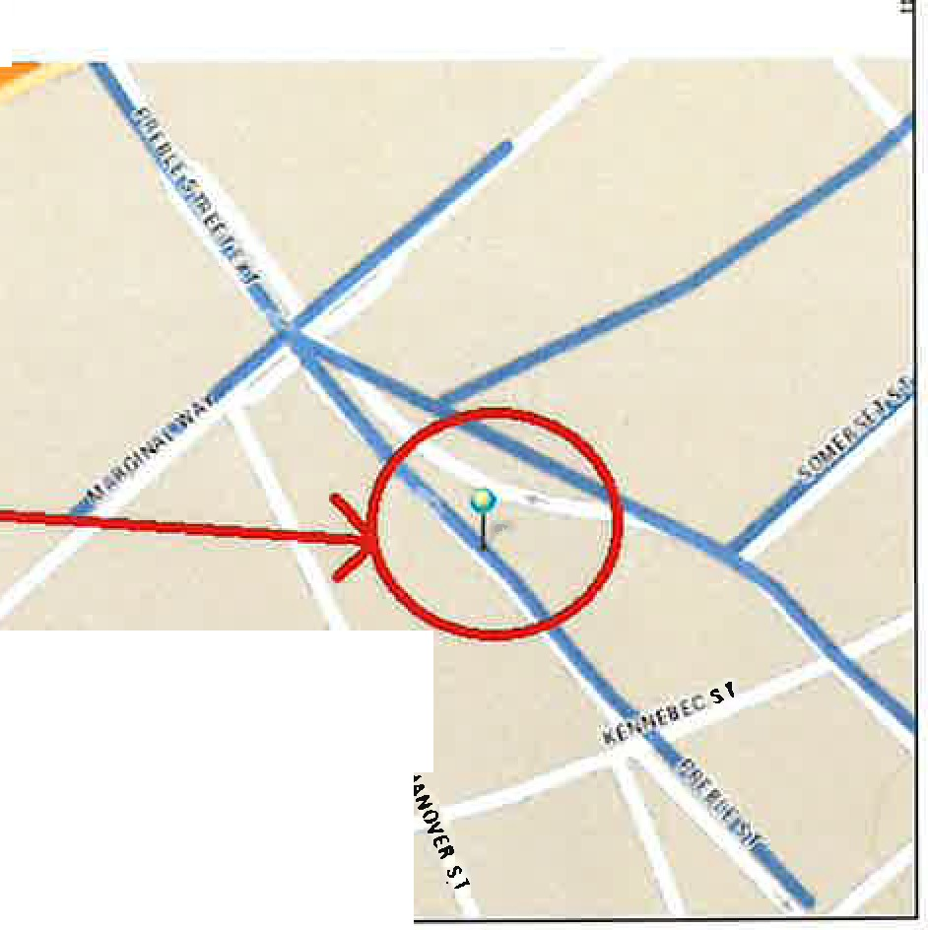

* · ***MaineDOT* Public Map Viewer**

150 preble st.,portlan

**X**

150 Preble St, Portland

43 661131 -7C•26444.3 (9 27 ft !

**0** Feature Found: AShow Road Info

**Address**

**150** Preble **St. Portland, ME**

Address

150 Preble SI, Por!land, ME

**PORTLAND**

*Note:*



150 Preble Street Portland

Error sean:hing for '150 Preble StreetPortlend'. The value you searched for was net found in the default search features_Pleaseadd the Layer you want to-seartli and use .the "Searth Dala" option

fo_unaby clicking on the-wrenchbutt.on neictto lhe

layer

)(

*An error message will appear if a comma is not used.*



Once you have the location, click on a blue/green line.

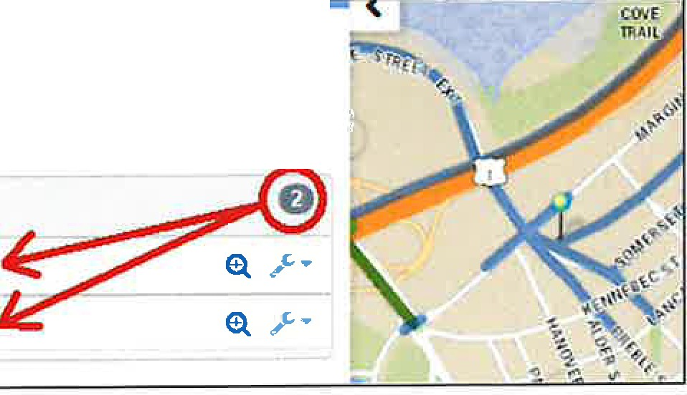

156 Elm **St, Portland**

43 661743 -70 264501 (9 1 ft)

***.I-•***

atures **Found: A** Show Road Info

**Right or ways**

030271-PORTLAND

030485--PORTLAND

Click on the file number­ town name to expand the panel to view brief details about it.

If the location selected covers more than one project, the menu will show both allowing the user to select which one they want.

*Note: The higher the file number the more recent the project.*

The Right of Way data will display on the left side of the screen. The user is provided with basic information such as

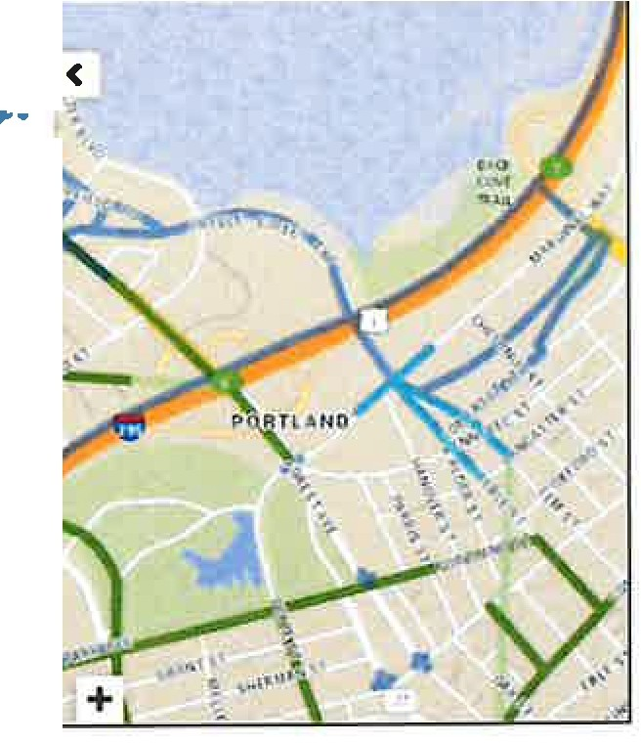

IC •

·--=

152 Pnlble SI. Portland

43661155,-70264541 (69H)

**lllghtofNlys**

----

**0**

OlOlTI-POR'll.ANO

0, ***,r*** •

-*v.*-*.,*

l',qet-t

**Higtt""10oog**

r.,..,

*R"""""*

T)'PO

E.-..-

**R01Yua1**

3I-'/271

M,06l7fl) WISCO' POR'IIJ\ND

PREliUa & tt/1SlllEETS

030711

o:ru,1, t'()ll1lM<O

Plan Number (aka DOT File No.) Year

...,

**8.** , Hover the cursor over the magnifying glass to the right of the file number and the area

------ -- covered by that project will highlight in a light blue. If the user clicks on the magnifying glass it will zoom into the project extents.

The user can also hover over the file number- town name and see the same highlighted extents of the project.

156 Elm St, Portland

43.661743, -70.26..t (9.41 ft.)

***0*** Features Found:

**Right of Ways**

*>..*

**I\Show** Road **Info**

**e**

030271--PORTLAND & *> ..*

**03048 RTLANO**

Plan Number Year

Project Number HighwayDesig. Town

Remasks Type

E-Plans Number

ROWL.abel

3-485

02

NONE

NONE

Draw **on** Map Sen<lFee<lback Dnving Direcbons

Create Buffer

POR

IT

View Property Plan

RAJLV!

HANG 030485

**i**

030485-PORTLANO

View the plans by clicking on the wrench icon and selecting View Property Plan

MaineDOT MEPLANS launches a Plan Details window where the user will need to confirm again that they want to "View Plan"



Plan Details: 5520_707_08_01.pdf-File Size 5.5 1B

Archive **Nam•** Property Plans

Description RAILYARO TO CITY Comments RAILYARD TO CITY

Created **By CreaceDate Modified By**

**Mcxflfied Daa**

robert.skehan

3/17f201411:25:28AM

I View Plan IBack to List

* ' ***MaineDOT* MEPLANS**

This will open another browser window with a pdf of the ROW map plan set:

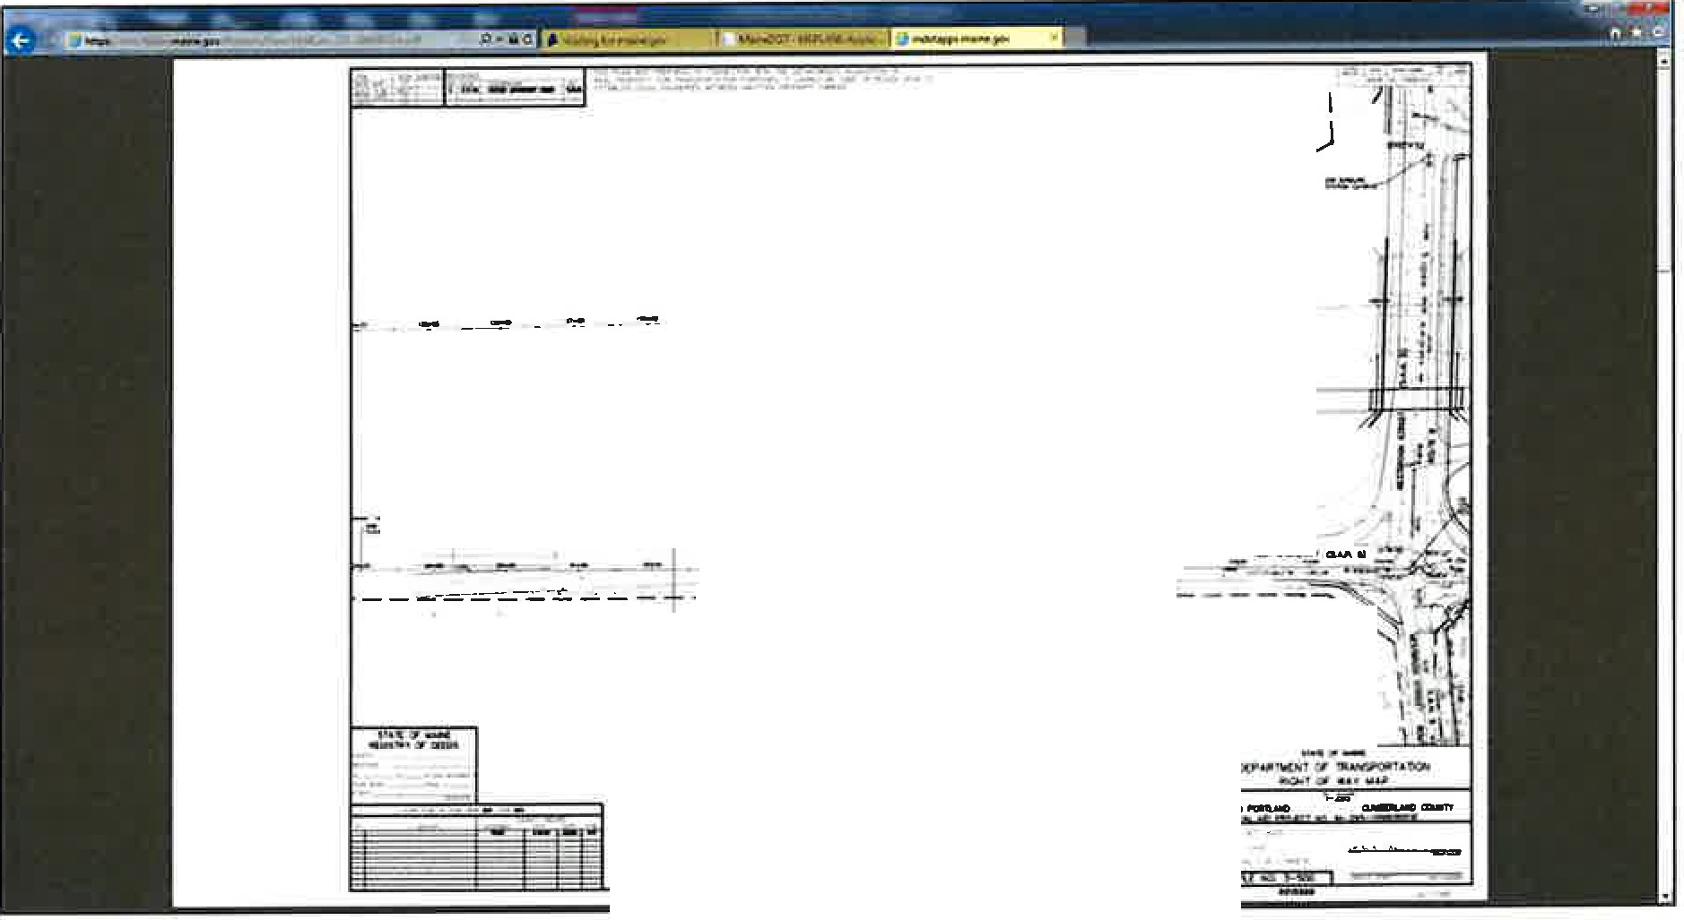

,.,,,,

*I*

*I*

--=. - -----=-=- ;;:;_---=--1

'\ .:,

---r-1.-::--_-

',

I 1'

I i I

'

You can now save this pdf to your computer for your use.

Search by DOT File No. (SHC File No.)

3-95 **X**

Right *or* Ways **0**

**030095.WlNDHAM**

**130095--BINGHAM**

**S 03-0095-HARPSWEU S 13-0095-DETROIT**

Click on the **Town name**

*This expand the details panel which activates the wrench.*

Click on the **Wrench**

Click on **View Property Plans.**

There may be multiple choices after selecting

**"View Property Plans".**

Select the correct plan for the **Town** wanted and click

**View.**

The DOT File No. *(numbers only)* can be entered in the Search Field.

*Example shown:* DOT File No. **3-95**

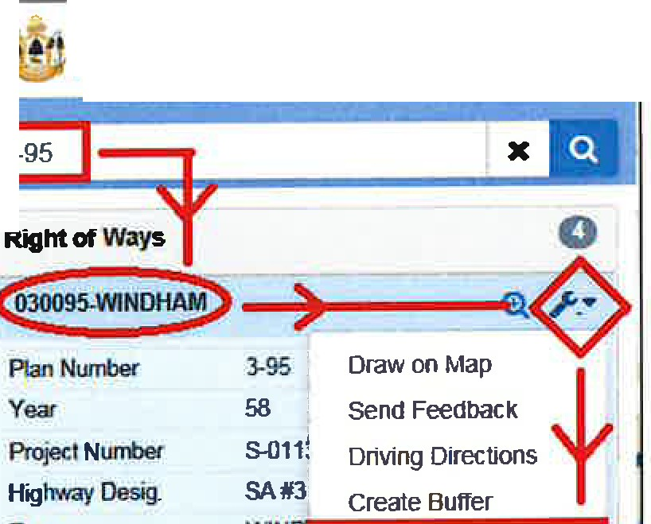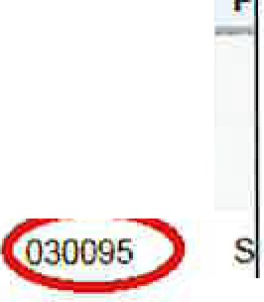

2 Documents Found

**Action** Size

Town

County

Route#

· **PIN**

ROW#

View

Derails

4.2MB

Harpswell Cumberland RD INV 05 00399

S 030095

Description: NOW SAH NO. *5,* (TC#3) CUNDY HARBOR ROAD

Cumbenand

Description: (SA #3)

,! ***MaineDOT*** Public Map Vie

As displayed in the example, there can be several references, which contain of the same numbers.

The Town name should help determine which plan set is desired.

|  |  |
| --- | --- |
| , ***MaineDOT*** Public Map Vie | |
| 3-95 |  |
| Town | WIN I View Property Plan |
| Remarks |  |
| Type | HANG |
| E-PlansNumber | 030095 |
| ROWLabel | 030095-WINDHAM |

When a Plan does not display...

Occasionally the user will encounter a plan that does not display and the Property Plans Archive page will say "O Documents Found".

|  |  |  |  |  |  |
| --- | --- | --- | --- | --- | --- |
| Property Plans Archive  This archive contams the Departments Raghl Of *Way* Maps and other documents pertam,ng lo ownership, easemenls and other property or real estate concerns  Filter **Archive**  Description PIN# Prajoct Number ROW# Town  020587  Bridge Ye3r Plonset Type | | | *Aw/* | Clear |  |
| 0 ll<>cuments Found |  |  | Plans per Pogo: | 25 | * [ |
|  | |  | | | |

Go back to the Map Viewer page and look at the project details. The "Type" may be listed is FLAT.



I'2--587

**Righi *at* ways**

**X**-.• .<

**020587-WAl..lAGRASS**

Plan-

Yeat

f'nl;ocl N...- Highway Cle9g Town

Romarb

**rw<-E:)**

2-587

2017

22585 00

**SM5**

WAU.AGRASS

SLY BROOKR(W)

E--.S- OlOS87

ROW IU0561-WAI..I.AGRASS

***i!JJ.MaineDOT***Public Map Viewer

FLAT describes a plan which MaineDOT has not finished processing.

This plan will not have been sent to the appropriate county registry, nor will it have been uploaded to the Map Viewer archive.

**Contact MaineDOT Right of Way Research for a copy of the plan.**

*Note:*

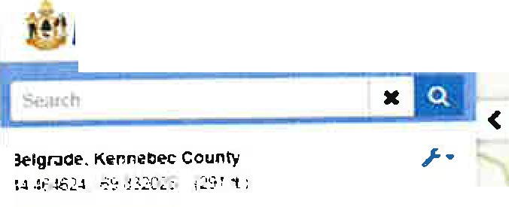

* ***MaineDOT* Public Map Viewer**

**o FNIWH Found:**

**Rlgllt of My. CGllfflr Roacl L.lyoutl**

**RiglltotW\,ys**

**0**

* *I*

*Jf the location selected has multiple choices, all plans or county layouts for a that location will display on a list to the left of the Map Viewer screen.*

I

Click on the category to expand the details.

Click on the County Layout Number

Right of way • County Road Layout

103011n **•k'11---**

0305227

**0**

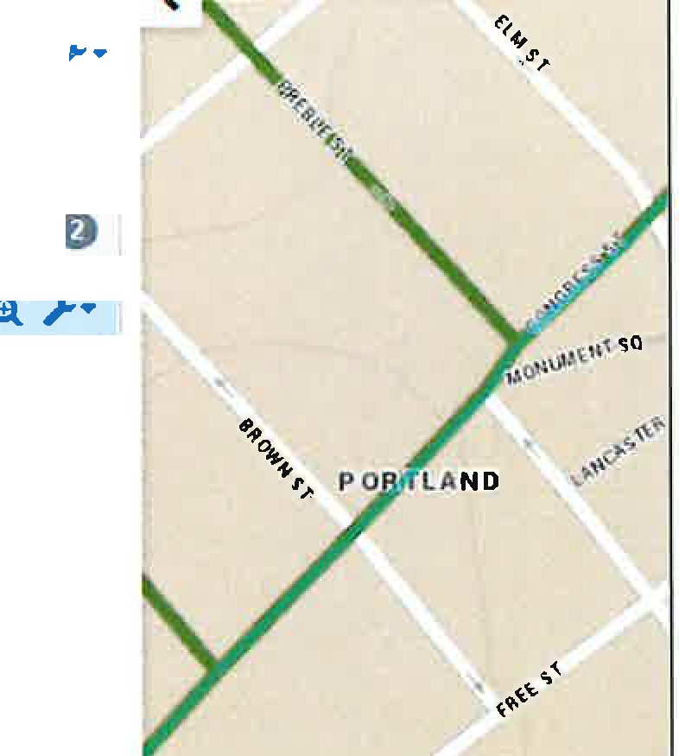

2 Preble St, Portland

43 657227 -70 259526 /77 79 I

**0 Features Found: A** Show Road Info

**Right of Way** • **County Road Layout**

ICounty

**Conment**

Cumberland **J**

Name

* Page

0301172

172 i

Status

Status Known

v.•o1•u•me 1--I

Town

Falmouth, Portland

**•1**

Wtdth 49.5 & 66 feet (3 & 4 *rods)*

*Year* 1768

0305227

MaineDOT uses a 7-digit number to identify county layouts. The first 2 digits are assigned County numbers -

01 -Androscoggin, 02 - Aroostook, 03 - Cumberland, 04 - Franklin, OS - Hancock, 06 • Kennebec, 07 - Knox, 08 - Lincoln, 09 - Oxford, 10 - Penobscot, 11 - Piscataquis, 12 - Sagadahoc, 13 - Somerset,

14 - Waldo, 15 - Washington, 16 - York.

The 3 and 4 digits are Volume number - 01 thru XX

The last 3 digits are the Page number - 001 thru XXX

**Disclaimer** -

The County Layout information that MaineDOT has consists of a hand sketch and photocopied pages. All information must be verified for accuracy at the user's discretion.

MaineDOT Public Mapviewer

**MEPLANS Archive** - **As-Built Plans**

From the Map Viewer Home Page, select any plan to view

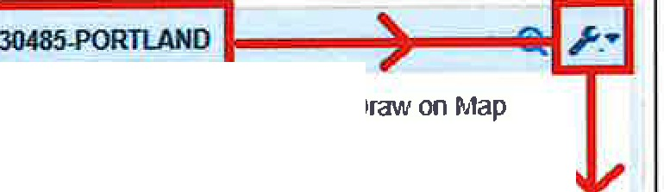

**Right of Ways**

***0***

Plan Number Year

Project Number Highway Desig. Town

Remarks

Type

E-Plans Number ROW Label

3-485

02

NONE NONE POR

RAIL

HANG 030485

Sencl Feedback Driving Directions Create Buffer

View Properfy Plan

030485-PORTLANO

**030271-PORTLAND**

**(ll** /-•

Located in the upper right corner of the MaineDOT MEPLANS page is the tab for Click on the tab and a drop-down list will allow the user to select the **Vault Plans.**

**Archives**

logm

Homo Holp Conua Arch1vt:. •

Plan Details:

**5520_707_08_01.pdf** · File Size 5 51,IB

***f*** n..,,.,11roans

Archive Name Property Plans **Description** RAILYARD TO CITY **Comments** RAJLYARD TO CITY

Created By robert skehan

**Creole Date** 3/17/2014 11 25 28 A/,1

**Modified By**

**Modified Dote**

View Plan Back to List

**Enter your Filter Criteria, then click Apply:**

This will limit the list of plan sets shown in the table to those meeting the filter criteria.

Flher Archive

Oueript1on

**PIN**

Town

Rou,e *4*

Bridge#

Year

- --' Clear

All filters except for the Planset Type are case-insensitive, "open-text" filters. This means you can put in a partial value and it will return all records that have the partial text in that field. The more complete the filter text, the fewer records are returned.

Example: Wint, wlNT, or WinT as partial filters in the Town field will all return the same result set. Records returned would include the towns of Winterport, Winter Harbor, Winthrop, Winterville Pit, etc. Combinations of filters further reduce the number of records returned from the archive search.

Example: If we are only interested in plans for route US lA in Winterport, we could use "wint" for town, and "lA" for route, and it would return only a single page of results, rather than multiple pages.

**Using the Planset Type filter:**

Planset Type is a powerful filter that allows you to choose from a list of standard values assigned to each record. Leaving this filter blank will return all planset types.

..

AERIAL_MAP_HALF

**d-i=l111ii#SW@i**

CONTRACT

PLANS

DEVELOPER AS­ BUILTS

MAINTFACILITY

POR

**CONTRACT PLANS**

"

More recent project plan sets "as-advertised" for bidding

**AMENDMENTS**

Amendments to advertised Contract Plans

**AS-BUilT PLANS**

Plans indicating field changes during construction

**VAULT_ARCHIVE**

Most of the historic plans from the Department's original plan archive before sets were scanned for electronic viewing

**Plans et Type**



**Important Search Tip!**

If you search by bridge, route, or PIN number and expected records are not shown in the results set, try filtering the Description field by those values. Many records also have common "street names" or "state aid highway numbers" as part of the description field.

**Viewing Plan Sets or Details about the plan set:**

Each record in the results table has two buttons in the Action column.

**View**

Loads the PDF in your default PDF viewing application.

**Details**

Look at the plan set record in greater detail than that which is shown in the table.

**Description**

**PIN**

**Projoct Numb«**

**Town**

**Route#**

,.

**Bridge**

"

Year

PlansetTypo

Apply Clear

**9** Documents Found

Action Sin Tawn C_ounty--'---

: PIN

ROWI Prolm_N_um_bo_r_ **llrldga** ; PlanY- ; **PllnMt** 1ypo

30.3MB Frankfort. Winterport waldo US1A 84-a 1924 VAULT ARCHIVE

**llelcrlpCfan:** S.H.i. , RTE1A,MARSH STREAM DUE NORTH 2.58 Mil.ES

0

l.iew

Delail$

34 1MB Winterport

Waldo

USIA

84-C

1925

VAULT ARCHIVE

Description: SH "L", RTE 1A. KALER ST DUE NOR!lj 4 975 MILES

¼M 47.5MB Winterport

Waldo

US1A

HHS-1126-2(28) I

1979

VAULT ARCHIVE

*As-Built example shown below*

