STATE OF MAINE 131st LEGISLATURE
FIRST REGULAR SESSION

REPORT OF THE ABANDONED AND DISCONTINUED ROADS COMMISSION

Commission Members:

Corp. Kris MacCabe Brian Bronson
Peter Coughlan
Vivian Mikhail, Deputy AG Rebecca Graham
Karla Black
James Katsiaficas, Esq. Steve Young
Ryan Pelletier John Monk Roberta Manter
Hon. Catherine Nadeau

Table of Contents

Page

Executive Summary 1
- Introduction 2
- Commission Process 2
  - First Meeting, October 7, 2022 2
  - Second Meeting, October 27, 2022 2
  - Third Meeting, November 17, 2022 2
  - Fourth Meeting, December 14, 2022 2
  - Fifth Meeting, January 11, 2023 2
  - Sixth Meeting, January 25, 2023 2
- Recommendations 3

Appendices

- Authorizing Legislation: PL 2021, chapter 743

- Membership, Abandoned and Discontinued Roads Commission

- Presentation: “Overview of Municipal Roads – Abandonment and Discontinuance” by James Katsiaficas, Esq., Perkins Thompson

- Presentation -- Results of ROADways’ survey of top issues, and “small tweaks,” to address those issues, by Roberta Manter, Maine ROADways

- Presentation: “MaineDOT Public Map Viewer Right of Way Research Guide” by Peter Coughlan, Local Roads Program, Maine Department of Transportation

- Meeting Minutes

- Public Hearing Written Comments

EXECUTIVE SUMMARY

The 12-member Abandoned and Discontinued Roads Commission has met six times to carry out its duties under PL 2021, chapter 743, “An Act to Establish the Maine Abandoned and Discontinued Roads Commission.” Maine local road law, particularly the law of abandoned and discontinued roads, is complex and raises both legal and policy issues, including those that the Legislature directed the Commission to consider. Given that complexity and the four months the Commission has had to examine the issues, the Commission’s recommendations are preliminary and do not contain any proposed legislation, but the Commission does recommend the following:

  - Enactment of a statute to limit property owner liability for maintenance of public easements where the municipality does not maintain them;

  - Automatic retention of a public easement upon discontinuance or statutory abandonment of a town way, particularly if there otherwise is no remaining access;

  - Clarification of terminology related to abandoned or discontinued roads in current law that may be confusing or contradictory, and care to avoid the same in future legislation;

  - Encourage greater accessibility to information regarding the status of roads, and possibly establish alternative dispute resolution pathways to more easily and less expensively determine the legal status of roads; and

  - Work toward ways by which the existing seller real estate disclosure for roads can be improved and an inventory of the legal status of roads -- town ways, public easements, abandoned and discontinued roads and private roads -- can be incrementally created.

- INTRODUCTION

The 130th Legislature enacted PL 2021, chapter 743, “An Act to Establish the Maine Abandoned and Discontinued Roads Commission.” That new law directed the formation of the Abandoned and Discontinued Roads Commission (the “Commission”) as a standing body that would consider specific topics, prioritize additional issues and matters of importance to listed parties, and submit a report to the Legislature by February 1, 2023, and annually thereafter.

The Commission has held six meetings since its organization in October 2022, and its work to date is summarized in this Report. This is a complex area of law and policy, and the Commission has just begun its work. Therefore, the Report’s responses to the questions and duties posed by the Legislature through chapter 743 are necessarily broad and preliminary. However, we hope the recommendations of this Report are helpful to the Legislature. As the Commission proceeds with this work, it hopes to offer more concrete suggestions to the Legislature for changes to Maine law to provide greater certainty and protections for landowners, road users, members of the public, the real estate business sector, and State, local and county government officers.

- COMMISSION PROCESS

  - First Meeting, October 7, 2022. Conducted organizational meeting to introduce members and to become acquainted with the Commission’s duties.

  - Second Meeting, October 27, 2022. Discussed methods and locations by which to provide public notice and public access to Commission minutes, reports and other documents and cost of same. Continued discussion of Commission’s duties, including planning and scheduling of future meetings: to obtain background information and public comment; to evaluate public comment; prioritize issues and reach consensus on concerns, issues and potential resolution of same; prepare and adopt report to Legislature.

  - Third Meeting, November 17, 2022. Continued discussion of methods and locations by which to provide public notice and public access to Commission minutes, reports and other documents, given cost of same and lack of State funding for Commission; Jim Katsiaficas presented: “Overview of Municipal Roads – Abandonment and Discontinuance” (Appendix C); Roberta Manter, Maine ROADways presented: Results of ROADways’ survey of top issues, and “small tweaks,” to address those issues (Appendix D).

  - Fourth Meeting, December 14, 2022. Adopted Remote Participation Policy; Peter Coughlan of MaineDOT’s Local Roads Program presented the “MaineDOT Public Mapviewer Right of Way Research Guide” tool (Appendix E). The Commission opened its public hearing and left the public hearing open for written comment from public and from municipal officials.

  - Fifth Meeting, January 11, 2023. Completed receipt of comment from public and from municipal officials; evaluated public comment; prioritized issues, and reached consensus on concerns, issues, and potential resolution of same.

  - Sixth Meeting, January 25, 2023. Review and revise draft Report to Legislature and adopt same.

- RECOMMENDATIONS

Chapter 743 sets out the following duties for the Commission:

- ​Duties. The commission shall:

  - ​Consider the following:

    - Property owner liability, including personal injury, property damage and environmental damage liability resulting from public use of an abandoned or discontinued road;

    - Public easement retention over an abandoned or discontinued road, including the scope of permitted and actual public use;

    - Statutory terminology related to abandoned or discontinued roads; and
    - he statutory process for the abandonment or discontinuation of a road, including barriers to determining the legal status of a road;

  - For matters relating to abandoned and discontinued roads other than those described by paragraph A, prioritize matters for consideration by the commission by determining which matters related to abandoned and discontinued roads have a significant negative impact, qualitatively or quantitively, on:

    - Owners of property that abuts an abandoned or discontinued road;

    - Owners of property accessible only by traveling over an abandoned or discontinued road;

    - Recreational users of an abandoned or discontinued road;

    - Members of the public;

    - Municipal, county or state governments; and

    - The physical integrity of an abandoned or discontinued road and surrounding land;

  - ​ Develop recommendations on ways to address matters considered by the commission, including recommendations for statutory changes; and

  - Review legislation affecting abandoned or discontinued roads and provide information to joint standing committees of the Legislature upon request.

As to the items in A. above, the Commission considers and recommends as follows.

    - Property owner liability. The Commission heard much in this regard from owners of property located upon a public easement, whether the public easement was created by

discontinuance of a town way or was specifically laid out as a public easement (or private way). A municipality has the right, but not the obligation, to maintain, repair and plow a public easement. 23 M.R.S. § 3105-A. Where the municipality decides not to exercise this right, the property owner may maintain, repair and plow the public easement, on its own or with others, and that property owner is liable for personal injury, property damage and environmental damage liability resulting from the work on the public easement. The Commission therefore recommends creation of a statutory limitation on liability for property owners who maintain, repair and/or plow a public easement where the municipality does not do so. This limitation on liability might resemble the limitation on liability for landowners who make their land available for passive outdoor recreation under 14 M.R.S. § 159-A and should require the work be performed in a reasonable manner.

    - Public easement retention over an abandoned or discontinued road, including the scope of permitted and actual public use. A majority of the Commission’s members generally favor the automatic retention of a public easement upon discontinuance of a town way in order to ensure that the owners of property along that way are not landlocked. There also was some support for ongoing payment to be made to the property owners if a town way is discontinued with retention of a public easement, but the municipality does not exercise its right to maintain, repair and/or plow the way. Some Commission members prefer that the property owners themselves attempt to reach agreement as to whether a road should be privately maintained and consider formation of a private road association, before any public easement is retained after town way discontinuance. (“There should be no automatic anything.”)

    - Statutory terminology related to abandoned or discontinued roads. Commission members point out several instances of confusing terminology related to these roads.

      - For example, the term “private way” has a specific meaning as a type of way with rights of public access that has been used in deeds since Maine separated from Massachusetts, but which now is included in the term “public easement” since the Maine Legislature recodified State, county and local highway law in 1976. 23 M.R.S. § 3021(2). However, until a 2007 amendment, the term “private way” also was used to refer to “private roads” in provisions of State law that concern “road associations.” 23 M.R.S.
§§ 3101-3104. (In 2007, “private way” in the road association statutes then was defined to have the same definition as in 23 M.R.S. § 3021(2)). The State’s motor vehicle laws define “private way” as follows: “58. Private way. ‘Private way’ means a way privately owned and maintained over which the owner may restrict use or passage and includes a discontinued way even if a public recreation easement has been reserved.” 29-A MRS § 101(58). This definition conflicts with the definitions that give the public a right of access over private ways, or “public easements” as they now are called. As a result, the general public often confuses the terms “private way” and “private road.”

      - The term “public easement” itself now seems to have two different definitions – one limited to rights of access by foot or motor vehicle as defined at 29-A M.R.S. § 101(42) (23 M.R.S. § 3022 for public easements formally laid out as such by municipalities after 1976, and since 2015, §23 M.R.S. § 3028-A for public easements after statutory abandonment of a town way), and one without such limitations (23 M.R.S. § 3021(2) for former private ways and 23 M.R.S. § 3026-A for public easements after

discontinuance of a town way). Because the definition of ‘motor vehicle” at 29-A
M.R.S. § 101(42) excludes ATVs and snowmobiles, it means they can be operated along public easements that used to be private ways before 1976 and public easements left after discontinuance, but not public easements laid out as such or left over after statutory abandonment.

      - The public and State, county and local officials often mistakenly confuse the terms “discontinuance,” which is a formal process to eliminate public maintenance responsibility for a town way, and “abandonment,” which is the elimination of public maintenance responsibility that happens by the passage of time.

The Commission recommends further work to determine the sources of confusion in Maine’s abandonment and discontinuance law terminology and to find ways to reduce this confusion. The Commission understands that Senator Vitelli is sponsoring LR 88, “An Act Regarding Private Roads,” that may attempt to dispel some of this confusion; the Commission is available to review such legislation and to provide information to the Legislature in this process.

    - The statutory process for the abandonment or discontinuation of a road, including barriers to determining the legal status of a road. Commission members recognize the difficulty people have in determining the status of a road. While the Maine Department of Transportation (MaineDOT) has presented the Commission with information about the Mapviewer tool on its website that displays information collected from municipalities as to whether a given road is publicly maintained, and while it is possible for the public, property owners, and attorneys to search State, county, and municipal records in search of information as to whether a road is a town way, a public easement, a private way, or a private road, some roads elude easy classification and require determination by the courts. Litigation over the status of roads is a fact-specific, time consuming and expensive process.

Several Commission members suggest creating an Alternative Dispute Resolution process for more affordable and timely mediation of road abandonment, road discontinuance, public easement, and private road issues. Commission member Roberta Manter notes that the University of Maine Cooperative Extensions offers a Maine Agricultural Mediation Program that already addresses neighbor disputes or disagreements (involving farm or forest land in production), which may concern public easements. Family and Community Mediation also may provide a model.

Increased compliance with State law could help create greater certainty about the status of municipal roads after their abandonment and discontinuance. Since 1959, Maine law has required an order of discontinuance to be recorded in the appropriate registry of deeds to be effective as against successors in title. 23 M.R.S. § 3024. However, in many cases, recording of these certificates has not occurred, to the detriment of persons purchasing property along the road who are unaware of its legal status. Commission members recommend strengthening this requirement, as was attempted through the 2015 enactment of 23 M.R.S. § 3026-A(5).

Finally, in this regard, the task of determining the status of a municipal road is made more difficult when the terminology, standards, tests, and processes for road abandonment and discontinuance change frequently, and, as seen above, often inconsistently. This determination used to be

relatively straightforward, although still occasionally subject to litigation. If a town way was discontinued before September 3, 1965, there was no automatic retention of a public easement, but the municipality could vote to retain “a private way subject to gates and bars” (since 1976, considered a “public easement”). If a town way was discontinued on or after September 3, 1965, a public easement was automatically retained, but the municipality could vote not to retain a public easement. If the presumption of abandonment of a town way arose because a municipality had not spent money to maintain the way for any 30-consecutive year period, a public easement was automatically retained. Since 2015, the Legislature has made several changes to the procedures and outcomes under these statutes, perhaps in an attempt to make improvements, but these instead appear to have created greater delay and uncertainty, which may lead to more disputes and litigation. Any further changes to the road abandonment and discontinuance statutes should be considered in the larger context of the road, real estate, nuisance, and other statutes in which they appear, with an emphasis on clarity and consistency. Again, the Commission is available to assist and provide information to the Legislature.

As to the items in B. above, the Commission determined based upon the public comments that aside from the considerations in A. above, the parties listed in B. have raised concerns and issues that it prioritizes as follows and makes related recommendations.

- Equal priority

  - Access. Property owner access comprises one set of access issues. Owners of property that abuts an abandoned or discontinued road need continued access, since their deeds likely do not include a private easement because the property was once on a town way. Where town ways are discontinued without a public easement, the private property owners may be landlocked, and owners of lots along that private road may block access by property owners located further down the road or may only permit access for a price. Property owners who must pay for their own maintenance of a road, either as a public easement the municipality does not maintain or as a private road, may see their work damaged by other users, such as the general public, ATV and snowmobile operators, and/or owners of forested parcels operating logging truckers and skidders. There is a State law making damage to a public easement by operation of a motor vehicle a Class E crime (see 17 M.R.S. § 3853-D. “Operating a motor vehicle on land of another,
- Damage or destruction to farmland, forest land or public easement. A person who, as a result of operating a motor vehicle on farmland, forest land or a public easement in fact, damages or destroys crops, forest products, personal property or roads on that farmland, forest land or public easement, commits a Class E crime.”). Municipalities may bring actions to enjoin persons who damage a public easement. But enforcement of incidents of damage to public easements under § 3853-D or by civil actions is challenging since these roads generally are not patrolled. Also, property owners note that there are no safety regulations, such as speed limits, on private roads, and that if safety regulations are applicable to public easements, they are not enforced.

Commissioner Roberta Manter’s Maine ROADWays group conducted a survey of those owning property on abandoned and discontinued roads, and she reports that the respondents’ primary issue was access-related -- the unconstitutionality (they believe)

of public easements, which they state are public roads with no guaranteed public maintenance and with no ongoing compensation paid to the landowners who must bear the cost of continued maintenance in the face of public use in order to preserve access to their property. Its members urge the Legislature to seek an Opinion of the Justices on the conflict between Jordan v. Town of Canton, 265 A.2d 96, 99-100 (Me. 1970) (stating “Without public responsibility for maintenance and repair, it is only a question of time before a public road will become impassable or unsafe for travel,” in requiring compensation for the taking of road rights by State law that allowed reclassification of town ways as ”limited user highways”) and Fayette v. Manter, 528 A.2d 887, 888 n.1 (Me. 1987) (“The parties also agree that [by definition] when a town discontinues a road and retains a ‘public easement,’ the public has an unfettered right of access over the road but the town has no maintenance responsibility. The parties disagree over whether this definition of a public easement is constitutional.”) Did the Maine Supreme Judicial Court, by ruling in favor of the Town of Fayette and the county's discontinuance of a county way with public easement, despite the Manters’ claims of the unconstitutionality of public easements, implicitly find the retention of a public easement without assumption of a maintenance responsibility is constitutional, or is that issue reserved for another day?

Recreational users also have access issues. ATV and snowmobile operators may operate on private roads with landowner permission and can ride on public roads only for limited distances and purposes. However, it is not clear whether they may operate on public easements generally, and it appears that they cannot operate on public easements created specifically as public easements (23 M.R.S. § 3022) and on public easements created by statutory abandonment (23 M.R.S. § 3028-A). In those cases, the public easement is limited to rights of access by foot and by motor vehicle as defined in the motor vehicle statutes, which specifically excludes ATVs and snowmobiles. Public easements created before July 29, 1976 and by discontinuance at any time do not appear to be limited in this regard. Also, do the apparent prohibition of ATV and snowmobile use on public easements created specifically as public easements or resulting from statutory abandonment preclude owners of property on those roads from accessing their property and perhaps homes by ATVs and snowmobiles?

Finally, property owner access and recreational access needs will have to be balanced, which may be an issue of particular importance to ATV and snowmobile operators.

  - Liability. As previously mentioned, the Commission members recommend limiting the liability of property owners who reasonably maintain their public easements where the municipality decides not to. Title 14 M.R.S. § 159-A, which limits the liability of landowners who open their land to the public for passive recreation in order to promote public outdoor recreation, may be a model for such legislation.

  - Maintenance and prevention of damage. Municipalities may bring a civil action to enjoin damage to public easements and property owners along a public easement may do so as well (23 M.R.S. § 3029-A), but there are difficulties in doing so. Proof that a particular person or truck or ATV operator damaged a road is difficult, and there is the

cost of legal action to recover damages and require repair. As noted above, 17 M.R.S.
§ 3853-D makes motor vehicle-caused damage to a public easement a Class E crime, but enforcement seems lacking and criminal prosecution does not repair the damaged road.

- Road inventory

For many years, it has been suggested that an inventory of the legal status of roads -- town ways, public easements, abandoned and discontinued roads and private roads -- be prepared. Legislation that would place that burden on municipalities has been defeated as a large unfunded State mandate, and municipalities lack the staff and funding to conduct such an inventory. MaineDOT likewise lacks the staff and funding to conduct such an inventory. A Legislative resolve that municipalities may develop road inventories and send them to MaineDOT expired December 1, 2018 without response. There are practical issues as well – even a well-funded and staffed attempt to determine the legal status of all roads in a municipality would leave a number of roads whose status would be unknown without a declaratory judgment by State courts. Several Commissioners, though, believe that such an inventory would address the legal status of the majority of roads in each municipality, and that MaineDOT and Maine Municipal Association could perform that inventory incrementally. MaineDOT’s Mapviewer tool is an excellent starting point, but it can only provide the information MaineDOT obtains from each municipality -- whether each road is publicly maintained, and not its legal status.

The Commission does recommend the development of a road inventory for each municipality. But whose responsibility is it to develop an inventory of roads in each municipality and their legal status – the municipality, county, or State? Who should pay to develop that inventory? Recently, the Legislature passed legislation to require the seller of real estate to disclose whether the means of access to the property to be sold is by a public way or by other means in which case road maintenance information must be disclosed, if known. Title 33 M.R.S. § 173(6) provides:

- Access to the property. Information describing the means of accessing the property by:
  - A public way, as defined in Title 29-A, section 101, subsection 59; and
  - Any means other than a public way, in which case the seller shall disclose information about who is responsible for maintenance of the means of access, including any responsible road association, if known by the seller.

There is a similar disclosure requirement for nonresidential property at 33 M.R.S. § 193(3).

The Commission recommends that for now, these disclosures could be improved to direct the seller and its real estate broker to at a minimum, consult the MaineDOT Mapviewer tool to help answer the question of whether the property is accessed by a publicly maintained way. When and if municipal road inventories become available, perhaps this statute could then be further amended to require reference to those. Eventually, when better

information about municipal road status is available throughout Maine, the matter might be addressed as a checkoff item on Real Estate Transfer Tax forms, the way Tree Growth taxation classification of real estate is addressed now.

  - Develop recommendations on ways to address matters considered by the commission, including recommendations for statutory changes. As this Report and the materials in the Appendices demonstrate, this is a complex area of law and policy, and the Commission has just begun its work. Therefore, the Report’s responses to the questions and duties posed by the Legislature through chapter 743 and its recommendations are necessarily broad and preliminary. However, we hope these recommendations are helpful to the Legislature, and as the Commission proceeds with this work, it hopes to offer more concrete suggestions for changes to Maine law to provide greater certainty and protections for landowners, road users, members of the public, the real estate sector, and State, local and county government officers.

  - Review legislation affecting abandoned or discontinued roads and provide information to joint standing committees of the Legislature upon request. The Commission is prepared to assist the Legislature in this regard upon request.

APPENDIX

A

LAW WITHOUT GOVERNOR'S SIGNATURE

MAY7, 2022
CHAPTER

743
PUBLIC LAW

STATE OF MAINE

IN THE YEAR OF OUR LORD TWO THOUSAND TWENTY-TWO

H.P. 1121 - L.D. 1513

An Act To Establish the Maine Abandoned and Discontinued Roads Commission

Be it enacted by the People of the State of Maine as follows: Sec. 1. 5 MRSA §12004-1, sub-§83-A is enacted to read: 83-A.
Transportation: Maine Abandoned and Discontinued Expenses Only Roads Roads Commission
Sec. 2. 23 MRSA §3036 is enacted to read:
§3036. Maine Abandoned and Discontinued Roads Commission

23 MRSA
§3036

The Maine Abandoned and Discontinued Roads Commission, referred to in this section as "the commission," is established by Title 5. section 12004-I. subsection 83-A and operates in accordance with this section.
- Members. The commission consists of the following 12 members:
  - One member who is an employee of the Department of Inland Fisheries and Wildlife. designated by the Commissioner of Inland Fisheries and Wildlife;
  - One member who is an employee of the Department of Agriculture, Conservation and Forestry, designated by the Commissioner of Agriculture, Conservation and Forestry;
  - One member who is an employee of the Department of Transportation, designated by the Commissioner of Transportation:
  - One member who is an employee of the Office of the Attorney General, designated by the Attorney General;
  - Four members appointed by the President of the Senate, who, in making the appointments, shall take into consideration any recommendation made by the association or organization from whose membership the appointment is made, as follows:
    - One member of a statewide association representing municipalities:

    - One member of a statewide association representing woodland property owners:
    - One member of a statewide association of attorneys who has expertise in real estate law; and
    - One member of a land trust organization; and
  - Four members appointed by the Speaker of the House. who. in making the appointments. shall take into consideration any recommendation made by the association or organization from whose membership the appointment is made, as follows:
    - One member of a statewide association representing county governments:
    - One member of a statewide ot:ganization representing all-terrain vehicle users or snowmobile users;
    - One member of a statewide association representing residents of the State living on or owning property that abuts an abandoned or discontinued road or that is accessible only by traveling over an abandoned or discontinued road; or. if no such association exists, a resident of the State Living on propertv that abuts an abandoned or discontinued road or that is accessible only by traveling: over an abandoned or discontinued road: and
(4) One member of the general publjc who is a resident of the State not di_rectly affected by matters related to abandoned or discontinued roads.
- Duties. The commission shall:
  - Consider the following:
    - Propertv owner liability, including personal injury. property damage and environmental damage liabihty resulting from public use of an abandoned or discontinued road;
    - Public easement retention over an abandoned or discontinued road, including the scope of pennitted and actual public use:
    - Statutory terminology related to abandoned or discontinued roads; and
    - The statutory process for the abandonment or discontinuation of .a road, including barriers to detennining the legal status of a road:
8. For matters relating to abandoned and discontinued roads other than those described by paragraph A, prioritize matters for consideration by the commission by detennining whicb matters related to abandoned and discontinued roads have a significant negative impact, qualitatively or guantitively. on:
(l) Owners of property that abuts an abandoned or discontinued road;
- Owners of property accessible only by traveling over an abandoned or discontinued road;
- Recreational users of an abandoned or discontinued road;
- Members of the public:
- Municipal, county or state f!0vemments; and

- The physical integrity of an abandoned or discontinued road and swrounding land;
C. Develop recommendations on ways to address matters considered by the commission, including recommendations for statutory changes; and
D. Review legislation affecting abandoned or discontinued roads and provide information to joint standing committees of the Legislature upon request.
- Chair. The members of the commission shall elect from among the membership a chair, who serves a 3 year term. The chair continues to hold the office until a successor is elected and may serve multiple tenns. The chair cal.ls and presides over meetings of the commission. In the absence of the chair. the member designated by the Commissioner of Inland Fisheries and Wildlife or the member designated by the Commissioner of Agriculture. Conservation and Forestrv may preside over meetings.
- Term of office. Members of the commission serve 3-year terms. A member may serve after the expiration of that member's term until a successor has been appointed. A member may serve multiple terms.
- Meetings. The commission shall meet at least 3 times, but may meet no more than 6 times. each year.
- Subcommittees. The commission may establish subcommittees to meet to conduct the work of the commission. Subcommittees may invite persons who are not members of the commission to participate in a nonvoting capacity.
- Public comment. The commission shall accept public comment during its meetings.
- Staff support The Office of the Attorney General shall provide staff support to the commission.
- Bvlaws. The commission may, by a majoritv vote of the members. adopt or amend bylaws as necessary or appropriate to carry out the purposes or exercise the powers of the commission. Prior to adoption or amendment of bvlaws. the commission shall ask the member designated by the Attorney General to review the bylaws and provide comments to the eommission.
- Fund established. The Road Commission Fund is established as a nonlapsing fund within the Office of the Attorney General to support the work of the commission. The fund consists of any funds received from any public or private source.
- Report. By February L, 2023, and annually thereafter, the commission shall submit a report of its activities and any recommended statutory changes to the joint standing committee of the Legislature having jurisdiction over state and local government matters. the joint standing committee of the Legislature having jurisdiction over agriculture, conservation and forestry matters and the jo.int standing commjttee of the Legislature having jurisdiction over inland fisheries and wildlife matters. If the report includes recommended statutory changes, the committee with jurisdiction over the subject of that statute may report out a bill related to the recommendation.
Sec. 3. Initial meeting. The initial meeting of the Maine Abandoned and Discontinued Roads Commission, established pursuant to the Maine Revised Statutes, Title 23, section 3036, must be called within 60 days of the effective date of this Act by the member designated by the Attorney General.

Sec. 4. Initial terms. Notwithstanding the Maine Revised Statutes, Title 23, section 3036, subsection 4, of the members initially appointed to the Maine Abandoned and Discontinued Roads Commission, the following members must be appointed to an initial term of 2 years:
- The member designated by the Commissioner of Transportation;
- The member designated by the Attorney General;
- The member from a statewide association representing county governments;
- The member from a statewide association of attorneys;
- The member from a statewide organization representing all-terrain vehicle users or snowmobile users; and
- The member who is a member of the general public.
Sec. 5. Appropriations and allocations. The following appropriations and allocations are made.
ATTORNEY GENERAL, DEPARTMENT OF THE
Administration - Attorney General 0310
Initiative: Provides funding for one Research Assistant Paralegal position and related All Other costs in the Office of the Attorney General, natural resources division to provide staff support to the Maine Abandoned and Discontinued Roads Commission and to assist the commission in the conduct of its duties.

GENERAL FUND | 2021-22 | 2022-23
POSITIONS - LEGISLATIVE COUNT | 0.000 | 1.000
Personal Services | $0 | $59,188
All Other | $0 | $3,919

GENERAL FUND TOTAL
Road Commission Fund N950
$0 $63,107

Initiative: Provides a base allocation for the newly established Road Commission Fund program to support the work of the Maine Abandoned and Discontinued Roads Commission in the event that funds are received from public or private sources.

OTHER SPECIAL REVENUE FUNDS | 2021-22 |  | 2022-23
Unallocated | $0 |  | $500
OTHER SPECIAL REVENUE FUNDS TOTAL | $0 |  | $500
ATTORNEY GENERAL, DEPARTMENT OF THE
DEPARTMENT TOTALS | 2021-22 |  | 2022-23
GENERAL FUND | $0 |  | $63,107
OTHER SPECIAL REVENUE FUNDS | $0 |  | $500
DEPARTMENT TOTAL -ALL FUNDS | $0 |  | $63,607

APPENDIX B

Maine Abandoned and Discontinued Roads Commission Membership

Name
- Corporal Kris McCabe

- Brian Bronson

- Peter Coughlan

- Vivian Mikhail, Deputy AG

- Rebecca Graham, Maine Municipal Association

- Karla Black, Dep. Exec. Dir. Maine Woodland Owners

- Jim Katsiaficas, Esq. Perkins Thompson

- Steve Young, President
Upper St. John River Organization

Representing
Member who is an employee of Maine Dept. of Inland Fisheries & Wildlife (MDIF&W)

Member who is an employee of Maine Dept. of Agriculture, Conservation and Forestry (DACF)

Member who is an employee of Maine Dept. of Transportation (MDOT)

Member who is an employee of Office of the Attorney General

Member of a statewide association representing municipalities

Member of a statewide association representing woodland property owners

Member of a statewide association of attorneys who has expertise in real estate law

Member of a land trust organization

- Ryan Pelletier, County Admin. Member of a statewide association representing Maine County Commissioners Association county governments

- John Monk, Exec VP Maine Snowmobile Association
Member of a statewide association representing all-terrain vehicle users or snowmobile users

- Roberta Manter Maine ROADways
One member of a statewide association representing residents of the State living on or owning property that abuts an abandoned or discontinued road or that is accessible only by traveling over an abandoned or discontinued road; or, if no such association exists, a resident of the State living on property that abuts an abandoned or discontinued road or that is

accessible only by traveling over an abandoned or discontinued road

- Hon. Catherine Nadeau One member of the general public who is a resident
of the State not directly affected by matters related to abandoned or discontinued roads

APPENDIX
C

Overview of Municipal Roads -
Abandonment and Discontinuance

Abandoned and Discontinued Roads Commission November 17, 2022

- Three Types of Roads Found in Municipalities. The following three types of roads are present in municipalities:

  - Town Way. In 23 23 M.R.S. § 3021 (3), "town way" is defined to mean:

    - An area or strip of land designated and held by a municipality for the passage and use of the general public by motor vehicle;

    - All town or county ways not discontinued or abandoned before July 29, 1976; and

    - All state or state aid highways, or both, which shall be classified town ways as of July 1, 1982, or thereafter, pursuant to section 53.

A municipality has the obligation to keep town ways' in repair so as to be safe and convenient for travelers with motor vehicles." 23 M.R.S. § 3651. Additionally, if a town way is 'blocked or encumbered" with snow, 23 M.R.S. § 3201 requires that it be opened and made passable within a reasonable time. See also Ouelette v. Miller, 183 A. 341, 134 Me. 162 (1936), and Rogers v.
Newport, 62 Me. 101 (1873). However, the municipality is immune from liability for accidents caused by ice and snow on streets and sidewalks (23 M.R.S. §§ 1005-A and 3658), and with regard to sidewalks is liable only for injury caused by a defect in the sidewalk (Ouelette v.
Miller). A town can be held liable under the Highway Defect Act (23 M.R.S. § 3655) for "any defect or want of repair or sufficient railing" that causes property damage and/or personal injury of which a municipal officer (select board member or councilor) or road commissioner had 24 hours' notice.

Private individuals have no right to repair or reconstruct town ways; this only may be done by the municipality or a person acting with authority of the municipality (see Lamb v. Euclid Ambler Associates, 563 A.2d 365 (Me. 1989); Hunt v. Rich, 38 Me. 195 (1854); and Harris v.
Larrabee, 109 Me. 373 (1912).

  - Public Easement. A public easement is "an easement held by a municipality for purposes of public access to land or water not otherwise connected to a public way," and it includes what formerly were known as "private ways" (or "private ways subject to gates and bars"). 23 M.R.S. § 3021(2). A municipality has the right, but not the obligation, to maintain public easements. The voters of a town or village corporation may authorize the selectmen or assessors to use municipal equipment to maintain public easements. 23 M.R.S. § 3105. The voters can determine the level of maintenance the town will provide, as there is no requirement
(P2084704.2} 1

that public easements be kept "safe and passable" on a year-round basis. The voters can designate that some public easements (or portions thereof) be maintained at public expense, while others are not.

By contrast with town ways, private individuals may repair or reconstruct public easements. At common law, an easement holder has the right (and generally, the duty) to maintain the easement; see Creteau, Principles of Real Estate Law (1977) at 145; and Dana v. Smith, 114 Me. 262, 95 A. 1034 (1915)). The Maine Superior Court has ruled that upon discontinuance of a public way, the individuals abutting the way have "very broad rights, including the right to maintain the way with respect to width and character that was sufficient to them so long as their exercise has some reasonable basis and was within the scope of the prior public use" (Wade v.
Wenal, No. CV-96-056 (Me. Super. Ct., Wal. Cty. Jan. 13, 1999)). Indeed, in Browne v. Connor, 138 Me. 63, 21 A.2d 709 (1941), the Law Court upheld the constitutionality of the public easement statute (now found at 23 M.R.S. § 3022) and implicitly allowed private citizens to improve a public easement (then called a "private way") at their own expense.

However, in the event that private repairs are performed improperly and cause injury, the person who made the repairs to a public easement (or contracted for them) may be personally liable. In addition, there are other related questions that as yet are unanswered, such as: whether it is possible to °'overburden" or 'surcharge" a public easement (in other words, to increase its use beyond that for which it originally was intended), as for instance, could occur if a landowner were to create a major subdivision on a lot abutting the public easement; whether a person could widen the traveled portion of the public easement right-of-way; and whether a person could improve a public easement not only for purposes of that own person's use but to handle additional traffic (Wade v. Wenal indicates that surcharge of a public easement may be possible).

  - Private Road. A municipality has no right to spend public funds to maintain private roads; to do so violates the "public purpose" doctrine (Opinion of the Justices, 560 A.2d 522 (Me. 1989)). The Law Court has stated that public funds or equipment may not be used to maintain or plow privately owned roads (see Opinion of the Justices, 560 A.2d 552 (Me. 1989)), even if the public is not prevented by signs or gates from using the road. The Court's reasoning was that the "implied consent of access" is transitory at best, and one or more of the road's owners could at any time restrict access. For example, the municipality might make substantial repairs to a private camp road open to the public, only to find the very next day that the road was closed to public access. Thus, the Court held that the proposed use of public funds to maintain a private road would represent an unconstitutional expenditure of public funds for a private purpose, thereby violating the "public purpose" doctrine of the Maine Constitution.

The Legislature has amended statutes that allow abutters along a private road to form road associations for the maintenance and repair of "private ways" (not to be confused with the "private ways" that have become "public easements" and "private roads." See 23 M.R.S. §§ 3101-3104.

- Creation of Municipal Roads.

There are three methods for creating municipal roads: (1) dedication and acceptance (23 M.R.S.
§ 3025); (2) laying out and taking, either by purchase and acceptance (23 M.R.S. §§ 3022, 3030), or by eminent domain (23 M.R.S. § 3023)); and (3) prescriptive use (23 M.R.S. § 3030; Longley
v. Knapp, 1998 ME 142, 713 A.2d 939; Glidden v. Belden, 684 A.2d 1306 (Me. 1996); and Inhabitants ofTown of Manchester v. Augusta Country Club, 477 A.2d 1124 (Me. 1984)). In the first two methods, there are formal documents and State law sets out the process for road acceptance. Prescriptive use, however, occurs over time without following any statutory procedure, and usually does not involve the exchange or recording of documents. Also as noted previously, town ways can be created by statute (23 M.R.S. § 302l(3)(B) regarding former county ways), by reclassification of State highways (23 M.R.S. §§ 53 and 3021(3)(C)) or by the discontinuance of a State highway (23 M.R.S. § 651). It is better that any dedication, whether by petition or by plan, be accompanied by a deed that the municipality can accept through its legislative body (town meeting or council). Because a municipality has responsibility and liability for the maintenance, repair and plowing of a town way, it is better for a municipality to accept a way through a process that results in formal documentation of town way status, such as by town meeting or council vote to accept the way, than to accept it by a means without a paper trail, such as by long public use or by some affirmative act.

- Dedication and Acceptance (23 M.R.S. § 3025). Dedication and acceptance is a two­ step process.

First, a property owner files a "petition, agreement, deed, affidavit or other writing" with the select board or council describing the property that the owner intends to dedicate to the municipality for highway purposes, and stating that the owner waives any claim for damages. More commonly, dedication is accomplished by the sale of lots with reference to a recorded subdivision plan, recorded in the registry of deeds, which shows or describes streets and roads in the development (until these streets are built and or actually used, they are known as "paper streets").

Second, the municipality's legislative body then votes to accept the dedication by affirmative vote (Glidden v. Belden, 684 A.2d 1306, (1313-1314 Me. 1996); Comber v. Inhabitants of Dennistown, 398 A.2d 376 (Me. 1979); and Harris v. City of South Portland, 118 Me. 356, 108
A. 326 (1919)).

Other Forms of Acceptance of Dedication. A municipality also may accept a dedication by prescriptive use (use by the public for at least twenty consecutive years, Glidden v. Belden, 684 A.2d 1306 at 1313), or by affirmative act, (Vachon v. Inhabitants of the Town of Lisbon, 295 A.2d 255 (Me. 1972) in which reconveying of property subject to the rights of the public to use it as a public street was held to be an acceptance of the dedication).

Nature of Interest in Road. For road acceptances after December 31, 1976, upon acceptance of the dedication, the municipality acquires the fee simple interest in the road unless the deed or acceptance article states otherwise (23 M.R.S. § 3025). For road acceptances prior to that date, municipalities generally obtained easement interests, except where the colonial Commonwealth

of Massachusetts proprietors conveyed the fee interest in the "rangeways" they laid out to the municipality or where a deed expressly conveyed the fee interest. The acceptance article also should state whether the road is accepted as a town way or as a public easement. Municipalities should record the deed to the road and should record a certification of the acceptance in the registry of deeds to create an official record of the acceptance.

- Layout and Taking

  - Purchase and Acceptance (23 M.R.S. §3022). The municipal officers (select board members or councilors) may on their own or on petition of any person, "lay out, alter or widen town ways." They also may "lay out a public easement for any occupant of land or for owners who have cultivated land in the municipality if the land will be connected to a town way or highway after the establishment of the public easement." The landowner voluntarily agrees to sell the property for a road to the municipality.

  - Eminent Domain (23 M.R.S. §§ 3022 and 3023). Eminent domain, also called "taking" or condemnation," is a process that allows the municipality to purchase private land for public use even if the landowner objects. Eminent domain can be used to create either a town way or a public easement. Title to land taken by eminent domain (for road purposes) after December 31 1976 is in fee simple unless otherwise specified in the order of condemnation. Title 23 M.R.S. § 3023 provides that eminent domain is available if "the municipal officers deteanine that public exigency (necessity) requires the immediate taking of such property interests, or if the municipality is unable to purchase it at what the municipal officers deem reasonable valuation, or if title is defective." Under Maine's Constitution (Art. I, Sec. 21), the property taken must be available for use by the public and the municipality must pay ''just compensation" (fair market value and any loss of value to the remaining property- severance damages) for the property taken.

- Prescriptive Use (23 M.R.S § 3030). Just as the fee in real property can be acquired by long public use under certain circumstances through adverse possession, long public use can create public road rights without dedication, purchase, or taking and acceptance. Both common law and statute (14 M.R.S. § 812 and 23 M.R.S. § 3030) recognize the right of a municipality to acquire road rights (as a town way or a public easement) through prescriptive use. Creation of a public road by prescription use requires a showing similar to that for a prescriptive easement -­ continuous, uninterrupted use by the municipality, the general public or private individuals for at least 20 consecutive years, which use must be without the owner's permission and "under a claim of right, adverse to the owner, with his knowledge and acquiescence, or a use so open, notorious, visible, and uninterrupted that knowledge and acquiescence will be presumed" (Lyons
v. Baptist School, 2002 ME 137,804 A.2d 364; Stickney v. City of Saco; Longley v. Knapp, 1998 ME 142, 713 A.2d 939; S.D. Warren Co. v. Vernon,· King v. Town of Monmouth, 1997 ME 151, 697 A.2d 837; Taylor v. Nutter, 687 A.2d 632 (Me. 1996); Great Northern Paper Co. v.
Eldredge, 686 A.2d 1075 (Me. 1996); Inhabitants ofTown of Kennebunkport v. Forrester, 391 A.2d 831 (Me. 1978); and Inhabitants of Town of Manchester v. Augusta Counfly Club, 477 A.2d 1124 (Me. 1984), quoting Dartnell v. Bidwell, 115 Me. 227,230, 98 A. 743 (1916)).

Where a road is created by prescriptive use, the type of way it is -- town way or public easement
-- will depend on the particular facts of its use and maintenance. If the municipality maintains a way as though it were a town way during the 20-year prescriptive period, then it likely will be considered a town way. While a private road established by prescriptive easement is limited to the level of its actual use, a town way established by prescriptive use "is not restricted by the type or extent of traffic which utilized the road during the prescriptive period, '; its level of use may increase over time (King v. Town of Monmouth, l 997 ME 151, 697 A.2d 837; and McKenna
v. Searsmont, 349 A.2d 760, 762-763 (Me. 1976)).

- Termination of Municipal Road Rights.
Municipalities are required to maintain town ways in a safe and passable condition, and under certain circumstances, are liable for property damage and injuries resulting from improper or insufficient maintenance. To avoid costs of maintenance responsibilities and exposure to legal liability, particularly where the general public no longer uses some or all of town way, a municipality may want to eliminate its responsibilities and liabilities by terminating its interests in that town way or a portion of that town way.
The three methods for terminating a municipality's interest in a town way are: discontinuance, common law abandonment, and the statutory presumption of abandonment. These methods are discussed below, and are not mutually exclusive options -- a municipality can maintain both common law and statutory abandonment claims and still may pursue discontinuance.
- Discontinuance. This is an action taken by the municipal officers and the legislative body (23 M.R.S.§ 3026-A).
  - Procedure. Discontinuance is a formal statutory process for the termination of the town way status of roads, in whole or in part. Title 23 M.R.S. § 3026-A outlines the process for discontinuing town ways.

Before July 29, 2016. From January 1, 1977 until July 29, 2016, the discontinuance process in 23
M.R.S. § 3026 involved six basic steps: 1) the municipal officers would determine whose property abuts the road in question and the amount of damages that should be paid to those abutters; 2) the municipal officers would give best practicable notice (mailed USPS notice to abutting property owners as listed in assessment records) of the proposed discontinuance indicating the road (or portion of road) proposed for discontinuance and the date, time and place of the meeting at which the municipal officers will discuss the matter; 3) The municipal officers would meet to determine
  - whether to order the discontinuance and b) on a second motion to: i) issue and file with the town clerk an order of discontinuance of the road or portion thereof (specifying the way or portion to be discontinued, the names of abutting property owners and the damages to be paid to each abutter) and ii) send abutting property owners best practicable notice of this action without delay; 4) the municipal officers would file the signed order of discontinuance with the municipal clerk and a notice of discontinuance would be mailed to the abutting property owners with a copy of the order of discontinuance; the legislative body would vote to approve the order of discontinuance and the damage awards, and to appropriate the money to pay the damages; and 6) the municipal clerk would record an attested certificate of road discontinuance in the registry of deeds, describing the road and the municipality's final action with respect to the road.

July 29, 2016 to October 1, 2018. Effective July 29, 2016, the Maine Legislature repealed and replaced the discontinuance statute, 23 M.R.S. § 3026, with 23 M.R.S. § 3026-A (PL 2015, c.464,
§5) and subsequently amended it through PL 2017, c.345, §15. Together, these changed the process and effect of discontinuance. The changes made by PL 2015, c.464, §5 generally imposed technical details and timelines on the existing procedures, but they also included requirements that the order of discontinuance specify whether a public easement would be retained and that if a public easement was proposed to be discontinued, "that must be stated explicitly in the order of discontinuance."

After October 1, 2018. The changes made by PL 2017, c.345, §15 are more significant, and apply to any discontinuance of a town way that was not discontinued as of October 1, 2018.

    - The municipal officers now must initiate a proposed discontinuance of a town way or public easement by mailing best practicable notice to abutting property owners. The notice must include information about potential discontinuance or retention of a public easement, maintenance obligations, access rights, and the rights of the abutters to enter into road maintenance and access agreements. If the proposal is for discontinuance of a town way and the abutting property is not otherwise accessible by a public way, this notice also must include information regarding the right to create private easements and the new requirements placed on municipalities in such cases.

    - If the proposal is for discontinuance of a town way and the abutting property is not otherwise accessible by a public way, the municipal offices must wait one year from the date of notice in order for the abutting property owners to grant each other private easements of access along the way, unless the town proceeds with retention of a public easement or municipal officers verify that private easements of access have been recorded.

    - Orders of discontinuance also must specify the location and status of negotiations with MDOT regarding the disposition of any bridge on the town way or public easement.

    - In towns where the town meeting is the legislative body, votes on discontinuances must be conducted by the annual town meeting.

  - Effect of Discontinuance.

Before July 29, 2016.
- Discontinuance before September 3, 1965. A discontinuance which occurred before September 3, 1965 (under 23 M.R.S.A. § 3004, the predecessor to§ 3026) left no public easement unless the article authorizing the discontinuance specifically provided for retention of one. Case law dictated that ownership of the way reverted to the abutters on each side to the centerline of the road. Ownership to the centerline became part of the statute (23 M.R.S.A. § 3026). The abutters may legally bar the public from using the road if no public easement remains (Frederick v. Consolidated Waste Services, Inc. 573 A.2d 387 (Me. 1990) (1950 discontinuance resulted in
neither public nor private easement); Brooks v. Bess, 135 Me. 290, 195 A. 361 (1938); Burnham
- Burnham, 132 Me. 113, 167 A. 693 (1933); and Dyer v. Mudgett, 118 Me. 267, 107 A. 831
(1919)).

  - Discontinuance occurring on or after September 3, 1965 A discontinuance occurring on or after September 3, 1965 terminates the municipality's maintenance obligation, but left a public easement automatically, unless the article authorizing the discontinuance specifically rejects retention of a public easement. All remaining interests of the municipality in the discontinued road pass to the abutting property owners to the centerline. Abutters could not legally bar public use of the road unless a public easement specifically was not reserved. The municipality has the right or option, but not the obligation, to maintain this public easement (23 M.R.S. § 3026(1)). This automatic retention of a public easement after discontinuance is helpful for two reasons - it prevented an abutting landowner from becoming landlocked, since that landowner s deed likely does not also include a private easement of access because the property was on a public way, and it reduces the amount of damages owed for the discontinuance because the abutting property continued to have access.

  - Damages. Damages generally must be paid to abutting property owners because of the reduction in the fair market value of their property as a result of the loss of a municipally maintained road. (In some instances, discontinuing all public rights of access to a road might increase the value of the abutting land, but usually there is a reduction in its value.) Damages for discontinuance are calculated pursuant to 23 M.R.S. § 3029 and 23 M.R.S. § 154E (August Realty
v. Town of York, 431 A.2d 1289 (Me. 1981)). The municipality's determination of damages is not final, and may be increased by the Superior Court (there is a right to jury trial on this issue).
  - Appeals. Any person aggrieved by the municipality's order of discontinuance may appeal to Superior Court within 30 days after the date of that order (23 M.R.S.A. § 3029 and Maine Rules of Civil Procedure, Rule 80B). Any person aggrieved by the municipality's award of damages may appeal to Superior Court within 60 days after the day of that order (23 M.R.S.A. § 3029).
  - Utility Easements. In 1977, the discontinuance law was amended to provide that the public easement retained after discontinuance also includes an easement for public utility facilities necessary to provide service (23 M.R.S. § 3026(1)). This allowed utilities to maintain and replace existing installations and to construct new installations, even if the tovm did not maintain the roao, so long as a public easement weas retained. As a result, a public easement which resulted automatically from a discontinuance between September 3, 1965 and October 24, 1977 does not include an easement for public utility facilities, and a utility would have to obtain an easement from whomever holds title to the road in fee simple in order to locate its poles, wires, or pipes. Sirnilarly, in 1987, the Legislature enacted a new provision as part of the State's public utility laws which states that unless the order of discontinuance of a public way provides otherwise, the public easement automatically retained under 23 M.R.S. § 3026 "includes an easement for public utility facilities (35-A M.R.S. § 2308). (Two years later, the Legislature enacted 33 M.R.S. § 458, which provides that for easements or rights of way established in writing after January 1, 1990, the owner has no easement by implication to install utilities on or under the easement or right of way unless the right to do so is expressly included in the written instrument; the Maine courts have not yet addressed how this interacts with discontinuance and abandonment.) Title 23 M.R.S. § 3026-A, enacted in 2016, includes a subsection 6, stating that "An easement for public utility facilities necessary to provide or maintain service remains in a discontinued town way regardless of whether a public easement is retained."
{P2084704.2} 7

  - Discontinuance Defects. Strict compliance with all steps in the discontinuance procedure is necessary to ensure that the road is effectively discontinued. As noted, the discontinuance statutes have changed over time, and did not always require the same steps as are now necessary. Therefore, when someone challenges the validity of a discontinuance, it is important to identify what statutes were in effect at the time of the discontinuance.
Even if a discontinuance is found to be defective, the road still may be presumed abandoned under 23 M.R.S. § 3028-A, so that there may be alternative grounds to support and permit termination of municipal road responsibilities and liabilities.

- Common Law Abandonment by Non-User. Maine case law recognizes that roads may be abandoned by long periods of non-use by the public. While discontinuance is a process that requires a formal affirmative action, abandonment ''just happens" by the passage of time, without formal action, notice, orders, or recording.

  - No Specific Time for Lack of Public Use. There is no clearly established time period necessary for abandonment; it varies depending on how the road was created. Where a town way originally was created by prescriptive use, the Court in Piper v. Voorhees, 130 Me. 305, 155 A. 556 (1931) held that an unexplained failure by the public to use a way for 20 years resulted in a loss of that way as a public way. In Smith v. Dickson, 225 A.2d 631 (Me. 1967), the Court concluded that 100 years of non-use was sufficient to terminate the public rights to a way created under the statutory process. See also Wooster v. Fiske, 115 Me. 161, 98 A. 378 (1916) and Pratt
v. Sweetser, 68 Me. 344 (1878). The Law Court in Shadan v. Town of Skowhegan, 1997 ME 187, 700 A.2d 245 upheld a Superior Court's finding that 20 years of public nonuse of a road is sufficient to result in common law abandonment of that road.

  - Public Non-use. The common law doctrine focuses on public non-use.

  - No Public Easement Retained. Unlike a post-1965 discontinuance, a public easement is not retained upon common law abandonment of a town way. In Maine cases that have addressed the issue, a road deemed abandoned by public non-use reverted to the ownership of the abutters to the centerline (Shadan v. Town of Skowhegan; see Martin v. Burnham, 631 A.2d 630 (Me. 1993) for a discussion of these cases). ·

- Statutory Abandonment (23 M.R.S. § 3028-A). As you can see, whether there has been a common law abandonment of some or all of a town way is a fact-specific inquiry that requires litigation to resolve - a process that is expensive and time-consuming.

Maine's Legislature has attempted at least twice to provide a way short of formal discontinuance to relieve municipalities of the responsibilities and !abilities of roads that see limited public use. In 1968, the Legislature enacted 23 M.R.S. § 2068, which created a category of "limited-user highways." The municipal officers, after notice and upon finding particular ways to be of limited use and value to the traveling public," could determine these ways to be limited-user highways. The ways would not be deemed abandoned or discontinued, but the municipality was not required to spend public funds to maintain such ways and was not liable for any defects in the way. The Maine Supreme Judicial Court held in Jordan v. Town of Canton, 265 A.2d 96 (1970) that this

statute effectively resulted in an actual or de facto discontinuance resulted in an unconstitutional taking of the abutting property owners' public access rights without payment of just compensation.

In 1976, the Legislature looked to the expenditure of public funds for road maintenance as an objective measure of public use of the way in adopting a statutory presumption of abandonment through 23 M.R.S. § 3028. Under this law, a town or county way which has not been kept passable for motor vehicles at public expense for a period of 30 or more consecutive years is presumed abandoned. This method of disposing of roads is "informal" in the sense that it requires no vote of the municipality, nor are any documents recorded or damages paid. Abandonment is presumed upon the passage of time coupled with lack of maintenance at public expense. The Law Court upheld the validity oftbis statute in Lamb v. Town of New Sharon, 606 A.2d 1042 (Me. 1992). In that case, an abutter to an abandoned road sued the town, claiming among other things that the statute allowed an unconstitutional taking of his property by reducing its value (through the loss of public maintenance of the road) without compensation. The Comt soundly rejected this claim, recognizing that the abandonment law essentially tracks the common law doctrine of abandonment by public non-use.

This statute has since been amended several times, and most recently has been repealed and replaced by 23 M.R.S. §3028-A through PL 2021, c.145, §2.

  - Determination of Presumed Abandonment. When § 3028 was enacted, the municipal officers would initially determine whether a road is presumed abandoned. If a review of the facts revealed that the road (or a portion thereof) had not been maintained at public expense for 30 or more consecutive years, the municipal officers would may make a determination under 23 M.R.S. § 3028 that the road is presumed abandoned and that the town has no further obligation to repair or maintain the way. After making this determination, the municipal officers could take the position that the town is not liable for defects in the road, since it had lost its status as a town way. Section 3028 provided that neither the municipality nor its officials would be liable for failing to maintain or repair a way if they relied in good faith on the presumption of abandonment. A person aggrieved by the determination could file a declaratory judgment action in Maine Superior Court to ask the court to determine the parties' rights and obligations with regard to the road.

Section 3028 was amended to make the municipal officers' determination a quasi-judicial act that could be directly appealed to the Superior Court.

Under the new Section 3028-A, the municipal offices initiate statutory abandonment by providing best practicable notice by mail to affected property owners - those whose property abuts the town way to be abandoned and owners of property for which the town way is the only access route. The notice is similar to·the notice of discontinuance and requires information about retention of a public easement, about maintenance obligations and access rights for the way and about the right or property owners to create private easements. The municipal officers then would vote at a regularly scheduled meeting whether to discontinue the town way by abandonment and whether a public easement is retained. The certificate of that action is recorded in the county registry of deeds. Appeals are made within 10 days of the vote to the municipal board of appeals if it is authorized to hear this appeal (this requires an ordinance or amendment to the board of appeals ordinance to give the board jurisdiction), or to the county commissioners if the board of appeals is not

authorized. Further appeal from the board of appeals or county commissioner decision is to the Maine Superior Court. M.R.Civ.P Rule 80B.

Discontinuance by abandonment requires a showing that "For a period of 30 or more consecutive years, the town way was not kept passable for the use of motor vehicles at the expense of the municipality or county. Isolated acts of maintenance by the municipality or county without other evidence that shows a clear intent by the municipality or county to consider or use the town way as if it were a public way as defined in section 1903, subsection 11 does not negate evidence that the town way was not kept passable for the use of motor vehicles;" However, "A municipality or county may not declare a town way discontinued by abandonment if evidence is presented to the municipal officers or county commissioners at a meeting held pursuant to paragraph B or a public hearing held pursuant to subsection 4 that the municipality or county received funds for any portion of the town way that is the subject of the discontinuance by abandonment for more than 84 months of the period of 30 or more consecutive years specified in paragraph A."

  - Status of a Road After Abandonment. 23 M.R.S. § 3028 provided that when a road is abandoned, it is relegated to the same status as it would have had following discontinuance under Section 3026, so that if the abandonment became effective on or after September 3, 1965, a public easement would automatically be retained (Town of Cornville v. Gervais, 661 A.2d 1127 (Me. 1995)). Under the current §3028-A, it is up to the municipal officers to vote whether to retain a public easement.

APPENDIX

D

Issues for Consideration by Commission on Abandoned and Discontinued Roads This is your chance to voice what you see as the most urgent problems for the Commission to tackle. I have tried to group these issues into rough categories, although there is some overlap and they could have been grouped differently. Your answers will help sort out which issues are affecting the most people, or are most critical.

- Access Issues: Please rate the following issues according to how important each one is to you, with 5 being extremely important and 1 being of little to no importance.

Constitutionality of public roads with no public maintenance, i.e. private citizens being compelled to bear the cost of maintaining public roads

Loss of safe and convenient access due to deterioration of a road caused by weather, erosion, public use without public maintenance, etc.

Loss of safe and convenient access due to abuse of road by another abutting landowner Loss of access due to obstruction of a road by a land owner
Loss of legal access due to discontinuance without retention of any easement

- Inequities and Intrusions: Please rate each of the following issues according to how important it is to you, with 5 being extremely important and 1 being of little to no importance.

Unfair taxation

Lack of emergency services

Lack of other public services supported by your tax dollars

Refusal of public to contribute to maintenance of road that provides access to public land

Loss of privacy and quiet enjoyment of land due to long-unused road being re-opened to use by others (landowners or public)

Abuse by ATV's/4wd's

Conflict between use ofroad for ATV and/or snowmobile trail and use of road for residential access

Littering/Vandalism

- Legal Issues: Please rate each of the following issues according to how important it is to

you, with 5 being extremely important and 1 being of little to no importance.

Problems figuring out the actual legal status of a road

Lack of information or faulty disclosure information re: road's status given at time of sale Defective or ambiguous action by town or county, leaving legal status of road uncertain Problems with the new abandonment or discontinuance process or appeal
Problems with the new statute regarding shared maintenance of private roads being applied to a discontinued or abandoned road

- Other Conflicts: Please rate each of the following issues according to how important it is to you, with 5 being extremely important and 1 being of little to no importance.

Winter closing of a road that has one or more year round residents

GPS indicating a road as a through road although part of it is not maintained and/or is impassible Lack of law enforcement
Prohibitive cost of litigation
Feuds, violence between neighboring landowners Question Title
- Is there any other issue that you would like to see addressed by the Commission on Abandoned and Discontinued Roads? If so, please describe.

- Would you be willing to testify, in person or on zoom or in written testimony, regarding your experience? If yes, please drop me a note to my email, roadways@juno.com with "ROADWays testimony" in the subject line, or send me a private message on facebook.
Yes No
Other (please specify)

Survey methodology

I wanted to get feedback from my ROADWays contacts as to what issues surrounding abandoned and discontinued roads are most important to them, since my duty as a member of the Commission is to represent not my own interests, but the interests of residents and landowners statewide whose access depends on these roads. To compose the survey, I used Survey Monkey's free service, which allowed me forty respondents. I looked back through the complaints that I have been sent over the past year to see what issues have been brought to my attention, and used that information as a basis for the survey questions. I asked that respondents rate each of the issues according to how important it was to them, with 5 being extremely important and 1 being of little to no importance.

Once I had composed the survey, I posted a link to it on the Maine ROADWays facebook page, which is where a large proportion of my complaints come from. Responses were slow to come in at first, so on day 2, I sent email notice of the survey to all the new contacts from the past year for whom I have email addresses, excluding the few whose issues had to do with private roads or paper streets. I also included several people whose complaints have been ongoing for a longer period who are still in contact with me due to continuing issues. That gave me a list of25 active complainants for whom I have email addresses. Then on day 3, I sent notices by facebook messenger to another 40 people who are in contact with me there.

By day 6, I had my forty respondents. Three people gave every single issue on the survey a 5 for ''extremely important." Since this information was not particularly helpful in prioritizing the issues, I debated deleting those answers to make room for other respondents. Once of those three had put his name on the survey, so I was able to contact him and ask him to please try to sort out which items he thought were most important. He was able to edit his responses. The other two respondents I could not identify. I deleted one, but let the other stand because the person had added a comment at the end.

Here are the issues that got the highest ratings for importance:

Two items tied as the clear winners for top priority. 77.5% of respondents (31/40) gave these two items a 5 for "extremely important:"
- "Constitutionality of public roads with no public maintenance, i.e. private citizens being compelled to bear the cost of maintaining public roads."
- "Problems figuring out the actual legal status of a road."

A close second had 75% ofrespondents (30/40) who gave this item a 5:
- "Defective or ambiguous action by town or county, leaving legal status of road uncertain."
(The above item is closely related to the previous one.)
The next highest priority had 65% of respondents (26/40) who gave this item a 5:
- "Prohibitive cost of litigation."

If we combine number 5 and number 4 ratings, the top two issues were:
- Problems figuring out the actual legal status of a road 77.5% + 15% = 92.5%
- Defective or ambiguous action by town or county, leaving legal status of road uncertain 75% + 15% = 90%

Three more issues tied for third place:
- Constitutionality of public roads with no public maintenance, i.e. private citizens being compelled to bear the cost of maintaining public roads. 77.5% + 5% = 82.5%
- Prohibitive cost of litigation 65% + 17.5% = 82.5%
- Lack of information or faulty disclosure information re: road's status given at time of sale 61.54% + 20.51% = 82.05%

No item got fewer than 12 ratings at 5 (extremely important.) In other words, the items that were rated less important by most respondents were nevertheless of prime importance to nearly 1/3 of the respondents.

While I think looking at the top ratings gives a good picture of which issues affect the most people, and which therefor deserve the Commission's attention, there are other factors that should be considered. For example, which issues may not affect as many people, but for those whom they do affect, the circumstances are so dire they really need to be addressed soon, and not left at the bottom of the list of priorities? And which issues have fairly simple solutions that we could put into effect quickly?

- One issue stands out as fitting both of these criteria, and that is the issue of towns closing a road to winter maintenance when there is someone living on the road year-round. In most cases, the town will then tell the resident that private maintenance of a public road is prohibited due to questions of liability. The result is the complete deprivation of access for a good portion of the year, effectively putting a person out of their home with no compensation. Jordan v Canton determined that access is a property right, and when that access is damaged, just compensation is required. (See also ME Const Art 1 section 6A.)
The statute that controls winter closing of roads is 23 MRS §2953. It specifies that in deciding to suspend winter maintenance, a town must consider if the road is "so located with reference to population, use and travel thereon, that it is unnecessary to keep the road or roads maintained and open for travel" during the winter months. The word "population" has been taken to mean that if only one or a few families live on a road, it's not worth the expense of plowing it. A relatively simple solution to this problem would be to amend the statute to clarify that if a town has been keeping a town way plowed, it cannot cease plowing if anyone still lives on the road year round.

I would not go so far as to demand that if someone knowingly moves in onto a road that has already been closed to winter maintenance, that the Town must resume winter maintenance; however, there should be some way to allow that person to perform snow removal himself - perhaps allowing signs to be posted warning the public that if they travel the road, they do so at their own risk. Another piece to this puzzle would be making sure the real estate disclosure includes notifying a buyer if the road that provides access to the property is closed to winter maintenance. Simply saying a property is "seasonal" is not enough, since a person may

understand that to mean that they will need to winterize the cabin, or that they will be able to plow the road themselves.

- Another of the seemingly lower rated issues is that of feuds and violence between neighboring landowners. The dire consequences in such cases demand something be done to mitigate the circumstances, even though they may not happen as frequently as the other issues. I have a growing list of reports of weapons used by one neighbor against another. These include "no trespassing" signs, locked gates and/or rows of boulders across the road, brandishing a hammer, metal pipe, machete, medieval style battle axe, pistol, or bunting rifle, or even firing shots overhead. One person was brutally assaulted, leaving him with several broken bones. Some people (myself included) have received anonymous death threats, threats that "your house will burn down and the fire department won't come," threats to a person's pets or livestock, and in one case a person's pigs were poisoned with antifreeze.

In my experience, there is a high likelihood that such occurrences are the combined result of several of the other issues: inability to determine the legal status of the road, or defective or ambiguous actions leaving the status of the road uncertain, inaccurate information given out at time of sale of property, lack oflaw enforcement (i.e. law enforcement agents saying it's a civil matter and there's nothing they can do, when in fact there are some remedies they could enforce,) and the prohibitive cost oflitigation. These factors combine to pit one landowner against another with nowhere to tum to resolve their differences. Eventually the frustration builds up until it explodes, and people take matters into their own hands.

My suggested solution would include the following:
- Provide resources to assist in determining the legal status of a road.
- Educate realtors in how to use the above resources.
- Educate law enforcement as to what remedies do exist that they can enforce
- Make low-cost mediation services readily available and provide incentives for participating. The Cooperative Extension's Agricultural Mediation Service provides mediation for free or at minimal cost if there is agricultural or forest land involved. Can this service be expanded to public easements, parallel to the law on trespass by motor vehicle, 17 MRS §3853-D, which was expanded in 2015 to include public easements along with farmland and forest land? Or another possibility is Family and Community Mediation, which also offers free or low cost services. The sticky part is getting both parties to agree to give mediation a try.

- The third issue that has dire consequences for a small group of people is that of roads that were discontinued with no easement retained, leaving properties legally land locked. In many cases, landowners have used these roads for decades, with the acquiescence of those whose lands they cross. In theory, this should have established a right by prescription. But when lands change hands, often the new owner is unaware of the history of use, and closes off all access. I know of two such cases that are currently being pursued by title insurers. Is there a way to make it simpler and less expensive to establish a prescriptive right where there has been continuous use for twenty years or more? In some cases, there was an existing common law road before it was accepted as a town or county road. If the town or county road is later discontinued, rights of the property owners to use the prior existing road should remain - but that can be hard to prove. Can

we make it easier? At the same time, can such rights be limited in some way to prevent overburdening of a road that was never built to sustain today's traffic burden? I.e. if the road was traditionally used for access to a home, farm, or forest land, can its future use be restricted to prevent uses that were never contemplated when the road was last maintained by the public?
Can a major subdivision be excluded? Can protections be provided to prevent damage by log trucks far bigger and heavier than what was in use at the time the road was last maintained by the public?

Now as to the top rated problems, what are some possible solutions? First there is the question of the Constitutionality of public roads with no public maintenance. In October of 1967, the "Limited User Highway" statute came into being. It allowed Selectmen to determine that a road was of "limited use and value to the traveling public" and declare it to be a limited user highway. Upon that declaration, the road would not be discontinued and the public would still have a right to use it, but the public would no longer be responsible for maintenance.
Abutters could provide maintenance if they wished, on a purely voluntary basis. It only took two and a half years for the matter to come before the Maine Supreme Court. In Jordan v Town of Canton, 265 A.2d 96 (1970), the Court determined that:
""'It is well established that the owner ofland abutting upon a conventional highway has an easement of ingress and egress. This has been treated as a property right, attached to the land. The courts unanimously hold that such an owner is entitled to just compensation if this easement or property right is taken or damaged.' (Italics ours).""
"We hold, however, that when all reasonable access has been destroyed, the property right has been "taken" within the meaning of Art. I, Sec. 21."
"The defendant contends in the instant case that since the road has not been technically discontinued and remains a public way, the plaintiffs have not lost their right of access. But cases involving loss of access depend on the practical and factual consequences of governmental action rather than the legal status of the highway." [Emphasis added.]
" In short, it is actual and practical discontinuance rather than technical discontinuance that destroys the easement."
"The fact that a 'limited-user highway' continues to have a legal status as a 'public way' over which there continues to be a public easement of travel is meaningless ifthere is no longer any public responsibility for maintenance and repair. Without maintenance or repair, it is only a question of time before a public road will become impassable or unsafe for travel. The rigors of Maine weather, the action of frost and the erosion from rain and melting snow will speed the process of disintegration. The ability to use the road for vehicular travel and thus the abutter's easement of access to and over the road to the public road system will inevitably be destroyed." [Emphasis added.]
"In judging whether a statute satisfies constitutional requirements, we look to the possible and not merely the probable consequences which may flow therefrom. "It is not what has been done, or ordinarily would be done, under a statute, but what might be done under it, that determines whether it infringes upon the constitutional right of the citizen. The constitution guards against the chances of infringement. It is evident that under this statute the citizen might in some cases be practically deprived of all remedy." Bennett v. Davis (1897) 90 Me. 102, 105, 37 A. 864, 865; Sleeper, Applt. (1952) 147 Me. 302, 308, 87 A.2d 115."
This is, in fact, what we have seen over and over again. When road becomes a public

easement as the result of a discontinuance, there may be some compensation at the time of discontinuance, but often this is minimal because abutters still have legal access to their property. If a road becomes a public easement due to statutory abandonment, no compensation is required because there has been no public maintenance for years, so the action is seen as simply confrrming the status quo. See Lamb v New Sharon 606 A.2d 1042 (1992):
"The common law has long recognized in the doctrine of abandonment that rights in public ways may be lost through neglect. See Town of South Berwick v. White, 412 A.2d 1225, 1227 (Me.1980); Smith v. Dickson, 225 A.2d 631, 635-36 (Me.1967); Piper v. Voorhees, 130
Me. 305, 309-310, 155 A. 556 (1931)." [Emphasis added.]
"Section 3028 merely codifies one aspect of this doctrine by raising the presumption of abandonment once evidence is shown of lack of town maintenance (and therefore lack of the public's asserting its rights in the road) for a period of thirty consecutive years." [Emphasis added]
What the Supreme Court failed to consider here was that when a public easement remains, the public rights are not lost. While the public (a well as the abutters) may have lost the right to demand that the Town repair the road, the public has not lost its right to use the road by foot or motor vehicle. So when an abutter who needs access to his land puts his own time, money, and materials into repairing the road, the public retains its right to use the road with few or no restrictions. The result, as the Court recognized in Jordan, is the inevitable destruction of the access. With no other remedy available, the abutter has little choice but to repair the road again, only to have it destroyed once more. This becomes an unending cycle, and no one-time compensation can ever make the landowner whole.
It has been said that the discontinuance and abandonment laws that create public easements have been "working well for years." The truth is that they have been working well for the public, as public easements provide the public with access by foot or motor vehicle, yet cost the public nothing. But for the landowners, these laws have been disastrous, resulting in repeated destruction of access with no due process or just compensation for each new taking. According to Browne v. Connor 138 Me 63 (1941), "If a statute violates any provision of the state or of the federal constitution, its antiquity will not save it." It's high time these statutes were repealed.
Another case to consider is Brown v Warchalowski, 471 A.2d 1026 (1984), in which the Court determined that it would be unconstitutional to lay out a private way (now known as a public easement) without proof that there is in fact a public need for the road. That being the case, if statutory abandonment amounts to proving that the public has had no need for the road for the past 30 years, how is it that abandonment results in a public easement being established? What often happens is that the public has not used the road much for 30 years because lack of maintenance has made it impassable. But then a landowner wishes to access his land, and repairs the road. As soon as he does, the public sees that it can now use the road once again. I joke that ROADWays' motto is, "Build a better public easement and the world will BEAT the pathway to your door!"
The difficulty is, how do we resolve the status of roads that have been put into this Unconstitutional status?
First of all, going forward, we need to see that no more roads get relegated to public easements. The public cannot cease all maintenance of a road while continuing to enjoy all the rights associated with a public road. But we realize that the skyrocketing cost of road maintenance makes it impossible for towns to maintain every road to current "town road

standards." I would suggest a multi-pronged solution:
- One piece of the solution could be "minimum maintenance" roads. This would allow little used roads to be kept to a lesser standard, suitable for their current use. Maintenance could be partially funded by dedicating an appropriate percentage of tax revenue from abutting properties back into the road that generates that income. Where a town has granted building permits on public easements, the town then receives more tax revenue than they would have from an undeveloped lot. Currently, residents on these roads often receive little or nothing in return for their tax dollar. They place little burden on the town's finances, yet they contribute to the town's coffers. Then they pay a second "tax" of sorts when they put money into the road only to have the public tear it up. Is this fair? What percentage of each tax dollar is spent on road maintenance? What if part of that percentage went back into the road that tax dollar came from?
- Make it simpler to extinguish the public easement while preserving shared private access. The 2017 amendment to 23 MRS §3026-A was a step in this direction, but it could be improved.
- Clarify the real estate disclosure law so that anyone buying land on a discontinued road will really understand who has rights to use the road and in what manner, and who will be responsible for the cost of maintenance.
- Make it easier for realtors and landowners to correctly determine the legal status of a road, so the buyers are not given misleading information.
- Have towns inventory their roads. There has been resistence against this, as being an "unfunded mandate." But Vermont did it a number of years ago, so it can be done. I suggest we take a tip from Vermont and take it in steps. Towns are already required to report the mileage of roads they DO maintain to the DOT, for purposes of determining the amount ofLRAP funding they receive. My suggestion is that we start there. Have each town post a big map on the wall of the town office, labeling the roads they DO maintain. Next, have towns publish a list of town maintained roads and mail it out with the tax bills (thereby eliminating the cost of an extra mailing.) Along with the list, send a notice that these are the town's public maintained roads, and if anyone thinks there is a road that has been wrongly omitted, there is a deadline by which they need to bring it to the town's attention. If it appears the road was omitted in error, it can be corrected. If there is disagreement, all abutting property owners on that road are to be notified by first class mail, and a bearing held to determine the road's status.
- Provide state resources to help research road histories. This could include training sessions for people interested in helping re earch their town's roads, and/or paying interns to do the research.
- In the 1980's, the DOT compiled most of the records of County road discontinuances, and that database is easily accessible if you know how. Records of discontinuance of town roads can often be found in the Annual Town Reports. Towns are supposed to be required to send copies of these reports to the State Library. In recent years, some towns have stopped doing so. Other towns have gaps. Some towns do not include the Warrant in the annual report. And very few towns send the library the result of votes on the warrant articles. Can we provide incentives for making the Library's collection more complete?

I hope these suggestions will give us a place to start. Thank you for your time. Roberta Manter, Maine ROADWays

Maine ROADWays' "Small Tweaks"
These are suggestions for (mostly) small adjustments in our current road laws that could make a huge difference for the people involved. Some of these should be fairly simple to put through - others will meet with resistance, or will require careful crafting to avoid creating more problems. CONSTITUTIONALITY OF PUBLIC EASEMENTS
I think the place to start is to get an Opinion of the Justices on the constitutionality of public easements. I would like to be allowed to present Maine ROADWays' arguments regarding the repeated loss of access due to continued public use without public maintenance. Figuring out what can be done instead will be more complicated, but I believe this is a critical first step. One possible solution would be "Minimum Maintenance Roads," where the town does not have to keep a road to full standard, but only keep it passable for its intended use. Many residents on these roads would thrilled if they just got a truckload or two of gravel in the worst spot each year, and annual grading. Other states do not even allow a road to be degraded to minimum maintenance if anyone still lives on it.
MUNICIPAL RECORD KEEPING
Provide better training for town officials so they understand the proper procedure for road discontinuance. The MMA Municipal Roads Manual is a good resource, but won't help if they don't read it. How about a video tutorial?
Maine has resisted requiring an inventory of roads. Vermont took several years to do their road inventory, in stages. We could require a map of roads the town does maintain to be prominently posted at the Town Office. This would be a good starting place. Provide state funding for providing each town with a copy of the map the DOT has for each town. In future years, towns could add private roads, then discontinued roads that remain public easements.
Require towns to se.O:d the State Library not only town reports, but the Warrants (which are not always included in the Annual report) AND the results of the votes. Link the requirement to incentives or sanctions. (How can we catch up on past years not filed at all?)
LEGAL ASSISTANCE
MMA is there to represent towns, but who is there to represent the people? (As a friend of mine says, "People think it's 'the people v the town.' They forget that the people ARE the town.") Family and Community Mediation (FCM) and the Cooperative Extension's Agricultural Mediation Program offer free or low cost mediation services. Either expanding those programs to include abandoned and discontinued roads, or funding a similar program, could go a long way towards keeping road disputes from erupting into violence.
TAXATION
It has been said that taxation is not tied to services. But without taxation, there would be no services. The trouble is, residents on these roads often pay at the same rate as residents on town ways, yet get few or no services, and are compelled to maintain the road for the public's use..
Some towns tax residents on discontinued roads at a reduced rate, but many do not. Some charge at a higher rate for "privacy." Access via a discontinued road should require a reduction in taxes. Another valuable change would be to require a percentage of tax revenue from properties on discontinued roads to be used to fund critical repairs to that road. Or those who contribute to the cost of maintenance of a public easement could apply for a tax rebate. (MMA has suggested the State should provide funding - this might be a good way to put that into effect.)
COMMON LAW ABANDONMENT
Common law abandonment should apply only when there are twenty year old trees or when the

bridge went out 20 years ago and there has been no other access - in other words, road has to in fact not have been used by ANYONE for twenty years, even by property owners.
Allow a prescriptive easement to be established where a way was used by a landowner during the period of abandonment.
No property should be left totally land locked.

STATUTORY ABANDONMENT
The new 23 MRS §3028-A is an improvement over the old §3028, in that it does provide some due process and it does exclude ATV's; however, as often happens with new legislation, putting it into practice has revealed some flaws that need to be corrected.
Notice to affected landowners needs to tell them the procedure and time limit for asking for a hearing.
It doesn't say how long landowners need to be given to prepare for the hearing. Is that held at the meeting 30 days after notice is sent out? That's just 20 days after asking for a hearing - not nearly enough time to research the road.
Lengthen the time for asking for hearing on statutory abandonment 23 MRS §3028-A and reduce the percentage of landowners. (In our case there are two dozen affected landowners, some of whom live out of state. We were the only residents, and the wood lot owners didn't care what happened to the road.)
If someone appeals to the appeals board and then it is determined the appeals board does not have jurisdiction, the date of their appeal should freeze their claim, allowing appeal to the County Commissioners.
Allow it to apply to public easements as well as town ways
See tweaks for common law requirements - cannot simply claim common law if it will leave parcels land locked
How do you prevent towns from circumventing the law by saying the road was already abandoned under the old law but not recorded?
Allowing 84 months of funding is excessive. Original law said ANY maintenance would prohibit abandonment. That was amended to say "isolated acts of maintenance" don't count. Now 84 months of funding don't count. What if a town applied for and received a FEMA grant within the last year before claiming abandonment? Shouldn't that indicate they still considered it a public road?

DISCONTINUANCE
The latest revision to 23 MRS §3026-A is a beginning in getting public easements converted to private roads, but it needs improvement. In subsection IA (A), iflandowners have established a private right in common before one year, they shouldn't have to wait an entire year - it should be put on the next annual town warrant.
After abutters have gone to the effort of agreeing to grant each other private easements, the Town can still vote not to give up the public easement. It was stated at the legislative hearings that it must go to a town vote - the town can't be mandated to give up the easement. But can't there be some incentive for giving up the public easement? I.e. Once abutters have agreed to grant private easement in common, if the public wants to keep public easement it must provide sufficient maintenance to support the public's continued use, perhaps through being a paying member of a road association. (After all, 23 MRS 3651 gives towns the obligation to keep their roads "safe and convenient..." Why should they be able to extinguish all public responsibility if they do not also extinguish all public rights?)

Amend the law to make it clear that if not all abutters can agree, the innermost end of a public easement can be extinguished with more added later if others get on board.
Amend the law to make it clear that it can be used to extinguish public easements that were created by prior discontinuance or abandonment.
DISCLOSURE 33 MRS §173. Required disclosures §§6. Access to the property. And 33 MRS 33 §193. Disclosures
In addition to disclosing the legal status of the road, there should be information as to what that legal status means for the landowner. For example, saying a road is a "private way'' may make the buyer think it is a private road, when in fact it's a public easement. Saying a road is a "public easement" may make the buyer think the road is maintained by the public. Saying a camp is "seasonal" may make the buyer think the building needs to be insulated, rather than alerting him to the road being impassable for parts of the year. Saying "access to ATV and Snowmobile trails" doesn't alert the buyer that the access road itself has been designated as an ATV and Snowmobile trail, prohibiting motor vehicles.
lf"unknown," require a notice alerting potential buyer to advisability of searching further, and the possible consequences if there is no easement.
Can't use "everyone shares" (23 MRS 3121) as a way to escape researching and disclosing the true legal status of a road.
Realtors need to be given the tools to accurately determine the status of a road, and to have training in how to use those tools.
LENDERS 23 MRS §3121. Responsibility for cost ofrepairs to and maintenance of private roads that benefit residential properties
In "lenders" bill, fix so residents don't get saddled with entire bill, and so there is recourse against non-residential owners under subsection 3.
Needs to include other roads that feed into it - "benefitted" properties.
Educate realtors that this applies to private roads, not discontinued roads that remain public easements, or roads that were discontinued with no easement remaining, and that there are good reasons for those omissions.
ATV's Title 12, §13157-A: Operation of ATVs
Prohibit ATV's on public easements unless unanimous landowner permission.
Where ATV trails use discontinued roads that remain the only access to land, the ATV trail prohibition against motor vehicles should have an exception for a landowner accessing his own land. Signs might need to be posted reminding landowners and ATVers to watch out for each other's use.
Closing of ATV trails during mud season should not prohibit a landowner from accessing his own land. If posting a sign that says by order of landowner, they should actually consult the landowner.
Educate Inland Fisheries and Towns that public easements are limited to foot or motor vehicle, excluding ATV's and Snowmobiles
SNOWMOBILES Title 12, §13106-A: Operation of snowmobile
The definition of "motor vehicle" in 23 MRS §3022 excludes snowmobiles from public easements. But snowmobiles rarely damage the land under the snow. If a public easement is not being plowed to allow winter access by motor vehicle, snowmobile clubs should be able to negotiate with landowners to use the easement, same as they do for using private land.
§13106-A subsection 4 - Snowmobiles on public rd plowed privately - "public road" should

include a public easement for purposes of this statute. A town should not have the right to mow down trees without landowner permission to make room for a snowmobile trail alongside the plowed portion of a public easement. There needs to be some process for negotiating shared use. This also raises questions about private plowing of public roads. This statute allows it.
According to MMA's Municipal Roads Manual, "The Maine Superior Court determined that upon discontinuance of a public way, the individuals abutting the way
have "very broad rights, including the right to maintain the way with respect to width and character that was sufficient to them so long as their exercise has some reasonable basis
and was within the scope of the prior public use." The Manual references Wade v Wenal and Browne v Connor. But in the section on closing roads to winter maintenance, the same manual recommends that towns not authorize private plowing of roads closed to winter maintenance.
WINTER MAINTENANCE 23 MRS §2953. Closing ofroads in winter
Towns should not be able to close to winter maintenance if there is a year round resident. How do 23 MRS §3201 and §3651 apply? Isn't the municipality required to keeps its roads safe for travel?
Closing a road to winter maintenance and prohibiting residents/landowners from plowing it deprives them of all reasonable access during the winter months. This constitutes a "taking" of access, and requires just compensation. See notes about landowners having broad rights to maintain a road.
DAMAGES
Educate law enforcement so they will actually enforce 17 MRS §3853-D. Allow posting of signs to warn users that damaging public easements is a Class E Crime. Assist landowners in identifying those who abuse roads. (Provide trail cameras during mud season?) OBSTRUCTION 23 MRS §3028-A - §§11. Removal of obstructions.
And 17-A MRS §505. Obstructing public ways
Educate law enforcement to remove obstructions on public easements. Put some teeth in the law. But this should go hand in hand with helping landowners come to agreements to make the road private.
TRASH DUlVIPING
What can be done about people using discontinued roads as a dumping ground?
SEASONAL or HEAVY LOADS LIMITED posting
Forested gravel or dirt roads are not ready to support heavy loads as early as paved roads. They should be posted for a longer period. Also the exception for when roads are frozen should require a substantial depth of frost. A road that was thawed for the previous day and night and then froze on the surface just before dawn is not capable of supporting heavy loads.
ROAD ASSOCIATIONS (Not really relevant to the Commission, but another needed change.) Eliminate 18 month expiration of Notice of Claim
In 23 MRS §3101, specifically allow Reclaim as a method of addressing deteriorating pavement If public land on road maintained by road association, public has to contribute its fair share to road association

The Need for Collaboration
The book, Rooting for Rivals, by Peter Greer and Chris Horst, is based on the premise that when a problem is too big for one entity to solve, we need to collaborate with others who are trying to solve parts of the same problem, not compete against them. We won't find a solution for abandoned and discontinued roads that works unless it helps more than one interest. We need to have cooperation between various agencies that have interrelated interests - no one agency can do it alone. We need to stop seeing each other as enemies, and begin helping each other.

How can we preserve recreational access for hunting, biking, horseback riding, etc, and access to land trusts, town owned land, and water bodies, without damaging residential access on discontinued roads? How can we help ATV clubs police use of ATV trails? How can we provide them with places where they can have fun in the mud without hurting someone's access or private land? How can ATV and snowmobile trails and residential access coexist?

How can we help the logging industry police use of shared access? How can we keep from cutting off a logger's income, yet preserve year round residential access on discontinued roads?

How can we help towns curb the rising expense of road maintenance? How can we help towns to get their records in order so they know how to answer requests about a road's status? How can we help relieve towns of the burden of maintaining little used roads to full town road standards, without shifting a public burden to private individuals?

How can we control runoff to lakes and streams so as to preserve water quality and fish habitat? How can we help lake associations identify roads that are not being maintained by anyone, or that are being maintained by a road association or an individual that has insufficient funds? How can we help residents and landowners on roads that are not maintained by the public, that are prone to erosion that contributes to runoff into lakes and streams? How can we assure that landowners are not punished for runoff caused by public use of a public easement?

How can we help realtors find the information they need to make accurate disclosures as to access? How can we help sellers to find buyers who want secluded land and who know what they are getting into? How can we assure that no one will be stuck with land locked land? How can we attach access information to a deed so it follows the chain ohitle?

How can we make it easier for County Commissioners to determine if a road legitimately qualifies for statutory abandonment? How can we make it easier for County Commissioners to determine who is responsible for maintenance of a road presented to them in a petition under 23 MRS §3652? How can property access be preserved when county roads are discontinued?

What can we do about properties that have been left land locked by old discontinuances? (Assist in negotiations with landowners to establish private access? State buyback program?)

How can we assist attorneys and surveyors in accurately determining the legal status of roads? How can we connect people with road issues with attorneys with road law expertise? How can we make legal assistance affordable for people on discontinued roads, who often chose to buy that land because it was all they could afford? (Many are veterans with PTSD who were looking for peace and seclusion, and instead found controversy.)

APPENDIX

E

MaineDOT Public Mapviewer Right of Way Research Guide January 2019

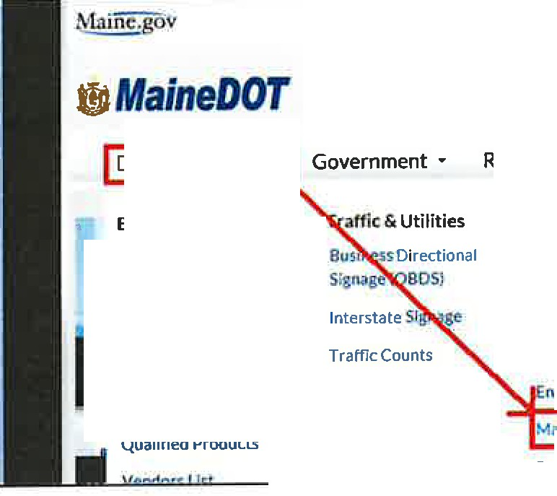
Locate MaineDOT Map Viewer on the MaineDOT web page by clicking on the tab...
File Edrt View Fnurites Toots Help
MaindJOT Intranl!t(2) (! SYggi&ed Sitt-: • Free Hotmail MaineOOT Intrand
Doing Business •
Residents • Explore Mal
Business Opportunities
Consultants
Resources
Civil Rights/DBE
Contractors ADA Accessibility
Program
•
Ii Products, Vendors &
Research
Advertise Schedule
Labor Rates
Flagger Resources
nv;ronmentat Info
Utilities Mal110DOT Map Viewer

Permits
Doing Business and selecting
MaineDOT Map Viewer
which is located within the Resources group.

Or the user can navigate to http://www.maine.gov/mdot/mapviewer/ You can use any search engine and search "mainedot mapviewer".

This should bring you to a page that looks like this:
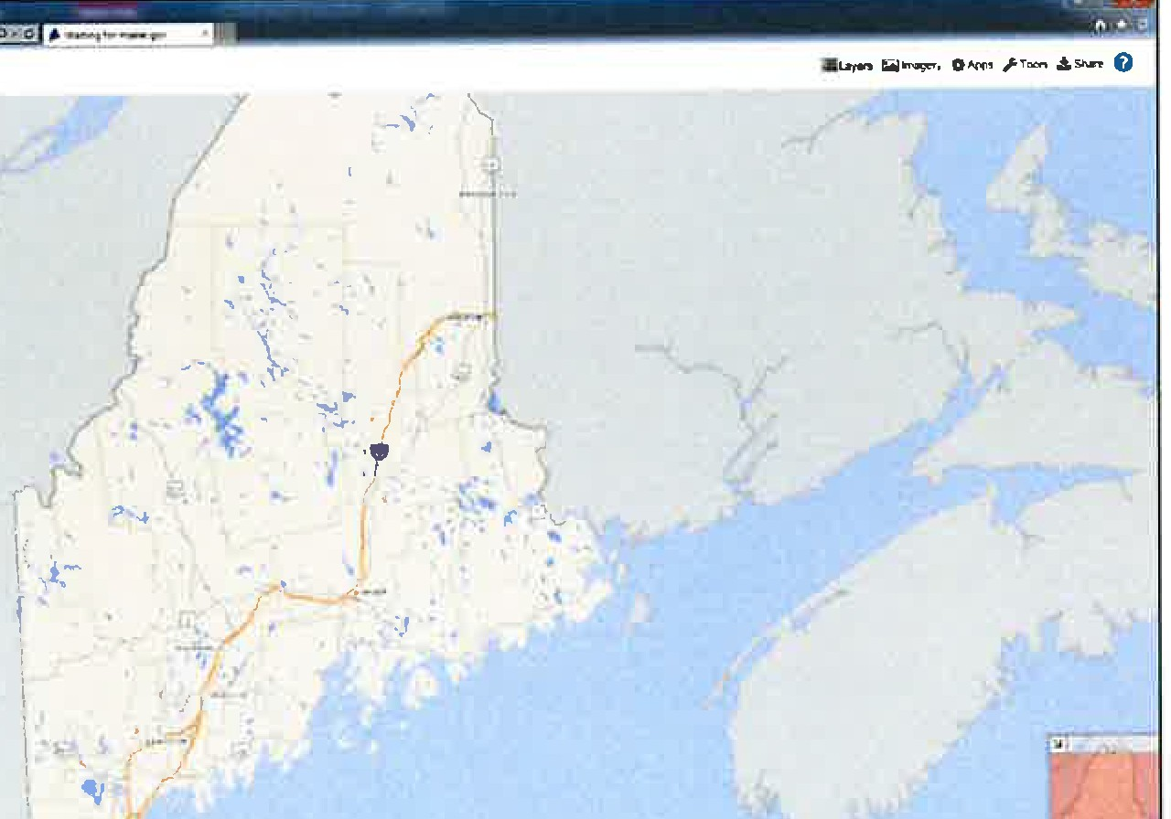
-t1JIAfa/neDOT Public Map Viewer
+

By default, only certain layers are turned on. For the user to see Right Of Way information the layers must be turned on.
- Maine DOT Pubhc Map Vie... X | /
I
!§Layersl lrnagery 0Apps rTools .t.Shara 0

In the top right corner of the Map Viewer page click on Layers

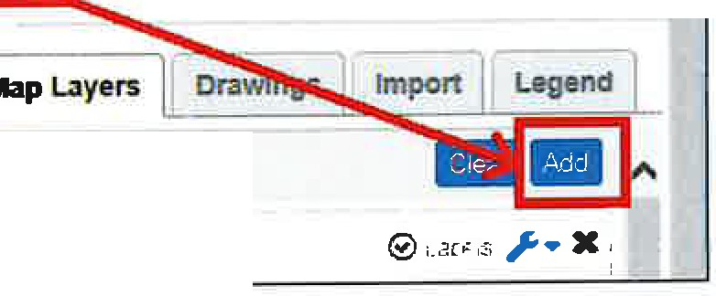
Note that by default there are only 15 User Layers. To add the ROW layers, select the blue 'S'
Layers :. Imagery 0AppsrTods .!,Share O A

G User Layers
0 Airports
button shown when the Layers tab is open.

Enter the word "Right" in the @earch for layers...!text
box.
LayersImagery0ApprsTools .!,Share 0
11
j llap Layers ]. Drawings Import
I
.. Legend ]
ADD USER LAYERS
- I Search for layers.
,,,,,,,VieY,ing Co1TV110n Layers: 48 Found
-
I X
Hlgnway atures

Bridges . AJI

Culverts - LMge
ShowAII
1
X
xi

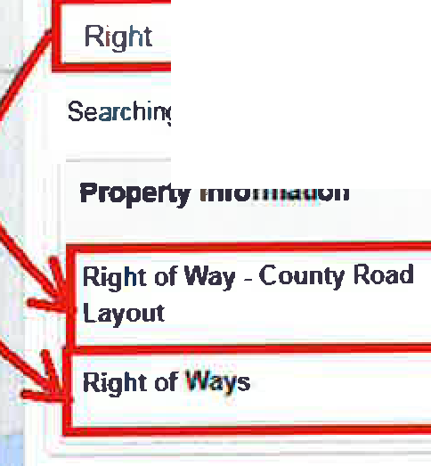
The Layers list reduces to show the two choices for turning on Right of Way data.
= Layers l;il Imagery O Apps Tools .!.Share Q
J Map Layers j Drawings Import Legend I
ADD USER LAYERS

)C
Searching Layers: 2 Found
Clear Search
0
+
+

Select the+ sign to the right of both Right of Way layer names.

This will add each option to the User Layers.
- Right of Way- County Layout is a layer depicting County Commissioner's Road Layouts (green lines).

- Right of Ways is a layer depicting MaineDOT Right of Way maps (blue lines).

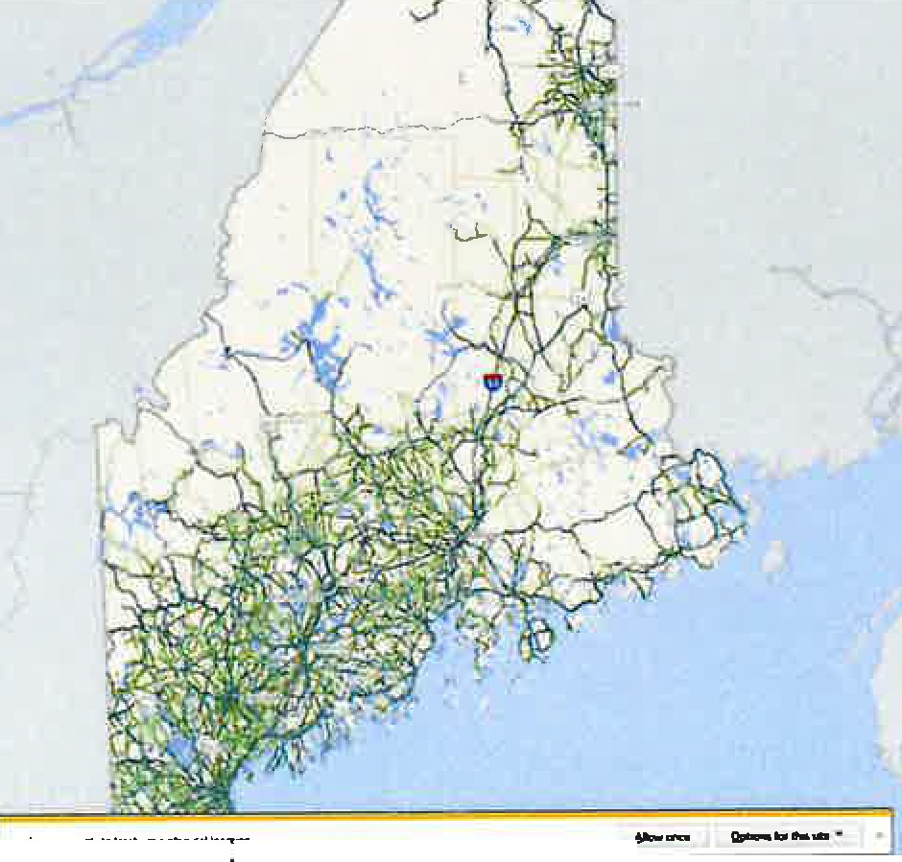
i!:JMaineDOTPublic M.ap.Viewer
--
--
--
--
ftlt0
,.,
AOO USER LAYDI
w..,11.p1,,nllH
.
"
+
+
+
II
+
+
.
+
+
.
+
+
" ....
.
+
+
-­
, ..,..,,.... -
+
..-,;;;.--,

Select the blue mm!button in the top right side of screen.
J Map uyers I, Drawtngs
ADD USER LAYERS
Import
Legend
Riaht

The Check box to the left of the Layer name will toggle the layer display on and off
laye;s [;i}Imagery O Apps r Tools ,& Share
J Map Layers Drawings Import Legend
User Layers
mam
0 Bridges - All

Right of Ways

Right of Way - County
Road Layout

Click on the Layers tab and the drop-down list will minimize.

Search a location ...

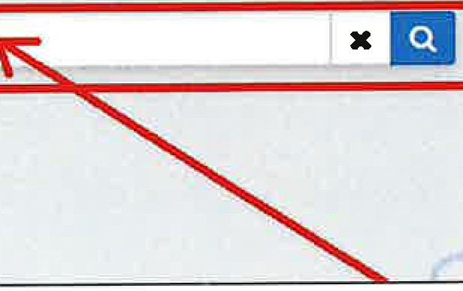
Use the "Search" text box located in the upper left corner of the Map Viewer screen to zoom to the location of your project.
File | Edit
 |  | I, http://www.maine.gov/mdo |  |  |  | "marr"',wer/
 |  | View | Favorites | Tools | Help
- MaineDOT Public Map Viewer
Search

Type the town name or address.

Tip: For town search, start typing town name and then you can select the town dropdown with your mouse.
Bridges-- All PORTER PORTER
PORTERCOVERED PORTERI.AKE STREAM PORTlANDWcSTBROOK I TER
Towns Portage Lake Porter
Portland
xEI
Port
f* MaineDOT Public Map Vie
File Edit View Favorites Tools Help

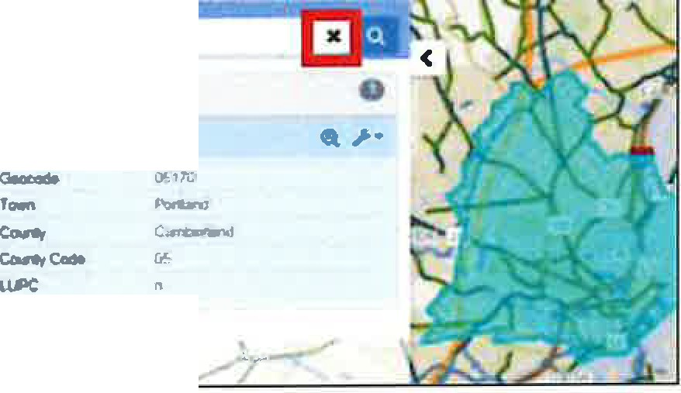
By default, the Town becomes highlighted in light blue. This highlighting can be removed by clicking the X just to the right of the search bar.
-,_
lfcMaineDOT Public Map Viewer
--
/

Search an address ...

Map Viewer requires the use of commas when entering an address. Use a comma between the street address and town.

Example shown 150 Preble Street. Portland

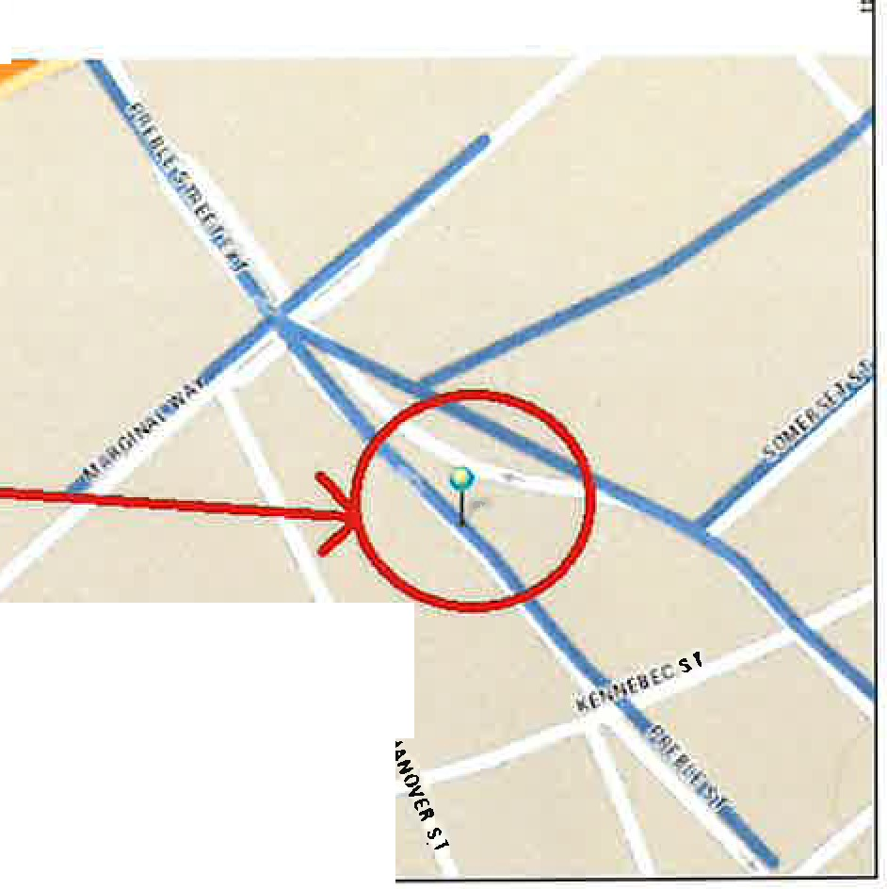
- · MaineDOT Public Map Viewer
150 preble st.,portlan
X
150 Preble St, Portland
43 661131 -7C•26444.3 (9 27 ft !
0 Feature Found: AShow Road Info
Address

150 Preble St. Portland, ME
Address
150 Preble SI, Por!land, ME
PORTLAND

Note:
150 Preble Street Portland

Error sean:hing for '150 Preble StreetPortlend'. The value you searched for was net found in the default search features_Pleaseadd the Layer you want to-seartli and use .the "Searth Dala" option
fo_unaby clicking on the-wrenchbutt.on neictto lhe
layer
)(
An error message will appear if a comma is not used.

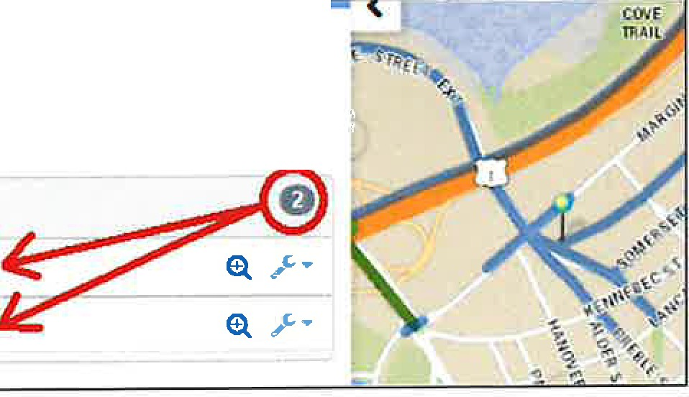
Once you have the location, click on a blue/green line.
156 Elm St, Portland
43 661743 -70 264501 (9 1 ft)
.I-•
atures Found: A Show Road Info

Right or ways

030271-PORTLAND

030485--PORTLAND

Click on the file number­ town name to expand the panel to view brief details about it.

If the location selected covers more than one project, the menu will show both allowing the user to select which one they want.

Note: The higher the file number the more recent the project.

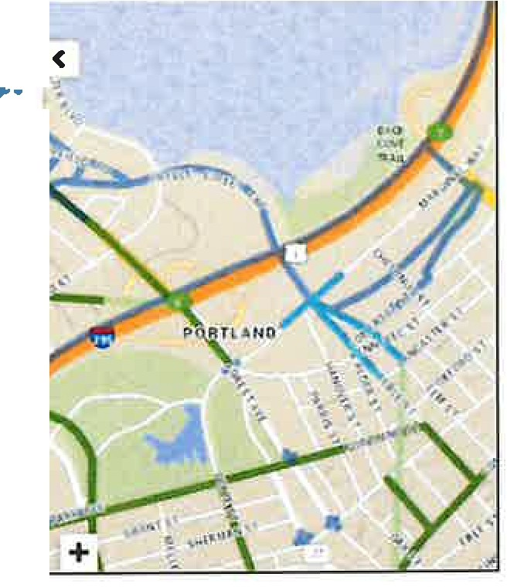
The Right of Way data will display on the left side of the screen. The user is provided with basic information such as
IC •
·--=
152 Pnlble SI. Portland
43661155,-70264541 (69H)

lllghtofNlys
----
0
OlOlTI-POR'll.ANO
0, ,r •
⁻v.⁻.,
l',qet-t
Higtt""10oog
r.,..,
R"""""
T)'PO
E.-..-
R01Yua1
3I-'/271
M,06l7fl) WISCO' POR'IIJ\ND
PREliUa & tt/1SlllEETS
030711
o:ru,1, t'()ll1lM<O

Plan Number (aka DOT File No.) Year
...,

8. , Hover the cursor over the magnifying glass to the right of the file number and the area
------ -- covered by that project will highlight in a light blue. If the user clicks on the magnifying glass it will zoom into the project extents.
The user can also hover over the file number- town name and see the same highlighted extents of the project.
156 Elm St, Portland
43.661743, -70.26..t (9.41 ft.)
0 Features Found:

Right of Ways
>..
I\Show Road Info
e
030271--PORTLAND & > ..
03048 RTLANO
Plan Number Year
Project Number HighwayDesig. Town
Remasks Type
E-Plans Number
ROWL.abel
3-485
02
NONE
NONE
Draw on Map Sen<lFee<lback Dnving Direcbons
Create Buffer
POR
IT
View Property Plan
RAJLV!
HANG 030485
i
030485-PORTLANO

View the plans by clicking on the wrench icon and selecting View Property Plan

MaineDOT MEPLANS launches a Plan Details window where the user will need to confirm again that they want to "View Plan"
Plan Details: 5520_707_08_01.pdf-File Size 5.5 1B
Archive Nam• Property Plans
Description RAILYARO TO CITY Comments RAILYARD TO CITY
Created By CreaceDate Modified By
Mcxflfied Daa
robert.skehan
3/17f201411:25:28AM
I View Plan IBack to List
- ' MaineDOT MEPLANS

This will open another browser window with a pdf of the ROW map plan set:
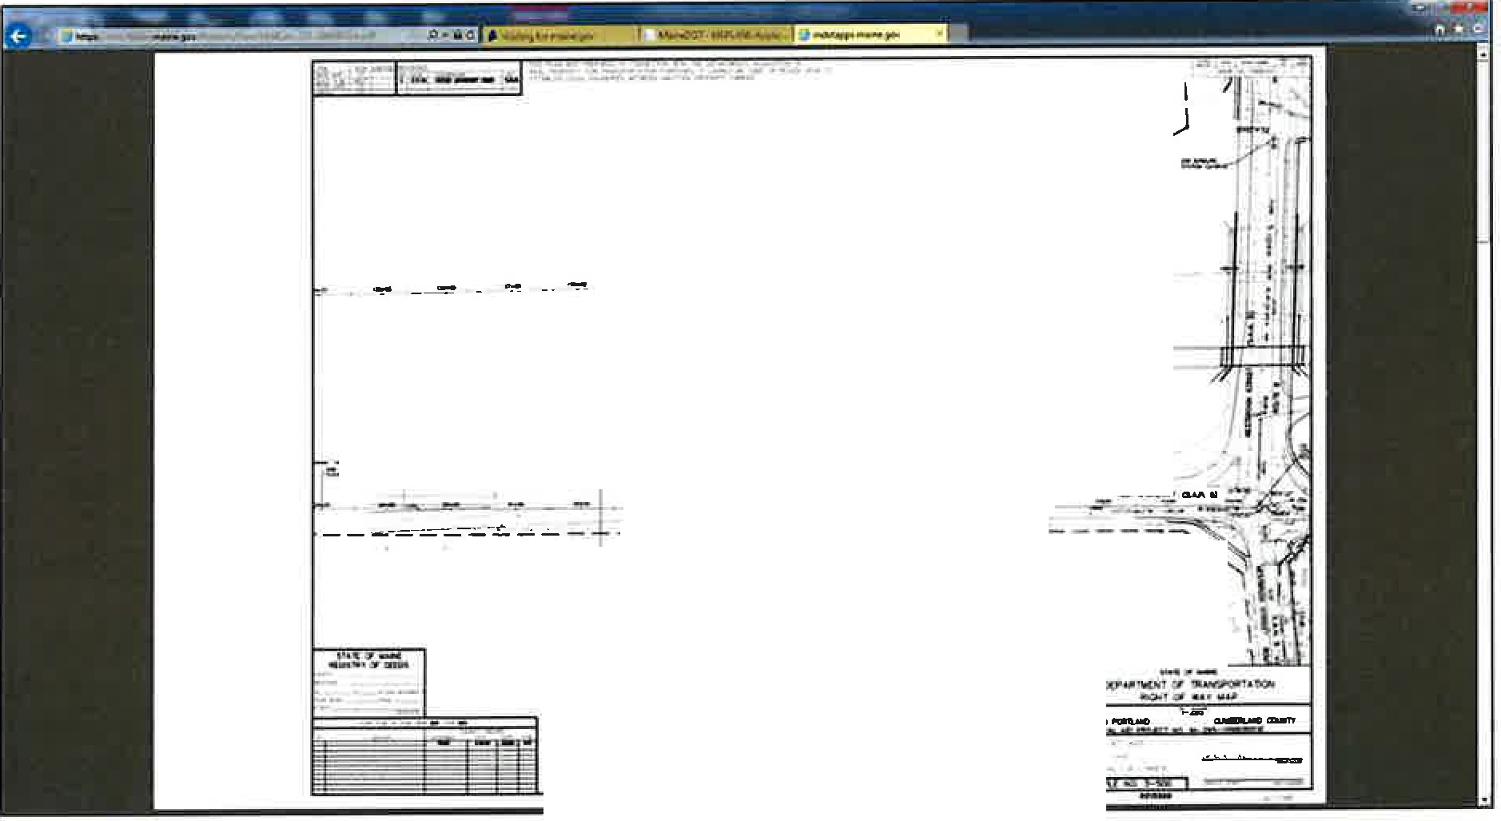
,.,,,,
I
I
--=. - -----=-=- ;;:;_---=--1
'\ .:,
---r-1.-::--_-
',
I 1'
I i I
'
You can now save this pdf to your computer for your use.

Search by DOT File No. (SHC File No.)

3-95 X

Right or Ways 0
030095.WlNDHAM

130095--BINGHAM

S 03-0095-HARPSWEU S 13-0095-DETROIT

Click on the Town name

This expand the details panel which activates the wrench.

Click on the Wrench

Click on View Property Plans.

There may be multiple choices after selecting
"View Property Plans".
Select the correct plan for the Town wanted and click
View.
The DOT File No. (numbers only) can be entered in the Search Field.

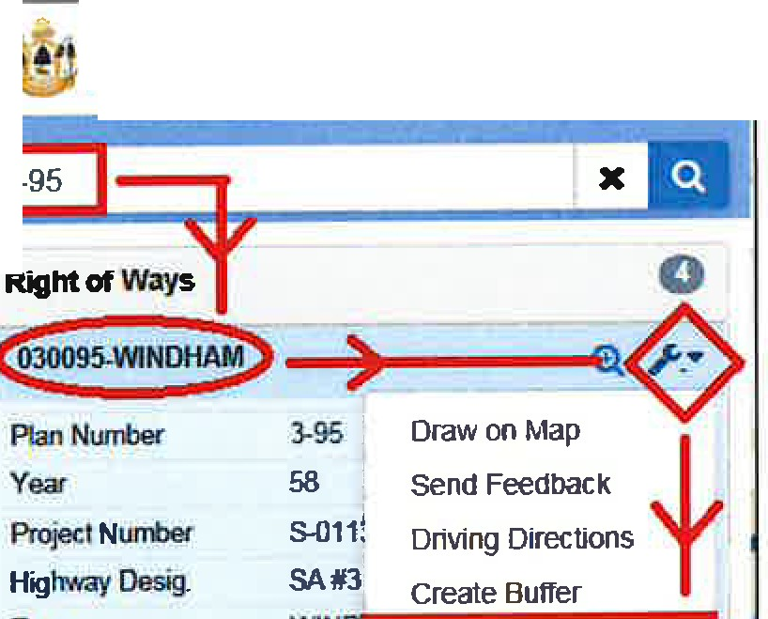
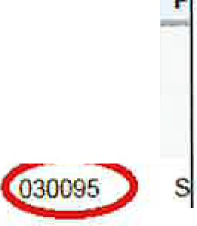
Example shown: DOT File No. 3-95
2 Documents Found

Action Size
Town
County
Route#
· PIN
ROW#
View
Derails
4.2MB
Harpswell Cumberland RD INV 05 00399
S 030095
Description: NOW SAH NO. 5, (TC#3) CUNDY HARBOR ROAD

Cumbenand

Description: (SA #3)
,! MaineDOT Public Map Vie

As displayed in the example, there can be several references, which contain of the same numbers.

The Town name should help determine which plan set is desired.

, MaineDOT Public Map Vie
3-95
Town | WIN I View Property Plan
Remarks
Type | HANG
E-PlansNumber | 030095
ROWLabel | 030095-WINDHAM

When a Plan does not display...

Occasionally the user will encounter a plan that does not display and the Property Plans Archive page will say "O Documents Found".

Property Plans Archive  This archive contams the Departments Raghl Of Way Maps and other documents pertam,ng lo ownership, easemenls and other property or real estate concerns  Filter Archive  Description PIN# Prajoct Number ROW# Town  020587  Bridge Ye3r Plonset Type |  |  | Aw/ | Clear
0 ll<>cuments Found |  |  | Plans per Pogo: | 25 | - [

Go back to the Map Viewer page and look at the project details. The "Type" may be listed is FLAT.
I'2--587
Righi at ways
X-.• .<
020587-WAl..lAGRASS
Plan-
Yeat
f'nl;ocl N...- Highway Cle9g Town
Romarb
rw<-E:)
2-587
2017
22585 00
SM5
WAU.AGRASS
SLY BROOKR(W)
E--.S- OlOS87
ROW IU0561-WAI..I.AGRASS
i!JJ.MaineDOTPublic Map Viewer
FLAT describes a plan which MaineDOT has not finished processing.
This plan will not have been sent to the appropriate county registry, nor will it have been uploaded to the Map Viewer archive.

Contact MaineDOT Right of Way Research for a copy of the plan.

Note:
- MaineDOT Public Map Viewer
o FNIWH Found:
Rlgllt of My. CGllfflr Roacl L.lyoutl
RiglltotW\,ys
0
- I
Jf the location selected has multiple choices, all plans or county layouts for a that location will display on a list to the left of the Map Viewer screen.
I

Click on the category to expand the details.

Click on the County Layout Number
Right of way • County Road Layout
103011n •k'11---
0305227
0

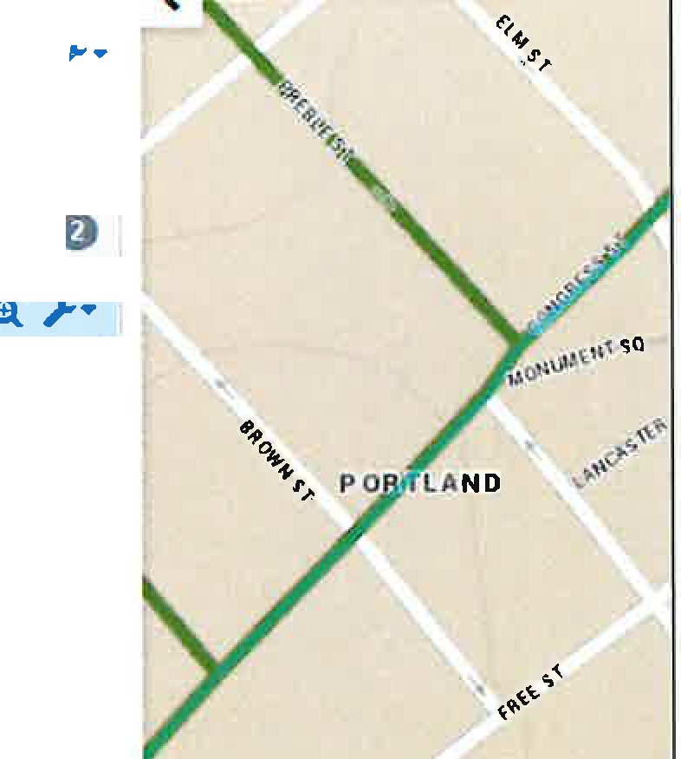
2 Preble St, Portland
43 657227 -70 259526 /77 79 I
0 Features Found: A Show Road Info

Right of Way • County Road Layout
ICounty
Conment
Cumberland J
Name
- Page
0301172
172 i
Status
Status Known
v.•o1•u•me 1--I
Town
Falmouth, Portland
•1
Wtdth 49.5 & 66 feet (3 & 4 rods)
Year 1768

0305227

MaineDOT uses a 7-digit number to identify county layouts. The first 2 digits are assigned County numbers -
01 -Androscoggin, 02 - Aroostook, 03 - Cumberland, 04 - Franklin, OS - Hancock, 06 • Kennebec, 07 - Knox, 08 - Lincoln, 09 - Oxford, 10 - Penobscot, 11 - Piscataquis, 12 - Sagadahoc, 13 - Somerset,
14 - Waldo, 15 - Washington, 16 - York.

The 3 and 4 digits are Volume number - 01 thru XX

The last 3 digits are the Page number - 001 thru XXX

Disclaimer -
The County Layout information that MaineDOT has consists of a hand sketch and photocopied pages. All information must be verified for accuracy at the user's discretion.

MaineDOT Public Mapviewer
MEPLANS Archive - As-Built Plans

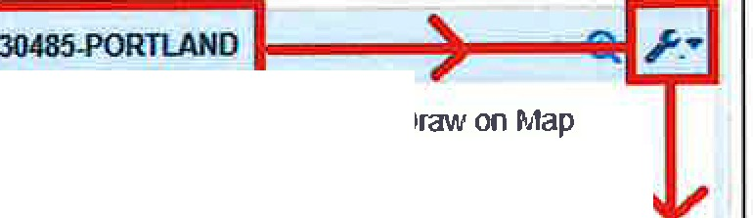
From the Map Viewer Home Page, select any plan to view
Right of Ways
0
Plan Number Year
Project Number Highway Desig. Town
Remarks
Type
E-Plans Number ROW Label
3-485
02
NONE NONE POR
RAIL
HANG 030485
Sencl Feedback Driving Directions Create Buffer
View Properfy Plan
030485-PORTLANO
030271-PORTLAND
(ll /-•

Located in the upper right corner of the MaineDOT MEPLANS page is the tab for Click on the tab and a drop-down list will allow the user to select the Vault Plans.
Archives

logm

Homo Holp Conua Arch1vt:. •
Plan Details:
5520_707_08_01.pdf · File Size 5 51,IB
f n..,,.,11roans
Archive Name Property Plans Description RAILYARD TO CITY Comments RAJLYARD TO CITY

Created By robert skehan
Creole Date 3/17/2014 11 25 28 A/,1
Modified By
Modified Dote
View Plan Back to List

Enter your Filter Criteria, then click Apply:
This will limit the list of plan sets shown in the table to those meeting the filter criteria.
Flher Archive

Oueript1on
PIN
Town
Rou,e 4
Bridge#
Year
- --' Clear

All filters except for the Planset Type are case-insensitive, "open-text" filters. This means you can put in a partial value and it will return all records that have the partial text in that field. The more complete the filter text, the fewer records are returned.
Example: Wint, wlNT, or WinT as partial filters in the Town field will all return the same result set. Records returned would include the towns of Winterport, Winter Harbor, Winthrop, Winterville Pit, etc. Combinations of filters further reduce the number of records returned from the archive search.
Example: If we are only interested in plans for route US lA in Winterport, we could use "wint" for town, and "lA" for route, and it would return only a single page of results, rather than multiple pages.

Using the Planset Type filter:

Planset Type is a powerful filter that allows you to choose from a list of standard values assigned to each record. Leaving this filter blank will return all planset types.
..
AERIAL_MAP_HALF
d-i=l111ii#SW@i
CONTRACT
PLANS
DEVELOPER AS­ BUILTS
MAINTFACILITY
POR

CONTRACT PLANS
"
More recent project plan sets "as-advertised" for bidding
AMENDMENTS
Amendments to advertised Contract Plans
AS-BUilT PLANS
Plans indicating field changes during construction
VAULT_ARCHIVE
Most of the historic plans from the Department's original plan archive before sets were scanned for electronic viewing
Plans et Type

Important Search Tip!

If you search by bridge, route, or PIN number and expected records are not shown in the results set, try filtering the Description field by those values. Many records also have common "street names" or "state aid highway numbers" as part of the description field.

Viewing Plan Sets or Details about the plan set:
Each record in the results table has two buttons in the Action column.

View
Loads the PDF in your default PDF viewing application.
Details
Look at the plan set record in greater detail than that which is shown in the table.

Description
PIN
Projoct Numb«
Town
Route#
,.
Bridge
"
Year
PlansetTypo
Apply Clear
9 Documents Found

Action Sin Tawn C_ounty--'---
: PIN
ROWI Prolm_N_um_bo_r_ llrldga ; PlanY- ; PllnMt 1ypo
30.3MB Frankfort. Winterport waldo US1A 84-a 1924 VAULT ARCHIVE

llelcrlpCfan: S.H.i. , RTE1A,MARSH STREAM DUE NORTH 2.58 Mil.ES
0
l.iew
Delail$
34 1MB Winterport
Waldo
USIA
84-C
1925
VAULT ARCHIVE
Description: SH "L", RTE 1A. KALER ST DUE NOR!lj 4 975 MILES
¼M 47.5MB Winterport
Waldo
US1A
HHS-1126-2(28) I
1979
VAULT ARCHIVE

As-Built example shown below

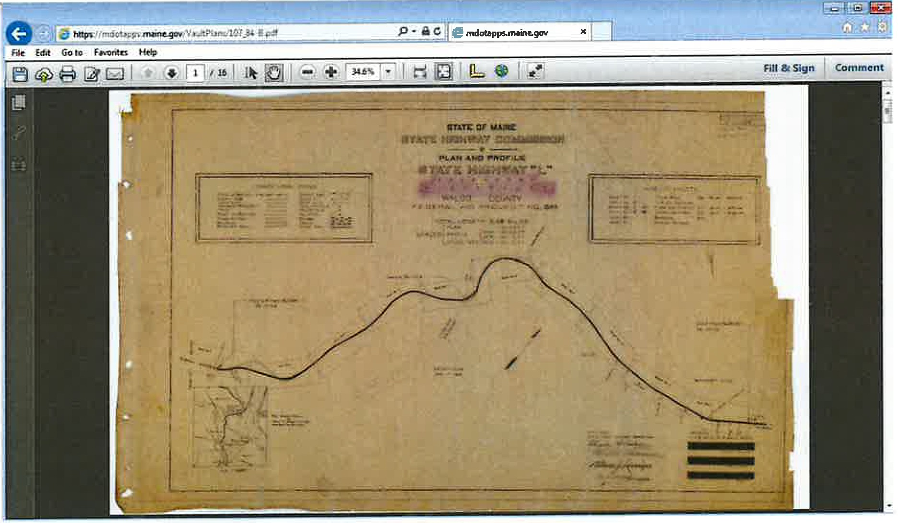

Maine Abandoned and Discontinued Roads Commission October 7, 2022
Meeting Minutes

In attendance: Brian Bronson, John Monk, Cathy Nadeau, Roberta Manter, Vivian Mikhail, Peter Coughlan, Karla Black, Ryan Pelletier (via Zoom), Rebecca Graham (via Zoom), Steve Young (via Zoom)
Absent: Kris McCabe
The meeting was called to order by Vivian Mikhail at approximately I 0:25 a.m. A roll call was conducted of those members present. It was noted that Seat 7, which had remained vacant had just been filled by the Speaker of the House. Attorney Jim Katsiaficas of Perkins Thompson will fill the seat at the next meeting.
Commissioners briefly introduced themselves and stated their interest in the Commission.
Vivian Mikhail introduced the policy regarding remote meeting participation. She indicated we can discuss the policy today, but it needs to be posted and opened for public comment before the Commission can vote on it. Roberta Manter asked if the public could participate remotely, the answer is yes. Brian Bronson asked if it allowed participation by telephone, the answer is yes, but if the meeting goes into executive session the party calling in will need to be in a location where they cannot be overheard.
Before the Commission began reviewing the statutory duties of the Commission Roberta Manter briefly outlined her priorities for the Commission. She started by indicating a book she is reading has a relevant message-when a problem is too big for one, you shouldn't be competing with others, instead you should be working together to encourage others. All interests tie in together and constitutionality is a big issue. She cited the case Jordan v. Canton and said the case holds that property access is a right that requires due process and just compensation.
Roberta quoted Jordan as saying that property access is a right attached to property, and when that access is taken or even damaged, the Constitution requires both due process and just compensation. Jordan says that a public road with no public maintenance will inevitably be destroyed.
She said further that a public easement is a public road with no public maintenance, she sees that as a constitutional issue. She recommended instituting minimum maintenance roads as an alternative.
With Vivian Mikhail leading the discussion, the Commission went on to review the duties outlined in Public Law Chapter 743. The duties fall into 4 primary categories:
I. Primary Considerations
- Matters to Prioritize
- Recommendations to Develop

- Legislation Review
A Com.mission report is due February 1, 2023 and annually thereafter.
The discussion turned to electing a chair. Ryan Pelletier nominated Pete Coughlan, seconded by Roberta Manter. Pete Coughlan declined the nomination. Ryan indicated he would then support Jim Katsiaficas as chair.
Pete Coughlan nominated Cathy Nadeau, Brian Bronson seconded. Cathy Nadeau declined the nomination.
Vivian Mikhail noted that in the absence of a chair, the designees from IF&W and Department of Agriculture can step in to call a meeting.
Rebecca Graham indicated she too would be supportive of Jim Katsiaficas as chair. She indicated he is an expert in this area and often provides training to bar members on these issues.
Pete Coughlan and Vivian Mikhail both agreed to reach out to Jim Katsiaficas to welcome him to the Com.mission and gauge his interest in becoming the chair.
The Com.mission discussion returned to the duties outlined in the statute. The first area for discussion was the Primary Considerations:
Property Owner Liability: Roberta Manter indicated that landowners can have liability for things like runoff, and the runoff might not be their fault and this should be considered.
Public Easement Retention over Abandoned or Discontinued Road Including the Scope of Permitted Public Use: Roberta Manter said this is number one on her list. She cited case law relevant to the issues surrounding public use.
Statutory terminology: Roberta Manter indicated there are at least 3 definitions of private way that conflict with each other. Definitions are scattered throughout the statutes and need to be clarified. Rebecca Graham indicated that Jim Katsiaficas' s bar training has the definitions broken down really well. He could also provide substantive history.
Vivian Mikhail will ask Jim Katsiaficas if he is willing to share this information.
Statutory Process: Might look to Jim Katsiaficas for this as well. Rebecca Graham said this essentially requires a deed ancestry which can be really expensive for either the property holder or the town.
The second area of focus is Matters to Prioritize--prioritizing the matters outlined in section
2(B). This will need some significant conversation.
Steve Young indicated recreation uses overlaps with the previous section. One of the biggest issues is ATVs. There could be some real conflicts particularly when it comes to snowsleds or designation of habitat.

Cathy Nadeau focused on number 5 regarding municipalities, indicated she would like to know what municipalities are doing about discontinued and abandoned roads or easements, are they on board?
Rebecca Graham said reaching out to the communities will help all of the commissioners understand the intersections and the problems associated with that directly from the people involved. Agrees that the recreational use is key. Should clubs have to bond for their maintenance. Many municipalities struggle to respond to landowner issues regarding roads that are discontinued.
Roberta Manter indicated that the big issue is when the road provides the only access to someone's home and the public is able to use it in any manner they please. Very little responsibility on the part of the municipality to repair any damage. Understands that municipalities don't have the resources but if there were a better mechanism for understanding what the public's rights are and responsibilities are. Rights and responsibilities go together and right now that's not the case. The rights are the public and the responsibilities are the private.
The remaining two duties are: Recommendations to Develop that will flow into the annual report in February and there may be legislation then to review as well.
Subcommittees and bylaws are premature right now.
Discussion was then had regarding getting notice to new property owners. Recent legislation that now requires real estate disclosures if access to property is not maintained by the public. Roberta Manter cited to several statutes regarding required disclosure including 33 MRS§ 173(6), 33 MRS§ 193 and 23 MRS§ 3121.
The Commission members agreed that including realtors and land surveyors as interested parties to the Commission made sense.
Vivian Mikhail is looking into getting an interested parties list and how/where to post Commission notices.
The Commission discussed next meeting dates. Vivian Mikhail will send a Doodle poll.
A motion to adjourn was made by Pete Coughlan and seconded by Brian Bronson. It was unanimous. The meeting was adjourned at approximately 11:50.

Maine Abandoned and Discontinued Roads Commission October 27, 2022
Meeting Minutes

In Attendance: Corp. Kris Maccabe, John Monk, Catherine Nadeau, Karla Black, Roberta Manter, Jim Katsiaficas, Vivian Mikhail, Peter Coughlan, Rebecca Graham, Ryan Pelletier (via Zoom), Steve Young (via zoom)
Absent: Brian Bronson

The meeting was called to order by Vivian Mikhail at approximately 1:00 pm. A roll call was conducted of the members present.

Discussion of the October 7, 2022 minutes, which Vivian previously had circulated for Commission members' review. Motion to accept the minutes was made by John Monk, seconded by Roberta Manter.

Election of Commission Chair- Jim Katsiaficas was nominated by Peter Coughlan, seconded by Catherine Nadeau. Unanimous vote in favor of Jim's service as Chair.

Discussion on how to inform public- Vivian Mikhail suggested MailChimp with the ability to reach 500 followers and with the ability to attach meeting notices, agendas, recordings and zoom links to it.
Avenues to distribute notices, etc: D.O.T. website, IF&W, MMA
Roberta mentioned Google search: if you put in "abandoned roads" it brings you to her website: maineroadways.blogspot.com (where people who have problems with these roads often find themselves when they search for "abandoned roads Maine" or "discontinued roads Maine" online). That, therefore, might be a good place to post meeting notices.

Steve Young: Radio or TV for Northern Maine whereas a lot do not have computers or access to them; also the U Maine System can do informational notes attached to their website.
Jim: what do other commissions do for invites?
the committee of jurisdiction = State and Local
7 to Rebecca: can MMA send an E mail blast to towns and possibly E Newsletter. YES but deadline was October 20
7 days' notice for participation from now on
Peter Coughlan - Mail Chimp using MMA, Roadways, Landowners (SWOAM) Upper St.John River.com ($25/mon to host)
Steve Young- Upperst.johnriver.com, Asgars Fjordor Ark Map (Geographical Information)

Jim: Who is in charge of Maine.gov = O.1.T
Kris Maccabe says he will check into using the Landowner Relations Page of IF&W Steve Young - Printed copies to Towns to distribute
Ryan Pelletier- Our mission is to streamline, establish a subcommittee to clarify the gray areas of the Roads Law/Adapt to include subcommittee to be subject to Freedom of Access
Final report to be submitted February 1, 2023 discussion: 2A of Law DUTIES

Property Owner Liability, Public Easement retention over an abandoned or discontinued road, Statutory terminology related to abandoned or discontinued road, Statutory process for the abandonment or discontinuation of a road,
2B - Owners of property that abuts abandoned or discontinued road, Owners of property accessible only by traveling over an abandoned or discontinued road, Recreational users of an
abandoned or discontinued road, Members ofthe Public, Municipal, County or State government, the physical integrity of an abandoned or discontinued road and surrounding road

Steve Young - Get Info out to Northern Maine
report due February 1, 2023 and then annually thereafter

Roberta - news media involvement may be a suggestion Rebecca - Key topic - outreach
Vivian- look into the murkiness of the law

Jim - to get on the same page need to identify the definitions as follows: Discontinuance,
Abandonment, Paper Street

title 23 (municipality) Title 29A
Title 33 - Landowner

Private Way- Historically used by farmers to get their items to towns with use of gates and bars; town has passage
Mention of the Kennebec Land Trust
To be taken up in the December Meeting:
List of concerns/issues involving roads (3 or 4 issues) Rank the issues
Public Comments
Reach out to stakeholders
Between December and January : Subcommittees to look at Stakeholders and determine results January meetings : January 11 2023 - policy direction
January 25 2023 - report out findings/adopt report

Concerns of landowners who live on abandoned/discontinued roads and will have the ability to maintain road and the expenses incurred
Recap:
Nov. - Road Law/ issues (3 or 4 issues); Jim will present a half hour primer on road law, and Roberta will present the top issues ROADWays members have with these roads.

Dec - identify stakeholders subcommittee to meet policy direction
adapt report
Jan. - Draft Form Report Final Draft

Feb - Progress Form/Report

Next meeting - November 17, 2022 - 1 to 4 pm - room 214
Roberta- link to Hancock registry of deeds : handcockcountydeeds.com/pdfs/discontinued-roads-sm.pdf Motion to adjourn: Rebecca Graham, Kris Maccabe seconded

Maine Abandoned and Discontinued Roads Commission November 17, 2022
Meeting Minutes

In Attendance: Corp. Kris Maccabe, Brian Bronson, John Monk, Catherine Nadeau, Karla Black, Roberta Manter, Jim Katsiaficas, Vivian Mikhail, Peter Coughlan, Ryan Pelletier, Steve Young (via Zoom)
Absent: Rebecca Graham

The meeting was called to order by Chair Jim Katsiaficas at approximately 1:08 pm, followed by a roll call of the members present.

The Commission unanimously accepted the minutes of the October 27, 2022 meeting, based on a roll call vote.

Jim opened the meeting with a resumption of the discussion about how to get word out to the public to maximize participation in meetings, advising the Commission that Vivian Mikhail's research confirmed a monthly fee of approximately $500 for a website hosted by maine.gov.

Vivian confirmed that a Commission email is available and will circulate it when formally notified by her office's IT lead. She explained the process she has attempted to set up a YouTube channel for the Commission and its video meetings and past recordings and is awaiting confirmation by mail of the online registration steps she has taken thus far. Using MailChimp as a way for the public/interested parties to sign up for Commission updates is still in limbo, as OIT for the State of Maine has not approved its use.

Jim suggested it would be ideal to get the next agenda out two weeks prior to the next meeting on December 14 (therefore, 12/1as a goal). It ideally would include the remote meeting policy, with notice of all sufficient if published in the Kennebec Journal. The next meeting is intended to have time dedicated to taking public comment.

Jim noted that other state commissions have websites, e.g., the Right to Know Commission, and stated that it seems logical that this Commission should have similar resources available to it. Jim said he would follow up with the IT contact the AGs Office has been in touch with early next week to try and appeal to them, if we don't get different information sooner. He also wondered about perhaps linking to the legislature's website somehow to house Commission notices, statement of purpose, reports, etc.
Eventually members of the Commission will also post similar information on their affiliated entities' websites where practicable.

Brian Bronson reported that his office's response was that the Commission needs its own stand-alone site, versus somehow linking to ACF's website. Brian stated that if this is to be an ongoing/permanent Commission, obviously $500/month for webhosting is not going to work.

Jim then delivered "Overview of Municipal Roads -Abandonment and Discontinuance", a presentation he noted he's given with Pete Coughlan in the past. The written materials (that Jim's presentation tracked) are attached to these minutes.

Ryan Pelletier noted that many roads never went through formal processes and inquired whether the 30-year standards are applicable to all. Jim said that if it's a town way, yes. Ryan followed up, asking how it can be discerned what the roads were/are. Jim responded that presumptive abandonment applies, offering the example of a case in Livermore. In that matter, county books/records from the 1800s that offered descriptions such as "the road by the oak tree, near so-and-so's house" were relevant.

Roberta Manter then had the floor to present information she has tracked, compiled and collated, in large part during her founding and leadership of the organization Roadways, which represents 20-30 years of accumulated issues raised by others she has worked with. She described she maintains a map with a pin in each town that has at least one road problem, and that she has received on average one new complaint per week for the past year.

Roberta then went through a handout capturing results of a Survey Monkey survey Roadways conducted, which is attached to these minutes.

Roberta explained that the biggest issues stem from what used to be through roads that towns stop maintaining- public easements that are not maintained, noting that private ways usually end at a destination (e.g., a home, a mill, etc.). Another problem she described is when an easement is not retained and a road becomes landlocked when discontinued (e.g., road is essentially gone).

Roberta gave an example of another problem around the cessation of winter maintenance of roads:
-Some towns say that private owners can't plow either.
-Then what? No access to a home and no compensation for the taking.

Ryan queried whether that issue example really falls within the Commission's purview and opined that it does not.

Roberta responded that Ryan's point was an interesting one, while noting it is a recurring issue that may still be one of the easier issues before the Commission to resolve (e.g., a section regarding winter plowing in real estate disclosures; prohibition on towns from ceasing winter plowing if there is a year­ round resident).

Jim agreed with Ryan that plowing/winter maintenance is not within the scope of the Commission's work, and turned to highlighting the top five areas from Roberta's survey:
- Constitutionality of statutory abandonment law (Jim noted this has been litigated)
- Figuring out the actual status of a road (Pete noted that the DOT map viewer tool is of utility and help here, and Roberta said that those roads are the clearer ones- it's the ones discontinued by the counties that present the difficult determinations)
- Defective or ambiguous action by a municipality, leaving legal road status uncertain
- Prohibitive cost of litigation (Roberta mentioned existing low-cost mediation, including existing resources (e.g., Family & Community Mediation, Maine Agricultural Mediation Program), and the need to encourage people to attempt mediation before real feuds ensue; Jim noted that mediation is required when a suit is filed; Roberta brought up the up-front costs of filing as a barrier to low-income people of accessing that intervention)
- Lack of information or faulty disclosure of information regarding road status at time of sale (Roberta noted that the use of weapons in such situations has gone up because people are so frustrated, taking matters into their own hands when there seems to be no other recourse,

including machetes, battle axes and assault rifles; this triggers PTSD that would be good to mitigate; Ryan suggested a sort of "Road Relations" mediation board for these matters; Cathy asked about the number of violent episodes, which Roberta does not have data on; Jim agreed that all property issues heighten tensions)

Ryan raised an overarching concern about how this Commission can change anything for those already struggling with such issues.

Steve noted a situation in Frenchville where the municipality plowed a short private way, which legislative action terminated, and a feud resulted.

Roberta raised the issue of town equipment on a private way, specifically, e.g., such equipment can be used to plow public easements but not private roads (because they are no public funds are to be spent on private roads), and said perhaps an easement would allow public use and therefore legitimate use of public equipment and dollars/resources

Roberta then shared a handout entitled "Small Tweaks" drafted to address some of the issues and situations raised in the meeting thus far. She referenced the case of Jordan v. Canton, which involved limited user highway law. The town argued that under the law it could just decide not to maintain a road because it is not of enough value to the public. The court disagreed saying that a public road that's not maintained will eventually be destroyed. It is not necessarily the legal status that determines a situation, but the facts and circumstances of what has happened to the road that bear on the rights and responsibilities. Roberta quoted the decision extensively. She joked that Maine ROADWays' motto is "Build a better public easement and the world will beat the pathway to your door!", and then said that it alludes to a sort of repeat taking, for which traditional one-time taking compensation is not just.

Steve raised the question of environmental liability in these situations. Roberta offered the example of run-off from ruts into bodies of water, such as the silt ending up in Lake St. George from property in the town of Liberty. She also noted that is why you see the words "hill", "bog" and "swamp" in a lot of discontinued road names.

Ryan queried as to when a road is laid out/created, it must be recorded at the Registry of Deeds, but when if it is discontinued, does that happen at the town level? Roberta responded that the law now says at the Registry of Deeds and DOT. Given all that, Ryan wondered about having town reports submitted to the State library from now on (and about past records as well). Roberta said the library does have a
lot of this information, although towns do forget to file and some do not include warrants and/or votes on warrants. Ryan clarified that the charge of the Commission is to move forward and not go back in time, which Roberta agreed with but noted it would be ideal to go back and fill in some existing gaps. Ryan guessed that might be very hard to do because there is not always a report. Jim said that as of 1959 there is a requirement to file a certificate of discontinuance, and before then such documentation was very rare. Roberta agreed, saying towns were not always aware of the need to file because the language of the law was quite ambiguous.

Steve raised a question regarding conservation efforts in the town of Hamlin and noted limited available public access to certain roads in harvest. Ryan noted state agency action to create access for harvest time.

Brian said roads built to cut wood may be open to public use for, e.g., hunting, with categorization for different uses (e.g., gravel road for ATV usage).

Ryan mentioned a group of landowners that controls access in the North Maine Woods. Brian said Down east tried something similar, but such organization was rejected.

Brian revisited the definition of "public easement" vis a vis ATV and similar use in Roberta's materials. Ryan then asked if definitions of such are the same or not. Jim said this could raise a similar situation as with two definitions of "private way" that exist.

Jim then turned to the statutory categories of consideration to focus the work of the Commission, and said we need public input to determine next steps and how to address concerns. Ryan said we need to limit the amount of time, and also accept written submissions. Vivian recommended a three-minute time clock, and Jim agreed with that and Ryan's comments.

Steve asked about the effect of road decommissioning on ATV and snowmobile usage. Brian responded that the law contains conflict, saying the easement is available for use. Cpl. Kris Maccabe noted that the snowmobile and ATV statutes are very distinct, likely violating Title 12.

Brian said that a town "gives" permission to use access routes maintained by the town (and that there is no access route permissible on a discontinued road). The town often directs working out a situation with the landowner, such as offering maintenance assistance to help with the landowner's costs.

Roberta noted that it only takes one person to do donuts and ruin it for all.

Brian gave the example of a late mud season when ATVs are prohibited, and impatient regular vehicles use a road to fish and ruin the trails. The only option there is to gate out the ruinous users.

Brian went on to say that ATVs/trucks are not permitted on snowmobile trails and vice versa unless there is permission from the landowner-and there can be a split in landowners' positions. Ryan asked about getting multiple permissions in such a situation-does it come down to keeping a piece of paper with it documented on your person to use the road? Brian said you're good to go having gotten permission, and that an ATV taskforce in 2019 made clear that the landowner has the final say- which needs to be cleaned up and clarified.

Kris mentioned reverse posting on land in general, as with ATV permissions. Brian commented that it's a lot of work to track it all and that owners have a right to know. For one example (of so many), Brian described a situation with a cabin in the Rumford woods wanted as a house, needing road bridge/road upgrades or resulting in blocking off the town and other uses.

Jim noted we need a longer meeting and public comment on December 14. Pete asked how to streamline the process and give the public guidance as to how to structure their comments. Ryan suggested the Chair can encourage avoiding repetition, which Jim agreed with.

Jim went on to say we will need subcommittees to tackle recommendations in the Commission report to the legislature. Roberta mentioned that previous stakeholders have only come up with written suggestions and then the legislature creates the subcommittee and then it comes up with language that loses the meat of the work.

Pete will give an overview of the DOT website and map viewer at the next meeting.

The December 14 meeting will begin at 10 am to accommodate the agenda developed throughout this meeting, specifically:
- Remote Participation Policy vote
- Overview of MOOT map viewer tool
- Public Hearing
- Discussion of Commission Priorities
- Formation of Commission Subcommittees

John moved to adjourn the meeting, seconded by Kris and Steve. The meeting was adjourned at 3:48 pm

Maine Abandoned and Discontinued Roads Commission December 14, 2022
Meeting Minutes

In Attendance: Corp. Kris Maccabe, Brian Bronson, John Monk, Catherine Nadeau, Karla Black, Roberta Manter, Jim Katsiaficas, Vivian Mikhail, Peter Coughlan, Ryan Pelletier (via Zoom), Steve Young (via Zoom), Rebecca Graham (via Zoom)

The meeting was called to order by Chair Jim Katsiaficas at approximately 10:05 am, followed by a roll call of the members present.

The Commission unanimously accepted the minutes of the November 17, 2022, meeting, based on a unanimous roll call vote.

Jim opened the meeting, first directing the attention of the Commission and members of the public who were present to the proposed remote meeting participation policy. Vivian offered background about the Commission's previous consideration and tentative/unofficial approval of it, noting that it was made available to the public in postings about the meeting. No members of the Commission had further comment. Jim invited public comment, and only David Manter of Fayette wished to be heard. Mr.
Manter was in favor of the policy and deemed it a legitimate way for people to participate. Vivian made a motion to institute the remote participation policy, which Roberta seconded. A unanimous roll call vote formalized acceptance of the policy.

Jim and Vivian then gave an update about efforts to establish the Commission's online presence, with the following being the current information status:
-YouTube authorized the Commission channel but it's hard to find due to character limits on the channel name. Vivian will work on that.
-Jim and Vivian were in touch with OIT about the prohibitive $500/month cost. Still waiting for further word about that, and any other way to go about this via maine.gov without a budget.
-Public notices in the KJ cost hundreds of dollars per notice, depending on length.
-The MPBN Community Calendar seems to be one no-cost option.

Pete gave a demonstration/walk-through of the MDOT map view tool. He will share his slides as a PDF. Pete noted that the information in the system/tool comes from TOWNS, and that the color coding is important to pay attention to. Additionally, the "town way'' label is in the process of changing to "town­ maintained way" because that is the significance of the label- it is not meant to convey the actual legal status of a road. DOT's query to town managers is "What do you maintain?", and that's the information that ends up in the system.

The addressing officers are the source of the DOT tool's information currently. DOT only reviews in certain circumstances when they are in the field; otherwise, the addressing officer makes changes, which populate to both the 911 and DOT systems. Pete ran through examples of how the tool is useful and shows information from towns. He noted that DOT also has 911 data that includes private roads, too, although DOT is not concerned with those. If blue on the DOT viewer, a road is maintained by the town and probably public.

Pete encouraged anyone with questions to contact him at Peter.Coughlan@maine.gov.

Jim then opened the Public Hearing by introducing the Commission's four areas of consideration, as set out in the Public Notice.

Steve mentioned that his organization paid Fiddlehead Focus and the St. John Valley Times to run ads to get the public notice out.

Public Testimony:

David Manter- Fayette Jennifer Grady- Whitefield
John Rasmussen- Perham (by Zoom)
Timothy Johns & lldiko Mizak- East Dixfield (by Zoom) Larry Daggett- Abbot (by Zoom)
Greg Hodgkins- Whitefield
Tom Wheeler- East Dixfield (by Zoom)
Steve Grady- Whitefield (read by Jennifer Grady)

Some of the individuals above had also submitted written testimony. Jim explained the Commission will accept written comments for one additional week, advised of the Commission's info.abandonedroadscommission@maine.gov email for submission, and then closed the Public Hearing at 11:45 am.

After a break, Jim reopened the Public Hearing at 12:04 pm to allow people who'd been in the Zoom waiting room to testify. Spencer Harjung of Troy testified, then Jim closed the hearing again at 12:09 pm.

Jim said we may form subcommittees after identifying priorities, as we decide how to approach work that will flow from our first/progress/priorities report to the legislature.

Brian noted his surprise at how much conflict there is among landowners themselves and said that includes debate about who actually is the landowner. He wondered if tweaks that have happened or could happen will even be enough, and that towns could just step up and fix certain roads, but that no one wants to hear that. Jim reminded that the current state of the law would not even allow that on private roads.

The 2017 real estate disclosure came up, and Roberta said we need a way to educate realtors about where to find information so that transactions can be based on accurate information. She gave several examples, including a discontinued road that was stated to be a private road and was in fact a patchwork of private land owned by each of the abutting landowners. Jim said realtors might just default to checking "Unknown", to which Roberta said it is incumbent on the buyer to do the research. Jim said that hits the nail on the head that buyers have to undertake due diligence.

Roberta said title insurers theoretically also should be interested in accurate facts. Jim asked if realtors have continuing education, and Pete said DOT has presented to the Maine Association of Realtors on certain issues. Kris has also spoken to realtors on hunting and fishing issues. Pete suggested getting on their agenda, and Steve responded that the DOT tool is the number one thing to promote while people are buying property, with the community itself being the weakest information link (records not always up to date and/or accurate).

Rebecca said there was a bill proposed to require towns to inventory all roads, which MMA deemed an unfunded mandate impossible to fulfill because of expense and records being unavailable. The legislature concluded that towns must keep records and the bill failed.

Roberta suggested towns start with what they do have and mentioned VT's efforts to identify and address problems.

Jim's concern is that the DOT tool indicates what towns maintain, not legal rights/status- so what can towns be required to inventory? Roberta said Pete said it's not a problem for DOT if the 487 towns all request their information. Pete clarified that towns should start with the DOT tool and print information from there, and then call with follow-up questions.

Roberta suggested towns can add missing roads, and if some should be off the list, perhaps hold a hearing. It might be a case-by-case basis to look at disputed ones- for example, how to determine is a road is abandoned with a public easement or abandoned without a public easement?

Brian noted that the easy part to start with could be realtors and towns identifying roads that are publicly maintained, and, for those that are not, that's' a big red flag to buyers to figure out from there. Towns would have to be willing, though, and as of now it seems they want the access out there but not to have to maintain (i.e., have their cake and eat it, too). Realtors should have to check publicly maintained or not publicly maintained, at least as a starting point. Brian then gave the example of a California buyer who outbid by $50,000 without any due diligence for a property.

Roberta again asked: shouldn't title insurers care about having accurate information? Pete said he will ask his nephew who just got his real estate license if his curriculum included road status. Cathy said her daughter has been in real estate for two years and does her own homework on any land and property, and that the owner of the agency double checks. Jim said we should find out if the realtor licensing curriculum includes road status. Pete did add that his nephew did not know about the DOT tool until Pete told him about it and that it was a huge help.

Steve raised that such efforts will not protect current owners from their property issues. Rebecca said court involvement may be necessary, even though it can be a huge lift. She also asked: when does it become a community responsibility? While it's the buyer's responsibility to do deed research, that is an expensive undertaking, and the community has information about town maintenance. Roberta said deed research can also be confusing and conflicting, so it would be helpful to get the DOT tool into people's hands (coupled with town reports to check for votes of discontinuance).

Rebecca noted the democratic process can be frustrating, but it is the town that decides what to spend money on in terms of maintenance. Ryan said that in unorganized territories (including plantations), there is no authority over land use. (Aroostook and six or seven other counties have unorganized territories.) Oftentimes a house is built by the time the question about road use even comes up. Pete said 10 out of 16 counties have public roads. Ryan explained there are varying levels of road maintenance, and trouble comes up when someone builds their own road maintained by the County in the summer, but it is closed to winter maintenance by vote, or when building happens just beyond the boundary of a maintenance area.

After that discussion and recap of matters considered since the Commission started meeting in October, Brian said we must flag communication as an issue in the Commission's February report. Roberta asked if we could look to her "Small Tweaks" document. Jim asked that we start with each Commission member identify three top issues/tweaks/things to pursue based on the testimony received.
Municipalities may also forward their input by 12/30. Those areas will become the list the Commission uses to decide how to proceed. The Commission members' lists are due to Vivian by January 4, and she will compile them for review before the January 11 meeting.

Brian moved to adjourn the meeting, seconded by John. The meeting was adjourned at approximately 3:20 pm.

Maine Abandoned and Discontinued Roads Commission January 11, 2023
Meeting Minutes

In Attendance: Corp. Kris Maccabe, Brian Bronson, John Monk, Catherine Nadeau, Karla Black, Roberta Manter, Jim Katsiaficas, Vivian Mikhail, Peter Coughlan, Ryan Pelletier, Rebecca Graham
Absent: Steve Young

The meeting was called to order by Chair Jim Katsiaficas at approximately 10:08 am, followed by a roll call of the members present.

The Commission unanimously accepted the minutes of the December 14, 2022, meeting, based on a unanimous roll call vote.

Jim opened the meeting, turning it to Vivian for an update on the Commission's online presence from her efforts. She explained the YouTube channel is still a work in progress. not easily found given the name the character limits forced, and that she will work on revising and optimizing it. Vivian submitted the current meeting to the MPBN Community Calendar, but it did not appear there. We will try that again for the 1/25 meeting and will also investigate getting onto the legislative calendar. Jim advised that he and Vivian had been in touch with OIT for the State of Maine, and they are running down last possibilities to afford the Commission a website. Jim has relayed to them that we will appeal to the legislature if OIT does not approve the Commission's request. Vivian shared that we are still without a paralegal to staff the Commission but do have one candidate getting back to her after another round of candidates and interviews since the last meeting. Rebecca noted it's important to address all those needs (website, calendar/notifications, paralegal) in our report to the legislature, and there was agreement amongst Commission members.

Rebecca pointed out that some municipalities provided input to the Commission via her after the public hearing, which Vivian pulled and circulated to the Commission in hard copy. Rebecca took over taking the minutes during that time.

Mark Robinson was present by Zoom, and he reiterated his written testimony.

Jim K- General use liability conflicts with recreational use- Presumes the road is used for general conveyance from one place to another and did not envision recreational use.

Brian -Why Wouldn't landowner protections extend to the road for public use? I thought that law apply?

Jim K- Tort claims protect the municipality but in this case it would be for the injury or harm from use that is general. Do you (ATVs) have the right to be on an easement has still been somewhat debated­ Public right of way - is public easement but under the new easement definition for post Abandonment­ use is restricted to pedestrian, motor vehicle and explicitly excludes ATVs.

Rebecca- Going forward- Future easement resulting from abandonment- not historic easement use is now explicit.

Brian -We would want the landowner liability in place where the town is not allowed to insure land under the easement -Trail systems and recreational use doesn't apply on town roads only the public private easement. Required to maintain a town way.

Jim- If town takes the lead it won't protect the abutter because tort claims act only applies to towns. The public right to retain access to land along those roads was automatic in 1965 unless otherwise stated.

Roberta - there is more general traffic thatn ATV traffic, so over time it does more damage. There are times when one ATV at the wrong time and used the wrong way can cause considerable damage.

Brian - Who is responsible if a trail is designated and ATV trail but Truck drives down it?

Ryan - I live on one of these roads and we wanted it private so established a road association because we maintain the easement. Provided the town?/county? a public easement for winter maintenance and now the town has formally accepted the road.

Brian - Under the new easement restrictions placed on abandonment there are deep questions if we can use these easements at all even if you are a landowner because of the way the statute reads. If ATVs are not permitted on the public easement due to this new restriction it impacts road owners ability to operate as well as the recreational trails.

Jim - Review Public Way in the ATV statute and they may operate to the side and except over private land (without permission) or sidewalk.

Brian - Town of Mercer opened up all roads in Mercer to ATV use.
(Note there are requirements for signage as well as municipal officer designation)

Road status discussion started with who obligates, who is going to pay, and what to do with the unknown maintenance status. - Vivian Returned.

Roberta mentioned a matter in Livermore as another example of a road being closed to winter maintenance when someone lives there. Brian said there have been similar cases involving snowmobiling, and we need to address liability and protect landowners in winter maintenance situations.

Jim directed the Commission members back to its statutory focus and responsibilities. Cathy raised caution to be careful about putting responsibility on landowners because if there is a loss of access due to that resulting burden, it could jeopardize what we have here in Maine. Jim echoed that perhaps the goal is to make sure a landowner does not get sued if they responsibly maintain and plow, but something happens when the public uses the road. If the landowner does not act in a way that was reasonable and prudent, then there may be liability. That is what the law generally requires, and we could perhaps explicitly extend it to situations the Commission has heard about. Kris noted that it might actually encourage access, as fear of liability and lawsuits often seems to motivate landowner action/inaction. Cathy expressed concern over how to prove certain things happen on someone's land. Jim explained the law applies and courts are decisionmakers as in any case where there is a dispute. The courts hear testimony and decide. Rebecca said situations can give rise to two sorts of causes of action

when there is damage to a public easement- civil when there is negligent behavior, or criminal when there is intentionality involved.

The Commission invited Mark Robinson to speak again via Zoom, and he raised the concern of unsuspecting purchasers of property along one of these roads. He asked if the Commission could add to real estate forms to clarify this information. Jim explained that there already is a real estate disclosure form, but the status of a road is often marked as "unknown". Jim still agreed that it is an important point about making purchasers more informed. Mr. Robinson commented that such knowledge might have changed the Manters' decision-making years ago. Roberta responded by saying the problem was that a private way is not a private road, and they did not know it was a public easement. Jim raised the question of who is responsible for getting the information and checking the appropriate box.

Cathy said if a logging truck creates damage, that's one thing, but what about a situation when an ATV goes in and makes a mess- who is responsible when the private citizen is not even identifiable? Roberta said that in fact is exactly what happens, and unless there are before and after photos as well as photos of the vehicle causing the damage, there is nothing to be done about it. Jim said video cameras are an option- to an extent, of course. Rebecca pointed out that this happens all the time on public roads, and you need proof and to go through the process. Cathy expressed concern that camera evidence doesn't stick, but Brian said it does sometimes.

Roberta raised the possibility of signs warning of criminal penalties to dissuade damaging behaviors. Brian said signs are a great idea in theory, but that doesn't answer how to manage neighbors fighting over the use of a road. Jim said that four or more abutting landowners could join and form a road association- but of course, that requires agreement. Roberta said there can be a road association on a public easement, but if dues are required to pay to maintain the public easement, that doesn't always work because people don't want to pay, and it is unconstitutional to compel private individuals to maintain a public road at private expense Ryan said eventually there could result a public easement for maintenance purposes.

The discussion turned to public easement retention on discontinued roads. Some related problems are that people with houses there need to be able to access their property. Loggers may need access. ATVs may want to recreate. Issues about the scope of permitted use come up. Brian said it is unclear as to when ATV usage is permitted or excluded, with the beginning of the access route in Mars Hill being an example.

Ryan asked why, if there is a maintained public easement, does the cost fall to the property owner? Brian said that issue will get worse with ruts in the recent more intense thaw/freeze cycles. Rebecca said municipal officers designate trails, but there is no public process around designating ATV trails. Brian said he has seen boards make those decisions, possibly sometimes after a public hearing. Rebecc;:i said MMA often advises not to open the process to the public.

Roberta said if there is nothing mentioned about a public easement, there automatically is one. Ryan said the town then should have to pay. Pete said nothing should be automatic; rather, leave it up to the abutters to make a proposal, have a public hearing, then a town vote, with the possible designation of public funding. Pete pointed out the priorities he outlined for the Commission's consideration. Rebecca said that's essentially the process now, and a legislative body needs to appropriate money.
Jim pointed out that automatic retention in the law since 1965 is important because no one wants to land lock a parcel. If you take away a public's right to access, you really might "not be able to get there

from here". The problem remains that the status of the law doesn't allow for maintenance while it's allowing for use. There remains the need for some automatic way to get to e.g., a house. Rebecca said public easement is sometimes the only way to get to a parcel if there are adverse neighbors.

Roberta raised Jordan v. Canton, reiterating the issue of a town only compensating once for damage to a road. How can there be compensation for recurring damage? The actual consequence of a public easement is damage over and over, i.e., repeat destruction. It is necessary for the town to keep it passable- grade it, fill potholes with gravel, etc.

Kris said logging permits should require that road/property is left as it was found. Ryan said that on roads closed to winter maintenance, towns can require loggers to get bonds, licenses, etc., to protect from damage, and wondered if this approach could be extended. It was unclear to the members what logging permits currently require.

Brian pointed out that often it can be a situation of multiple vehicles passing for multiple reasons, and unknowable who caused the damage. He gave the example of cutting on Duck Lake, where there were many parties involved and tricky to halt because there was a contract dispute. Rebecca reiterated that there are now continual thaw zones, making maintenance access complicated. Roberta agreed, saying that the question of "what is a frozen road?" is subject to quick changes, and conditions that are not enough to support a logging truck. Brian said that the statutes need to line up and terminology needs to be made consistent, and Rebecca reminded of the need to be aware of unintended consequences.

Roberta then suggested that maybe it's not necessarily a public easement that should be retained, but some access, and maybe better to let landowners decide. She gave an example in Newburg, when private easements in common are established, then discontinued, resulting in the public not having access but the owners do have access. Kris, Brian and Jim raised concern that privatizing means no chance of, for example, trail usage.

Pete said every road has the potential of discontinuance in the future, in different situations- sometimes being landlocked is a possibility, sometimes not. Why not let the abutters/owners decide what to do?
Kris said the problem is that 95% of Maine is privately owned, and it would be hard to recreate without access. He gave the example of Winthrop's limitations on moorings that has been in the news recently. Jim noted that coastal towns have mooring plans, but that that is not usually the case with inland waters.

Brian posed an example of six people on a road, with those six people as the only access holders. How many have to decide to give access? There could be hold outs who gate it off, then the matter has to go to court for resolution. Jim agreed that private agreements are preferred, but it's not known how it actually works out.

Roberta brought up a law requiring one year for landowners to come to an agreement. Maybe this should be modified so it's not all or nothing so there is still the possibility of it working out. Perhaps it should be changed to allowing one year to work it out, then if in about five years it seems that a public easement is not ideal, there can be a return to private status. The law says it is for discontinuance of town ways and public easements, but then it really only specifies the process for discontinuance of town ways.

Jim brought up again that it is already difficult for realtors to know road status. If the process changes, and it becomes even harder to discern, the likelihood of defaulting to checking "Unknown" on disclosures will be even higher. Roberta pointed out that 23 MRS 3024 has required filing a notice of discontinuance with the registry of deeds since 1959, but few towns did so, perhaps in part due to the ambiguous language. How can the discontinuance be effective against everyone but the one person who didn't get notified? Again, it is difficult to know how to find, follow and apply the laws.

The Commission took a break from approximately 3:02-3:12 pm. Upon reconvening, Jim focused the discussion on areas of agreement around which to craft the Commission's report to the legislature. It was unanimous that (1) the body supports preventing landlocking (i.e., there needs to be some access, but not necessarily a public easement) and (2) the issue is then the nature of the access (public easement? limited access road?).

It came up that abandonment is what happens when a municipality does not do what it is supposed to do with regard to maintenance for long enough that it is no longer expected to maintain a road. Then the road is effectively treated as discontinued. Roberta said the abandonment statute needs work because the "no use" component is not clear. Kris emphasized that if there is no public use, many of these roads would not even be roads/passable at all.

Jim restated the presumption as: if a town has not spent money to maintain a road for 30 years, then the road is abandoned. Roberta pointed out that it's not clear which definition of public easement to use in the differing statutes. The discontinuance statute is not specific as to which one to use. Jim agreed that there is confusing interplay around public easement versus public roads. Roberta said legislators Hepler and Vitelli are working on a bill that addresses "private way'' language, striking it and replacing it with "private road" or "public easement" as appropriate.

Jim noted that it is fact-specific and expensive to legally dispute and determine the legal status of a road. He raised mediation as another way to address it short of pre-litigation. The Commission came to a rough consensus for some sort of streamlined Alternative Dispute Resolution process around these issues. Roberta reminded of the possibility of tapping into existing programs and resources, including agricultural mediation through Cooperative Extension, and Family and Community Mediation, as possibly a good starting point. A funding request will be necessary if this is an option to pursue. Jim brought up the existing business docket, but of course we don't know if the superior court is interested in having a roads docket.

Jim focused the conversation of the Commission's top priorities, eliciting conversation about what issues we bump up against most often. Roberta emphasized loss of access. Jim raised liability, such as someone trying to do the right thing but still held liable. Ryan agreed, giving the example of a truck following GPS in contravention of signage. Kris reiterated that addressing liability issues might alleviate access issues. Roberta said her focus is landowner access, not recreational access. Recreational access is important, however, as Commission members talked about revenue to the state (e.g., $606M from snowmobiling in 2019, and $746M attributed to ATVs).

Kris asked Roberta to explain her access points more. Roberta said the concern is when you create access, others use and destroy it. Kris said that goes back to leaving land as you found it. Roberta said there can be actual access cut-off, which Kris said is often a private road issue. Brian said the same thing is happening on other roads and there is landlocking.

Jim gave an example of buying a property, and the deed it specifies "town way", which really means nothing. The realtor then has to make a disclosure. Road inventories then came up, which MMA has recommended for years. The questions then become: Whose obligation is it to do that? Who pays? What about the remaining "unknowns"? Roberta suggested starting with what we do know about what roads, then go through existing resources and information to sort out others, agreeing that some will still be hard to determine.

Rebecca said an inventory alone does not tell the status. There still are due process rights for those who live there, and the legislature backed off recently due to the price tag attached to doing this work.

Brian brought up that the DOT site already offers the easy information. Pete said that information is 95% correct, with very few tweaks necessary. Roberta emphasized that realtors need to know this tool. Pete agreed that realtor training should be a next step. Roberta said that if a situation falls into a "we don't know" or similar category, buyers should get some information about what that means. Jim suggested that buyers could get MMA's roads manual. Jim said a road status inventory could be good for questionable roads, but who knows who would undertake that, where the information would live, etc.

With time running short, Jim said that he and Vivian will work on a draft report for the Commission's review, highlighting the priorities the Commission has identified, and requests to the legislature to continue this work.

The meeting adjourned at approximately 4:02 pm.

APPENDIX G

Mikhail, Vivian

From: Sent: To: Subject:
Sheila Dube <dubesheila@gmail.com> Friday, December 9, 2022 12:27 PM info.abandonedroadscommission Abandoned Roads Commission Testimony

EXTERNAL: This email originated from outside of the State of Maine Mail System. Do not click links or open attachments unless you recognize the sender and know the content is safe.

There are MANY of these cases that go to litigation all over the state. I've personally experienced not only one, but two in my lifetime. And you are correct. The litigation is very costly, oftentimes covered by insurance. The first case was Gay vs. Dube, et al., Docket No. Yor-11-112, Maine Supreme Judicial Court, Dayton, which lasted 7 years and was covered by Chicago Title. The second one was also Gay vs. Dube, et. al, Lincoln County Superior Court, Docket No. CV-2-23, Nobleboro, and was covered by State Farm, Liberty Mutual, MMG and Chicago Title. Both cases I was a defendant and both cases we had warranty deeds with clear deeded easement access. Both cases had previous owners who utilized the access. Both cases, the plaintiffs resided out of state.

Regards,

Sheila A. Dube

Peak Elevation Guide Service
Registered Maine Guide
Professional Maine Guides Association

PO Box 13
Nobleboro, ME 04555
Mobile: 207-229-1481
dubesheila@gmail.com

Mikhail, Vivian

From:
Sent:
To:
Cc: Subject:
Attachments:
Robert Ludwig <raludwig184@gmail.com> Saturday, December 10, 2022 11:53 AM info.abandonedroadscommission
Bronson, Brian N.
Abandoned and Discontinued Roads Commission- Public Comment For the Record 12-10-22 ATV CONCERNS DISCONTINUED ROADS.pdf

EXTERNAL: This email originated from outside of the State of Maine Mail System. Do not click links or open attachments unless you recognize the sender and know the content is safe.

12-10-22
Abandoned and Discontinued Roads Commission Dear Commission
Please find public comments for the record attached from the Moosehead ATV Riders Club, Greenville. Thank you.
Bob Ludwig, MATVRC Trailmaster
raludwig184@gmail.com 201-741-1545 cell/text

MOOSEHEAD ATV RIDERS CLUB PO Box 376
Greenville Junction, ME. 04442

December 10, 2022

Abandoned and Discontinued Roads Commission
Via email to: info.abandonedroadscommission@maine.gov

Dear Commission

The Moosehead ATV Riders Club in the Greenville area is responsible for the maintenance of 90 miles of trails in Piscataquis and Somerset Counties. Many of our trails may in fact be abandoned and discontinued roads that you are charged to review. These likely were old carriage roads of the 1800's or built by the Civilian Conservation Corps in the 1930's and 40's. Their history and current status is somewhat difficult to reconstruct and verify. Their boundaries vary on tax maps and landowner deeds vaguely identify past traditional access. We and many other clubs address their use on an annual basis by obtaining permission from adjacent landowners. This process has served us well over the last several decades although it could be better.

Let me take a moment to explain the function of our club that is similar to most all others. Riders come from all parts of New England, pay an annual out-of-state $115 registration fee to the state, book reservations at local camps, B & B's or open up their summer lodg_e and enjoy days or weeks of scenic riding. This is vital to our local summer economy just as snowmobiling is on many of the same routes in the winter.

The club members may never take pleasure rides but function as the trail managers and caretakers, maintaining them to the Best Maintenance Practices as required in the Maine Motorized Trail Construction and Maintenance Manual. From experience I can say that trails on old road beds are the safest and maintained at the lowest costs as compared to other forest pathways. Having a continued access to these abandoned and discontinued roadways is vital to the economics of our region. Maintenance costs are far lower, the trails more environmentally compliant and they are in many cases the only viable route from one destination to another.

So we surely have a very real interest in the work your committee is conducting and hope that you can incorporate our needs into your commission recommendations.

Respectfully submitted;
Bob Ludwig, MATVRC Trailmaster raludwig184@gmail.com
201-741-1545 cell/text

Cc. 8. Bronson

Mikhail, Vivian

From: Sent:
To: Subject:
Attachments:
Tom <narsbars@gmail.com> Saturday, December 10, 2022 1:04 PM info.abandonedroadscommission Testimony for Dec. 14 Roadways.docx; Roadways.pdf

EXTERNAL: This email originated from outside of the State of Maine Mail System. Do not click links or open attachments unless you recognize the sender and know the content is safe.

I have included my testimony in both Word and PDFformat.
I will be attending the Dec. 14 hearing, but please feel free to contact me if you have any questions.

Thank you Thomas Maher

1

December 5 2022

Re: Dearborn Dr. Stetson ME

To the committee,

Thank you for this opportunity to present written testimony.

I am writing to a brief history of moving into a house with a discontinued road in Stetson Maine in 2001.

I knew the road was discontinued when I moved in. but had no easily found resources to explain what that implied. The real estate agent and even my lawyer gave me no information beyond "the town won't plow it".
For nearly two decades I have had to plow half a mile of road to get to work, to get my mail, to provide access for emergency vehicles. I had physically challenged children that depended on electrically powered breathing devices. The first time I called the town was about a power line causing a fire in the tree tops. After several minutes of hearing sirens, I drove to the end of the road meeting volunteer fire workers, a large fire engine, and several volunteers but was told they were not allowed to respond to my location due to it being a "private road". As you probably know a fire response unit may cross any property necessary, cut chains, or even knock down a fence and be protected by state law.
When I got my first tax bill, I found that frontage on either a discontinued or abandoned road was simply considered frontage and was taxed at the same rate as a maintained road. The tax authority told me that a discontinued road regardless of condition, lack of maintenance, or cost to maintain access has no bearing on the valuation of Real Estate on said road all while ignoring guidance provided by Maine Municipal stating that such situations should be considered.
For many years the drainage issues on Dearborn Dr. continue to create a dangerous condition on Lapoint Rd. that Dearborn meets on after a½ mile descent.
Due to this being a discontinued town rd. the ditching has mostly filled in and both spring water and run off due to rain and melted snow cause a large area of Lapoint Rd. to be covered in ice up to several inches thick and up to 60 feet wide at times covering the whole width of the road.
I realize the town has no obligation to maintain a discontinued Rd., but Lapoint Rd. is a maintained town road. I have had people stop while I was plowing and physically threaten me for making this dangerous situation not realizing that both roads are town roads.
Unlike when other town roads are being plowed, the snow is simply pushed onto the end of Dearborn Dr. causing a large build up. No plow driver for the town has ever agreed not to dump several feet of snow at the end of Dearborn telling me that they are allowed to block a discontinued road.
Due to the pile of snow and the constant drainage problems the water flow repeatedly removes all of the salt and much of the sand from Lapoint Rd. and then freezes again, leaving a large dangerous area.
This is a dangerous situation that can cause accidents because it creates a huge rutted, slippery and bumpy ice dam. Worse yet, this is on a curve, and in one direction vehicles are coming down hill with little visibility especially at night.

I have been told by several select persons over many years that the town is not allowed to do anything to correct the drainage on Dearborn as that would obligate the town to maintain the road.
I have asked the town if they could drop loads of gravel at the reduced town price which I would pay for on the road that I would spread and have been refused as again, "that would obligate the town to maintain the road".
I have asked for the records of when my piece of a through road was broken off, when it was discontinued, or any records of the disposition of the road and have been told that the town has no records and I have to take their word for it or (Laughingly) told "take it to court".
The only other response I have ever gotten was verbal threats to abandon the road while still maintaining a public right of way and leaving me with the possibility of being landlocked or facing large legal bills I cannot pay on a retiree income.
I'm not a road engineer, but I think that cleaning out the existing ditches on Dearborn for a few hundred feet would cause the runoff to enter the existing drainage system on Lapoint, some repair of old ditching and avoiding leaving large amounts of snow to melt from Dearborn onto Lapoint would seem to be the easiest solution but even with the clear and present danger to the public the town has taken no action.
Due to the town's representatives "forgetting" there have ever been any complaints about the situation I have jrecently notified the town select board and the town road commissioner of this situation by certified letter as they have always said they have no record of any complaints for the last 20 years, or in fact ever.
Towns and cities need clear guidance on the existing laws to allow them to remedy situations like this, or new laws to allow them clearly to provide limited maintenance or assistance without taking on the responsibility to maintain a discontinued or abandoned road.
Citizens need some way to operate on a level playing field with information about abandoned or town roads readily available and enforceable on a state wide level.

Thank You Thomas Maher 84 Dearborn Dr.

Mikhail, Vivian

From: Sent: To:
Cc:
Subject:
Debbie De Havens <debbiedehavens1@gmail.com> Saturday, December 10, 2022 1:28 PM info.abandonedroadscommission debbiedehavens1@gmail.com
Damaged property

EXTERNAL: This email originated from outside of the State of Maine Mail System. Do not click links or open attachments unless you recognize the sender and know the content is safe.

Good morning,
My recently deceased husband bought property off a dirt road. He was never informed of the road status. It turned out to be abandoned in the 1940's and then the town discontinued it in the mid 1970's without comment, which made the road status a public easement. The deeds read that we own to the center of the road and we own the land on both sides. No one told him about the usage, not the town or the realtor or the sellers. He put $25,000.00 into the rebuild and later on put in our home where I live now only to have an abutter hire a logging company who damaged the road
through our property by crushing culverts and pushing the top layer to the sides. The logging company was rude and did not care that this road was the only way out to the main road. My husband had health issues which caused us to make frequent hospital and doctor visits. They came in when the road was soft leaving ruts that eventually froze and difficult to navigate. They also cut trees on our property roadside and used our private property to park and turn heavy equipment around.
Their remedy was to pull a rock rake over the road months later which caused more damage by pulling up the tailings which is the road foundation.

Leaving roads in this status causes great emotional and financial burdens to the landowner and cultivates bad blood between all parties involved. Nobody monitors these issues!! Please help folks like myself in this situation.

My thought is that these roads, at least in this situation, should not be publicly used and the landowner should have the right to prohibit use by heavy equipment when the road can not handle it. And who knows better about the real time condition of the road better than the resident living on it.

I hope that you can find a solution to this disturbing problem.

Deborah S. DeHavens-Gibeau
regarding the George H. Rippere homestead in Milbridge, ME.

Mikhail, Vivian

From:
Sent:
To:
Subject: Attachments:
Herbert Fremin 1 <h.fremin@verizon.net> Saturday, December 10, 2022 9:57 PM info.abandonedroadscommission Arundel, ME discontinued road
Keith Trefethen 6.10.16 final.pdf

EXTERNAL: This email originated from outside of the State of Maine Mail System. Do not click links or open attachments unless you recognize the sender and know the content is safe.
10 December, 2022

Commission on Abandoned and Discontinued Roads 6 State House Station
Augusta, ME 04333-0006
Att: Deputy Attorney General Vivian Mikhail Dear Ms. Mikhail,
I am writing as an owner of property abutting a discontinued road in Arundel, ME. I purchased the property in 1987 not realizing that the property had no legal access. That was to be discovered at a later date. For 35 years now, I have not been able to resolve the access problem despite much time and effort. As a result, property that I purchased in 1987 has less value today than the purchase price in 1987. No town officials have assisted in a resolution to the problem. Despite an appraisal of the property by a Maine Certified Appraiser in 2015, the town will not recognize the appraisal in making its assessment for tax purposes.

Attached is my 2016 letter to the Arundel Town Manager, summarizing the issues that have plagued the property for 35 years.

I hope you can help to resolve the problems facing a number of Maine residents concerning abandoned & discontinued roads in Maine

Sincerely,

Herb Fremin

June 12, 2016

Mr Keith Trefethen, Town Manager 468 Limmerick Road
Arundel, ME 04046

Dear Keith,

Thanks for letting me dispel a little frustration last Thursday during my unannounced visit. I really do wish I could fully convey the irritations I have experienced after discovering in 2001 that the property I purchased in 198.7 was landlocked and without legal access due to the town of Arundel's discontinuance of Curtis Road in 1954. Land that should have escalated in value since my purchase has in fact depreciated over time. Intentions to build a retirement house have been denied.

I want to be brief, but I would like to highlight just a few of the issues related to my property and Curtis Road:

- At the time of purchase in 1987, no one - the seller, the real estate agent, my attorney, the title insurance company or any Arundel town official - hinted to the lack of an easement for access.

- It wasn't until 2001 that Clifford Booth -Arundel's Code Enforcement Officer - advised me of the access problem to my property.

- Between 2004 - 2006 neighbors and attorneys met to attempl resolution of the roadway access. At the time, I did not know that my deed was a rarity. My deed did not retain an easement for the use of Curtis Road. My neighbors were accessing Curtis Road via the Irving Road legally via easements referenced in their deeds. No resolution over cooperative use of Curtis Road was achieved. The attorneys at the time suggested the continued payment of property taxes but in hindsight this advice may have been more appropriate for other owners whose property values were less impacted than mine.

- In 2005 Ron Couture drafted a letter to property owners who sought entry to Curtis Road from the Downing Road. He also demanded $240,000.00 to grant the privilege of crossing his ownership portion of the former Curtis Road. In 2014 Norman Schieren reiterated his prior demand of
$200,000.00 to travel over his ownership portion of the road. The remaining abutters have been held hostage to these extortionist demands over land that was and virtually remains a roadway and not some other valuable or productive asset.

- In 2013 when more time was avai!able to me, I began to investigate the history and issues related to Curtis Road and possible options for resolution of my access problem. Almost all of the options involved attorneys along with their significant fees and most likely litigation amongst neighbors or the town. It did not look promising.

- My discussions with the town planner -Tad Redway - became more earnest in 2014 but his recommendations continued to place the burden of the access resolution entirely on me - working with neighbors and more attorneys. The neighbors were uncooperative and the attorneys were expensive.

- Tad then made it abundantly clear that if I were to establish legal access, the town would require me to upgrade Curtis Road to the strictest requirements of the Land Use Ordinance section 7.7.B.2. That would also require a 'taking' - increasing the roadway width from its original 37' width to 50'0. Tad did not offer the means to achieve this increased width - if owners were to donate this

land or whether owners would work in a cooperative manner. The current roadbed seems adequate to the property owners but not to the town. Tad also said that all abutters were to establish a Road Agreement which would specify future (private, not public-financed) road maintenance relieving the town of that burden. However, he failed to mention how property owners would apportion costs or enforce the agreement in the case of a dispute. I highlight that these imposed costs come without town benefits - only costs to property owners.

- I have to mention that according to Tad, the trigger which requires the roadway upgrades and a road agreement is the appearance of 8 units or lots along the roadway. I submit that there are currently 16 lots along the portion of the road that was discontinued. In 2013 a building permit was issued to Matt Tardiff to build house 118 on this portion of the road. In April of 2016 a building permit was issued to James Jones for house #9. Neither of these two building permits were accompanied with a requirement for roadway upgrades.

- The minutes of a town selectmen meeting in 2011 suggested that future construction on Curtis Road would require the road to be brought up to town standards. How does the town explain the issuance of the 2013 & 2016 building permits? The town seems to be negotiating private deals and it has the scent of favoritism or perhaps cronyism.

- James Nagle denied my building permit in May of 2014.

- Litigation between Ron Couture and Katherine Bassett regarding access across Curtis Road erupted in 2006.

- Litigation between Kevin Yetman/Steve Pelletier and Stoneridge Farms regarding access across Curtis Road erupted in 2007.

- In the fall of 2015, realizing that I had achieved nothing to resolve the access issue and burdened with additional town-imposed costs in moving forward, I decided it was time to request a property tax abatement from the then current valuation of $64,400.00. To my surprise, Beth Newcombe did not accept my claim of landlocked property indicating that her conversations with the town planner
and the code enforcement officer suggested my property was in fact developable. As a result, she
demanded proof of my claim. Jim Nagle's denial of my building permit application was most likely the evidence she needed but several other documents were forwarded to her including an appraisal made by a Maine Certified Appraiser which valued the property at $6,000.00 in 2014.

- Beth's revised assessment now stands at $13,400.00 - twice the appraised value.

- My overpayment of taxes for 28 years seemed to matter little in establishing an appropriate new valuation more in line with an official outside appraisal. Beth suggested my next course of action was to file an appeal to the town's Board of Assessment Review. She did not mention that the Board was currently inadequately staffed and a quorum unattainable, nor did she mention that the town was not responsible for providing a response to my appeal. The courtesy of a town response wasn't offered. I was supposed to divine the automatic denial.

- Now, when I asked for your recommendation, you suggest I sell the land - land that should have escalated considerably in value since the time of my purchase is now worth a fraction of what I paid in 1987. There is an injustice here - an injustice directly attributable to the discontinuance which did not leave an easement for access to my property. 1 am currently a victim of neighboring extortionists who demand excessive amounts of money to drive on a roadway that has now become their private property. The town has made minimal effort to help in the resolution of the consequences of its 1954 action.

I'm glad we had our brief talk last week but there is still no reasonable recommendations for resolution of this problem. I doubt seriously if any town official would trade places with me. Their lack of empathy has been absent in my every encounter with them. They have emphasized over and over again that the issue is my problem - not theirs. Their adherence to rules and regulations takes precedence over the particular set of circumstances that created this problem.

To this day, I still cannot access my property.

Sincerely,

Herb Fremin
10 Concord Sq #1
Boston, MA 02118

Mikhail, Vivian

From: Sent: To: Subject:
m Cardoza <mmcardoza@gmail.com> Sunday, December 11, 2022 4:24 PM info.abandonedroadscommission
Public Hearing for Commission for Dec 14, 2022

EXTERNAL: This email originated from outside of the State of Maine Mail System. Do not click links or open attachments unless you recognize the sender and know the content is safe.

Written Testimony
Dear Commission Committee members:
Although your focus is on Discontinued roads, private ways have the same problem as discontinued roads,
PUBLIC EASEMENTS!!!!
Therefore my focus is this same issue that
burdens residents and taxpayers, that the public can abuse and destroy the roadways WITHOUT any public law enforcement or funds.
My property is on a privateway in Windham. As you have heard, Windham made a deal behind the scenes with MMA to prevent MMA from disagreeing with the Town's need to sand/plow and collect trash on privateways as presented to legislation last year. In my neighborhood this has saved property owners over $9000 to pay out of pocket for these services but we still have to pay out of our personal money to maintain and repair the roads while the public get a "free" ride on our roads.
We have NO law enforcement on our roads on a public easement. We have no safety in our homes; trash dumpers, homes broken into, trespassers. Plus speeders, ATV's and BIG trucks just ruin our roads in addition to the weathered storms which in turn causes soil erosion into our pond. Our pond feeds into a watershed stream.

The worst is neighborhood fights. Neighbors threatening to kill each other (I was threatened) or blocking the road so no one can access their homes. No police help so we suffer and have to spend $5000 or more on attorneys to take it to court. Is this the way you want Maine to be like this?
I say please correct the definition of public easements, define clearly the difference between a private road and a private way. Define the definition of abandoned roads and discontinued roads to say what it sounds like - that there is NO PUBLIC ACCESS therefore it can be chained off.
If it's a public easement, towns MUST PAY for the public and LAW enforcement MUST be provided.
Please help us all that we can feel safe, supported and live in a respected community in Maine.
Regards, Margaret Cardoza
Windham, Maine (summer camp)

Mikhail, Vivian

From: Sent: To: Subject:
Schwerling, Tim
Monday, December 12, 2022 11:34 AM info.abandonedroadscommission Dresden Abandoned Road

To Whom This Concerns:

I live at 212 Common Rd in Dresden, ME. My driveway is 300' after the pavement ends and the road turns to mud. My section of Common Rd is labeled by the town as "Unmaintained Town Road". I amok with the town not maintaining the road, but I feel it should be labeled private and not for public auto use. Walking/hiking/bicycling can still be allowed.

Reasons we have for wanting it labeled private:

- GPS devices are sending Semi-Trucks up Common Rd where they get stuck when the pavement ends. Last week a truck turned around and wiped out 5 mailboxes and tore up a lawn. Semi-trucks coming up Common Rd. happens several times a year because GPS shows it as a public road that is navigable and a throughway.
- This road is not navigable by car. You need a large truck with 12" of ground clearance or an ATV to pass through the boulder and ledge section. After this section the road is underwater! It's very dangerous for someone without experience to use this section of road...especially at night.
- I do not mind maintaining the road with fresh gravel every few years, but public use with large lifted trucks intentionally spray the gravel and damage the road because it's assumed to be an ATV trail.
- Since police cars cannot navigate this road is has become the known hideout for drug use and parties in the woods. Cars often creep up the road and pull off into the woods and shoot-up their drugs. These people have been found multiple times passed out in their cars. We have 5 young children living in this section and 5 more coming next year when a new home is completed.
- The town owns a couple acres in this section of Common Rd. Even with a private designation the town still has a ROW should they ever need to access their land.
- There are only three homes on this road that need to access the muddy section. A fourth home is after the boulder/ledge section and has access from the opposite direction(they do have to drive through the water previously mentioned). All three homes are on the East side of the road. The West side of the road is privately owned in large acreage parcels.

I have addressed these concerns to our road selectman via email, but he will not respond. He has often responded to other questions I have had in the past. This town has a reputation and many fear consequences if they speak
out. Probably best that I remain anonymous and details of my driveway location not be revealed. Although, there are only three homes on this section of Common Road.

In summary, having the road registered as Private will change GPS and mapping software from routing cars into a dangerous situation, make it illegal for drug addicts to park in the woods and large trucks tearing up the road for fun will be lessened. It will at least give us the right to call law enforcement for trespassing.

Sincerely,

Tim Schwerling
Programmer/ Analyst

MainelT, Department of Administrative and Financal Services
207-215-8010 (mobile)

Mikhail, Vivian

From:
Sent:
To:
Subject: Attachments:
Laclair, Tiffany
Monday, December 12, 2022 11:44 AM info.abandonedroadscommission Testimony
AbandonedRoadsCommissionTestimony.docx; townminutes4Jpeg; townminutes3Jpg; townminutes2Jpg; townminutes1jpegjpeg; TownLetterJpg

Please see our attached testimony and supporting documentation.

Tiffany LaClair
Oil & HAZMAT Responder I Eastern Maine Regional Office
Maine Department of Environmental Protection Cell 207-974-6731
Office 207-941-4570

To the Commission on Abandoned and Discontinued Roads, please hear our testimony regarding the abandoned Kimball Hill Road in Jackson, ME. We have been following the Commission and understand the duties it is trying to manage, as well as it being a new Commission. We will try to not repeat what others have already written or said but we are sure there will be some overlap. Since we moved into this property in 2014, we have had nothing but issues regarding this road. We understood that the town was not maintaining the road anymore and were aware that we would be responsible for plowing. That was all we really knew until the first winter and spring. Between snowmobiles, ATV's, 4x4 trucks, dumping's and complete disregard for the road and the land surrounding it. Multiple calls to local law enforcement, Game Wardens, and the governing town body with no resolutions or help.
Some of our biggest issues living on this abandoned road, of the many are as follows:

- Actual terminology used by the governing body to the actual standing of the road and the records showing the actuality of the road status.
- The costs of litigation to prove legal status of the road vs. the governing body that is backed by the Maine Municipal Association.
- Recreation on public easements is considered more important than livelihoods of the actual property owners or abutters.
- Enforcement of the laws that are already put in place but aren't enforced because it turns into a case of "he said vs. she said" situation that ends up needing litigation.
- Ability to remove public easements without having to go through litigation or rely on a governing body to vote it out when "small town" politics exists.
Our example, one the of many that exist, is that even though we have the documentation (see attached photos). We sent that documentation to the governing body; they state it differently and have been using interchangeable terminology to their benefit. In a letter from the town (also attached: The town claimed the road was closed for winter maintenance Title 23 2953 and claims that the property is owned by the town, but it was not on the winter maintenance list. Yet no maintenance has ever happened since we have lived here and the documentation states it was voted abandoned in 1995. This has led to safety issues and access issues on this abandoned road that no public easement is needed. The road does not go to any public resource, water body or landlocked property. There remains a question of if a public easement actually exists due to the lack of mention in the meeting minutes at the time of
abandonment. Even if it was abandonment under 3028, 3022 says that public easements are for use by foot or motor vehicle, and it uses a definition of motor vehicle that EXCLUDES snowmobiles and ATV's. Our property is on both sides of the road, yet we are limited to what we can do with our property due to this road issue. We have tried to submit documentation through legal channels with no avail. Our trees have been marked and cut down by one of the town selectmen. Our property has been trespassed on by other governing officials and we cannot utilize our property to its fullest extent for fear our livestock will be harmed or killed yet our tax rate remains the same. The most ongoing and more serious issue is the near misses and almost head-on collisions with snowmobiles and ATV's that are not legally allowed to be on the privately plowed road regardless of public easement. Yet, they are, and the governing body has supported this ongoing issue. We ask the commission to take into consideration these bulleted
issues, along with the many others that may have been heard to resolve many Maine residents abandoned or discontinued road issues.

Thank you,

Tiffany and Erick Laclair

January 13) 2022

Roger L. Huber Esq.
Fa.rrellt Rosenblatt & Russell
61 main meet
P.O. Box 738
Bangor, Maine 04402-0738

RE: Town of Jackson
Erick and Tiffani; LaC/air• Kimball Road (alk/a Kimball Hill Road)
Dear Attorney Huber.

As you are aware, I repre.sent the Town of Jackson. In the interest of public safety, the Town is going to be doing some cutting on the Kimball Hill Road. As you are aware, under Title 12 §13106-A a snowmobile may be operated on any _portion of a public way when the public way bas been closed in accordance with Title 23 § 2953 that is pursuant co subsection SC, There are also issues being able to operate snowmobiles on this right of way pursuant to SG and SB. In the interest of public safety in particular to section SC the Town is going o be cutting trees along this so-called Kimball HiU Road so that the snowmobiles may operate outside of the B.{ea which your client is:plowing.

In addition, there are a couple of areas where the Town is going lo widen the road for public safety. Th.ese include that they are going to widen it near the cemetery so that people visiting the cemetery can park their cars without obstructing traffic or creating a safety hazard. If you have questions on 'the cutting, please feel free to give me a caJJ and we look forward to your cHent's cooperation with the c-0nununity in helping with public safety.

179 Main Street, Suite 304 • Waterville, Maine 04901 t 207.877.8969 • dan@bemieriawoffice.com

banckihment.111.;;road m;s laid
- f !h a shO\"Jf> more !arlv
5abz.."ffi rium ; ,.7, ,1 tfin.: 21 a.'"ld-:33.
g cons ered for abandonmeot. is the on on of . and U?e reskfenoe tr Steven Ral¢igh.Thf5
road \#as latd - ay _ ·r!sSf!Proximarely .75 ml\es in length as shown
mote ctif Tax Map f3 aollttiog Jots Ollmbered 32, 33, 3'4. 54 and
also abutti and 5 of Map #5.

ad . alsoreferred to as the Ofd· alley road, being
can for abandonmen is the section between the intersection of the Page road. so ca!Jed, ana extencfin no· · to theEdwards road, so called. Thfs road was Jaid
tiQt as a way and ximately 1.2 miles in length as shown more particularly
on,the :rown Tax Map a mg lo1s numbered 2, 3, a.9, 17. and 33.
- The P,ortion of tne Common HIU road.being consrdeted for abandonment, is the section betweeo the residence of David Greeley extending northerly to the Dixmont/ Iroy town line. ihis road was1faid out as a town way and is approximately ]5 miles in length as sJ,own more paiticuiarty on the Town Tax Maps #8 abutting lots numbered 10
:thru 13."'

X(]1Toe portion of the Grant roao being considered for abanaonnient is the section be entheresidence of :A'ftlillr Vuilleumler anct the Monroe town line. Thls r:oad was laid out as a town way and is approximately .2 miles in length as shown more
on
particolfirfy the Town Tax Map #7 abutting rots Umbered 7 thru 10.
1C. The portion of the Valley road being considered for abandonment. is the section between a.poi,:it wpich is .3 ,:nit.@s northerly of the East Thqmdike road and ending 3
at ,..

tne ifif rsection ofttie Page:.rqad_and Kimball HUI road, which intersection i&>aiso·known
aas _COJ"O !·ThjS.f£cid We l ta,out a town way.and-is.appt_px ately .:11 mlle:ln
lenmtaas shown more,:parti9!-1Jar}Y.'l" th ..Town T Map#3 abutfuig Iots numbered 3,
4,13thr:u33..35,.36anq.38. •s: .-: · •·! .. 4?'

:, ._r
•i9J..,.. •
- - ..'
•. •
.•..... ,. ,i,• • 1
- • • J -• ....
- •.-•

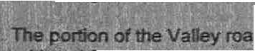
. :, • • i\ • .,.. l,.;.:-) '-' I • ;f ,,. •• •
,'.11. Th -PQ_ on,(?f e roa .b eJt=t9 consider, for abandonment. is the section between page comer, so called, and extending_ westerly to the former residence of J. W.ge _This roafbYJaS laid ut as-a:to way nd is approximately .6 mJles. length as show mor partjG_ulaf11ort.tgeJownTax M p #3 abutting Jots numbered 8 Uiru 13 andrq 5.a9uttinJi lots and-i. · ·· • ·.·•· . · ·· : f.> .:
in

Whereas the,foflowfng'roads In the Town of Jackson·ar so iocated w th refere·nce to,popufatio , use and travel ffiereon, that'it is unn•,cessary. keep...safd·r ads maintained and oJien for: travel during the ri\onthe'of
...f'(.o.vemher₁'December\ January Februar,, March and Apnl or any rf of

these mont• hs. ^{J} "' ..' · '"''•

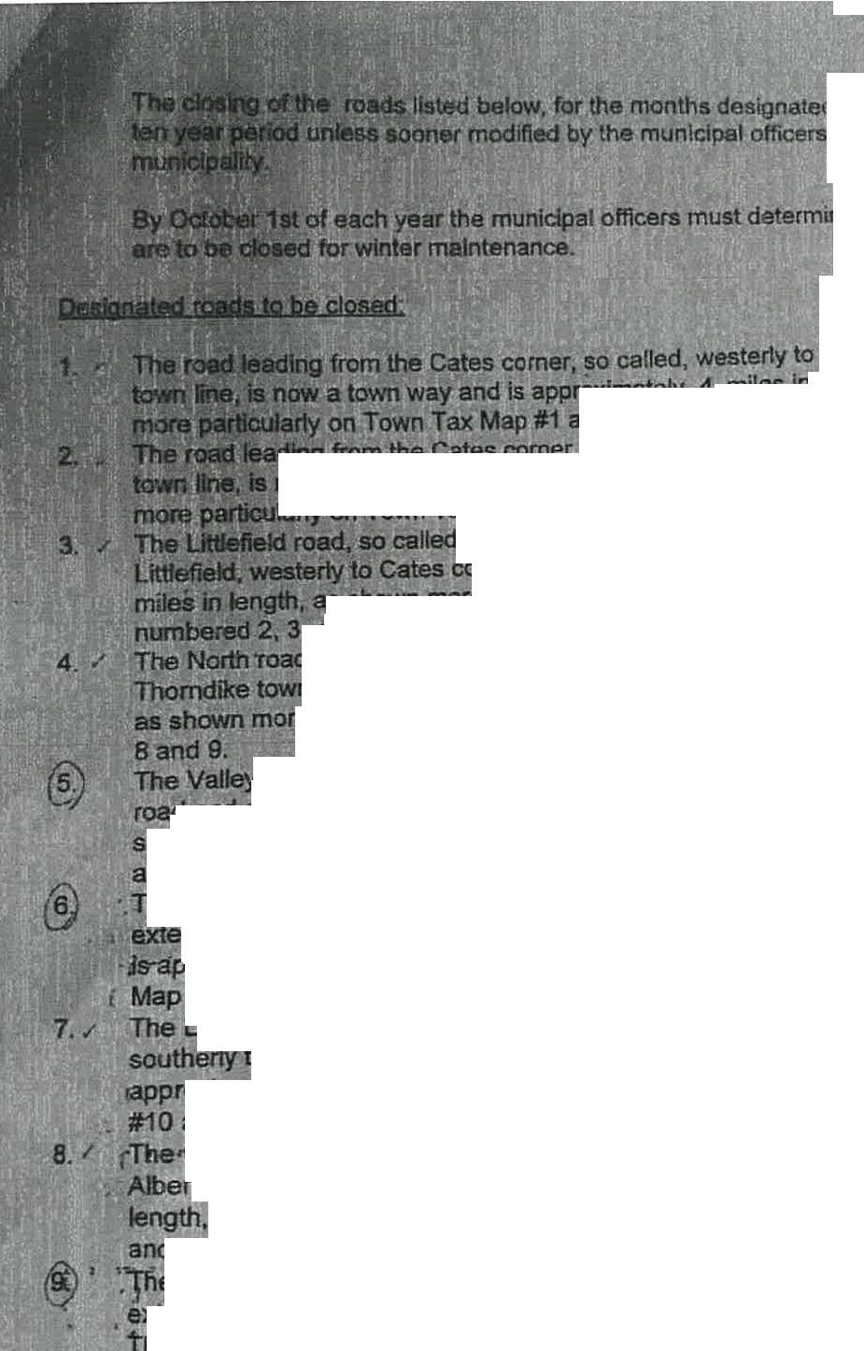
ated, would be for. a
f officers or the

rmine lf any roads

.

, y to tlie Thorndike
t1 Is mately .4 miles in length, as shown
1 abutting tots numbered 1, 5 and 6.
r- er, so called, southerly to the Brooks
1 Is ay and is apprmdmately .5 miles in length, as shown
· Tax Map #1 abutting tots numbered 1 and 2. ..
lied. leading from the former residence of E. 0. comer, is now a town way and is approximately .3
, as shown more particularly on Town Tax Map #1 abutting lots
, 3, and 4.. ··
oad, so balled, leading from Cates comer. so caUed, northerly to the

wn line, is now a town way and rs approximately 1 mire in lengtn,
o particularly on Town Tax Map #1 atfutting lots numbered 4. 5, 7,
ey road, so called, leading from the intersection of the East Thorndike
·ad and extending northerly approximately .3 miles, is now a town way• as shown more particularly on Town Tax Map #1 abutting lots numbered 4, 5, 7, 8 and 9.•
:r
J"he Long Swamp road, so called from the residencetof Ruth Schultz and •· '- ending northerly to the residence of John An.rte. Thls·road is now a town way.
·ppfoximate4 :2 :miles rn lert , as shown·more·particulany:on Town Tax
P #7,abutting•fotscnumbered 21, and 28 and fnapi#10 abuttitfg lot 1'8:r _·,:·;,::-. <,,
I , • f
Long Swamp road, so called, from the Dixmont town line e>ctending
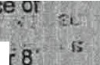
to,the residence of Donald Burns. This road is now a town way, is . _ roxrmately.,3 miles iri lengtht·as shown mbre Qarb°'cularly on Town Tax Map 1 abutting lot.st"Aumbered 12, 26 anp 27-: J • . · . !_ 'Y ; • • !
,Chase road, so called, from Route 7 extending easlerly to theresideh rtll:ldden ffl. This•foad·is now·a town way, is-appreximatel t.ftniles lro
  - as shown more pamcular1y on Town Tax Map #6 al:1'uttlng lot 'numoer 8· • ,;
nd map #9 abutting lots numbered 4 and 5. , , =- i:.r • • z. .!.
!!Cli"ase roaa.sp called. tqr:n the intersection of the--Hadley MiH road • .!
xtendiog wester1y to the residen s of Louise Shorette ana Michael Sm1 .
way..
1 his..road 'is:no a town_ is approximately .25 miles in l ngtn. as shown
rt. ,more. particularty..on T abuttin lo s numeered 101 d f
a
-
J
#9 • A" •
i••l:3W"..C 1:--:v::: =...::;. - t 17

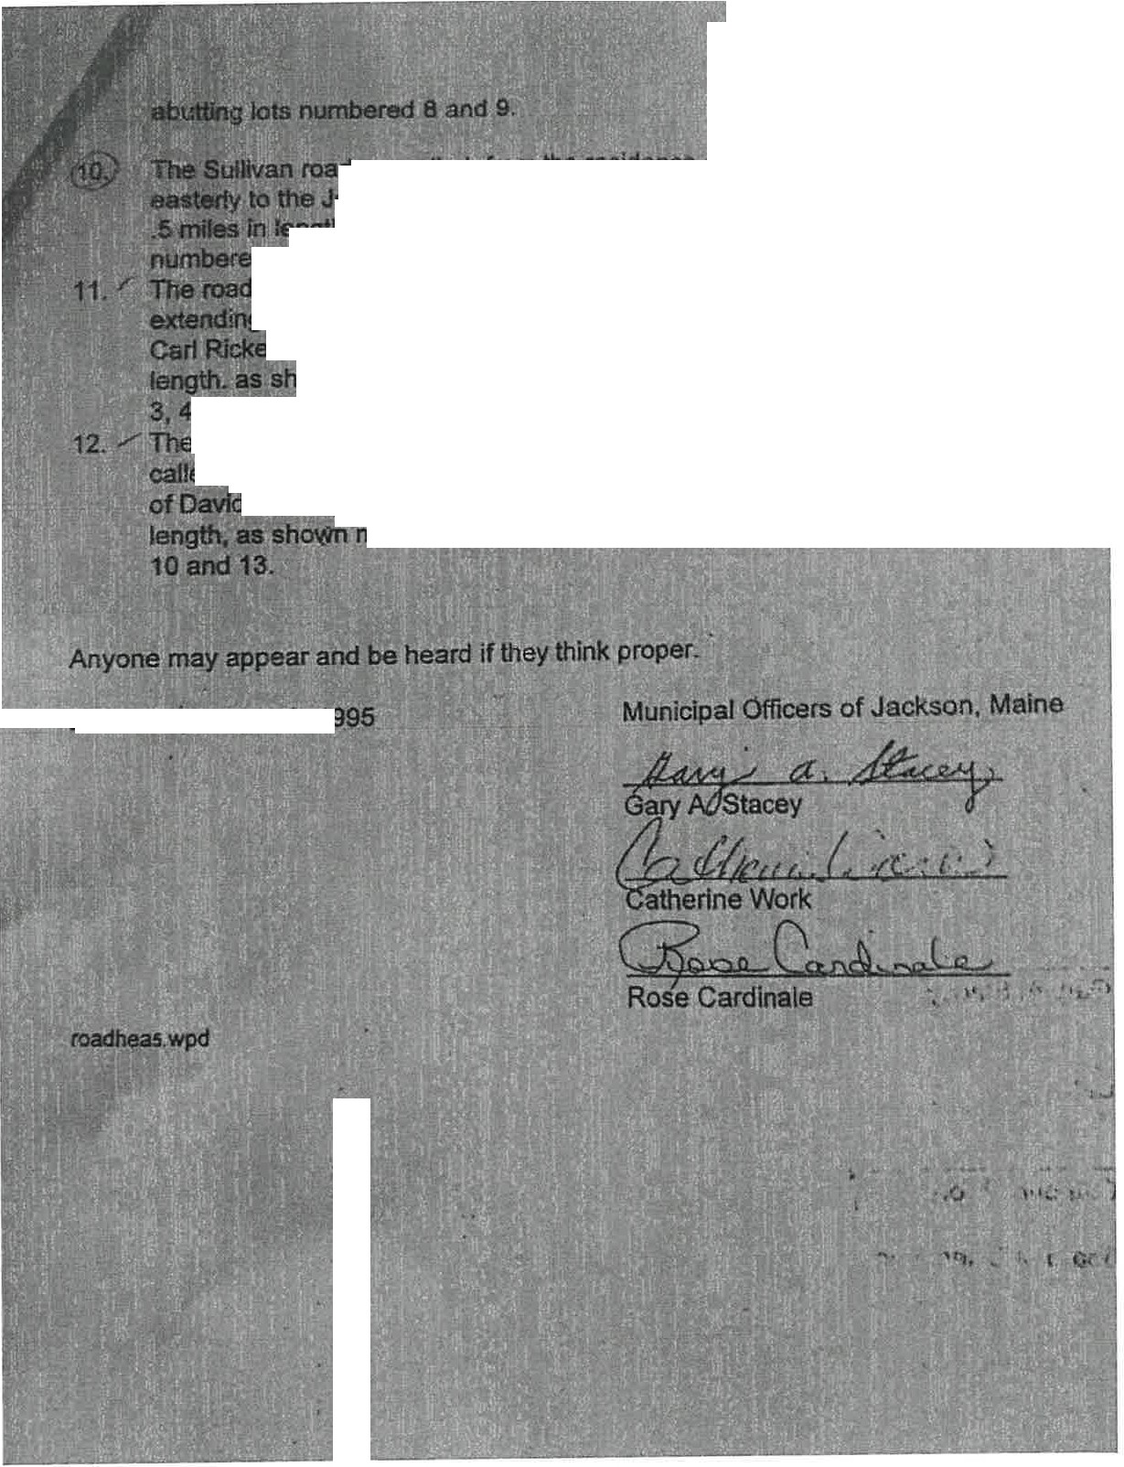
ad, ence of Archle Lahaye extending
Jerry u e. This roadis now a town woy, is .approx mately
- as sh re particularly oh Town T x M p #2. abutUng l()ts
1

!fed 18. 19, ana 3 thru 7i.
d f d1ng e formeri Snow school owned by Harvey Shue and
ndi weste residence of Elizabeth Snue, formerty known as the er Place dis now a town·way, is approximately .2 miles in

hown rticularfy, on Town ax MaP, # abutting lots numbered
4a . .

e Common Hill roa called, the interseotion of th.E! Hatch ,
ted. al$6 referred to as the.Do aa. extending northerly to the residence
d Gre y. Tnis s n n way, is approximately .4 miles in
" more a cular1 ow Tax Map #8 abutting lots numbered

0ated S tember 2.1995

..

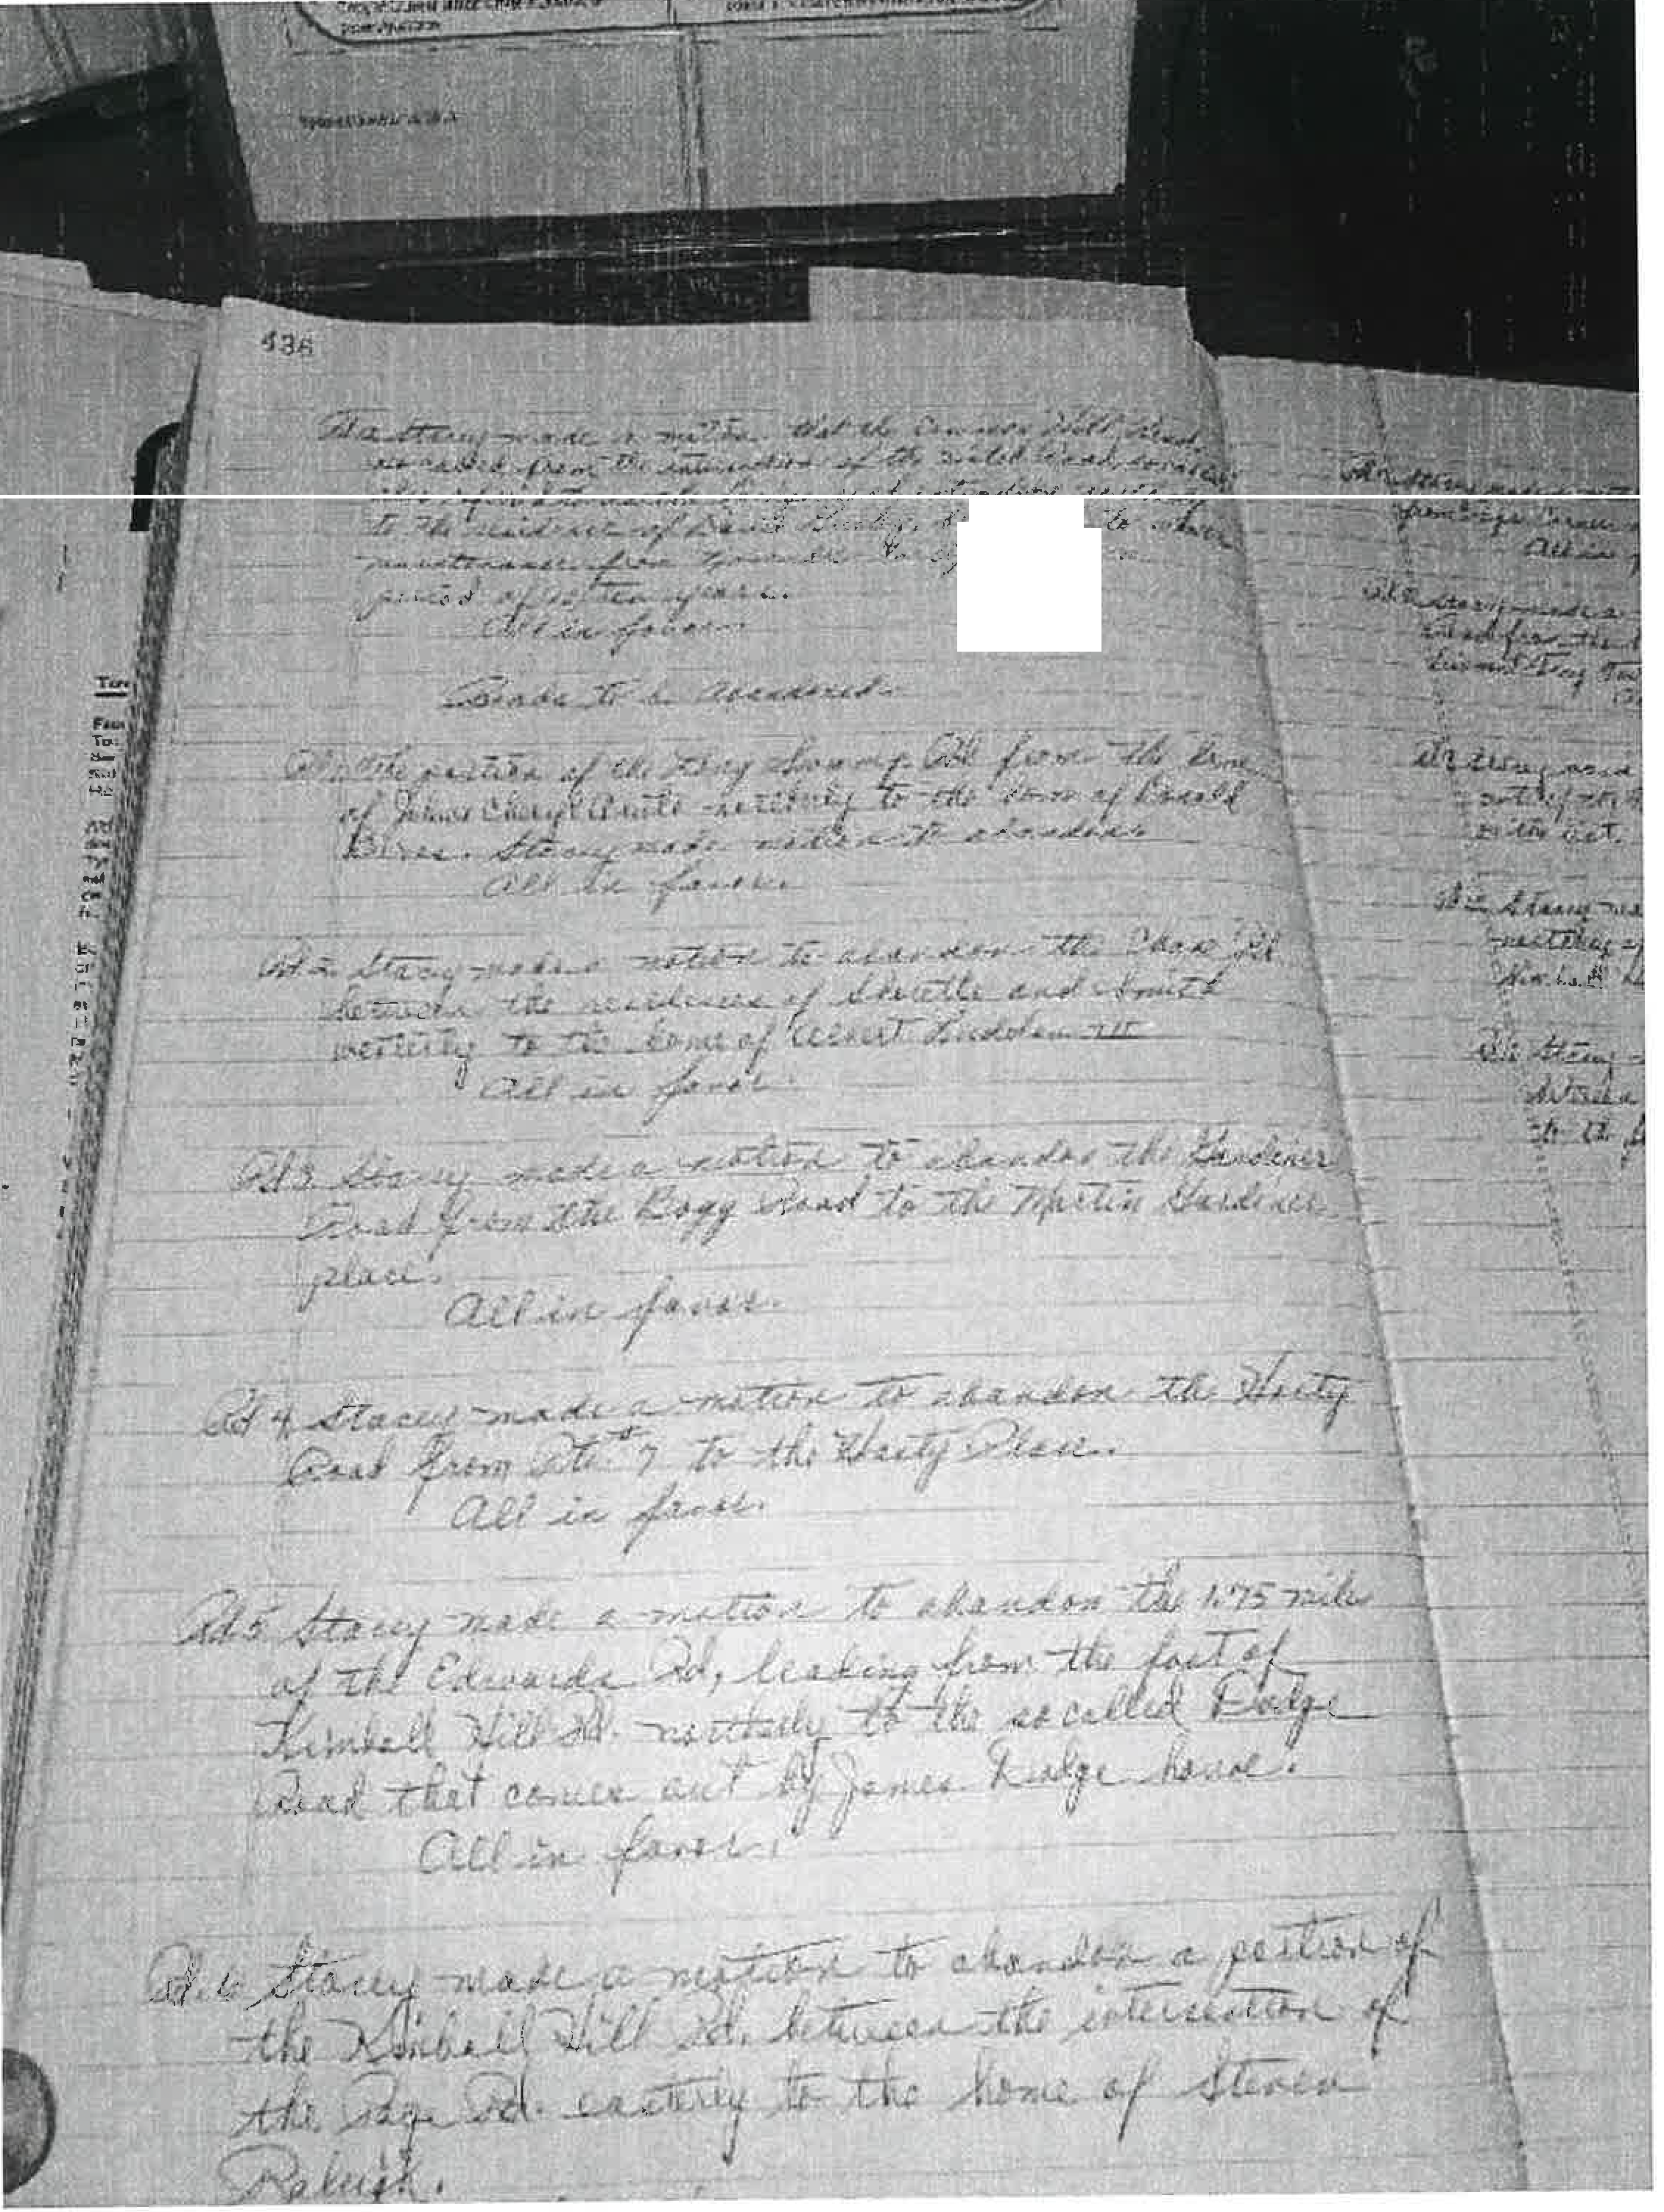

t ...... ,, ..... _,;t
.;1:: • ..-J:..•-.. - 1(
.,_._; .:..• -_;,.J 4

Mikhail, Vivian

From: Sent: To: Subject:
lldik6 Mizak <mizak.ildiko@gmail.com> Monday, December 12, 2022 12:07 PM info.abandonedroadscommission
Our road issue

EXTERNAL: This email originated from outside of the State of Maine Mail System. Do not click links or open attachments unless you recognize the sender and know the content is safe.
To Whom It May Concern, Hi,
Our names are lldiko Mizak and Timothy Johns and we purchased 105 Rover Rd. Dixfield Maine 04224 on 11/04/2021.
Our road issues started when neighbors started telling us we are not allowed to fix the road because it is a private road and each landowner owes the center of the road and our property is not part of the road even though we have the address and the previous owner used this road. Also we were told we are consider ourself lucky to use the road because they can block the road any time they pleased especially the neighbors below us because they have properties both side of the road. The road itself is in a terrible shape because no one is maintain it. We were told the previous owners maintained the road and it was not private until the neighbors below us moved in and somehow made it private.
Because the road is in terrible shape and knowing that they can block the way any time they pleased, we tried to find out more about our road situations but it was very difficult to collect knowledge about it because no one really knew the rules and laws of the abandoned roads. Not even the town.
We really did not have major problems using the road until mud season. My understanding about the mud sesion was it is not a set date, it usually starts when it is getting warmer and the ground is softer so when weather conditions change. Well we were told by the neighbors an exact date when the season is starting disregarding any weather conditions. We were also told that we have to park our vehicle at the bottom of the road and either walk up or use a fourwheeler.
Unfortunately we both have health issues so sometimes we had to use our vehicle to get up and down. Neighbors below us did not like that we disobeyed their demand so they put a one inch thick metal rope across the road on the steep hill tied to a tree. To release the cable you had to climb a 2 foot hill and unlock a lock. We found that dangerous and we voiced our concern to them but they did not care. Unfortunately one day when I tried to open this lock I slipped and fell off the hill and an ambulance had to get me to take me to the hospital. After they released me and on the way home we noticed they put the cable back like nothing happened. That moment we knew we needed legal help, fortunately our title company takes care of the attorney fees but if we wouldn't have them we would looking to spend up to $40.000 just to have a piece of paper saying we have the right to go to our home and no one allowed to put us in danger to do so.

Thank you for reading it Sincerely
lldiko Mizak and Timothy Johns

Mikhail, Vivian

From: Sent: To: Subject:
lldik6 Mizak <mizak.ildiko@gmail.com> Monday, December 12, 2022 12:55 PM info.abandonedroadscommission
Our road issues

EXTERNAL: This email originated from outside of the State of Maine Mail System. Do not click links or open attachments unless you recognize the sender and know the content is safe.

To Whom It May Concern,

Hi,
Our names are lldiko Mizak and Timothy Johns and we purchased 105 Rover Rd. Dixfield Maine 04224 on 11/04/2021.
Our road issues started when neighbors started telling us we are not allowed to fix the road because it is a private road and each landowner owes the center of the road and our property is not part of the road even though we have the address and the previous owner used this road. Also we were told we are consider ourself lucky to use the road because they can block the road any time they
pleased especially the neighbors below us because they have properties both side of the road. The road itself is in a terrible shape because no one is maintain it. We were told the previous owners maintained the road and it was not private until the neighbors below us moved in and somehow made it private. Because the road is in terrible shape and knowing that they can block the way any time they pleased, we tried to find out more about our road situations but it was very difficult to collect knowledge about it because no one really knew the rules and laws of the abandoned roads. Not even the town.
We really did not have major problems using the road until mud season. My understanding about the mud sesion was it is not a set date, it usually starts when it is getting warmer and the ground is softer so when weather conditions change. Well we were told by the neighbors an exact date when the season is starting disregarding any weather conditions. We were also told that we have to park our vehicle at the bottom of the road and either walk up or use a fourwheeler. Unfortunately we both have health issues so sometimes we had to use our vehicle to get up and down. Neighbors below us did not like that we disobeyed their demand so they put a one inch thick metal rope across the road on the steep hill tied to a tree. To release the cable you had to climb a 2 foot hill and unlock a lock. We found that dangerous and we voiced our concern to them but they did not care. Unfortunately one day when I tried to open this lock I slipped and fell off the hill and an ambulance had to get me to take me to the hospital. After they released me and on the way home we noticed they put the cable back like nothing happened. That moment we knew we needed legal help, fortunately our title company takes care of the attorney fees but if we wouldn't have them we would looking to spend up to $40.000 just to have a piece of paper saying we have the right to go to our home and no one allowed to put us in danger to do so.

Thank you for reading it Sincerely
lldiko Mizak and Timothy Johns

Mikhail, Vivian

From: Sent:
To: Subject:
Attachments:
Laura Geiger <lgeiger1@icloud.com> Monday, December 12, 2022 1:10 PM info.abandonedroadscommission Public hearing written comment
Dlscontinuance_Statement_Ludlow-Maine.docx

EXTERNAL: This email originated from outside of the State of Maine Mail System. Do not click links or open attachments unless you recognize the sender and know the content is safe.

I will be attending the Zoom call but my internet is not reliable so please see my comments below and attached.

Subject: Maintenance of Morrison Road, a .58-milediscontinued Town Way located in Ludlow, Maine by owner of a property accessible only by traveling over it.
1985: Morrison Road was voted to be discontinued as a town way by majority Selectmen vote. No notice of discontinuance was filed in the Registry of Deeds. The Town of Ludlow
continued to list the road for year-round maintenance at the DOT until 1992, when they issued a building permit for home construction, and changed its status to a seasonal road. In 1996,
the Ludlow Town Manager requested that Morrison Road be removed from the DOT list of roads and that it be labeled as a private road. This was done even though no language in the vote to discontinue indicated that the road should become private, so per Maine law at the time, if the discontinuance was valid, Morrison Road became a public easement, allowing unfettered access to the road by the public. In 2006 the Town issued a building permit for the construction of the second year-round residence at the end of Morrison Road (which we purchased in 2012). In 2020 the Town issued a building permit for the construction of a home for the 3.. year-round resident on the road. In 2020 a 100-acre tract of land abutting Morrison Road, was purchased and became a working organic farm. From 2020 -present a 2000-acre tract of land at the end of Morrison Road, was purchased and has undergone major improvements (new bridges, roadwork, home construction}.
Current Situation: Morrison Road provides access to 6 taxpayers; 3 year-round residents, 1 organic farm, 1100 acretract purchased with the intent to build another year round residence, and a 2000 acre tract of land providing year round access (resides in another state) to owner and a proposed 500 acre solar farm. We are at the end of Morrison Road and have maintained the road for approximately 10 years. The damage to the road over the past few years is
extensive (due to heavy farm equipment, the tree harvest, the new building activity, etc.} with culverts that are no longer working and near failure and several areas of erosion. The financial burden of fixing and continuing to maintain the road has become unmanageable.
July 13, 2022: We submitted our request to the Town of Ludlow to resume maintenance of the road, and presented our findings regarding the discontinuance, status of road being a public easement, and the lack of proper filing of paperwork to the registry of deeds. The Selectmen indicated their support and that they would investigate their options in providing support. During the next and following monthly Selectmen meetings, the board indicated that they had no

obligation to maintain the road per their Lawyer. The Town Manager has blocked access to us to public records - citing that we now have to submit a FOA request and schedule a time to view any town artifacts under her oversight.
October 2022: The Town Manager informed us recently that the owner of the 2,000 acre tract of land was planning on building out a 500 acre solar farm. When we requested that the road be weight limited, the Town refused. Because we are the last residents on the road, and the only permanent resident beyond the failing culverts, we will be expected to burden the cost of the repairs to maintain access to our home, unless something occurs to compel the town to assume responsibility.
Cost: Over the past 10 years we estimate that (aside from snow removal) we have spent approximately 10,000 on maintaining the road (most in the past few years). The yearly revenue the Town receives in property taxes for Morrison Road is approximately $25,000. Though we feel we have a good case for proving that the discontinuance of our road was not valid, the cost of legal representation required to manage the case is prohibitive.
Recommendation: The proposed language in LD 1513 that requires maintenance of a discontinued public road that provides the sole access to one or more residences, should be enacted.

Warm regards,
Laura Geiger, 703-350-2435
103 Morrison Road
Ludlow, ME 04730 Sent from my iPhone

Subject: Maintenance of Morrison Road, a .58-mile discontinued Town Way located in Ludlow, Maine by owner of a property accessible only by traveling over it.
1985: Morrison Road was voted to be discontinued as a town way by majority Selectmen vote. No notice of discontinuance was filed in the Registry of Deeds. The Town of Ludlow continued to list the road for year-round maintenance at the DOT until 1992, when they issued a building permit for home construction, and changed its status to a seasonal road. In 1996, the Ludlow Town Manager requested that Morrison Road be removed from the DOT list of roads and that it be labeled as a private road. This was done even though no language in the vote to discontinue indicated that the road should become private, so per Maine law at the time, if the discontinuance was valid, Morrison Road became a public easement, allowing unfettered access to the road by the public. In 2006 the Town issued a building permit for the construction of the second year-round residence at the end of Morrison Road (which we purchased in 2012). In 2020 the Town issued a building permit for the construction of a home for the 3rd year-round resident on the road. In 2020 a 100-acre tract of land abutting Morrison Road, was purchased and became a working organic farm. From 2020 -present a 2000-acre tract of land at the end of Morrison Road, was purchased and has undergone major improvements (new bridges, roadwork, home construction).
Current Situation: Morrison Road provides access to 6 taxpayers; 3 year-round residents, 1 organic farm, 1100 acre tract purchased with the intent to build another year round residence, and a 2000 acre tract of land providing year round access (resides in another state) to owner and a proposed 500 acre solar farm. We are at the end of Morrison Road and have maintained the road for approximately 10 years. The damage to the road over the past few years is extensive (due to heavy farm equipment, the tree harvest, the new building activity, etc.) with culverts that are no longer working and near failure and several areas of erosion. The financial burden of fixing and continuing to maintain the road has become unmanageable.
July 13, 2022: We submitted our request to the Town of Ludlow to resume maintenance of the road, and presented our findings regarding the discontinuance, status of road being a public easement, and the lack of proper filing of paperwork to the registry of deeds. The Selectmen indicated their support and that they would investigate their options in providing support. During the next and following monthly Selectmen meetings, the board indicated that they had no obligation to maintain the road per their Lawyer. The Town Manager has blocked access to us to public records- citing that we now have to submit a FOA request and schedule a time to view any town artifacts under her oversight.
October 2022: The Town Manager informed us recently that the owner of the 2,000 acre tract of land was planning on building out a 500 acre solar farm. When we requested that the road be weight limited, the Town refused. Because we are the last residents on the road, and the only permanent resident beyond the failing culverts, we will be expected to burden the cost of the repairs to maintain access to our home, unless something occurs to compel the town to assume responsibility.
Cost: Over the past 10 years we estimate that (aside from snow removal) we have spent approximately 10,000 on maintaining the road (most in the past few years). The yearly revenue the Town receives in property taxes for Morrison Road is approximately $25,000. Though we feel we have a good case for proving that the discontinuance of our road was not valid, the cost of legal representation required to manage the case is prohibitive.

Recommendation: The proposed language in lD 1513 that requires maintenance of a discontinued public road that provides the sole access to one or more residences, should be enacted.

Mikhail, Vivian

From: Sent: To: Subject:
Brent Parker <brent@1ike2hike.com> Monday, December 12, 2022 12:58 PM info.abandonedroadscommission
Commission on Abandoned and Discontinued Roads is Meeting

EXTERNAL: This email originated from outside of the State of Maine Mail System. Do not click links or open attachments unless you recognize the sender and know the content is safe.

<https://gcc02.safelinks.protection.outlook.com/7url=https%3A%2F%2Fdrive.google.com%2Ffile%2Fd%2Fle6tdOGQmU qF7qvqOZRJIESorEeFyyvBM%2Fview%3Fusp%3Ddrivesdk&data=0S%7C01%7Cinfo.abandonedroadscommission%40main e.gov%7C2c04be2be8a54517c30608dadc6a7ac8%7C413fa8ab207d4b629bcdeala8f2f864e%7C0%7C0%7C63806464774 3457495%7CUnknown%7CTWFpbGZsb3d8eyJWljoiMC4wljAwMDAiLCJQljoiV2IuMzliLCJBTil6IklhaWwiLCJXVCl6Mn0%3 D%7C2000%7C%7C%7C&sdata=lqXUS0vCPQYfumOAsYx7t8jl74rqhNKW0n3SmSeAG2o%3D&reserved=0>
<https://ssl.gstatic.com/ docs/doclist/images/mediatype/icon_3_pdf_x32.png> Commission on Abandoned and D...

Monday, December 12, 2022

The Maine Abandoned and Discontinued Roads Commission Cross Office Building 111 Sewall Street
Augusta ME 04333

To Whom It May Concern:

Our journey for road status clarification has been one of on again/off again to say the least. We live in Ripley and have property that abuts a discontinued road. What makes this situation somewhat unique is that the discontinued road actual begins in another town and different county (Dexter in Penobscot County; road status unknown).

Our journey currently is on again due to an abutter from the Dexter side (the property may also partially cross into Ripley) has decided to make a walking trail out of the discontinued Head of Pond Road and has gone so far as to post the trail to foot traffic only. I tried to get the town of Ripley to issue a Cease & Desist until clarification could be obtained in regards to road status and property lines but that did not happen.

The people from the town that I have communicated with are very helpful, some are even very sympathetic to the situation I have mentioned, but knowledge as to the actual road status or any legal descriptions is completely nonexistent.

I am hopeful that the creation of "An Act to Establish the Maine Abandoned and Discontinued Roads Commission" will be able to help property owners that have greater needs than my own. If what has been conveyed needs any clarifications I would be happy to discuss further.
Thank you for this opportunity.
Brent & Alison Parker
65 North Road
Ripley ME 04930
brent@like2hike.com <mailto:brent@like2hike.com>

<https://gcc02.safeIinks.protection.outlook.com/?url=https%3A%2 F%2Fdrive.google.com%2Ffile%2Fd%2Flcr7KCiMcMN
J­
wWbEN6IvR_SpGet4KLEo%2Fview%3Fusp%3Ddrivesdk&data=05%7C01%7Cinfo.abandonedroadscommission%40maine. gov%7C2c04be2be8a54517c30608dadc6a7ac8%7C413fa8ab207d4b629bcdeala8f2f864e%7C0%7C0%7C638064647743 457495%7CUnknown%7CTWFpbGZsb3d8eyJWljoiMC4wljAwMDAiLCJQljoiV2IuMzliLCJBTil6IklhaWwiLCJXVCI6Mn0%3D
%7C2000%7C%7C%7C&sdata=kraPJyDolfSXADkEZ4XyeOIHoSRW0WO6JFFPsZMXXyA%3D&reserved=0>
<https://ssl.gstatic.com/docs/doclist/images/mediatype/icon_l_image_x32.png>
IMG_E7914.png

Mikhail, Vivian

From: Sent: To: Subject:
bud grib <budgrib@hotmail.com>
Monday, December 12, 2022 2:43 PM info.abandonedroadscommission; info.abandonedroadscommission Testimony - Written Comments for December 14th 2022 meeting

EXTERNAL: This email originated from outside of the State of Maine Mail System. Do not click links or open attachments unless you recognize the sender and know the content is safe.

To:

The Maine Abandoned & Discontinued Road Commission

Attention: Deputy Attorney General Vivian Mikhail, Members of the Commission 6 State House Station, Augusta, Maine 04333-0006

Hi.

Thank you for the opportunity to submit comments/ testimony to your Commission.

I am going to do my best to try to attend the December 14th meeting in person, where I would like to read my comments or testimony in to the record,

but if something prevents me from being able to attend, I would request you please add comments or testimony in to the meeting record.

Thank You, Regards, Boris F. Grib 207-737-4826
If there is a best time to attend the meeting, to be able to read such, please advise

To the Maine Abandoned and Discontinued Roads Commission

Attn: Deputy Attorney General Vivian Mikhail

Greetings,

I'm Boris F. Grib & I live in Richmond.

Recently, the Town's misapplication of MRS 3028-A Abandonment of Town Ways exemplified the potential of abuse within untested, ambiguous legislation & terrible unfairness of placing the burden on the wronged, to have to seek legal redress after the fact, instead of mandating necessary due diligence & appropriate Judicial determination, beforehand.

My property's southern boundary abuts Knickerbocker Road & eastern abuts the MCRR tracks. In the 1920's to 1930's within historical events the "lower" section of the road was Abandoned. Numerous ensuing survey plats detail the 'Abandoned Section', including upon the plat submitted by the owner of an 1/8th acre parcel, which also abuts the abandoned section west of the tracks & regarding his 23 acres directly across from that, east of the tracks. He requested "the town hold a public hearing prior to voting on the status of the portion of Knickerbocker being considered for discontinuance by abandonment". The Town then arranged for a Road Discontinuance by Abandonment LD 596 23 MRS 3028-A Meeting.

At the meeting testimony was presented that the section of road had already been abandoned within Common Law, without having public easement, but the person requesting the hearing urged the SelectBoard vote to officially abandon it & to retain public easement to afford access over the abandoned section to his "1/8 acre" parcel.

Multiple property owners raised dire concerns of opening public access to where inappropriate, but the SelectBoard disregarded them & voted to "to abandon the Knickerbocker road with a public easement", later recorded as "to abandon the portion of Knickerbocker Road & maintain a public easement to allow the residents to access their property".

Before the vote a SelectBoard member stated "I'm not a real estate lawyer, so I can't answer the specificities about what deed says what, how far back we have to go for those deeds, that's not my job, my job is to look out for the best interests and the least adverse affect on people in our community".

That's what we're all facing here.

The SelectBoard's action denied my Civil rights & of other abutting property owners, regarding an abandoned section of road the Town no longer held legal interest in.

I've invested months seeking legal redress of this & the Town & it's Counsel's ensuing errors & I still am. The efforts involved seeking redress for their wrongful actions is unfathomable & that is neither fair nor just.

Thank You for your consideration,

Boris F. Grib

(207) 737-4826

(If I have time left, I will also read the following:)

I'm pleased to share additional detail if it might assist the Commission in it's Duties to consider the corresponding issues of public easement retention over abandoned or discontinued roads & involving the statutory process for the abandonment & discontinuation of roads.

References: Richmond Town SelectBoard's MRS-3028-A Meeting

June 27th, 2022: The Town's MRS 3028-A 1st Public Meeting was begun: https://townhallstreams.com/stream.php?location id=78&id=46247

July 11th, 2022: The Town's MRS 3028-A 2nd Public Meeting, where additional testimony was presented & the SelectBoard vote was taken: https://townhallstreams.com/stream.php?location id=78&id=46496

Mikhail, Vivian

From: Sent: To: Subject:
Alicia <aliciaplaisted@aol.com> Monday, December 12, 2022 4:02 PM info.abandonedroadscommission Written Testimony

EXTERNAL: This email originated from outside of the State of Maine Mail System. Do not click links or open attachments unless you recognize the sender and know the content is safe.

To Whom it May Concern,

More than 20 years ago I purchased land on Flinn Rd in Newburgh. Since that time, my section of Flinn Rd has been designated as Flinn Rd North.

I have already spent approximately $30,000.00 in repairs and maintenance of the road with a large amount more needed due to recent heavy rains. That figure is only in building and repairing the road. It does not account at all for plowing and sanding.

I must use this road to access my property. I have been told by the town office that Flinn Rd was discontinued to save the town money, but that it will forever remain a public right of way. It is actually the designated snowmobile trail and is used recreationally by four wheelers and dirt bikes as well.

When I first purchased, I was the only year round resident. There was one hunting camp above and one below my property. The folks below are out of state and only come for one week a year. I rarely saw the man from above, but he was from Maine and sold to an older couple that would be my new neighbors. I never asked any party to contribute to the repair and maintenance of the road.

After years and years of dumping money into the road, I finally had it in a good place, that was until the neighbors above decided to improve the road from my driveway up to their property. That created deep indents

from loaded heavy equipment. The 800 yards from Western Avenue to my driveway on Flinn Rd North is narrow and steep uphill
grade. Therefore, water runoff has gone straight down the road creating more washouts right after I had brought in 200 yards of gravel, which was only one of the instances of repair and maintenance. In my time here, I have never asked anyone to contribute to the road maintenance but I have been pressured for years by the very neighbors who damaged the road to repair and maintain the 800 yards I had before they moved· there.

The situation has created so much stress that I now question whether I should cut my losses and try to sell. Admittedly, I was younger and perhaps naive when I purchased my property, not realizing the massive financial and emotional burden that maintaining this road would bring, nor did I anticipate disputes with neighbors. The history is too long and complicated to retell. It is very difficult to literally pour your blood, sweat, tears and money into your property and then be faced with needing to sell merely to survive.

Alicia Plaisted
328 Flinn Rd North Newburgh, ME 04444
207-944-3473

Sent from the all new AOL app for iOS

Mikhail, Vivian

From: Sent:
To:
Cc:
Subject: Attachments:
David McDaniel <damlame@yahoo.com> Monday, December 12, 2022 4:14 PM info.abandonedroadscommission
David McDaniel; Heather Selin Written Comment for Public Hearing
Abandoned and Discontinued Road Commission.docx

EXTERNAL: This email originated from outside of the State of Maine Mail System. Do not click links or open attachments unless you recognize the sender and know the content is safe.

Dear Deputy Attorney General Vivian Mikhail,

Please accept the attached written comments for your hearing on December 14, 2022. Thank you.
David McDaniel

David McDaniel and Heather Selin Earth Dharma Farm
USDA- Organic
78 East Chase Rd Jackson, ME 04921

207-722-3386 home/farm
207-323-4315 cell

Abandoned and Discontinued Road Commission Attn: Deputy Attorney General Vivian Mikhail
6 State House Station Augusta, ME 04333-0006
December 12, 2022

Dear Commissioners,

My wife and I live at 78 East Chase Rd in Jackson, Maine. We bought our property in 2007 and have built our home and farm at this address and operate a commercial MOFGA certified vegetable and vineyard operation.

East Chase Rd is one mile long. It can be divided into three distinct sections: 1) ¼ mile of dirt road to west (West Chase Rd) that receives summer maintenance from the town (no winter maintenance); 2) a central½ section that was abandoned by the town in 1995 using an odd hybrid of discontinuance and abandonment law, 3) an eastern ¼ mile section ( East Chase Rd) that is a four-rod dirt, fully maintained, town road. Chase Road is a historic town road appearing on our 1859 town map. It serves as an inconsequential throughway between State Route 9 to the west and Hadley Mill Rd to the east. The road is very rough to the west, and more passable to the east. Daily historic traffic is 1-3 vehicles per day during the week, increasing to a half dozen vehicles per day on the weekend.

Chase Rd also serves as a major utility access for a buried underground telephone line for Consolidated Communication.

Our home and farm are located on the central abandoned section of Chase Rd. We receive commercial USPS, UPS, Fedex and freight truck deliveries to our farm entering from east Chase Rd. We are responsible for all winter snow clearing and maintenance to keep our abandoned section of Chase Rd open via East Chase Rd to Hadley Mill Rd. Our last significant maintenance to Chase Rd was $2200 for gravel and grading improvements in September of 2022.

In 2022 the Selectmen for the Town of Jackson opened the entire Chase Rd to ATV access. The local ATV clubs have a goal to use Chase Rd as a major throughway connector between ATV trails to the west, north and east of our town. This ATV connector trail via Chase Rd is currently on hold pending the creation of a connecting ATV trail in the abutting town of Dixmont.

My wife and I have historically had no issues with our responsibilities maintaining our small section of East Chase Rd. However, the recent ATV changes, and potential for high out of town recreational ATV usage have us very concerned about our ability to maintain our road adequately for commercial farm usage, life safety access, and the unknown liability issues for recreational access.

We would ask the Commission to consider these common sense solutions to our concerns and for similar issues affecting other property owners on abandoned roads:

- The new Maine law Title 23 MRSA 3028 is an excellent step going forward and clearly states that if a town abandons a road and keeps the right of way that only foot traffic or motor vehicles may only access the road.
- Maine needs to fold previously abandoned and discontinued roads into this same law so the basic standard is that all abandoned roads start with basic protection for foot and motor vehicle access.
- Conditions should be placed on usages that can significantly degrade common passage by foot or motor vehicle.
- If a town opens previously abandoned or discontinued roads to recreational or other high impact uses, the town or the local ATV clubs should be responsible for maintaining the roads for the use of safe motor vehicle traffic.
- All abandoned dirt roads should be held to the same road postings as town maintained roads to prevent damage during mud season.
- Unusual heavy commercial use of abandoned dirt roads, i.e. heavy construction equipment or logging operations, should be regulated so that the roads are always accessible for life safety access. Weight limits need to be placed during mud season.
- Property owners that maintain abandoned roads for common usage should be allowed to deduct legitimate and reasonable maintenance expenses from their property taxes or state taxes.
- Maine law should provide a hold-harmless provision for property owners who get approval from their town or local road commissioners to perform routine maintenance on abandoned roads.

A final request is that the Commission creates a comprehensive mailing and e-mail list of property owners abutting abandoned or discontinued roads and use the mailing list to notify abutters of public hearings and comment periods. It was only through word of mouth that we learned of the hearing this week and unfortunately will be unable to attend on short notice.

We thank the Commission for the important work they are doing to assure that resources held in common are fairly and reasonably regulated and protected for the use of all Maine residents.

Sincerely,

David McDaniel 78 East Chase Rd
Jackson, ME 04921
207-722-3386

damlame@yahoo.com

Mikhail, Vivian

From: Sent: To: Subject:
wendy aronsson <w.aronsson@hotmail.com> Monday, December 12, 2022 4:49 PM info.abandonedroadscommission
Road trouble in Sebago

EXTERNAL: This email originated from outside of the State of Maine Mail System. Do not click links or open attachments unless you recognize the sender and know the content is safe.

To Whom it May Concern,

My name is Wendy Aronsson. My partner, Adam Nappi and I purchased a large lot off of Kimball Corner Rd, in Sebago in April of 2021. During the time of purchase we were under the assumption that we owned the¾ mile long road as it goes solely to our property. After having the property surveyed we were told that it was a discontinued town rd. Shortly thereafter, we were told it was actually abandoned and after months of digging into town records we discovered the motion to discontinue in 1991 had been denied, leaving it a town road.
Since the discovery one year ago, we have tried to work with the town, but they have stated that they have zero intention to discontinue but will allow us to make (extensive/expensive) repairs with our personal funds.

We purchased this property to build a business and the road issues have been a major block in any possible advancements. We have been in a continual loop with our two attorneys, the town attorney, the CEO of Sebago, surveyor, site planner, fire chief and road commissioner. We are exhausted and seemingly no closer to a solution today than we were a year ago. The laws very clearly states that personal funds cannot be used to repair or maintain town ways, and yet the laws also make it extremely difficult to push the town to take action and make the needed repairs. Our road is not safe. It is not convenient. No more than a 4 wheeler can make it up that road and these issues are single handedly preventing us from constructing our business. The process has been beyond costly and unequivocally maddening.

Our situation is unique in the fact that the road was never discontinued. Finding that information was wildly difficult even for the town officials and fixing the problem is anything but simple. The laws surrounding road status are unclear, heavily nuanced and in deep need of restructure.

Thank you for listening to our personal challenge. Wendy Aronsson

Mikhail, Vivian

From: Sent: To: Subject:
gretchen briggs <1Ogretchen@gmail.com> Monday, December 12, 2022 6:36 PM info.abandonedroadscommission
Fwd: My discontinued road in Hollis Maine

EXTERNAL: This email originated from outside of the State of Maine Mail System. Do not click links or open attachments unless you recognize the sender and know the content is safe.

---------- Forwarded message ---------
From: gretchen briggs <10gretchen@gmail.com> Date: Mon, Dec 12, 2022, 4:09 PM
Subject: My discontinued road in Hollis Maine
To: <info.abandonedroadcommission@maine.gov>

The crisis that i am currently experiencing has many angles leading to frustrations. About 24 Years ago we purchased a 13 acre unsurveyed piece of land in Hollis Maine. The road that I am referring to is on Bean St in Hollis Maine and the discontinued portion of Bean St juts off from a corner that intersects with a road called mailman way and Bean St itself. When we purchased the property it had a locked metal gate that kept cars from coming down and dumping trash and the kids from accessing the discontinued road to party. The town removed the gate once we started building and their requirement was that we upgrade the discontinued portion that would provide access to the property in order to build a home there. We spent $11,000 24 years ago to add gravel and excavate to have access with a verbal agreement that the town would not maintain the discontinued portion of Bean St. More than half of that was the discontinued town road. We had stolen cars driven down it and left behind, roofing shingles dumped, a dead dogs skinned body left(we called the State police for that as it was super disturbing) concrete blocks dumped, leaves, tires and trash, you name it. The town agreed to place a private road sign up and that was super helpful, until a new Town selectman with a bad attitude came and tore it down and yelled at us for putting it up, even though the town put it up, he did not care. People walk it, horses ride through and 4 wheelers come through as well. Most people have been very courteous with the exception of 2 people. one a neighboring home who decided it would be nice to blast us on social media regarding the fact that when we plow it ourselves, the snowbankings are not in the spot she would like and she accused us of strategically placing the
snowbanks in her way from walking.When i offered a solution of coming to the town with me to try and get them to plow it she wanted no part of that, she just liked the complaining part.please keep in mind we are the only home down here and have always been responsible for the maintenance ourselves. Our town road commissioner also happens to own the business that wins the Towns snow plowing contract every year.Can you say conflict of interest? Several years ago a small parcel was sold beyond us with the only access being through the discontinued road that we are on. Once that lot sold, the selling realtor made it a personal mission to have the town on her beckon call for every tree that falls past our driveway. she parks her car here to walk down it at least once a week and any tree that falls she will call the town have them come pick it up and blames us, even though we have no part of it. My concern is the fact that the town is playing hopscotch with this road now beyond us. they let us take care of everything to our house and they take care everything past that with, the exception of snowplowing. Two weeks ago someone thought it would be cool to dump 5 truckloads of leaves on our maintained part of the driveway and this summer during broad daylight dumped a truck and trailer load of wood and tree stumps again, on our part of the driveway. The realtor is not even a taxpayer in my town yet has the town at her beckon call for a lot that she sold years ago and i feel that she enjoys harrassing us. My point here is either the town should take care of the whole thing including plowing or not at all. How can they pick and choose and what can i do about it legally? The selective maintenance is very concerning and i pay a lot in taxes to them. If they are making us plow it and people are walking through are we liable if they get injured and if so, shouldnt they be closing it to others? Thank you for letting me share my concern and I will be reaching out to the road commissioner tomorrow

to look into this further and can let you know how it go's. Wish me luck, because I'll need it and Thank You For your time,
Sincerely

Gretchen Briggs
238 Bean St
Hollis Me 04042

Mikhail, Vivian

From: Sent:
To: Subject:
Attachments:
roadways@juno.com
Monday, December 12, 2022 11:09 PM info.abandonedroadscommission Testimony for Commission
Testimony David.pdf; 883949_928765600535286_8398174600750317343_oJpg

EXTERNAL: This email originated from outside of the State of Maine Mail System. Do not click links or open attachments unless you recognize the sender and know the content is safe.

Attached is testimony of David Manter, 51 year resident on a discontinued road. The picture is what this road often looked like during mud season. The picture was taken in the early 1980's after yet another logging operation had used the road over the winter.
Thank you, David Manter

Fellow Citizens of the State of Maine,
My name is David Manter and I exist in Fayette.
FIFTY-ONE YEARS, beginning Sept 20, 1971. Think about it. What have you done for the last 51 years? I have spent it maintaining a public road, without pay, and with no reimbursement for the materials or equipment.
In 1986, when the Town sued me to prove the road abandoned under 23 MRS 3028, I was told by a judge that, "The information was available to Mr. Manter at the time he purchased his property which, if understood or pursued, might have influenced his decision to purchase or develop the Young Road property." Well, what COULD I have known?
- My deed said the road was discontinued.
- My predecessor's deed said the road was discontinued, and it was signed by the Selectmen of the town.
In 1945, the Town asked the County Commissioners to discontinue several roads because they were "no longer used and are not kept open any part of the year. The Town of Fayette desires to retain the right of way as it now exists." (The right of way that then existed was a County way. Were they asking to keep what already existed? Or were they saying the Town would take over ownership and what had been the county's responsibility?)
The Commissioners granted that the road be "closed, to be retained as a private way subject to gates and bars."
In 1945 the powers of the County Commissioners did not include "closing" roads, and their only power to create a private way was in response to an appeal from an owner of improved land not yet connected to the public road system, which the road would so connect; but the Commissioners only had that authority if the petitioner had already asked the Town to lay out the way, and the town had refused, and the town's refusal had been unreasonable. If any one of those factors was lacking, the Commissioners had no jurisdiction to lay out a private way. When a private way was laid out, the person who requested it was responsible for maintenance of the road; however, since the road created would invariably be a dead end, use by the public would pretty much be limited to those coming to do business with the person who requested the road. If the road was not opened and built within two years, it was automatically discontinued.
- I could have known that according to Burnham, Mae v. Burnham, Ralph 132 Me 113 (1933), when a road was discontinued prior to 1965, the road ceased to exist as a public way; rights of owner of land were revived, discharged of the public easement. (It was not until 1976 that 23 MRS 3021 was amended to say that private ways are public easements.)
I could have known that the 1946 Town report said that the road was "legally closed, but with the provision that the Town of Fayette continues to hold the right of way so that if in the years to come these roads should be reopened we will not have to purchase the property."
- In theory, I could have known that in May of 1970, over a year before I purchased my property, the Maine Supreme Court declared that a law that would create a public road with no public maintenance was unconstitutional. In Jordan v Canton, the Court stated that, "...it is actual and practical discontinuance rather than technical discontinuance that destroys the easement. The fact that a [way] continues to have a legal status as a "public

way" over which there continues to be a public easement of travel is meaningless if there is no longer any public responsibility for maintenance and repair. Without maintenance or repair, it is only a question of time before a public road will become impassable or unsafe for travel. The rigors of Maine weather, the action of frost and the erosion from rain and melting snow will speed the process of disintegration. The ability to use the road for vehicular travel and thus the abutter's easement *100 of access to and over the road to the public road system will inevitably be destroyed."
"In judging whether a statute satisfies constitutional requirements, we look to the possible and not merely the probable consequences which may flow therefrom. 'It is not what has been done, or ordinarily would be done, under a statute, but what might be done under it, that determines whether it infringes upon the constitutional right of the citizen. The constitution guards against the chances of infringement. It is evident that under this statute the citizen might in some cases be practically deprived of all remedy.' Bennett v. Davis (1897) 90 Me. 102, 105, 37 A. 864, 865; Sleeper, Applt. (1952) 147 Me. 302,308,
87 A.2d 115. Under Sec. 2068 an abutter could be deprived of his sole access to the road system with no statutory method provided for obtaining compensation." So when I purchased my property, I could have known that it had been declared Unconstitutional to have a public road with no public maintenance, with no just compensation for the loss of access that would be the inevitable result.
I could NOT have known in 1971 that in 1976, a law would be passed (section 3028) that would say if a town had not maintained a road for 30 years, it could declare it to be a public easement by virtue of abandonment.
- I could not have known in 1971 that in 1976, 23 MRS 3021 would be amended to say that private ways created by statute prior to July 29, 1976 were public easements, or that in so doing, they would change not only the terminology but also the definition of a private way. (If I had, I should have been able to know that section 3021 would not apply to Young Road because it was already a public way and didn't need to connect land to a public way, and because the private way was not created pursuant to sections 3001 and 3004, but by the County Commissioners, who had no such power to act.)
- In 1971, I could not have known that in 1984 the Town would use section 3028 to claim the road abandoned. But by January 19, 1984, I could have known that the Maine Supreme Court had declared in Brown v Warchalowski that, "To avoid a constitutional violation, the establishment of any road or way, whether a state, county, town or private way, must be for a public use and its requirement must be in response to public exigencies." Therefore, section 3028 should be Unconstitutional because it creates a public easement (formerly known as a "private way") where it has just been proven that the public has not needed the road for 30 years.
- In 1971, I could not have known how popular ATV's would become, or the damage they would do
I could not have known that as soon as I made the road passable, the owners of the abutting wood lots would see their chance to finally harvest their wood, and that there would be another harvesting operation using the road every couple of years until the wood was gone.
- I could not have known that once I made the road passable, the Town would grant building permits for four other houses on the part of the road I had rebuilt, and that the

residents who moved in would expect me to continue to keep the road passable for their use, including their contractors, deliveries of building supplies, concrete trucks, well drillers, fuel and other delivery trucks, trash pickup, etc.
I could not have known that the town would benefit from greatly increased tax revenues on those lots which had gone from wood lots to residential properties thanks to my having rebuilt the road, but that the Town would refuse to return any of the tax revenue to the road that generated it, and that the town would refuse to resume any maintenance of the road. What did they mean when they said in the 1946 Town Report, "if in the years to come these roads should be re-opened we will not have to purchase the property"? Did they mean the town could resume maintenance if the road was needed in the future, or did they anticipate that someone else might re-open the road and they had no intention of paying for it?
I could not have known that there would be people all over the state who would struggle with the same issues, but the towns would convince the legislature that 23 MRS 3028 was "working well" and should not be repealed. Yes, it works well for the towns, which get to use these roads without spending a cent towards their maintenance, while mining tax revenue from the residents which can then be used elsewhere in town.
In Jordan v Canton, the Court stated, "The statute is designed to permit a governmental entity to avoid the expense of maintaining and keeping certain designated roads open for travel and free from dangerous defects. Its responsibility for accident caused by such defects in a road so designated is removed. All this is accomplished without technical discontinuance of the public way and without terminating the public easement therein. No provision is made for compensation to abutting owners for the destruction of property rights." The Court found that Unconstitutional. This is exactly the situation with abandoned and discontinued roads that remain public easements. Towns have an obligation under 23 MRS 3651 to keep their roads "opened and kept in repair so as to be safe and convenient for travelers with motor vehicles." Public easements allow towns to evade this responsibility while preserving public rights to use the road.

When I was in the service, stationed stateside during Vietnam, I was tasked with burying 57 of my fellow soldiers. They and I swore to uphold the Constitution of the United States. How many of you have taken a similar oath? Our Declaration of Independence said the King "has erected a multitude of New Offices, and sent hither swarms of Officers to harass our people, and eat out their substance." My substance has been eaten out by the oppressing government because of the road.

When I purchased my property, my deed said the road was discontinued. I assumed that meant I would have to maintain it myself, for my own use, and that was fine with me. I didn't know at the time that I was suffering from PTSD. I also didn't know that my doctor's prediction that I had six months to live would be revised after they identified the allergy that was triggering my unending pneumonia. I only knew that I wanted a place where I could get away and die in peace. But I found I couldn't get away from government inconsistency.

For the past 51 years, I have been forced into involuntary servitude, maintaining a public road for public use, with no pay. Money I could have put into improving my property has gone into the road, or into equipment to plow and maintain the road. Not counting the cost of that equipment

or its maintenance, we estimate it has cost us about $2,000 per year to maintain the road, so after 51 years we now have more invested in the road than our property is worth.

It has been impractical to hold a year round full time job because on snow days I have to be home to plow the road, and in mud season I can lose access completely for six weeks or so because I cannot keep up with the damage other members of the public do to the road. (This includes other residents on the road and their need for deliveries, people following their GPS, 4wd mud runners, ATVers, and loggers who think that a crust of frost on top of a foot of mud means the road is frozen.) We had finally gotten the road to where it was passable year round for us when more neighbors moved in, and their use of the road was more than I could keep up with. I am now 73 years old, the road is deteriorating, and my body is objecting to the abuse.

In Maine, statutorily, town road maintenance is an all or nothing proposition. If a town cannot afford to keep up with the rising cost of keeping all its roads to full town road standards designated by the state, its only other option is to cease maintenance entirely. Every person in town deserves equal protection of the law, but what can one voter do when the rest of the town wants to keep their taxes from going up? This needs to change.

My wife and I have tried for years to get legislation to mitigate the issues with these roads. One of the best solutions we have found is the concept of "minimum maintenance" roads. This would allow towns to keep little used roads to a lesser standard, such as keeping them just "passable" for residential use. We have been told that towns can't do that because the law doesn't allow it. So let's change the law so they can do it. We have been told that it would be an unfunded mandate to require towns to maintain these roads. (Is it an unfunded mandate to require towns to keep town ways safe and convenient under section 3651?) Yet no one considers that it's an unfunded mandate to force the residents to maintain these roads for the public's use as well as for their own use. All we asked was that if a town wants to retain public rights to use a road, that they contribute enough maintenance to support that public use. States that already allow minimum maintenance roads do not allow a road to be reduced to that standard if anyone still lives on it. Yet in Maine, we allow ALL public maintenance to cease. Most of the residents on these roads would probably be thrilled to get annual grading and a load or two of gravel in the worst spot each year.

Why can't some of the tax revenue from properties on these roads be put back into the road that generated those tax dollars? We have been told that taxes are not tied to services. But if everyone stopped paying their taxes, there would be no services, so there is a relationship between the two. It's Unconstitutional to tax properties on these roads, as many towns do at the same rate as properties on town ways, and then give them virtually nothing in return.
If a town doesn't think the public need for the road is sufficient to justify public maintenance, then why does the town insist on keeping public rights to the road? Most of the residents on these roads would not complain if they only had to maintain the road for their own use. But where the public still has full use of the road, even forming a road association does not place the burden where it belongs. In fact, it's unconstitutional to require division of the burden of maintenance for public use among the private landowners when on a public right of way.

Since this was too short notice to get all my thoughts organized, here are some ramblings out of my frustration. I hope you will understand that after 51 years of frustration, I need to vent.

Put L.D. 1513 through as originally presented, or use NY's Minimum Maintenance bill.

If a town cannot afford to keep its roads passable for its residents, it should de-organize.
If public easements are such a great solution, let's make ALL municipal roads into public easements, and see how well that works. Think of all the tax money we'd save! And yet the roads would still remain open for public use, right? Like how are you going to get to work this Friday in the snow storm on your public easement?

The town required me to have a mailing address on this road, but if I don't keep the road passable, the mail service won't deliver. If they don't deliver, I won't get my tax bill.
Taxing a property on a public road and not providing a way to get to it is unconstitutional. I've been paying taxes for all these years, and if I stop paying, you will take my property and sell it to some other sucker. We've been told ifwe don't like it we can just move. That would mean selling our property at a loss, or lying to the person who wants to buy it, and we will not do that. If it were my own private road, it would be my property and I could keep others off of it. Then maintaining it would not be such a problem.

The Court is supposed to be a permanent entity, without a five year memory that doesn't keep track of its own precedents. Why can't they remember that they said public roads with no public maintenance are unconstitutional, or that they said you cannot have a public easement where it's been shown there is no public need? And yet they said 3028 was Constitutional. If you look at the decision in Lamb v New Sharon, the Court said the public lost its rights in the road. Would their decision have been different if they had realized 3028 kept the public rights in the road, just as the unconstitutional limited user highway did? How is the physical result of abandonment any different from the result of the limited user highway? The Court in Lamb assumed no due process was necessary because nothing had changed in 30 years. But something DID change - the road became known as a public easement. Jordan was not so much about due process as it was about just compensation, and the Court recognized that continued public use of the road after public maintenance ceased would damage property access, requiring just compensation.
Who is advising towns that they can do these things? Don't they know it's unconstitutional?

I was arrested for "obstructing a public way" for posting the road as private property, and then the court decided not to charge me with what I was arrested for but for contempt of court. (Contempt is supposed to be for what I did in the court, not for what I did outside the court.) I was never found guilty of the crime I had supposedly committed. I spent 8 days in jail for political reasons, not because I had violated the law. I may act respectfully when I am in court, but don't ask me to respect the court.

If a government agency uses a word that isn't in the statutes to do a job that is described by a particular word in the statute, then that action should be void because no one should be expected to understand the ignorance of 1,362,359 people of the state. If we have to rely on 1.3 million different opinions of what's going on in this state then why do we need statutes? Or do we need

statutes so that 3.1 million people can understand what each other is supposed to do? As the court told me, if I'd looked into the information that was available to me, it might have affected my decision to buy the property. But how can I understand what they meant when they didn't follow the rules? And when the town got what the County Commissioners gave it, they told the townspeople what they thought they wanted to get. After which they used the statutory term on the deed when they sold the property, which meant something totally different from what the Commissioners' Order said, or what the Town thought they got.

When I offer you sane legislation to straighten this out you can't do it because it might be an unfunded mandate. Don't blame me for not understanding you when you don't follow the rules. The legislature has knowingly screwed me for years. When Will Tuell finally understood what's going on, he got this Commission going. If the State can make a law that's kept me as a slave for all these years, the state can come fix the road from one end to the other. End my driveway at my north property line and everyone else has to come in from the north.

Municipal home rule gives municipalities only 2 things they can do completely on their own: 1) choose their form of govt, and 2) support a business venture in their town. All other things are regulated by the state. Roads, schools, tax rate - so towns don't have freedom with those things. Home rule does not mean they can ignore the statutes and make up their own rules - yet many towns seem to do this when discontinuing roads.

Discrimination and equal protection of the law - how can they take care of public roads for some people and not for others?

Somehow, the legislature knew that something was wrong with the limited user highway because they repealed it. And yet all the attorneys who are involved with the legislature were not capable of not repeating it in 3028. I blame this on the legislature, those who advise them and the revisors office for changing perfectly well worded legislation into legal gobbledygook.

My deepest sympathies for your having to put up with me and this issue! David L. Manter

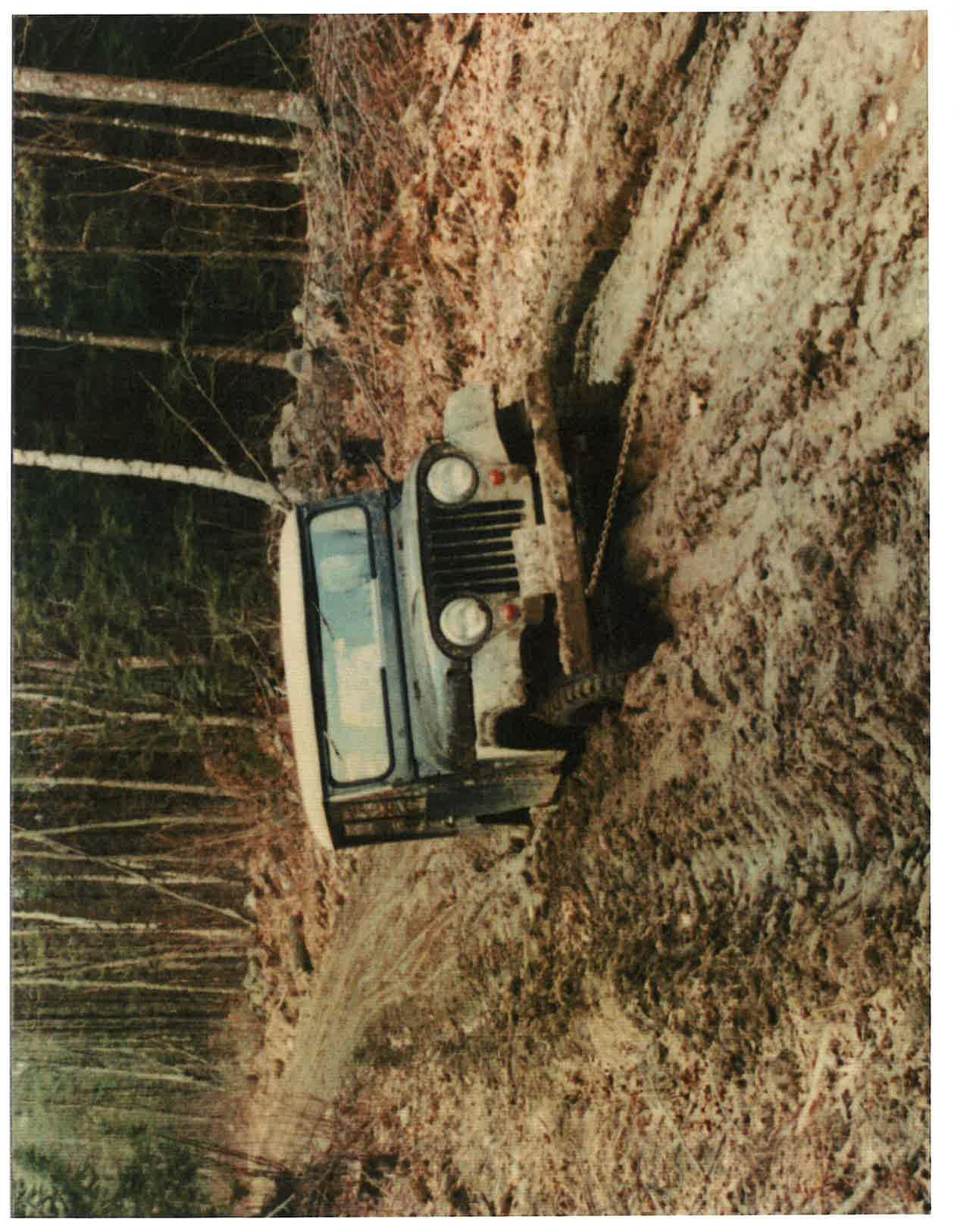

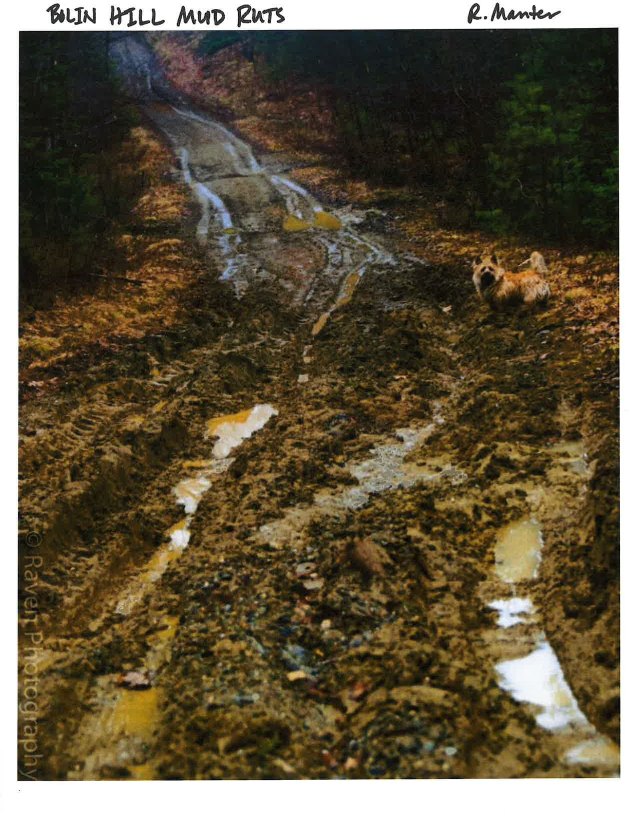

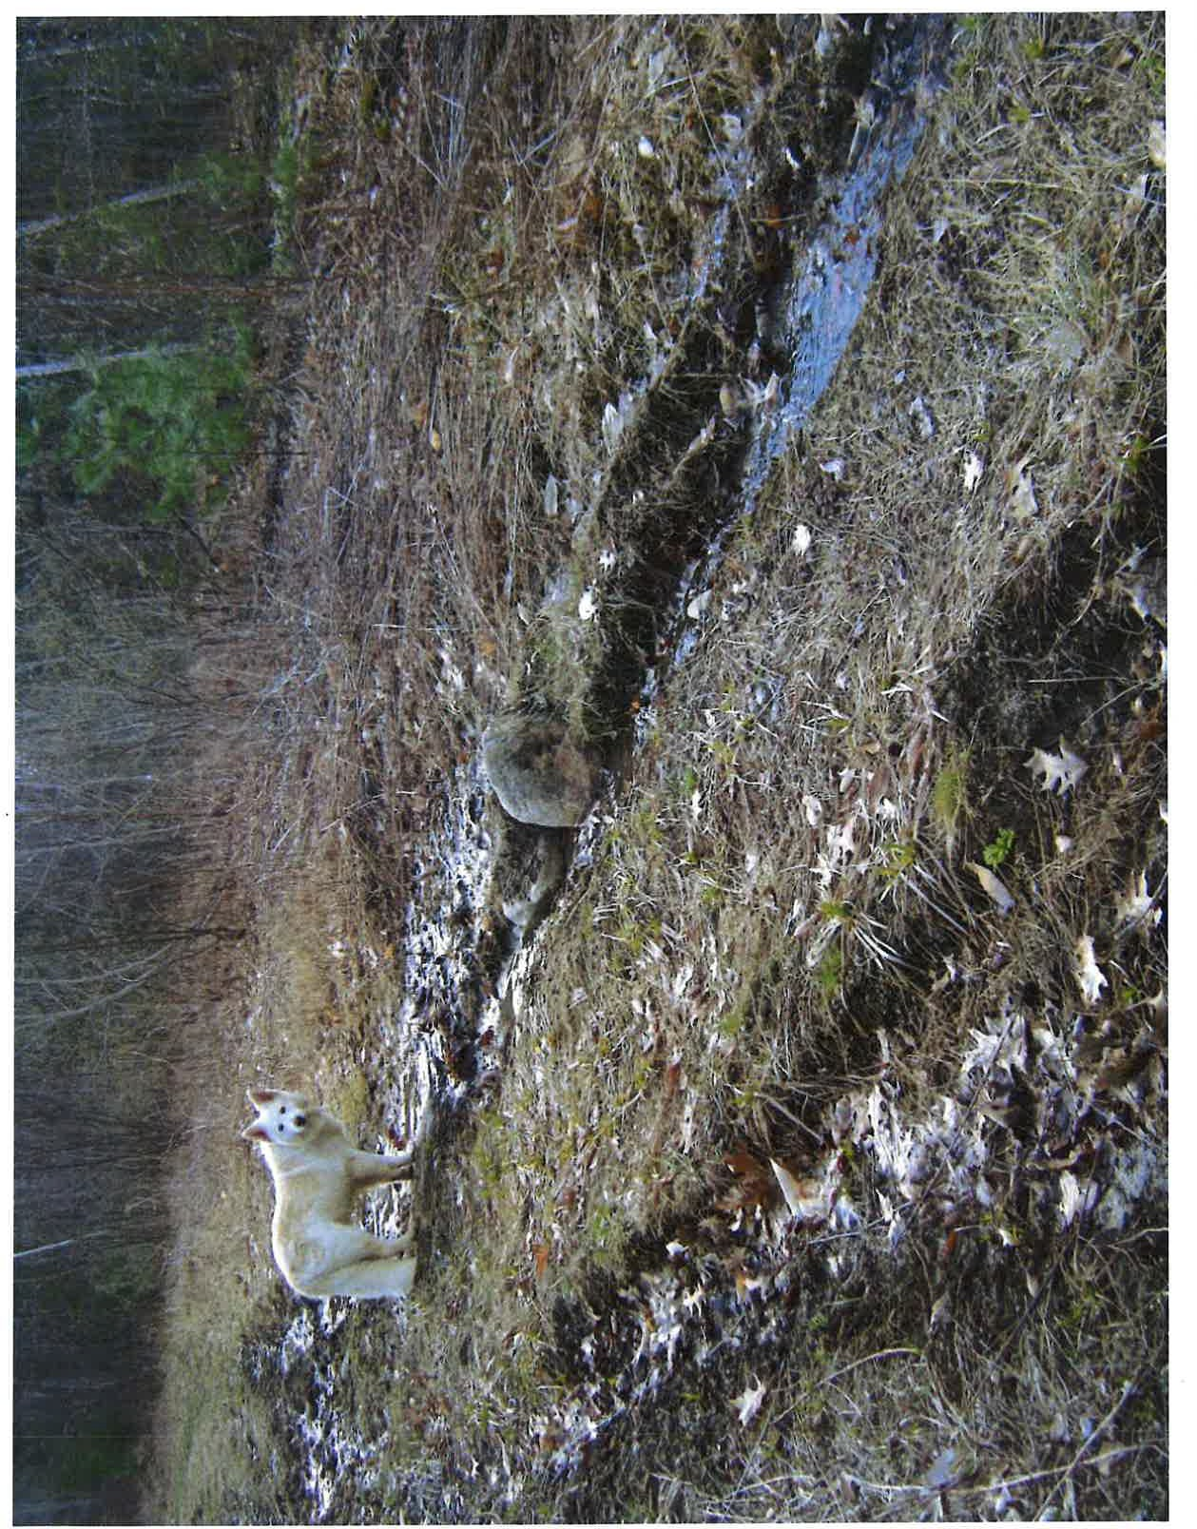

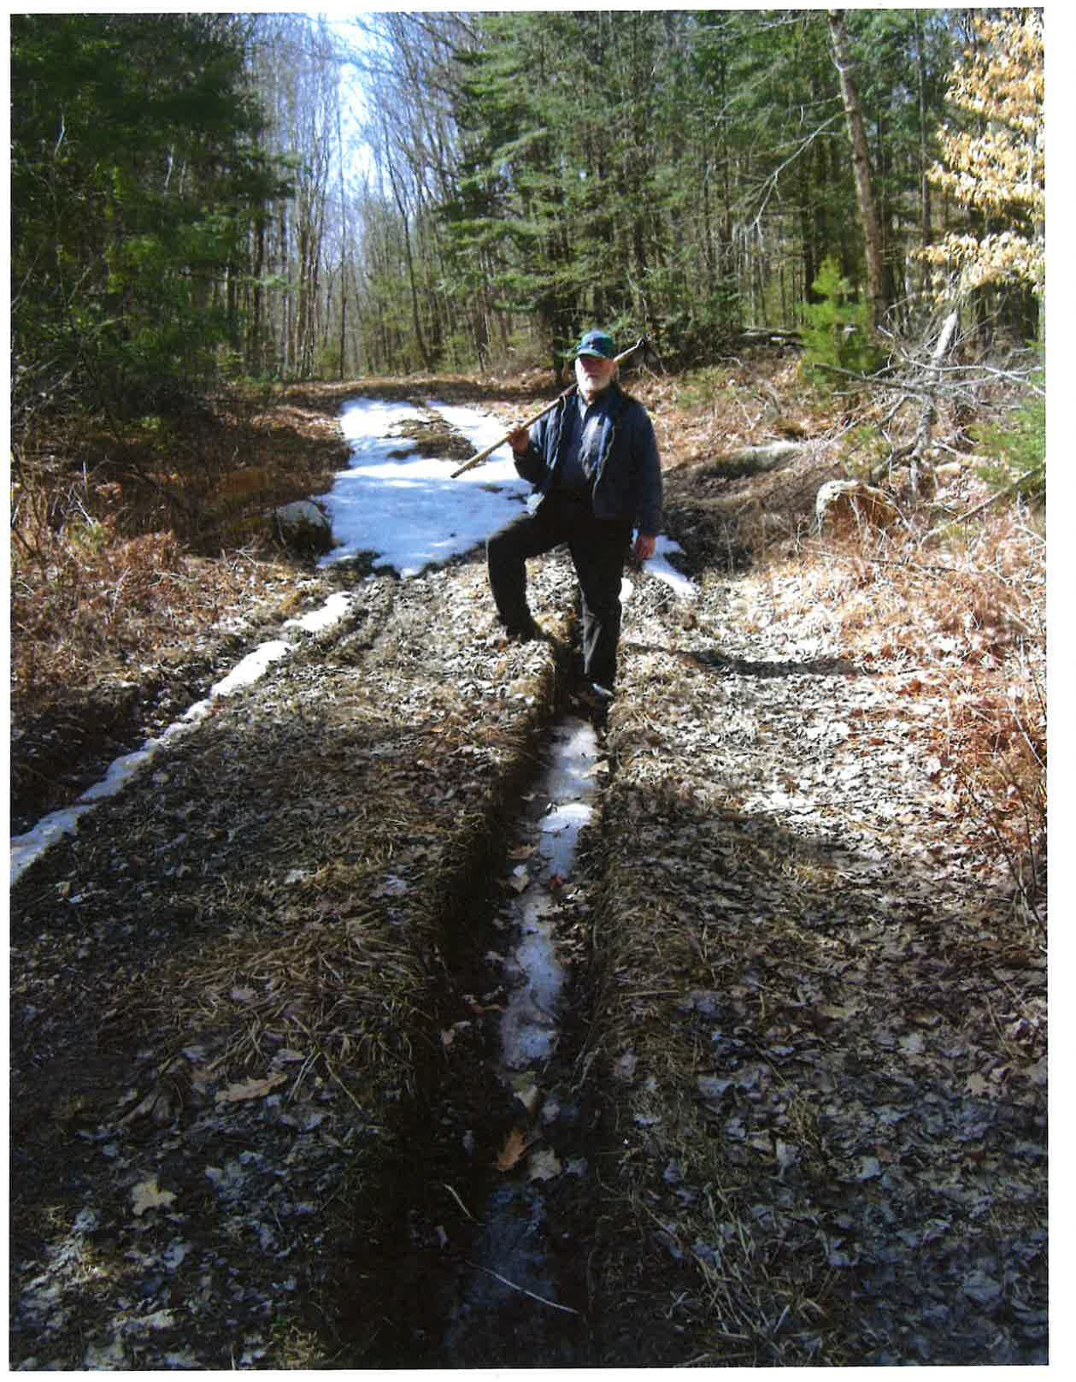

Mikhail. Vivian

From: Sent:
To: Subject:
Attachments:
4PCS@hotmail.com
Tuesday, December 13, 2022 7:36 PM info.abandonedroadscommission
Neil Lanteigne Testimony Abandoned and Discontinued Roads Commission Neil Lanteigne Testimony 12132022.pdf

EXTERNAL: This email originated from outside of the State of Maine Mail System. Do not click links or open attachments unless you recognize the sender and know the content is safe.

I have attached my Testimony for tomorrows public hearing of the Abandoned and Discontinued Roads Commission in PDF format.

Neil Lanteigne
18 Ellingwood Road
West Paris, Maine 04289 Phone: 207-370-4727
Ham Radio: NB9D
Email: 4pcs@hotmail.com

DISCLAIMER:
This e-mail and any file or attachment transmitted with it, is only intended for the use of the person and/or entity to whom it is addressed and may contain information that is privileged, confidential, and exempt from disclosure under applicable law. If the recipient of this message is not the intended recipient or otherwise responsible for delivering the message to the intended recipient, be notified that any disclosure, distribution or copying of this information is strictly prohibited. If you received this communication in error, destroy all copies of this message, attachments and/or files in your possession, custody or control and any other copies you may have created, and notify the sender at the sender's e-mail address listed above.

1

Neil Lanteigne
18 Ellingwood Road West Paris, Maine 04289 Phone: 207-370-4727
Email: 4pcs@hotmail.com Ham Radio: NB9D

December 13, 2022

Dear Committee Members:

Thank you for the opportunity to provide my input to the Maine Abandoned and Discontinued Roads Commission.

My Name is Neil Lanteigne, I am a landowner in Paris along an old Maine Road that has been Abandoned, Discontinued, and voted Closed.

The road in Paris is known as Dean Road and in West Paris is known as Finn Road. The Paris side of the road was discontinued to the Dean Homestead (My Property) in 1931. West Paris split from the Town of Paris in 1957. The West Paris side of the road was voted "Closed" in March 1965 to the Paris/ West Paris town line.

Easements were deeded to the early landowners in the township of Paris and West Paris that predated the town road. In 1773 Rangeways were established by the Proprietors of Township# 4 (Paris and West Paris) that exist forever. On November 4, 1773, when the Proprietors were lotting out the township, they held a meeting at Coolidge Tavern in Watertown Massachusetts, and they voted that there be reserved for the use of the proprietors their heirs and assigns forever two rods in width on the eastward side of every range line through the length of the township for the convenience of ways if it should be needed. These Rangeways were established in order to prevent landlocking and segregation in our community. Finn Road was built as the Rangeway for the 9th range of lots in the township of Paris and West Paris. My Survey shows the old road and the Rangeways that crosses through my property has been recorded in the Oxford County Registry of Deeds Plan# 5361.

When the township was lotted out, Double Lot 19 and 20 in the 9th Range was a single lot according to the 1795 plan. (Oxford County Registry of Deeds Plan# 1133) When Double Lot 19 and 20 was subdivided, it created dominant (backlots} and servient estates along the road to prevent landlocking and segregation and ensure property access to the backlots. Double Lot 19 and 20 consists entirely of what is now known today as Korhonen Houselot, Kashner Houselot, Korhonen Backlot, Kashner Backlot, and My Backlot. Me and my neighbors, all of our properties along the road combined together are Double Lot 19 and 20 in the 9th Range. We are all part of the same Double Lot 19 and 20 in the 9th Range.

In 1799 Lots 19 and 20, Range 9 was one double lot containing 200 acres and the deed states: "Subject to any right of way that exists over the same" Source: Cumberland County Registry of Deeds Book 29 Page 310

Later in 1799, deed for Lot 19 and the undivided half of Lot 20 in Range 9 containing 150 acres states: "Reserving a privilege for a road or roads if hereafter necessary."
Source: Cumberland County Registry of Deeds Book 30 Page 459

In 1800 Edmond Dean bought Lot 19, Range 9 containing 100 acres (backlots} and the deed states: "Reserving a privilege for a road if hereafter necessary." Source: Cumberland County Registry of Deeds Book 32 Page 108

In 1815 Edmund Dean Jr and Noah Dean deed for Lot 19, Range 9 containing 100 acres (backlots) states: "Reserving a privilege for a road or roads if hereafter necessary."
Source: Oxford County Registry of Deeds (Early Books} Book 11 Page 321

In 1815, Edmund Dean deed for lot 19, Range 9 containing 100 acres {backlots) states: "Reserving a privilege for roads if necessary." Source: Oxford County Registry of Deeds (Early Books) Book 11 Page 322

In 1848 Edmund Dean deed for the south part of lot 19 Range 9 (my backlot) references Book 11 Page 321 & 322 and states: "the part hereby quitclaimed from the southerly part of said premises by a line fence built by myself
{Edmund Dean Jr) and Noah Dean and is the part that has been in the exclusive possession and occupancy of said Noah and said John Dean for many years and constituting a part of the Noah Dean farm, so called, on which the buildings of said farm stand." Source: Oxford County Registry of Deeds (Early Books) Book 80 Page 41

In 1799 Double lot 19-20 in the 9th Range was conveyed "subject to any right of way that exists over the same". These rights of way are the Rangeways that were established in 1773 that exist forever in the township of Paris and West Paris. In 1800 lot 19 (backlots) was subdivided off Double lot 19-20. The later 1799, 1800 and 1815 backlot deeds state: "Reserving a privilege for a road or roads if hereafter necessary." The backlots (Kashner, Korhonen, my backlot) was a single lot in 1815. Sometime after 1815, and "many years" before 1848 the south part of the backlots {my backlot) was subdivided from the north part of the backlots (Kashner, Korhonen). Kashner and Korhonen backlots are the servient estates to my backlot (dominant estate) along the road.

On October 30, 2015 I was brutally assaulted by my neighbors while walking my dog along the public Finn Road in West Paris Maine. I suffered 4 broken ribs, a broken eye socket, a broken vertebra in my back, a concussion and a traumatic brain injury resulting in PTSD, flashbacks, night terrors and memory issues. I fear for my life. During the assault, a gun was placed against my head and I was threatened to be killed and buried in the swamp if I walked down the road again, told anyone what happened, or went before the West Paris Selectmen to get road access.

On November 12, 2015, less than 2 weeks after the brutal assault, the Town of West Paris after consulting with its Attorney, Mary Costigan of Bernstein Shur law Firm, behind closed doors in executive session, presumed the road was abandoned sometime prior to 1965 "unless and until there is some evidence that the road was not abandoned prior to 1965". There was no public deliberation. However, no determination was made on November 12, 2015.

"A presumption of abandonment may be rebutted by evidence that manifests a clear intent by the municipality or county and the public to consider or use the way as if it were a public way." 23 M.R.S.A. § 3028{1} {2nd sentence}. Source: https://law.justia.com/codes/maine/2015/title-23/part-3/chapter-304/section-3028

I provided numerous written statements, documents, information and oral comments to the town of West Paris prior to November 12, 2015 and my evidence rebutting the towns presumption of abandonment was apparently ignored and not even considered by the town or the towns attorney.

My email to the town dated August 14, 2017 rebutted the towns presumption of abandonment. The road could not have been abandoned prior to 1965 as presumed, primarily because in 1965 the road was voted closed by the town. The road had to have been a town way in 1965 for the town to vote the road closed in 1965. The road could not have been abandoned prior to 1965 as evidenced by the towns own attested statement provided to me by the town prior to November 12, 2015 that the road was voted closed in 1965. The towns own attested statement of the 1965 closing effectively rebuts the towns own presumption of abandonment prior to the 1965 closing.

After receiving my August 14, 2017 rebuttal, the town realized the road could not have been abandoned prior to 1965 as presumed, and on September 25, 2017 the town filed its "Notice of Determination of Presumption of Abandonment" determining the road was abandoned due to non-maintenance beginning April 15, 1985 and ending on April 15, 2015, resulting in a public easement pursuant to 23 M.R.S.A. § 3028.
Source: Oxford County Registry of Deeds, Page 5369 Book 459

The Maine Supreme Judicial Court has long upheld that the public has an unfettered right to use any public easement. Town of Fayette v. Manter 528 A.2d 887 (1987)
Source: https://law.justia.com/cases/maine/s upreme-court/1987/528-a-2d-88 7-0.htmI

According to the Maine Supreme Judicial Court, the common law rule is that a perfect legal title cannot be lost by abandonment. The common law rule that "one cannot assert a claim of title by adverse possession against a municipality" precludes any common law abandonment claim based on adverse possession. Town of Sedgwick v. Butler HAN-97-727 (1998). Source: https://caselaw.findlaw.com/me-supreme-judicial-court/1430104.html

Common law abandonment and adverse possession are insufficient in extinguishing or taking a public easement. The inclusion of common law abandonment under 23 M.R.S.A. § 3028-A is an unjust and discriminatory practice and creates an unfair advantage against those with limited means and opens a minefield that only landowners with deep pockets with expensive lawyers can successfully navigate. Effectively landlocking and segregating the poor.

Common law abandonment is something that is only determined or decided by a Court of law, not a town. If someone wants to argue for common law abandonment in court, that's their right. Towns should be obligated to follow the law. Please don't give the towns the option of claiming common law abandonment in the statutes, the towns have and will abuse the privilege. Common law abandonment is no longer needed, as the statutes are in place. The inclusion of Common Law abandonment in the statute will only lead to further confusion and conflict along our old Maine roads.

The terms "only means of access" or "alternative access" or "only access route" should not be used in 23 M.R.S.A. § 3028-A because it is discriminatory and promotes segregation and landlocking. It should not matter if there is or someone has alternative access. If someone has a right to use the road they should be able to use it. "Oh he has access over there, he doesn't need access over here." This ignorant mentality has to be abolished. Something needs to be done to protect the rights of landowners who are deemed to have alternative access.

The Maine Supreme Judicial Court dealt with the very issue of someone deemed to have alternative access in another town. The Frustaci case involved a situation where the City of South Portland discontinued two City roads which abutted Frustaci's property in Cape Elizabeth. Even though Frustaci had access to his property from town roads in Cape Elizabeth, the discontinuance of the South Portland streets made it harder for him to develop his property and reduced the number of lots he could develop. The City had awarded Mr. Frustaci no damages, on the theory that he still had access to his property from Cape Elizabeth. Frustaci sued the City and won a jury verdict in the amount of $380,000.00. Needless to say, the Frustaci case poses a warning to a municipality considering the discontinuance or abandonment of any town way. The Town must assess all the facts and circumstances of the situation and determine what impact the discontinuance or abandonment will have on the value of abutters' properties, because that impact is compensable in damages even if the abutters retain other access to their properties. Frustaci v. City of South Portland 2005-MElOl (2005).
Source: https://cases. justia.com /maine/supreme-court/05mel0lfr.pdf?ts=1462359569

Affected Property should be expanded to all or any landowners along the road, even those that abut the end of the road, regardless if alternative access exists. Affected property should also be expanded to anyone who has a right to or is a beneficiary of the road. The exclusion of others along the road lacks due process and is a discriminatory policy and practice that will undoubtedly lead to landlocking and segregation and further confusion and conflict along our old Maine roads.

23 M.R.S.A. § 3028-A also states that any public utility easements remain even if the public easement is extinguished. Likewise, private and public easements may still exist along the road. Private easements may still exist when a road is discontinued or abandoned. Even when this occurs, however, private individuals may have a right to continue using the road. The municipality should not spend public funds protecting (i.e., litigating) these private rights, but it can suggest to the parties that private rights may exist.

It would not be correct to assume that each property owner owns the abutting former way to the centerline free of any encumbrances such as underlying public or private rights-of-ways that may exist in the same location. A granter may have expressly reserved rights in this street or may have recorded a notice of intent to reserve an interest in the way. The elimination of one easement may not necessarily result in the elimination of all easements.

I encourage you to read and review "Maine Roads and Easements". There are some excellent diagrams that show even if the public easement to the road was extinguished, underlying rights likely exist in the form of a rangeway or other easement(s). The elimination of one easement does not necessarily cause the elimination of all easements. Source: https://digitalcommons.mainelaw.maine.edu/cgi/viewcontent.cgi?article=1581&context=mlr

23 M.R.S.A. § 3028-A makes it easier for towns to dispose of roads by allowing landowners to form private easements, but what happens in the case where a landowner is unfairly landlocked or segregated? Landowners who depend on or otherwise benefit from the road may abut the road at the end of the road or in other towns. A licensed surveyor must be tasked with determining who the interested or affected parties to a road are. Each road situation is unique, and the towns must sometimes look beyond its own borders into other municipalities to determine the effected landowners/ who the interested parties are along our Old Maine Roads.

The legislature cannot ignore the historical record and the wording in the property deeds. The Maine Supreme Judicial Court has also recently decided and upheld that that one can convey only what one has been conveyed, and "much is to be presumed in favor of ancient deeds". Almeder v. Town of Kennebunkport (Goose Rocks Beach Case} 2019 ME 151 (2020). https://www.courts.maine.gov/courts/sjc/lawcourt/2019/19me151re.pdf

The property boundaries are clearly defined by the language in the deeds. The fact is NONE of the other properties along Finn road own the road according to their deeds and chain of title. It is clear by the historical record and language in all the deeds along the road in West Paris that ownership of the road was not intended to be conveyed to the abutting landowners. The landowners along the road have clearly not been conveyed the road according to the language in their deeds, they only own to the side of the road. It is a public road and built as the Rangeway for all landowners in the township of Paris and West Paris to access our properties.

Property of Jon Kashner (previously owned by Peter and Deirdre Binney) - West of the Old County Road: "Thence in an easterly direction along the southerly boundary line of said Mike Korhonen property to the westerly boundary of the Old Discontinued County Road; Thence in a southerly direction on and along the westerly boundary line of said Old Discontinued County Road to its intersection with the Paris -West Paris town line." Source: Oxford County Registry of Deeds, Book 5688 Page 252

Property of Michael and Linda Korhonen - East of the Old County Road. "BOUNDED westerly by the Old County Road so-called." Source: Oxford County Registry of Deeds, Book 2226 Page 305

The Oxford County Sheriff's Office confirm my neighbors do not own the road. "The Binneys and Korhonens own the property on either side of the road leading up to the gate." Chief Deputy James Urquhart Oxford County Sheriff's Office Source: Sun Journal May 5, 2019

I was not trespassing as alleged by the State. My neighbors are attempting to claim something that is not theirs. Neither of my neighbors own the road according to their deeds. The gates are in place illegally. The deed for my neighbor's properties references the road. It defines the properties as ending on the side of the County Road. If your boundary ends at the side of the road, or your property was conveyed subject to rights of others (to the road), then you don't own the road. Finn Road is a public road and Rangeway that the public has an unfettered right to use.

To help ease the burden placed upon landowners (and the courts) there needs to be an appeals process readily and easily available to the county commissioners if a landowner does not agree with a towns decision, both now and in the past, town decisions years, or decades ago. The reality is not even the towns really know what happened in the past nor what to do with any of our old Maine roads. Without an effective appeals provision or policy in place at the town (or county) level, how can we even ensure an equal, fair, and balanced process for landowners? Without an appeals process, neighbors can and will landlock and segregate others along our public roads.

Statutory terminology is one issue identified as a priority matter for the commission. An abutter "on" the way, or an abutter "of" the way? Can an abutter that is not technically on the way, but of the way, maybe at the end of the way, in another town, should they not also be able to petition the county commissioners to have obstructions and gates removed? The definition of "Damage to a road" should also be extended to include someone blocking a public easement, resulting in damage to, destruction, or loss of access.

Many other roads in Maine have been illegally voted "Closed" by the towns in the past resulting in landlocking and segregation. I am hopeful the legislature will consider adding protections and an appeals process at the town and county level for landowners for roads that were voted "Closed". Young Road in Fayette is an example of a road that has been illegally voted "Closed" by the town and is now a public easement for the greater good. There have been numerous instances of our Old Maine Roads that have been voted "Closed".

According to my research, Towns Routinely voted Roads "Closed" due to property rights of access. The towns wanted to discontinue the road, but retain an easement for all abutting landowners along the road. The status of a closed road was decided in Superior Court. Miner v. the Town of Benton, Kennebec County (2008} KENN-AP-06-77. In 1949 the town decided to close a road because the Selectmen had found it difficult to discontinue the road due to issues of property rights. The Court ultimately determined that it was only Closed. Because the town did not maintain their closed road from 1949 to 1979, the Court decided it was now Abandoned under 23 M.R.S.A. § 3028 with a public easement retained. Source: https://cases.justia.com/maine/superior-court/KENap-06-77.pdf

The status of another Closed road was also decided in Superior Court. Schott v. Cyr and the Town of Greene, Androscoggin County (1996}. AND-CV-94-203. In 1948, the Town of Greene voted to close Hills Ridge Road. In 1993, the town Selectmen declared the road had been closed in 1948 and abandoned as of 30 years after 1948. The Court determined the road has been Abandoned 30 years after the 1948 closing and a public easement was retained pursuant to Title 23 M.R.S.A. § 3028. Source: Androscoggin County Registry of Deeds, Book 3687 Page 252

Any of our old Maine roads that was voted "Closed" in the past by a town should retain a public easement by Statute for the greater good. Routinely towns do not even know what happened in the past and a closing is not a discontinuance or abandonment. It is neither, it is a closing. According to statute, Closing is always a temporary action, and one would have the expectation the road would be reopened at some point in the near future.

I have spent a considerable amount of effort in researching Abandoned Roads in the various Registry of Deeds throughout the State. Thus far I found a total of 181 Abandonment Determinations from 1995 to present including:

In Androscoggin County I found 18 Abandonment Determinations: Lisbon 1 road in 2002
Minot 15 roads in 2004, and 1 road in 2005
Sabattus 1 road in 2008
In Aroostook County (North) I found 1 Abandonment Determination: Fort Kent 1 road in 2015
In Aroostook County (South), I found 17 Abandonment Determinations: Caribou 1 road in 2014 and 1 road 2017
Island Falls 9 roads in 2014, 4 roads in 2015, 1 road in 2017, and 1 road in 2018 In Cumberland County, I found 3 Abandonment Determinations:
Bridgton 1 road in 1997
Gorham 1 road in 2002
Harpswell 1 road in 2012
In Franklin County, I found 4 Abandonment Determinations: Farmington 1 road in 1995, 1 road in 2011, and 1 road in 2019
New Vineyard 1 road in 2018
In Hancock County, I found 11 Abandonment Determinations: Bar Harbor 1 road in 1999 and 1 road in 2009
Blue Hill 1 road in 2012
Bucksport 1 road in 2018

Deedham 1 road in 2007
Hancock 1 road in 2002
Lucerne-In-Maine Village Corporation 1 road in 2006
Penobscot 3 roads in 2021
Surry 1 road in 2010
In Kennebec County, I found 6 Abandonment Determinations:
Vienna 5 Roads in 1997
Benton 1 road in 2008
In Knox County, I found 8 Abandonment Determinations:
Union 4 roads in 2000, 1 road in 2007, and 1 road in 2008
Vinalhaven 1 road in 2014
Warren 1 road in 2006
In Lincoln County, I found 2 Abandonment Determinations: Edgecomb 1 road in 2006
Somerville 1 road in 2016
In Oxford County, I found 29 Abandonment Determinations: Brownfield 1 road in 2008
Buckfield 4 roads in 2008
Fryeburg 1 road in 1995, 1 road in 1996, and 1 road in 2000
Lovell 1 road in 2018
Otisfield 1 road in 2010
Paris 1 road in 2001, 1 road in 2002, 1 road in 2005, and 1 road in 2008
Sweden 13 roads in 2006
West Paris 1 road in 2017 (Finn Road)
Woodstock 1 road in 2016
In Penobscot County, I found 39 Abandonment Determinations: Garland 1 road in 2020
Howland 1 road in 2000
Lincoln 1 road in 1995, 1 road in 1996, and 1 road in 1998
Newburgh 22 roads in 2001
Orrington 9 roads in 2004
Plymouth 1 road in 2012
Veazie 1 road in 2002
Winn 1 road in 2011
In Somerset County, I found 5 Abandonment Determinations: Anson 1 road in 2000, and 1 road in 2009
Madison 1 road in 2000
Skowhegan 1 road in 2017 St Albans I road in 2016
In Waldo County, I found 18 Abandonment Determinations: Frankfort 1 road 2008
Searsmont 15 Roads in 2006, and 1 road in 2007
Unity 1 road in 2011
In Washington County, I found 3 Abandonment Determinations: Beals 1 road in 2004
Perry 1 road in 2000
Princeton 1 road in 2019
In York County, I found 17 Abandonment Determinations: Hollis 1 road in 2020
Kennebunkport 1 road in 2020
Limerick 1 road in 2003
Lyman 1 road in 2019
Newfield 1 road in 2019
Old Orchard Beach 1 road in 2019
Wells 11 roads in 2001, and 4 roads in 2006

I highlighted examples where towns have abandoned multiple roads in the same year. In my research I have noticed quite often, towns abandon roads without any public input, mostly on advice from the towns Attorney and/or the Maine Municipal Association. Most of these decisions appear to be based solely on an "opinion" of an individual or attorney working for the town in order to limit the towns responsibility and liabilities. This is going to pose a significant liability for the towns and the landowners in the future. The towns have abandoned many more roads that have not been filed in the registry of deeds. West Paris is an example of a town that abandoned one single road which highlights even one abandonment can open the floodgates to future litigation, resulting in significant liabilities for landowners, towns, and the State.

I appreciate Maine ROADWays speaking up on my behalf to the Commission. I am hopeful the Maine Abandoned and Discontinued Roads Commission will consider implementing my suggestions in the future legislation for the greater good.

Respectfully Submitted,
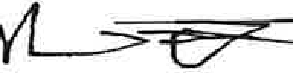
Neil Lanteigne Paris, Maine
https:ljwww.qrz.com/db/NB9D

Mikhail, Vivian

From: Sent:
To: Subject:
Attachments:
Larry Daggett <daggettla@gmail.com>
Tuesday, December 13, 2022 9:57 PM info.abandonedroadscommission; Bronson, Brian N. December 14th Comments
Abbot Explorers ATV Club Hearing discontinued roads.docx

EXTERNAL: This email originated from outside of the State of Maine Mail System. Do not click links or open attachments unless you recognize the sender and know the content is safe.

Attached please find input from the Abbot Explorers ATV Club.
Brian, I will be trying very hard to join the Zoom meeting, andwill be glad to read this if needed. Regards, Larry

1

Abbot Explorers ATV Club
PO Box 168
Abbot Maine 04406
December 13th, 2022

Abandoned and Discontinued Roads Commission lnfo.abandonedroadscommission@maine.gov
The Abbot Explorers ATV Club, located in Abbot, Maine, are responsible for approximately 59 miles of ATV trail system which encompasses the towns of Abbot, Guilford, Blanchard, Monson, and sections of Kingsbury, Maine. Our Club tries very hard to verify correct ownership of the Landowners which graciously allow the use of their land for ATV (and Snowmobile} trails. However, researching deeds and tax maps, we have occasionally found ourselves with discrepancies between what the landowners believe they own, and what Town and County records indicate.

In review of the responsibilities charged to this Commission, Our Club would encourage support of duties A. (1), by extending the Liability coverage to Landowners/or Organized use and maintenance, as currently used under the ATV Trail grant guidelines. Duties A. (2} We also feel that Public Easement Retention should be a very high priority for several reasons, such as sustained use/ maintenance often creates access for Forest fire control and emergency services. Duties A. (4) will be very helpful to all clubs if clarification can be provided on determining the legal status of roads previously belonging to Towns and Counties which have thought to be discontinued for use, but ownership has been retained by said Town or County.

Regarding duties B. (3), (4} Recreational Users, even though these trails are organized and maintained by ATV/ Snowmobile clubs, many are multiuse trails which are shared with non-registration revenue generating activities such as walkers, Bicycle riders (including increasingly popular "Fat Tire" bikes} and Horse riders. We are supposed to be Vacationland. The Economic impacts of these recreational uses are also very significant to our rural areas.
Thank you for the opportunity to share our input on this issue. Our Club looks forward to being a continuing partner in this issue, and in the effort to encourage responsible use of our recreational opportunities.

Regards,
Larry Daggett, Trailmaster Abbot Explorers ATV Club. daggettla@gma iI.com Abbotexplorersatv@gmail.com 207.717.9733 cell/ text

Mikhail, Vivian

From: Sent:
To: Subject:

Follow Up Flag: Flag Status:
Paradise Maine < paradisemaine@gmail.com > Tuesday, December 13, 2022 11:24 AM info.abandonedroadscommission
Abandoned & Discontinued Road Commission,

Follow up Completed

EXTERNAL: This email originated from outside of the State of Maine Mail System. Do not click links or open attachments unless you recognize the sender and know the content is safe.

December 12, 2022

Dear Abandoned & Discontinued Road Commission:

We are land owners in Hancock County in Bucksport.
We use a discontinued town road, the Gullies Road, for access to our Land and Cabin on Thurston Pond. There are approximately 25+ owners along a through road from Jacob Buck Pond Road to Bucksmills Road. It has been there for 200+ years. It provides access to many deeded properties.

Town councilor, James Morrison, with his brother Harold Morrison live on one end of the Gullies road. His family has owned 50+ years. Upon being elected to the town council, he put forth a article to extinguish the public easement. Siting reasons that he needed to protect his land from Covid, monkey pox and thieves. They contacted 3 landowners of the 25 landowners that are serviced by this public easement. We are one of those 25.

The town council voted unanimously with no notice to all 25+ property owners, no public purpose or opposition to the closure, to close the
road. And extinguish the easement. As a consequence, we found that we could not access our land or cabin through the Gullies road, due to this

local Bucksport Town Council action and Mr. Morrison blocking the road with his tractor. We hired an attorney to fight the town of Bucksport for this illegal action. To a cost of $4000.

When the town hired a specialist attorney, Phil Saucier of Bernstein and Shur, he agreed with our attorney to procedural errors by the town and the vote was rescinded. Then councilor Morrison tried to get the issue back on the table, and failed by a slim margin that infuriated him and now he is strategizing how to make the town shut the public easement down again.
For his personal objective.
Which will mean a projected 1000s of dollars for us and no liability for him as he is using the town's resources.

Discontinued Roads should remain open and protected.
Let the legislature settle this once and for all. The abuse and corruption of closing these roads is a burden on the landowners. Attorneys are the only ones who have something to gain.

Sincerely,

Kristina Ryberg Don Jewett
Paradisemaine@gmail.com 207-974-6547

Mikhail, Vivian

From: Sent:
To: Subject:

Follow Up Flag: Flag Status:
althea walker <atwalker82056@msn.com> Tuesday, December 13, 2022 1:45 PM info.abandonedroadscommission
Range Road, Brunswick ME. French's Rock Road, Hartland, ME

Follow up Completed

EXTERNAL: This email originated from outside of the State of Maine Mail System. Do not click links or open attachments unless you recognize the sender and know the content is safe.

Hello,
My name is Althea Walker and as luck would have it, I own two pieces of property on roads that are not being maintained by the towns where the properties are located.
I will first write about Range Road, in Brunswick, ME.
In the early 701s two couples purchased lots of land to build their homes. The town of Brunswick was not sure about the issuing of permits, but in the end finally agreed to the homes being built. The property owners were told that the town would take over maintenance of the section of road where they had built. Long story short, the Town Manager eventually reversed his decision to maintain that section of Range Road. This same process and routine had continued into 2007 with the last two homes being built.
Once again, somewhere in the 80s-90s the Town of Brunswick was approached to take over the ~.s-mile dirt road. It was almost up to town specs at this time. The town responded saying that it would agree to take over the road if the property owners would agree to give the town right of ways across their properties. Two property owners refused, so the remaining seven property owners were out of luck.
The latest attempt ( somewhere in 2018-2019) to have the Town of Brunswick take over this section of Range Road, ended with the current Town Manager sending information to the town's attorney to get a ruling on the status of the road. The attorney determined that the road was abandoned. There was NO documentation indicating that the town notified any of the land owners as such.
Then during the 2020-2021 timeframe the landowners received a letter from CMP stating that the section of Range Road has NOT been abandoned according to the research completed by the attorneys for CMP. The Town Manager was given this information and well....
Since 1988, the road has been maintained by anywhere from 2 to 9 landowners. This is including snowplowing, and gravel work when needed.
While this section of Range Road is considered abandoned, for many years the area humane society would park cars along the part of the road that was being maintained by the landowners.
In addition to the humane society, the town has authorized two businesses, one being a day care center and the second being a B & B. There are also two apartment units at the end of the road, which at times has given landowners before the apartments an excuse to forgo supporting the road work. (The humane society has since moved out of their location on Range Road and we are waiting to see who buys that piece of property and how it will be used.
Because this is part of a dead-end road, people drive their ATVs up and down the road causing ruts and spin­ outs that are needed to be repaired by us. The Town of Brunswick school bus turns around at the end of the town section. However, every day the bus MUST back onto the abandoned section of road to turn
around. This causes almost permanent holes and ruts that also add to the cost of maintaining Range
Road. The bus comes to the daycare center that is actually on the first lot of the privately maintained road as

a result of the town permitting such a use of the land, with no stipulation on responsibility for road use or maintenance.
This is an extremely shortened version of the past 30 years of trying to get the town to take over maintenance of the road. Because the landowners were told in the 70's that the town would take over maintenance of the road the USPS approved house to house mail delivery service. The postal workers will often refuse to deliver mail to these homes because of the condition of the road. There are currently two residents who rely on postal deliveries of their medication so this is a huge risk to them if they do not receive their medications.
We sold our home at the end of Range Road 4 years ago. Because there was not a formal road agreement, we lost approximately $100K+ on the value. Others who have sold their homes have had challenges presented by lenders whoi had concerns about Range Road not being maintained.

French's Rock Road, Hartland, Maine
My husband and I purchased the land at 8 French's Rock Road in 1990. At the time there was no electricity and the road was not maintained by any of the three towns that we had to drive through to get to our house. The telephone company agreed to put in the poles so that CMP could provide electrical service to the landowners.
To get to our piece of property, we would have to cross over roads that traversed through St. Albans and Harmony in order to reach our Hartland property.
Within three to four years, Hartland town manager agreed to snow plow the section of road in Hartland. Because of this agreement, the entire length of the 5-mile road was being plowed. They also had a service cut the brush on the sides of the road. Then money got tight and the Town Manager wanted to back out of the agreement to take care of the road and asked for a refund from the residents for the cost of plowing. Things got rather confusing and long story short, Hartland would no longer plow the road and required that we pay the ~$3,000 it cost them to plow. Since the 1980's the residents of the three towns and the town managers have had numerous discussions about maintenance of the road.
The road is used by many recreational users, driving ATVs and digging up the road. It is also used by heavy logging equipment and you can image what the road looks like after they leave. There has been a considerable amount of construction going on in the three towns, also causing much damage to the road as heavy equipment vehicles make deliveries.
About 3 years ago, (sorry I don't have my records in front of me), a large culvert had to be dug out and a new one put in to ensure access to our properties beyond that point. This cost was HUGE ( I don't want to report an amount and not remember correctly, but $30K is my guess) and the majority of the cost was absorbed by landowners.
Until this year there were about 100 members paying maintenance fees to keep up the condition of the road. With unexpected consequences, the town of Harmony decided to tar and take care of 1 mile of beginning of the road. This 1 mile ended at precisely the turnoff point to a town approved development, whose members were paying their dues. Now these ~30 residents do not feel as if they need to contribute to the road funds. A HUGE monetary loss, resulting in increased dues for those who continue to pay.
Because of the large number of non-residents who drive on this road, there is also the expense of liability insurance that is paid by the residents also.

In closing, I would like to thank-you for reviewing my letter and learning of our experiences as landowners on roads not maintained by towns and cities. As you consider how you are going to vote on this proposed bill, please think that residents who choose to be homeowners in the State of Maine are often faced with affordable land not being maintained by municipalities. Your vote on this matter will make a huge difference in the lives of many Maine residents.

Thank-you.

Respectfully submitted,
Althea T. Walker

Mikhail, Vivian

From:
Sent:
To:
Subject: Attachments:
John Lowry <jhlowry@mac.com> Friday, December 16, 2022 10:29 AM info.abandonedroadscommission
Testimony to the Commission on Abandoned and Discontinued Roads Road Testimony.pdf

EXTERNAL: This email originated from outside of the State of Maine Mail System. Do not click links or open attachments unless you recognize the sender and know the content is safe.

Dear Commissioners,

Please accept and consider the attached testimony. Respectfully,
John Lowry Porter, Maine

December 16, 2022

Commission on Abandoned and Discontinued Roads 210 State St,
Augusta, ME 04330 Dear Commissioners,
This note is in response to a request for testimony prior to December 21, 2022.

I own land on Town Pound Road in Porter Maine. The road was originally laid out and accepted as a "driftway" in the 1830's apparently to be able to move cattle and sheep from one populated portion of town to another along the Ossipee River. Town records regarding roads are incomplete with significant gaps for the mid to late 1800's and early 1900's. Other than acceptance of the road as a driftway, there are no records for the road.

The town maintains one half of the length of road on a seasonal basis. The other half of the road has not been maintained for the 20 years of my residency and most likely for approximately 100 years. It is impossible to determine whether it has been used regularly during the last 100 years.

All town roads are verbally asserted to be public rights of way by the Town. A recent exception is the case of Libby Road with a similar history to Town Pound Road.
Here, the abutters blocked the road with significant barriers and indicated a willingness to fight the town's blanket assertion in court. The town has allowed the barriers to remain.

The town also discourages maintenance by abutters of these public right of way that are de facto abandoned or discontinued roads. Their rationale is that maintenance might convince the unwary to use the roads and make the town liable for any injury to persons, animals, or personal vehicles.

Both roads were and are used only by ATVs and snowmobiles. They provide no maintenance, nor does the town. In essence they are trespassers. The only significant 'maintenance' is when an abutter hires a logging company, and the company makes the road capable of passing their equipment. The logging company 'maintenance' acts for further damage the road except for passage by buncher­ fellers, bulldozers, and other heavy equipment.

We would welcome the designation of private way with the ability to pass given to the abutters and their guests by permission. Maintenance of my section of the road has resulted in financial cost and effort. My inability to get permission from the town to maintain the road or protect it is equivalent to an unlawful taking. The town should either maintain the road or relinquish their claim that it is a public right of way.

Respectfully, John Lowry
351 Old Meetinghouse Road Porter, Maine 04068
207-625-4316

Mikhail, Vivian

From: Sent: To: Subject:
lamna13@aol.com
Friday, December 16, 2022 6:29 PM info.abandonedroadscommission abandoned roads

EXTERNAL: This email originated from outside of the State of Maine Mail System. Do not click links or open attachments unless you recognize the sender and know the content is safe.

Hello. My name is Molly Alexander and I live at 259 Birmingham Rd, Chelsea, me 04330. I am presently involved in a law suit concerning the discontinued portion of the Birmingham rd in Chelsea. I am 70 years old and my husband is 75 years old. We both live on social security and our retirement.

The town of Chelsea did A perfect job (in my opinion) and crossed all the t's and dotted all the i's in the process of discontinuing the old end of the Birmingham rd certified mail sent to each land owner, public hearing, citizen vote at
town meeting, the result filed with the registry of deeds ihe end of the Birmingham Rd was discontinued "with no
public access"---using that specific wording. The land was returned to the abutting land owners, it seems like this should be a done deal but it is not. A person with ALOT of money has filed a lawsuit against all of on the discontinued portion becasue he want to use the road to access the back line of his property.

My point of the above is to stress the importance of CLARITY, Simplicity, INTENT, of any legistation passed. As you can see---a town, in conjunction with their attorney took all the correct steps and the discontinuance is still involved in a lawsuit. Also make it clear on how any changes will affect the current status of discontinued roads.--the Birmingham Rd was discontinued with NO PUBLIC ACCESS-----is any new legislation going to change that status???

My other concern is Liability if by any chance, we lose this case in court and have to allow this person and all public
to be on our property-----who is liable???? It is a very sad day when a person cannot say who can and cannot be on their property.

As sad as it is, it almost seems like the person with the most money gets his way. We donot have the money to hire an attorney so I am representing myself in this case. I pray that his lawyer is not some fast talking lawyer that will blow over the judge.

This entire subject is extremely serious and I donot think you will find any town in maine without a road in this category. I cannot stress enough how important your work is on this matter----thank you. Mike Pushard is the selectman in Chelsea who has the most dealings concerning the process of discontinuing roads in Chelsea is you wanted his input on the process used as set by current law and how it has worked.

As a final note-----I am very scared if we lose this court case the man is NOT nice and does not take NO for an answer
and this will only be the beginning of his bullying. it will not end. thank you and best wishes on your job and thank you for all you do

Mikhail, Vivian

From: Sent: To: Subject:
Sheila Dube <dubesheila@gmail.com> Saturday, December 17, 2022 7:43 AM info.abandonedroadscommission Abandoned Roads Commission

EXTERNAL: This email originated from outside ofthe State of Maine Mail System. Do not click links or open attachments unless you recognize the sender and know the content is safe.

As a real estate broker, I can add that this topic is covered in all three tiers of licensure. Our responsibilities do not cover giving legal advice or making a legal determination regarding the status of a road or any other legal determination. Our responsibility to our buyer client is to recommend seeking legal advice. In both of the suits we were Involved in, we did just that. We have a very reputable real estate attorney complete our title work and research. The problem in my opinion is more with our legal system. Frivolous lawsuits with no basis are permissible in this state with no means to collect attorney fees as a defendant. That means someone with deep pockets can keep you in the legal system with a frivolous lawsuit, in our case for seven years. With one of our suits, the plaintiff had sued two different abutters receiving settlements from insurance companies in each one. I think the populous has learned how to take advantage of the system. We will all pay for that in the long run. Other states allow collection of attorneys fees and Maine should consider the same. Additionally, the disclosure referenced is the "Sellers Property Disclosure", not the real estate agents disclosure.

Sheila Dube

Sent from my iPhone

Mikhail, Vivian

From:
Sent:
To:
Subject: Attachments:
Neil Lanteigne <4PCS@hotmail.com> Tuesday, December 20, 2022 2:28 PM info.abandonedroadscommission
Neil Lanteigne Additional Testimony Abandoned and Discontinued Roads Commission Neil Lanteigne Testimony 12202022.pdf

EXTERNAL: This email originated from outside of the State of Maine Mail System. Do not click links or open attachments unless you recognize the sender and know the content is safe.

I have attached my additional Testimony to the Abandoned and Discontinued Roads Commission in PDF format.

Neil Lanteigne
18 Ellingwood Road
West Paris, Maine 04289 Phone: 207-370-4727
Ham Radio: NB9D
Email: 4pcs@hotmail.com

DISCLAIMER:
This e-mail and any file or attachment transmitted with it, is only intended for the use of the person and/or entity to whom it is addressed and may contain information that is privileged, confidential, and exempt from disclosure under applicable law. If the recipient of this message is not the intended recipient or otherwise responsible for delivering the message to the intended recipient, be notified that any disclosure, distribution or copying of this information is strictly prohibited. If you received this communication in error, destroy all copies of this message, attachments and/or files in your possession, custody or control and any other copies you may have created, and notify the sender at the sender's e-mail address listed above.

Neil Lanteigne
18 Ellingwood Road West Paris, Maine 04289 Phone: 207-370-4727
Email: 4pcs@hotmail.com Ham Radio: NB9D

December 20, 2022

Dear Commission Members:

Thank you for the opportunity to provide additional input to the Maine Abandoned and Discontinued Roads Commission. I previously submitted testimony on December 13, 2022 to the Commission.

I have attached a legal memorandum from real estate Attorney John W. Conway, Esq. of Linnell, Choate & Webber, LLP regarding the legal status of the Old Finn Road in West Paris, Maine.
Attorney Conway's independent research (paid for by the State) confirms the legal status of the road is a public easement. See Exhibit 1.

By law the road is a public right of way. The road was determined by the municipality to be a public easement pursuant to M.R.S. Title 23, §3028.

The State prosecuted David Manter in State v. Manter and sentenced him to ten days in jail because he obstructed a public easement on a discontinued or abandoned road. Ken-01-270 (2001). The public has an "unfettered right of access." to any public easement. Town of Fayette v. Manter 528 A.2d 887 (1987), footnote 1. It is the obligation oflaw enforcement to enforce the law equally, without exception, and order the landowners to remove the obstructions blocking the public right of way pursuant to M.R.S. Title 17-A, §505.

I contacted Oxford County Sheriff Christopher Wainwright, informing him of the public easement and requested the removal of the gates, bars, and obstructions blocking the public right of way. My request was adamantly denied by Sheriff Wainwright. See Exhibit 2.

"[O]ne whose property abuts a public way may suddenly find himself barred from access because the way has been converted to a limited access highway, or barriers or obstructions have been installed under police power authority" (without affording to abutters thereon compensation and due process of law) Jordan v. Town of Canton 265 A.2d 96 (Maine 1970). http://law.justia.com/cases/maine/supreme-court/1970/265-a-2d-96-0.html

What can the Commission do to ensure that the police follow the law so that the roads with public easements are open to the public and free of any and all gates, bars, and obstructions?

Statutory terminology is one issue identified as a priority matter for the Commission. The definition of "Damage" to a road pursuant to 23 M.R.S.A. § 3029-A should also be extended to include someone blocking a public easement, resulting in damage to, destruction, or loss of access.

Pursuant to 1 M.R.S.A. § 405-6(A)(2) "(a]ny person charged or investigated must be permitted to be present at an executive session if that person so desires." Furthermore, while 1 M.R.S.A. § 405- 6(C) allows the "[d]iscussion or consideration of the condition, acquisition or the use of real or personal property permanently attached to real property or interests therein or disposition of publicly held property or economic development only if premature disclosures of the information would prejudice the competitive or bargaining position of the body or agency", landowners and other interested parties along our old Maine roads should be afforded the opportunity to attend said executive sessions.

I find the lack of transparency afforded to Towns and Counties by executive session privilege in the State of Maine especially as they relate to the public's interest in the public easements quite appalling. The executive session privilege afforded to Towns and Counties as they relate to the public's interest in the public easement effectively violates landowners rights to free speech under the First Amendment and rights to due process and equal protection under the 14th Amendment of the U.S. Constitution. What can the Commission do to help ensure transparency and accountability?

Towns and Counties are abusing the executive session privilege. In my research I found 10 instances from 2019 to present where the Oxford County Commissioners entered executive sessions where the "precise nature of the business of the executive session" was not stated in the Minutes.
Upon information and belief, the Oxford County Commissioners discussed Finn Road during the April 15 2022 executive session. Upon information and belief, the Town of West Paris also entered executive session on at least 2 occasions (November 12, 2015 & March 10, 2022) to discuss Finn Road. However, the "precise nature of the business of the executive session" was not stated in any of the Minutes. See Exhibit 3.

Pursuant to 1 M.R.S.A. § 405-4 "[a] motion to go into executive session must indicate the precise nature of the business of the executive session and include a citation of one or more sources of statutory or other authority that permits an executive session for that business." Furthermore, 1
M.R.S.A. § 405-5 provides "[m]atters other than those identified in the motion to go into executive session may not be considered in that particular executive session." http://Jegislature.maine.gov/statutes/1/titlelsec405.html

I appreciate Maine ROADWays speaking up on my behalf to the Commission. I am hopeful the proposed Maine Abandoned and Discontinued Roads Commission will consider implementing my suggestions in the future legislation for the greater good.
Respectfully Submitted,
yl_s:t72
Neil Lanteigne Paris, Maine
https://www.qrz.com/db/NB9D

EXHIBIT 1
Finn Road public easement legal memorandum by Attorney John W. Conway, Esq. (highlighted)

LINNELL, CHOATE & WEBBER, LLP MEMORANDUM

TO: FROM: SUBJECT: DATE:
JUSTIN W. LEARY, ESQ JOHNW. CONWAY, ES..
STATUSOFTHEOLD" 1 ROAD,WESTPARIS,MAINE
MAY 12, 2022

This memo is a response to a request for an opinion regarding the status of the Old Finn Road, which bisects the property of Neil Lanteigne and also bisects property owned by the Binneys and the Korhonens. The request is to determine the legal status of the Finn Road, that is whether or not it is a public way, or has been discontinued and, if it has been discontinued or abandoned, then is there a public easement remaining in the underlying road?

Background Information.

In determining this opinion I have done the following research:

- Review of an 1858 Atlas of Paris showing all of the Finn Road leading from Forbes Road to Sumner Road.

- State of Maine general highway maps as follows:
  - 1959 map which shows no road between the Forbes Road and the towri line but does show a stub of the road in Paris extending north from Sumner Road;
  - 1968 map (actually dated 1964) shows a stub of the road extending south from the Forbes Road in West Paris. There is no road stub in Paris; and
  - 1976 map also shows only the stub from the Forbes Road.

- 1967 US Geological Sm-vey of the West Sumner Quadrangle. This shows a jeep trail coming off the end of an established road, presumably Finn Road, leading to what is called Sumner Road on the Paris tax map.

- 2011 and 2014 US Geological St11-veys. These show the whole road as a "local road",, The 2018 survey also shows a short section of Finn Road as on the tax map.

- The West Paris and Paris tax niap, both revised in 2021, show a single dotted line leading from the end of Finn Road in West Paris to Sumner Road in Paris.

- A survey done for the property of Lanteigne in Paris dated January 18, 2019, which is recorded in the Oxford Registry of Deeds as Plan #5361. This shows that the Lanteigne land abuts the town line between Paris and West Paris and is located on both sides of the Finn Road (also known as the Dean Road). The survey also contains a note on the Plan ,vhich states, in part, "The legal status of Finn Road (aka Dean Road) is assumed to be discontinued by abandonment under Notice of Determination in Book 5369, Page 459" recorded in the Oxford County Registry of Deeds and under M.R.S..A.. 23 §3028. ("A way that has been abandoned under this section shall be relegated to the same status as it would have had under a discontinuance pursuant to §3026... )". Under §3026, a discontinued road "unless otherwise stated in the order, a public easement shall, in the case of town ways, be retained." The survey goes on to state that "Finn Road was apparently CLOSED by vote of the people of West Paris ... on March 7, 1965 ... There appears to be no legal statutory right for a Town to close a Town road ... ".

I have also reviewed some deed history regarding the parcels. They are as follows:

- Paris tax map Lot 8 of Neil Lanteigne, Book 5229, Page 694 (all book and page references refer to the Oxford County Registry of Deeds) dated July 1, 2015. This describes a parcel in Paris with no distances, no acreage and no reference to any roadway or right of way. This is property on the Paris side of the town line.

- West side of Finn Road on town line, West Paris, Lot 25 on tax map: description of this parcel was first used in 1986 in a deed from Young, et al to Binney, et a Book 5284, Page 43. The parcel is bounded on its east by the "Old Discontinued County Road." Previous descriptions of the larger parcel from which this is derived back in 1919 make no mention of the road.

- East side of Finn Road on town line and up to the intersection with Forbes Road, being West Paris Lots 22 and 22.1. Deed from Fred H. Austin, et al to Peter M. Binney, et al,June 27, 2006, Book 3960, Page 286. This description first runs on the east side of the road, then crosses the road and runs south on the west side of Finn Road. The deed states that the premises are "subject to possible rights of others to that portion of the discontinued or abandoned Finn Road which crosses the westerly portion of the premises."

- These premises are all part of the former Matti Keranen homestead. A tax lien against him for 1938 taxes recorded in Book 440, Page 152, calls the bound on the west side "town road" with no reference to it being discontinued or abandoned. The title for this lot goes back to a deed of a 100 acre lot in Range 3, Lot 20, dated June 14, 1811, recorded in Book 7, Page 34 and states "reserving the privilege of a road or roads if required by the town."

Additional documents reviewed:

- A Notice of Determination of Presumption of Abandonment recorded in the Oxford County Registry of Deeds in Book 5369, Page 459, and dated September 25, 2017, refers to a public hearing held on November 12, 2015 regarding the status of the Finn Road. I will discuss this document in detail further along.

- March 14, 2022, letter from the Selectmen of the Town of West Paris to Neil Lanteigne re Finn Road. This letter attempts to summarize the Notice of Determination of Presumption of Abandonment mentioned above and will be discussed further.

- A letter from the selectmen from the Town of West Paris dated March 14, 2022, to Neil Lanteigne slliillnatizing the Notice of Determination of Presumption of Abandonment mentioned above. This will be discussed further as well.

Legal Basis for Determining Status of Town Ways.

In 1976, the Legislature passed a reorganization of road responsibilities in the state which had the effect of transferring all county ways to town ways in the organized areas of the state. As a result of this legislation all former county ways not discontinued or abandoned before July 29, 1976, became town ways under 23 M.R.S.A. §3021 (3)(B). There are three methods for terminating a municipality's interest in a town way: the statutory process of discontinuance, the common law doctrine of abandonment by public nonuse, and the statutory presumption of abandonment. Depending on which process is used and when that process is completed, will determine whether or not it remains a public easement in the extinguished road.

Discontinuance.

My review of the information, including registry records, does not indicate that there has ever been a formal discontinuance on this road section. In order for a discontinuance to h ve been completed properly it would require record notice. See 23 M.R.S.A. §3024.
Because there is no record of this, I will not discuss this method of discontinuance.

Common Law Abandonment bv Nonuser.

This provision in Maine law allows for a common law abandonment of a road which has not been used by the public for long periods of time. In the case of Shadan v. Town of Skowhegan, 1997 Me. 187, 700 A.2d 245, the court determined that for this particular type of abandonment, 20 years of public nonuse would be sufficient. However, there is nothing statutorily or otherwise which dictates the length of time for public nonuse to result in common law abandonment. It appears to be a case-by-case determination.

It is also important to note that there is no specific method for determining common law abandonment by nonuse, other than by litigation. In order to determine this it would be the result of a declaratory judgment action by a court of competent jurisdiction. I am not aware

of any court action which has been taken to determine the status of the toad via the common law abandorunent by nonuse.

The important factor with this is that if it were determined that the common law abandonment doctrine controlled this matter, there would be no retention of a public easement. However, at this point, I am not aware that there has been any judicial determination regarding common law abandonment.

Statutory Abandonment. 23 M.R.S.A. §3028.

Under this statute, a municipality can be relieved of any obligation to maintain a town way if its municipal officers have determined there has not been any maintenance by public expense for 30 or more consecutive years. In reviewing the evidence as described above, it appears that this is the method which the Town of West Paris has adopted to detetmine the abandonment of the Finn Road.

As I mentioned above, on September 25, 2017, the Town of West Paris issued a "Notice of Determination of Presumption of Abandonment." This is the process embodied in Title 23
M.R.S.A. §3028 and requires that the municipal office make the determination regarding abandonment. This determination relieves the town of any requirement that it repair or maintain the way and that they ,vill not be liable for any defects in the road subsequent to this determination. If a person were to believe that this determination were incorrect, then they would be allowed to bring an action for declaratory judgment in the Superior Court asking the court to determine the parties' rights and obligations. This determination is not subject to appeal to the county commissioners.

This determination by the municipal officers creates a "rebuttable presumption of abandonment". This establishes that the municipality would bear the initial burden of establishing the presumption of abandonment and anyone challenging it would then, once that burden has been met, have to prove that the road cannot meet the criteria for the abandonment. I am not aware of any litigation that has been filed against this Notice of Determination of Presumption of Abandonment.

Given that this document was recorded in the Oxford County Registry of Deeds at Book 5369, Page 459, this, I believe, constitutes the determination by the municipal officers.

Lega1 Discussion.

Having reviewed the three methods described above for discontinuance of a town way, it is my opinion that the Town chose to discontinue this road under the statutory abandonment statute, 23 M.R.S.A. §3028. In doing that, the Town made a determination regarding that presumption of abandonment and recorded that determination in the Registry of Deeds. In many cases, I think that this would be a pretty straight forward determination regarding the status of the road. However, the Notice of Determination of Presumption of Abandonment is not the most clearly drafted document that I have come across.

While indicating that it is in fact the Notice of Determination of Presumption of Abandonment, it then goes on to say that the municipal officers took oral comments from the highway department employees and former employees who stated that no work had been done on the Finn Road since before 1965, says "extinguishing all easements and rights of way and research by the Town's attorney, Maiy Costigan of Bernstein Shur law firm." I have attempted to contact Attorney Costigan to see if she will discuss this with me but have not yet heard back.

In reading this document, you can see that it is difficult to determine exactly what it says. If you go down to the third to lase paragraph, it indicates that the records do not indicate any maintenance done on the road in over 30 years. However, it is important to note in regards to this Presumption of Abandonment that the actual abandonment does not occur until 30 years following the last work that is done on the road. Therefore, while there may not have been any work done in over 30 years, that would not mean that the abandonment occurred 30 years ago. It would mean that the process of abandonment began whenever the last work was done on the road. This document does not determine the exact date of that.

However, the next paragraph goes on to state what I believe is the actual finding of the municipal officers. This paragraph says, "The Municipal Officers also determined that the Town of West Paris has not kept said way or portion of way passable for the use of motor vehicles at Town expense for a period of at least 30 consecutive years beginning on April 15, 1985 and ending on April 15, 2015." Based on this statement of determination by the municipal officers, this would indicate that the road was finally abandoned on April 15, 2015. Because the abandonment would have taken place after 1965, that mean that a public easement would have remained in the abandoned road.

However, to complicate this matter, the last sentence of the paragraph mentioned above states, "It is the opinion of the Municipal Officers that the abandonment occurred before 1965." Obviously, this.is stated simply as an opinion and not the determination of the municipal officers. Given these two apparently conflicting statements, I believe that the determination by the municipal office.rs, as stated in the first sentence of this paragraph, would be controlling.

While this Notice of Determination of Presumption of Abandonment is at times somewhat confusing, it appears that the determination that the Town of West Paris made was that the 30 year period for a determination of presumption of abandonment began on April 15, 1985 and ended on April 15, 2015. Even if the opinion of the municipal office.ts that the abandonment occurred before 1965 were to be considered, it is not clear whether that means that the last work done on the road was done before 1965 or if the last work on the road was done 30 years before 1965, i.e., 1935. There is nothing in this document that would indicate that there was any evidence that work on the road had not been done since 1935. In fact, the only evidence suggested in this document regarding when the last work was done simply stated that it was before 1965.

Conclusion.

Obviously, the best way to determine the actual status of this road would be to have a court of competent jurisdiction to hear this matter. However given that the initial burden of determining abandonment is on the municipality, and the municipal office.cs of the Town of West Paris determined by recorded document that the 30 con ecutive year period began on April 15, 1985 and ended on pril 15, 2015, the best evidence is that the ab:tndonment of thi property occurred on April 15, 2015. Given that <lllte a the date for abandonment, a public easement would be retained in the underlying road.

As an additional note, I have received a letter from the Town of West Paris dated March 14, 2022, to Neil Lanteigne, regarding the status of the Finn Road. 11:us letter appears to be an attempt to clear up any confusion .in their Notice of Determination of Presumption of Abandonment but unfmtunately, if anything, it makes it less clear. Additionally, this is not a letter .tequired under the statute, is not in a form which would comply with the Notice of Determination of Presumption of Abandonment, therefo.te I do not believe it is disposicive of the status of Finn Road. I also note that all of the selectpeople who signed the March 14, 2022 letter are different from the ones who made the Determination of Presumption of Abandonment on September 25, 2017. Therefore, while this letter appears to attempt to clear up any confusion, I do not believe that it has any effect on the Notice of Determination of Presumption of Abandonment.

I trust that this answers your question. As I mentioned above, the final determination of this may still be subject to a final determination made a court of competent jurisdiction

:N tie-pf Determination of:Presymption-of abandonme_nt
Be•it l<nown by,alt pei'sons.a·s follows:
On Novemb r ti; ·2Q S the'OodersignedMuniclpal Officers of 1:h'e town of West;Paris met in
public session with th ir attorney" nd aftereJ_ibeiation, determi e 't'1at a portion of Fihn
Road,more,pattitutarly dest:ril:ied as follows: From the town of West-Paris plow turnar.ouncrto
the West Paris/Paris Tqwn lfne, ·
. - .....· - ... -_ '
In making.this deten;,lnatlon, the Municipal Officers heard ora_l com'ments from pa West Paris
Highway"Dep qmenrtrip!o:y:ee·s·arid former mployeeS'Whoated0that nb,wiJrk hafbeen
' ... . .. : : --. . . - .
dbhe on the-Finn Roain¢ "1?efqr.e 19.BS eX!i!'lguishiog aU easerrfents a.mtrights of way ahd
-research by ttle low '.s attornev,;_Mary pstigan ofBetnstei Shur l_awfir:'!1.-
Minutes,pfthe-:r,foven,per 12, 2(f15 are available.
ffils tfeter'minati'on,is-based upari the {o.llowihg infor:m,atlon,
.
- -· .. . ; '
ih -:town:r.qad:mainteriance r.etoras do not iridieate any maintena·nc.e done·on J,e road.in over 3.0.years.
lfh Mun1cip l,Officer:s also d termined thai the Town of West Pafis·r.i-as not'" ept saidway,or -
p-ottion ofw ¥ passabli? for.ttre use of motor ve_hicles at T'ciwri exi?, n$e for,a pJriod o(at lea-st- 3"0 consecutive.yea:1;>,ee;n· ing•on April ±5, 19SS··arid.endJng.qn April }.5, 2()15.n is'.th'e-ppinion
ohhe MuriiGipal,dfficerH.h.aUhe.ab ri"ctonmen.t ecco...rr:ed t.lefor.,..e 1965.. .
This det rry,iii tia is,bas d·c::>r1rese r.rih b.y the tbwn·'s attofoey, nd by o_.ral comments from
lang·tim higli\vay··d p rtment e,-nploy ·es and c;itizens f West P."itr:is.
Dated:·september 2.S, 2017 By.: .
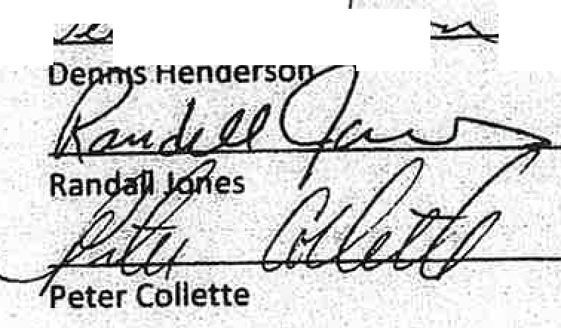
,
_$,
. .
• r· •
·• ...::., ,
.
_.. l
<
. :

. '·
·- . 'Municipal Offices of the
, . r' •.
Town-of West Paris
I'"• •
. ;

.: . DO1-lf356 BK 53.6_9 .PG 460.

ACKN-C>WLEO·GEMENT.
·_. For Notice of Determination of Presumption Qf abandonment :
·. . For Finn Road West 'Paris, ME \: I •

STATEOF MAINE
, tQuntv ofOxford
. ,·

· 'Date: September 25, 2017 · t ••

. ,-.·
Personally appea.recHhe bove narri.ed-Rand IIJones,-l;)ennis Henderson, and Peter Collette
·· Munidpal Officers of the iown of We'st Pa ,-Maine and adcriowledged the foregoing ·
in
instrument to be their free act and deed ·t'h ir-capacity. .
' . .

......,...,....,...,..,,..-...·-·-- Before me,
NO·;...,Y WC·Y:,m} .O.F.. ,NE
MY COMMISSldN.EXPlRES.04-0$-20.19'
.....c. or,oQOrn' °'Q'""'" """
0F OXFORD

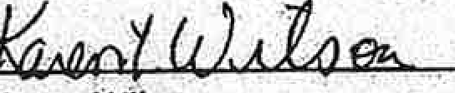
,
Ka"tenWll n
.

Notary Public

,.
. ., . ' .

.. ..

. .
'Reoorded:Oxtord East eount:v Sl26l2017 08:09:-12 AM
. P;iiricia A_,ShQ rrn:an 'f?ii!gi.s:htr of Oe.ad:s;:

.. - '• ' . . . ·'.

. ·.

. _ ..

...

•'• .

, ..

; •,

. .-.

: ..

., ., .
. .

EXHIBIT 2
Oxford County Sheriff Christopher Wainwright emails dated May 2022. (highlighted)

From: Neil Lanteigne
Sent: Monday, June 6, 2022 12:08 PM
To: cwainwright@oxfordcountysheriff.com <cwainwr,ight@oxfordcountysheriff.com>
Subject: Re: Legal Status Finn Road Public Easement

Sheriff Christopher Wainwright,

Thank you for your response.

As indicated in Attorney Conway's legal memorandum (page 6, paragraph 2), the towns March 14, 2022 letter is not dispositive of the status of Finn Road. The March 14, 2022 letter you are referring to does not have any effect on the towns 2017 Notice of Determination of Presumption of Abandonment which resulted in a public easement pursuant to M.R.S. Title 23,
§3028. Furthermore, the Oxford County Board of Commissioners decided on April 15 2022 "the March 14 letter was not a vote by the town under 23 M.R.S. § 3028-A" and therefore does not constitute a determination as to the status of the road. (Please see attached Notice of Decision dated April 19, 2022)

The towns 2017 Notice of Determination of Presumption of Abandonment resulted in a public easement pursuant to M.R.S. Title 23, §3028. By law, the towns 2017 determination resulting in a public easement is binding and unless and until a court orders otherwise, the obstructions blocking the public right of way need to be removed.

You need to abide by the law. It is the obligation of law enforcement to enforce the law equally, without exception, and order the landowners to remove the obstructions blocking the public right of way pursuant to M.R.S. Title 17-A, §505.

Neil Lanteigne
18 Ellingwood Road
West Paris, Maine 04289 Phone: 207-370-4727
Ham Radio: NB9D
Email: nlanteigne@hotmail.com

DISCLAIMER:
This e-mail and any file or attachment transmitted with it, is only intended for the use of the person and/or entity to whom it is addressed and may contain information that is privileged, confidential, and exempt from disclosure under applicable Jaw. If the recipient of this message is not the intended recipient or otherwise responsible for delivering the message to the intended
recipient, be notified that any disclosure, distribution or copying of this information is strictly prohibited. If you received this communication in error, destroy all copies of this message, attachments and/or files in your possession, custody or control and any other copies you may
have created, and notify the sender at the sender's e-mail address listed above.

From: Sheriff Christopher Wainwr-ight <cwainwright@oxfordcountysheriff.com>
Sent: Monday, June 6, 2022 10:47 AM
To: Neil Lanteigne
Subject: Re: Legal Status Finn Road Public Easement

Mr. Lanteigne:

Thank you for your email this morning regarding the "obstructions" on Finn Road. I attach correspondence addressed to you from the Town of West Paris stating that there is no public easement retained. Given the Town's position, any 'obstructions" are not unlawful. Unless a Court order or the Town determines otherwise, l will a/Jide by the Town's determination fi·om November 20I 5 that the Road was abandoned at some point prior to 1965 and that there is no public easement retained
Sincerely,

Sheriff Christopher Wainwright

Oxford County Sheriff's Office 26 Western Avenue
PO Box 179
South Paris, ME 04281

(207)743-9554 Ext. 111
(207)743-1510 FAX

FBINA 224th Session

"Of every one-hundred men, ten shouldn't even be there. Eighty are nothing but targets. Nine are real fighters. We are lucky to have them, they make the battle.
AH, BUT THE ONE! One of them is a WARRIOR,
And he will bring the others back." - Hericletus c. 500 B.C.

The information contained in this e-mail is legally privileged and confidential information intended only for the use of the individuals or entities names as addressees. If you, the reader of this message, are not the intended recipient, you are hereby notified that any dissemination, distribution, publication, cir copying of this message is strictly prohibited. If you have received this facsimile in error, please forgive the inconvenience, immediately notify the sender, and delete the original message without keeping a copy.

-----Original Message ­

From: "Neil Lanteigne"
Date: 06/06/2022 07:37 AM
To: "cwainwright@oxfordcountysheriff.com" <cwainwright@oxfordcountysheriff.com>
Subject: Legal Status Finn Road Public Easement Sheriff Christopher Wainwright,
I have yet to receive a response from you. Have you notified the landowners? When are the obstructions going to be removed?

By law the road is a public right of way. The road was determined by the municipality to be a. public easement pursuant to M.R.S. Title 23, §3028. The State prosecuted David Manter in State v. Manter and sentenced him to ten days in jail because he obstructed a public easement on a discontinued or abandoned road. Ken-01-270 (2001). The public has an "unfettered right of access." to any public easement. Town of Fayette v. Manter 528 A.2d 887 (1987), footnote
- It is the obligation of law enforcement to enforce the law equally, without exception, and order the landowners to remove the obstructions blocking the public right of way pursuant to
M.R.S. Title 17-A, §505.

The Maine Intelligence and Investigative Record Information Act protects information from being disclosed to the public. Premature disclosure of protected information may prejudice an ongoing investigation. Unlawfully, the County has made protected information available to the public at large.

Prejudicial, misleading and false allegations were leaked to the media by the Oxford County Sheriff's Office and published in the news outlets including the Sun Journal. According to
M.R.S. Title 16, §804(2) there are limitations on the public dissemination of prejudicial information concerning an accused person or concerning the prosecution's evidence that will interfere with the ability of a court to impanel an impartial jury. The documents in question are exactly the type of documents that the Legislature intended to protect from public disclosure by M.R.S. Title 16, § 804.

Pursuant to M.R.S. Title 16, §809, unlawful dissemination of confidential intelligence and investigative record information is a Class E crime. I am hopeful you will fully investigate this matter and identify the individual in the Oxford County Sheriff's Department responsible for negligently and improperly leaking this information so that they can be held accountable in accordance with the law. The public release of the documents in question by the Oxford County Sheriff's Office was not in good faith and in violation of the law.

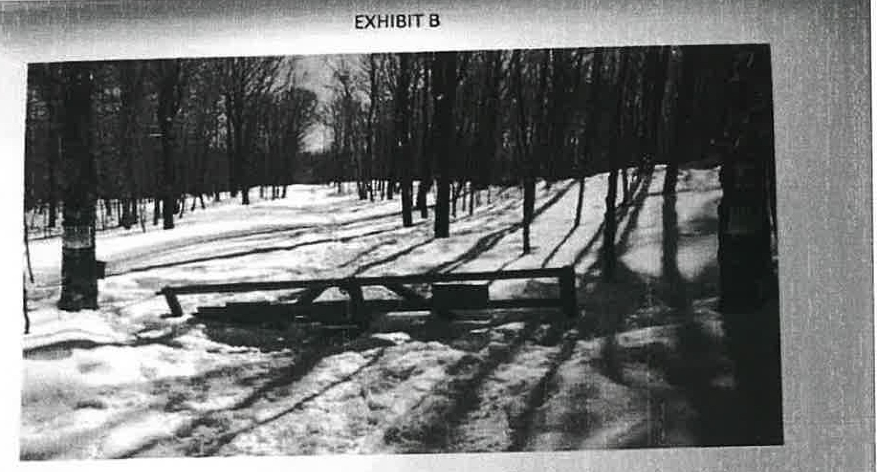
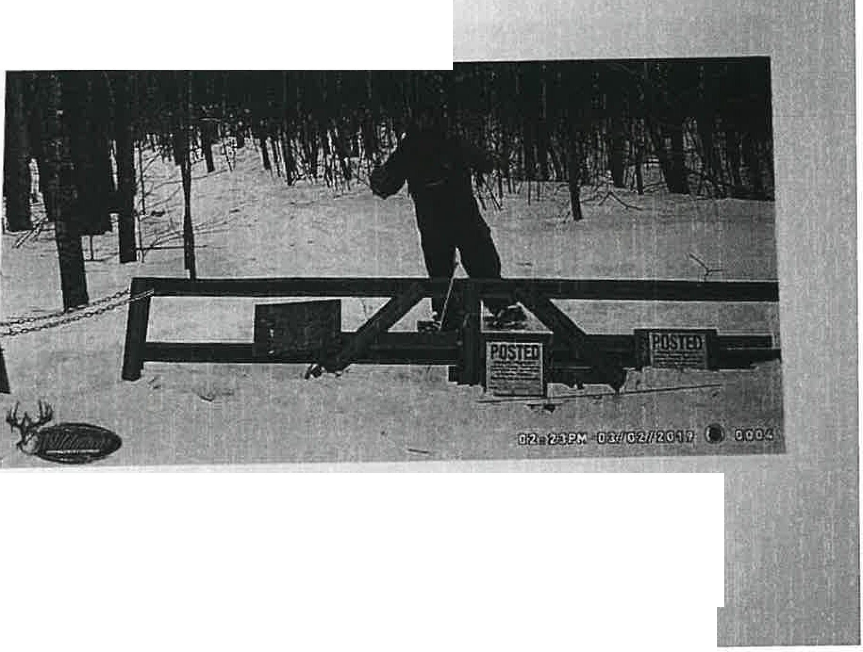
Gate separating Neil Lanteigne and Binney property Ne trespassing signs facing
Lanteigne property.

EXHIStTC
Neil Lanteigne taking his own photo trespassing on Binney pri;,perty

"Oxford County Sheriffs.Office photosp

Source: http://www.sun jou rna I.com/2019 /04/16/paris-man-44-indicted-on-weapons-charges/

I have attached a legal memorandum from real estate Attorney John W. Conway, ESQ of Linnell, Choate & Webber, LLP regarding the legal status of the Old Finn Road in West Paris,
Maine. Attorney Conway's independent research (paid for by the State) confirms the legal status of the road is a public easement. The road is a public easement by law and the Oxford, County Sheriff's Office needs to treat it as such. Please order the removal of the obstructions blocking the public easement immediately and I would appreciate a public apology from the Oxford County Sheriff's Office because I was not trespassing.

Neil Lanteigne
18 Ellingwood Road
West Paris, Maine 04289 Phone: 207-370-4727
Ham Radio: NB9D
Email: nlanteigne@hotmail.com

DISCLAIMER:
This e-mail and any file or attachment transmitted with it, is only intended for the use of the person and/or entity to whom it is addressed and may contain information that is privileged, confidential, and exempt from disclosure under applicable law. If the recipient of this message is not the intended recipient or otherwise responsible for delivering the message to the intended
recipient, be notified that any disclosure, distribution or copying of this information is strictly prohibited. If you received this communication in error, destroy all copies of this message, attachments and/or files in your possession, custody or control and any other copies you may have created, and notify the sender at the sender's e-mail address listed above.

From: Neil Lanteigne
Sent: Saturday, May 28, 2022 1:05 PM
To: cwainwright@oxfordcountysheriff.com <cwainwright@oxfordcountysheriff.com>
Subject: legal Status Finn Road Public Easement

Sheriff Christopher Wainwright,

I have attached a legal memorandum from real estate Attorney John W. Conway, ESQ of Linnell, Choate & Webber, LLP regarding the legal status of the Old Finn Road in West Paris,
Maine. Attorney Conway's independent research (paid for by the State) confirms the legal status of the road is a public easement.

I hereby wish to exercise my right to use the public easement to access my properties in Paris. The public easement is available to me and any other member of the public. The Maine Supreme Judicial Court has long upheld the public has an unfettered right of access to any public easement. Town of Fayette v. Manter 528 A.2d 887 (1987).

As you may be aware, obstructing public ways is a Class E Crime pursuant and according to Title 17-A, §SOS: A person is guilty of obstructing public ways if he unreasonably obstructs the free passage of foot or vehicular traffic on any public way, and refuses to cease or remove the obstruction upon a lawful order to do so given him by a law enforcement officer.

You have an obligation and duty to enforce the laws in the State of Maine. It is within your authority to order the obstructions blocking the public easement removed. I hereby demand that the landowners be notified and the obstructions blocking the public easement need to be removed. If the landowners along Finn Road in West Paris are unwilling to remove the obstructions blocking the public easement, they should be charged in accordance with the law.

Neil Lanteigne
18 Ellingwood Road
West Paris, Maine 04289 Phone: 207-370-4727
Ham Radio: NB9D
Email: nlanteigne@hotmail.com

DISCLAIMER:
This e-mail and any file or attachment transmitted with it, is only intended for the use of the person and/or entity to whom it is addressed and may contain information that is privileged, confidential, and exempt from disclosure under applicable law. If the recipient of this message is not the intended recipient or otherwise responsible for delivering the message to the intended recipient, be notified that any disclosure, distribution or copying of this information is strictly prohibited. If you received this communication in error, destroy all copies of this message, attachments and/or files in your possession, custody or control and any other copies you may have created, and notify the sender at the sender's e-mail address listed above.

EXHIBIT 3
Executive Sessions Town of West Paris and Oxford County Commissioners (highlighted)

OXFORD COUNTY COMMISSIONERS MEETING MINUTES

February 19, 2019

Meeting Convened
At the Court of Oxford County Commissioners begun and held at Paris, Maine within and for the County of Oxford at 9:00 am on Tuesday, February 19, 2019 being a special session, there were present:

David Duguay Timothy Turner Steven Merrill Tom Winsor
Chairman Commissioner Commissioner County Administrator

The Pledge of Allegiance was recited.

,Agenda Adopted
The agenda was adopted with the addition of reviewing Magalloway communication and discussion with Marc Roy.

,Minutes Approval
The following action occurred regarding sets of minutes of previous meetings:

December 18
January 3
January 15 February7
approved with amendments approved with amendments tabled
tabled

_Public Comment
None.

_Department Heads
Department heads met with the Commissioners to discuss a variety of topics, some being unique to specific departments and other topics being of concern to several or all departments.

'"Executive Session to Consult with Attorne re Litigation Matter
IThe Commissioners entered into an executive session with Attorney Jim Pross to discuss a litigation matter. They took no action upon returning to open session.

Sheriff's Report
Sheriff Chris Wainwright and Chief Deputy Jim Urquhart spoke with the Commissioners and updated them on departmental matters such as the billing rates, CID building repairs, and a recent law enforcement meeting with district chiefs.

The Commissioners noted that the check from Nova Northeastern University would be deposited as Sheriff's Office miscellaneous revenue as discussed at the February 7 meeting.

OXFORD COUNTY COMMISSIONERS MEETING MINUTES

April 16, 2019

Meeting Convened
At the Court of Oxford County Commissioners begun and held at Paris, Maine within and for the County of Oxford at 9:00 am on Tuesday, April 16, 2019 being a regular session, there were present:

David Duguay Timothy Turner Steven Merrill
Chairman Commissioner Commissioner

The Pledge of Allegiance was recited.

Public Comment
;
None.

_Department Heads
Department heads met with the Commissioners to discuss a variety of topics, some being unique to specific departments and other topics being of concern to several or all departments.

.Treasurer's Report
Treasurer Beth Calhoun updated the Commissioners on current financial operations.

It was noted that now that Berry Talbot and Royer are closing in on the transition process, she will be able to start producing standard monthly reports.

_Executive Session to Confer with Counsel
The Commissioners entered into an executive session with Attorney Jim Pross. They took no action upon returning to open session.

_Sheriff's Report
Sheriff Chris Wainwright and Chief Deputy Jim Urquhart spoke with the commissioners regarding departmental matters.

The Commissioners authorized an additional $655.56 for office furniture with funds to be qrawn from the drug account.

The Commissioners authorized a contract with MSAD #10 for a part time school resource officer.

The Commissioners entered into an executive session to discuss a personnel matter. They took no action upon returning to open session.

_Lunch Recess
The Commissioners recessed for lunch in RCC to celebrate telecommunications week at 12:30pm
and reconvened at 1:00pm.

OXFORD COUNTY COMMISSIONERS MEETING MINUTES

May 28, 2019

Meeting Convened
At the Court of Oxford County Commissioners begun and held at Paris, Maine within and for the County of Oxford at 9:00 am on Tuesday, May 28, 2019 being a special session, there were present:

David Duguay Timothy Turner Steven Merrill Tom Winsor
Chairman Commissioner Commissioner County Administrator

The Pledge of Allegiance was recited.

Agenda Adopted
The agenda was adopted as amended.

Executive Sessfon to Confer with Counsel
The Commissioner entered into an executive session with Attorney Jim Pross. They took no action upon returning to open session.

Executive Session to Discuss Union Contract Negotiations
The Commissioners entered into an executive session to discussion union contract negotiations. They took no action upon returning to open session.

Adjournment
The Commissioners adjourned at 11:41am.
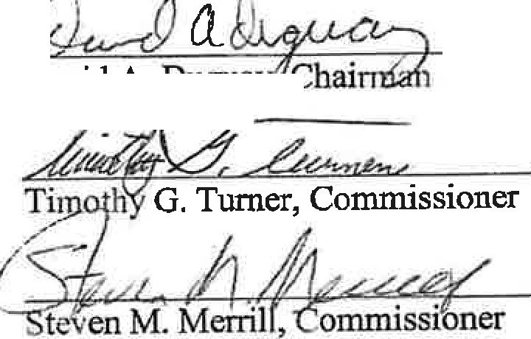

David A. Dugua
y

Notes:
- These minutes are intended to be a brief description of meeting actions to provide, in a general sense only, an account of what was discussed.

- Unless otherwise noted, all votes taken by the Commissioners were unanimous.

OXFORD COUNTY COMMISSIONERS MEETING MINUTES

October 11, 2019

.Meeting Convened
At the Court of Oxford County Commissioners begun and held at Paris, Maine within and for the County of Oxford at 2:00 pm on Friday, October 11, 2019 being a special session, there were present:

David Duguay Timothy Turner Steven Merrill Tom Winsor
Chairman Commissioner Commissioner County Administrator

It was noted that Commissioner Merrill was late due to a previously scheduled medical appointment and arrived at 2:40

The Pledge of Allegiance was recited.

Agenda Adopted
The agenda was adopted as written.

,Executive Session to Discuss Potential Litigation w/ Counsel
The Commissioners entered an executive session (I M.R.S.A. § 405-6 E) with Attorney Jim Pross of Skelton Taintor & Abbott. They took no action upon returning to open session.

Union Grievance
The Commissioners heard a union grievance from former employee Chris Davis regarding severance pay.

Both parties agreed to hold the hearing in public. A recording of this hearing is available via request of the Administration Office.

It was noted that a decision will be made at a future meeting once the Commissioners have had a chance to deliberate.

"'Adjournment
The Commissioners adjourned at 4:30pm.
()Ja

David A. Dugua'

ffloner
<._ y.,._ /l-'/ /1 &£
Steven M. Merrill, C"ommissioner

OXFORD COUNTY COMMISSIONERS MEETING MINUTES

November 19, 2019

Meeting Convened
At the Court of Oxford County Commissioners begun and held at Paris, Maine within and for the County of Oxford at 9:00 am on Tuesday, November 19, 2019 being a regular session, there were present:

David Duguay Timothy Turner Steven Merrill Tom Winsor
Chairman Conirnissioner Commissioner County Administrator

The Pledge of Allegiance was recited.

_Agenda Adopted
The agenda was adopted as written.

_Minutes Approval
The following action occurred regarding sets of minutes of previous meetings:

September 17
October 3

October 11
October 15
October 21 November?
approved with amendments
approved with amendments - Commissioner Merrill abstained as he was not in attendance at this meeting due to an urgent family matter approved
approved with amendments approved
approved with amendments

_Public Comment
Hartford resident Joan Kelly asked the Commissioners for an update on a recent IA into the report of damaged county property. Commissioner Duguay responded that although the investigation itself is essentially finished, the final document has not been completed and further advised that it will need to be redacted for public review.

Ms. Kelly also asked the Commissioners for a copy of the County's contract for labor consulting services and whether it has ever been discussed to use an Attorney for such services instead.
County Administrator Tom Winsor said that it appears there is not currently a written contract in place.

Department He.ads
Department heads met with the Commissioners to discuss a variety of topics, some being unique to specific departments and other topics being of concern to several or all departments.

Sheriff's Report
Sheriff Chris Wainwright and Chief Deputy Jim Urquhart spoke with the commissioners regarding departmental matters.

The Commissioners acknowledged the promotion of Michael Damon to Corrections Sergeant with a wage rate of$19.75/hr effective December 1.

The Commissioners authorized a six-month extension of the Inmate Boarding Agreement with Two Bridges Regional Jail noting that there are no changes.

,Treasurer's Report
Treasurer Beth Calhoun updated the Commissioners on current financial operations and distributed written reports.

Lunch Recess
The Commissioners recessed for lunch at 12:15pm and reconvened at 12:45pm.

_Personnel Updates and Actions
The Commissioners authorized a wage increase for part-time dispatchers to $17.50/hr effective December 1.

The Commissioners entered an executive session (1 M.R.S.A. § 405-6 A) to review a recent exit interview. They took no action upon returning to open session.

Executive Session to Confer with Counsel re County's Legal Rights
0

The Cornnti sioners entered an executive session with Attorney Jim Pross of Skelton Taintor and Abbott to discuss the County's legal rights. They took no action upon returning to open session.

_Berrv Talbot Rover Report
Marc Roy of Berry Talbot Royer met with the Commissioners and several department heads to review changes to the proposed 2020 general fund budget in preparation for the budget committee workshop at 6:00pm.

Items for Discussion and Action - Considered as Time Permits Throughout Meeting
The Commissioners discussed the following and acted only as underlined.
- Received Update from Maine County Commissioners Association
- Received Update on Legislative Matters
- Received Administrator's Report

OXFORD COUNTY COMMISSIONERS MEETING MINUTES

September 28, 2020

Meeting Convened
At the Court of Oxford County Commissioners begun and held at Paris, Maine within and for the County of Oxford at 12:00 pm on Monday, September 28, 2020 being a special session, there wer present:

Timothy Turner Steven Merrill David Duguay Tom Winsor
Chairman (via Zoom) Commissioner Commissioner (via Zoom)
County Administrator (via Zoom)

The Pledge of Allegiance was recited.

Executive Session to Confer with Counsel
The Commissioners entered an executive session (1 M.R.S.A. § 405-6 E) via Zoom with Attorney James Pross ofSke1ton Taintor and Abbott and Attorney Laura Rideout of Preti Flaherty. No action was needed upon returning to open session.

Executive Session to D.iscuss a Personnel Matter
The Commissioners entered an executive session (I M.R.S.A. § 405-6 E) via Zoom with Attorney James Pross and County Administrator Tom Winsor to discuss a personnel matter. No action was needed upon returning to open session.

Adjournment
The Commissioners adjourned at 1:53pm.

Tiinotw G. Turner, Chairman
Merrill Commissioner

LAtevenM.
/4 ,JJ,-,,

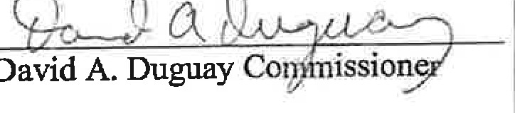

Notes:
- These minutes are intende'<J, to be a brief description of meeting actions to provide, in a general sense only, an account of what wa.s discussed.

- Unless otherwise noted, all votes taken by the Commissioners were unanimous.

OXFORD COUNTY COMMISSIONERS MEETING MINUTES

November 5, 2020

Meeting Convened
At the Court of Oxford County Commissioners begun and held at Paris, Maine within and for the County of Oxford at 9:00 am on Thursday, November 5, 2020 being a workshop, there were present:

Timothy Turner Steven Merrill David Duguay
Chairman Commissioner Commissioner

The Pledge of Allegiance was recited.

Agenda Adopted
The agenda was adopted with the addition of accepting an updated resignation letter.

Minutes Approval
The following action occurred regarding sets of minutes of previous meetings:

October 20
October 21 October28
approved with amendments approved
approved

Department Heads' Report
The Commissioners toured the parking lot with several department heads to discuss possible employee parking solutions. The Commissioners were in favor of purchasing additional parking signs to help clearly identify employee parking.

The Commissioners also discussed using existing spaces in the upper parking lot for the DA's Office employees to use during Commissioner meeting days when parking is more limited.

Executive Session to Consult with Attorne
The Commissioners entered an executive session (1 M.R.S.A. § 405-6 E) with Attorney James Pross of Skelton Taintor and Abbott to discuss a litigation matter. No action was needed upon returning to open session.

Treasurer's Report
Attorney Pross explained the bond process to fund the relocation of the public safety offices; RCC, EMA, and the Sheriff's Office. It was determined that the next step is to determine the County's borrow limit and conduct an engineer study to identify the true cost of the project.

Sheriff's Report
Sheriff Chris Wainwright updated the Commissioners on departmental matters.

OXFORD COUNTY COMMISSIONERS MEETING MINUTES

March 3, 2022

Meeting Conyened
At the Court of Oxford County Commissioners begun and held at Paris, Maine within and for the Connty of Oxford at 9:00 am on Thursday, March 3, 2022 being a workshop, there were present:

Timothy Turner Steven Merrill David Duguay
Chairman Commissioner Commissioner

The Pledge of Allegiance was recited.

Agenda Adopted
The agenda was adopted as written.

Minutes Approval
The following action occurred regarding sets of minutes of previous meetings:

1 February 15 approved with Commissioner Merrill abstaining as he was not present for the February 15 meeting due to medical reasons.

2022 Tax Commitment
The Commissioners authorized the 2022 tax commitment with a mil rate of 9.60, a slight decrease
fi;:Qm the 2021 mil rate q_f 9. 72.
The 2022 tax commitment is attached to these minutes.

Executive Session to Review Correspondence from Cou.nseJ
The Commissioners entered executive session (I M.R.S.A. § 405-6 E) to review correspondence from Counsel. No action was needed upon returning to open session.

Personnel Updates and Actions
The Commissioners authorized the hiring of Heidi Schreiber as a full-time Legal Secretary with the following confirmed:

- Effective Date:
- WageRate:
- Special Conditions:
March 7, 2022
$17.45/hr (4th year rate) none

It was noted that Kiersten Kise who was hired as a Legal Secretary on February 15 withdrew her application.

OXFORD COUNTY COMMISSIONERS MEETING MINUTES

April 15, 2022

Meeting Convened
At the Court of Oxford County Commissioners begun and held at Paris, Maine within and for the County of Oxford at 9:00 am on Friday, April 15, 2022 being_ a special session, th.ere were presen

Timothy Turner Steven Merrill David Duguay
Chairman Commissioner Commissioner

The Pledge of Allegiance was recited.

Agenda Adopted
The agenda was adopted as written.

Executive Session to Consult with Counsel
The Commissioners entered an executive session (1 M.R.S.A. § 405-6 E) to consult with Attorney James Pross of Skelton Taintor and Abbott. No action was needed upon returning to open session.

Public Hearing - Finn Road Abandonment Appeal
Chairman Turner opened the hearing by explaining the context of hearing pursuant to 23 M.R.S.. 3028-A (7), and identifying the March 16, 2022 appeal filed by Neil Lanteigne of West Paris who asked the Commissioners to reconsider a vote and decision regarding Finn Road which he alleges the Town of West Paris took on March 14, 2022, which he alleged is evidence by a letter he received from the Town.

Attorney Zachary Brandwein who represents the Town of West Paris argued that the March 14th letter Mr. Lanteigne is referring to was not record of new action and was just an informational summary of previous action taken by the Town regarding Finn Road. Attorney Brandwein asked the Board to dismiss the appeal as the request for an appeal was not submitted in a timely manner and therefor the Com.missioners would not have jurisdiction under 23 M.R.S. § 3028-A.

After hearing public comment from West Paris officials and multiple residents, the Commissioners voted unanimously to dismiss the appeal and adopt a finding that they do not hav jurisdiction because the Finn Road in West Paris was abandoned prior to March 14, 2022 and wac; not a town way, and that the March 14th letter was not a vote by the Town under 23 M.R.S. § 3028-A.

Adiournment
The Commissioners adjourned at 10:53am

1

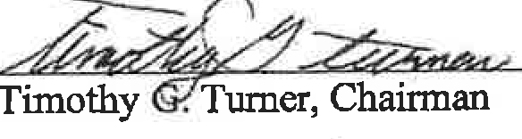

Steven M. Merrill Commissioner
' <;JkC\ 44' .
Qc,.,J2a
David A. Dugua

OXFORD COUNTY COMMISSIONERS MEETING MINUTES

Septem her 1, 2022

Meeting Convened
At the Court of Oxford County Commissioners begun and held at Paris, Maine within and for the County of Oxford at 9:00 am on Thursday, September I, 2022 being a workshop, there were present:

Timothy Turner Steven Merrill David Duguay
Chairman Commissioner Commissioner

The Pledge of Allegiance was recited.

Agenda Adopted
The agenda was adopted as written.

Minutes Approval
The following action occurred regarding sets of minutes of previous meetings: August 16 approved with amendments
Executive Session to Consult with Attorney
The Commissioners entered an executive session (1 M.R.S.A. § 405-6 E) to consult with Attorney Jim Pross of Skelton Taintor and Abbott regarding the legal rights of the County involving potential litigation. No action was needed upon returning to open session.

Sheriff's Report
The Commissioners authorized the submission of a Byrne/JAG grant application to utilize unused funds that remain available.

The Commissioners ratified an MOU with the Teamsters Union dated September 1.

The Commissioners authorized the hiring of Matthew Steinort as a full-time Corrections Officer with the following confirmed:

- Effective Date:
- Wage Rate:
- Special Conditions:
September 1, 2022
$17.94/hr (1st year rate) none

Jail Administrator Dana Dillingham noted that the jail is now full-staffed.

Personnel Updates and Actions
The Commissioners accepted th,e resignation of full-time Dispatcher Tina Suttles effective August 14 and authorized the posting of the open position.

1

l •
- h/

TOWN OF WEST PARIS
Regular Selectmen's Meeting November 12, 2015

Call to order.
Pledge of Allegiance.
I. Accept minutes of October 22, 2015.
Agenda

- Meet with the Town's Attorney. Executive Session pursuant to Title I M.R.S.A. Section 405(6)(e) Issues lo be discussed may include rht sratu.s of the Fin11 Road and a defau/1 on a lax acquired property repurchase agreemenJ.
- Chandler Wright property-potential junkyard violation (remove from table).
- Approve tax acquired property repurchase agreement.
- Schedule a public hearing for a junkyard pennit application.
- Schedule a public hearing for a special amusement pennit
- Consider a waiver of foreclosure on a tax lien.
- Discuss initiation of a yard sale ordinance.
- Appoint a Selectman to serve as an AVCOG General Assembly representative.
- Accept resignation of Nata.lie Andrews from the Planning Board.
- Appoint Diane Holt as a regular member of the Planning Board.
- Town Manager's report
- Treasurer's Warrants.
Adjourn.
Minutes

The meeting was called to order at 5:00 pm with Selectmen Randall Jones, Dennis Henderson and Peter Collette present.
0
- Mr. Henderson moved acceptance of the minutes of October 22, 2015. Mr. Collette seconded. Vote: 3 in favor, 0 opposed

- Mr. Collette moved to enter executive session pursuant to Title 1 M.R.S.A. Section 405(6)(e) a meeting with the Town's legaJ counsel. Mr. Henderson seconded. Vote: 3 in favor, 0 opposed
At 5:34 p.m. the Selectmen return to regular session.

The Selectmen asked their attorney Mary Costigan to make a statement about the status of the abandoned portion of Finn Road. Attorney Costigan stated that the Selectmen were and are of the opinion that the road was abandoned and that abandonment occurred prior to 1965 extinguishing alt easements and rights-of-way. From all the material reviewed they have seen no evidence to rebut their opinion.
Carl Lanteigne the father of Neil Lanteigne asked to speak. He reported that his son had been assaulted recently over this issue. He then read a statement from his son. Mr. Henderson stated. that the Finn Road end where the plow ond grader stops. /Cwn'ctirm nddcd upoo,,._ .,.,,,me!!,m .\1,.-l!mher 15. 2n1 SJ He then said the
Town was partia.lly at fault for the assault and said Mr. Henderson was partial1y responsible as he said in court that the road was private property. Mr. Jones ended the discussion at that point.

- The tabled item regarding a potential junkyard violation was removed from the table as no further action is required.
- Mr. Henderson moved to approve the tax acquired property repurchase agreement with Erica Johnson. Mr. Collette seconded. Vote: 3 in favor, 0 opposed
- Mr. Henderson moved to schedule a junkyard permit hearing for Frank Perham for the December 11, 2015
() meeting. Mr. Collette seconded. Vote: 3 in favor, 0 opposed
...
\ .,./

Page I of2

Opened: 5:00pm by Eli White, Chairman

TOWN OF WEST PARIS
Selectboard's Meeting March 10th, 2022 Minutes

Eli led the Pledge of Allegiance to our country's llag.

Present: Eli White, Chairman; Dale Piirainen, Selectman; Jen Billings, Selectman; Joy Downing, Town Manager; Wade Rainey, citizen· Dinn Rainey, citizen; Mark Jackson, visitor; Madeline Jackson, visitor; Neil Lanteigne, visitor; Kevin Davis, fire fighter, Brianna Davis, citizen; Angie Paine, Rec Director; Chad Stearns, citizens; Mike Henderson, fire fighter; Troy Billings, ire Chief; Warren Packard. Road Foreman; Claire Gelinas. Planning Board; Clay Abbott, Water District Trustee; Brenda Gould, Library Director. and Ralph Brown, citilcn. ·

Old Business:

No old business to discuss.

New Business:

Eli made a motion to nominate Dale as the Chairman of the Selcctboard. 2nd by Jen. Unanimous in favor ofmolion.

Jen made a motion to accept the February 24'h. 2022, regular Selectmen's mecling minutes. 2nd by El.i. Unanimous in favor of motion.

Jen made a motion to approve Payroll Warrant #9 in the amount of$ 17,269.89 and Accounts Payable Warrant #10 in the amount of
$131.155.08. 2rn1 by Eli. Unanimous in favor of motion.

Dale read out loud Troy Bil.lings resignation Jetwr. Dale also stated that he and the Town appreciates everything that he has done for
the Town. Dale made a motion to accept Tmy's resignation letter. 2nd by EH.

Dale made a motion to enter into execuLive session pursuant to I M.R.S.A. § 405(6)(A) to discuss a personnel matter at 5:04pm. 2nd by Eli. Unanimous in favor of motion.

Executive session ended at 5:17pm.

Eli made a motion to sign the Certificate of Appointment for: Mike Henderson to take over as Acting Fire Chief for the Town of West Paris. Fire Dept. 2nd by Dale. Jen abstained.

Eli made a motion tu sign the Certificates of Appointment for Claire Gelinas. Jeffrey Holle.y, and Andelina Henderson to he Planning
Board members for the Town or West Paris. 2nd by Jen. Unanimous in favor of motion.
Eli made a motion to sign the Certificate of Appointment for Ralph Brown to take over for Clay Abbott for the remainder of his tem1
as West Paris Water District Trustee (l year term). 2n<i by Jen. Unanimous in favor of motion,

Certificate of Appointment for Benjamin Leonard to be a West Paris Water District Trustee was i;igncd by all Sclcctboard members.

Certificate of Appointment for Veronica Poland to be a ScbQol Board Director for the Town of West Paris was signe.d by all Sekctboard members.

Dale made a motion to open bids for spring cleanup and seasonal maintenance. 2nd by Eli. I bid was submitted from Fred Waterhouse for $20.000.00 total for the season or $1,000.00 per week for 20 weeks.

Article failed. No motion was made to accept bid.

Dale made a motion to ope-n bids for culvert installaLion on Snow Falls Road. 2"" by Jen. I biu was submitted from Cross Excavation
in the arn<,unt of$l9,498.00.

Article failed. No motion was made to accept bid.

Eli mode a motion to put lhc old fire !ruck/highway truck and rrackfcss machine out to bid. 2nd by fon. Unnnimous in favor of motion.

Dale made a motion to move into ex.ecuciw session pursuan1 to I M.R.S.A. § 405(6)(A) to discuss a personnel matter at 5:J9pm. 2"J
by Eli. Unanimous in favor or motion.

Executive session ended at 5:47pm.
Daie made a motion to move into executive session pursuant to l M.R.S.A. § 405(6)(E) to have a consultation with legal counsel at
5:48pm. 2111b1y Jen. Unanimous in favor of motion.

Executive session ended at 6: I lpm.

Other Business

Town Managers Update:
The Public Hearing for the Special Town Meeting wmbe in the paper on 3/31/2022 and 4flf2fJ22.
The Public Hearing will be on Thursday, 4/14/2022 alli!r the Selectboard's Meeting.
The-Special Town Meeting will be in the paper on 3/1412022 and 3/21/2022.
The Special Town Meeting will be on Saturday, April 23"'. 2022 al the Ring Mckeen American Legion Post 151 on Church
Street in West Paris.

Bids for the paving of Ellingwood Road wtl1 be opened at the next Selectmen's Meeting (3/24/2022).

Basebtillffec ball/ and Softball wen: disc

Culverts needed for this year were ordered on Monday and will be here in 6-8 weeks. We have enough culverts on hand to complete the work that is needed on Ellingwood Road before paving occurs.

Rec Dept Informarioo:
Chad stated that 2 of Ifie fields need to he resurfaced.

Library:

Brenda slated that maybe we could use some of the ARPA money to fix the roof drain issue/heat tape.

Eli made a motion to adjourn at 6:40pm. 2rd by Jen. Unanimous in favor of motion.

Respectfully.
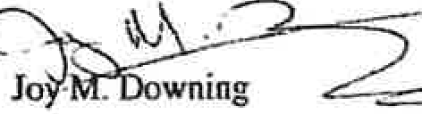

MRS Title 1. §405. EXECUTIVE SESSIONS

§405. Executive sessions
Those bodies or agencies falling within this subchapter may hold executive sessions subject to the following conditions. [PL 1975, c. 758 (NEW).]
- Not to defeat purposes of subchapter. An executive session may not be used to defeat the purposes of this subchapter as stated in section 401.
[PL 2009, c. 240, §2 (AMO).]
- Final approval of certain items prohibited. An ordinance, order, rule, resolution, regulation, contract, appointment or other official action may not be finally approved at an executive session.
[PL 2009, c. 240, §2 (AMO).]
- Procedure for calling of executive session. An executive session may be called only by a public, recorded vote of 3/5 of the members, present and voting, of such bodies or agencies.
[PL 2009, c. 240, §2 (AMO).]
- Motion contents. A motion to go into executive session must indicate the precise nature of the business of the executive session and include a citation of one or more sources of statutory or other authority that permits an executive session for that business. Failure to state all authorities justifying the executive session does not constitute a violation of this subchapter if one or more of the authorities are accurately cited in the motion. An inaccurate citation of authority for an executive session does not violate this subchapter if valid authority that permits the executive session exists and the failure to cite the valid authority was inadvertent.
[PL 2003, c. 709, §1 (AMO).]
- Matters not contained in motion prohibited. Matters other than those identified in the motion to go into executive session may not be considered in that particular executive session.
[PL 2009, c. 240, §2 (AMO).]
- Permitted deliberation. Deliberations on only the following matters may be conducted during an executive session:
  - Discussion or consideration of the employment, appointment, assignment, duties, promotion, demotion, compensation, evaluation, disciplining, resignation or dismissal of an individual or group of public officials, appointees or employees of the body or agency or the investigation or hearing of charges or complaints against a person or persons subject to the following conditions:
    - An executive session may be held only if public discussion could be reasonably expected to cause damage to the individual's reputation or the individual's right to privacy would be violated; ·
    - Any person charged or investigated must be pennitted to be present at an executive session if that person so desires;
    - Any person charged or investigated may request in writing that the investigation or hearing of charges or complaints against that person be conducted in open session. A request, if made to the agency, must be honored; and
    - Any person bringing charges, complaints or allegations of misconduct against the individual under discussion must be permitted to be present.
This paragraph does not apply to discussion of a budget or budget proposal; [PL 2009, c. 240,
§2 (AMO).]
  - Discussion or consideration by a school board of suspension or expulsion of a public school student or a student at a private school, the cost of whose education is paid from public funds, as long as:

10.04.2022 §405. Executive sessions I I
Generated

MRS Title 1, §405. EXECUTIVE SESSIONS

    - The student and legal counsel and, if the student is a minor, the student's parents or legal guardians are permitted to be present at an executive session if the student, parents or guardians so desire; [PL 2009, c. 240, §2 (AMO).]
  - Discussion or consideration of the condition, acquisition or the use of real or personal property permanently attached to real property or interests therein or disposition of publicly held property or economic development only if premature disclosures of the information would prejudice the competitive or bargaining position of the body or agency; [PL 1987, c. 477, §3 (AMO).]
  - Discussion of labor contracts and proposals and meetings between a public agency and its negotiators. The parties must be named before the body or agency may go into executive session. Negotiations between the representatives of a pubUc employer and public employees may be open to the public if both parties agree to conduct negotfations in open sessions; [PL 1999, c. 144, §1 (RPR).]
  - Consultations between a body or agency and its attorney concerning the legal rights and duties of the body or agency, pending or contemplated litigation, settlement offers and matters where the duties of the public body's or agency's counsel to the attorney's client pursuant to the code of professional responsibility clearly conflict with this subchapter or where premature general public knowledge would clearly place the State, municipality or other public agency or person at a substantial disadvantage; [PL 2009, c. 240, §2 (AMO).]
  - Discussions of information contained in records made, maintained or received by a body or agency when access by the general public to those records is prohibited by statute; [PL 1999, c. 180, §1 (AMO).]
  - Discussion or approval of the content of examinations administered by a body or agency for licensing, permitting or employment purposes; consultation between a body or agency and any entity that provides examination services to that body or agency regarding the content of an examination; and review of examinations with the person examined; and [PL 1999, c. 180, §2 (AMO).]
  - Consultations between municipal officers and a code enforcement officer representing the municipality pursuant to Title 30-A, section 4452, subsection 1, paragraph C in the prosecution of an enforcement matter pending in District Court when the consultation relates to that pending enforcement matter. [PL 1999, c. 180, §3 (NEW).]
[PL 2009, c. 240, §2 (AMO).]
SECTION HISTORY
PL 1975, c. 758 (RPR). PL 1979, c. 541, §A3 (AMO). PL 1987, c. 477, §§2,3 (AMO). PL 1987,
  - 769, §A1 (AMO). PL 1999, c. 40, §§1,2 {AMO). PL 1999, c. 144, §1 (AMO). PL 1999, c.
180, §§1-3 (AMO). PL 2003, c. 709, §1 (AMO). PL 2009, c. 240, §2 (AMO).

The State of Maine claims a copyright in its codified statutes. If you intend to republish this material, we require that you include the following disclaimer in your publication:
All copyrights and other rights 10 statutory text are reserved by the State of Maine. The text included in this publication reflects changes made through the Second Regular Session of the I30th Maine Legislature and is current through October 1, 2022. The text is subject to change without notice. It is a version that has not been officially certified by the Secretary of State. Refer to the Maine Revised Statutes Annotated and supplements/or certified text.
The Office of the Revisor of Statutes also requests that you send us one copy of any statutory publication you may produce. Our goal is not co restrict publishing activity, but to keep track of who is publisbfog what, to identify any needless duplication and to preserve the State's copyright rights.
PLEASE NOTE: The Revisor's Office cannot perform research for or provide legal advice or interpretation of Maine law to the public. If you need legal assistance, please contact a qualified attorney.
10.04.2022

2 I §405. Executive sessions Generated

Mikhail. Vivian

From: Sent: To: Subject:
makies1@comcast.net
Wednesday, December 21, 2022 2:22 PM info.abandonedroadscommission
Property Owners of Discontinued Town Roads

EXTERNAL: This email originated from outside of the State of Maine Mail System. Do not click links or open attachments unless you recognize the sender and know the content is safe.
Good Morning,

I understand that you are interested in hearing from owners of land on discontinue town roads. As land owner, I'd like to share my experiences with this issue.

I own a parcel on Old Long Cove Road in Bristol, ME. The road was discontinued by the town in 1911.

I purchased it from Walker Gilbert in 1972. Walker submitted a plan to Bristol's Planning Board in 1974 to subdivide his parcel into 8 lots (all of these were sold prior to this submission), The Planning Board unanimously approved it along with a ROW approved by the Board-see book 21, page 69. I have a copy of the approval if you would like to see it.

Walker Gilbert also provided an affidavit which outlines his intention and is recorded in 1999 in the Lincoln County Registry-see book 2446. Page 301. Please note that the affidavit refers to book 21, pages 68-
69. However page 68 is not part of the affidavit and should not have been reference in the affidavit.

I subsequently worked with two attorneys to determine what might be needed to secure an official ROW from the east side of Old Long Cove Road. Apparently the owner of the first lot also owns a lot directly across hi home and felt that he could refuse access (he is allowed access to his home from the subdivision which abuts his land).

I received an email from attorney Richard Salewski in 2008 in which he was satisfied that I did have a ROW as he received easements from two land owners at the beginning of Old Long Cove from the east. Unfortunately he passed away many years ago.

However others do not feel that I have a ROW. So we're at a standstill.

It would seem to me that the Planning Board believed that their approval did provide for a ROW. Why would they approve it if they felt there was no ROW. It is quite disappointing that this situation exists and all the land owners continue to pay taxes on land they cannot access. One land owner is anxious to upgrade the road to a 'camp road' so he can build a home. Other land owners may decide to do the same.

There are any benefits to the town as this land is developed and it just doesn't make sense that we are denied access. I'm sure there are many similar situations since you are looking into this matter.

Thank you and please contact me with any questions. Happy Holidays!
Patrick Macomber

6 Oxford Drive West Hartford, CT 860-930-4072

To the Abandoned Roads Commission,

Thank you all for taking the time to address the issues of discontinued and abandoned roads within our State. I imagine it will be an arduous process to come to appropriate recommendations.

My wife and I moved into our home on a private road about 11 years ago. Our property has an easement written into it for access to a state road about 800 feet from our home. Years later from a neighbor who was lived here since 1965 and some subsequent research, we found that this wasn't a private easement, it was a public easement. The title insurance didn't identify it, nor was it identified on our title, or any readily available Town map. The only official reference I found to it from the Town was from a Town Warrant that referred to our road as "road" noted with property boundary Owners and the two roads on either side.

The road we moved onto is understood to be a crossroad between two roads that has been discontinued. Currently, the western end is not passable for vehicular traffic, which means the road is not currently used by vehicles to cross. Tree growth, boulders, and uneven terrain prevents most traffic. Three residences require the use of our road to access their residences, all from the eastern end.

When the Town discontinued our road in 1978, a public easement was retained per the statute. A discontinued road with a public easement, also known as a private way, eliminates the Towns requirement to maintain a road. The maintenance liability, including the damage done by the public, falls on the property owners that require use of the road to access their homes and/or property.

The benefit of retaining the easement to abutting property owners is:

- that landowners do not become landlocked, and keep access to their property.

The downsides are that landowners using the road to access their property now have the responsibilities of:

- maintaining the road to non-local vehicular traffic,
- continued cost and time for repair the road due to public traffic that would otherwise not be allowed on Town Ways (ie. ATV's, UTV's, dirt bikes, skidders, etc.),
- maintenance liability
- safety concerns due to normal traffic laws no longer being applicable
- insurance liability

When maintenance is performed on roads (Town Ways or Public Easements/ Private Ways) a Town is generally not held liable to injury due to the Tort Claims Act. The Tort Claims Act states that a "all governmental entities shall be immune from suit on any and all tort claims seeking recovery of damages"¹ unless expressly provided by the statute and "a governmental entity is not liable for any defect, lack of repair or lack of sufficient railing in any highway, town way, sidewalk, parking area, causeway, bridge, airport runway or taxiway or in any appurtenance thereto."² Individuals maintaining a public easement are not privy to the same protections. If the "repairs are performed

1 Immunity from suit, Title 14 MRSA §8103(1) (1987). https:ljleglslature.ma.lne.gov/statutes/14/title14sec8103.html
2 Exceptions to immunity, Title 14 MRSA §8104-A(4} (2003). https:ljlegislature.maine.gov/statutes/14/title14sec8104-A.html

improperly and cause injury, the person who made the repairs to a public easement (or contracted said repairs) may be personally liable."³ The landowner liability law states the landowner "does not have a duty of care to keep the premises safe for entry or use by others for recreational or harvesting activities or to give warning of any hazardous condition, use, structure or activity on these premises to persons entering for those purposes."⁴ In other words, landowners are provided some liability protection on private property, but private caretakers of public easements are not afforded the same degree of protections as Towns are or any protection under the landowner liability law. Additionally, a snowmobile trail crosses our property and then continues along a section of the road that we maintain. If someone did hurt themselves on that section, we may be liable without the protections afforded to other landowners along the trail. The irony is that if we didn't maintain it, people wouldn't use it, as the western end of the road isn't used.

From the maintenance aspect, my neighbor and I have invested over $30,000 in capital costs to install proper access over the past decade to our property. This does not include other regular maintenance activities such as plowing, sanding, or damage to maintenance equipment. When trucks, dirt bikes, and ATV's spin tires and rut up the road, or non-local traffic decides to go mudding when the ground is soft, we take it very personally as it is costs us a significant amount money and labor to repair.

Safety of the abutting landowners using the road is also of concern. ATVs attempting to access the snowmobile trail (which is not allowed) and lost vehicles do not adhere to any speed limit when traveling our road. We have had both ATV's and snowmobiles traveling at least 60 miles an hour up a road that supports vehicle traffic at not much more than 20 mph. On more than one occasion, several of us have almost been hit by ATV's traveling at uncontrollable speeds. In addition to that, we've had people who were too intoxicated to walk driving UTV's to access the snowmobile trail system. This road is essentially our driveway, the same driveway that our kids walk up and down, that we push a stroller up and down, and are arguably less safe at times than being on the State road that intersects our private way.

In an ideal world, roads would only be discontinued that do not have a public benefit and are not used by the public. If the discontinued road retains a public easement, allowing unfettered access along that easement, is it fair to put all of that maintenance responsibility and liabilities on the shoulders of road abutters without them being able to have any representation of road use? Especially considering there isn't a property tax discount for living on one of these roads and it is more often than that unknown to the property buyer.

Respectfully, Paul Denis Bowdoinham

³ Maine Municipal Association. (2009). Municipal Roads Manual, 44
⁴ Limited liability for recreational or harvesting activities, Title 14 MRSA §159-A(2) (2015). https:ljlegislature.maine.gov/statutes/14/title14sec159-A.html

From: wptwnmgr@megalink.net
Date: December 30, 2022 at 09:05:08 EST
To: Rebecca Graham <rgraham@memun.org>
Subject: RE: Abandoned and Discontinued Roads Commission seeking your Input

CAUTION: This email originated from outside your organization. Exercise caution when opening attachments or clicking links, especially from unknown senders.

Good morning Rebecca.

The most recent conflict we have dealt with was regarding Finn Road in West Paris. There was a question as to whether this road was abandoned at some point prior to 1965. On November 12th, 2015, the Board of Selectmen held a public heating and a vote had taken place and it was determined that Finn Road was abandoned at some point prior to 1965 following 23 M.R. § 3028-A(2). "For a period of 30 or more consecutive years the town way was not kept passable for the use of motor vehicles at the expense of the municipality or county. Isolated acts of maintenance by the municipality or county without other evidence that shows a clear intent by the municipality or county to consider or use the town v ay as if it were a public way as defined in section 1903, subsection 11 does not negate evidence that the town way was not kept passable for the use of motor vehicles. Finn Road was abandoned sometime prior to 1965, and no public easement over the traveled right-of-way was retained. Additionally, the Town has not maintained Finn Road at any point since 1965. After conversation and review with our Town Attorney, it was determined that following State Statues regarding abandonment of public ways, the Road in question is not a town way, no public easement exists, and the Town has neither the legal obligation not the right to maintain the Road. This also includes removing any gates, bars obstructions placed on this road on a landowner s prope1ty. After receiving this decision, Mr.
Lanteigne filed an appeal with Oxford County Board of Commissioners whose decision is as follows: "At the duly noticed April 15th public hearing of the Oxford County Board of Commissioners, all the Commissioners were present. After hearing public comments and presentations from West Paris representative and multiple residents who attend the public hearing, the Oxford County Commissioners voted unanimously to dismiss the appeal and adopt a finding that they do not have jurisdiction under 23 M.R.S. § 3028-A(7) because the Finn Road in West Paris was abandoned prior to March 14th, 2022".
Respectfully Submitted, Joy M. Downing
Town Manager
Town of West Paris 25 Kingsbury Street
West Paris, Maine 04289 Office: (207) 674-2701
Fax: (207) 674-2703
E-mail: wptwnmgr@megalink.net Website: www.westparisme.com

Co11jide11tiality Notice: This e-mail message, inc/11ding any a11achments, is for !he sole use of 1he i11111nded reciplem(s) and may comaill co1ifideniial a11d priwleged infor111a1ion. ff you are 1101 lhe i111e11dec/ reciplen1. or an authorized agent of 1he intended recipient, please immedia1ely comae/ the sender by reply e-mall and destroy/delete all copies of the original message. Any 11na11thorf=ed review. use, copying. fo,warding. disclos11re, or dls1rib11tio11 by o/her than the illlended recipie111 or awhori=ed age111is prohibi1ed. Under Maine's Freedom of Access
("Right to Know") law, all e-ma,l and e-mail alfachmenls received or prepared/or use in mailers concerning Town business or containing

Mikhail, Vivian

From: Sent: To: Subject:
Rebecca Graham <RGraham@memun.org> Wednesday, January 4, 2023 6:14 PM Mikhail, Vivian
Fwd: Abandoned and Discontinued Roads Commission seeking your Input

EXTERNAL: This email originated from outside of the State of Maine Mail System. Do not click links or open attachments unless you recognize the sender and know the content is safe.

Hi Vivian,
Here is some additional comments from Fayette. Rebecca

Rebecca J. Graham
Legislative Advocate, Advocacy & Communications Maine Municipal Association
60 Community Drive
Augusta, Maine 04330 rgraham@memun.org
207-624-0101 (Direct Line)

Listen to our podcast: "Potholes & Politics" Local Issues from A-Z on your favorite podcast service or here: https://www.buzzsprout.com/2015308/episodes/10916270

Begin forwarded message:

From: Mark Robinson <fayette@myfairpoint.net>
Date: January 4, 2023 at 14:40:15 EST
To: Rebecca Graham <rgraham@memun.org>
Cc: Mary Denison <mdenison@lakedenison.com>, L Badeau <lbad_2004@yahoo.com>, Brian
<bdholhd03@aol.com>, Jon Beekman <jonbeekman@hotmail.com>, Michael Carlson
<meccpa@outlook.com>, toby pond <tobypondl@gmail.com>
Subject: RE: Abandoned and Discontinued Roads Commission seeking your Input

CAUTION: This email originated from outside your organization. Exercise caution when opening attachments or clicking links, especially from unknown senders.
Hello Rebecca thank you for your request. I apologize for the delay in response. I hope you may accept this submittal to the Committee for its January 11th hearing.

With all due respect, the Town of Fayette is assiduously following the current road laws and have no expressed desire to advocate changes to the current status. The Young Road in Fayette as referenced in your material statements below is one of several discontinued roads throughout the Town of Fayette and a larger number throughout the State of Maine.

Young Road is a private road across which the public in general has a public easement. The Town of Fayette has no obligation, statutory or otherwise, to maintain a private road, whether or not there is a public easement. The Town of Fayette may, in its discretion, maintain private roads pursuant to 23 MRSA section 3105-A, however, the Inhabitants of Fayette have not so authorized the use of public funds or public equipment to maintain Young Road. In the event emergency services are needed along Young Road, the Town of Fayette is authorized to, and will plow/maintain Young Road to provide necessary emergency services.

In closing, the Town of Fayette is fully complying with, the laws on the books. It goes without saying that should the Legislature change the current laws the Town of Fayette will comply with the those changes when they are required to do so.

Kind regards Mark

Mark Robinson, Town Manager Town of Fayette
2589 Main Street
Fayette, Maine 04349

207-685-4373 office
207-620-0263 mobile

From: Rebecca Graham [mailto:rgraham@memun.org]
Sent: Thursday, December 15, 2022 11:01 AM
To: fayette@myfairpoint.net
Subject: Abandoned and Discontinued Roads Commission seeking your Input

To: Municipal Officials in Key Roads Issue Communities

Fr: Rebecca Graham, Legislative Advocate, MMA

Re: Abandoned and Discontinued Roads Commission Seeking your Input

Date: December 15, 2022

The Permanent Commission on Abandoned and Discontinued Roads has been

meeting with several interested parties to identify areas of law that need clarity or are absent from statutes, thereby resulting in conflicts with communities and abutters.

The Commission has received several pieces of testimony from individuals who live on a variety of roads in your communities that call out municipalities, solely from an abutter's perspective, and advocate for road maintenance mandates, or removal of public easements, or forced municipal inventories of the status of roads in all areas. I have linked the information that the Commission has received so far: Bucksport letter; Abbot & West Paris; compilation of municipalities.

I am reaching out to you because your communities are mentioned in many of these comments and the municipal story is missing from the personal testimonies.

The Commission is seeking input from municipalities on how current road law impacts your community, how changes to current road law may improve or adversely impact your community and any ideas the Commission should consider that would help municipalities manage these concerns going forward. The Commission would like to receive written comments by Friday, December 30, 2022, and will also being holding a meeting on January 11, 2023, to accept comments in person or via Zoom. The details of that meeting will be forthcoming.

MMA would encourage you to submit comments that at least identify the priority for your community regarding the management of discontinued and abandoned roads, challenges you face in your role as a municipal official to address these issues, and any other ideas that you believe would be helpful in balancing the conversation. You may submit comments directly to the Attorney
General's Representative on the Commission, Vivian Mikhail via email at Vivian.Mikhail@maine.gov or send them to me directly at

rgraham@memun.org. If you would like to attend in person in January, I will be sending this information out regarding location and Zoom link as soon as it is available.

Thank you for sharing your experiences and helping us keep your voices included in this process. Please feel free to reach out to me directly if you have any questions about this effort at 207-624-0101.

Copyright© 2022 Maine Municipal Association, All rights reserved.
You are receiving this email from MMA's State and Federal Relations Department as an FYI. If you do not wish to receive these emails, please click the unsubscribe button.

Our mailing address is: Maine Municipal Association 60 Community Dr
Augusta, ME 04330-8603

Add us to your address book

Want to change how you receive these emails?
You can update your preferences or unsubscribe from this list.

Mikhail, Vivian

From: Sent:
To: Subject:
Attachments:
info.abandonedroadscommission Friday, January 6, 2023 3:04 PM Mikhail, Vivian
Fwd: Testimony submission: Contested RoW on Black Road S. in Searsport, ME Searsport Selectboard meeting minutes from 12.27.1967.pdf; Town of Searsport Assessor's report_1939.pdf; map.pdf

Get Outlook for iOS

From: Susannah Magers <susannahmagers@gmail.com>
Sent: Thursday, January 5, 2023 12:10:42 PM
To: info.abandonedroadscommission <info.abandonedroadscommission@maine.gov>
Cc: Roberta Manter <roadways@juno.com>; manager@searsport.maine.gov <manager@searsport.maine.gov>
Subject: Re: Testimony submission: Contested RoW on Black Road S. in Searsport, ME

EXTERNAL: This email originated from outside of the State of Maine Mail System. Do not click links or open attachments unless you recognize the sender and know the content is safe.

My apologies, here are some additional historical materials that may support/demonstrate the undetermined, contested RoW access to Black Road S.

On Thu, Jan 5, 2023 at 12:05 PM Susannah Magers <susannahmagers@gmail.com> wrote: To the Commission on Abandoned and Discontinued Roads:

As impacted residents on a contested portion of Black Road S., in Searsport, ME, we are writing to submit testimony about our personal experience regarding the ongoing difficulty and challenges around determining the status of Black Road S.

While it's my understanding that Searsport town manager James Gilway may be working on a testimony to submit as well on behalf of the Town of Searsport, we only just found out from Roberta Manter, of Maine ROADWays (Residents & Owners on Abandoned & Discontinued Ways) about the possibility of testifying ourselves.

We apologize for this late submission. We believe the deadline to submit our individual testimony has passed, so if it's too late, we understand. If the Commission is open to considering our testimony, we would be most grateful.

We have enclosed many documents related to our personal journey with the major impacts of living on Black Road S. since we moved here in 2020.

The details of our experiences can be found there, but the comprehensive gist is that our neighbor at 95 Black Road S. challenged right-of-way access and successfully closed the portion of Black Road S that this same neighbor claims is their private property-when it was used as public access until they moved in around July 2020.

After we moved in to 93 Black Road S. November 2020, Greg Birgfeld showed up on our doorstep and let us know he purchased 100+ acres that abuts two sides of our property at 93 Black Road 5. (and two sides of our property at 85 Black Road S.). Birgfeld explained that though his preferred access road to his property was via the contested right-of-

way of Black Road S., he was going to abandon that due to his perceived lack of interest from the Town of Searsport to fight the closure. His next viable option would be to clear trees and build a road on another (then-unknown-to-us} access point between our two lots (93 and 85 Black Road S.}.

This was obviously concerning to us, as Birgfeld's "Plan B" road significantly alters the wetlands and surrounding property-including ours-not to mention our privacy.

Much has happened since that initial conversation with Greg Birgfeld that is detrimental to our quality of life. For example: shouting matches we can hear from inside our home between Birgfeld, his wife, and our neighbor at 95 Black Road S. The neighbor at 95 Black Road S. has also set off skunk bombs to keep Birgfeld away along our shared property lines which ended up impacting us more than anything.

We have tried, in vain, to handle this on our own before involving the town or lawyers-including meeting with Birgfeld a second time to propose other solutions that didn't involve such a drastic alteration of the wetlands directly abutting our property lines. However, after almost two years, it is clearly very much out of our hands and control to mediate and come to an amicable resolution with all affected parties.

Perhaps more to the point, we feel as taxpayers and residents we should have more support from the people that govern our town-not left to fend for ourselves in this way.

Since then, major construction has commenced on Birgfeld's "Plan B" access road that goes between our two properties (see photos} and in addition to the emotional stress, noise, and disruption to our privacy, we are already noticing impacts to our own property including pooling of water that did not happen before (due to raising a road up between our two lots} which will cause a host of issues for us.

After we alerted the DEP, Birgfeld obtained a tier 1 wetlands permit from the DEP to build the access road, but we are very concerned about the adherence to the DEP's environmental impact mitigation standards. Of primary concern is the root systems of tall trees that will be flooded and eventually fail, risking potential tree falls and resulting damage. We should not have to worry about trees being compromised on our own property due to construction on another property, or trees falling from someone else's property while being in our backyard-especially ifthis can be avoided.
1

We have repeatedly requested that the Searsport Town Manager, James Gilway, and other town employees and the Searsport Selectboard, pause the Birgfeld access road permit until the contested Black Road S. right-of-way is officially resolved. We are turning to the Commission on Abandoned and Discontinued Roads for support in this matter that we have devoted an incredible amount of time, resources, and energy to trying to resolve.

Seeing the impact on us, other town residents who have land they can't access, and the wetlands behind and surrounding us, it's really hard to accept and digest these major changes when we know there's a potential for another option that would be significantly less impactful on the environment and the quality of life for us and other impacted town residents.

Knowing that it remains unresolved, despite months and years of repeatedly voicing our concerns to local town government-and, that employees in our local town government have the power to pause the Birgfeld access road permit while the contestation of the currently closed portion of Black Road S continues until it is resolved-weighs heavily on us. Every minute that the contested right-of-way on the affected portion of Black Road S. remains, so too does this access road permit remain, resulting in irreversible alteration of tier 1 wetlands, property, and privacy.

We need a clear, definitive answer as to whether residents with property will be granted access via the contested right­ of-way of Black Road S. or if it will be officially, permanently closed and considered private property.

We thank you for your time and look forward to the possibility of engaging further and finding workable solutions to resolve this matter. We are attaching a PDF of this letter of testimony, as well as other supporting materials (such as

town and DEP permits, our appeal of the permits, and correspondence with Birgfeld). Sincerely and with appreciation,
Susannah Magers Kelli Sager
Residents of 93 Black Road 5., Searsport, ME, 04974

- . Hotion by P.Pearson 2nd by R.Ames to appoint Richard '"endrick
for :-· yrs, and R2.ymond Ham:i.l ton to fill unexpired term of P.Wolley to Planning B··a.rd. All in favor
- Mot:on by P.Pearson 2nd R.Ames to close Warrant Feb.12,1968 and
have Town Meeting March 11,1968. All in favor.
- Motion by R.Ames 2nd by P.Pearson to sell Vernon Grar1t and Star:ley Lanphier prcperti1:,s back to them.
D:iscussed Maine State Petirement Plan.
Motion to adjourn.

Selectmen Is Meeting Jtm.8,1968

l. Motion by R.A...es.2nd by F.Whiting to sign Pistcl permit for
\falter Hickson •. All in favor.

Motio,1 by R •.Ames 2.nd 1 :f Whiti'ig to clo..:·ii'y vcte cf Dec.11 Voted to declare .Limited User Roads
Cobb Rd County Rd.
Bowen .Rd. Car,.-;1:r Orchard ?.d.
Black Rd.
Voted not to declare Iim:i.ted User Rd.s

Ca.ins Pond Rd Black P.d.
Tu:!'npike
Mer:t·i thew Lan.e
Loop Rd. Robertson Bog Hill Rd.

All in favor

January 2211968

'IJ'oted to help Mrs.Dawson on F'uel bill 20.09 to 30.00 per Mo ,
Vote:d to appoint Velma Sambrook as Special Police.Motion Whitipg: 2nd
R•.runes. Al i favor
Motion by R.Arnes 2nd by P.Pearson to purchase land from
Russell Bryant. All in favor
Suggested names Cor Recreation Committee-George Small,B:r·u.ce Probert.

February 5,1968
Present C.Robbins,R.Ar.J.es,F.Whiting,P'.Pearson,S.Borodko
i": , 7;.
l. Unanimous to have Waldo Peirce p on Town Report.
- Trust F•:11nds signed •
- Budget items discuss d.
  - L₀ader- r-fotion by R.A,_,es 2nd .F.Whiting to put $4000. "in Capital Reserv Highway Equip.Bidget. All in favor-.
  - Town Garage-Motion by F.Pea:rson 2nd S.Borodko to Budget
for garage - $27000. to be budgeted in 3 or 4 yrs. All
J.n favor.
  - Winter Rds.-Motion by S.Borodko 2nd by P.Pearson to put
$12,500 ir, Budget for Winter Rds. ill in favor.
  - 1'-10rtland Rd drant.- Motion y R.Allies 2r.d by F.vll'.itir:g po to L.1c...tide- 4'.il')O. :!.:1 B ·, g-:t for fire ydrant on
1·'0:r-tland Rd. Ir ... a.vo!' .h.Ames,F.Wx.ti g,P.Pear-o .. id no
voi:e S..Bcroill·s.
ot o by ?..Ames 2 d b7,
ai t- g Fire ro;,;.s_ ·mt

i
p
.tl

11'

Selectmen 1 s Meeting Dec.1111967

All members present- C.Robbins,R.Ames,F.Whiting,S.Borodko₁P.Fearson

- (a) Mbtion by S.Borod..ito,seconded by R.Ames to leave Loop Road as is Voted fo R.Ames,S.Borodko,C.Robbins,F',Whiting,opp. P.Pearson
  - Motion by R.Ames 2nd,by F.W"niting to leave Robertson Road as is.
Voted for R.Ames,C.Robbins,S.Borodko,F.Whiting opp.P.Pearson
  - Motion by R.Atnes 2nd by .S.i3orodko to leave :aog Hill road as is.
Voted for S.Borodko,R.A.1'!1es,F.Whiting opp.P.Pearson
  - .t>iotion by R.Ames 2nd by S.Borodko to leave Cains Pond Road. as is Voted for .Ames,S.tiorodko C.Robbins ,opp-P.Pearson,F.Whiting ion by R.Ames secon ed by ::;.Borodkc to leave Carter Orchard
(e) Mo .. 1
Road as is.
,r Voted fer R.Ames,S.Borodko opp-F.Whiting,P.Pearson,C.Robbins Motion by P.Pearson seconded by F.Whiting that Carter Orchard Road to be Limited access.
Voted for F.Whi>:,ing,C.Robbins,P.Pearson, opp-8.Borodko,R,Ames
Se:ction 3 ( f) Ble.c, Road Motion by R.Junes sec.by S.Borodko to leave action on Savery Road as is. Voted for P.Pearson,S.Borodlro,F.Whiting R •.Mnes
Section 2. froCT County Road to so called Roby camp,motion by P.Pearson seconded by F.Whiting to make Limited user access.
Voted for P.Pearson,F.Wbiting,C.Robbins,S.Porodko, opp-R.Ame
5,"c,-cion 1. Black Road from Old County Road to Miliar:.c's-Motion by R•.Ames seconded by 6.Borodko to leave as is.
feted for R.A.mes,F.Whiting,S.Borodko, opp-P.Pearson.
    - Turnpike Road- Motion by R.Ames seconded by ?.Pearson to
leave as is.
Voted for R.Ames,P.Pearson F.Whiting
    - 01d County Road(Cobb Rd) Motion by R.Ames seconded by S.Borodko to leave as is.
Voted for S.Eorodko,R. es opp-C.Robbins,F.Whiting, PeaTsoJ (µx;re. nfeewsbru:ie-
(j) Merrithew Lane- Motion by R.Ames seconded by S.Borodko to
leave as ls.
Voted for C.Robbins,s.Borodko,R.Ames,F.Whiting
opp- P.Pearson.
( i) Bowen F,o!id to Swanville line-
Motion by R.Am.es seconded by s.Borodko to leave as is (do not declare as Limited access)
Voted for R.Ames ,s.Borodko, opp- P.Pearson,F.wniting
C.Robbins

2 •• Light on Wharf.
Motion by R.Ames seconded by ?.Whiting to leave light off. Voted for C.Robbins,R •.Ames,F.vfuiting,P.Pearson opp S.Borodko

Motion by S.Bcrodko seconded by R.Ames,to send letter to Textile Center to cha.. ge to earsport instead of Belfast in their
advertising.
Voted for R.A.mes,S.Borodko opp-C.Robbins,F.Whiting, P.Fea:rscn.
I
4, \- Motion by R.Ames seconded by S.Borodko to give employees a days
pay f Christmas. All in favor

i•fotion to adjourn R.Ames 2nd F.Whiting All in favor

lleeting of Board of Selectaen, 5 p.m. October 7, 1963 Tmm Office, Searsport, Maine. All members present except Carl B• .Robbins.
DiscussiOII on4,'Be: Street light changes, Polley- on trees in town wq and Special.
Tc,,m Meeting. Signed warrant..
Veeting o! Board or s·electmen 5 p.m. Oeto\ler 14, 1963 Town Office, Searspon., Yaine.
All members present. .
uiscussion only, Special. Town Meeting and Snow removal. signed Trust Fund/warrant.
Meetin& o! Board or Selectmen S p.m. October 21, 1963 Tcnm Office, Seaniport, Maine. ill members present.
l Permission to use 'llnion Hall at no charge for the childrens Hallaween Party.
Vote, yes, unanimaus.
- Extension or sewer on Howard Street to serve Ura. ffl.llJJ (Colaon house) Vote, No, 1lllanimcnu,.
- Signed Special Election Warrants and Ballot Clerks tor Special Town Keetinr
October 15, 1963.
- Voted 1Dl8l'limOUB to petition CCW1t7 Cammiasioners !or closing or Tam !cads, for winter, to be posted, namely Nichols road Clements to Nichols, Loop Road Chas Seekins to Ell.wells, Bo« Hill Road Traey to Black Road, Black Road County Road to approx. l mile going north discmmid, County Road Roberts Pl.ace to
TOffll Line, Black Road Rogers Pl.ace to TOIID Line,diseontinuance, Isl.and Road
_. Weddell.a to end or road, Coonty Road f'rom. Brock' Raad to Mt. Ephriam, Camp Ground Road Brock Road to Yeer,y Pl.ace, Bowen Road Cains Pond Road to Camp Ground Road and BoweD Road Porter School Road fran Percy Stairs to Sll'anviU. line.
Heating of Board of Selectmen 5 p.m. October 28, 1963 Town Office, Searsport, Haine.
all members present.
Signed Sb8i-OJ.!,1lg o! roads tom, lien fOl"ID.SIJ. tl-wit fund and warran , Special
elect.ion b-o■-, agreed to have Wardens releived with an assistant. ·
l Appointed Alt.cm Johnson, Jess Tqlor, LeRo,- lloocy- and Jobn Merithew as members
or School Bllilcling COllllllittee.
Voted yes to all members except Miliano No, tor Jess Tqlor. '
2 DieC11Ssi011 as to the water situation.
Above items l and 2 acted en at meeting or November 4, 1 3 al.l members present.
Three members ot board agreed to postpc:ne 1118eting ot Navember ll, 1963 to
9.30 a.m. November 12, 1963, Town Manager to mail notices to all. members to observe Novsmber l.lth. Anlistin :ilay.
Meeting of Bo,,rd ot Selectmen 9,.30 a.m. November 12, 1963 Town Office Searsport, Jlaine.
All members present except 16.liano.
l Meeting with Water Board }[embers present Nleksrson and Small, voting unanimous to appear before P. U. c. AllgtlSta, !lain1. with unified support to go to ½ moon pond with pipe line to Searaport.
Meeting ot Board of Selectmen 5 P,M. November 18, 1963 TOWll Office, Seiarsport, Maine.
All members present. ·
l Kot.ion b7 Clark second by- Robbins to use for drainage elementa17 school the balance
or money- !rC1111 former school district and school. building f'und.
Vote, yes, unanimous.
2 Winter cl.osin( of roadlil meeting 'With county commissioners set for NOY. 29, 1963
at t-own offic. in Searsport at 10 A.M.
Jlee g of Board of Sel.ectmen 5 P. Y. November 26, 1963 TO'iltl Office, Searsport
Maine. All members present except Wentworth.
l -Motion b7 Cl.ark second by Gent Ile: surplus truck to expend not to exceed
200.00 £or repairs fran capital. resernt f\md.
Vote, Yea, unanimous.
2 Discussion of town acquired properv, agrred t.o act at l.ater date.
ll&eting o! Board of Selectmen 10 A..ll. NO'VelDber 29, 1963 Town Of.flee Searsport, Kaine/ With county commissianera. minutes of meeting by- COWlty Commission.era.
selectmen present amit, Robbins and Cl.ark.
Veeting of Board of Selectmen 5 P.M. December 2, 1963 Town office Searsport, Kaine.
All members present except Robbins.
,1iscusi:don OP.J;y .nd worldng ou.t detc.ils or meetins nth !:•.1., .;: -':, Advisory Board.
decided to invite Budget ColllmUttee to meet ecember 12, 1963 at High School. 7.30 p.m.

Yeeting o! Board of Selectmen 5 P.:11. December 9, 1963, Town Office, Searsport, Haine.
All members present except Wentwort.
Discussion . Re; TOllll acquired property and Budget advisory Board.
No action taken.
Meeting with Budget Advisory Board December 12, 1963, High School, Searsport, 11&ine. 'llinutes of meet:!.Dg by- Budget Advisory Board.
S lecti!J!ln pr sent Robbins and Gant9

'1 J
--- i-v. ;p--·_.- ){_
- w.A£.,..,7-If/ lf /,
'/}, u
, ,., r,:_ L • l,... Y----
!I

1939, sums of money in the aggregate not exceeding twelve thousand dollars ($12,000.00); and authorize the Treas­ urer ot the Town ·o execute the negotiable :1ote or notes of e own therefor. pnyahle within_ saicl municipal ye:ir from moneys rased by taxation therem and upon such terms
as shall be satisfactory to said Treasurer and the Select­ men o! said Town.
/
Art. 44. To see if tbe Town will vote to buv a Fire Truck with pump and Booster Tank. and how mt;ch mon­ ey it will rai e therefor. oi- ad anything thereon. (By petition).

Resident Non-Resident

ASSESSOR'S REPORT

VALUATION
Real Personal
Estate Property Total
$375,717.00 $ 33,935.00 - $409,662.C 334,110.00 69,650.00 403,760.C

$709,827.00 $103,685.00 $813;412.0

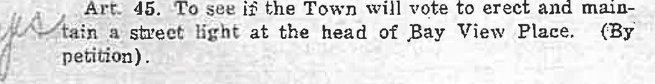
Art. 46: To see if the Town will vote to discontintie the '.'.'urnpike, so called, from Percy Partridges to Bert Dun­ Ol'ers.
Tax rate 60 mills on $813,412.00 $48,804.72
309 polls @ $3110 927.00
Supplemental tax 471.80
Committed to Collector
APPROPRIATIONS
$50,203.E

1 , • Art. •'7. To see if the Town will vote to discontinue the
t-f.;._.,JB]ack Road from the Pest House, so- cal!ed, to th'! County
/ Road, and from tlie Stairs Rill Roa.d to the Harry P. Robie
, . . Place, or act anything thereon.
i ..
Fi·ee High School Common Schools
Superintendent of Schools
Text Booka and Supplies for Schools Repairs and Insurance for School
$3,386.00 7,532.00
600.00
320.00

The Selectmen hereby give notice that they will be in
S!)SSion in the Selectmen's office on ,Thursday, the,9th day ot
,March, 1939, at two o'clock in the afternoon for the pur­ pOBe of_ correcting and revising the Ust of voters.
Given under our hands at S arsport, March 8, A. D.,
1939.
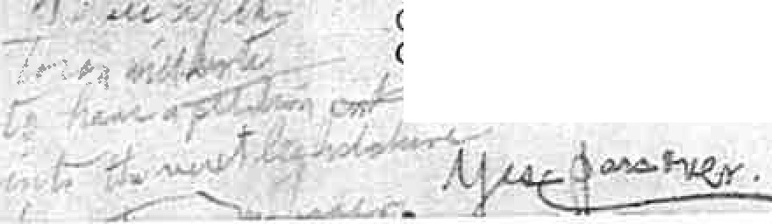
M. F. PARKER,
CHARLES A. ROGERS, GEORGE M. ELMENDORF,
Selectmen of Se&rsport.
Houses, Tuition, Equipment, Com-
pulsory Education and Census 1,162.00
Principal and Interest on School House
bond 1,685.00
Carver Memorial Library 882'.75 General Government and Incidentals 3,500.00 Support of the Poor 6,000.00
Highways and Bridgea 2,000.00
Patrol Maintenance 680.00
Sno-w Removal Equipment 2,126.00
Winter Breaking 2,000.00

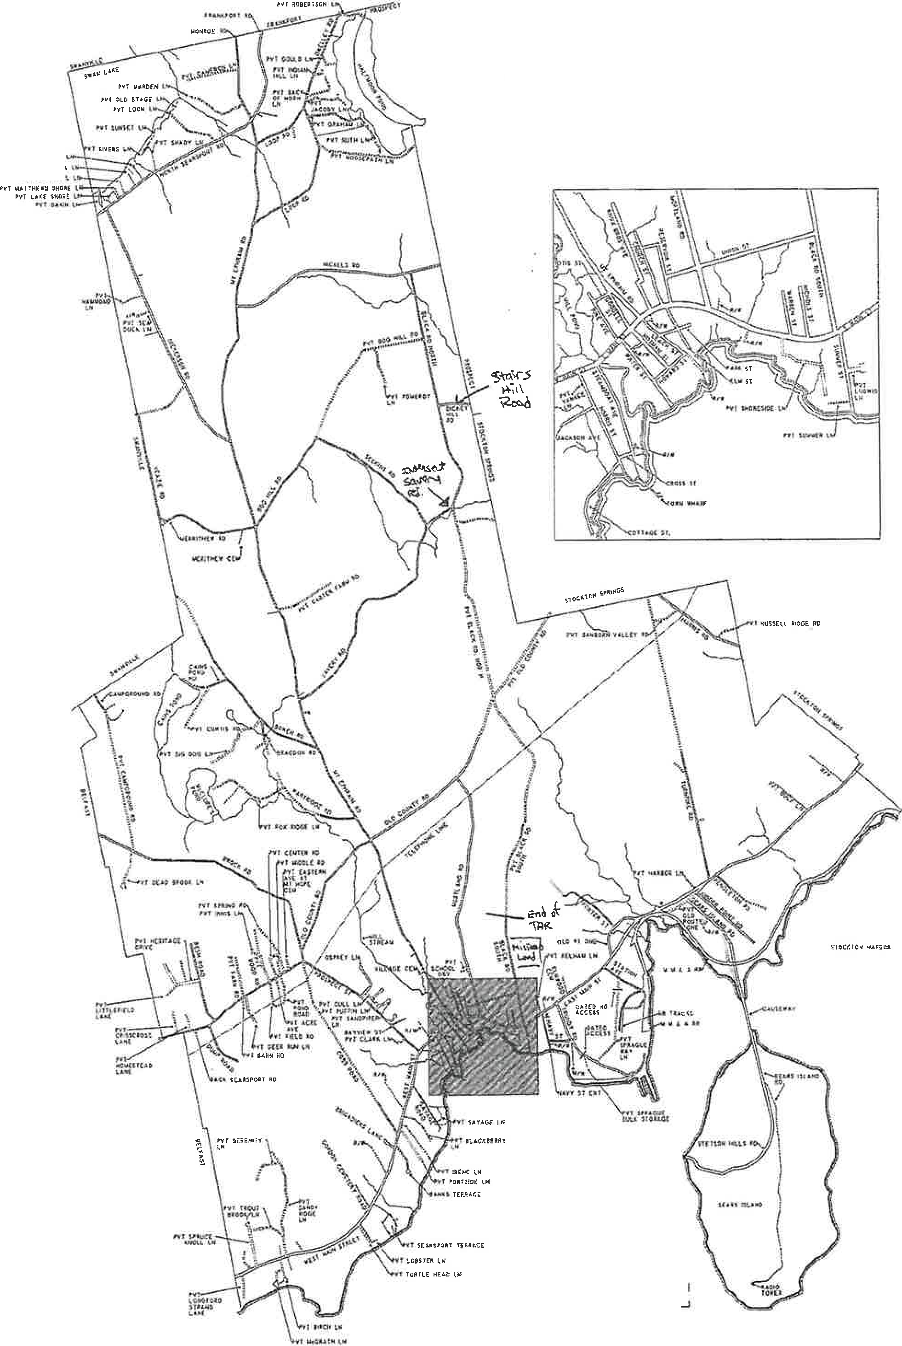

TOWN OF SEARSPORT .MAINE 2009 ROAD MAP
i'Y1C:QHN:)k
nl OOCHNE:-C,_
rN,iilrlflL \

0
t

MILES

Mikhail, Vivian

From: Sent:
To: Subject:
Attachments:
Neil Lanteigne <4PCS@hotmail.com> Thursday, January 19, 2023 3:12 PM
Mikhail, Vivian; rgraham@menun.org; info.abandonedroadscommission Lanteigne testimony in response to the town of west paris
Attorney Conway Finn Road Public Easement.pdf; west paris meeting minutes november 12 2015 executive session finn road.pdf; West Paris 1965 Closing Attested Letter.pdf

EXTERNAL: This email originated from outside of the State of Maine Mail System. Do not click links or open attachments unless you recognize the sender and know the content is safe.

To the Commission on Abandoned and Discontinued Roads,

Thank you for the opportunity to provide additional testimony to the Commission.

I previously submitted written testimony to the Commission on December 13, 2022 and I submitted additional Testimony to the Commission on December 20, 2022.

I am in receipt of information provided on or about December 30, 2022 to Rebecca Graham by Joy Downing, the Manager of the Town of West Paris.

In the December 30, 2022 email, the town of West Paris stated:
"On November 12th, 2015, the Board of Selectmen held a public hearing and a vote had taken place and it was determined that Finn Road was abandoned at some point prior to 1965 following 23 M.R.S § 3028-A{2}" This is a lie by the Town of West Paris.

According to the Agenda and Minutes of the November 12, 2015 Selectmen meeting (attached) there was NO public hearing on the status of Finn Road that had taken place on November 12th, 2015. The vote that had taken place, was actually a vote by the selectmen to "enter executive session pursuant to Title 1 M.R.S.A. Section 405(6)(e) a meeting with the Town's legal counsel." There was NO public hearing on November 12, 2015 regarding the legal status of Finn road. The selectmen simply voted to enter executive session. There was no public deliberation or public hearing, and no determination was made on November 12, 2015. Furthermore, 23 M.R.S § 3028-A was not enacted into law until 2019.

The "Municipal Story" provided to the Commission by the Town of West Paris is misleading. Several important pieces of information are [intentionally?] missing from the "Municipal Story".

The first piece of information that is missing from the "Municipal Story" by the Town of West Paris is the March 1965 vote to Close the road (attached). Finn road could not have been abandoned prior to 1965 as presumed, primarily because in March 1965 the road was voted Closed by the town of West Paris. The road had to have been a town way in 1965 for the Town of West Paris to vote the road Closed in 1965. The road could not have been abandoned prior to 1965 as evidenced by the town's own attested statement provided to me by the town prior to November 12, 2015 that the road·was voted closed in 1965. The Towns own attested statement of the 1965 Closing effectively rebuts the Town's own presumption of abandonment prior to the March 1965 vote to Close the road by the Town of West Paris.

The second piece of information that is missing from the "Municipal Story" by the Town of West Paris is the September 25, 2017 "Notice of Determination of Presumption of Abandonment". On September 25, 2017 the Town of West Paris filed its "Notice of Determination of Presumption of Abandonment" determining the road was abandoned due to non-

maintenance beginning April 15, 1985 and ending on April 15, 2015, resulting in a public easement pursuant to 23
M.R.S.A. § 3028. Source: Oxford County Registry of Deeds, Page 5369 Book 459

I have attached a legal memorandum from real estate Attorney John W. Conway, Esq. of Linnell, Choate & Webber, LLP regarding the legal status of the Old Finn Road in West Paris, Maine. Attorney Conway's independent research (paid for by the State) confirms the legal status of the road is a public easement. (see attachment).

By law the road is a public right of way. The road was determined by the municipality to be a public easement pursuant to M.R.S. Title 23, §3028. The town's September 25, 2017 determination is binding pursuant to M.R.S. Title 23, §3028. By law, the only way for the Town to refute the town's September 25, 2017 abandonment determination is by a Declaratory Judgment action.

In the December 30, 2022 email, the town of West Paris stated:
"After receiving this decision, Mr. Lanteigne filed an appeal with Oxford County Board of Commissioners whose decision is as follows: "At the duly noticed April 15th public hearing of the Oxford County Board of Commissioners, all the Commissioners were present. After hearing public comments and presentations from West Paris representative and multiple residents who attend the public hearing, the Oxford County Commissioners voted unanimously to dismiss the appeal and adopt a finding that they do not have jurisdiction under 23 M.R.S. § 3028-A(l} because the Finn Road in West Paris was abandoned prior to March 14th, 2022". This is another lie by the Town of West Paris.

As indicated on page 6, second paragraph, of Attorney Conway's legal memorandum, on March 14, 2022 the Town of West Paris provided me with a letter regarding the status of the Finn Road. The Town of West Paris is apparently now suggesting the March 14, 2022 letter is a determination pursuant to 23 M.R.S. § 3028-A. As Attorney Conway had pointed out, the March 14, 2022 letter does not have any effect on the towns September 25, 2017 Notice of Determination of Presumption of Abandonment which resulted in a public easement pursuant to 23 M.R.S.A. § 3028. The March 14, 2022 letter was ultimately determined by the Oxford County Board of Commissioners and verified by Attorney Conway not to be a determination under 3028-A.

The Town of West Paris is lying to the Commission. I am hopeful this additional testimony will help to correct the "Municipal Story".

Respectfully Submitted,

Neil Lanteigne
18 Ellingwood Road
West Paris, Maine 04289 Phone: 207-370-4727
Ham Radio: NB9D
Email: 4pcs@hotmail.com

DISCLAIMER:
This e-mail and any file or attachment transmitted with it, is only intended for the use of the person and/or entity to whom it is addressed and may contain information that is privileged, confidential, and exempt from disclosure under applicable law. If the recipient of this message is not the intended recipient or otherwise responsible for delivering the message to the intended recipient, be notified that any disclosure, distribution or copying of this information is strictly prohibited. If you received this communication in error, destroy all copies
of this message, attachments and/or files in your possession, custody or control and any other copies you may have created, and notify the sender at the sender's e-mail address listed above.

LINNELL, CHOATE & WEBBER, LLP MEMORANDUM

TO: FROM: SUBJECT: DATE:
JUSTIN W. LEARY, ESQ JOHNW.CONWAY,ES . ,.. --
STATUS OF THE OLD ◄ r ROAD, WEST PARIS, MAINE MAY 12, 2022

This memo is a response to a request for an opinion regarding the status of the bld Finn Road, which bisects the prope1ty of Neil Laate.igne and also bisects property owned by the Binneys and the Korhonens. The request is to determine the legal status of the Finn Road, that is whether or not it is a public way, or has been discontinued and, if it has been discontinued or abandoned, then is there a public easement remaining in the underlying road?

Background Information.

In determining this opinion I have done the following research:

- Review of an 1858 Atlas of Paris showing all of the Finn Road leading from Forbes Road to Sumner Road.

- State of Maine general high._;,.ay maps as follows:
  - 1959 map which shows no road between the Forbes Road and the towri line but does show a stub of the road in Paris extending north from Sumner Road;
  - 1968 map (actually dated 1964) shows a stub of the road extending south from the Forbes Road in West Paris. There is no road stub in Paris; and
  - 1976 map also shows only the stub from the Forbes Road.

- 1967 US Geological Sm-vey of the West Sumner Quadrangle. This shows a jeep trail coming off the end of an established road, presumably Finn Road, leading to what is called Sumner Road on the Paris tax map.

- 2011 and 2014 US Geological Smveys. These show the whole road as a "local road". The 2018 sutvey also shows a short section of Finn Road as on the ta..'>: map.

- The West Pa1i.s and Paris tax map, both revised in 2021, show a single dotted line leading from the end of Finn Road in West Paris to Sumner Road in Paris.

- A survey done for the property of Lanteigne in Paris dated January 18, 2019, which is recorded in the Oxford Registry of Deeds as Plan #5361. 1bis shows that the Lanteigne land abuts the town line between Paris and West Paris and is located on both sides of the Finn Road (also known as the Dean Road). The survey also contains a note on the Plan which states, in part, "The legal status of Finn Road (aka Dean Road) is assumed to be discontinued by abandonment under Notice of Determination in Book 5369, Page 459" recorded in the Oxford County Registry of Deeds and under M.R.S.A. 23 §3028. ("A way that has been abandoned under this section shall be relegated to the same status as it would have had under a discontinuance pursuant to §3026... )". Under §3026, a discontinued road "unless otherwise stated in the order, a public easement shall, in the case of town ways, be retained." The survey goes on to state that "Finn Road was apparently CLOSED by vote of the people of West Paris ... on March 7, 1965 ... There appears to be no legal statutory right for a Town to close a Town road ... ".

I have also reviewed some deed history regarding the parcels. They are as follows:

- Paris tax map Lot 8 of Neil Lanteigne, Book 5229, Page 694 (all book and page references refer to the Oxford County Registry of Deeds) dated July 1, 2015. This describes a parcel in Paris with no distances, no acreage and no reference to any roadway or right of way. 1bis is property on the Paris side of the town line.

- West side of Finn Road on town line, West Paris, Lot 25 on tax map: description of this parcel was first used in 1986 in a deed from Young, et al to Binney, et al, Book 5284, Page 43. The parcel is bounded on its east by the "Old Discontinued County Road." Previous descriptions of the larger parcel from which this is derived back in 1919 make no mention of the road.

- East side of Finn Road on town line and up to tl1e intersection with Forbes Road, being West Paris Lots 22 and 22.1. Deed from Fred H. Austin, et al to Peter M. Binney, et al,June 27, 2006, Book 3960, Page 286. This description first runs on the east side of the road, then crosses the road and runs south on the west side of Finn Road. The deed states that the premises are "subject to possible rights of others to that portion of the discontinued or abandoned Finn Road which crosses the westerly portion of the premises."

- These premises are all part of the former Matti Keranen homestead. A tax lien against him for 1938 taxes recorded in Book 440, Page 152, calls the bound on the west side "town toad" with no refereni:e to it being discontinued or abandoned. The title for this lot goes back to a deed of a 100 acre lot in Range 3, Lot 20, dated June 14, 1811, recorded in Book 7, Page 34 and states "reserving the privilege of a road or roads if required by the town."

Additional documents reviewed:

- A Notice of Determination of Presumption of Abandonment recorded in the Oxford County Registry of Deeds in Book 5369, Page 459, and dated September 25, 2017, refers to a public hearing held on November 12, 2015 regarding the status of the Finn Road. I will discuss this document in detail further along.

- March 14, 2022, letter from the Selectmen of the Town of West Paris to Neil Lanteigne re Finn Road. This letter attempts to summarize the Notice of Determination of Presumption of Abandonment mentioned above and will be discussed further.

- A letter from the selectmen from the Town of West Paris dated March 14, 2022, to Neil Lanteigne summarizing the Notice of Determination of Presumption of Abandonment mentioned above. This will be discussed further as well.

Legal Basis for Determining Status of Town Ways.

In 1976, the Legislature passed a reorganization of road responsibilities in the state which had the effect of transferring all county ways to town ways in the organized areas of the state. As a result of this legislation all former county ways not discontinued or abandoned before July 29, 1976, became town ways under 23 M.R.S.A. §3021 (3)(B). There are three methods for terminating a municipality's interest in a town way: the statutory process of discontinuance, the cotnmon law doctrine of abandonment by public nonuse, and the statutory presumption of abandonment. Depending on which process is used and when that process is completed, will determine whether or not it remains a public easement in the extinguished road.

Discontinuance.

My review of the information, including regist:1.y records, does not indicate that there has ever been a formal discontinuance on this road section. In order for a discontinuance to h ve been completed properly it would require record notice. See 23 M.R.S.A. §3024.
Because there is no record of this, I will not discuss this method of discontinuance. Common Law Abandonment by Nonuser.
This provision in Maine law allows for a common law abandonment of a road which has not been used by the public for long periods of time. In the case of Shadan v. Town efSkowhegan,
1997 Me. 187, 700 A.2d 245, the court determined that for this particular type of abandonment, 20 years of public nonuse would be sufficient. However, there is nothing statutorily or otherwise which dictates the length of time for public nonuse to result in common law abandonment. It appears to be a case-by-case determination.

It is also important to note that there is no specific method for determining common law abandonment by nonuse, other than by litigation. In order to determine this it would be the result of a declaratory judgment action by a court of competent jurisdiction. I am not aware

of any court action which has been taken to determine the status of the road via the common law abandorunent by nonuse.

The important factor with this is that if it were determined that the common law abandorunent doctrine controlled this matter, there would be no retention of a public easement. However, at this point, I am not aware that there has been any judicial dete1mination regarding common law abandorunent.

Statutorv Abandonment, 23 M.R.S.A. §3028.

Under this statute, a municipality can be relieved of any obligation to maintain a town way if its municipal officers have determined there has not been any maintenance by public expense for 30 or more consecutive years. In reviewing the evidence as described above, it appears that this is the method which the Town of West Paris has adopted to dete1mine the abandorunent of the Finn Road.

As I mentioned above, on September 25, 2017, the Town of West Paris issued a "Notice of Determination of Presumption of Abandorunent." This is the process embodied in Title 23
M.R.S.A. §3028 and requires that the municipal office make the determination regarding abandonment. This determination relieves the town of any requirement that it repair or maintain the way and that they will not be liable for any defects in the road subsequent to this determination. If a person were to believe that this determination were incorrect, then they would be allowed to bring an action for declaratory judgment in the Superior Court asking the court to determine the parties' rights and obligations. This determination is not subject to appeal to the county commissioners.

This determination by the municipal officers creates a "rebuttable presumption of abandonment". This establishes that the municipality would bear the initial burden of establishing the presumption of abandorunent and anyone challenging it would then, once that burden has been met, have to prove that the road cannot meet the criteria for the abandonment. I am not aware of any litigation that has been filed against this Notice of Determination of Presumption of Abandonment.

Given that this document was recorded in the Oxford County Registry of Deeds at Book 5369, Page 459, this, I believe, constitutes the determination by the municipal officers.

Legal Discussion.

Having reviewed the three methods described above for discontinuance of a town way, it is my opinion that the Town chose to discontinue this road under the statutory abandonment statute, 23 M.R.S.A. §3028. In doing that, the Town made a determination regarding that presumption of abandonment and recorded that determination in the Registry of Deeds. In many cases, I think that this would be a pretty straight forward determination regarding the status of the road. However, the Notice of Determination of Presumption of Abandonment is not the most clearly drafted document that I have come across.

While indicating that it is in fact the Notice of Determination of Presumption of Abandonment, it then goes on to say that the municipal officers took oral comments from. the highway department employees and former employees who stated that no work had been done on the Finn Road since before 1965, says ''extinguishing all easements and rights ohvay and research by the Town's attorney, Ma1y Costigan of Bernstein Shur law firm." I have attempted to contact Attorney Costigan to see if she will discuss this with me but have not yet heard back.

In reading this document, you can see that it is difficult to detetmine exactly what it says. If you go down to the third to last paragraph, it indicates that the records do not indicate any maintenance done on the road in over 30 years. However, it is important to note in regards to th.is Presumption of Abandonment that the actual abandonment does not occur until 30 years following the last work that is done on the road. Therefore, while thete may not have been any work done in over 30 years, that would not mean that the abandonment occun:ed 30 years ago. It would mean that the process of abandonment began whenever the last work was done on the road. This document does not determine the exact date of that.

However, the next paragraph goes on to state what I believe is the actual finding of the municipal officers. This paragraph says, "The Municipal Officers also determined that the Town of West Paris has not kept said way or portion of way passable for the use of motor vehicles at Town expense for a period of at least 30 consecutive years beginning on April 15, 1985 and ending on April 15, 2015." Based on th.is statement of determination by the municipal officers, th.is would indicate that the road was finally abandoned on April 15, 2015. Because the abandonment would have taken place after 1965, that means that a public easement would have remained in tl1e abandoned road.

However, to complicate th.is matter, the last sentence of the paragraph mentioned above states, "It is the opinion of the Municipal Officers that the abandonment occurred before 1965." Obviously, th.is is stated simply as an opinion and not the determination of the municipal officers. Given these two apparently conflicting statements, I believe that the determination by the municipal officers, as stated in the first sentence of th.is paragraph, would be controlling.

While this Notice of Determination of Presumption of Abandonment is at times somewhat confusing, it appears that the detennination that the Town of\Vest Paris made was that the 30 year period for a determination of presumption of abandonment began on April 15, 1985 and ended on April 15, 2015. Even if the opinion of the municipal officers that the abandonment occurred before 1965 were to be considered, it is not clear whether that means that the last work done on the road was done before 1965 or if the last work on the road was done 30 years before 1965, i.e., 1935. There is nothing in th.is document that would indicate that there was any evidence that work on the road had not been done since 1935. In fact, the only evidence suggested in this document regarding when the last work was done simply stated that it was before 1965.

Conclusion.

Obviously, the best way to detennine the actual status of this road would be to have a court of competent jurisdiction to hear this matter. However, given that the initial burden of detenni.ning abandonment is on the municipality, and the municipal officers of the Town of West Paris determined by recorded document that the 30 consecutive year period began on April 15, 1985 and ended on April 15, 2015, the best evidence is that the abandonment of this property occurred on April 15, 2015. Given that date as the date for abandonment, a public e-asemeot would be retained in the underlying road.

As an additional note, I have received a letter from the Town of West Paris dated March 14, 2022, to Neil Lanteigne, regarding the status of the Finn Road. This letter appears to be an attempt to clear up any confusion in their Notice of Determination of Preswnption of Abandonment but unfortunately, if anything, it makes it less dear. Additionally, this is not a letter required under the statute, is not in a form which would comply with the Notice of Determination of Presumption of Abandonment, therefore I do not believe it is dispositive of the status of Finn Road. I also note that all of the selectpeople who signed the March 14, 2022 letter are different from the ones who made the Determination of Presumption of Abandonment on September 25, 2017. Therefore, while this letter appears to attempt to clear up any confusion, I do not believe that it has any effect on the Notice of Determination of Presumption of Abandonment.

I trust that this answers your question. As I mentioned above, the final determination of this may still be subject to a final determination made a court of competent jurisdiction

·oo-c 1035 BK 5369 P'G 459

· N,atic qf Determination of:Pres1.unption of·abandonment
Be·it kaown by,allpersons.a·s follows:
Oo Novemb r 12-;2·0_15 theilJridetsigried:Municipal_Officers-()f th'e Town qf-We$t Paris met in public session with their attorney-and -after de{i eration, determine tbat,a porticm of-Fin·n Roadrricu:e particul rly de_scriiled-·as follows: From the Town of West Paris plow turnaround lo the West Paris/Pilris T9wn-lfr1e.
In:aicii:ig this-determination,·tne'WlunicjpalGfficer:s h ard oral.com·ments from past We-st Paris
• . ·- - • ' ,J
Hlgt,way,· pa ,rient mployees"and former employe·es whe stated-that no_work hatJ been
.dane on the,Fiii'n R a'd sJnce"'t>eforie i!tGS extir,guis_hiag all.easern rits- ddights of way and
re'searcfr by•the Town's attornf!y,ilVlary Costigan ofBernstein Shur law firm.
. ' ·. . .. ·- . . ...
Minutes,.of the Noverilber i2, 2 1-5: Hie available.
Thi d-e-Jei:minatron,iS'based apen th. (o!.lowing infor:mation_
T.helown n;,a·d.:mairitenance1records do not iridic:: te any maintenanc' e don·eon·the road.in over
30•y;ears. · · · ·
T .M nfcip l,Qffi ers,also de ermined tbal th Town of W_est Parlis h s nof' ept said av or
p r1_ipn o.fwa¥ trassable fQr the-use of-motor vehicles aj iFow ,exp.ense'.for a p;ripd ofat least
3' con ecuti yeai: ,li, gin ing-·on,f\pril 15, 19_$."S-a-ri·delidinghr prll.15 101s._-1t is-. he',opinion
ofthe Munlc.ipa·, Officers-thauhe abandonment ocd..i,ir.ed b.efor:e196.5.
"'Fhis determii'lat_ion-is,based on researe::n,by the Town!s attorney,:and b ('Or,al·conim nts·fr:om long•time liigliway.-c:fEtpar:tm nt employees and itizens of WesH?:13ris.
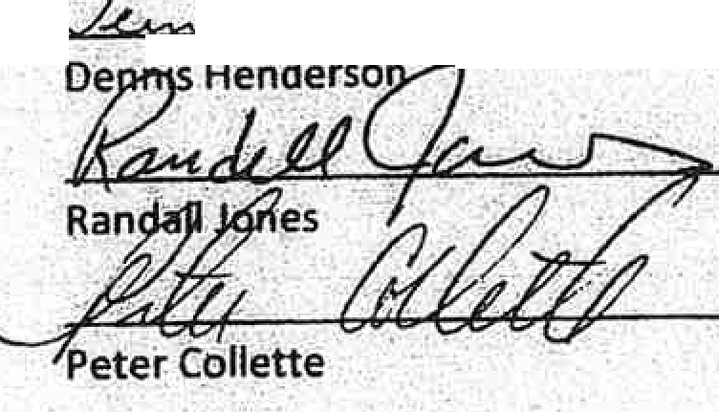
.-
. - .
..,-, ---- .
..
.
'
-i :.!.J. -41:::!:::::,,.<.

IDat-ed: Sept mber:2-5, 2017
By: -

,.

nlci al 0ffice:s of th
Town.of'West Paris
.
\ ._ \ ..
- I ..' • ••
- .
. .
.. . . .. . ..;

.. ..
. , ..
.. For Notice of Determination·ofPresumption o,f aban.dbnment :
, For Finn Road West Paris, ME
- J
: .-
. •,

STATE,QFMAINE-:
· .:to1.1nty of Oxford
... '

Oat¢: September 25, 2017

Personally appe r theabove nalJ)ed.Randall Jones,-Dennis Hen h:!rson> and Peter Collette
M nicip I Offic::e of the Town of West Pari, Maln·e and aclcnow1¢"ged 'th, .foregoing ._; instrument to-be their free act. and·deed in their-a-padty.
.._..

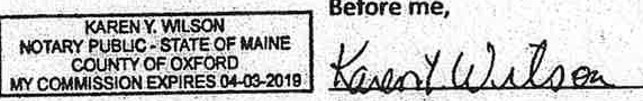
.1<a·ten Wilson -
Notary'Pubfic

't. •••

.'

..•

. .. r, , ..

'.
..
'·'
.. .

,•. .··. ... : . ..
,.
' ,..
.
•' ..
'· •,
•• • I •• f
.,
. . . ,

. ; ' :...
l • •

..
..
'

Io 1 •'
, .

, .·• r

.. , •' ..

I Regular Selectmen's Meeting
I November I 2, 2015
\

Agenda
CalJ to order.
Pledge of Allegiance.
I. Accept minutes of October 22, 2015.
- Meet with the Town's Attorney. Executive Session pursuant to Title 1 M.R.S.A. Section 405(6Xe) Issues to be discussed may Include the status of the Finn Road anda default on a tax acquired property repurchase agreement.
- Chandler Wright property-potential junkyard violation (remove from table).
- Approve tax acquired property repurchase agreement.
S. Schedule a public hearing for a junkyard permit application.
- Schedule a public hearing for a special amusement permit
- Consider a waiver of foreclosure on a tax lien.
- Discuss initiation of a yard sale ordinance.
- Appoint a Selectman to serve as an AVCOG General Assembly representative.
- Accept resignation of Natalie Andrews from the Planning Board.
- Appoint Diane Holt as a regular member of the Planning Board.
- Town Manager's report
- Treasurer's Warrants.
Adjourn.
Minutes

The meeting was called to order at S:00 pm with Selectmen Randall Jones, Dennis Henderson and Peter Collette present.
0
I. Mr. Henderson moved acceptance of the minutes of October 22, 2015. Mr. Collette seconded. Vote: 3 in favor, 0 opposed

- Mr. Collette moved to enter executive session pursuant to Title I M.R.S.A. Section 405(6)(e) a meeting with the Town's legal counsel. Mr. Henderson seconded. Vote: 3 in favor, 0 opposed
At S:34 p.m. the Selectmen return to regular session.

The Selectmen asked their attorney Macy Costigan to make a statement about the status of the abandoned portion of Finn Road. Attorney Costigan stated that the Selectmen were and are of the opinion that the road was abandoned and that abandonment occurred prior to 196S extinguishing all easements and rights-of-way. From all the material reviewed they have seen no evidence to rebut their opinion.
Carl Lanteigne the father of Neil Lanteigne asked to speak. He reported that his son had been assaulted recently over this issue. He then read a statement from his son. Mr. Henderson stated, that the Finn Road ends where the plow and grader stops. /Correction added upon uc:ccptw1c:c 011,\'1we111h11r 25. 201SJ He then said the Town was partially at fault for the assault and said Mr. Henderson was partially responsible as he said in court that the road was private property. Mr. Jones ended the discussion at that point.

- The tabled item regarding a potential junkyard violation was removed from the table as no further action is required.
- Mr. Henderson moved to approve the tax acquired property repurchase agreement with Erica Johnson. Mr. Collette seconded. Vote: 3 in favor, 0 opposed
- Mr. Henderson moved to schedule a junkyard pennit hearing for Frank Perham for the December 11, 2015 meeting. Mr. Collette seconded. Vote: 3 in favor. 0 opposed
Q

. .I
•
"' "\,>,,'

(-'. ,/ 6.

7.

8.
Mr. Henderson moved to schedule a special amusement pennit hearing for Jason Koskela for the November 25, 2015 meeting. Mr. Collette seconded. Vote: 3 in favor, 0 opposed
Mr. Henderson moved to approve a waiver of tax lien foreclosure on the Bowden mobile home as
recommended by the Treasurer. Mr. Collette seconded. Vote: 3 in favor, 0 opposed

Mr. Henderson said that he would like to consider a limitation of yard sales to prevent long tenn and on-going sales. The major problem was the accumulation of junk and the unkempt appearance that occurs over time.
Mr. Henderson noted that the Town had been asked to consider limitation on junk and debris in peoples' yards. He said that he envisioned permitting one up to 4 consecutive day sale per household per year. He said that we could get some ordinances from other towns. Dian Rainey, Chainnan of the Planning Board asked if this could be done by policy rather than an ordinance. Mr. White said that you can only enforce an ordinance. Mr. Henderson will get some ordinances and meet again with the Planning Board in December.

- Mr. Jones moved to appoint Peter Collette to serve as a member of the Androscoggin Valley Council of Governments General Assembly. Mr. Henderson seconded. Vote: 3 in favor, 0 opposed
- Mr. Henderson moved to accept the resignation of Natalie Andrews from the Planning Board with regret. Mr. Collette seconded. Vote: 3 in favor, 0 opposed
- Mr. Henderson moved to appoint Diane Holt to the vacancy of the Planning Board. Mr. CoJlette seconded. Vote: 3 in favor, 0 opposed
- Mr. Collette moved to accept the Manager's report. Mr. Henderson seconded. Vote: 3 in favor, 0 opposed
- Mr. Henderson moved to approve Treasurer's Warrant #48 in the amount of$9,439.14 and# 49 in the amount of$125,443.62. Mr. Collette seconded. Vote: 3 in favor, 0 opposed
The meeting adjourned at 6:15 p.m. Respectfully submitted,
0
John F. White Secretary

Minutes Approved as corrected
JFW
November 25. 2015

TO\\#J OFWESTPARIS
25 Kingsbury Street
P. 0. Box247

West Paris, Maine 04289

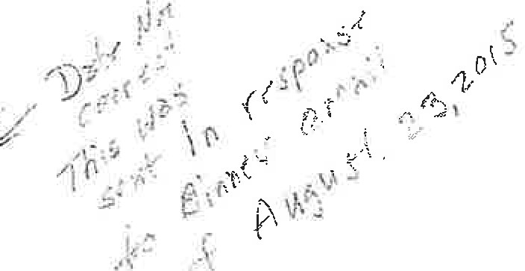
Telephone (207) 674-2701
Facsimile (207) 674-2703
E-Mail wpto@megalinknet

/
'\. June 25, i.o15 ,.,.

··, /
Mr. Peter Binney Finn Road
West Paris, ME 04281
'
VIA FAX to 617-385-0733

Dear Mr. Binney:

The following was taken from the West Paris Record Book including the activities of the year 1965.

Pg.188 - March 2, 1965 Town Meeting Warrant:
"Article 41. To see if the citizens will vote to close the road from the Herny Damon place to the Paris-West Paris Line."

Pg.189 - Minutes of the March 2, 1965 Town Meeting signed by Marie L. Hibler, Clerk:
"Article 41. The location and condition of the road in was explained. Mr. Clarence Todd made the motion, seconded by Richard Baker, to close the road from the Herny Damon place to the Paris, West Paris line. This was passed by a show ofhands."

Attest, a true COPY......,,, - -- --k _·'-"_•·
erk

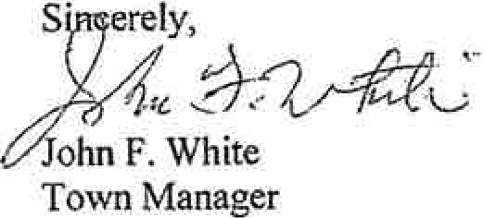
Should you have further questions please do not hesitate to contact me.

Mikhail, Vivian

From: Sent: To: Subject:
Neil Lanteigne <4PCS@hotmail.com> Thursday, January 26, 2023 5:51 PM
Mikhail, Vivian; rgraham@menun.org; info.abandonedroadscommission Lanteigne testimony in response to the town of west paris

EXTERNAL: This email originated from outside of the State of Maine Mail System. Do not click links or open attachments unless you recognize the sender and know the content is safe.

To the Commission on Abandoned and Discontinued Roads,

Thank you for the opportunity to provide additional testimony to the Commission.

I previously submitted written testimony to the Commission on December 13, 2022 and I submitted additional Testimony to the Commission on December 20, 2022.

I am in receipt of information provided on or about December 30, 2022 to Rebecca Graham by Joy Downing, the Manager of the Town of West Paris.

In the December 30, 2022 email, the town of West Paris stated:
"On November 12th, 2015, the Board of Selectmen held a public hearing and a vote had taken place and it was determined that Finn Road was abandoned at some point prior to 1965 following 23 M.R.S § 3028-A{2}" This is a lie by the Town of West Paris.

According to the Agenda and Minutes of the November 12, 2015 Selectmen meeting there was NO public hearing on the status of Finn Road that had taken place on November 12th , 2015. The vote that had taken place, was actually a vote by the selectmen to "enter executive session pursuant to Title 1 M.R.S.A. Section 405(6)(e) a meeting with the Town's legal counsel." There was NO public hearing on November 12, 2015 regarding the legal status of Finn road. The selectmen simply voted to enter executive session. There was no public deliberation or public hearing, and no determination was made on November 12, 2015. Furthermore, 23 M.R.S § 3028-A was not enacted into law until 2021.

The "Municipal Story" provided to the Commission by the Town of West Paris is misleading. Several important pieces of information are [intentionally?) missing from the "Municipal Story".

The first piece of information that is missing from the "Municipal Story" by the Town of West Paris is the March 1965 vote to Close the road. Finn road could not have been abandoned prior to 1965 as presumed, primarily because in March 1965 the road was voted Closed by the town of West Paris. The road had to have been a town way in 1965 for the Town of West Paris to vote the road Closed in 1965. The road could not have been abandoned prior to 1965 as evidenced by the town's own attested statement provided to me by the town prior to November 12, 2015 that the road was voted closed in 1965. The Towns own attested statement of the 1965 Closing effectively rebuts the Town's own presumption of abandonment prior to the March 1965 vote to Close the road by the Town of West Paris.

The second piece of information that is missing from the "Municipal Story" by the Town of West Paris is the September 25, 2017 "Notice of Determination of Presumption of Abandonment". On September 25, 2017 the Town of West Paris filed its "Notice of Determination of Presumption of Abandonment" determining the road was abandoned due to non­ maintenance beginning April 15, 1985 and ending on April 15, 2015, resulting in a public easement pursuant to 23
M.R.S.A. § 3028. Source: Oxford County Registry of Deeds, Page 5369 Book 459

I have attached to my previous testimony a legal memorandum from real estate Attorney John W. Conway, Esq. of Linnell, Choate & Webber, LLP regarding the legal status of the Old Finn Road in West Paris, Maine. Attorney Conway's independent research (paid for by the State} confirms the legal status of the road is a public easement.

By law the road is a public right of way. The road was determined by the municipality to be a public easement pursuant to M.R.S. Title 23, §3028. The town's September 25, 2017 determination is binding pursuant to M.R.S. Title 23, §3028. By law, the only way for the Town to refute the town's September 25, 2017 abandonment determination is by a Declaratory Judgment action.

In the December 30, 2022 email, the town of West Paris stated:
"After receiving this decision, Mr. Lanteigne filed an appeal with Oxford County Board of Commissioners whose decision is as follows: "At the duly noticed April 15th public hearing of the Oxford County Board of Commissioners, all the Commissioners were present. After hearing public comments and presentations from West Paris representative and multiple residents who attend the public hearing, the Oxford County Commissioners voted unanimously to dismiss the appeal and adopt a finding that they do not have jurisdiction under 23 M.R.S. § 3028-A{l} because the Finn Road in West Paris was abandoned prior to March 14th, 2022". This is another lie by the Town of West Paris.

As indicated on page 6, second paragraph, of Attorney Conway's legal memorandum, on March 14, 2022 the Town of West Paris provided me with a letter regarding the status of the Finn Road. The Town of West Paris is apparently now suggesting the March 14, 2022 letter is a determination pursuant to 23 M.R.S. § 3028-A. As Attorney Conway had pointed out, the March 14, 2022 letter does not have any effect on the towns September 25, 2017 Notice of Determination of Presumption of Abandonment which resulted in a public easement pursuant to 23 M.R.S.A. § 3028. The March 14, 2022 letter was ultimately determined by the Oxford County Board of Commissioners and verified by Attorney Conway not to be a determination under 3028-A.

The Town of West Paris is lying to the Commission. I am hopeful this additional testimony will help to correct the "Municipal Story".

Respectfully Submitted,

Neil Lanteigne
18 Ellingwood Road
West Paris, Maine 04289 Phone: 207-370-4727
Ham Radio: NB9D
Email: 4pcs@hotmail.com

DISCLAIMER:
This e-mail and any file or attachment transmitted with it, is only intended for the use of the person and/or entity to whom it is addressed and may contain information that is privileged, confidential, and exempt from disclosure under applicable Jaw. If the recipient of this message is not the intended recipient or otherwise responsible for delivering the message to the intended recipient, be notified that any disclosure, distribution or copying of this information is strictly prohibited. If you received this communication in error, destroy all copies of this message, attachments and/or files in your possession, custody or control and any other copies you may have created, and notify the sender at the sender's e-mail address listed above.

