Featured Habitats
Wildlife (like people!) requires food, water, shelter and sufficient space to survive. If any of these habitat components are missing or significantly altered, animals become stressed and exposed to disease, predation or severe weather and may die. Because some habitats are rare, many of the animals that are specialized to live there are also rare. This section features some of Maine's most important and vulnerable habitats for state-listed reptiles, amphibians and invertebrates.

Pitch Pine Woodlands and Barrens

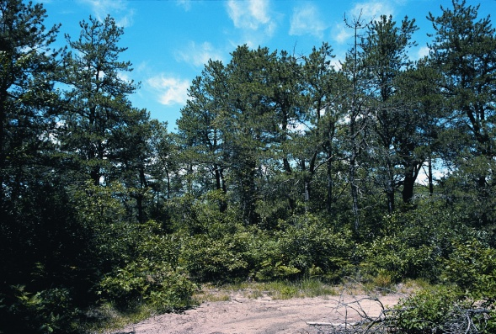
Pitch Pine woodlands and barrens are lightly forested upland areas with dry, acidic, often sandy soils. Pitch pine, red pine, scrub oak, blueberry, huckleberry, and/or bluestem grasses are commonly among the sparse vegetation of this unique natural community. It's estimated that over half of the State's original pine barren acreage has been lost to residential development, agriculture, and gravel mining. Many dry woodlands and barrens also require periodic fire to prevent succession to a more common, closed canopy white pine-oak system, a natural disturbance that is now short-circuited by habitat fragmentation and fire suppression.
Waterboro Barrens
photo by Phillip deMaynadier

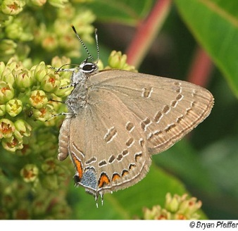
Once viewed as unproductive "wastelands", Maine's few remaining pine woodlands and barrens are now recognized as areas of exceptional wildlife value, providing habitat for a variety of highly specialized plants and animals. Several rare and endangered species persist in the State's few remaining intact barren communities, mainly in the towns of Kennebunk, Wells, Waterboro, Shapleigh, Hollis, and Fryeburg. These unique habitats are especially rich in rare Lepidoptera (butterflies and moths), hosting species that feed on the specialized barrens vegetation, such as Edwards' Hairstreak (Endangered), Sleepy Duskywing (Threatened), Cobweb Skipper (Special Concern) and Barrens Buck Moth (Special Concern). Other rare species associated with Maine's barrens include the Black Racer (Endangered), Grasshopper Sparrow (Endangered), Upland Sandpiper (Threatened), Short-eared Owl (Threatened), and Northern Blazing Star (a Threatened plant). MDIFW is committed to working cooperatively with landowners, land trusts and towns to conserve Maine’s few remaining good examples of Pitch Pine woodlands and barrens and the unique biota found there.
Edwards’ Hairstreak
photo by Bryan Pfeiffer
To learn more about two barrens of statewide ecological significance visit "Focus Area Descriptions" on the Maine Natural Areas Program website (http://www.maine.gov/doc/nrimc/mnap/focusarea/factsheets.htm) and select "Kennebunk Plains and Wells Barrens" or "Waterboro and Shapleigh Barrens" in York County.

Vernal Pools
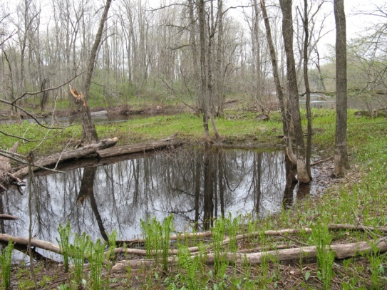
Vernal pools come in myriad shapes, sizes and settings but nearly all are small, forested wetlands whose depressions fill with water from spring snowmelt and rain and dry partly or completely by late summer. What makes these habitats so valuable for wildlife is a rich food base fed by surrounding forest organic matter and a lack of fish. Isolated from streams and subject to periodic drying, vernal pools provide a nearly predator-free haven for a diversity of specialized amphibians (salamanders, frogs, and toads) and aquatic invertebrates (over 500 species in New England alone) that lack the physical and chemical defenses to reproduce in more fishy environs. Some of Maine’s better known pool-breeding specialists -- Spotted Salamanders, Blue-spotted Salamanders, Wood Frogs, Fairy Shrimp, and Fingernail Clams -- have become iconic for their nearly exclusive use of vernal pools.
photo by Phillip deMaynadier

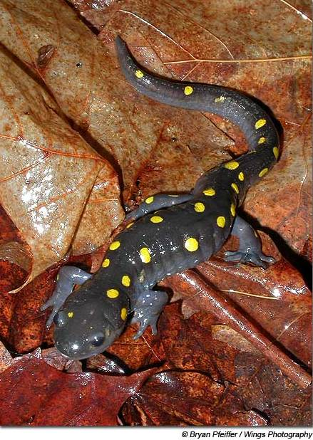
Just as the State’s more traditionally recognized wildlife habitats such as deer wintering areas and waterfowl and wading bird wetlands host more than just deer and ducks, so do vernal pools provide habitat for more than a few specialized frogs and salamanders. Over half of Maine’s amphibian and reptile species frequent vernal pool habitats during their life cycles, as do many more familiar species such as black and wood ducks, great blue herons, broad-winged hawks, deer, moose, fox, mink, bats and other small mammals. Some forest herbivores are drawn to vernal pools because they serve as spring oases where the season’s first herbaceous forage is available. Forest predators are attracted to vernal pools because of the abundance of amphibian prey occupying the surrounding forest floor. The collective weight (or “biomass”) of these unseen spring amphibian sentinels has been estimated to exceed that of all birds and mammals combined in some forests! Indeed, their sheer abundance and palatability has many biologists and sportsmen convinced that the terrestrial wanderings of pool-breeding frogs and salamanders play a powerful role in the local ecology of Maine’s woodlands.
Spotted Salamander
photo by Bryan Pfeiffer

Additionally, among Maine’s dozens of wetland community types, few host as many rare and endangered species as do vernal pools, providing sustenance and shelter to animals as varied as the Blanding’s Turtle (Endangered), Ribbon Snake (Special Concern), and Ringed Boghaunter dragonfly (Threatened), and plants as elusive as Featherfoil (Threatened) and Sweet Pepperbush (Special Concern). Some of these species could face extinction in Maine without the presence of high value vernal pools distributed throughout their range.

MDIFW cooperates with the Departments of Environmental Protection (DEP) and Conservation, municipalities, and landowners to conserve vernal pools. Workshops on vernal pool biology and conservation are held throughout the state for landowners, land trusts, and land managers, and several new publications designed to offer voluntary techniques for protecting vernal pools and their wildlife are now available. The Maine Citizen’s Guide to Locating and Documenting Vernal Pools provides a comprehensive introduction to recognizing and monitoring vernal pools, including color photographs of the indicator species. Also available are two complementary guide-books for protecting vernal pool habitat during timber management (Forestry Habitat Management Guidelines for Vernal Pool Wildlife) and development (Conserving Pool-breeding Amphibians in Residential and Commercial Developments in the Northeastern United States). Together, these publications provide recommendations designed to help maintain functioning vernal pool landscapes throughout Maine. All of the guides can be obtained by contacting Becca Wilson at Maine Audubon Society (207-781-6180 ext. 222; bwilson@maineaudubon.org).

Finally, MDIFW and DEP developed a definition of Significant Vernal Pools, a relatively new Significant Wildlife Habitat under the state’s Natural Resource Protection Act, approved by the 120th Maine Legislature in 2006. Criteria for designating Significant pools include: a) the presence of a state Endangered or Threatened species, or b) evidence of exceptional breeding abundance by specialized amphibian indicator species. Recognizing a subset of Maine’s vernal pools as Significant will help biologists provide guidance on development activities within a critical upland life zone surrounding one of our highest value wildlife habitats.

Riparian Sedge Meadows
Vernal pool
photo by Phillip deMaynadier

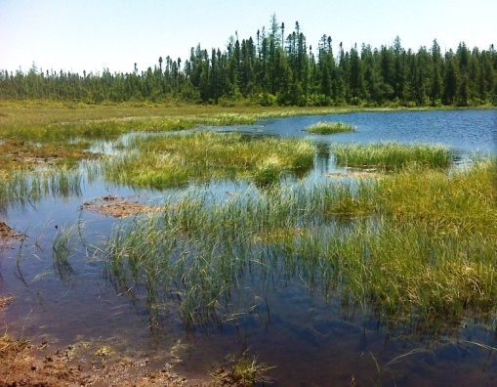
Maine’s riparian sedge meadows are seasonally flooded wetlands that occur along the borders of free-flowing rivers and streams. They are a dynamic habitat, characterized by a short period of flooding from snow and ice melt during April and May, followed by receding water from the floodplain during summer months. This powerful ebb and flow of flood water and ice scour prevent the herbaceous meadow from succeeding into less flood tolerant shrub and tree growth. Standing water often remains until May or June as isolated pools or channels, concentrating aquatic life as the meadow dries. Tussock sedge and rushes are typically the dominant vegetation. The inundated, decomposing sedge provides shelter, substrate, and abundant food for an unusually diverse and abundant aquatic invertebrate community. This rich food source in turn attracts and supports a wide variety of fish and wildlife species.
Riparian Sedge Meadow
photo by Maine Natural Areas Program

While sedge meadows are common throughout the State, extensive stands of riparian tussock sedge meadow are more restricted in distribution. Historically, these habitats were often altered by the damming of Maine’s rivers and streams for mills, water storage, and timber transport. These activities created many lakes on reaches of streams and rivers formerly bordered by wide flood plains, and drastically altered the normal seasonal flow patterns that create such a dynamic and productive ecosystem. Today these habitats are still threatened by intensive riparian land use practices and water pollution.

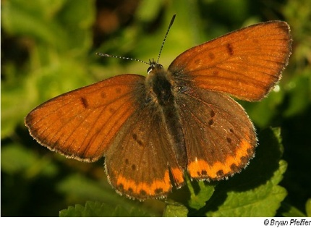
Several rare species of invertebrates, reptiles and amphibians rely on riparian sedge meadow habitat during part or all of their lifecycles. The regionally endemic Tomah Mayfly (Threatened) depends entirely on this habitat during its nymphal stage, where it feeds voraciously on other mayfly larvae eating the decaying sedge. Bronze Copper butterflies (Special Concern), Northern Leopard Frogs (Special Concern) and Ribbon Snakes (Special Concern) are also found in sedge meadows. Other rare species associated with this unique Maine habitat include the Sedge Wren (Endangered), Least Bittern (Endangered), and Northern Harrier (Special Concern). MDIFW is committed to working cooperatively with landowners, land trusts, and towns to conserve Maine’s best examples of riparian sedge meadow and the unique biota found there.
Bronze Copper
photo by Bryan Pfeiffer

