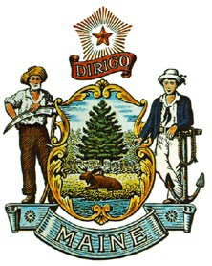**STATE OF MAINE 7**

# Department of Agriculture, Conservation & Forestry

**Board of Pesticides Control 28 State House Station Augusta, Maine 04333**

**Janet T. Mills Governor**

**Amanda E. Beal Commissioner**

MAINE BOARD OF PESTICIDES CONTROL POLICY ON DETERMING ALLOWABLE PESTICIDE

APPLICATIONS PURSUANT TO CMR 01-026, CHAPTER 29, SECTION 6

Adopted March 5, 2010

Revised April 25, 2025

# BACKGROUND

The Board amended Chapter 29 in May of 2008, adding new Sections 5 and 6. Section 6 prohibits “broadcast” application of pesticides within 25 feet of certain defined surface waters, but does not prohibit pesticide applications that are not considered broadcast applications. The staff asked for clarification on what types of applications are allowed in the 25-foot-buffer area.

# POLICY

The Board determined that the following characteristics indicate that an application is not a broadcast pesticide application, and therefore not prohibited by Chapter 29, Section 6. Pesticide applications must be:

1. Directed away from surface water;
2. Directed at specific pest organisms or infestations in a manner that minimizes deposition to non-target species and areas;
3. Conducted using non-powered application equipment capable of targeting pest organisms while avoiding non-target species;
4. During any calendar year, is confined to no more than 20% of the area located within 25 feet of surface water; and
5. During any calendar year, does not cover any one contiguous area greater than 100 square feet.

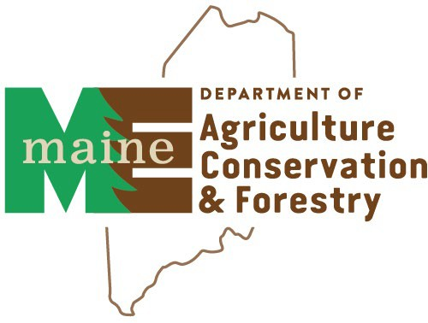**ALEXANDER PEACOCK, DIRECTOR** PHONE: (207) 287-2731

90 BLOSSOM LANE, DEERING BUILDING [WWW.THINKFIRSTSPRAYLAST.ORG](http://WWW.THINKFIRSTSPRAYLAST.ORG/)

1. During any calendar year, cut stump/stem and/or direct injection treatments for control of Japanese Knotweed (*Fallopia japonica, syn. Polygonum cuspidatum, Reynoutria japonica*) does not cover any one contiguous area greater than 100 square feet.

**Notes:** Use of herbicides within 25 feet of a surface water must not violate shore land zoning requirements or the Natural Resource Protection Act for vegetation removal. In addition to limiting tree removal and trimming, minimum shore land zoning requirements also prohibit removal of vegetation under three feet in height, other ground cover, leaf littler and forest duff. Consult the local municipal ordinance or for applicable requirements for the shore land zone or the Land Division staff at the Department of Environmental Protection for locations outside the shore land zone. Consult the municipal code enforcement officer about treatment of invasive vegetation. For regulations covering Maine’s unorganized territories, contact the Maine Land Use Regulation Commission.