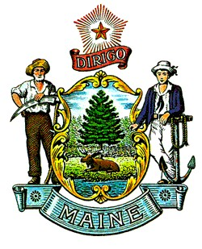  Paul R. LePage  Governor | State of Maine  Department of Agriculture, Food and Rural Resources  Board of Pesticides Control  28 State House Station  Augusta, Maine 04333-0028 | Walter E. Whitcomb  Commissioner  Henry S. Jennings  Director

Board Rules Under Consideration for Rulemaking

Chapter 10—Definitions and Terms:
- Amend the definition of “Spray Contracting Firm” to clarify the legal interpretation of a corporation and exempt companies that subcontract pesticide application work from the need for a Spray Contracting Firm License.
- Create a definition for “Low Risk Pesticides” so that landlords may provide certain pesticides to their tenants without the requirement of a general use pesticide dealer’s license.
- Amend the definition of “Custom Application” to exclude the use of antimicrobial copper hardware.
- Create a definition of “Government Employee,” consistent with the interpretation from the Office of the Attorney General, to clarify when such employees are required to possess an applicator’s license and which employees are exempt from paying fees.
- Amend the definition of “Commercial Applicator” to clarify that adults other than parents or guardians may apply insect repellents to children, and others who aren’t able to do it themselves, without the need for a pesticide applicator’s license.

Chapter 21—Pesticide Container Disposal and Storage: The Legislature repealed the container deposit mandate with the expectation that the Board would repeal the requirement in rule.

Chapter 27—Standards for Pesticide Application and Public Notification in Schools:
- Incorporate recommendations below that the Board supports in the Report to the Joint Standing Committee on Agriculture, Conservation and Forestry To Enhance the Use of Integrated Pest Management on School Grounds.
- Strengthen the role of the IPM Coordinator.
- Reduce and consolidate the school pesticide record-keeping requirements.
- Eliminate the beginning of year notification requirement.
- Address communication weaknesses between contractors and IPM coordinators.
- Provide for a way to maintain accurate contact information for school IPM coordinators.
- Add exemptions for high school agricultural and horticultural programs from certain requirements on of Chapter 27, and put into place alternate requirements to protect students.
- Align the outdoor sign requirement with Chapter 28, and adjust some typos and ambiguity.

Chapter 50—Record Keeping and Reporting Requirements: Remove requirements related to the container deposit records (see Chapter 21, above).

