2012 FIFRA SECTION 18 EMERGENCY SPECIFIC EXEMPTION
FOR THE USE OF AVIPEL TO REDUCE CROW PREDATION OF CORN SEED IN MAINE

General information requirements of 40 CFR 166.20(a, b) in an application for a specific exemption.

TYPE OF EXEMPTION BEING REQUESTED

 SPECIFIC

QUARANTINE

PUBLIC HEALTH

SECTION 166.20(a)(1): IDENTITY OF CONTACT PERSONS

(i) Contact person:
This application to the Administrator of the Environmental Protection Agency (EPA) Is for a specific exemption to authorize the use of Avipel (9,10-anthraquinone) as a seed treatment on corn seed to repel crows from eating freshly planted corn seed in Maine. This application is submitted by the Maine Board of Pesticides Control. Any questions related to this request should be addressed to:

Mary Tomlinson
Pesticide Registrar
Maine Board of Pesticides Control
Maine Department of Agriculture Food and Rural Resources
State House Station 28
Augusta, ME 04333-0028
mary.e.tomlinson@maine.gov
Phone: (207) 287-7544
Fax: (207) 287-7548

(ii) Qualified experts:
The following qualified experts are also available to answer questions:

Dr. Michael Braverman
IR-4 Project, Rutgers University
500 College Rd. East, Ste. 201W
Princeton, NJ 08540
(732) 932-9575 ext 4610

Richard Kersbergen
Extension Professor
Sustainable Dairy and Forage Systems
992 Waterville Rd
Waldo, ME 04915
207-342-5971
Richard.kersbergen@maine.edu

SECTION 166.20(a)(2): DESCRIPTION OF PESTICIDE
PROPOSED FOR USE

Common Chemical Name
(Active Ingredient): Anthraquinone

Trade Name(s) and EPA Reg. No.: Avipel Dry Powder Corn Seed Treatment (95% a.i.)
Registrant: Arkion Life Sciences, 3521 Silverside Road. Wilmington, DE 19810.

There is no EPA registration number as the proposed Section 3 label for Avipel has recently been submitted.

See the proposed Section 18 label.

SECTION 166.20(a)(3): DESCRIPTION OF PROPOSED USE

(i) Sites to be treated:
Corn seed planted in all Maine cropping areas is vulnerable to foraging or damage and could be potentially treated. During recent growing seasons, corn growers experienced depredation in all areas of Maine. This depredation often caused substantial stand loss leading to silage corn yield reduction, or in severe cases, caused growers to abandon the damaged crop and necessitated replanting. Maine growers planted an average of 27,800 acres of field corn per year from 2001-2010, with 28,000 acres planted in 2010 (USDA National Agricultural Statistics, 2011). The average acreage planted to sweet corn during the same time period was 2,170 acres, with 1900 acres planted in 2010. The potential utilization of this seed treatment would depend primarily upon a grower’s historical level of crow depredation, their risk management philosophy, and the expense and supply of the bird repellant seed treatment.

(ii) Method of Application:

Seed treatments will be used since crow depredation typically occurs between planting and early seedling stages. Corn seeds and seedlings may be vulnerable to depredation for a period generally ranging from three to five weeks after planting. This time is dependent upon soil temperatures during the spring, which primarily govern corn seed germination rate and early seedling growth. The most effective way to prevent damage and minimize exposure using the least amount of deterrent is to target the planted seed with a seed treatment application. The most common method of treating seed is expected to be the traditional planter box treatment where the required amount of active ingredient (a.i.) as a dry formulation is manually mixed with seed prior to filling the planter.

(iii) Rate of application (lbs of product /A):

Field corn and sweet corn – dry formulation: Use at a rate of one pouch per 42 pounds of seed [3.5 ounces per 42 pounds, or 3.3 ounces a.i. per 42 pounds of seed] as a dry mixture in the planter box as a seed treatment prior to planting.

(iv) Maximum number of applications:

One (1) per season.

(v) Total acreage to be treated:

Maine growers will likely plant about 28,000 plus acres of silage corn and 2000 acres of sweet corn in 2012 that are potentially susceptible to crow damage and may need a treatment. In reality, however, only a portion 10% (approx. 3,000 acres) of that amount may receive a treatment.

(vi) Total amount of pesticide proposed (active ingredient and product):

Assuming that 10% of Maine’s silage and sweet corn acreage will be treated, 3960 oz (247.5 lbs) a.i. or 4200 oz (262.5 lbs) of total product will be used in the state of Maine.

(vii) Restrictions and requirements concerning the proposed use and the qualifications of applicators using the pesticide:

- Mixers / loaders and applicators treating seed must wear coveralls, protective eye wear, chemical resistant and waterproof gloves, shoes plus socks and respirator. Follow manufacture’s instructions for cleaning and maintaining personal protective equipment (PPE). If there are no instructions for washables, use detergent and hot water. Keep and wash PPE separately from other laundry.

- Applicable restrictions and requirements concerning the proposed use and the qualifications of applicators using Avipel are as follows:

- Applicable directions, precautions and restrictions on the EPA approved Section 18 label must be followed.

- This label must be in the possession of the user at the time of the pesticide application.

- Avipel shall be applied only by licensed applicators or by persons under the direct supervision of a licensed applicator. The licensed applicator must be certified in the category applicable to the application of the restricted use pesticide.

- Read and follow “DIRECTIONS FOR USE” and “MIXING INSTRUCTIONS” sections of the Avitec label for essential product performance information.

(viii) Duration of proposed use:
Corn is generally planted from early May to mid June in Maine. It is essential to treat corn seed prior to or during this planting season, as corn productivity and resulting profitability decline considerably when plantings are delayed.

(ix) Earliest possible harvest dates:

Corn grain harvest may begin as early as late-August and continue through late October, depending on seasonal temperatures and environmental conditions. Sweet corn harvest may begin as early as mid-July.

Section 166.20(a)(4): ALTERNATIVE METHODS OF CONTROL

Freshly planted corn fields offer an attractive food source for native and overwintering crow populations. The lack of effective, alternative control methods has caused growers increasing concern over the past few years as crows are extremely adaptable and acclimate quickly to physical deterrents.

(i) Currently registered pesticides
There are currently no registered pesticides available for the control of crow depredation on corn seed and newly emerged corn. The application submitted for 2011 referenced an historical use lindane for pest control in corn; however, that claim was withdrawn in April 2011.

(ii) Alternative Control Practices:
Maine growers have employed a variety of physical deterrents such as: shotguns, cannons, scarecrows, inflatable eyeballs, owl decoys, radios, liquid starter, reflective flagging, bait corn to lure crows away, hunting, and hanging up dead crows, but these are all largely ineffective on crows since they quickly become acclimated to these practices. Large numbers of these devices would be necessary to have any impact at all in large acreage fields. Investment in practices that do not work or employing fulltime watchers with shotguns is not cost-effective.

Increasing planting depth has also been tried as a potential deterrent. Cool wet soils and deep planting depth often results in loss of plants due to rots and seed decay.

To avoid corn damage, Maine corn growers must have access to an effective, environmentally acceptable method of crow repellency. Several repellents have been tested to reduce crow damage, but the only effective product that persists long enough to protect recently emerged corn seedling in the field is anthraquinone.

Section 166.20(a)(5): EFFICACY OF USE PROPOSED UNDER SECTION 18

Limonene (LIM), Methyl Anthranilate (MA), and 9, 10-anthraquinone (AQ) have been cited as possible pesticidal deterrents to crow damage on corn seeds and young seedlings. A 1.0 % solution of AQ was effective as a crane deterrent while LIM and MA were not. Both MA and LIM metabolized in the soil too quickly to be effective during the entire period that corn plants were susceptible to crane damage.

In two trial periods, cranes did not damage the AQ treated fields, but there were approximately a 60% (Trial 1) and a 50% (Trial 2) reductions in corn seedlings per row foot in non-treated fields. Reports of the effectiveness of LIM, MA, and AQ seed treatments in deterring sand hill cranes are attached.

Section 166.20(a)(6): EXPECTED RESIDUE LEVELS IN FOOD

Michael Braverman at IR-4 is coordinating the residue program for anthraquinone. The residue program was conducted during 2006 and 2007. Texas samples have been analyzed for 2007. Results are shown in Section 8. During 2006, the trials were conducted at the 1X and 5X rates in the states of WI, MI, NY, OH and ND. In 2007, a trial was conducted at 1X and 10X at Weslaco, Texas.

In samples during 2006, there was not any parent or metabolite found in grain or any other fraction across several states. In 2007 studies, there were no residues in grain even at the 10X rate. The 1-OH metabolite was found at .012 ppm in stover at the 10X rate. The bottom line is that there have not been any detectable residues in grain from any sample from any state even when corn has been treated.

Section 166.20(a)(7): DISCUSSION OF RISK ASSESSMENT

HUMAN HEALTH

Anthraquinones, including 9,10-anthraquinone, are widespread in plants, including plants used for human consumption. The overall toxicological risk from human exposure to anthraquinone is considered negligible.

Toxicology Assessment
Acute Toxicity
For 9,10-anthraquinone the acute oral LD₅₀ in rats was >5000 mg/kg (Tox category IV); acute dermal LD₅₀ in rabbits was >5000 mg/kg (Tox category IV) and acute inhalation LC₅₀ in rats was > 2.11 mg/L (Tox category IV). Anthraquinone caused mild ocular irritation symptoms in rabbits which cleared by 72 hours post-instillation (Tox category III); anthraquinone caused slight dermal irritation in rabbits which cleared by 24 hours postdosing (Tox category III); and it was not a contact sensitizer in guinea pigs.

Mutagenicity and Developmental Toxicity
Anthraquinone did not induce positive increases in the number of revertants when tester strain cell cultures were dosed. Based on the data obtained from the mouse lymphoma forward mutation assay, anthraquinone did not induce a significant increase in mutant cells; no dose-response effects nor cell toxicity effects were observed. Based on the data obtained from the in vivo mouse microsomal assay, anthraquinone did not induce increases in micronucleated polychromatic erythrocytes; no bone marrow toxicity was observed for any dose. Based on the data obtained from the Chinese hamster ovary (CHO) chromosomal aberration assay, anthraquinone did not induce significant increases in chromosomal aberrations, polyploidy, and endoreduplication. Additionally, there were no visual signs of cell toxicity and no reduction in mitotic indices. These mutagenicity studies demonstrate that anthraquinone is not a mutagenic agent.

Subchronic Toxicity
A 90 - day feeding study was not required because of the nonfood use of anthraquinone. Also, the 90 - day dermal and inhalation toxicity studies are not required because the proposed use pattern does not result in prolonged exposure at concentrations that are likely to be toxic. The immunotoxicity study was waived based on the minimal potential for exposure and the low toxicity of anthraquinone.

Chronic Exposure and Oncogenicity Assessment
Chronic exposure studies are conditionally required to support nonfood uses only if the potential for adverse chronic effects are indicated based on 1) the subchronic effect levels established in Tier I subchronic oral, inhalation, or dermal studies, 2) the pesticide use pattern, or 3) the frequency and the level of repeated human exposure that is expected. Oncogenicity studies are required to support non-food uses only if the active ingredient or any of its metabolites, degradation products, or impurities produce in Tier I studies morphologic effects in any organ that potentially could lead to neoplastic changes. The triggers for chronic exposure and oncogenicity studies were not met.

Effects on the Endocrine Systems
EPA does not require information on endocrine effects at this time. However, it was considered if the available information on this compound may have an effect in humans similar to an effect produced by a naturally occurring estrogen or other endocrine effects. There is no known evidence that anthraquinone acts as an endocrine disruptor in humans. No adverse effects to the endocrine system is known or expected.

Dose Response Assessment
No toxicological endpoints are identified.

Dietary Exposure and Risk Characterization
Dietary exposure is unlikely to occur because of the nonfood use of anthraquinone. In the absence of any toxicological endpoints, risk from the consumption of residues is not expected for the general population including infants and children.

Occupational, Residential, School and Day Care Exposure and Risk Characterization
Human exposure to anthraquinone is expected to be minimal in these areas.

Occupational Exposure
The possibility for dermal, eye and inhalation exposure is mitigated as long as the product is used according to label directions, which recommends allowing the material to dry before allowing human activity in the treated areas.

Residential, School and Day Care Exposure and Risk Characterization
No indoor residential, school, or day care uses currently appear on proposed labels.

Drinking Water Exposure
Exposure to anthraquinone in drinking water is not expected.

Acute and Chronic Dietary Risks for Sensitive Subpopulations Particularly Infants and Children
There are no food uses associated with the proposed use of the anthraquinone. Therefore, the acute dietary risks should be negligible based on the lack of exposure.

Aggregate Exposure from Multiple Routes Including Dermal, Oral, and Inhalation
Aggregate exposure would primarily occur in the mixer/loader/applicator subpopulations via dermal and inhalation routes. Risks associated with dermal and inhalation aggregate exposure are measured via the acute toxicity studies submitted to support registration. Because the inhalation toxicity studies for anthraquinone showed no toxicity, the risks anticipated for this route of exposure are considered minimal. Results of the acute dermal study indicated low toxicity, and no significant dermal irritation. Based on these results, the anticipated risks from dermal exposure are also considered minimal. Therefore, the risks from aggregate exposure via dermal and inhalation exposure are a compilation of two low risk exposure scenarios and are considered negligible.

Cumulative Effects
Anthraquinone is not toxic and therefore there would be no expected cumulative effects from common mechanisms of toxicity.

Risk Characterization
EPA has considered anthraquinone in light of the relevant safety factors in FQPA and FIFRA. A determination has been made that no unreasonable adverse effects to the U. S. population in general, and to infants and children in particular, will result from the use of anthraquinone when label instructions are followed.

Therefore, the relatively minor increment in use as a result of the approval of these section 18 requests would not be expected to measurably increase risk.

THREATENED AND ENDANGERED SPECIES

There are few federally listed threatened and endangered birds, mammals and plants that occur perennially or seasonally, in Maine, and none that will be adversely affected by a bird repellant.

Recent AQ feeding study (2006) in sandhill cranes by International Crane Foundation (ICF) using treated whole kernel corn (0.5% AQ) concluded that birds were able to taste the chemical and find it repelling. Birds ingesting AQ-corn did not appear to be in any physical distress as evidenced from clinical chemistry and physical examination data. Further observations in the field by ICF in Wisconsin determining efficacy of AQ to repel sandhill cranes from germinating corn revealed that overall most birds avoided AQ-corn at 0.5% level. This dose level had maximum efficacy without any adverse effect on the birds. Under Section 18 use, the efficacy was being monitored in this area from 2006 to 2007 growing seasons.

In a most recent EUP field study by International Crane Foundation, AQ-corn (AQ) was planted on 4 ha next to 9.31 ha planted with non-treated seed (Lacy et al. 2007). At either 1% or 0.5% level, AQ was the only chemical found with desired chemical repellent characteristics protecting the corn seeds. Moreover, 0.5% AQ concentration was found adequate to persist throughout the vulnerable period of corn kernel. This study demonstrates that fields planted with treated seed altered the foraging behavior of cranes and reduced seed predation as a result of taste deterrence.

BENEFICIAL ORGANISMS

The pesticide anthraquinone works as a taste deterrent and has been effectively used to repel avian species from croplands and other areas (e.g. airports). It has been promoted as an environmentally friendly replacement for the recalcitrant pesticide lindane. Anthaquinones occur naturally in some plants, fungi, lichens, and insects. Ecotoxicity data was not provided by the manufacturer for review, but other sources show this compound to have a favorable toxicological profile. It has little toxicity to avian species, and is practically non-toxic to mammals, fish, and daphnids. Thus risks to beneficial and non-target species is minimal due to the lack of toxicity, use pattern, and mitigating label language. However, all efforts should be made to not apply this product directly to water, to areas where surface water is present or to inter-tidal areas below the mean high water mark. Do not contaminate water when disposing of equipment rinsate. Use of anthraquinone as directed in this FIFRA Section 18 application to repel avian species is not likely to pose any serious risk to Maine ecological communities.

ENVIRONMENTAL FATE

After review of the manufacturer’s data dealing with standard fate studies, no adverse effects are expected to Maine’s ecosystems with use of this product. Data indicates that this polyaromatic as expected is very insoluble in water and very immobile. Hydrolysis, photolysis, and aerobic and anaerobic soil degradation tests indicate this compound degrades primarily photolytically and under anaerobic conditions. Standard precautions are warranted even though contamination of Maine surface and groundwater is not likely to be an issue. Contamination of water should be avoided when disposing of equipment wash waters. With the precautions and restrictions proposed on the label, this pesticide can be used effectively and safely. After review of the proposed use and information, label language is sufficient to mitigate and minimize potential risks to native Maine wildlife and the environment.

Section 166.20(a)(8): COORDINATION WITH OTHER AFFECTED FEDERAL, STATE AND LOCAL AGENCIES

The Maine Department of Agriculture’s Board of Pesticides Control and the Maine Cooperative Extension Service have cooperated in the preparation of this petition. USDA-APHIS has been consulted and supports this application. Other state and federal agencies will be informed, if necessary, when the exemption is approved.

Section 166.20(a)(9): NOTIFICATION OF REGISTRANT

Arkion Life Sciences has been notified of this agency’s intent regarding this application (see letter of support).

Section 166.20(a)(10): ENFORCEMENT PROGRAM

The Maine Board of Pesticides Control (BPC) is the State Lead Agency for the regulation of pesticides. The BPC will monitor the application of the exempted pesticide as needed to determine that the provisions of the specific exemption are being followed.

Section 166.20(a)(11): REPEAT USES

This is the second year Maine has applied for this specific exemption, but the first request was denied in 2011. A crisis exemption was granted for 2011.

Section 166.25(b)(ii): PROGRESS TOWARDS REGISTRATION

Anthraquinone is registered with EPA under a section 3 label (Flight Control Plus) to repel geese. IR-4 is conducting residue trials in several states for Section 3 registrations. Arkion Life Sciences filed a Section 3 label for use of Avipel on corn seed in late 2010.

Section 166.20(b): NAME OF PEST

Scientific and Common Name of the Pest: American crow (Corvus brachyrhynchos)

Section 166.20(b)(2): DISCUSSION OF EVENTS OR CIRCUMSTANCES WHICH BROUGHT ABOUT THE EMERGENCY SITUATION

Historically, high populations of crows overwinter or are native to Maine. According to the North American Breeding Bird Survey (2011), the crow population in Maine grew annually between 1966 and 2009 by 1.6% (confidence interval of 1.0% - 2.2%). Over the most recent 10-year interval (1999-2009), the population grew annually by 1.5% (95% confidence interval of 1.0%-3%) (Appendix A, Figure 1). The increase in crow population is likely be due to less bird die-off as a result of the increasingly mild winters Maine has experienced. Data from the National Weather Service does show the average seasonal (September-May) temperatures have been gradually increasing from 1995-1996 through 2009-2012 (Appendix A, Figure 2).

While crows have been damaging corn in Maine for the past 20-plus years, it is important to note that the crow pressure appears to have exceeded the economic threshold around 2008, impelling growers to seek assistance from the Maine Department of Agriculture, Food, and Rural Resources. The department’s agricultural compliance supervisor reported that he began receiving calls from corn growers in 2008 requesting guidance in dealing with crow depredation on corn. There were no products available on the market to repel crows, leading growers to employ a variety of physical deterrents which became less effective over time.

Section 166.20(b) (4): DISCUSSION OF ECONOMIC LOSS

The lack of effective control measures for crows has been very costly to Maine corn growers since 2008. Crow predation during the corn seed germination and plant establishment stages may cause substantial stand loss leading to considerable yield reductions, or in severe cases, cause growers to abandon the damaged crop and require replanting. Corn grain yield is very responsive to plant density and uniformity. Therefore, corn seed and plant stands are extremely vulnerable to relatively minor stand loss resulting from crow depredation. Stand loss of more than 10% is generally considered unacceptable.

Crow predation of corn seed produces non-uniform stand reduction as crows opportunistically feed down a planter row, extracting numerous adjacent seeds within a row. Corn seeds are typically spaced about six-inches apart down a row. Consequently, if a single crow extracts 6 to 10 adjacent seeds, then they produce large three to five foot skips with no plants within a row. Furthermore, corn has relatively poor compensatory ability for stand reduction compared to other crops, because corn does not possess the physiological capability to branch or tiller, like sorghum, soybeans, cotton, wheat, or rice. As a result, corn’s compensatory ability is primarily limited to enhancing ear size, which severely restricts the plant’s ability to offset stand reduction.

If a grower suffers severe stand loss (more than 25% stand reduction), he or she suffers this monetary loss, and must replant as well. The planting process is very expensive ($80 to $110/acre) and accounts for about 20% of the total budget to grow a corn crop. Not only does a grower suffer the monetary loss associated with planting a crop twice, but replanted corn includes additional expense of pesticide application or tillage ($20-$25/acre) to control remaining plants from the failed stand and is normally far less productive and very inconsistent, compared to normal plantings, because sensitive corn reproductive stages occur later in the summer, or not at all given Maine’s narrow window for planting. Certain herbicide programs used by Maine farmers do not allow for the potential to replant to corn, potentially adding to the financial loss.

The increased cost of corn seed and fuel also adversely impacts the damage costs. These factors contributed to a rise in total farm production expenditures which peaked in the Atlantic states in 2008, after rising 8% from 2007 (New England Agricultural Statistics Service, 2011, p. 21). The rise in total expenditures in 2008, combined with increasing crow depredation, at a time when the value per ton of silage corn was at its highest since 2001, conspired to create a non-routine loss for growers in 2008 which continues to worsen.

The yield for silage corn remained constant for 2007, 2008, and 2010, but fell in 2009 (New England Agricultural Statistics Service, 2011, p. 35). In 2007, silage corn was valued at $33.00 per ton, but rose by 33% to $44.00 per ton in 2008. It remained at this level for 2009, decreasing to $42.00 per ton in 2010. Current market prices in New England for corn silage range from $50-$60 per ton (R. Kersbergen, p.c). The yield for sweet corn rose in 2007, but declined from 2007 through 2010 while the value increased for the same period (New England Agricultural Statistics Service, 2011, p. 45). The yield in 2010 was the lowest since 2002. The value per hundred weight (cwt) of sweet corn also increased in 2008 by just over 10%, rising from $37.50 per cwt in 2007 to $43.00 per cwt in 2008 and 2009. The value of sweet corn continued to rise to $49.00 per cwt in 2010.

Crop loss data for Maine growers are not available for 2007 through 2009. However, 2010 crop loss data were obtained via a survey of Maine growers who applied Avipel, through a Crisis Exemption granted for 2011. Due to confidentiality, the survey was administered through the two distributors who sold Avipel. Only one distributor provided the requested crop loss data, thus the results are based only on 19 of the 43 growers who used Avipel. These growers represent seven counties with average crop loss by county ranging from 14% to 52% (Appendix B, Table 1).

Participating growers planted 2213 acres to silage corn in 2010 and reported an average crop loss of 29% due to crow depredation. This translates to a loss of five tons per acre of silage corn with a value of $219 per acre (Appendix, Table 2). However, based on a 5-year average yield for silage corn of 17 tons per acre (baseline value for calculating the significant economic loss), the gross revenue or value of that loss was $195 per acre which also was 29% of the baseline gross revenue (Appendix B, Table 3).

Participating growers planted 73 acres to sweet corn in 2010. A 29% crop loss translates to a loss of 16 cwt of sweet corn per acre with a value of $782 (Appendix B, Table 4). Based on the 5-year average yield of 64 cwt/acre and average value of $39 per cwt, the gross revenue or value of that loss was only $195 per acre (Appendix, Table 5). However, that loss is 29% of the baseline gross revenue (Appendix B, Table 4).

In conclusion, the 19 growers, representing seven counties, experienced substantial economic losses since 2007 due to crow depredation on silage and sweet corn. The yield loss estimates for both silage corn and sweet corn appear to exceed both the Tier 1 and Tier 2 thresholds and qualify as significant economic losses.

Section 166.20(b) (ii) & (iii): ESTIMATED REVENUES FOR THE SITE TO BE TREATED

Estimated net and gross revenues for the site without the use of the proposed pesticide but with the next best alternative:

There is no alternative product.
REFERENCES

National Weather Service Forecast Office Gray/Portland. Climate Data – Past Weather and Normals. 2012. Available at: http://www.erh.noaa.gov/er/gyx/climate_f6.shtml. Accessed 19 January 2012.

New England Agricultural Statistics Service, USDA. 2011. New England Agricultural Statistics 2010. Concord. New Hamsphire.

North American Breeding Bird Survey. 2011. North American breeding bird survey 1966-2009 analysis. Available at: http://www.mbr-pwrc.usgs.gov/cgi-bin/atlasa09.pl?ME &2&09. Accessed 25 April 2011.

Kersbergen, Richard, Sustainable Dairy and Forage Systems Professor. 2012. Personal Communication.

APPENDIX A – Maine Crow Population and Climate Trends

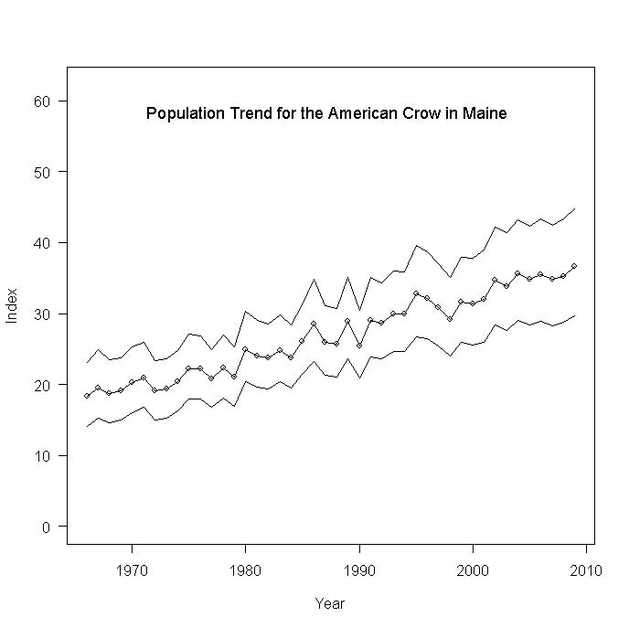
Figure 1

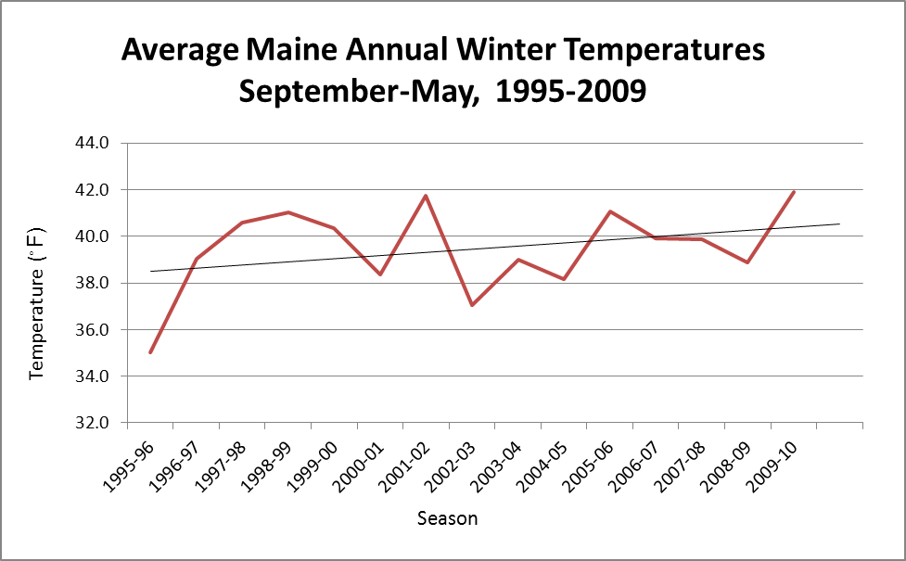
Figure 2
APPENDIX B – Maine Corn Yields and Losses

Table 1. Average percent corn
crop loss by Maine county in 2010.
County | Crop loss (%)
Androscoggin | 52
Kennebec | 21
Penobscot | 28
Somerset | 23
Sagadahoc | 20
Waldo | 14
York | 20

TABLE 2. Yield and value of silage corn for Maine. Loss derived using average crop loss of 29% sustained by growers. Yield (tons/acre) and value per ton obtained from the New England Agricultural Statistics 2010.
 | Yield (tons/Acre) | Value ($/ton) | Value ($/acre) | Yield Loss (tons/acre) | Loss of Revenue ($/acre)
2006 | 17.0 | 32 | 544
2007 | 18.0 | 33 | 594
2008 | 18.0 | 44 | 792
2009 | 12.5 | 44 | 550
2010 | 18.0 | 42 | 756 | 5 | 219
5 Year Average | 16.7 | 39 | 647

Table 3. Calculation of SEL for Maine silage corn.
 | Yield (tons/acre) | Value ($/ton) | Gross Revenue ($/acre)
Baseline - Absence of Emergency | 17 | 39 | 663
Change as a Result of Emergency | -5 | n/a | 195
Expected as a Result of Emergency | 12 | 39 | 468
Loss as % of baseline | 29% | n/a | 29%
Loss Thresholds | Tier 1  SEL if ≥ 20% |  | Tier 2  SEL if ≥ 20%

TABLE 4. Yield and value of sweet corn for Maine. Loss derived using average crop loss of 29% sustained by growers in 2010. Yields per acre and value per hundredweight (cwt) obtained from the New England Agricultural Statistics 2010.
 | Yield (cwt/acre) | Value (cwt/acre) | Value ($/acre) | Yield Loss (cwt/acre) | Loss of Revenue ($/acre)
2006 | 65 | 39 | 2,535
2007 | 80 | 34 | 2,680
2008 | 60 | 43 | 2,580
2009 | 60 | 47 | 2,820
2010 | 55 | 49 | 2,695 | 16 | 784
5 Year Average | 64 | 42.3 | 2662

Table 5. Calculation of SEL for Maine sweet corn.
 | Yield (cwt/acre) | Value ($/cwt) | Gross Revenue ($/acre)
Baseline - Absence of Emergency | 64 | 39 | 663
Change as a Result of Emergency | 16 | n/a | 195
Expected as a Result of Emergency | 48 | 39 | 468
Loss as % of baseline | 25% | n/a | 29%
Loss Thresholds | Tier 1  SEL if ≥ 20% |  | Tier 2  SEL if ≥ 20%
Significant Economic Loss ? | Yes |  | Yes

