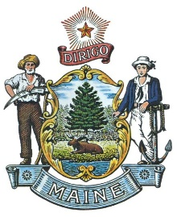
State of Maine
Department of Professional & Financial Regulation
Bureau of Insurance

Janet T. Mills
Governor
Anne L. Head
DPFR Commissioner
Robert L. Carey
Superintendent

CONSUMER COMPLAINT CONTACT UPDATE

The Maine Bureau of Insurance maintains a consumer contact database to contact companies efficiently and correctly regarding consumer complaints. Please use this form to notify the bureau annually and each time the information changes.
Please note that you are required to keep the Bureau updated, in writing, if any of this information changes throughout the year.

Address for: Life/Accident/Health/Annuity/Credit Insurer (Email: Heather.P.Greenleaf@maine.gov ) Property/Casualty Insurer (Email: April.Breton@maine.gov )
Please type all information.
Maine Company License #: -and- NAIC Code:

Company Name:

Contact Person/Division:
(Name of Contact Person or Attention Line)

Email:

Phone #: Ext.

Fax #:

Address:
(Street) (PO Box)
(City, State, Zip Code & 4 Digit Code)

Note: Please use this form for any future changes in your complaint contact information.
Mail, Email or Fax the completed form to the attention of the appropriate division at the address above or fax number below.

O F F I C E S LO C A T E D A T 76 NO R T H E R N AV E N U E , GA R D I N E R , M A I N E 04345 www.maine.gov/pfr/insurance
Phone: (207) 624-8475 TTY: Please call Maine Relay 711 Consumer Assistance: 1-800-300-5000 Fax (207) 624-8599

Revised 3-7-2024

