Board of Trustees

MAINE CRIMINAL JUSTICE ACADEMY

BREATH TESTING DEVICE OPERATOR CERTIFICATION

Specification S-26

Purpose:

The program is designed to provide the appropriate knowledge and necessary skills for operators of self-contained evidential Breath Testing Devices (BTDs).

General Requirements:

The BTD Operator Certification and Recertification course will consist of classroom and/or on-line training and practical training as approved by the Board. Upon the successful completion of the training, a certificate of proficiency valid for a period not to exceed four (4) years shall be issued by the Director.

Certification:
- The candidate must:
- Be sponsored by an agency department head.

- Successfully complete the BTD Operator Certification course, including:
a. Final examination cumulative average of 80% or greater.
b. Completion of the required training breath tests monitored by and to the
satisfaction of an MCJA Certified BTD Instructor.

Recertification:
- The candidate must:
- Successfully complete the BTD Re-certification classroom or on-line training course and score a minimum of 80% on the recertification exam.

- Successfully complete the required training breath tests (a practical assessment) reviewed by and to the satisfaction of an MCJA Certified BTD Instructor.

- Submit or cause to be submitted all supporting materials for the recertification to the Academy between January 1st and November 30th of the year in which their certification expires.

- Recertification materials received by the Academy after November 30th will not be accepted and the candidate’s BTD Operator Certification will expire on December 31st of that year.

- A BTD Operator whose certification expires must repeat all the requirements for the initial certification, as outlined above in the certification section of this specification.

Suspension of Certificate:
- The BTD Operator certificate may be suspended by the Academy Director for:
- Failure to maintain certification or recertification requirements listed above, or

- Failure to follow program curriculum guidelines that would jeopardize the integrity of the program.

Adopted: 10/23/2009
Amended: 01/27/2023
Review Date: 01/27/2026
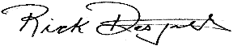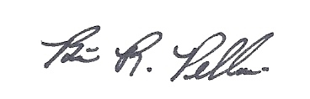
____________________________ __________________________
Richard R. Desjardins, Director Brian R. Pellerin, Chair
Maine Criminal Justice Academy MCJA Board of Trustees

