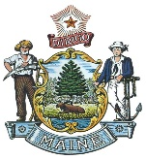**STATE OF MAINE**

**WORKERS' COMPENSATION BOARD**

John C. Rohde

Executive Director

Janet T. Mills Governor

# The Workers’ Compensation Board Portland Regional Office is moving from Forest Avenue in Portland effective December 4, 2023

Please visit us at our new location:

**56 NORTHPORT DRIVE, PORTLAND**

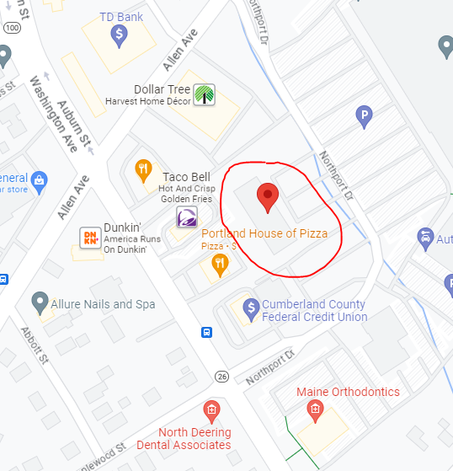

* Phone, fax & email will remain the same.
* New mailing and physical address (effective December 4th):

***56 Northport Drive, Suite 201***

***Portland, ME 04103***

* You will not be able to reach us by telephone, fax or email while we are in the process of moving on November 30th & December 1st.

# Directions to New Portland Regional Office

# 56 Northport Drive

# Portland, ME 04103

**FROM POINTS SOUTH:**

* Head north I-295.
* Take Exit 8 for ME-26 N/Washington Ave.
* Drive approximately 2 miles.
* Turn right onto Northport Drive, just after Maine Orthodontics.
* Northport Drive will loop to the left. The building is on the left.

**FROM POINTS NORTH:**

* Head south on I-295.
* Take Exit 10 for Bucknam Rd toward US-1/ME-9/Falmouth.
* Keep right at the fork, follow signs for Cumberland and merge onto Bucknam Rd.
* Merge onto Bucknam Rd.
* Continue straight onto Falmouth Rd at the intersection.
* Turn Left onto Allen Avenue Ext.
* Turn Left onto Northport Drive.
* The building will be on the right.