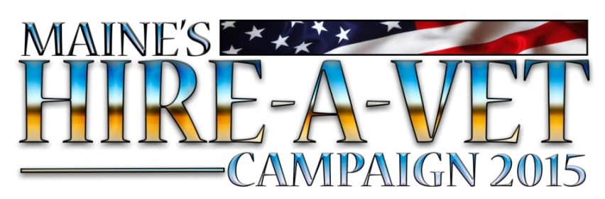

Maine Hire-A-Vet Fact Sheet

- 135 participating employers in the Maine Hire a Vet Campaign who have reported 261 Veteran hires at an average wage of $17.89 per hour. Top wage of $50.48 per hour.
- A total of 89 participating employers attended the Military 101 events in August and October. Those employers who attended Military 101 training reported hiring 219 of the total reported 261 Veteran reported hires or 84 percent. That is significant and shows just how valuable those two training sessions actually were.
- We have employers from all 16 Maine counties participating, as well as veteran hires from all 16 counties.
- Connecting homeless veterans with employment:
  - Homeless veteran, with a wife and two young girls, who not long ago were living in a tent, is now working for SME Corp. as a metal worker and making $15 per hour. The veteran's wife is now also working and they will soon move into an apartment.
  - SME Corp. also hired a homeless veteran who was living in his sister’s chicken coop.
  - Washington-Hancock Community Agency (WHCA) originally hired a homeless female veteran as a temp. intake specialist for the Low Income Heating Assistance Program (LIHEAP). The veteran and her two children had relocated to Maine. When they arrived she couldn't find work. By late Sept the veteran was promoted to a full-time position.
- Attracting veterans to Maine:
  - Navy Reservist from Virginia, who contacted the campaign through the MHAV Facebook page, is now hired as an Administrative Program Director for Goodwill starting Dec 31.
  - A veteran who lives in Maine but has worked and stayed in Massachusetts with a coworker Monday–Friday as he could not find wages in Maine comparable to his current position has now been hired in Maine by NETco.
- Social media strategies are working:
  - During the campaign, Facebook users from 8 countries, 24 states, and 176 cities “Liked” the Maine Hire A Vet Facebook page; these 541 people commented/liked/shared/mentioned 2,142 times, helping our message reach nearly 8,000 Facebook users and generating more than 66,000 impressions about hundreds of job opportunities and many employment resources in Maine.
- The work of the campaign continues:
  - The campaign itself is wrapping up, but the resources and best practices for job matching will continue! Veterans and employers alike can still tap Maine Hire A Vet partners through the MHAV FB Page and the Maine DOL Veterans Employment Team FB Page.

