DVR News & Views

Maine Department of Labor,  Bureau of Rehabilitation Services  Division of Vocational Rehabilitation  Volume 2, Number 1 January 2011 | 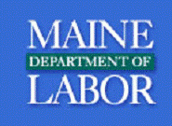

Welcome

Welcome to the new and improved NoQ4U Newsletter, recently renamed “DVR News & Views.” When we started this newsletter a year and a half ago, it was with the goal of providing timely updated information to staff and our partners about all the work being done in the “Eliminate the Wait list Project” throughout the division. Although we accomplished that goal in October 2010, we must remain vigilant in our oversight of staff, services and financial resources as we learn to adjust to life without a wait list. Therefore, this newsletter, using a little different format, is a way for us to continue to share information and receive feedback from staff and partners as we move forward.

I know you don’t hear it often enough – Thank you for all the work you have done and continue to do as we focus on improving access to employment for people with disabilities. I love the success stories that are shared through your staff meetings and I appreciate all the feedback that you have shared with us in the Staff Reflections section of this newsletter. Karen Fraser and I will be visiting the offices at staff meetings in April to circle back around regarding the “Beyond ARRA” work plan. As case files are reviewed, we can see the level of dedication that comes through in your case notes and plans you write with people. In closing, special thanks from us all to Jill Duson for her leadership, support and belief in the mission of our agency. She will be missed!

Betsy Hopkins
DVR Director

BRS Director Scribbles

Because of your focused tenacity and hard work, DVR has moved into the closure and sustaining improvements stages of the NoQ4u project. The renaming of this newsletter is a reflection of your success.

Operating without a waiting list; providing the right service at the right time is now, simply, the way we do business. In the course of this project, you shared your insight in workgroups, examined your service practices, and implemented new ideas – and most importantly you remained client-focused even when so much around you was changing.

There are promising signs in the OOS category distribution report and in early data about the impact of the Career Exploration Workshop on outcomes. Going forward we will focus on completing the “Plan, Do, Check, Act” cycle for NoQ4U and implementing Maine Aware to help sustain the systems changes the Division has accomplished.

While we celebrate a job well done – we also recognize that the work continues.

What next, you ask? Well, that will be very much up to you. Let’s tie down the details of the enormous work just accomplished and make sure we can sustain improved results over the long term. Then, it’s up to us all to devise and prioritize what is next along a continuum of service improvements for our participants and a supportive working environment for employees.

Thank all of you for your continued commitment to improving employment opportunities for people with disabilities across Maine.

Jill Duson
BRS Director

P.S.: As of Friday January 28th, my tenure with the Bureau of Rehabilitation Services has drawn to a close. I have every confidence that with accountability and dedication to mission, you and the Bureau Lead Team will continue to achieve incredible results in partnership with Maine residents with disabilities who want to work. It has been my pleasure and privilege to work with and learn from you over the past seven years.

"You don't have to see the whole staircase, just take the first step." MLK, Jr.

DVR Data

A note from Betsy Hopkins -
Included below are two charts which compare pre- and post project data on Order of Selection and applications for VR services. The distribution of clients being placed in Categories 1, 2 and 3 reflect that the new tool is working as it was intended. These distributions are more in line with the intent of the federal rule that those people found eligible for services in Category 1 are truly those that have the most significant disabilities.

Staff are reporting considerable stress related to the numbers of people coming in to VR for services. As you can see from the numbers below, our actual application numbers have dropped a bit when compared to this same time period last year. As we adjust to not having a wait list and even see that our actual caseload sizes have dropped a bit compared to previous years, the difference is that every person on a counselor’s caseload is active and engaged in the VR process, which is absolutely our goal! On the other hand, this means many more appointments, telephone calls and overall work for counselors. Please be assured that we are monitoring this carefully and urge you to work closely with your supervisors as we all strive to manage the ongoing workload.

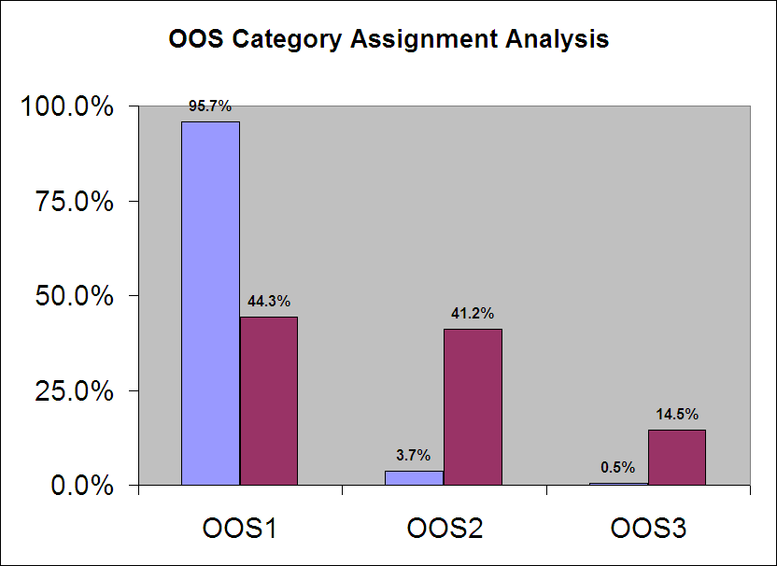

Jan - Dec 2009 | 2452 | 96 | 13
Jan - Dec 2010 | 917 | 853 | 299

Graphs prepared by Alice Johnson – Rehabilitation Consultant
NoQ4U – One Year On … Staff Reflections

The NoQ4U – Eliminate the Waitlist initiative has resulted in many changes to DVR policies and practices. We asked staff to share their thoughts on what these changes have meant for clients and themselves. Some of their challenges, successes, and ideas for the future are captured below:

Getting regular updates about changes and new resources is valued by many VRC’s.
Fran Day

I attended a CEW…in that particular session were three clients – two attendees were individuals who are deaf, the last was an individual with progressive hearing loss. What I saw happen in that group was quite lovely. The two younger deaf individuals brought the older hard-of-hearing individual to new understandings…that person was able to gain a much better understanding of the skills and possibilities that exist in the world for persons who don’t hear well – or at all. The three got along well and communicated well. One of the deaf individuals began to come out of their shell more as well…the experience was worth every moment. Mary Borelli Bean

What I (and some others have also expressed to me) need is more clerical assistance. So much of what I do is what a clerk level person could and all this prevents me from doing case management in the way it should be done. Mary Knowlton

With the ARRA staff, there has been a noticeable element of support to RCII’s in the area of processing intakes. We have a concern about …not being able to get to the intakes in a timely manner (post ARRA)…How is this going to be dealt with?
Rosie Hartzler, Barbara Greenstein, Kim Waite, Marie Peaslee, Angela McInnis

I did an analysis of the 15 clients I have had attend the CEW so far. I had 7 clients who ended up closing their cases. That is a success to me in that they were able to decide for themselves that working was not right for them at this time and we did not use more expensive resources to come to that same conclusion. Of the other 8, 2 are in college, 1 is receiving Job Development services and 5 are still exploring with me what their options are. I know these statistics are a little premature …but I find them valuable and interesting. Sheryl Smith

I would say that having the ARRA staff in combination with the excellent VRC I staff in our offices have been a great help. When I took over this caseload in August 2010, I identified that with their help my caseload had been decreased to a manageable level. Some of the ways the ARRA and VRC staff assisted with this task was by following up with clients that had not been in contact with their VRC II for a long period time (including those eligible and those on the waitlist) to see if they were still interested in VR services, gathering updated contact information to assist their VRC II to be able to contact those who remained interested in a timely fashion, providing updates to VRC II as to what statuses they had been asked to target (which were very helpful to me because it allowed me to focus on my other clients in active statuses), closing cases of folks who expressed they were no longer interested, and assistance with both orientations and intakes. Rachel Merriam

We are wondering about how the statistics are being compiled in regard to the impact of the CEW on client success.
Rosie Hartzler, Barbara Greenstein, Kim Waite, Marie Peaslee, Angela McInnis

My Client attended CEW in Dec 2009. She had never worked before. She worked in a special appointment position in Nov-Dec 2010 in a State agency. They were very pleased with her performance and would have hired her if the position was available to be filled. She is now on the state register for Office Assistant II and is affected by the hiring freeze statewide at this time. The experience of the CEW and the Special Appointment work experience have both given her confidence in her skills and ability, and given her positive feedback about her soft skills as well as her job specific abilities.
Barbara Clement

For a resource, I would really like to see all of us have the newer version of Microsoft Outlook. Sheryl Smith

While I’m feeling like it’s a bit early for me to comment on NoQ4U…I can see that my clients’ near immediate access to VR services (upon eligibility) is bringing employment results more quickly.
Monica Mitchell

Transition from School to Work

Our new Cooperative Agreement with the Maine Department of Education is now available on the web! http://inet.state.me.us/rehab/brs_staff_resources/mou/index.shtml

Technology Updates

The project to implement the new case management system, Maine AWARE, is continuing to move ahead on schedule (and on budget) for the September 2011 roll out. The project team is currently working to clean up case data to move it from ORSIS to AWARE so that existing cases will be available when the system goes on line. Additionally, adaptations and designs are currently being completed for changes to the system to make it function according to Maine business rules. In late February and early March, the project team will have its first walk through of the customized Maine system and begin the process of documenting any new processes or business rules in preparation for statewide staff training on the new system later this summer.

Submitted by Joshua Howe – Rehabilitation Consultant

Other VR Updates

BRS Highlights 2009-2010
This publication is intended to provide a snapshot of the current state of the Bureau of Rehabilitation Services with highlights of both our accomplishments and challenges. Hard copies have been distributed to local offices through the supervisors, and it is currently available on the web at http://www.maine.gov/rehab/brs_highlights. If you would like your own hard copy, please talk to your supervisor.

Comprehensive Assessment of Rehabilitation Needs Training
March 2011
Lee Brinkley Bryan from Athens, Georgia will be the presenter for this exciting training opportunity. The comprehensive assessment training will be centered in vocational analysis, case management and vocational rehabilitation planning. Lee has been a vocational rehabilitation practitioner for over twenty five years, providing services in the public and private sectors. She is a Certified Rehabilitation Counselor and a Certified Vocational Evaluator. Lee has such great enthusiasm for her work and teaches regularly at Roosevelt Warm Springs Institute in Warm Springs, GA. I hope you plan to join us for this energizing and didactic training event. If you have not already registered (or for more information concerning dates/locations) contact Barbara at barbara.a.michaud@maine.gov. Look forward to seeing you there.
Submitted by Barbara A. Michaud – Training Coordinator

Tambrands Hiring Initiative Project Underway
BRS is partnering with Tambrands, a Proctor & Gamble Company located in Auburn, Maine, to implement a manufacturing environment designed to maximize the inclusion of people with disabilities in the Tambrands’ workforce. This project, the “Tambrands Hiring Initiative,” is adapted from an innovative project implemented by Walgreens that has earned national recognition. Presently, job offers have been made to four applicants pending background checks; and arrangements are being made to consider up to 24 additional referrals. In phase two of the project, BRS will match job seekers to several positions (20 to 25 FTEs) in a “Customization Center” that is currently under design. Other partners in the Tambrands Hiring Initiative include the Div. for the Blind & Visually Impaired, MDOL Bureau of Employment Services, DHHS, Pathways, Inc., and Staffing Management. For further information, contact Valerie Oswald at 623-7963.
Submitted by Valerie Oswald – Rehabilitation Consultant

Memorandum of Understanding in development with Veterans Administration
In an effort to improve our services to veterans, a team of staff from DVR and DBVI has begun work on a Memorandum of Understanding with representatives from the United States Veterans Affairs – Vocational Rehabilitation & Employment office. Among topics that the MOU will address will be - referrals for service, shared cases, and developing regular interagency communication. Work on the MOU is moving quickly, and is anticipated to wrap up by the end of March.
Submitted by Libby Stone-Sterling – Assistant Director

