Vocational Rehabilitation Services and
Extended Learning Opportunities
Working Together to Increase Opportunities for Maine Students

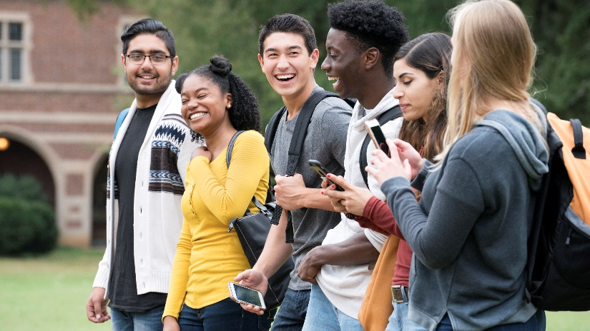
Research has shown that work experience before high school graduation is one of the best predictors of post-secondary success. For students with disabilities, participation in paid work experience and other work-based learning is critical to building skills and overcoming stigma and misconceptions about what young people with disabilities can achieve in employment.
The Maine Department of Labor’s Division of Vocational Rehabilitation and Division for the Blind and Visually Impaired set aside 15% of their federal funding to provide Pre-Employment Transition Services and other VR services to nearly 4000 transition-age youth and young adults each year to assist them to prepare for and enter meaningful career pathways.

What services does Vocational Rehabilitation provide?
Pre-Employment Transition Services include:
- Job Exploration Counseling
- Work-based Learning Experiences
- Counseling on Opportunities for Post-Secondary Training and Education
- Workplace Readiness Training to Develop Social Skills and Independent Living
- Instruction in Self-Advocacy
VR offers students activities such as – virtual job clubs, job shadows, business tours, Virtual Job Shadow, paid work experience, summer work experience, college prep programs, Transition Career Exploration Workshop, soft skill and work readiness training, and driver’s education – as well as more individualized transition services such as job development and placement and education and training.

What are the Benefits of ELO and Vocational Rehabilitation Partnership?
- Both programs share a goal of increasing access to real-world experiences that lead to improved student outcomes
- Every Maine high school has an assigned Vocational Rehabilitation Counselor who brings knowledge of best practices in youth employment and disability services to the team
- VR Counselors have access to resources and funding that may be blended and braided to support students with disabilities who participate in ELO.
- VR can support students during the ELO, helping them to make the most of their experience and linking their learning to coordinated transition planning.
- VR also can provide support services including assistive technology or job coaching that promote access to work-based learning opportunities.
- VR has strong established partnerships with employers and other service providers to develop opportunities for youth who would otherwise face barriers to entry into the world of work – including through the use of its funds to pay wages during work experiences.

What Can Success Look Like?
- “Jay”, a young man with autism, participated in the JMG program at Bangor High School and was referred to Vocational Rehabilitation’s Progressive Employment model in his senior year. He did not think that he was going to be employable because he thought “People don’t really like me and I am not really good at anything.” He went on a tour and interview at a local barbecue restaurant. Jay discovered during his interview that workers could have a free meal and soda during each shift. The manager saw the sparkle in his eye and heard the enthusiasm in his voice, “I can work, get money, and free root beer?” Jay began a Paid Work Experience and was hired at its completion! Jay returned to his JMG class with his barbecue restaurant hat on and announced, “I got a job!” Jay enrolled at the University of Maine at Augusta following graduation.

- Watch Mitchell’s story at
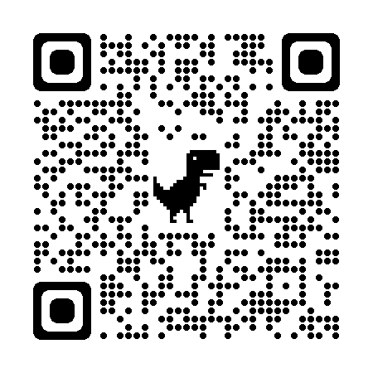
Get Connected with Vocational Rehabilitation! Find Your Local Transition VR Counselor at https://www.maine.gov/rehab/docs/2022/dvr/TransitionCounselorList.pdf
