

Bureau of Rehabilitation Services Highlights

2014-2015

The Bureau of Rehabilitation Services works to bring about full access to employment, independence and community integration for people with disabilities.

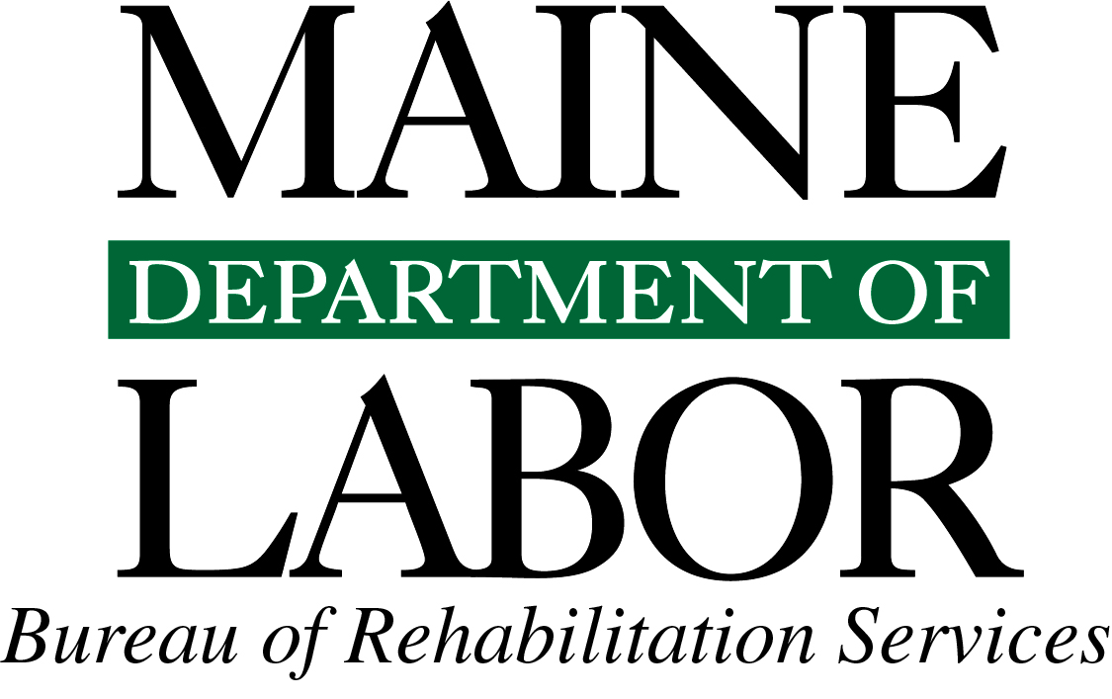


April 3, 2015

The Maine Department of Labor is committed to serving Maine workers and businesses, ensuring that our beautiful state prospers and continues to be a wonderful place to live and work. We are proud to house the Bureau of Rehabilitation Services (BRS), an agency whose main focus is to assist people with disabilities to become self-sufficient, live independently and enjoy all the benefits that employment brings – financial, social, and psychological.

This bureau’s leadership in developing employment opportunities for people with disabilities continues to serve as a role model for efficient and effective service delivery. Much has been accomplished, during a time of very limited resources, as BRS has enhanced services and increased the number of individuals becoming employed since 2010 by over 65 percent. Along with what you will read in the following pages, the bureau is in the process of completing videos that will show how BRS facilitates opportunities that connect people with disabilities to employers in need of a loyal, dependable workforce. We encourage you to view these at www.maine.gov/rehab and share them with your colleagues.

It is a testament to the hard work of the bureau’s staff that they have accomplished the goals highlighted in this document. Yet there is far more to be done, and we are up for this challenge to the benefit of our employers and the citizens

The enactment of the Workforce Innovation and Opportunity Act (WIOA) in 2014 affords us the opportunity to work across education and workforce systems as we have never done before. Under this Act, we will be able to better align resources among state agencies and partners that address the demand-driven needs of employers while staying true to serving the employment needs of our diverse population.

I invite you to learn more about the variety of services the bureau provides and its initiatives to continuously improve the opportunities for people with disabilities to fully participate in their communities, live independently, and be employed. If you have any questions, please reach out to the Bureau’s acting director, Karen Fraser, or me at any time. If you know of an employer that could benefit by hiring talented and loyal workers, do not hesitate to connect them to the Bureau of Rehabilitation Services.

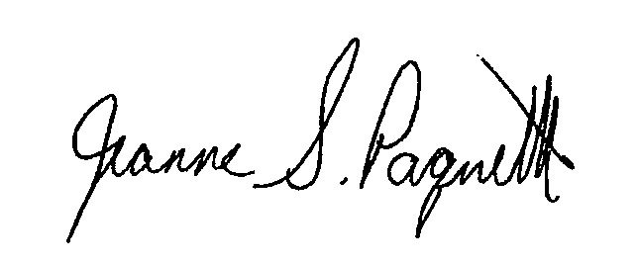
Sincerely,

Jeanne Paquette
Commissioner

Table of Contents

Message from the Commissioner 2

Bureau of Rehabilitation Services Overview 4

Division of Vocational Rehabilitation (DVR) 6

DVR Initiatives and Innovations 7

Division for the Blind and Visually Impaired (DBVI) 8

DBVI Initiatives and Innovations 9

Business Relations Activities and Outcomes 10

Office of the State Accessibility Coordinator 11

Partners in Advocacy, Advisory Boards and Councils 12

BRS Office Directory 12

Bureau of Rehabilitation Services Overview
The Bureau of Rehabilitation Services (BRS) is comprised of three Divisions – the Division of Vocational Rehabilitation (DVR), the Division for the Blind and Visually Impaired (DBVI), and the Division of Systems Improvement and Quality Assurance (SIQA). A total of 158 BRS employees currently deliver public vocational rehabilitation and independent living services to Maine people with disabilities and are co-located at CareerCenters statewide. BRS also houses the Office of the State Accessibility Coordinator, who leads the State’s compliance under the Americans with Disabilities Act (ADA) and Section 504 (see page 11).

The Rehabilitation Act of 1973, as amended, establishes program eligibility and the scope of services provided through DVR and DBVI. Included are vocational counseling guidance, physical restoration services, education and skills training, and job placement services. DBVI, in conjunction with the Department of Education, also serves all blind children in Maine.

In 2014, 10,862 Mainers with disabilities received services from BRS; of those participants, 5,903 received services with a plan for employment. Counselors work with clients who have an employment plan, on average, for 28.7 months. This year, 1,055 clients were successfully employed earning an average wage of $381.04 per week.

BRS receives the majority of its funding from the federal Department of Education’s Title I grant program. These grants (one administered by DVR and one administered by DBVI) provide funding for rehabilitative services to eligible clients. The Title I grant has a 4:1 state matching requirement, which is met using the General Fund appropriation.

Federal Grants Required General Fund Match
Independent Living 9:1 state match
Supported Employment None
Client Assistance None
Staff Training 4% DBVI and 10% DVR

Special Revenue income is received from the Business Enterprise Program (see page 9) managed by DBVI, from the Worker’s Compensation Board as a result of a memorandum of understanding with DVR (see page 7), and from the Public Utilities Commission for telecommunications managed by the Division for the Deaf, Hard of Hearing and Late Deafened (see page 7). The use of the Special Revenue funds is restricted for these specific purposes.
How We Define Success…


“Bob” maintained his employment with a large school system thanks to his new hearing aids. “Bob” reported that “the new hearing aids are working great!” He is currently working on an exciting initiative to promote use of locally-grown healthy foods in schools.

As a New Mainer, “Mohammed” wasn’t sure where his career path would lead when he began receiving VR services. He stated that he appreciated the “compassion you showed me, made me to be comfortable and for taking my case seriously and give the necessary attention.” He said that now “I am not only Mohammed, but I am also Mohammed, a Pharmacy Technician.”



With Vocational Rehabilitation support for IT training, “John” landed a new position as a Digital Security Administrator – a job with great growth potential!

A DVR client, “Rebecca”, continues her successful (and unusual!) employment as a researcher as highlighted in these two videos: http://sanfrancisco.cbslocal.com/video/10494900-wheelchair-bound-biologists-study-treetops-thanks-to-climbing/ and http://www.calacademy.org/sciencetoday/waterbears-from-treetops-to-your-backyard/5516385/
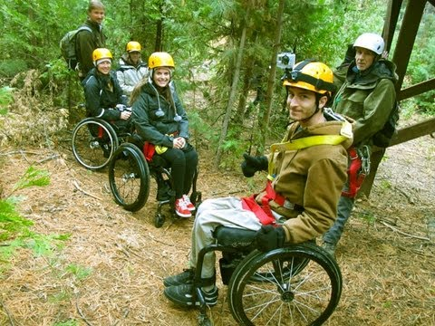
Division of Vocational Rehabilitation (DVR)
Maine’s DVR assists eligible individuals with disabilities who wish to achieve or retain employment in the community. Any individual who is committed to work and has a disability that creates a barrier to employment is encouraged to apply. Once determined eligible, individuals develop a plan for employment, which outlines the services needed to successfully achieve their employment goal.

Contributing to the Maine Economy
While continuing to maintain no wait list for services, DVR assisted 1,010 people to find employment success in Federal Fiscal Year 2014. This resulted in these individuals earning a total of $25,846,216.08 in annual wages. Across the state and across industry sectors, DVR clients are joining or rejoining the workforce in such jobs as:

Administrative Assistant | Farmworker | Nursing Aide
Automotive Service Technician | Financial Clerk | Office Clerk
Business Operations Specialist | Financial Manager | Packer/Packager
Cabinetmaker | Fire Fighter | Personal Care Aide
Carpenter | Food Service Manager | Photographer
Cashier | Hairstylist | Police/Sheriff’s Patrol Officer
Child Care Worker | Highway Maintenance Worker | Recreational Therapist
Community Health Worker | Home Health Aide | Recyclable Material Collector
Computer Support Specialist | Industrial Truck/Tractor Operator | Registered Nurse
Customer Service Representative | Janitors and Cleaner | Retail Salesperson
Data Entry Keyer | Laborer | Secondary School Teacher
Education Administrator | Librarian | Security Guard
Educational/Vocational Counselor | Machinist | Stock Clerk
Electrician | Medical Assistant | Veterinary Assistant

Individuals Served in 2014
4,126 New Applicants
4,758 Received Services through Employment Plans
1,010 Individuals Placed in Employment

Education Outcomes
578 Individuals Increased their Education Level

DVR Initiatives and Innovations

“Jill”, a York County teacher, was at high risk of losing her job due to hearing loss before she learned about VR and applied for services. Since receiving her FM receiver and transmitter, she writes that “I love it and it has made such a difference in my work day. I can easily hear individual students or small groups of students in noisy environments.”
Division for the Deaf, Hard of Hearing and Late Deafened (DDHHLD) houses a director, assistant to the director, and three Rehabilitation Counselors for the Deaf (RCDs). The RCDs help individuals who are deaf or hard of hearing access and maintain employment. DDHHLD provides referrals, information and training to employers and other state agencies, as well as deaf, hard of hearing and deaf-blind consumers regarding equal access issues. DDHHLD administers a contract with the Maine Center on Deafness to provide Telecommunications Equipment, Civil Rights and Advocacy services

Community Rehabilitation Providers (CRPs) and DVR have redesigned how we work together and moved from a fee-for-service to an outcome based payment system. DVR continues to look closely at aligning our resources with the goal of continually improving our program.

Progressive Employment, with technical assistance from Vermont VR and the Instiute for Community Inclusion, will be piloted this coming year with transition-age youth in southern Maine. This model was developed in Vermont and significantly improved their clients’ employment outcomes. DVR will be completing an in-depth review of data and process mapping our services, which we believe will help us keep more individuals engaged throughout the VR program.
A former carpenter who was no longer able to meet the physical demands of his job, “Dave” was depressed before participating in the Career Exploration Workshop and learning how he could use his skills in a new employment field. In his new position in customer service for the hardware store, he has already been a stand-out breaking the store record by selling three pellet stoves in one day! “Dave” is feeling better these days too and is appreciative of the assistance that his VR Counselor and job developer provided.

Workforce Innovation and Opportunity Act (WIOA), signed into law on July 22, 2014 and reauthorizing the federal Rehabilitation Act, is intended to help streamline services with Maine’s workforce development system and provide access to employment, education, and training to help all job seekers find good paying jobs and to assist employers to find skilled workers. Immediate changes took effect for the public Rehabilitation programs, including the need to move individuals with disabilities into employment plans within 90 days. Many of DVR’s initiatives and excellent existing partnerships with other state agencies will help us prepare for these changes, improve our program and meet the requirements of the new law.

Career Exploration Workshop (CEW) Series, developed by DVR and partners, is designed to introduce participants to the world of work through activities that uncover skills and identify career interests. CEW is available in three versions: Adult, Transition, and Bridge – Pathways to Employment. The CEW series utilizes flexible modules making it ideal for delivery in schools and provider agencies, as well as CareerCenters around the state.
“Cindy”, a client served through DVR’s partnership with the Workers’ Compensation Board, was successfully closed as a residential care specialist at an agency that provides services to people with significant disabilities. On the basis of VR sponsored training, she now holds a certificate as a Behavioral Health Professional with CPR/First Aid and Bloodborne Pathogens certifications. In addition to her living wage salary, “Cindy” is now covered by her employer’s health insurance policy.
Workers’ Compensation Board’s Memorandum of Understanding with DVR has meant a number of injured Maine workers have been able to return to employment. Through participation in VR services, these individuals received the supports and resources they needed to return to the Maine workforce.

DVR Continues Strong Partnership with the Maine Department of Education (MDOE) through joint planning and regional and statewide staff training opportunities. DVR is actively involved in MDOE’s State Personnel Development Grant and Maine’s Employment First transition committee. These shared efforts promote stronger coordinated transition planning for youth served by both agencies.
Division for the Blind and Visually Impaired (DBVI)
Maine’s DBVI provides a continuum of rehabilitation services to individuals who are blind or have low vision. Services may include individual counseling and guidance related to employment and adjustment to blindness issues, use of adaptive technology, low vision therapy, alternative skill training in communication (such as braille), instruction to develop independent travel skills (orientation and mobility), and instruction of daily living skills geared to being more self-sufficient. These services are provided through various programs, including:

Vocational Rehabilitation Program is primarily for working-age adults who seek employment. Services may include individual vocational counseling and guidance, vocational assessment, orientation and mobility instruction, low vision services, independent living services (vision rehabilitation therapy), and more.

Business Enterprise Program (BEP) provides training and support to manage and operate snack bars, cafeterias, and vending-machine facilities on state, federal and municipal properties.

Independent Living Services (IL) provides training in adaptive skills and alternative techniques for accomplishing daily tasks that enable individuals who are older to be more self-sufficient.

Education Services for Children Who Are Blind or Visually Impaired provides adaptive instruction services to students in home or local schools related to academics and independence.

Individuals Served in 2014
201 New Applicants
481 Received Services through Employment Plans
116 Individuals Placed in Employment

Education Outcomes
24 Individuals Increased their Education Level

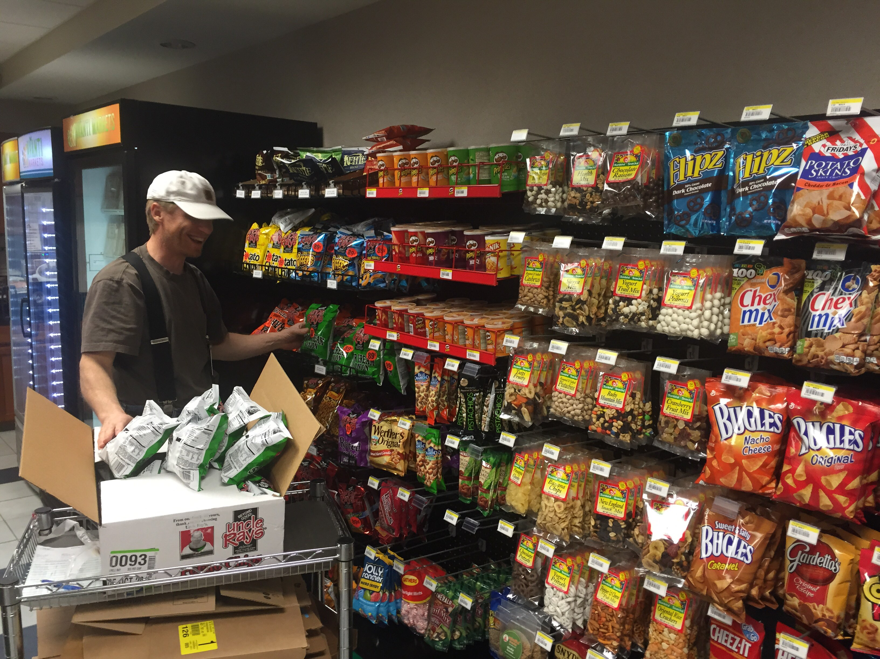
DBVI Initiatives and Innovations
Maine’s Business Enterprise Program (BEP) leads the nation in the use of a self-serve food service operation – the Avanti Market – an innovative convenience store concept. This system uses an unmanned, self-checkout kiosk designed specifically for use in secure work places and allows for a much larger product selection than customary vending machines. This micro-market allows BEP managers to increase yearly earnings and expand to 24-hour service at Avanti sites. There are currently six sites located in Bangor, Calais, Portland and Augusta.

Employability Skills Program (ESP) is a five-day immersion program utilizing peer mentoring and self-discovery exercises related to acquiring additional blindness-specific competencies to enhance one’s marketability of his or her specific job skills. The program was developed to assist individuals who are blind and chronically unemployed or underemployed. Structured individual and group activities are presented to identify and address barriers to employment, as well as to resolve “discrepancies” between perceived ability and measured ability with respect to job skills, career goal setting, vocational exploration, job seeking skills training, practice interviewing, and networking with other successfully employed individuals with vision impairment.

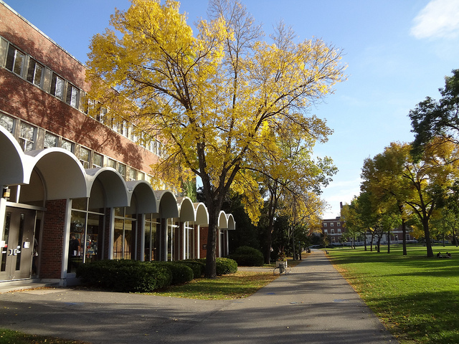
College Vision Quest is a five-week college preparation program housed on campus at the University of Maine in Orono. The students take an entry level college course that meets five days a week, and also participate in daily learning labs related to succeeding in college as a student who is blind or severely visually impaired. In addition to the college course and learning labs, the participants learn how to integrate their current assistive technology to meet the pace of reading, notetaking and studying requirements at the college level, and receive training in a variety of blindness-specific skills geared toward enhancing success while at college. The students are also required to complete a number of community service projects during the program.

“Sam” is a 46-year-old husband and father who has a progressive eye disorder known as Retinitis Pigmentosa (RP). RP affects the peripheral vision and results in significant eye fatigue as it progresses. He was a manager for in the Division for the Blind and Visually Impaired Business Enterprise Program (BEP) for many years, and then stepped down due to the toll this progressive eye disorder had on both of running a manned snack bar and having a young family. After looking at other business opportunities, he decided to come back to the BEP and took over a self-serve Avanti Market in a new state office building. “Sam”, who is a naturalist, was able to promote organic products at his new facility and work flexible hours, which allowed him to manage the eye fatigue and to spend more time with his family. With the assistance of specific training, a computer and video magnifier, “Sam” has been successful to the point that he has grown this facility into one of the most profitable in the state. In addition, he has been able to purchase a home and is now able to assist his wife with the homeschooling of their four children.
Business Relations Activities and Outcomes
The Bureau of Rehabilitation Services (BRS) partners with businesses interested in the inclusion of people with disabilities into the workforce. The Business Relations component of the BRS is staffed with one full-time Business Relations Specialist. The Business Relations Specialist works closely with Regional Directors and staff to operationalize and sustain partnerships with businesses in the region. These partnerships result in discovery of work opportunities for the job seekers we support.

Currently, there are 25 active business partnerships across the state. These active partnerships are well established with agreements around recruitment, hiring, and other services. Services provided to business partners vary depending on the business’s needs may include a variety of services to the business customer, such as:
- A pipeline of qualified job applicants who are pre-screened to employer’s specifications.
- Consultation and training regarding the employment of people with disabilities (i.e., the ADA, disability etiquette, workplace accommodations, etc.).
- Promotion of company to expand customer base.
- Job retention/return to work services unique to the business partner.
- Connections to local and national business to business networks and resources.


The types of industries represented by the active partnerships include manufacturing, retail, health care, entertainment, construction, research and call centers/customer services. These partnerships have resulted in job placements with a majority of hires occurring at P&G/Tambrands FlexiCenter in Auburn.

Partnership discussions have been initiated with an additional 38 businesses. To date, we do not have sufficient data to determine the Return on Investment (ROI) from the BRS perspective. However, our lead business partner, P&G/Tambrands FlexiCenter has documented some of their ROI with their feedback on the partnership:
- Employees with disabilities attrition rate was 5% (1 of 20) from December 2013 to December 2014.
- The percentage of people with disabilities in the FlexiCenter started and finished the year at 41% (20 of 49).
- The FlexiCenter has achieved or surpassed productivity goals while maintaining zero safety or quality incidents.

Key strategies of success:
- P&G Auburn and the Maine Bureau of Vocational Rehabilitation (VR) developed an excellent partnership with open communication. Maine VR is used as a Single Point of Contact for working with agency partners.
- P&G Auburn now uses real time on-site assessments to evaluate potential new hires. The State of Maine will pay for a job coach and for up to 20 hours of a person with a disability to work on the FlexiCenter production floor, which allows us to evaluate both the individual’s capability to perform the various tasks and the soft (social) skills.
- P&G Auburn brought several small groups of students with disabilities to the site for tours of the FlexiCenter. Several of these students are now employed in the FlexiCenter.
- P&G Auburn participated in many tours and meetings with other businesses to support increased employment opportunities for people with disabilities.
- Our total plant population is proud of P&G Auburn for employing people with disabilities as reflected by a 92 score on our OCS for Diversity and Inclusion.
- The perspective of P&G Auburn, based on results, is consistent with that of other companies that partner with the NET and/or the USBLN, most notably, Walgreens.

For more information: http://www.maine.gov/rehab/employer_services/index.shtml
Office of the State Accessibility Coordinator
The Accessibility Coordinator leads the State’s compliance under the Americans with Disabilities Act (ADA) and Section 504. The office works with State Executive branch departments and the public to ensure that programs and services are not discriminatory and are accessible for individuals who have disabilities. State accessibility policies cover all State services (including contracted services), facilities, web design, communication, and employment.

2014-2015 Highlights

Technical Assistance and Training Programs
- Established State contracts that will make Video Remote Interpreting (VRI) available throughout State offices.
- Trained code enforcement officers, architects and engineers on Standards for Accessible Design.
- Delivered ADA Employment Rights training for DBVI clients.
- Consulted with Towns of Freeport and Brunswick, county correctional agencies, and community non-profits about program accessibility and barrier removal.

Resources and Information
The Accessibility Coordinator answers questions about disability rights, promotes community integration and develops affordable resources for families and businesses:
- As a member of the mPower Adaptive Equipment Loan Program, helped promote loans for assistive technology and accessibility for businesses and families, including a webinar through MaineCITE at: http://www.mainecite.org
- Provided public information about service animals to people with disabilities, State programs, town clerks, school nurses, and businesses.
- With the Information Technology Accessibility Committee and the Equal Employment Opportunity Officers, developed a plan to improve acquisition and deployment of Assistive Technology in State offices.

Complaints
Each department is required to have an ADA coordinator and grievance procedure. The State Accessibility Coordinator works with departments to resolve any complaints.

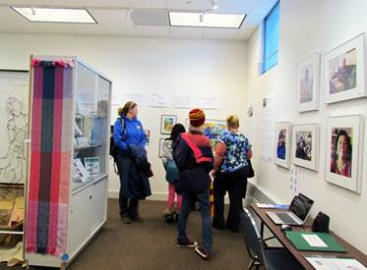
Exhibit Features History of Disability Movement
In celebration of the ADA’s 25th anniversary, the ADA Accessibility Coordinator assisted with an exhibit, The ADA at 25: Show Me The Incredible, displayed from January 17, 2015 through March 13, 2015 at the University of Maine Augusta in the Holocaust and Human Rights Center. Artwork, oral histories, and historical artifacts showed the accomplishments, as well as the indignities that sparked the disability rights movement.
The mother of a son who has a learning disability, seeing the sculpture titled, “You Don’t Look Disabled,” cried, “That’s it! That’s what people keep saying. It’s so frustrating.”

Eric Dibner, ADA Accessibility Coordinator
150 State House Station, Augusta, ME 04333
(207) 623-7950 voice, TTY users call Maine Relay 711
Email: Eric.Dibner@maine.gov
Partners in Advocacy, Advisory Boards and Councils

Bruce Archer and Flash at the 2010
BRS Statewide Conference
Client Assistance Program, operated by C.A.R.E.S., Inc. provides information, advice, advocacy, and (if determined necessary) legal representation to persons who have concerns about the rehabilitation services they receive from DVR and DBVI. Website: http://caresinc.org/

Commission for the Deaf, Hard of Hearing and Late Deafened is an Advisory Council that provides a review of the status of services to deaf and hard-of-hearing persons, recommends priorities for development, evaluates the progress made as a result of recommendations, sets goals for activities of the division to carry out its obligations and responsibilities to the deaf and hard-of-hearing communities. Website: http://www.maine.gov/rehab/advisory_councils/dod/index.shtml


Commission on Disability and Employment (CDE) is a subcommittee of the State Workforce Investment Board. The commission fosters workforce development in Maine that includes meaningful employment and equal opportunity for people with disabilities and promotes collaboration to increase public awareness and influence public policy. Website: http://www.maine.gov/swib/committees/disabilities/index.shtml

DBVI State Rehabilitation Council (SRC) is a diverse group of people concerned with the quality of vocational rehabilitation services provided to blind Maine citizens. The SRC’s core functions are to review, analyze, and advise on the policies and other related entities involved with the employment of people who are blind or have vision impairments. Website: http://maine-src-dbvi.org/

DVR State Rehabilitation Council (SRC) serves its mission to partner with DVR in developing state goals, priorities, policy and practice, as well as to review and analyze DVR’s results and performance in support of securing and maintaining employment through a process of informed choice for individuals with disabilities. Website: http://www.mainesrc.org/

State Independent Living Council (SILC) promotes a philosophy of independent living, which encompasses consumer control, peer support, self-help, self-determination and equal access, as well as individual and system advocacy to maximize the leadership, empowerment, independence and productivity of individuals with significant disabilities. Website: http://www.mainesilc.org/

BRS Office Directory From any location, TTY users call Maine Relay 711
Central Administrative Office
Bureau of Rehabilitation Services
150 State House Station, Augusta, ME 04333-0150
Tel: 207-623-6799

Augusta CareerCenter
21 Enterprise Drive, Suite 2, Augusta, ME 04433-0073
Tel: 207-624-5120 or 1-800-760-1573

Bangor CareerCenter
45 Oak Street, Suite 3, Bangor, ME 04401-7902
Tel: 207-561-4050 or 1-888-828-0568

Lewiston CareerCenter
5 Mollison Way, Lewiston, ME 04240-5808
Tel: 207-753-9001 or 1-800-741-2991
Machias CareerCenter
53 Prescott Drive, Suite 1, Machias, ME 04654
Tel: 207-255-1900 or 1-800-292-8929

Greater Portland CareerCenter
151 Jetport Boulevard, Portland, ME 04102
Tel: 207-822-3300 or 1-877-594-5627

Presque Isle CareerCenter
66 Spruce Street, Suite 1, Presque Isle, ME 04769-3222
Tel: 207-760-6300 or 1-800-635-0357

Rockland CareerCenter
91 Camden Street, Suite 201, Rockland, ME 04841-3424
Tel: 207-596-2600 or 1-877-421-7916

Skowhegan CareerCenter
98 North Avenue, Skowhegan, ME 04976-1923
Tel: 207-474-4950 or 1-800-760-1572

