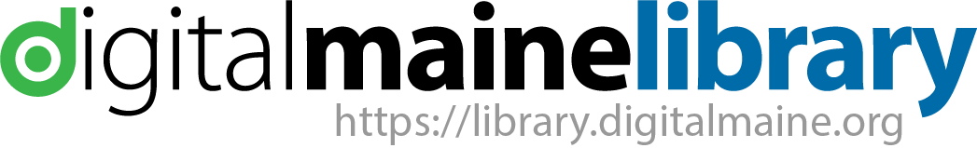
Why are you asking me to share my location?

Geolocation, geo-authentication, what does this all mean?

In the past, use of the old MARVEL resources were authenticated from Maine libraries via a variety methods that worked “behind the scenes” but when a library patron got home they were required to use a library card barcode number – or create an account. This created barriers and confusion for many Maine citizens and the use of great resources were impacted.
We are striving to make access to all resources that are paid for with state and federal money easy to access for library patrons, students and all Maine citizens. For the new Digital Maine Library resources, we have a large percentage authenticating in a new way using new technologies.
Our contracts with providers of our statewide online content require that we determine that users are in Maine. We are striving to use the latest technologies to make access to resources as easy as possible.

Geo-location is an easy way to determine that you are in Maine. That is why the Digital Maine Library asks if you will share your location. We only use this data to determine that you are in Maine – and not someone from New York or California trying to access our paid for Maine content. No personal data is retained. If you do not Share Your Location, then we do ask for additional data. If you are accessing resources from home, the IP address of your computer is checked against a list of IP addresses of all Maine Internet providers. Again, this is done anonymously. We only see that you are using a Maine Internet provider (like Spectrum or GWI).
If that doesn’t work, we ask for an address, town or zip code. If you appear to be out of state – maybe you are on vacation – or maybe you have a cell phone with an out of state telephone number – or your cell service makes it look like you are from out of state. Then we will ask for more information.

The goal is to:
- Not require that you be in a library to access content
- Not require you have a library card (although please do get one – they are free)

We respect your privacy and collect no personal information. Your browser (Firefox, Chrome, Internet Explorer) allows our system to “see” where you are – but not who you are. Librarians and libraries are all about privacy. So, when you knock on the Digital Maine Library door, we are asking:

Are you in Maine?
Do you live in Maine?

When you say yes, we say come on in and use the resources your state and federal taxes are paying for!

Because with the Digital Maine Library …No matter where you are in Maine, you're always at the library!

https://library.digitalmaine.org

