How To Training
for
Searching
The Search option will allow the users to retrieve information depending upon entered search criteria (“indexed” information); or search by text contained in a document (“Google” search capabilities). Search results will only show information that the user is allowed to see. Public User will only see public documents; External Registered Users will only be able to see public documents unless provided access to confidential documents through issuance of a protective order.

Searching for Case or Document

Objective:
- Searching for a Case
- Searching for a Document
Step | Action
From the Home Page
- Click on Case File from the Access Menu
- From the Submenu, click on View/Search to search for a Case or Document

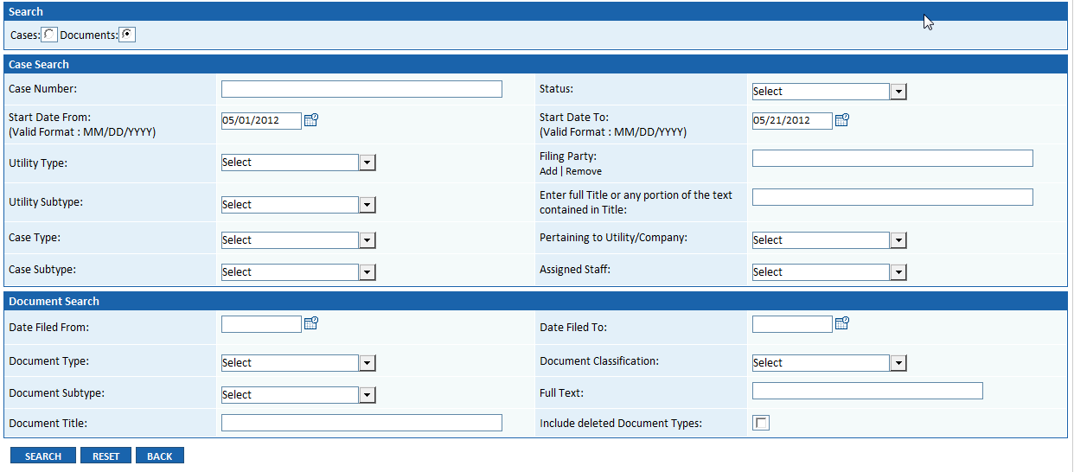

- Select the Radio Button before Cases or Document depending on which you are searching for
- Enter known search criteria
- Click on Search Button

Search Result grid will be displayed
- Search criteria will be displayed above the grid
- Result grid for Case Search Result will display
  - Case No. (with hyperlink to view Case File)
  - Case Type
  - Case Subtype
  - Status
  - Start Date
  - Case Title
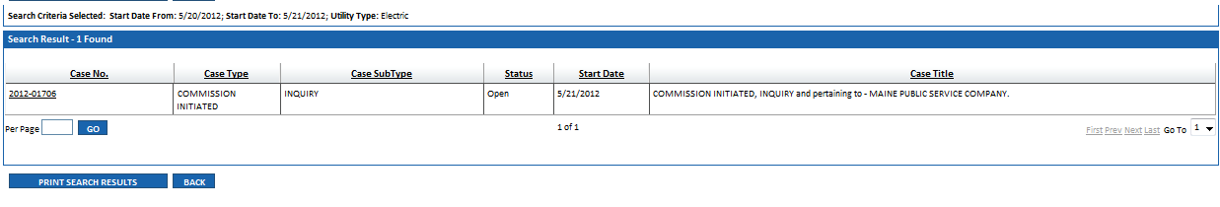
- Click on Case Number hyperlink to view Case File
- Click on Print Search Results Button

Search Result grid will be displayed
- Search criteria will be displayed above the grid
- Tabs will be displayed above the grid for: Filed Documents, Internal Materials and Public Documents with prescribed security measures in place
  - Case No. (with hyperlink to view Case File)
  - Filing No. (with hyperlink to view filing information)
  - Document Type
  - Document Title (with hyperlink to view filed document)
  - Filing Party
  - File Name
  - File Size
  - Software Type Icon
- Result grid for Document Search Result will display
