How To Training
For
Manage Favorites
External Registered Users will be able to customize their Home Page with personalized, easy to access search results. These favorites can be added, updated and deleted as needed by the logged in user.

Manage Favorites

Objective:

- Manage Favorites

Step | Action
From the Home Page , Click on Manage Favorites on the access menu list
- Manage Favorites Screen will be displayed listing all of the logged in External Registered User’s favorites. Grid will list the following
  - Favorite Title
  - Search criteria
  - View hyperlink to view search results
  - Update hyperlink to modify existing search criteria
  - Delete hyperlink to remove favorite from list

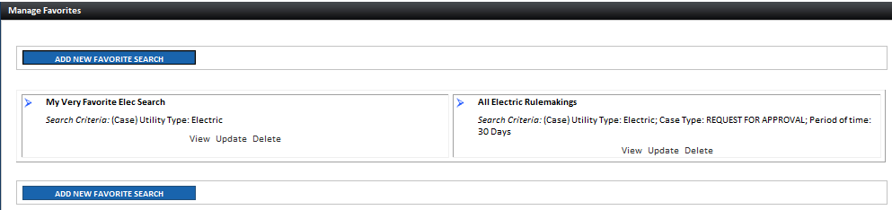

Add New Favorites

Objective:

- Add New Favorites

Step | Action
From the Manage Favorites Screen
- Click on Add New Favorites Search Button
- Enter know search criteria and click on Preview Button

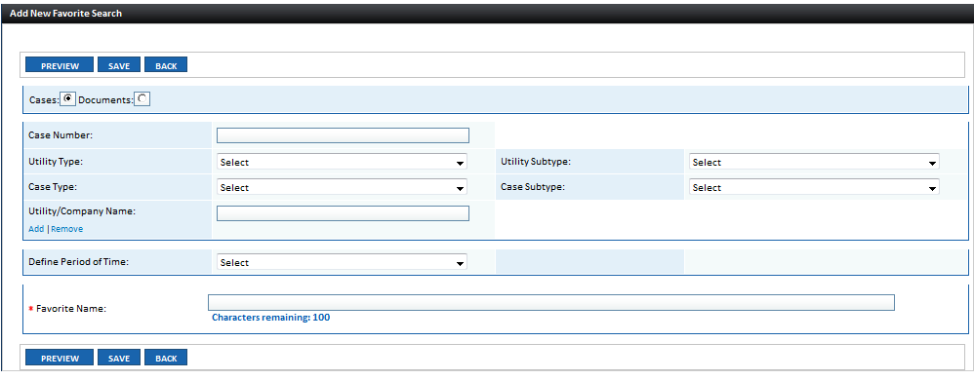

- Pop-up window will display an example of the search result.

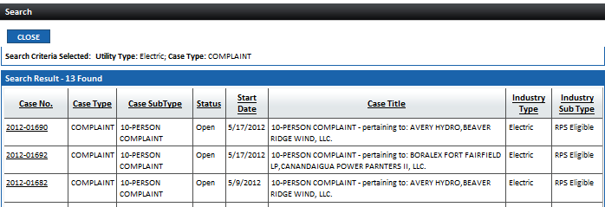

- Click Close Button to close pop-up window

If user is satisfied with result, continue with the following steps
- Determine timeline for report generation. Do you want to see results for the past 5 days, 10 days or 30 days? Select choice from Define Period of Time drop down list
- Enter Favorite Name in textbox
- Click on Save Button
- Confirmation Message will be displayed

- Click on Home Icon at the top right-hand corner of the screen to be navigated to the Home Page.

- New Favorite will be posted on the Home Page My Favorite Searches Section

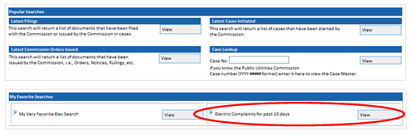

Update Favorites

Objective:

- Update Favorites

Step | Action
From the Manage Favorites Screen
- Click on Update hyperlink for one of the displayed favorites
- Details will be displayed in editable format.
- Enter changes and click on Update Button
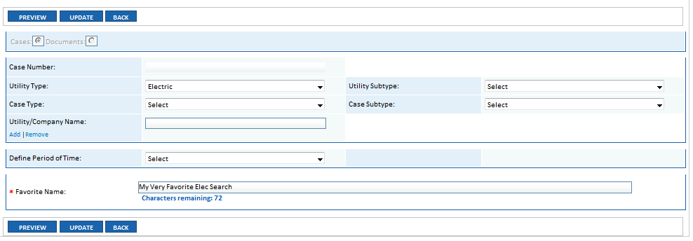

Delete Favorites

Objective:

- Delete Favorites

Step | Action
From the Manage Favorites Screen
- Click on Delete hyperlink for one of the displayed favorites
- Click OK Button to Delete; otherwise, click Cancel Button

