How To Training
for
CMS Case File – Assigned Staff Tab
The Assigned Staff tab will display the information of the staff currently assigned to the case. .

Step | Action
 | From the Home Page Click on Case File Case Files on the access menu list
Case Search will be displayed
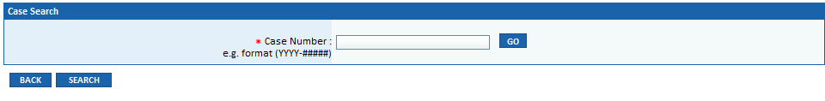
- Enter Case Number in Text Box
- Click on GO Button to display specified Case File.

- OR -
If user does not know case number:

- Click on Search Button, enter known search criteria
- Click on Search Button
- Search result will display all cases matching entered parameters
- Click on Case Number hyperlink to be navigated to the Case File Screen for the specified case.

By default the Filings tab will be selected and the grid will display all Commission filings and issuances.

- Click on Assigned Staff tab
- Assigned Staff grid will be displayed

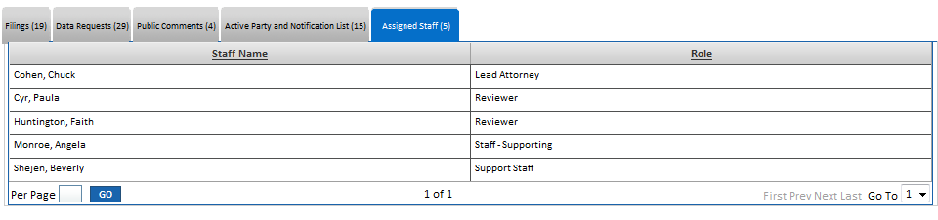

Assigned Staff grid will display with the following columns:

- Staff Name
- Role

