Town: | Route: |  |  | WIN:
State Project No: |  | Federal Project No:
Project Type:
Project Location:
Length: | BMP: |  | Begin Latitude/Longitude:
 | EMP: |  | End Latitude/Longitude:
Program: Multimodal Program |  |  | Program Manager: Jeff Tweedie
Project Manager: |  |  | Designer:
FHWA Oversight: |  | Engineer of Record:

LOCATION MAP Insert map similar to the example below using Google Earth or a similar program. Please label beginning and ending points of a project.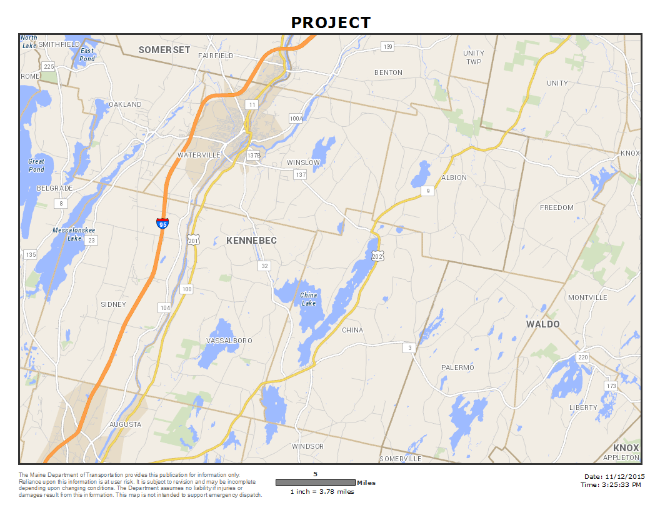

PLANNING

Project History:

Purpose & Need:

Brief Summary of Proposed Scope of Work:

Scope changes:

TRAFFIC

Intersections

Design Vehicle (without encroachment):

Design Vehicle (with encroachment):

Auxiliary Lanes:

Crash Data

Analysis Period:

High Crash Locations (including Critical Rate Factor and number of crashes):

DESIGN CRITERIA

Basic Design Controls
 | Section 1 | Section 2 | Section 3
Corridor Priority
Functional Class
NHS/Non-NHS
Posted Speed
20XX AADT (Current)
20XX AADT (Design)
DHV
Scope (choices below)
(New Construction, Reconstruction, Rehabilitation, Restoration/Resurfacing, Spot Improvement

Controlling Criteria
Element | Required Standard | Required Standard | Required Standard
 | Section 1 | Section 2 | Section 3
Design Speed
Lane Width
Shoulder Width
Horizontal Curve Radius
Superelevation Rate
Stopping Sight Distance
Maximum Grade
Cross Slope (Travelway)
Vertical Clearance
Clear Zone

Typical Section
Element | Proposed Value | Proposed Value | Proposed Value
 | Section 1 | Section 2 | Section 3
Lane Width
Shoulder Width
Cross Slope (Travelway)
Side Slopes*
*If side slope standards cannot be met, no Design Exception will be required. If not meeting side slope standards results in clear zone standards not being met, a clear zone design exception will be required.

DESIGN EXCEPTION SUMMARY
☐ No design exceptions are required.
Controlling Criteria
Element | Required Standard | Proposed Value | Date Approved

Drives and Entrances
Station | Maximum Grade | Grade Change | Date Approved
PAVEMENT STRUCTURE

Pavement Structure Design
Design Method | Design Guidance |  | DARWin 3.1
Layer | Thickness | Type | Thickness | Type
Hot Mix Asphalt Pavement
Recycled Layer
Base Course Gravel
Subbase Course Gravel
Shoulder Pavement

Final Pavement Structure Design
Design Method | Design Guidance |  | DARWin 3.1
Layer | Thickness | Type | Thickness | Type
Hot Mix Asphalt Pavement
Recycled Layer
Base Course Gravel
Subbase Course Gravel
Shoulder Pavement

Comments:

COMPLETE STREETS COMPLIANCE

A Complete Street provides safe and efficient access to the transportation system to all users. Each element of a Complete Street shall be considered according to the guidelines in the MaineDOT Complete Streets Policy.

Select the Complete Streets elements incorporated into the project:
☐ Sidewalks
☐ Crosswalks
☐ Lighting (street or pedestrian scale)
☐ Pedestrian Signals
☐ Streetscaping (benches, landscaping, etc.)
☐ Shoulder Improvements
☐ Bike Lanes/Shared Use Paths
☐ Public Transit (bus stops, etc.)
☐ Other (explain)

Summarize:

Select the most applicable reason(s) these elements may not be incorporated into the project:
☐ Use by pedestrians, bicyclists, and others is prohibited by law.
☐ The cost is disproportionate to the need or probable use.
☐ Components are outside the scope, due to the nature of the project.

Summarize:

ADA COMPLIANCE

Pedestrian facilities shall be upgraded to comply with the MaineDOT ADA Compliance Policy for Construction and Maintenance and the Minimum ADA Requirements for Pedestrian Facilities Design Guidance.

Select all that apply:
☐ No pedestrian facilities exist on the project and none will be installed.
☐ Existing pedestrian facilities will not be upgraded to ADA compliance based on project scope.
☐ New pedestrian ADA compliant facilities will be installed where none previously existed.
☐ Existing pedestrian facilities will be upgraded to ADA compliance unless technically infeasible.
☐ Pedestrian signals will be installed or upgraded if required.

Summarize:

If a new or upgraded curb ramp cannot fully comply with the MaineDOT ADA Compliance Policy for Construction and Maintenance and the Minimum ADA Requirements for Pedestrian Facilities Design Guidance, an ADA Technical Infeasibility Form must be submitted for approval for each location identified.

☐ No technical infeasibility forms are required to be completed at this time.
☐ Technical infeasibility forms have been submitted as indicated in the table below.

Curb Ramp ID/Location | Reason Full Compliance Infeasible | Date Approved

Summarize:

ENVIRONMENTAL COORDINATION
(To be completed by the Environmental Office)
Team Member:

Project Scope/Description

NEPA Determination
STIP Date
Section 106
Section 4(f)
Section 6(f)
Federal Endangered Species
State Endangered Species
Essential Fish Habitat
Fish Passage Design Review
In-Stream Work Window/Other Construction Restrictions
Hazardous Material
Dredge Material
Stormwater/MS4
DEP/LUPC
ACOE
Mitigation
Other

RIGHT-OF-WAY COORDINATION
Team Member:

 | Section 1 | Section 2 | Section 3 | Section 4
Total Existing Width:
Total Proposed Width:
# of Abutters:
# of Acquisitions:
# of Relocations:
Building Availability:
Reserved Limits:

UTILITY COORDINATION
Utility Coordinator:

Above Ground Utilities:

Below Ground Utilities:

 | Necessary for this Project?  (Yes or No) | Coordination Still Needed?  (Yes or No)
Pole List:
Utility Agreements:
RR PRTS:
Railroad Agreement:

ROW issues related to utilities:

GEOTECHNICAL COORDINATION
(To be completed by the Geotechnical Section)
Team Member:

Available Soils Information:

Additional Borings Required? (Y/N)

Additional Geotechnical Analysis Required? (Y/N)

Comments by Geotechnical Engineer:

Are foundations for Overhead Sign Structures, Traffic Signals or Lighting Required? (Y/N)
(If yes, one boring per foundation is required.)

PUBLIC PROCESS

Proposed Public Contact Method and Date(s):

Concerns Identified at Preliminary Public Meeting:

M&O ISSUES /CONCERNS

CONSTRUCTION SCHEDULE

PS&E Date
Advertise Date
Construction Begin Date
Construction Complete

TAME RESULTS (Transfer results from returned Tame Request Form)

Morning Restrictions
Evening Restrictions
Maximum Closure Length
Minimum Lane Width

Additional Comments:

BUDGET

 | Programmed | Available | PDR Estimate
Date
Preliminary Engineering
Right of Way
Construction
Construction Engineering
Other
TOTAL
Total Cost per Mile:
Funding Strategy (Sources):

SUMMARY OF PRELIMINARY ENGINEERING

Alternatives Analysis
(This may only be applicable to some projects, such as Large Culverts, Rehabilitations, and Roundabouts.)

Design Variances
(Discuss design elements that do not meet standard but do not require a formal design exception)

Proposed Design Elements
(Discuss existing vs. proposed condition)

Horizontal Alignment:
Vertical Alignment:
Typical Section:
Pavement Structure:
Drainage/Hydrology:
Guardrail:
Intersection Geometry:
Right-of-Way:
Utilities:

Other Design Issues:
(Discuss any issues that have been identified but have not yet been resolved.)

DRAFT PDR DISTRIBUTION TEAM COMMENTS AND RESPONSE
(Minor edits and corrections can be made to the body of this document above without reference in this section. More significant comments that result in design or other changes should be noted in this section before the Final Distribution.)

Comments:

Comment Deadline | Date:

APPROVALS

Local Agency Approval
Preliminary Design Report Complete  LPA certified official |  | Date:

MaineDOT Approval
Preliminary Design Report Complete |  | Date:

For Large Culvert Projects, Preliminary Design Report Complete also signifies Plan Impacts Complete.

