
Research Brief

Center for Workforce Research and Information
October 2011

Tracking New Businesses Opened in 2009
The Center for Workforce Research and Information is conducting research using existing data to gain a deeper understanding of the dynamics of new private sector businesses in Maine. Unlike other data reporting job gains and losses, this project follows businesses over time. This report is the most recent of three papers examining the characteristics of new businesses and tracking employment and wages over the first full year of operation. The first report examined businesses that opened in 2005; the second examined businesses that opened in 2008. This report examines new businesses that opened in 2009.

Defining and Identifying New Businesses
For the purposes of this analysis, a new business is defined as a business or worksite reporting workers covered by unemployment insurance law for the first time. This includes start-up businesses, established businesses that are first-time employers of covered workers, and new worksites opened by existing employers. Government-owned businesses, construction firms, private households, and membership organizations are excluded from this study.
Data for this study is extracted from the Quarterly Census of Employment and Wages, a database derived from employers’ unemployment insurance tax reports. The start and end dates on the unemployment insurance account serve as proxies for business birth and business death, respectively.
Each business that reported employment and wages for the first time in 2009 was extensively screened against a set of criteria (detailed in the Appendix). Businesses were researched for links to pre-existing businesses, for missing or incomplete data, and for account status. Those that did not meet the criteria for a new business were excluded from the final data set.

Scope of Analysis
This analysis examines businesses that first reported employment and wages in 2009 and were still open in the fourth quarter of that year (2009Q4). The analysis employs quarterly data (average employment, total payroll and average wage) to examine the group of new businesses as a whole and sub-groups of new businesses by industry. The analysis compares employment, payroll, and wage data of new businesses in 2009Q4 to data of surviving new businesses in 2010Q4.
Individual businesses and worksites are counted as business units for the purposes of calculating survival and analyzing industry composition. For our purposes, survival is determined by a business’s unemployment insurance account status, not by employment and wages. Therefore, an employer may report zero employment and wages, but the business is counted as surviving until an end date is assigned.
Where comparison is made to the state as a whole, private sector employment and wages are used, excluding government-owned businesses, construction firms, membership organizations and private household employers. All data in this report are from the Maine Department of Labor’s Center for Workforce Research and Information.

2009 New Businesses – All Industries

Survival and Employment
Of the 2,144 new businesses open in 2009Q4, 1,940 remained open in 2010Q4 yielding an average survival rate of 90 percent. Though aggregate employment decreased from 6,529 to 6,307 over the year, businesses that survived added jobs, indicated by a small increase in the average number of employees per business. Average new business size of three employees is well below the state average of more than 11 employees per business.
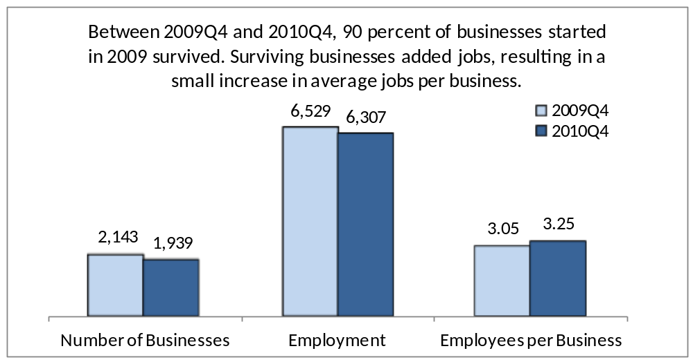

Comparison to Existing Businesses
In 2009Q4, jobs created by businesses that opened in 2009 totaled 6,529. These new jobs were created during a year in which Maine experienced a net loss of 13,663 private jobs. Job creation at new businesses partially offset a loss of 20,192 jobs at previously existing businesses.
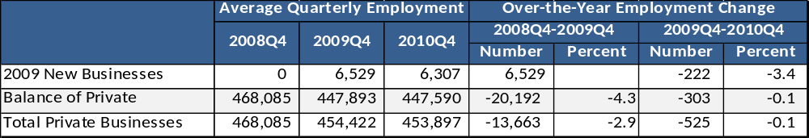
Between 2009Q4 and 2010Q4, the number of jobs among surviving new businesses decreased by 222, or three percent. Statewide employment among all private businesses remained almost unchanged, decreasing by 525, a loss of one-tenth of one percent.

Average Wage
In 2009Q4, the average quarterly wage paid by new businesses was $8,304, about 14 percent less than, the average quarterly wage of $9,668 for all private businesses. Over the year, the average quarterly wage for surviving new businesses increased by $331, or four percent, to $8,635. In comparison, between 2009Q4 and 2010Q4 the average quarterly wage for all private businesses increased by $144, or one percent, to $9,812. As a result, the gap between the average quarterly wage earned by workers at new businesses and the average for all businesses narrowed slightly to 12 percent.
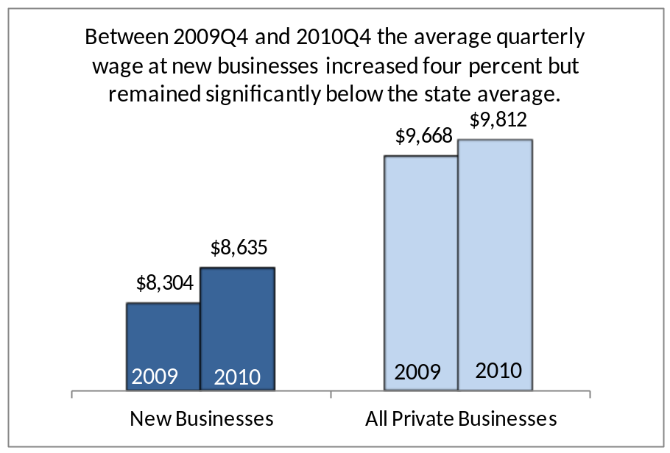

2009 New Businesses – Distribution by Industry
In 2009, new businesses opened in every industry sector from accommodation to wholesale trade. The following analysis examines six sectors, each claiming at least eight percent of either new business units or employment. These key industries are: professional, scientific and technical services; wholesale trade; retail trade; administrative, support and waste management services; accommodation and food services; and health care and social assistance.
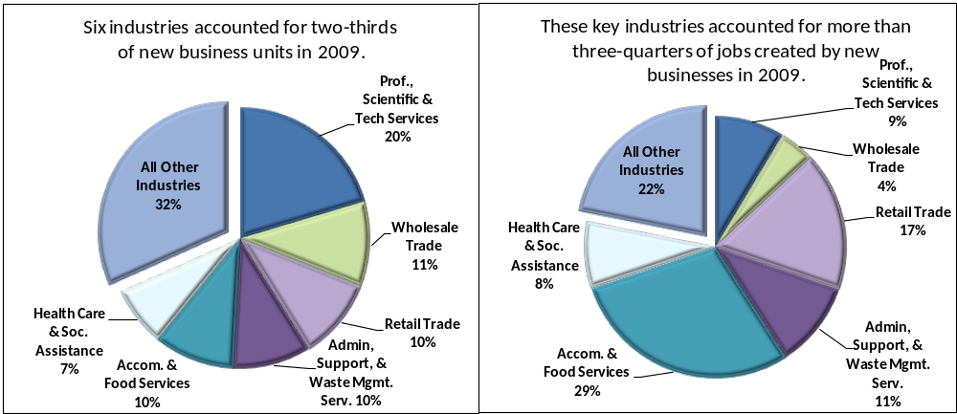
On average, 90 percent of new businesses in all industries survived the one-year interval between 2009Q4 and 2010Q4, aggregate employment decreased by three percent, and business size remained relatively small at about three employees per business. However, averages mask significant differences in size, survival and growth among sectors.
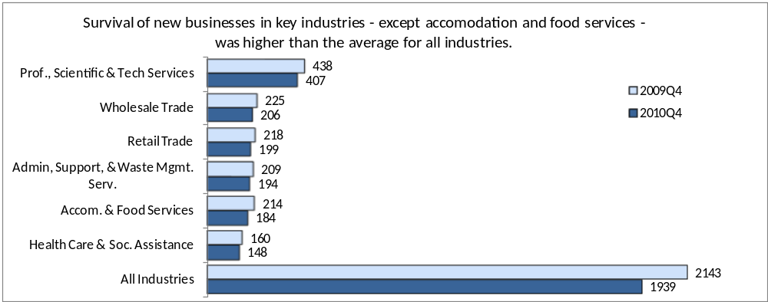
- In professional, scientific, and technical services, 93 percent of new businesses survived. This industry was one of only two key industries to increase employment. Over the year, the number of jobs increased by nine percent, a net gain of 53 jobs. Average business size remained small at one to two individuals per business.
- New businesses in wholesale trade survived at a rate of 91 percent. Over the year, these businesses lost 15 jobs, a five percent decrease. Average business size remained small, between one and two employees per business.
- In retail trade, 91 percent of new businesses survived. Seventy jobs were lost within the industry– a net loss of six percent. Average business size remained above the average for all industries at about five employees.
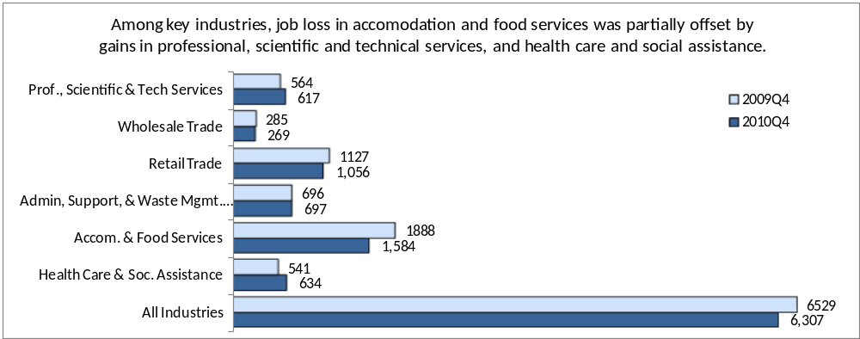
- In administrative, support, and waste management services new businesses survived at a rate of 93 percent. Employment within this industry remained steady with an average business size of between three and four employees per business.
- Eight-six percent of new businesses in accommodation and food services survived over the year. Employment fell by 305 jobs, or 16 percent. On average, business size in this industry remained relatively large compared to other industries at about nine employees per business.
- New businesses in health care and social assistance survived at a rate of 92 percent. One of two key industry groups to increase employment, 91 jobs were added over the year - a net gain of 17 percent. The average size of surviving new businesses in this industry increased from three to four employees over the year.

Average Wage by Industry
The average quarterly wage paid by new businesses in all industries increased four percent between 2009Q4 and 2010Q4, from $8,304 to $8,635. It remained more than ten percent lower than the statewide average for all businesses. Nearly half of new business jobs are in retail trade and accommodation and food services, industries that have below-average wages. The concentration of jobs in lower-wage industries has a dampening effect on the new business average wage for all industries. As with survival and employment, the average wage for new businesses in all industries masks significant differences among sectors.
- The average quarterly wage paid by new businesses in professional, scientific and technical services was more than twice the average for new businesses in all industries. The average wage decreased by 12 percent over the year, from $22,400 to $19,700, yet remained the highest average wage among key industries. Jobs in this sector tend to be full-time, generally require higher levels of education and training, and are concentrated at the upper end of the earnings spectrum.
- Wholesale trade had the second highest wage behind professional, scientific, and technical services. The average wage paid by new businesses in this industry increased ten percent, from $14,700 to $16,189.
- The average quarterly wage among new businesses in retail trade remained comparatively low but increased seven percent, from $5,086 to $5,423. Jobs in this sector, and in accommodations and food services, below, are often seasonal and/or part-time. Many of these jobs tend to be concentrated in the lower end of the education/skill and earnings spectrum.
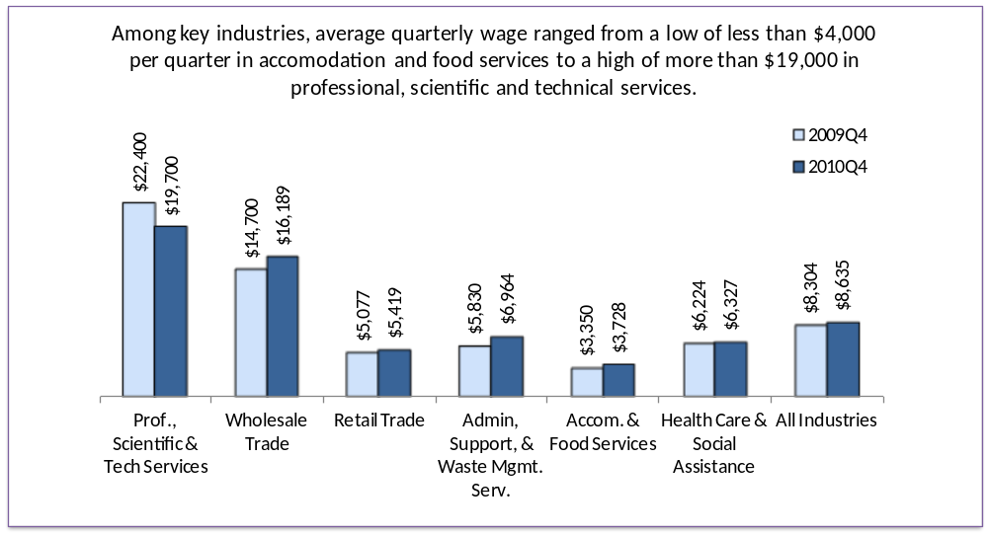
- The average wage paid by new businesses in administrative, support, and waste management services remained below the average for new businesses in all industries but recorded the greatest over-the-year increase among the key industries. The average wage increased by 19 percent, from $5,833 to $6,964.
- In accommodation and food services, the average quarterly wage remained less than half that of the new business average for all industries. However, the average wage paid by new businesses in this industry increased 11 percent, from $3,350 to $3,728. Jobs in this sector, as in retail trade, are often seasonal and/or part-time and tend to be concentrated in the lower end of the education/skill and earnings spectrum.
- The average quarterly wage for new businesses in health care and social assistance increased two percent over the year, from $6,174 to $6,272, but remained below the new-business average for all industries.

Economic Impact
Wages paid by new businesses equaled about one percent of total wages paid by Maine’s private businesses. In 2009Q4 new businesses paid $54.2 million in quarterly wages. In 2010Q4 surviving new businesses paid $54.5 million in wages, a net increase of about one-quarter million dollars, or one-half percent over the year. During the same time period, quarterly wages paid by all private businesses increased more than $60 million, or 1.4 percent.
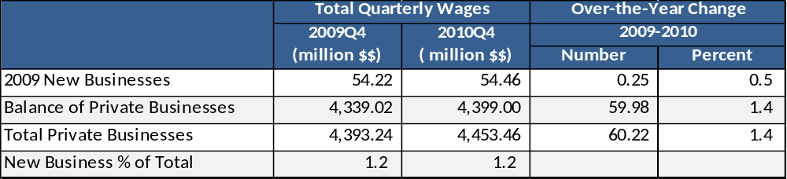

Summary of Findings
As with prior studies, the notable feature of this group of new businesses that started in 2009 is its contribution in employment during a grim period following a severe recession. These mostly small businesses created 6,500 jobs during a period when previously existing businesses shed 20,000 jobs. Between 2009Q4 and 2010Q4, the total number of jobs at surviving new businesses decreased by three percent, while overall, the number of jobs at all private businesses decreased by one-tenth of one percent.
However, the industry composition of new business employment, with 45 percent of new jobs in retail trade and accommodation and food services, sets it apart from statewide employment where 29 percent of jobs are in these low-wage sectors. Industry composition is a factor contributing to the gap between the average quarterly wage paid by new businesses and the comparable state average wage.
As more data is available, we hope to document how these businesses, launched during adverse economic conditions, fare compared to established businesses and to businesses launched in better economic times. This project is ongoing at the Center for Workforce Research and Information.

Appendix

Data Source
The data are from the Quarterly Census of Employment and Wages (QCEW), a cooperative program between state workforce agencies and the US Bureau of Labor Statistics (BLS) that maintains a database of quarterly employment and wages. Data for QCEW are extracted from state unemployment insurance (UI) tax reports of quarterly employer contributions. Additional data is collected from employers operating multiple worksites and by employer surveys administered by state labor market information offices. In addition to employment and wages, each QCEW record specifies industry designation, ownership, location, and links to other employers via wage records.
Workers counted by QCEW are limited to those covered by state UI law. BLS estimates that covered workers account for an estimated 97% of total non-farm employment nationwide. QCEW, therefore, provides a comprehensive and detailed record of employment, a universe against which other workforce programs are benchmarked. In Maine, QCEW contains nearly 50,000 records, each representing a worksite with covered employees.
A new UI account may signal the initial entry of a business to the UI system because it is employing covered employees for the first time, or may indicate that an employer is changing UI accounts. (Reasons for covered employers to change UI accounts include transfer of ownership, merger, acquisition or other reorganization.) When a new QCEW record can be linked by wage records or other means to a pre-existing record it is not considered to be a new business. Until an end date is assigned, the account remains open in QCEW and the business is counted as surviving for the purposes of this analysis.

Preparing a Data Set of New Businesses for Analysis
The data are assembled according to the year in which the businesses first report employment and wages. The initial extract of QCEW records employs the following criteria:
Initial liability date within the target year 2009. This criterion is an imperfect indicator of the start of reported employment. Initial data extraction includes records later screened out for lack of reported data in 2009.
No predecessor link. Records that indicate continuity of employment from a prior or existing business are excluded. For example, a business that changed ownership is screened out if service and employment are continuous, as would a satellite location staffed by existing employees.
Private ownership This study examines only private sector businesses.
Excluded industries. Private households, membership organizations, and construction firms are excluded for reasons of volatility and reporting.
These criteria produce a list of potential new businesses then subject to individual record review. Each record is screened for positive business activity in the target year and for predecessors not previously identified. The latter involves a search of the database for links by name, location and wage records. If no predecessor is found, employer validation is attempted for a sample of businesses but not required for inclusion in the data set if other criteria are met.
The records are further reviewed for missing, incomplete or inconsistent data. Records showing an end of liability date during the study period are researched for links to successor businesses showing a continuation of employment and business activity. Successors to new businesses are added to the data set, as are businesses with a start date in a prior year but with first reported employment in 2009.

