|  |
| --- |
| This picture shows an upward trend graph superimposed on an image of the state of Maine. |
| Maine Workforce Outlook 2012 to 2022 |

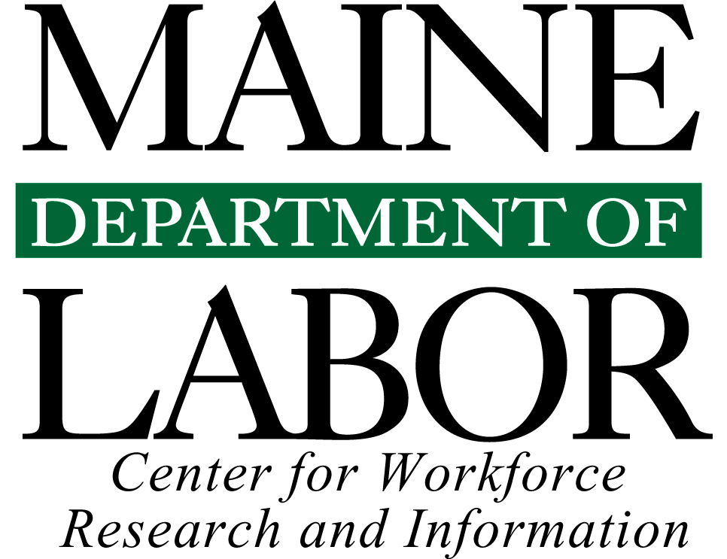

# Introduction

The landscape of work has been transformed in the last several decades. First, the baby boom generation that poured into the labor force from the 1960s until the 1980s is aging to retirement. Next, international trade barriers have been significantly reduced, creating opportunity for some companies, industries and communities while devastating others. In addition, technology has become a pervasive part of our lives, both at work and home, providing the means to do old things better, faster, and less expensively, and to do new things that, not long ago, few imagined could be done.

The deep 2008–2009 downturn accelerated the pace of change, causing massive job displacement from certain sectors, especially manufacturing, construction, retail trade, and government. The recovery brought job growth, but it has been concentrated in a few sectors, especially education, healthcare, professional and business services, and leisure and hospitality. The education, knowledge, and skill requirements for the jobs in growing sectors differ from what was required of workers displaced from declining sectors.

We face major workforce development challenges in the years ahead from the restructuring of employment; this restructuring is reallocating not only the types of jobs available, but also the performance requirements of jobs. It is further complicated by our advancing age structure that is slowing labor force growth. The future direction of our economy depends on how we manage these challenges to fully and effectively staff companies to meet demand for their products and services. If employers are not able to find enough staff, or staff with the appropriate education and skills, they won’t be able to expand in Maine.

## Demographic Challenge

Maine is the oldest state in the nation by median age. The leading edge of the large baby boom generation has reached retirement age and all of that group will surpass age 65 in the next 15 years. A great deal of high-value experience will be lost to employers with their exodus from the workforce. Combined with a much smaller population of youths and young adults to replace them in the labor force, the situation makes for a slow job growth outlook in the near term, and, if we do not foster an environment that will entice higher rates of in-migration to stem this demographic tide, we will see outright decline longer-term.

## The Job Matching Challenge

Job trends over the last 30 years in two sectors illuminate the momentous changes occurring in workplace performance requirements. From 1982 to 2012, the number of wage and salary jobs increased 44 percent. Like the nation, growth was uneven across sectors. In 1982 the 109,000 manufacturing jobs made it the largest sector, accounting for more than one quarter of wage and salary jobs. The 36,000 healthcare jobs comprised less than one tenth of jobs. Today the situation is nearly reversed. We have fewer than half as many manufacturing jobs (50,000) and healthcare is now the largest employing sector, with nearly three times as many jobs (101,000).

This is just one of many examples of the structural shifts that are reallocating knowledge and skill requirements of workers. Technology and automation have become much less expensive and more capable of performing both routine and advanced functions. The skills required on an assembly line performing repetitive tasks not only differ greatly from those required to diagnose and to treat patients, but also differ from the techniques advanced manufacturers use—techniques that increasingly involve math, problem solving, effective communication, decision making, and other attributes not required in assembly-line production.

This is a two-headed problem. Many individuals need work or better work, but their years of experience are no longer in demand; many employers need staff for specific functions but are challenged to find the workers with the education, experience, or skills needed for critical operations. Demand for workers in healthcare, information technology, and social and business services is rising. The staffing needs of those industries primarily require, first, professional and technical functions and, second, service functions. Jobs in professional and technical occupations generally require post-secondary education or training (and often a specific credential) and offer higher-than-average earnings; jobs in service occupations generally do not require post-secondary education or training and offer lower-than-average earnings. Job growth is expected to continue to be concentrated at the upper and lower ends of both the education and earnings spectrums and more limited in the middle.

The recent recession caused massive displacement in production, construction, administrative support, and associated functions that have been the primary source of a middle-class lifestyle for those without a college education. Some individuals who have been displaced have gained new skills through education or job-training programs, but the supply of these workers has not declined as fast as demand for their services has, causing wage stagnation for those who continue to work in these fields. The result for many has been re-employment in lower-skill, lower-paying occupations for many who must settle for whatever job they can find.

The long-term outlook by occupation is remarkably similar to the current demand situation. Projections through 2022 indicate that 68 of the 100 fastest-growing occupations require some form of post-secondary credential; 24 of the 40 fastest-growing occupations will be healthcare-related; and business, financial operations, computer, mathematical, science, and legal occupations will grow faster than average. On the other end of the spectrum, of the 40 occupations expected to lose the most jobs, 13 are in production occupations and 12 are administrative support.

In addition to the trend toward jobs at the upper and lower ends of the education and earnings spectrums, the flattening of organizations in all sectors puts a premium on self-organization, self-management, and personal initiative by workers at all organizational levels. Jobs that once required little more than a strong back or manual dexterity now require higher levels of reading comprehension, communication, and decision making.

The nature of work in the twenty-first century increasingly demands higher levels of literacy and more sophisticated technology competencies. We can generalize that primary performance attributes of jobs in growing occupations are concentrated around critical thinking, problem identification, mathematics, reading comprehension, active listening, oral communication, instruction, and decision making. Those contrast with the primary work activities or knowledge requirements of occupations that are expected to have the highest rates of job loss, which include handling and moving objects, controlling machines, repairing and maintaining equipment, and clerical functions.

Workers can be better equipped if they understand the forces that will impact their future. Educators and those charged with workforce development have the important responsibility of anticipating job performance requirements and future needs. The charts and narrative in this publication broadly highlight the demographic and workforce trends and challenges Maine faces through 2022. A more detailed look at job projections for industries and occupations is available at [www.maine.gov/labor/cwri/outlook.html](http://www.maine.gov/labor/cwri/outlook.html).

# Section 1 – Labor Force Outlook

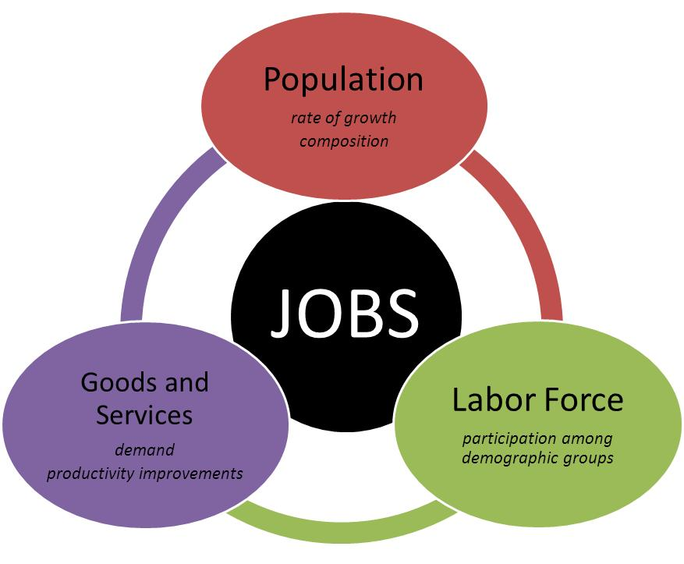

The economy is constantly changing. New products and services emerge and others fade; technology and process improvements make us more productive. The labor force also constantly changes. The rate of growth and composition of the population as well as the share of the population participating in the labor force differs among demographic groups and changes over time. In addition, human-capital resource needs of employers — the knowledge, skills, abilities, and other attributes of work — also constantly change. These dynamics have been interplaying at an ever-increasing pace. The relationships between all these factors produce the types of job openings occurring at a point in time.

## Labor Force Outlook – Components of Population Growth

Our population is not growing because births are way down

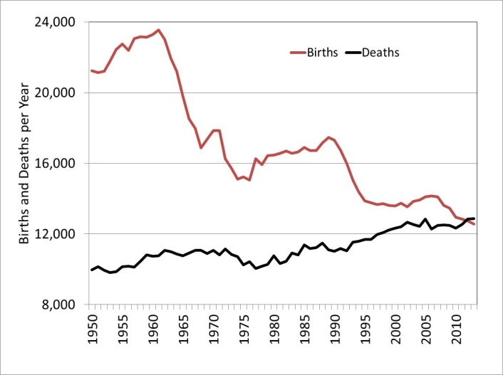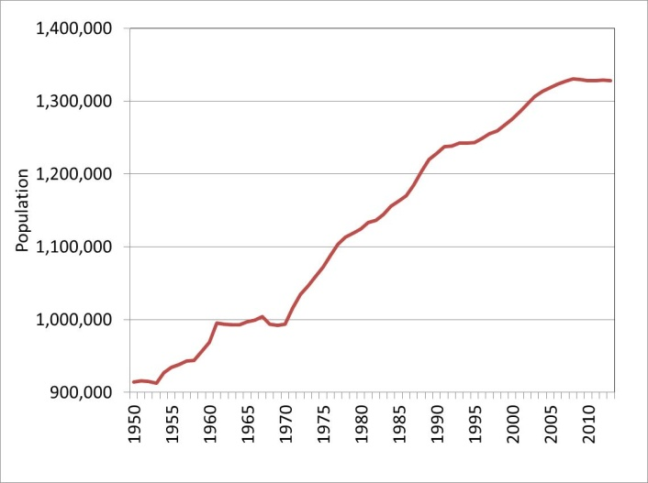

After decades of consistent growth, the size of Maine’s population has been flat since 2008. Population change is driven by two factors: natural change, which is the difference between the number of births and deaths, and net migration, which is the difference between the number of people moving into and out of the state.

For more than a century, Maine had positive natural change, which peaked during the 1946 to 1964 baby boom. Since then the number of births per year has trended lower and the number of deaths per year has trended higher—to the point that we no longer have any natural increase in population. Given the advanced age of much of our population, this trend is not likely to be reversed in the next two decades.

Without positive natural change, Maine will depend on net in-migration to maintain our population and workforce. The good news is that, since the 1960s, we have had more people moving into than out of the state, with the exception of three periods, each of which coincided with a recession and two coinciding with a military-base closure that took thousands out of the state.* In the recent recovery, net-migration to and from Maine has remained near zero. That trend must be reversed to maintain the size of our workforce.

*(Loring Air Force Base closed in the early 1990s. Brunswick Naval Air Station closed recently with most personnel leaving Maine in 2008 and 2009).

## Labor Force Outlook – Aging Population

In 2022, nearly 1 in 4 Mainers will be age 65 or over

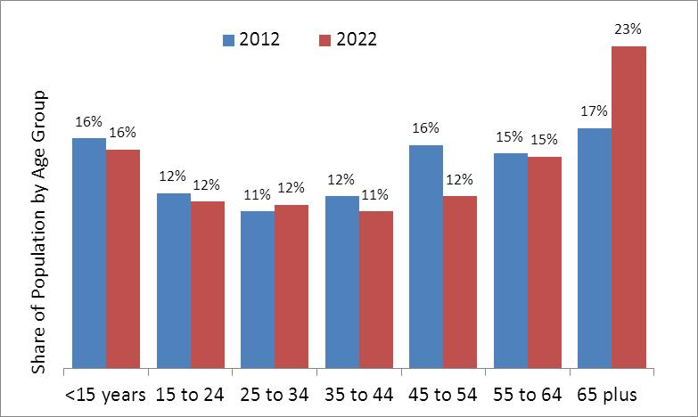

Though the total population of Maine has not changed significantly since 2008, the age composition has advanced. Forecasts indicate the trend of a flat total population advancing in age will continue over the next two decades. This will have major implications for the size of our workforce.

To illustrate this point, it is instructive to look at our current population composition. In 2012 the number of residents age 45 to 64 numbered 411,000. Most of that group will be labor force “leavers,” retiring in the next two decades. At the other end of the spectrum are the 302,000 residents under age 20, most of whom will be labor force “entrants.” The 109,000 gap between potential labor force leavers and entrants poses a significant challenge, particularly when our labor force totals just 700,000.

Lack of working-age population growth can significantly impact businesses’ abilities to attract the staff they need to meet demand for their products and services. As the economy continues to recover from the recent downturn, our ability to attract and retain young working people will be an increasingly important issue.

## Labor Force Outlook – Impact of Aging

The population in their peak years of labor force participation is declining

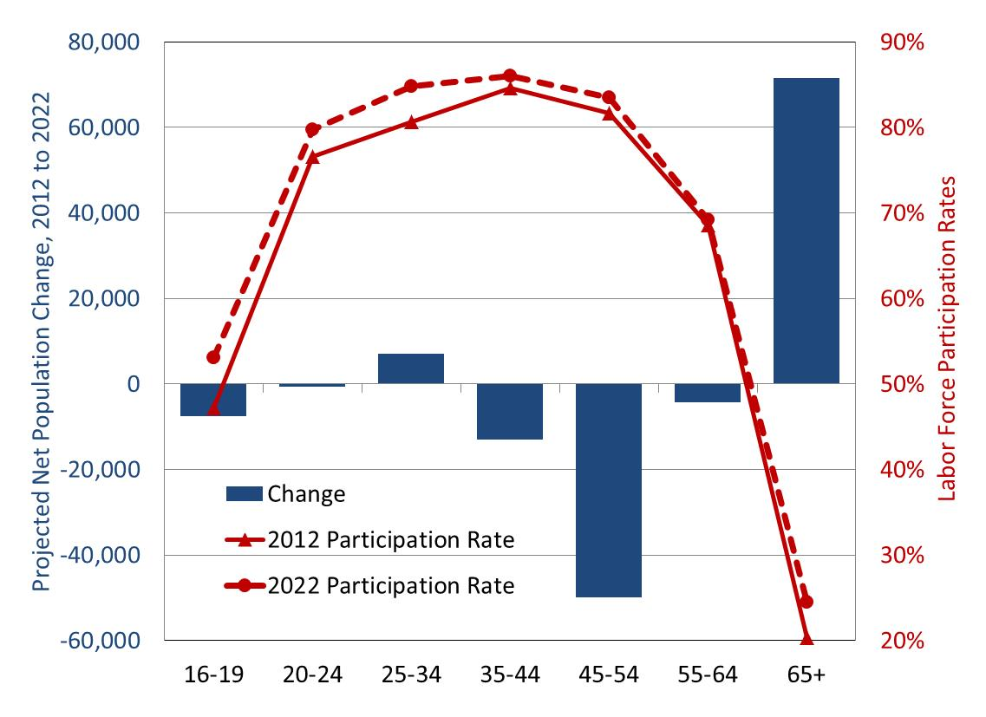

Labor force growth is driven by changes in the size and composition of the population— especially among age groups—and changes in labor force participation. The labor force participation rate is the share of the population age 16+ who are employed or unemployed (jobless people are counted as unemployed only if they are actively seeking work). Participation rates differ significantly among demographic groups, with higher rates among men than women, often due to family considerations, and higher rates among those 25 to 54 years of age than younger or older people.

Participation rates for demographic groups can change over time. The share of women in the labor force doubled between 1950 and 2000 while the participation of men remained relatively unchanged. Since 2000 labor force participation has trended lower for both men and women. This is due to a higher share of population in their fifties and sixties, beyond their peak years of labor force attachment.

The outlook to 2022 is for rising labor force participation among all age groups, especially those under 35 and over 65. For younger people this reflects greater opportunity as the economy strengthens and large numbers of seniors retire. For seniors this reflects financial need, changes in eligibility for retirement benefits, changing norms about work and retirement, and a higher share of jobs that are not physically demanding, but it primarily reflects the rising share of “young seniors” in their upper sixties and early seventies. “Young seniors” have always been more likely to work than those in their upper seventies and beyond. This rise in participation of those ages 65 and older is expected to last for about the next ten to 15 years, and then turn lower as most baby boomers age into their seventies and eighties. Despite rising participation among all age groups, the overall labor force participation rate is expected to continue to trend lower as more people move beyond prime working age.

## Labor Force Outlook – Growth Outlook Slowing

The size of the labor force is not expected to change significantly through 2022

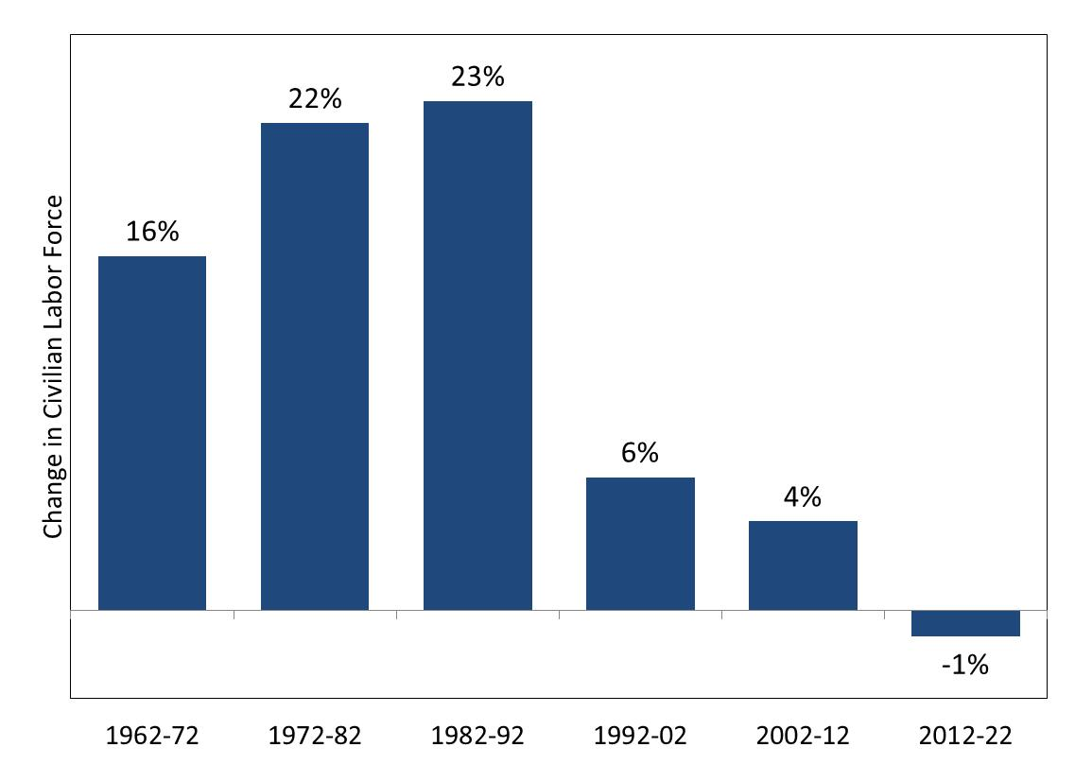

The net effect of these population and participation trends is significant slowing in labor force growth from more than 20 percent per decade in the 1970s and 1980s, to single digits the last two decades, to a small decline expected from 2012 to 2022.

## Labor Force Outlook – Job Growth

Job growth is expected to exceed labor force growth reflecting declining unemployment from elevated 2012 levels

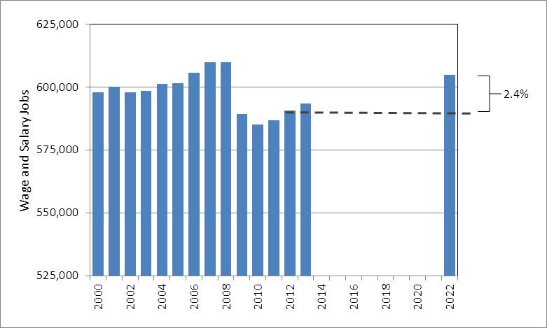

Though the size of the labor force is expected to decline slightly through 2022, employment is expected to rise by 15,000. How can employment increase without labor force growth? Unemployment is expected to continue to trend lower from the 7.2 percent average in 2012, as thousands become re-employed.

Most growth is expected in wage and salary jobs, which are projected to increase 14,000 to nearly 606,000. The number of self-employed, private household and unpaid family workers is expected to rise about 1,000 to 65,000.

The projected 2.3 percent rise in total employment between 2012 and 2022 is well below the 11.3 percent growth the U.S. Bureau of Labor Statistics projects for the nation. This slower expected growth reflects our larger share of population approaching retirement. Beyond 2022, job growth is expected to be further constrained by our advancing age structure, which also will impact demand for products and services and the types of available jobs. Aging will keep demand for health and retirement services high and limited labor force growth is likely to cause employers to pursue improvements in productivity through automation and more efficient work practices.

# Section 2 – Industry Employment Outlook

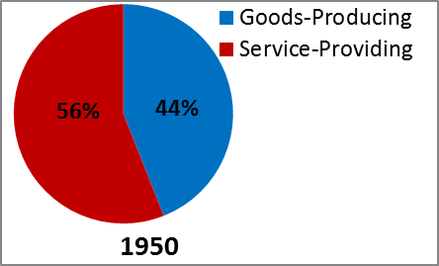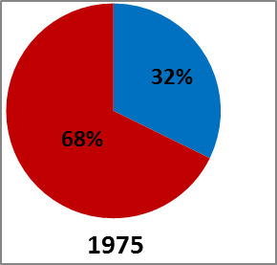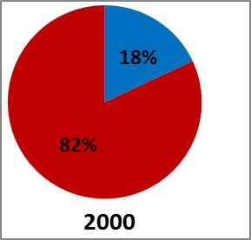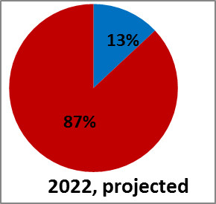

The structure of employment shifts over time as some industries add and other industries lose jobs. Over short periods of time these shifts tend to be small, but over decades the profile of employment changes significantly. Many of Maine’s cities were built around paper or textile mills or shoe shops. Large brick buildings in the center of some cities attest to the prominence those industries once had as the economic backbone of an entire region. Today some of those buildings have been torn down, others stand empty, while others have been redeveloped for housing, retail, medical, and other uses. The redeveloped uses of many of those buildings symbolize the major changes our economy has undergone in just a few decades.

In 1950, Maine had 109,000 manufacturing jobs, accounting for 43 percent of nonfarm jobs. A full 11 percent of nonfarm jobs were in textile and apparel mills; 10 percent were in forest products, including paper and lumber mills and logging; 7 percent were in shoe shops and tanneries; and 4 percent were in food manufacturing. In the following 62 years to 2012, the total number of nonfarm jobs more than doubled, adding 344,000 jobs, yet manufacturing declined by 58,000 jobs to just 8 percent of jobs today.

## Industry Outlook – Structure of Employment

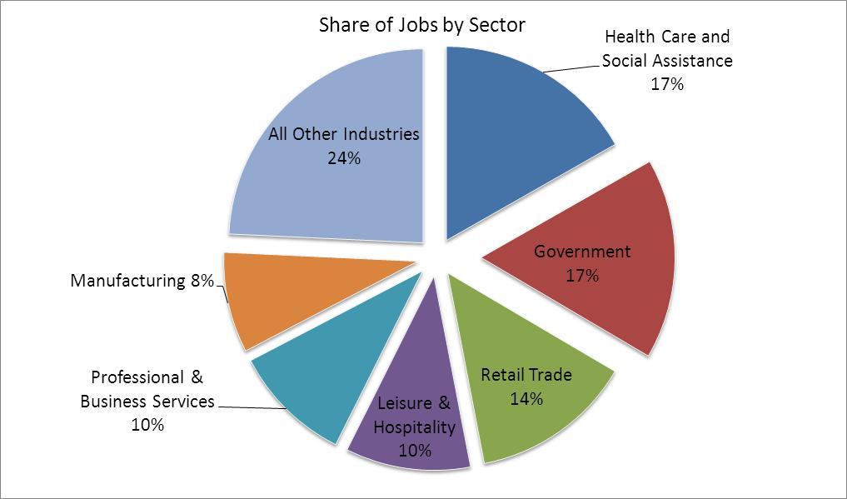

With 101,000 jobs, healthcare and social assistance is now our largest employing sector. Government (federal, state, and local, including public schools, colleges, and universities) is nearly as large, with 97,000 jobs. Retail trade (81,000 jobs), leisure and hospitality (62,000), and professional and business services (58,000), and manufacturing (51,000) are the next largest.

## Industry Outlook – Projected Industry Employment Change

Only four sectors are expected to have more jobs in 2022 than in 2008

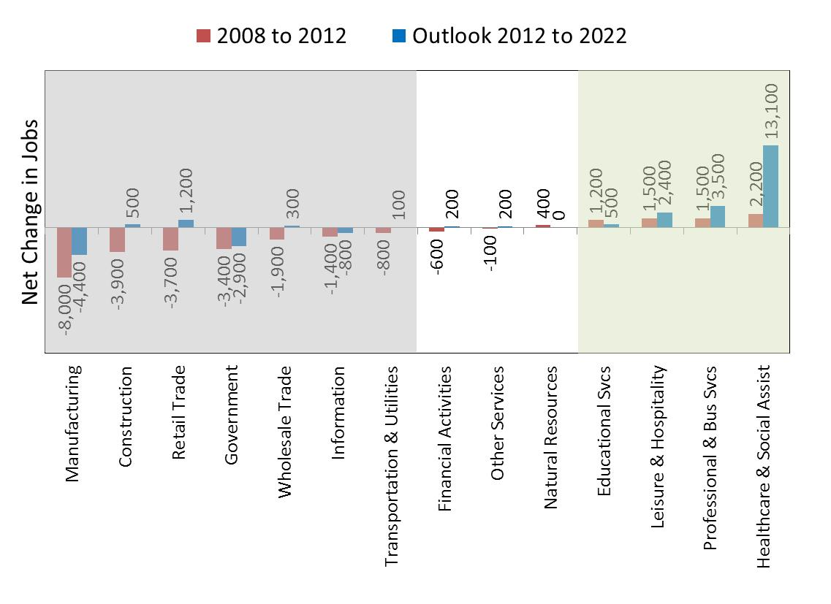

Employment in Maine peaked in 2008 at the beginning of the recent recession. From 2008 to 2012, including the recession and early recovery, nine sectors experienced net job losses and five experienced net job gains. Job losses were primarily in industries that make, move, or sell products, particularly manufacturing, construction, retail and wholesale trade, as well as information and government. Job gains were primarily in human capital-intensive sectors including educational services, healthcare and social assistance, professional and business services as well as leisure and hospitality.

The outlook from 2012 to 2022 is for growth to continue to be uneven among sectors. Those shaded green in the chart are expected to reach new highs, while those in white are expected to have about the same number of jobs in 2022 as they had at the onset of the recession in 2008. The six sectors shaded gray are expected to recover fewer jobs than were lost during and shortly after the recession or to continue to lose jobs (manufacturing, government, and information). The following four pages look at employment in certain sectors in 2008 and 2012 and our projections for 2022.

## Industry Outlook – Sectors Reaching New Job Highs

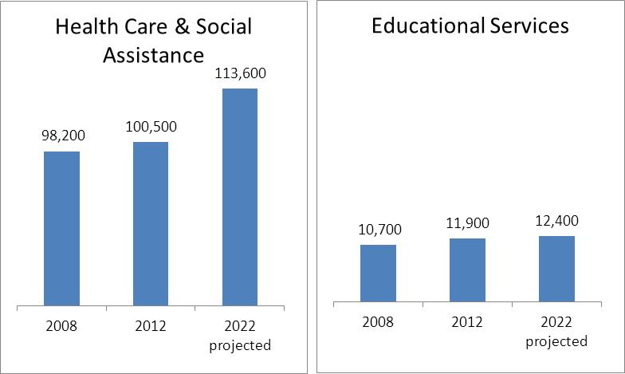

Healthcare and social assistance added 2,300 jobs from 2008 to 2012 and is expected to add 13,100 additional jobs through 2022, creating job opportunities in healthcare practitioner and technician, healthcare support, community and social service, and office and administrative support occupations.

Private educational services (not including public schools) added 1,200 jobs from 2008 to 2012 and is expected to add 500 additional jobs through 2022, creating job opportunities in education and training, administrative support, and management occupations.

## Industry Outlook – Sectors Reaching New Job Highs

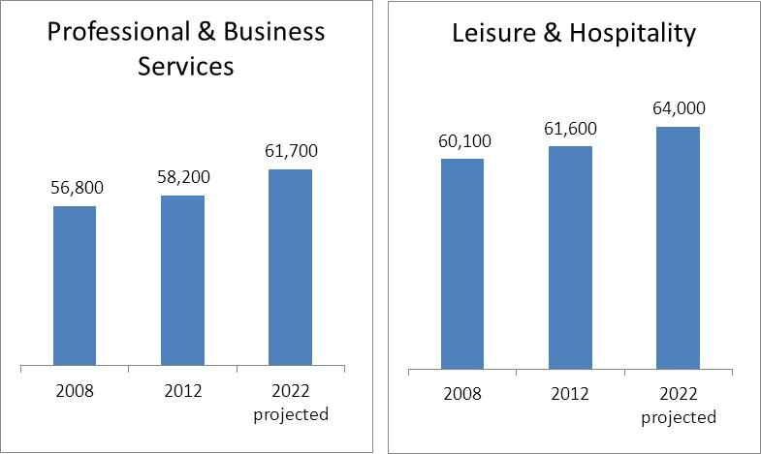

Professional and business services added 1,400 jobs from 2008 to 2012 and is expected to add another 3,500 jobs through 2022, creating job opportunities in business and financial, management, computer and mathematical, architecture and engineering, and legal occupations.

The leisure and hospitality sector added 1,500 jobs between 2008 and 2012 and is expected to add 2,400 additional jobs through 2022, creating job opportunities in food preparation and serving, building and grounds cleaning and maintenance, office and administrative support, and management occupations.

## Industry Outlook – Sectors Expected to Grow, But Not Recover to Pre-Recession Levels

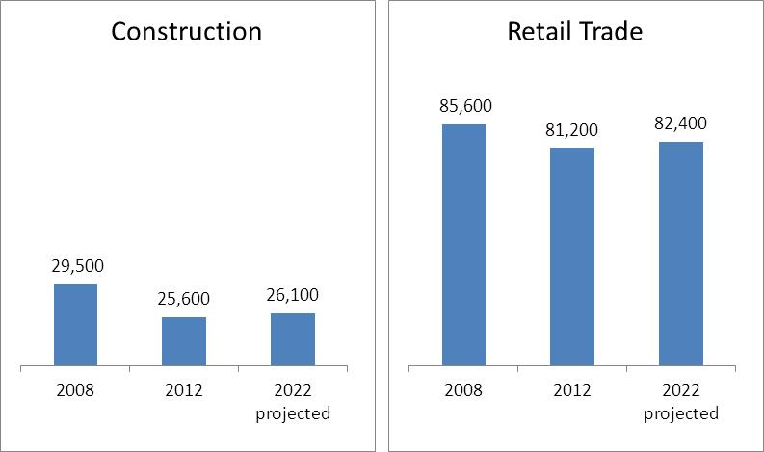

Construction jobs fell 3,900 from 2008 and 2012. The industry is projected to add just 500 jobs through 2022, not fully recovering to pre-recession job levels. This affects job growth and openings primarily in construction and extraction occupations.

The situation in retail trade is similar. The industry shed 3,700 jobs from 2008 to 2012. Retail is projected to add 1,200 jobs through 2022, not fully recovering to pre-recession levels. This affects job growth and openings in sales and related, office and administrative support, transportation and material-moving, and buildings and grounds cleaning and maintenance occupations.

## Industry Outlook – Sectors Expected to Continue to Lose Jobs

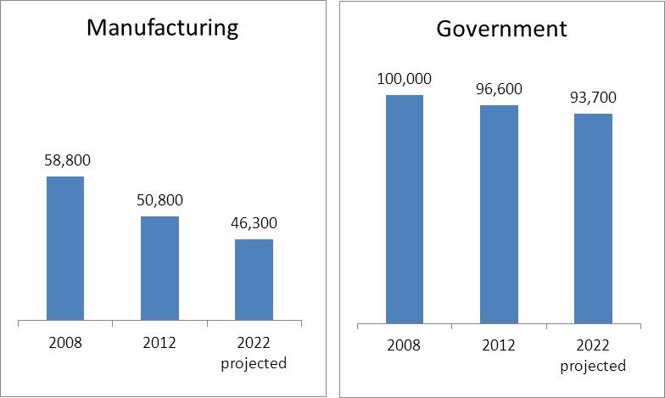

Manufacturing shed 8,000 jobs from 2008 to 2012 and is expected to shed 4,400 additional jobs through 2022. This adversely impacts the number of job openings in production, office and administrative support, transportation and material-moving, and installation, maintenance and repair occupations.

Government shed 3,400 jobs from 2008 to 2012 and is expected to shed 2,900 additional jobs through 2022. This adversely impacts the number of jobs and opening in education, protective service, and office and administrative support occupations. (Much of the decline in government is in local schools due to a declining population of children.)

# Section 3 – Occupational Employment Outlook

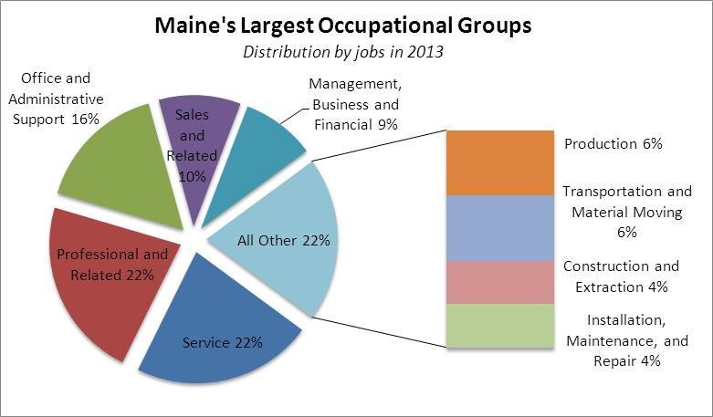

As massive as the changes in employment have been across industries, the changes in the occupational structure of employment have been even greater over the last several decades. Many factors drove these changes. The reallocation of jobs across industries was a primary factor. Manufacturers require large numbers of production-line workers and hospitals require large numbers practitioners and support workers to care for patients. Declines in manufacturing jobs have required many production workers to learn new skills or gain additional education to become employed in other sectors.

Within each industry there also is a reallocation of functions as technology and work-practice improvements change how we produce goods or deliver services. Banks were once heavily staffed by tellers, but the rise of ATM machines, then online and mobile banking, allowed customers to perform transactions on their own. Lower paying, entry-level teller jobs were replaced by information technology jobs to design and maintain these systems. The IT jobs have much higher education and skill requirements and offer much higher earnings. Similarly, rising automation of manufacturing production lines require fewer assembly line workers and more technicians to operate and troubleshoot advanced machinery. This sort of reallocation is occurring across all industries.

We can generalize that the share of jobs in occupations physically making, building, moving, or fixing things is declining, while the share in human-capital intensive occupations is rising.

## Occupational Outlook – Change in Employment by Occupational Group

Growth is expected to be concentrated in a few occupational groups

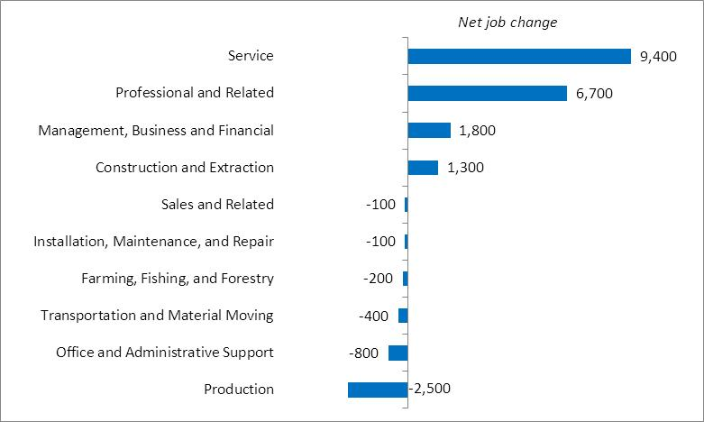

The occupational job outlook is largely for a continuation of those same long-term trends. Most job growth is expected in the two largest groups of occupations, professional-related and service jobs, as well as management and financial occupations and construction and extraction occupations. Most other occupational groups are expected to experience little change, though jobs in office administrative support, production, and transportation and material-moving occupations are expected to decline.

## Occupational Outlook – Jobs by Education Requirement and by Earnings

Growth is expected to continue to be concentrated in occupations that require post-secondary education that pay well or in low-skill, low-paying occupations

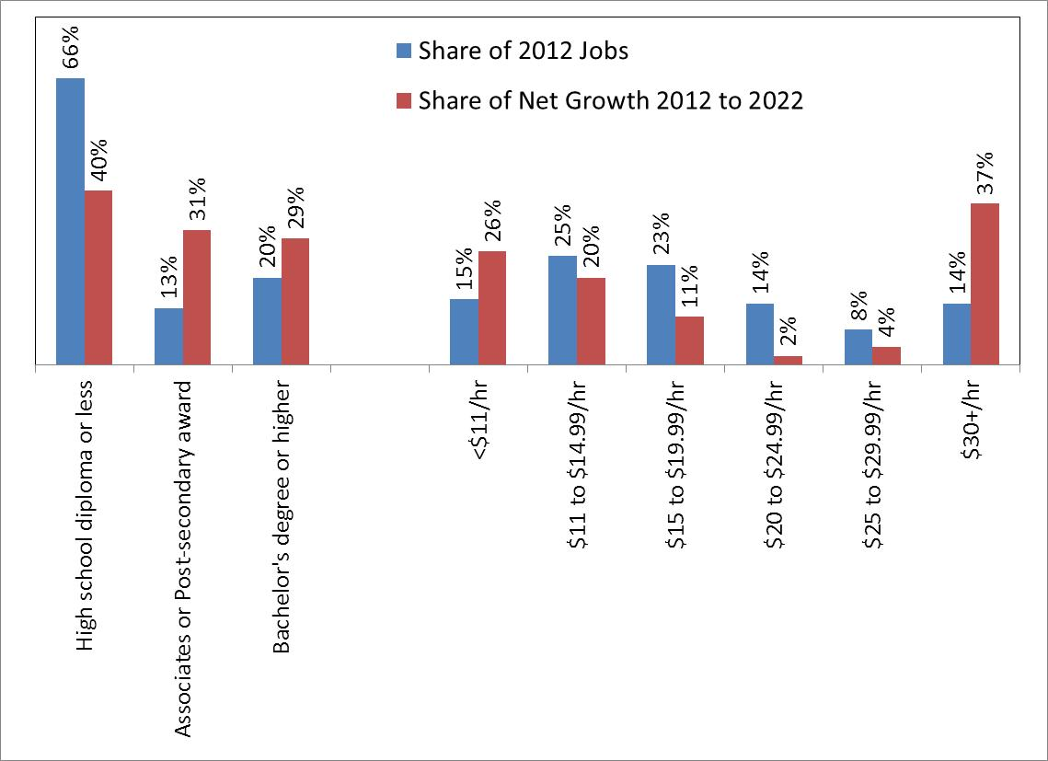

The result of these trends is a concentration of job growth in occupations with generally higher-than-average education and skill requirements that fall at the upper end of the earnings spectrum (professional and management/finance jobs), on the one hand, and in occupations with generally lower education and skill requirements that fall at the lower end of the earnings spectrum (service jobs), on the other. Jobs in occupations that require a post-secondary credential accounted for just one third of employment in 2012, but are expected to produce 60 percent of net job growth through 2022. Meanwhile, the two thirds of jobs in occupations that generally do not require a post-secondary credential are expected to account for just 40 percent of net growth.

The number of jobs in many occupations in the middle of the earnings spectrum that generally do not to require post-secondary education, such as production, transportation, repair and installation, and administrative-support jobs, are either expected to continue to grow very slowly or decline.

## Occupational Outlook – Training and Work Experience for Jobs Requiring a High School Diploma or less

This matrix shows the distribution of occupations with a usual education requirement of a high school diploma or less. Most of these types of jobs require some sort of work experience and/or on-the-job-training.

It is important to note that most jobs in occupations that do not require post-secondary education do specify that training and/or prior work experience is required for entry. Ninety percent require on-the-job training (OJT), mostly short-term or moderate OJT. Thirteen percent of jobs require prior work experience. Post-secondary training that leads to a certificate of completion up to an associate degree may exist as an alternate means of entry into these occupations.

It is less common in occupations with higher education requirements that additional training or prior work experience is specified. In the middle of the education spectrum – occupations requiring some post-secondary education or training but less than a bachelor’s degree – about one quarter of jobs specify a work experience or OJT component. About 25 percent of these types of jobs require work experience or OJT of any duration.

Just over half of jobs in occupations with the highest education requirements – bachelor’s degree or higher – specify additional work or training requirements. One fifth requires internships or residencies (common in healthcare occupations); one third requires either prior work experience or moderate to long-term OJT.

## Occupational Outlook – Average Annual Openings: Opportunities from Growth and Replacement

Job openings stem from replacement demand as well as job creation. Nearly 6 of 7 openings will be due to replacement needs.

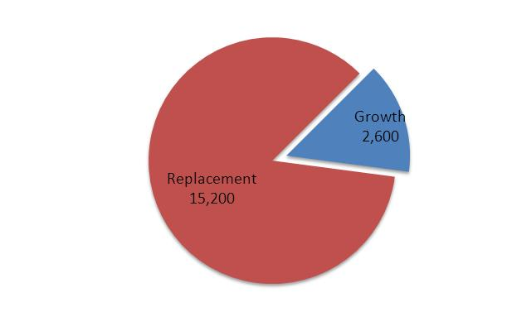

We focus on job openings occurring due to expansion or not occurring due to contraction in industries and occupations because that is what drives the structural shifts that are reallocating the types of jobs and the associated knowledge, skills, and abilities in demand. However, the largest source of job openings each year occurs due to the need to replace those who retire or leave an occupation. Openings due to replacement demand outnumber those due to growth by nearly 6 to 1. In occupations growing extremely rapidly the ratio is much lower.

The number of job openings is very high in some occupations with little or no growth. This is especially true in lower-paying, high-turnover functions, such as retail clerks and hospitality occupations. Alternatively, the number of openings is relatively low in some jobs with high rates of growth, especially occupations with low levels of employment.

## Occupational Outlook – Annual Openings by Occupational Group

Replacement openings are expected even in occupations losing jobs

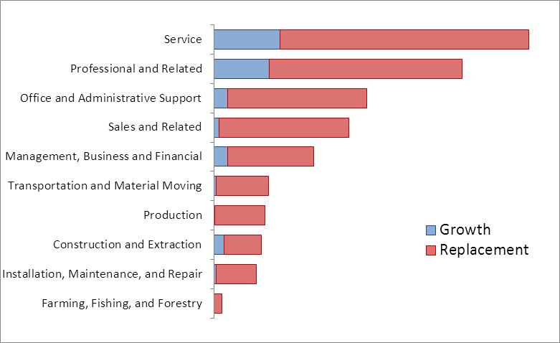

Retirements and turnover will create job openings in all occupational groups. Increased use of robotics and automation to meet demand over the last three decades limited hiring in the manufacturing sector, which led to an older workforce than most other sectors. Nearly 28 percent of the manufacturing workforce is over 55. Thus, despite a projected decline in manufacturing jobs through 2022, there will still be substantial numbers of openings each year in production, transportation and material moving, and installation and repair occupations, which comprise a large share of manufacturing.

Similarly, the workforce in retail trade and food services is younger and turnover rates are higher than average, leading to large numbers of jobs openings in those kinds of occupations.

## Occupational Outlook – STEM Jobs



Report after report over the last two decades from educational, trade, and other interest groups exhorted the need to educate more people for STEM* jobs. Many portray an impending shortage of workers in highly skilled, well-paying science, technology, engineering, and math based occupations. Most treat STEM jobs as a homogeneous group with similar growth prospects.

The problem with these characterizations is that there is a great deal of diversity of functions and an equally wide range in growth prospects not only between science and technology, for example, but also the range of occupations within sciences, within technology, within engineering, and within mathematics. The variety of STEM occupations creates very different growth prospects.

Under the Standard Occupational Classification system used by economic agencies to classify and count jobs there are 653 occupations in which there is employment in Maine and for which we have developed projections. Of that number, 181 occupations are designated as STEM by either the O*Net consortium or the U.S. Bureau of Labor Statistics. Collectively, the number of jobs in those 181 occupations is expected to rise 6.5 percent from 2012 to 2022, which is nearly three times the rate for all occupations. The expected gain of 6,800 jobs in STEM occupations accounts for 46 percent of expected net job growth.

Individually, 107 of those STEM designated occupations are expected to grow faster than average, another 13 are expected to grow more slowly than average, and 61 are expected to be unchanged or lose jobs. Like other types of functions, slowly growing or declining STEM occupations generally are those being impacted by new or changing technologies that are improving or replacing processes.

*Science, Technology, Engineering and Mathematics

## Occupational Outlook – The Nature of Work

Work attributes valued in growing and declining occupations differ

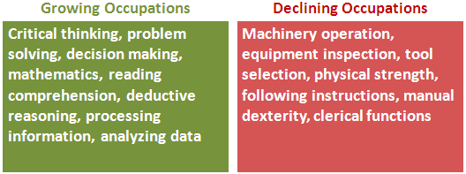

The nature of work increasingly demands higher levels of literacy and more sophisticated technology competencies. The primary performance attributes of jobs in growing occupations are concentrated around critical thinking, problem solving, reading comprehension, effective communication, and decision making. Those contrast with the primary work activities or knowledge requirements of occupations that are expected to have the highest rates of job loss, which include handling and moving objects, controlling machines, repairing and maintaining equipment, and clerical functions.

Detailed projections for individual industries and occupations are available at [www.maine.gov/labor/cwri/outlook.html](http://www.maine.gov/labor/cwri/outlook.html).