October 2010

Maine Labor Market Activities of Veterans

The Current Population Survey (CPS) defines veterans as men and women who have previously served on active duty in the U.S. Armed Forces and who were civilians at the time they were surveyed. According to CPS data published by the U.S. Bureau of Labor Statistics, in 2009 there were 141,000 veterans ages 20 and over in Maine; 71,000 were in the labor force. In a separate section, American Community Survey (ACS) data is used to provide more detail.
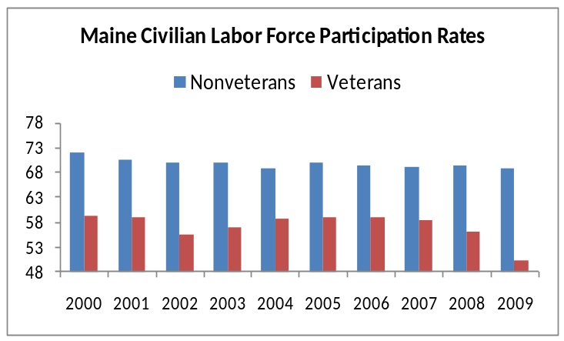

Labor Force Participation-CPS data indicates that veterans in Maine have consistently participated in the labor force at a lower rate than the nonveteran population. In 2009, 50.3 percent of the veterans were active in the labor force compared to 68.8 percent of the nonveteran civilian noninstitutional population. In part, the lower rate of veteran participation is due to the age distribution of the veteran population. Veterans are older, on average, than nonveterans (see ACS data below). Labor force participation drops as individuals age beyond the prime working years.

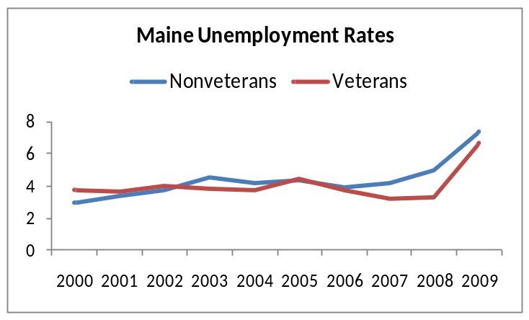Unemployment Rate-Maine veterans lately have recorded an unemployment rate below the nonveteran statewide average. The Maine unemployment rate for all veterans of the U.S. Armed Forces was 6.6 percent in 2009 according to the CPS compared to a nonveteran unemployment rate of 7.3 percent. However, ACS data presented below indicates that younger veterans recorded a relatively high unemployment rate for 2009.

From the American Community Survey
More detailed data concerning veterans is available from the ACS. The ACS differs slightly from the CPS due to methodologies and timing of the surveys. In addition, the CPS statewide count is for veterans 20 and over while the ACS counts veterans 18 and over for population and 18 to 64 for labor force.

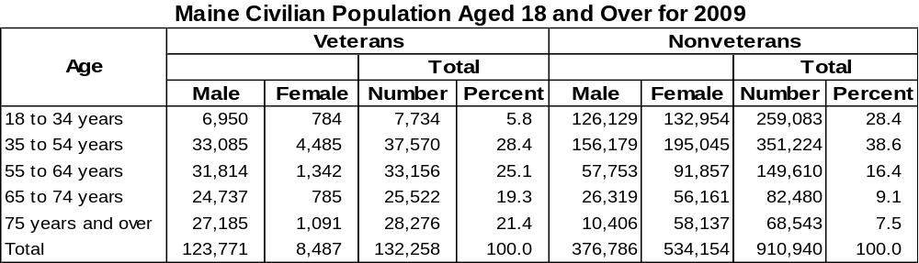In Maine, veterans are predominately male, and over 60 percent of the veterans are 55 or older. In part, this reflects the characteristics of veterans who served during World War II, the Korean War, and the Vietnam era.

The ACS provides estimates of labor force by age for veterans (ages 18 to 64). Veterans under the age of 35 participated in the labor force at about the same rate as veterans 35 to 54 years of age; however, younger veterans had a much higher unemployment rate.
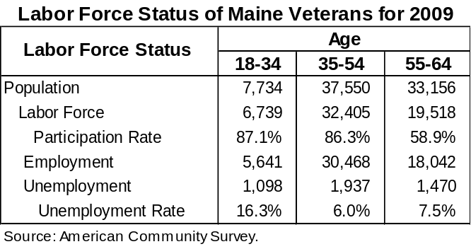

The high unemployment rate for veterans aged 18 to 34 may be accounted for in part by the higher unemployment rate normally experienced by younger workers. However, the unemployment rate for young veterans (16.3 percent) was also higher than the unemployment rate for young nonveterans (10.5 percent).


