Employment outcomes for Maine’s public post-secondary graduates

*A publication of:*



*Prepared by:*

*Paul Leparulo, CFA*

*Principal Economic Research Analyst*

Issued October 22, 2014

The data in this publication is in the public domain and may, with appropriate credit to the Maine Department of Labor, be reproduced without permission. The Maine Department of Labor provides equal opportunity in employment and programs. Auxiliary aids and services are available to individuals with disabilities upon request.

Telephone: (207) 623-7900 TTY 1-800-794-1100 FAX: (207) 287-2947

# Wage and employment outcomes for Maine’s public post-secondary graduates

The Maine Department of Labor’s (MDOL) Center for Workforce Research and Information (CWRI) recently unveiled a new data system that measures the wage and employment outcomes of college graduates. The system links the records of University of Maine System (UMS) and Maine community college students with their corresponding unemployment insurance wage records available at MDOL. Bringing these sets of data together improves our ability to answer important questions regarding the extent to which new graduates find jobs in Maine, and what are they paid.

The outputs shed new light on what happens to students as they leave school and progress through the workforce. We’re learning that a majority of the graduates stayed in Maine and found employment, that those with two year credentials earned competitive first year wages and that nursing graduates remained in high demand, plus much more. As more data is added and longer term outcomes developed, we expect to gain a better understanding of the market value of specific credentials in the Maine economy.

This type of information offers value to a range of stakeholders. Prospective students will be better equipped to choose among different paths of education, and guidance counselors and parents will have reliable data to help students navigate these career decisions. College administrators and educators will have more comprehensive data for evaluating programs and allocating scarce resources. Economic developers, employers and policy makers will be able to better understand the supply of newly trained graduates in strategic sectors and occupations.

## Methodology

Records of graduates from UMS and Maine’s community colleges, Classes of 2009 to 2011, are linked to quarterly wage data available at MDOL. Wage data is available for jobs in Maine that provide unemployment insurance benefits, or covered employment. Combining three academic years enables greater reporting at the area of study level while at the same time maintaining confidentiality.

The data system produces employment and wage outcomes for the first year after graduation, defined as quarters three through six post-graduation. This gives individuals two quarters after completing school to find employment. Longer term outcomes will be added as more data becomes available. Results are aggregated and reported by credential, area of study and school.

Data sharing among partners is established and governed in accordance the Family Education Rights and Privacy Act and other federal and state confidentiality and privacy laws and provisions.

## MDOL Wage & Employment Outcomes Data System

**MDOL Unemployment Insurance Wage data**

**UMS, MCCS Classes 2009-2011**

*First year wage & employment outcome reports are created.*

*Unit level records from separate databases are linked.*

*Results are aggregated to protect confidentiality.*

## What does the system measure?

The system aggregates the number of completers by credential, area of study and school, and measures the number employed and wages paid. Two separate definitions are used to measure employment: those that had any employment during the first year (regardless of duration and amount earned) and those that were employed during all four quarters with wages above a minimum threshold of $3,120 in each quarter. The former definition is a broad measure of the number remaining in Maine and finding some employment; the latter captures those who were more fully and continuously employed during the first year after graduation.[1]

## Core Measures

## What are the limitations?

Linking education and wage data has numerous benefits, but there are also limitations that govern how the results should be interpreted and the system used. Primary limitations are highlighted below.[2]

* Outcomes data only include those that have employment records in the Maine unemployment insurance wage record data base. Graduates that are ‘not found’ are not necessarily unemployed; they may be working in another state, self-employed or employed by the federal government. Moreover, graduates that re-enrolled in education programs may not be seeking employment. Overall, 76 percent of the graduates in the cohort were accounted for in the Maine wage record system during quarters three through six post-graduation.
* The data-system measures first year outcomes, which may not be reflective of longer term results. Longer term outcomes will be developed as the data becomes available.
* Employment outcomes will vary with a number of factors, including the economic cycle, region and industry of employment.
* The system does not measure intangible factors such as personal satisfaction with earning a credential and the intrinsic value of an education.
* Wages are not adjusted for inflation.
* MDOL wage records reflect aggregate quarterly wages for individuals in covered jobs. Wage records do not indicate whether an individual is employed full or part-time, and may reflect multiple jobs in a single quarter.
* Wage outcomes in areas of study with small numbers of completers may be affected by graduates with unusually high or low wages.

## Highlights of first year outcomes

Matching student data with wage records helps address important, but heretofore difficult to answer questions regarding the employment outcomes of those in post-secondary education programs. Do new graduates get jobs in Maine? Do they remain employed? What are they paid? Answers to these questions shed light on the Maine economy, education programs, career options, plus more. Following are preliminary observations of the first year outcomes for The Classes of 2009 – 2011.

### Most graduates stayed in Maine and found employment

Overall, 76 percent of the graduates were identified as having been employed in Maine during the first year after completing their degree. As noted above, this broad measure captures any individual that had a wage record at any point during quarters three through six post-graduation. While this does not tell us how long individuals were employed or what they earned, it does indicate that a relatively high proportion remained in-state and successfully garnered some type of work subsequent to earning their award. Recall that the completers that were not found in MDOL’s wage database (24 percent of the total) were not necessarily unemployed; they may have left the state for jobs, been self-employed, garnered employment with the federal government or re-enrolled in further education.

Community college graduates were more likely to have been employed in Maine than university completers. Eighty-four percent of those with a community college award worked in-state during their first year compared to 73 percent of university graduates. Considering that 11 and five percent of the UMS students originated from other states and countries, respectively, these figures are not surprising.

By credential, the percent employed ranged from a low of 50 percent for those with doctorates to 96 percent for graduates with post-masters certificates. Results are displayed in the chart below. Several factors shed light on the range in outcomes.

* Graduates with higher level credentials and those originating from outside Maine may have been more willing to seek employment outside the state, yet this system only captures employment in Maine. These factors may explain the below average employment figures for those with doctorates, law and bachelor degrees.
* Many students earn their credential while remaining employed, which can affect post-graduation employment figures (if students remain in those jobs). This may be an underlying factor in the very high employment ratio for post-masters certificates.[3]
* Some graduates re-matriculate and do not seek employment. The associates in arts program prepares students for transfer into an upper level bachelor’s program, which may explain why the ratio of graduates employed (76 percent) is below that of other associate degrees.

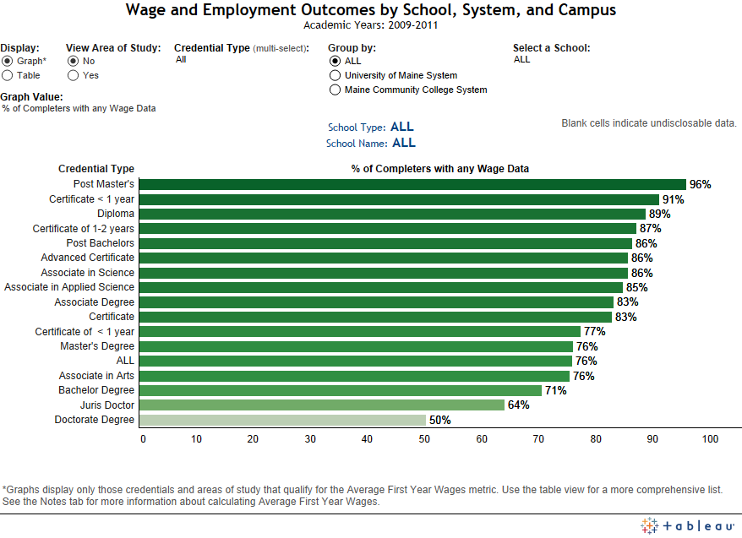

*Overall, 76 percent of graduates in the cohort were employed in Maine during the first year after graduation.*

To replicate this chart on the “Colleges” tab, select ‘Graph” under the display menu and under Graph Value select, “% of completers with any wage data.”

### Fewer than one out of two appear to be working full-time

While three fourths of the graduates found employment in Maine, less than half had wage records consistent with full employment. Specifically, 46 percent had earnings above a minimum wage threshold in each quarter of the measurement period. The remaining 30 percent of working graduates were either not employed in all quarters or had wages below the minimum threshold.

As noted earlier, we’re not able to more specifically determine the outcomes of the 24 percent of the cohort that had no wage records in Maine.

The ability of graduates to find employment was likely hampered by the ongoing repercussions of the Great Recession. While the Classes of 2009-2011 entered the job market during an economic recovery, hiring demand remained historically low for years after the recession’s end.[4] As more data is collected and longer-term outcomes processed, we expect to gain a better understanding of the economy’s impact on hiring demand and job retention.

### Higher credentials typically resulted in higher pay

To understand what graduates earned we evaluated the group of completers that had wages above the minimum threshold in every quarter throughout the measurement period. By focusing on the 46 percent that met these criteria—and excluding the 30 percent that did not—we are able to better understand what those who were more fully and continuously employed earned during the first year after completing their award.

Average First Year Wages (AFYW), displayed below, support the widely held notion that higher levels of education tend to be accompanied by higher remuneration. On one side of the spectrum, those who completed certificates had wages in the low $30,000 range, while those with a doctorate earned approximately twice that amount. In general, graduates with higher levels of education had higher first year wages.

Some programs stand out as exceptions to the general rule, with wages above that of the next higher credential. These programs (diplomas, post-associate certificates, post-baccalaureate and post-master’s certificates) were relatively small and had high percentages of graduates in well-paid areas. Analyzing future cohorts will help determine if these results are anomalies or normative.

First year wages for associate and bachelor degrees were also similar. While this could reflect something about the mix of jobs available in Maine, longer term outcomes are necessary to fully understand the differences between these credentials. Two and four year programs have different emphases, with the former tending to be more vocationally focused, and the latter typically including more general education credits and affording a wider array of career options. The comparative value of these degrees will be better understood—and measured—over longer periods than just the first year.

### Area of study detail

MDOL’s employment outcomes dashboard makes the types of data presented above available for hundreds of credentials and areas of study. For example, by manipulating the dashboard’s filters and drop-down menus we learn that more than 740 students across six campuses graduated with an associate degree in nursing. These students were highly employable—approximately 91percent found jobs during the first year and 78 percent had wage data consistent with full-time employment. Moreover, with first year wages of approximately $46,000, these graduates were among the highest paid for those with a two year credential. Employment outcomes were comparable across campuses, as seen in the screenshot below.

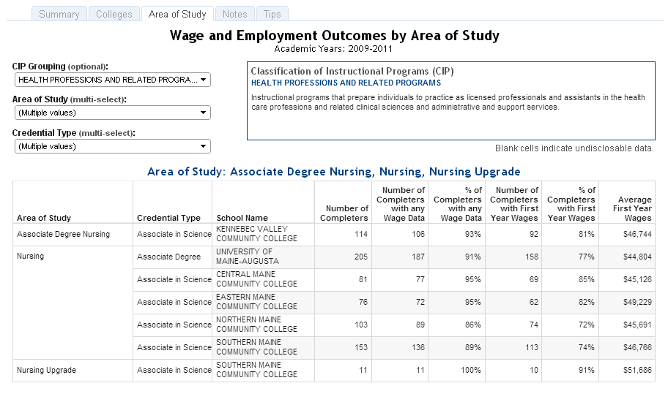

To replicate this chart, on the Area of Study tab, select Health Professions and Related Programs under the CIP Grouping filter. Under the Area of Study filter, multi-select Associate Degree Nursing and all other nursing programs on the menu. Under the Credential Type filter, select Associate Degree and Associate in Science.

We can also use the dashboard to understand the progression in outcomes associated with higher levels of educational attainment within a field of study. To extend the previous example, those graduating with a bachelor’s in nursing had, on average, ten percent higher wages than those with the associate’s degree, but lower employment ratios. Those graduating with a master’s in nursing had first year wages 30 to 45 percent higher than those with bachelor degrees.[5]

Readers will find similar information for an array of other fields of study, programs and schools at <http://www.maine.gov/labor/cwri/wdqi/>

The matching of education and wage records provides objective and quantifiable information on the outcomes that have resulted for groups of individuals with specific credentials. This type of data has broad application for a wide range of stakeholders. With further development, longer term outcomes and new sources of data will be added, and our understanding of the complex relationship between educational attainment and employment outcomes will increase. In an environment of scarce resources, this type of information may play an increasingly prominent role in career and resource planning decisions.

1. Unemployment insurance wage records do not indicate whether a person is employed full or part-time. As a result, to understand the extent to which graduates were more fully and continuously employed this measure was developed. To be included in the calculation, an individual must have wages above $3,120 in each quarter, which is the amount an individual working 32 hours per week at minimum wage would earn in a quarter.
2. For more information, please visit: http://www.maine.gov/labor/cwri/wdqi/index.html
3. Post-master certificates awarded were predominantly education related areas of study. These 30 credit hour programs are targeted at practicing educators and administrators.
4. http://www.maine.gov/labor/cwri/recessionIndex.html
5. Use the Credential Type drop-down menu to get this information. Data is also available for download, which can be helpful in sorting the information.