
Research Brief

Center for Workforce Research and Information
November 2011

Maine Labor Market Review
The national recession, which began December 2007, proved to be the longest-running downturn since the Great Depression. While the national economy stopped shrinking and began growing in mid 2009, there has been only limited improvement in U.S. and Maine labor markets through September 2011. The economic restructuring, under way for many years, continued during the recession and beyond with changing jobs requiring more and different education and skills.
Starting in 2010 some indicators pointed towards an improving economy, others were more ambivalent. Economic growth in Maine returned in 2010 after two years of decline, although not enough to have a substantial impact on unemployment. Gross domestic product (GDP, the most comprehensive measure of economic activity) rose 2.1 percent after adjustment for inflation.
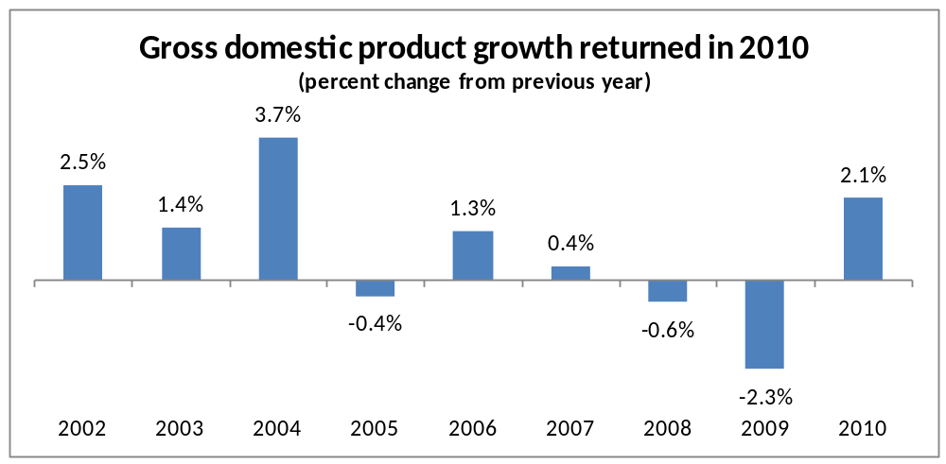
Total retail sales in Maine increased in 2010 after falling the two previous years (not adjusted for inflation). Through the first eight months of 2011, sales rose 2.8 percent (if adjusted for inflation, total retail sales were essentially even with a year ago). All major categories recorded gains in 2011 with the exception of general merchandise. Business operating sales were up 7.3 percent; auto/transportation, 4.6 percent; lodging 3.9 percent; building supply, 3.0 percent; other retail, 2.9 percent; restaurant, 1.9 percent; and food stores, 1.3 percent.
Sales growth improved as 2011 progressed. While up 2.8 percent over the year based on eight-month averages, average sales for the three months ending August 2011 were up 4.0 percent.
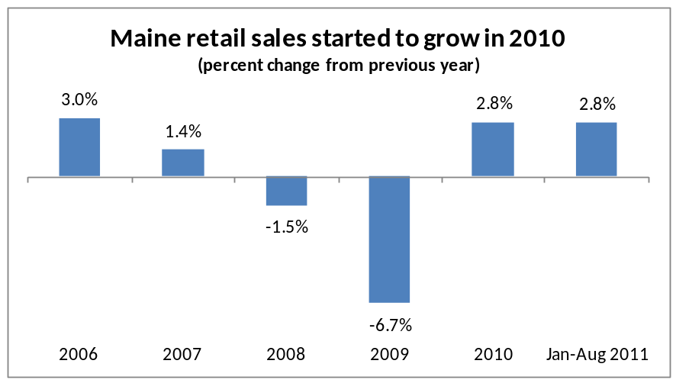
Consumer confidence is an indicator that measures the degree of optimism that consumers feel about the overall state of the economy and their personal financial situation. How confident people feel about stability of their incomes determines their spending activity and therefore serves as one of the key indicators for the overall shape of the economy. Nationally, the University of Michigan Consumer Sentiment Index increased by 6.6 percent between August and September. Although this marked the end of a precipitous decline that began in June, sentiment remained at a low level.
The latest index of Consumer Sentiment published by Marketing Decisions indicates that consumer sentiment in Maine remained at a low level in July. The index, at 62 in July 2011, has not changed substantially since April 2009 (60.4) and is well below the peak reached prior to the recession of 83.6 in October 2006. Consumers appear to be expecting a prolonged period of economic stagnation.

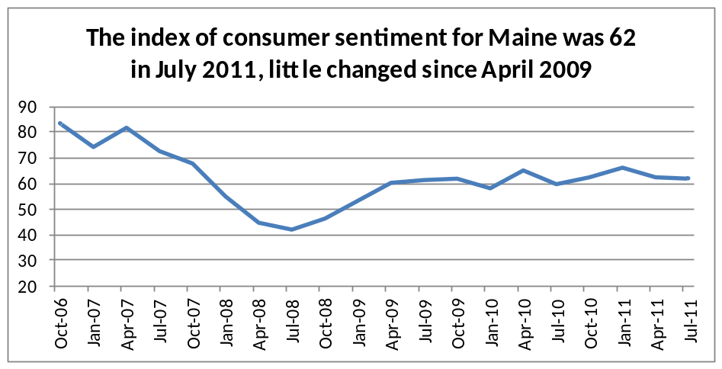
These indicators portray an economy that stopped declining and showed some signs of improvement in 2010. However, 2011 thus far is a year of uncertainty. Retail sales have remained about even with a year ago after adjustment for inflation. Consumer confidence remains weak. Job postings provided by Help Wanted Online rose from spring 2009 through June 2011, but have fallen since. Current labor market conditions reflect the anemic recovery.

Maine Labor Market
The initial impact of the Great Recession resulted in a slight decline in employment and increase in unemployment between 2007 and 2008. As the full force of the recession bore down on the labor market, the number of employed Maine residents fell substantially between 2008 and 2009, before stabilizing in 2010. Unemployment rose significantly in 2009 before falling slightly in 2010. As a net result of these changes, employment fell 24,327 and unemployment rose 22,373 between 2007 and 2010– the difference resulting from 1,955 leaving the labor force.
With little change in labor force participation in 2011, a slight increase in employment resulted in a corresponding decline in unemployment
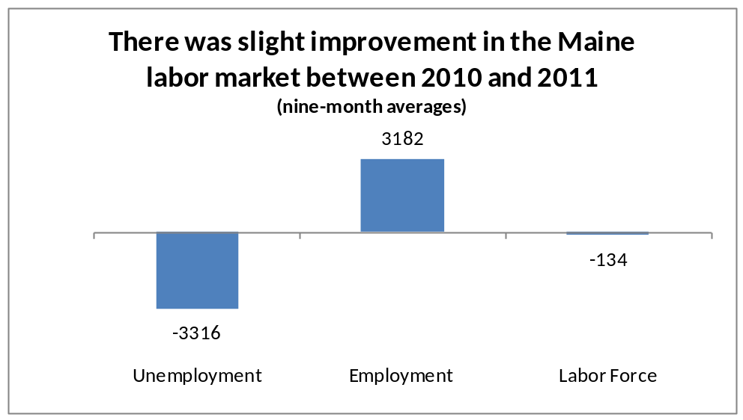

Unemployment and the Civilian Labor Force
As job losses mounted, the unemployment rate rose, before edging down slightly in 2010. Through the first nine months of 2011, Maine’s unemployment rate averaged 7.7 percent, down from 8.1 percent for the corresponding period in 2010. The unemployment rate fell below the national rate after 2007 due in part to a decline in the number of labor force participants in Maine (individuals do not work or actively seek work and thus are not counted as in the labor force) and a lower rate of job loss.
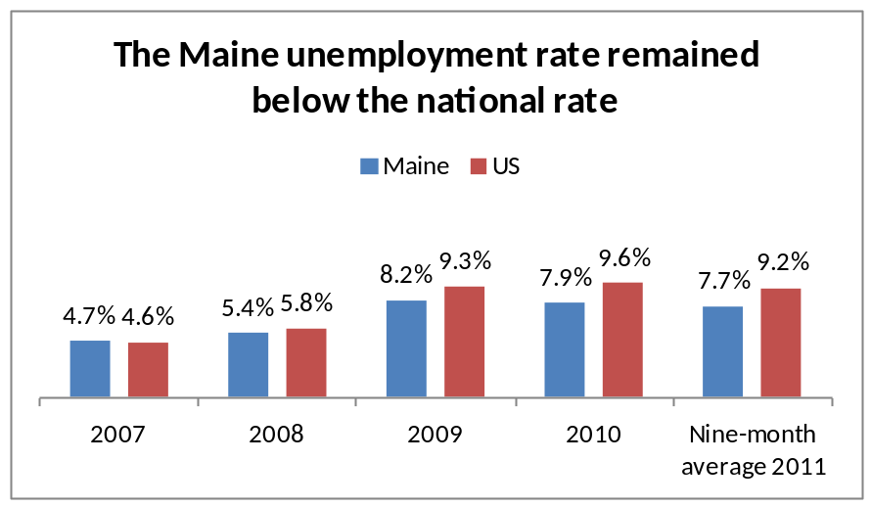

Measures of Economic Hardship
While the unemployment rate remains the primary measure of changes in labor underutilization, alternative measures indicate the depth of economic hardship in the state. These measures rose between 2007 and 2009, and continued to rise in 2010 as labor market conditions remained poor.
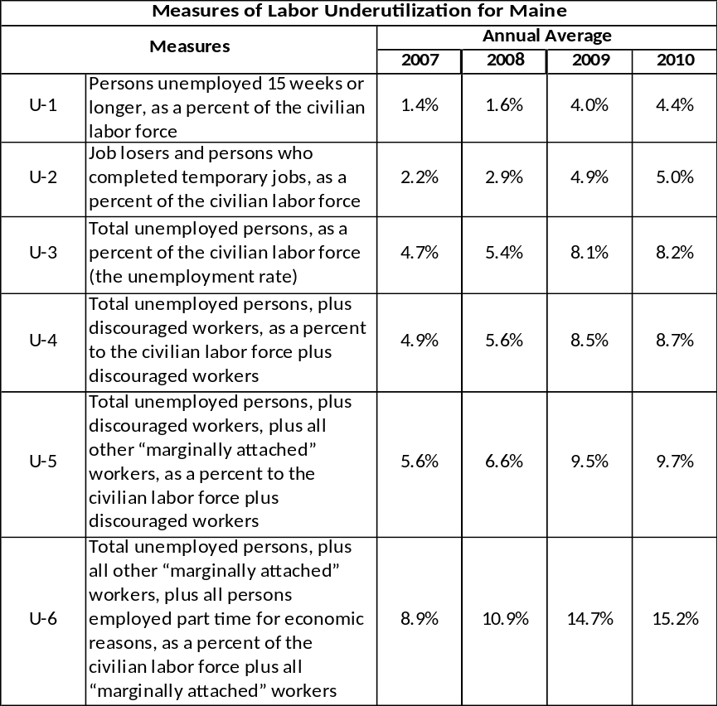
Most of the six measures of labor underutilization were little changed in 2011. The rate of job losers (U-2) fell from 5.1 to 4.7 percent as the number of layoffs slowed. However, other measures remained nearly unchanged as the lack of a substantial increase in job opportunities discouraged entry to the labor force and resulted in many workers taking part-time work when they wanted full-time jobs.
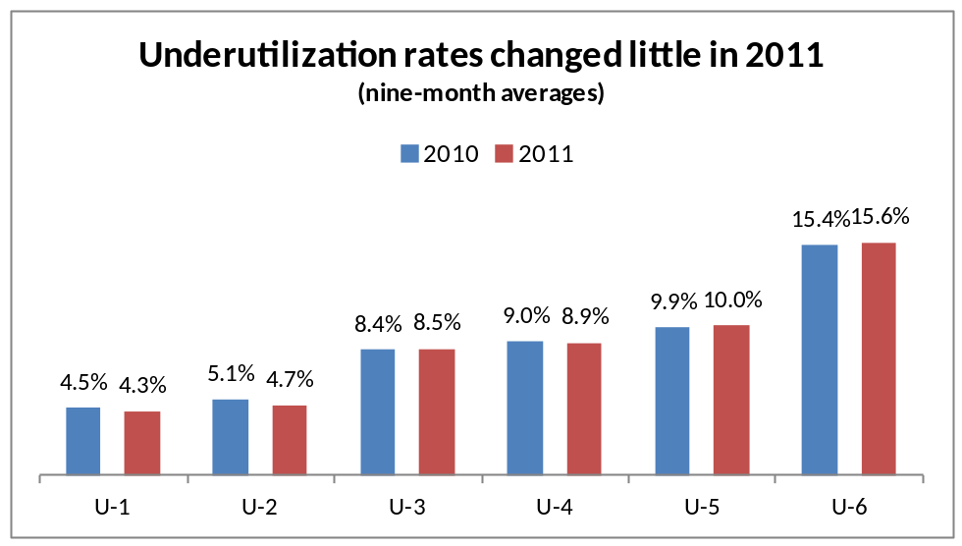

Long-Term Unemployment
The number of long-term unemployed rose steeply between 2008 and 2010. Nationally, poor economic conditions led to a record-high proportion of long-term joblessness (defined as unemployed for 27 weeks or more). Over 43 percent of the unemployed in 2010 were long-term unemployed – the highest proportion on record, with national data back to 1948. While this historical data is lacking for Maine, recent data shows a substantial increase in the number of long-term unemployed between 2008 and 2010. The percentage of long-term unemployed (27 weeks or more) edged down from an average of 37.0 percent for the first nine months of 2010 to 35.4 percent for 2011.
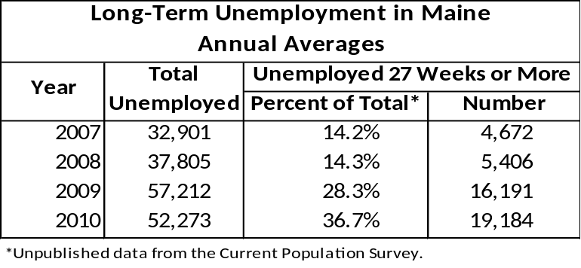

Civilian Labor Force
The percentage of the population active in the civilian labor force (employed and unemployed) ranged between 66 and 67 percent between 2002 and 2008, and then fell in 2009 and 2010. The decline was likely due to 1) unemployed ceasing to look for work (discouraged workers) and 2) individuals deferring entry to a poor labor market to go to school or follow some other pursuit, and 3) other factors such as the rising age of the population. Through the first nine months of 2011, an average of 64.9 percent of the eligible population was in the labor force, little changed from the rate of 64.5 percent recorded a year ago.
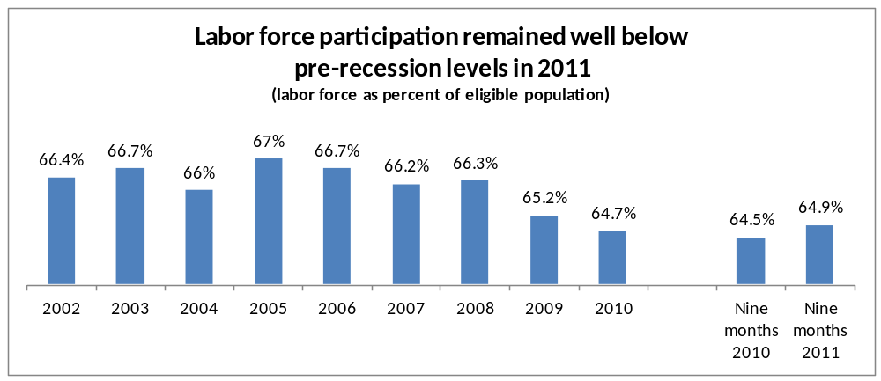

Nonfarm Wage and Salary Employment
Nonfarm wage and salary jobs fell 3.4 percent between 2008 and 2009, followed by a slight drop of 0.6 percent between 2009 and 2010. Resulting from these job losses, annual average nonfarm wage and salary employment was at its lowest level since 1999.
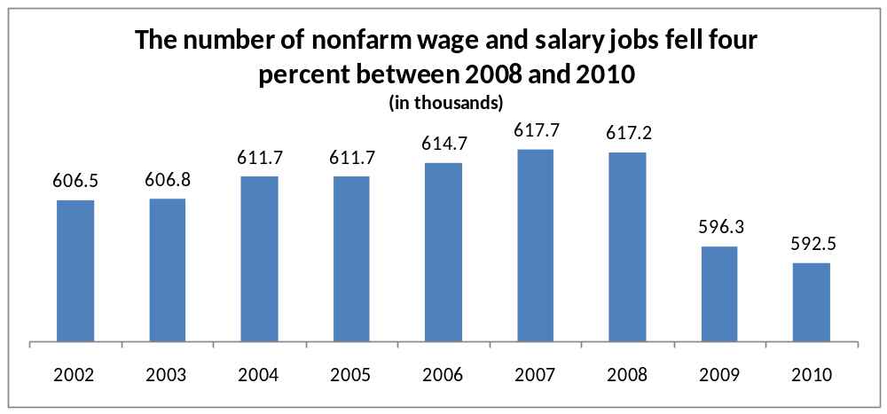
Job losses were widespread. Manufacturing, construction, and retail trade registered the most substantial losses. Private educational services, and health care and social assistance, were the only industry sectors to record job gains.
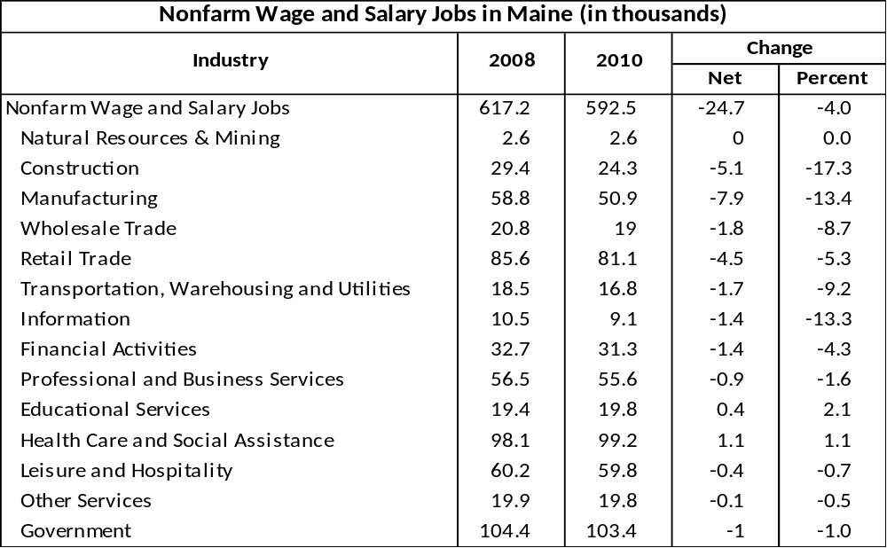
Nonfarm wage and salary jobs increased 4,700 between the first nine months of 2010 and 2011. Revisions to the preliminary data will likely show over-the-year job gains that were not as robust as preliminary estimates indicated. Preliminary estimates indicate the most substantial gains were recorded by leisure and hospitality, health care and social assistance, and private educational services. Partially offsetting private sector gains were losses in all three branches of government.
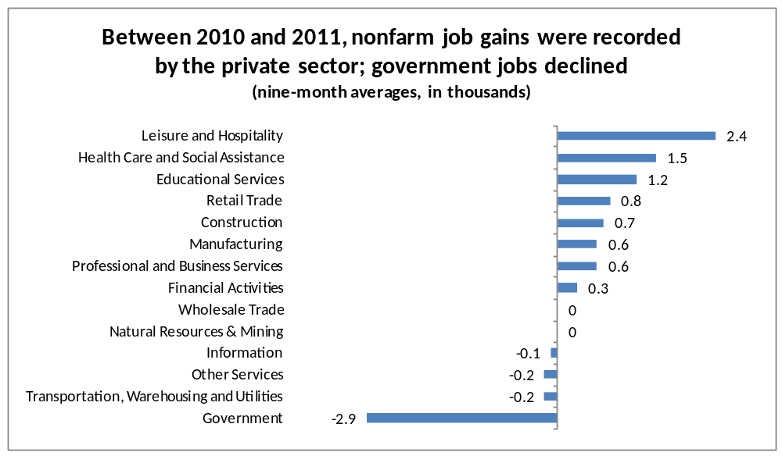

Rising Need for Educated Workers
Even as jobs rose and fell over the years, the educational requirements of employers continued to rise. The share of workers within each industry sector with a bachelor’s degree or higher increased while the share with a high school education or less fell between 1990 and 2009. Employment of workers with some college or associate’s degree as a share of total employment rose over the past nineteen years in most sectors.
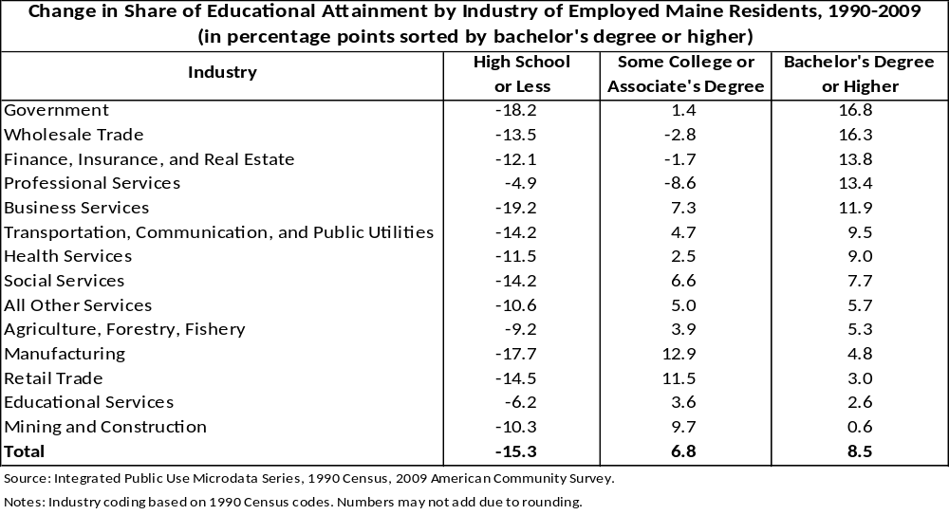

Where the Jobs Are
Jobs have become more centralized in Maine. Between 2002 and 2007, the number of nonfarm wage and salary jobs rose 13,100 in the three metropolitan areas. Jobs in the nonmetropolitan areas fell 1,900. The number of jobs in manufacturing continued to decline, with many of those losses occurring in rural Maine. At the same time, jobs increased in most of the other industry sectors, with the lion’s share of the job gains in many of the service industries going to the metropolitan areas.
With the onset of the recession, job losses were more widespread as manufacturing firms cut back or closed, construction activity slowed, and the number of service-related jobs (with the exception of health care) fell. As a result, job losses in the metropolitan and nonmetropolitan areas did not differ radically between 2007 and 2010, with metropolitan areas losing 11,800 jobs while nonmetropolitan area jobs dropped 13,400.
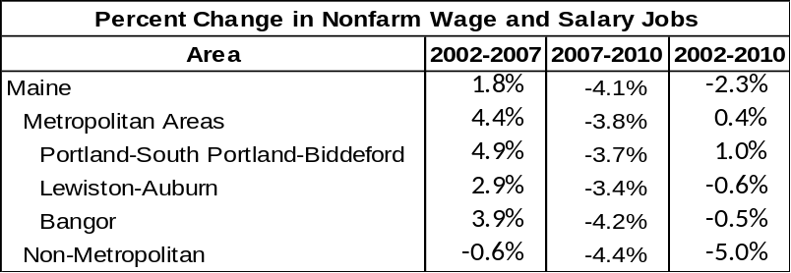

Reemployment Issues
Current forecasts call for jobs to increase, but not fast enough in the near-term to significantly reduce unemployment. Furthermore, there are mismatches between the skills of many people who are out of work and the skills needed by employers. A high share of job openings are in occupations requiring post-secondary education. A high share of job seekers do not have the education or work experience necessary for entry into those fields of work. For example, many workers separated from construction and production occupations while job openings offering good wages are concentrated in healthcare and information technology.
Some industries/occupations that have been reducing employment for many years have job openings that require specialized skills. Between 1990 and 2009, the number of production workers fell 44 percent. This decline was tied to significant job loss in the manufacturing sector. At the same time, educational attainment of production workers rose, with the share of workers with some college or an associate’s degree and a bachelor’s degree rising by 21 percentage points and 4 percentage points, respectively. While there are fewer production workers now, the need for more highly educated production workers has grown. According to many employers, growth in the workforce will be accomplished, in large part, by workers with some kind of post-secondary training.
There is also a geographic mismatch as industries that are growing or primed to hire workers tend to be concentrated in service-center communities. A high share of job displacement has been in outlying areas, often beyond commuting distance to service centers. Between 2002 and 2010, nonfarm jobs in Maine metropolitan areas increased 1,300 while nonmetropolitan areas lost 15,300 jobs.
Even as the number of job postings in Maine as measured by the Conference Board (Help Wanted Online) rose from the low point reached in spring 2009, unemployment remained at high levels, likely due in part to these mismatches.
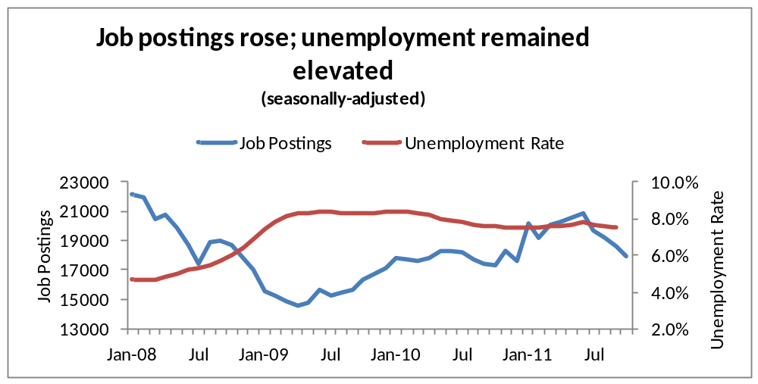

Employment Projections

Short-Term
The September 2011 national forecast by Economy.com projected GDP will grow by 1.6 percent in 2011; improving to 2.7 percent in 2012. Some job growth is expected in 2011 (0.9 percent increase from 2010), with little change in 2012 (0.7 percent increase). These anemic job gains will not be substantial enough to lower unemployment.
The latest forecast (November 2011) from the Maine Consensus Economic Forecasting Committee indicated that statewide nonfarm wage and salary employment would record little change in 2011 and 2012.

2008-2018
With the uncertainty surrounding the strength of the economic recovery and the rapid changes taking place in the workplace, projections of future job change must be viewed with caution. Whenever technological innovation, new market developments, and public policy initiatives combine and transform the employment landscape, formidable challenges confront those charged with producing official employment estimates and projections. The traditional industrial and occupational employment projections are developed to provide the basis for educational and training programs that prepare students to meet demands of the future job market and guide jobseekers making a career choice. However these projections must be viewed as a base from which to operate, and should be analyzed and amended with current information. For example, the healthcare sector is expected to be the source of many new jobs between 2008 and 2018. However, the effect of recently enacted healthcare reforms and changes in funding for Medicare and Medicaid may have an impact on healthcare jobs not accounted for by the projections. Employment projections for 2008 to 2018 are presented below with these caveats in mind.

Employment by Industry
The outlook for the 2008 to 2018 period is for a continuation of trends that have been on-going for some time. Employment is expected to record a net increase of about 14,400, or 2.1 percent, with wage and salary job growth almost exclusively among service-providing industries. Education and health services is expected to account for more than two-thirds of the net increase in wage and salary jobs. The manufacturing sector is expected to continue to lose jobs.
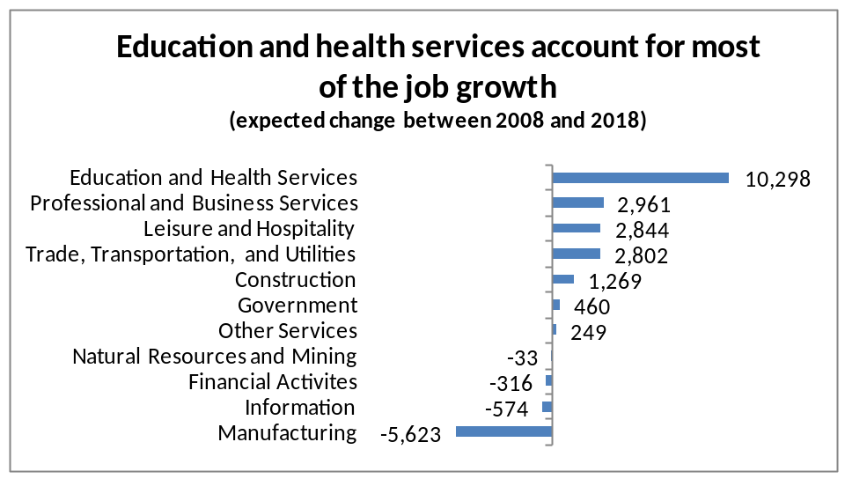
Employment by Occupation
The occupational structure of employment will shift along with changes in the industrial structure and technology. Healthcare practitioners and technicians; healthcare support; business and financial operations; computers and mathematics; life, physical, and social science; protective service; and personal services jobs are expected to grow at more than twice the rate for all occupations. These occupations will account for more than half of the net gain in jobs between 2008 and 2018. Production; farming, fishing and forestry; transportation and material moving; and building and grounds cleaning and maintenance jobs are expected to decline as a result of a combination of trends, including continued manufacturing job losses, and challenges in agriculture, forest products, and fishing industries. Some of the expected job losses will be due to mechanization and other productivity improvements that allow for less labor per unit of output.
Twenty-one of the forty fastest growing individual occupations between 2008 and 2018 are health related. This growth in health-related occupations is largely due to an increased use of specialized services and growth in the number of middle age and elderly people.
When considering the future demand for occupations, projected net growth is as important as the growth rate. Occupations with lower growth rates but high employment levels may account for a substantial number of jobs. The list of the top forty occupations expected to add the most jobs is more diverse that the list of the fastest growing, reflecting the broad base of the Maine economy. Among the top ten occupations are customer services representatives, retail salespersons, and accountants – occupations that are not among the fastest growing but with a large employment base.
Job openings arise from two sources: growth and replacement. Between 2008 and 2018, an average of 18,000 job openings is expected each year; about 2,800 due to growth and 15,200 due to replacement needs. Replacement needs arise as workers leave occupations. Some transfer to other occupations, while others retire, return to school, or quit to assume household responsibilities. In general, occupations with high employment levels also have a large number of openings due to replacement demand. As a result, cashiers, waiters and waitresses, retail sales persons, who are not among the fastest growing occupations, are the three occupations with the largest number of job openings between 2008 and 2018. Registered nurses, which provides the fourth largest number of job openings, is among the fastest growing occupations, has a large employment base, and is expected to provide the highest level of net growth.
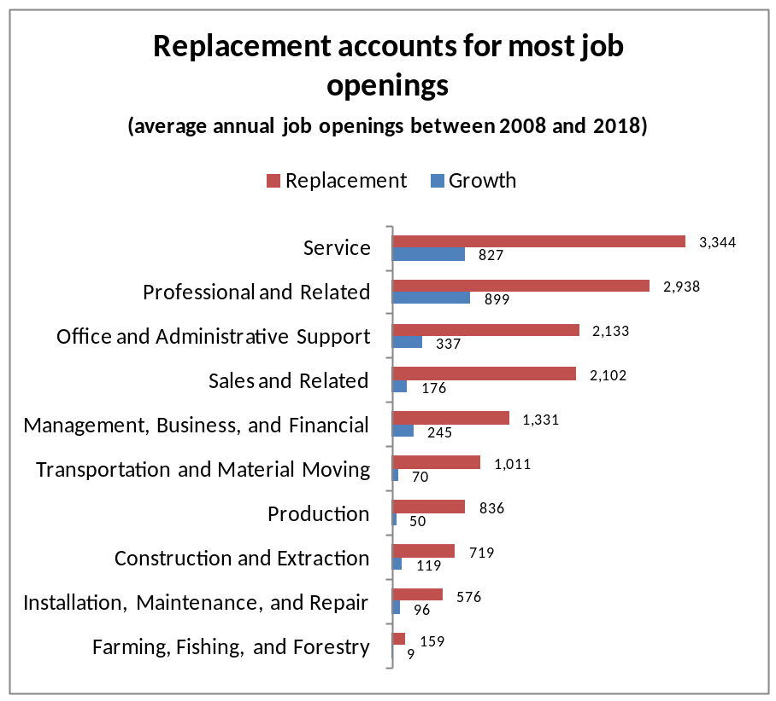

Summary
The recovery from the Great Recession has yet to make a significant impact on labor markets. The Maine labor market stabilized in 2010, with slight job gains recorded thus far in 2011. Current forecasts do not call for jobs to increase fast enough in the near term to substantially reduce unemployment.
Reemployment faces some challenges, in addition to forecasted slow net job growth. Currently, there are mismatches between the skills of people who are out of work and the skills needed by employers. There is also a geographic mismatch as the growing services sector centralizes in urban areas while rural areas experience a continued erosion of jobs. Even as the number of job postings increased this year, unemployment remained elevated, likely due in part to these mismatches.
Employment opportunities in the years ahead will occur increasingly in services occupations, with many of them requiring high levels of skills and education. Even firms within industry sectors that have lost jobs for many years are expected to require their workers to have more education and skills.
Although there is a labor surplus now, shortages are expected in the future as the population grows slowly and older. This makes training the labor force in place, as well as individuals preparing to enter the labor force, to meet the current and future needs of Maine employers vitally important.

