Board of Trustees
MAINE CRIMINAL JUSTICE ACADEMY

FIREARMS INSTRUCTOR CERTIFICATION

Specification S-7
Purpose
To establish certification requirements and procedures for firearms instructors to assure proper qualifications, training, education, experience, and effectiveness.
Requirements
- The applicant must meet the following criteria:
  - Be employed as a full-time or part-time law enforcement officer or corrections officer in the State of Maine, OR
  - Be a retired full-time law enforcement officer or corrections officer from an agency in the State of Maine.
  - Be designated by the employing agency as a firearms instructor for the agency, unless retired in accordance with Requirements, section A.2 above.
4. Have a minimum of three (3) years of full-time experience as a law enforcement officer or corrections officer. This requirement may be waived upon presentation to the Director of evidence that the applicant has extensive experience as a firearms instructor.
5. Be a certified MCJA Instructor or the equivalent determined by a MCJA staff review.
6. Successfully complete the Firearms Instructor Development Program, as approved by the Board or a comparable course as determined by staff review.
7. Submit a lesson plan and be monitored instructing an Academy approved unit of instruction in the Board approved firearms program. The Academy staff will evaluate as to form, content, and competency and will make a recommendation (on an approved form) as to whether the applicant demonstrates proficiency worthy of certification as Firearms Instructor.

Procedures
A. The candidate must apply to the Academy on approved forms submitted with required material.
B. The application and material will be reviewed by the Academy staff for recommendation to the Board. The applicant may appeal the Academy staff’s findings to the Academy Director.

C. A certified firearms instructor who maintains employment in the State of Maine as a full-time or part-time law enforcement officer or a full-time corrections officer, OR a retired full-time law enforcement or correctional officer (in accordance with Requirements 1.b, above), may apply for renewal of certification every three (3) years upon submission of the following:
1. Documentation of assisting a lead firearms instructor for a minimum of 40 hours during firearms training for the Basic Law Enforcement Training Program or other Academy approved firearms training, or;
2. Documentation of having instructed for a minimum of 40 hours of Academy approved firearms training within the three (3) year period of the certification. These 40 hours must include instruction on the following:
a. Low light drills.
b. Multiple target drills.
c. Re-loading drills.
d. Use of cover.
e. Use of force decision making.
f. Scenario based training

D. A certified firearms instructor who fails to meet recertification standards shall be placed in a suspended or inactive status by the Academy Director.
E. A formerly certified firearms instructor who is inactive for three (3) to five (5) consecutive years who wishes to be re-instated as active must demonstrate proficiency by submitting two (2) qualifying 50-round courses of fire with a score of 90% administered and scored by a certified MCJA Firearms Instructor. In addition, this individual must attend a 40-hour BLETP range to be observed instructing by a MCJA Lead Firearms Instructor. If the MCJA Lead Firearms Instructor is satisfied with the performance of the inactive instructor, a letter will be forwarded to the MCJA Training Coordinator who oversees the firearms program recommending the change in status from inactive to active for the firearms instructor in question.
F. A formerly certified firearms instructor who is inactive for more than five (5) consecutive years must repeat the 80-hour Firearms Instructor class to regain active firearms instructor status. This requirement may be waived by the Academy Director upon submission of documentation of the applicant’s relevant participation in sufficient firearms instruction in the intervening time and upon successful completion of the criteria enumerated in Procedures, section E above.
Adopted: 05/02/2008
Revised: 09/13/2019
Review Date: 09/13/2022

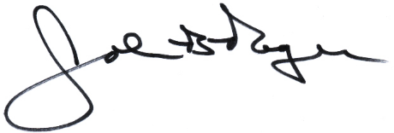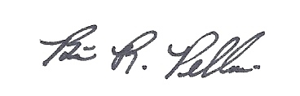
____________________________ __________________________
John B. Rogers, Director Brian R. Pellerin, Chair
Maine Criminal Justice Academy MCJA Board of Trustees

