Board of Trustees

MAINE CRIMINAL JUSTICE ACADEMY

INSTRUCTOR CERTIFICATION

Specification S-6

The following requirements are intended to assure the Board that instructors who are certified meet minimum qualifications as to training, education, experience, and effectiveness.

Requirements:

A. An applicant must successfully complete the MCJA Methods of Instruction course of 80 hours as approved by the Board of Trustees, or a comparable course of instruction as determined by staff review.

B. The applicant will submit a lesson plan and be monitored instructing, over an Academy approved unit of instruction by the Academy staff. The Academy staff will evaluate the lesson plan and the instructors’ delivery as to form, content, facilitation skills, adult learning styles addressed, and competency.

C. The applicant should show a background of training and experience as one of the following:
1. A bachelor’s degree or advanced degree and 2000 hours of criminal justice agency employment.
2. An associate degree and 4000 hours of criminal justice agency employment.
3. A criminal justice basic training course and 2000 hours of post criminal justice basic training employment.
4. Continual training in criminal justice and six years’ criminal justice experience.

D. The applicant must have an interest and desire to instruct in Academy programs and must provide a letter of support from the head of the agency to be considered for admission.

- The applicant shall be recommended to the Assistant Director by the Academy staff.

F. Instructor certificates shall be issued for a period of three years and renewal will occur upon submission of material as prescribed.

Procedures:

A. The applicant will apply on approved forms submitted with required material to the Academy.

- The application and material are to be reviewed by the Academy staff for recommendation to the Assistant Director. The applicant may appeal the Academy staff’s findings to the Academy Director.

- Once the Methods of Instruction Course has been completed and the applicant has met all the standards, Academy staff will present an approved list to the Board, so the names can be presented by the Academy Director for certification approval.

- Renewal of certificates shall occur on submission of material and proof of having instructed in at least two Academy approved courses within the three (3) years.

- Certified instructors who fail to meet certification or recertification standards may be brought before the Board for review.

- Any Certified Instructor who violates the standards outlined in the MCJA Instructor Manual may be subject to suspension of his or her Instructor Certification by the Academy Director. Such suspension may be reviewed by the Board providing the review is requested by the Instructor and the Instructor’s agency head.

- Any student who took the Method of Instruction (MOI) Course before January 1, 2005 and has not followed through to achieve certification will be required to attend an alternative program designed by the staff and approved by the Board to gain their Instructor Certification.

Adopted: 05/01/2009
Amended: 09/13/2019
Review Date: 09/22/2022

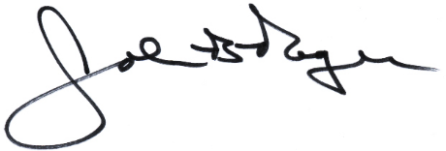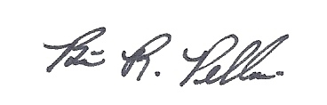
____________________________ __________________________
John B. Rogers, Director Brian R. Pellerin, Chair
Maine Criminal Justice Academy MCJA Board of Trustees

