Ages: 1-2 3-5 6-12

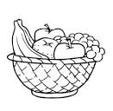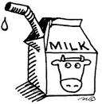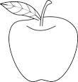

Food Chart

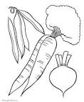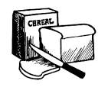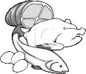

Child and Adult Care Food Program

Breakfast

1 Fluid Milk 1/2 cup 3/4 cup 1 cup

1 Vegetable/Fruit 1/4 cup 1/2 cup 1/2 cup

1 Grain/Bread: *Oz. Eq. = product weight in grams (g)* **1/2 Oz. Eq.** **1/2 Oz. Eq.**  **1 Oz. Eq.**

* Bread 14 g 14 g 28 g
* Biscuit/Roll/Muffin/Cornbread 14g/14g/28g/17g 14g/14g/28g/17g 28g/28g/55g/34g
* Cold Dry Cereal (flakes or rounds) 14 g = ½ cup 14 g = ½ cup 28 g = 1 cup
* Hot Cooked Cereal 1/4 cup cooked or 1/4 cup cooked or 1/2 cup cooked or

14 g dry 14 g dry 28 g dry

Snack (Select at least **two different components** from the following five)

1 Fluid Milk 1/2 cup 1/2 cup 1 cup

1 Fruit 1/2 cup 1/2 cup 3/4 cup

1 Vegetable 1/2 cup 1/2 cup 3/4 cup

1 Grain/Bread 1/2 Oz. Eq. 1/2 Oz. Eq. 1 Oz. Eq.

1 Meat/Meat Alternate

* Cheese 1/2 oz. 1/2 oz. 1 oz.
* Large Egg 1/2 egg 1/2 egg 1/2 egg
* Peanut Butter or Nut/Seed Butters 1 Tbsp. 1 Tbsp. 2 Tbsp.
* Yogurt 1/4 cup 1/4 cup 1/2 cup

Lunch/Supper

1 Fluid Milk 1/2 cup 3/4 cup 1 cup

1 Fruit (or no fruit & 2 vegs.) 1/8 cup 1/4 cup 1/4 cup

1 Vegetable 1/8 cup 1/4 cup 1/2 cup

1 Grain/Bread: *Oz. Eq. = product weight in grams (g)* **1/2 Oz. Eq.** **1/2 Oz. Eq.**  **1 Oz. Eq.**

* Bread 14 g 14 g 28 g
* Biscuit/Roll/Muffin/Cornbread 14g/14g/28g/17g 14g/14g/28g/17g 28g/28g/55g/34g
* Pasta or Rice 1/4 cup cooked or 1/4 cup cooked or 1/2 cup cooked or

14 g dry 14 g dry 28 g dry

1 Meat/Meat Alternate

* Meat/Poultry/Fish 1 oz. 1 ½ oz. 2 oz.
* Cheese 1 oz. 1 ½ oz. 2 oz.
* Large Egg 1/2 egg 3/4 egg 1 egg
* Cooked Dry Beans or Peas 1/4 cup 3/8 cup 1/2 cup
* Peanut Butter or Nut/Seed Butters 2 Tbsp. 3 Tbsp. 4 Tbsp.
* Tofu 1 oz. 1 1/2 oz. 2 oz.
* Yogurt 1/2 cup 3/4 cup 1 cup
* Alternate Protein Product 1 oz. 1 ½ oz. 2 oz.

This institution is an equal opportunity provider.

Child and Adult Care Food Program