Adults

Breakfast

1 Fluid Milk 1 cup

1 Vegetable/Fruit 1/2 cup

2 Grain/Bread *Oz. Eq. = product weight in grams (g)* **2 Oz. Eq.**

* Bread 56 g
* Biscuit/Roll/Muffin/Cornbread 56 g/56 g/110 g/68 g
* Cold Dry Cereal (flakes or rounds) 56 g = 2 cups
* Hot Cooked Cereal 1 cup cooked or 56g dry

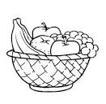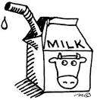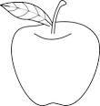

Food Chart

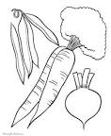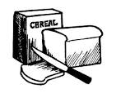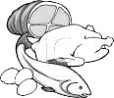

Child and Adult Care Food Program

This institution is an equal opportunity provider.

Child and Adult Care Food Program

Snack (Select at least **two different components** from the following five)

1 Fluid Milk 1 cup

1 Fruit 1/2 cup

1 Vegetable 1/2 cup

1 Grain/Bread *(1/2 the weight required for meals)* **1 Oz. Eq.**

1 Meat/Meat Alternate

* Cheese 1 oz.
* Large Egg 1/2 egg
* Peanut Butter or Nut/Seed Butters 2 Tbsp.
* Yogurt 1/2 cup

Lunch/Supper

1 Fluid Milk (not required at Supper) 1 cup

1 Fruit (or no fruit and 2 vegetables) 1/2 cup

1 Vegetable 1/2 cup

2 Grain/Bread *Oz. Eq. = product weight in grams (g)* **2 Oz. Eq.**

* Bread 56 g
* Biscuit/Roll/Muffin/Cornbread 56/56/110/68 g
* Pasta or Rice 1 cup cooked or 56 g dry

1 Meat/Meat Alternate

* Meat/Poultry/Fish 2 oz.
* Cheese 2 oz.
* Large Egg 1 egg
* Cooked Dry Beans or Peas 1/2 cup
* Peanut Butter or Nut/Seed Butters 4 Tbsp.
* Tofu 2 oz.
* Yogurt 1 cup