NEO Daily Attendance Student Lookup Instructions
In order to access the Attendance Reports, you will need an active NEO login with Student Data access for your school district.
If you do not yet have a NEO account or Student Data access, you must contact your Superintendent/Director to submit an access request form on your behalf.
Note: If your SAU does not operate any schools, you will not have any reports to view.

- Login to NEO

- Choose ‘Student Data’ module from up top:
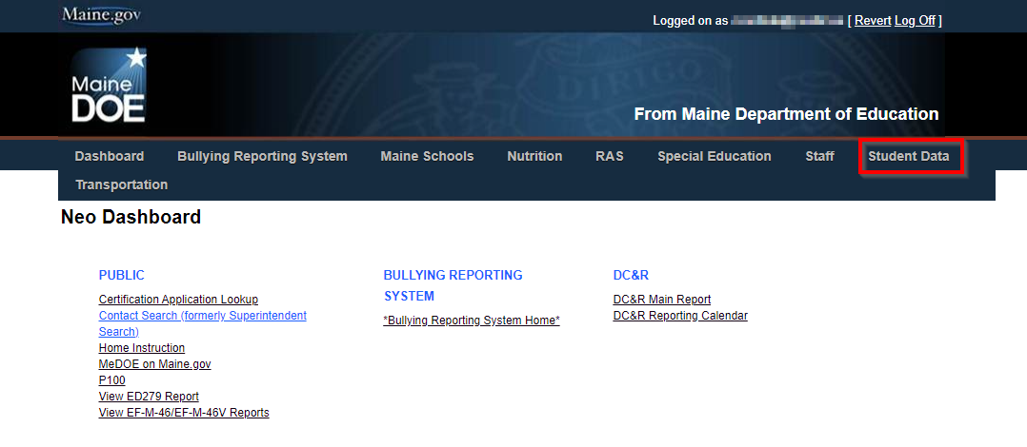
- Choose ‘Student Reports’: 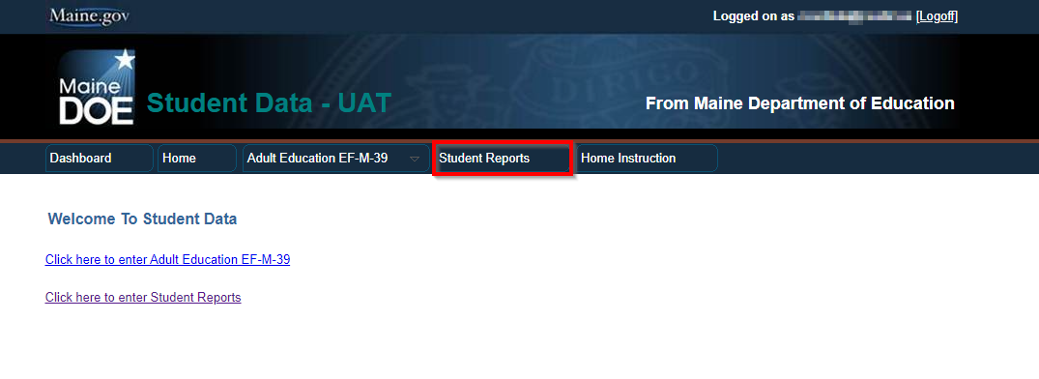

- Scroll down in the report listing to locate the Daily Attendance Student Lookup, and click ‘View Report’ on the right side:
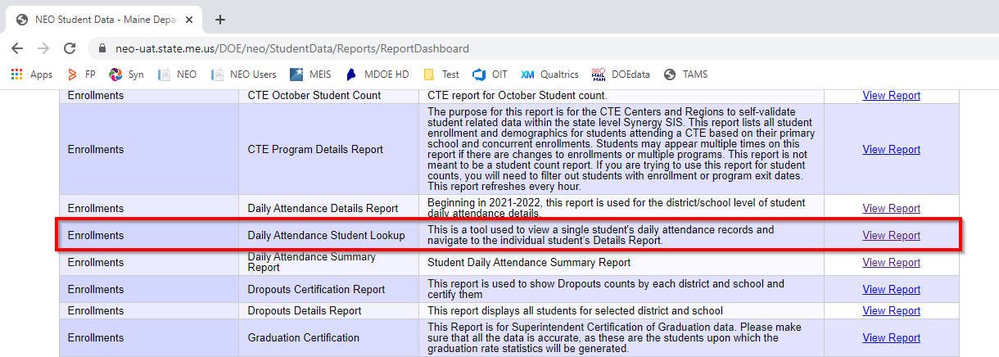

- The lookup tool opens in a new tab. It defaults to search all schools for the SAU in the current year:
(See below)
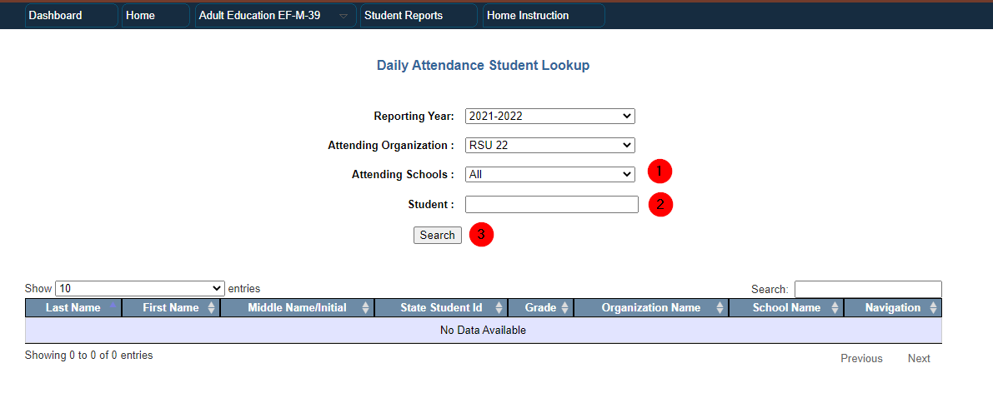
1 – Attending Schools filter allows you to view only a single school’s data.
2 – Allows you to search for the student by First Name, Last Name, or State ID.
3 – Once you have entered your search criteria, click the ‘Search’ button.

- The results will be displayed in the grid:
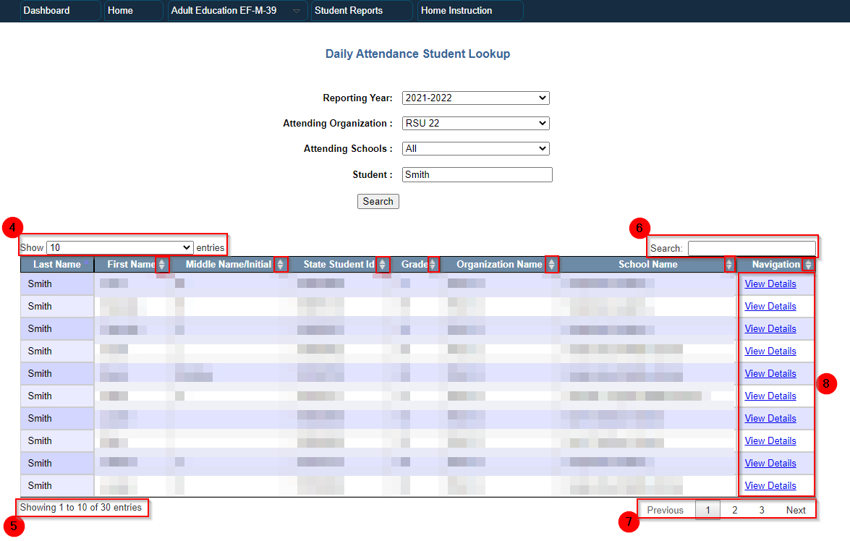
4 – Allows you to list 10-100 results per page.
5 – Displays which records are shown and the total number of results.
6 – Search box allows for further searching of the results.
7 – Navigation buttons allow you to flip through the page of results.
8 – ‘View Details’ links will load an individual Attendance Details Report for the student, showing all attendance records for the student.

FAQs:
- This data is loaded directly from Synergy each hour. Check the student’s attendance records in Synergy if they are not found by the lookup tool. If Synergy is correct and the report is recently updated, contact the Helpdesk.
- Students must have attendance records in Synergy to appear on this lookup tool.
- You can only search for students enrolled in schools at your district.

If you have any questions, comments, or concerns regarding this document please do not hesitate to contact the Maine Education Data Management Systems Helpdesk directly.

Contact Us
(207)-624-6896
Medms.helpdesk@maine.gov
Hours: Mon-Fri – 8:00 am to 4:00 pm

