Teacher Performance Evaluation and Professional Growth (T-PEPG) Model
Facilitator Guide for Training Module 3:
Reflection and Goal Setting

Teacher Performance Evaluation and Professional Growth (T-PEPG) Model
Facilitator Guide for Training Module 3: Reflection and Goal Setting
November 2014

Contents
Page
T-PEPG Modules: Purpose and Goals 1
Audience 1
Timing and Structure 1
List of Training Modules 2
Preparing for Module 3 4
Module Overview 4
Intended Outcomes 4
Agenda 5
Equipment and Materials 6
Maine DOE Model Resources 6
Facilitator Guide 7
I. Welcome (5 minutes) 7
II. Connecting: Supporting Your SLO (20 minutes) 8
III. Learning (45 minutes) 10
IV. Implementing (40 minutes) 21
V. Reflecting and Wrap-Up (10 minutes) 23

T-PEPG Modules: Purpose and Goals
This series of five T-PEPG modules is designed to provide teachers with information and guidance on the Maine Department of Education (Maine DOE) Teacher Performance Evaluation and Professional Growth (T-PEPG) model, which is being implemented in their schools. T-PEPG Leads and the administration (if necessary) will train the Professional Cohort facilitators, who will then train teacher participants using the module materials. The module materials are intended to:
- Make the four-step T-PEPG process meaningful, doable, concrete, and actionable for teachers
- Support teachers in developing a common understanding of the evaluation model, the MSFE Rubric, and the opportunities for professional growth and development grounded in the five National Board Core Propositions
- Provide participants with tips, strategies, and opportunities to share best practices aligned with the T-PEPG model
The T-PEPG modules provide facilitators with consistent, standardized materials and content, detailed facilitator guides, and participant handouts that align with the T-PEPG model. Facilitators may use some or all of these materials and may modify them as appropriate to meet teachers’ needs and accommodate the amount of available time.

Audience
The T-PEPG modules will be presented to teachers by Professional Cohort facilitators in their respective schools. Districts and schools can determine whether to bring educators together for a schoolwide or districtwide training session or provide training to smaller, grade-level or content-area teams.
The modules are designed so that Professional Cohort facilitators can facilitate abbreviated, chunked, or complete versions of each module to teachers, as necessary (see the section on timing and structure for more details).

Timing and Structure
Each training module varies in length (from two to three hours) and includes interactive learning activities, which were designed within a framework of adult learning theory and best practice. Suggested assignments described at the conclusion of each module are intended to help participants extend and apply their learning and are designed to be integrated into the work teachers are already doing. Each module allocates time for participants to share what they have learned as a result of completing the assignment and collaborate on the appropriate next steps.
The modules are organized into four parts to help facilitators and participants pace the content appropriately. The four segments of each module are as follows:
- Connecting—Builds community, prepares the team for learning, and links to prior knowledge, other modules, current work, and the MSFE Rubric; designed for all school-based educators
- Learning—Describes key concepts and highlights various implementation scenarios; supports teams in applying knowledge and sharing ideas; designed for all school-based educators
- Implementing—Supports teams in problem solving and planning next steps for schools and districts; geared toward school leadership teams
- Reflecting—Engages participants in providing feedback, reflecting on learning, and closing the session

List of Training Modules
Module 1: Model Overview. The first module provides participants with a big-picture overview of the key features of the T-PEPG model, including its purpose and goals, timelines, and annual process; the National Board of Professional Teaching Standards (NBPTS) Core Propositions; multiple measures of effectiveness; and summative scoring and professional growth plans. Participants unpack the basic structure and terminology of the MSFE Rubric and examine the rubric’s standard indicators in preparation for self-assessment, reflection, and goal setting, which is covered in Module 3.
Module 2: Student Learning Objectives. The second module engages participants in the student learning objective (SLO) development process. Knowing how to set realistic and rigorous targets is critical for supporting student learning throughout the year. SLOs are specific and driven by needs, and they include an instructional plan that enables students to meet their learning targets. SLOs also inform teachers’ professional goal setting, which is covered in Module 3.
Module 3: Reflection and Goal Setting. The third module supports participants in reflection in order to set professional goals. Participants engage in SMART goal development, a process that can help teachers achieve or maintain effective practice and ensure students meet the rigorous learning targets established through the SLO process. Professional growth is one of the multiple measures of the T-PEPG model, and SMART goals provide participants the opportunity to strategically identify specific areas of growth and focus for the school year.
Module 4: Evidence, Observation, and Feedback. The fourth module describes expectations for observations (both inside and outside classrooms), the collection and organization of observation evidence, and the sharing of timely, constructive feedback. All participants engage in peer observation, and the module provides information about how to make the process meaningful, collaborative, and constructive.
Module 5: Reflecting and Adjusting. The fifth module supports participants in the use of the MSFE Rubric, evidence, and student data to monitor progress toward their professional goals. Participants explore when and how to revisit their professional goals, check in on student progress, and collaboratively determine appropriate midcourse adjustments to their practice. The module includes an extension section that facilitators can use as needed to prepare teachers to gather evidence in preparation for the summative evaluation conference and as a tool to guide reflection and future goal setting. The section also includes an overview of the summative scoring process and professional growth planning process.

Preparing for Module 3

Module Overview
The third module supports participants in reflection in order to set professional goals. Participants engage in SMART goal development, a process that can help teachers achieve or maintain effective practice and ensure students meet the rigorous learning targets established through the SLO process. Professional growth is one of the multiple measures of the T-PEPG model, and SMART goals provide participants the opportunity to strategically identify specific areas of growth and focus for the school year.

Intended Outcomes
At the end of this session, participants will be able to:
- Complete an accurate and evidence-driven self-assessment grounded in the MSFE Rubric
- Use data and the language of the MSFE Rubric to set SMART professional goals grounded in their student learning objectives

Agenda
- Welcome (5 minutes)
- Connecting (20 minutes)
- Connecting Content: Connecting Student Learning and Professional Goals (5 minutes)
- Connecting Activity: Supporting Your SLO (10 minutes)
- Connecting Wrap-Up/Debrief (5 minutes)
- Learning (75 minutes)
- Learning Activity 1a: Sources of Evidence (15 minutes)
- Learning Content 1: Overview of Self-Evaluation and Reflection Process (10 minutes)
- Learning Activity 1b: Mr. Brown’s Self-Evaluation (20 minutes)
- Learning Content 2: SMARTer Goals (10 minutes)
- Learning Activity 2: Mr. Brown’s Professional Goals (15 minutes)
- Learning Wrap-Up/Debrief (5 minutes)
- Implementing (45 minutes)
- Implementing Activity: Practicing Self-Evaluation and Goal Setting (40 minutes)
- Implementing Wrap-Up/Debrief (5 minutes)
- Reflecting and Wrap-Up (10 minutes)
- Reflection: 3, 2, 1
- What’s Next: Module 4

Equipment and Materials
- Equipment: Laptop computer, projector
- Materials:
- Make a copy of the Participant Handout packet for each participant.
- Make a copy of the MSFE Rubric and Companion Guide for each participant.
- Put the following materials on each table:
  - Sticky notes
  - Markers
- Bring the following materials (for you to use as the facilitator):
  - Chart paper, easel, and markers

Maine DOE Model Resources
Maine DOE model resources can be found on the Maine DOE website at http://www.maine.gov/doe/effectiveness/index.html. Specific resources that are useful to review before facilitating this training include:
- Maine DOE Teacher Performance Evaluation and Professional Growth Model (T-PEPG Model) Handbook and Implementation Guide for School Administrative Units
- MSFE TEPG Rubric Companion Guide 2014–15 (which includes the MSFE Rubric in Appendix A)

Facilitator Guide

I. Welcome (5 minutes)

Slide 1 is the title slide.

Welcome participants to the training and introduce yourself as a facilitator. | Slide 1
Explain:  “This is Module 3 of a series of five modules on the Maine DOE teacher evaluation model.  In this third module, we engage in reflection in order to set professional goals. We are going to engage in SMART goal development, which is a process that can help you achieve or maintain effective practice and ensure students meet the rigorous learning targets you established through the SLO process. Professional growth is one of the multiple measures of the T-PEPG model, and SMART goals provide an opportunity to strategically identify specific areas of growth and focus for the school year.” | 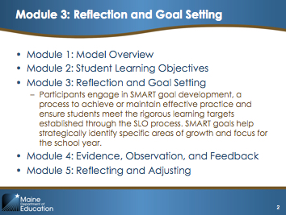Slide 2
Provide an overview of the agenda to the teachers, or give them a minute to read the agenda themselves. | 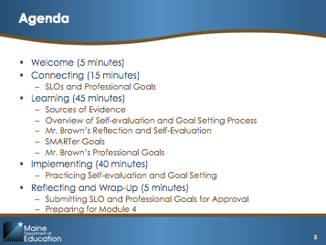Slide 3
Explain:  “By the end of today, you will be able to:  - Complete an accurate and data-driven self-assessment grounded in the MSFE Rubric  - Use data and the language of the MSFE Rubric to set SMART professional goals grounded in your student learning objectives” | 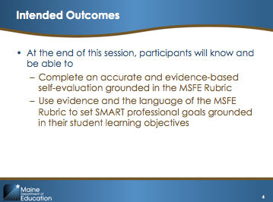Slide 4

II. Connecting: Supporting Your SLO (20 minutes)

Slide 5 is the divider slide for this section.
Explain:  “Last time, we started the process of writing student learning objectives. As you will recall, the process began with looking at your students’ data; analyzing their needs; setting growth targets; and identifying the instructional plan, formative assessments, and adjustments needed to ensure students meet the targets.  Today, we are going to focus on professional goal setting, which follows a similar process and comes after your SLO writing process. The professional goals you set should be aligned with your SLO. What does it mean to align these goals? Let’s look at the different types of goals, side by side:  - First, your professional goals should be rooted in a data-based analysis of your students’ needs, the growth targets, and the instructional plan you identified in your SLO. How do your professional goals—and the activities you undertake to achieve those goals—help you better support your students in meeting their growth targets?  - Second, your professional goals should be based on a self-evaluation of your strengths and your areas for growth. Use the MSFE Rubric and evidence about your practice to reflect on your performance relative to the performance descriptions in the rubric.  - What particular areas of practice described in the rubric are most directly related to the instructional plan, formative assessments, or instructional adjustments you identified in your SLO?  - Where specifically in those areas do you need to develop and grow so you can best support your students in meeting their growth targets?  SLOs and professional goals are parallel goals, in that they both seek to focus instruction and assessment on student growth objectives. They are not, however, the same goal. Your professional goals focus on what you do to improve your own practice, knowledge, or skills. They are separate, but aligned with, the student growth targets you establish in your SLO.” | 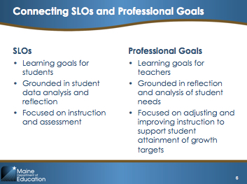Slide 6
Explain:  “Because SLOs are tightly connected with the professional goal-setting process, let’s take a few minutes before we start to discuss the connection between your SLO and your professional goals. At your tables, take out your draft SLO, find a partner, and discuss the questions on the slide:  - What skills, knowledge, or structures do you need to implement the instructional plan effectively?  - What skills, knowledge, or structures do you need to support student attainment of growth targets?  - Identify two or three ways you could develop the skills, knowledge, or structures you discuss.”  Give participants 10 minutes to share with each other.  After 10 minutes, ask for volunteers to share out their answers by asking, “Did anyone else have similar discussions?”  Explain:  “Great, thank you for sharing. This process helps us to surface shared challenges so we can learn from each other and prepare for setting our professional goals today to align with your SLOs.” | 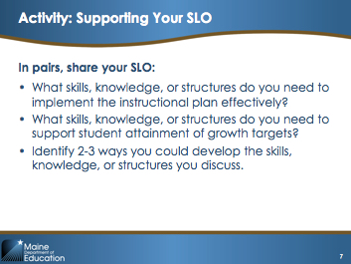Slide 7

Possible Facilitation Challenges and Solutions
Challenge | Solution(s)
Participants may not have brought their SLO or may not have completed it fully. | Suggest that participants look at Handout 4 (Mr. Brown’s SLO) for this activity instead.

III. Learning (45 minutes)
Slide 8 is the divider slide for this section.

Learning Activity 1a: Sources of Evidence (15 minutes)
The purpose of this activity is to allow participants to generate sources of evidence for several representative standard indicators. This helps prepare participants for self-evaluation and goal setting by ensuring they start with a clear understanding of what constitutes evidence within the T-PEPG model.
Activity Detail
Read through the slide and ask participants for other options. Tell participants to reference their Points of Contact Menu and see where the menu items might align with the sources on the slide.  - Classroom observations: Evidence should be quotations, numeric, objective statements, or statements of the environment. Ask participants for an example of each.  - Observations of teacher collaboration: Evidence will be similar to classroom observation evidence.  - Feedback conversations (such as a pre- or post-observation conference): Evidence from these conversations could be quotes but could also be evidence from written documents (artifacts) submitted by the teacher.  - Teacher-collected evidence: Evidence could include unit and lesson plans, assessments, rubrics, letters to parents, etc.  - Student work: This could be used to demonstrate growth over time or identify trends across students.  All of these sources of evidence can be used to support reflection during the self-evaluation process. | 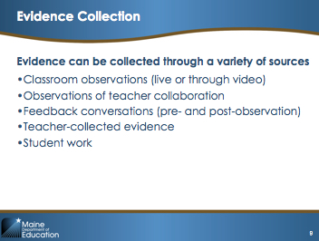Slide 9
Explain:  “Strong evidence is needed in order to have meaningful conversations about a teacher’s practice, whether evaluative or as a source of feedback for professional growth.  Evidence is also crucial as a starting point for your self-evaluation and goal setting. Before we begin discussing those activities, we are going to complete a short activity to acquaint ourselves with what evidence looks like as part of the T-PEPG evaluation system.  Strong evidence consists of factual statements rather than opinions. There are four types of evidence.  - The first type of evidence is verbatim (that is, an exact recording of what is said or done), such as ‘Teacher said “Please get out your notebooks.”’  - The second type of evidence is numeric—statements that quantify something that was seen, such as ‘5 out of 10 student work assignments involved student choice.’  - The third type of evidence is factual summaries, which are descriptions of exactly what happens in the classroom. If the verbatim example above were written as a factual summary, it might read: ‘The teacher asked the students to get out their notebooks.’  - The final type of evidence is observed aspects of the classroom, for example: ‘Rules were posted by the door of the classroom’ or ‘Slide presentation was made available on handouts.’” | 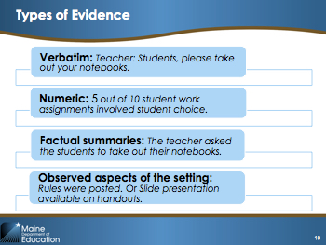Slide 10
In order to prepare for this activity, create pieces of sticky chart paper with the text from the following standard indicators written on them:  1.1 Understanding of Students (Classroom Observation and Teacher-Collected Evidence)  2.1 Subject Knowledge (Classroom Observation and Observation of Collaboration)  2.2 Pedagogical Content Knowledge (Classroom Observation and Feedback Conversation)  3.3 Assessment of Student Progress (Student Work and Teacher-Collected Evidence)  4.2 Continuous Professional Growth (Teacher Artifact and Student Work)  5.1 Professional Collaboration (Observation of Collaboration and Feedback Conversations)  On each piece of chart paper, divide the chart into two columns and place one possible source of evidence at the top of each column. Each group will write evidence statements that might come from the sources listed on the chart.  Ask participants to count off from one to six. Tell participants to go to the chart paper that begins with their number. Ask them to take the Points of Contacts Menu with them for reference.  Explain:  “At each chart, spend one or two minutes with your group generating evidence statements (that is, statements that reflect what can be seen or heard in an observation or recorded from other data sources).  For example, standard indicator 2.2 (Pedagogical Content Knowledge) states that ‘the teacher creates learning experiences that make the discipline accessible and meaningful for learners to ensure mastery of the content.’  One example of a statement of evidence that could be observed would be that the teacher used whole-group lecture, small-group work, and individual work during the observation.”  Direct participants to move to the next piece of chart paper after three minutes. | 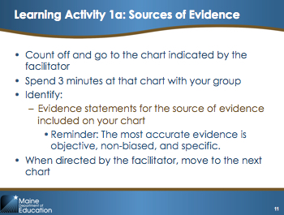Slide 11
Wrap-Up/Debrief (3 minutes)  After each group has visited each chart, get the group’s attention again and direct them to return to their original chart.  Explain:  “At your chart, examine the evidence statements your colleagues created. Determine if the statements of evidence are objective, non-biased, and specific. Read any statements that are not objective, non-biased, or specific to the group.”  Allow each group one or two minutes to share out. Groups can quickly brainstorm how to improve the statements of evidence that are not objective, non-biased, and specific. | 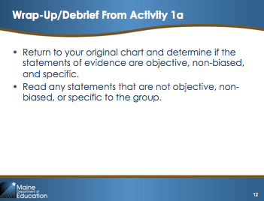Slide 12

Possible Facilitation Challenges and Solutions
Challenge | Solution(s)
Participants may have difficulty generating examples of evidence statements for aspects of the rubric that are not observed in a classroom observation. | Encourage participants to think about how they would know what performance level in the rubric reflects the teacher’s practices. If necessary, remind participants about the examples in the Companion Guide and suggest they review the critical attributes and examples for the standard indicator to help spur their ideas.
Participants may note that in the MSFE Rubric, performance descriptions in standard indicators under Core Propositions 4 and 5 are listed as “nonobservable” (e.g., they are presented in bold text). | Explain to participants that there is a slight difference in the types of evidence collection activities available in the Maine DOE T-PEPG model and the MSFE model. In the T-PEPG model, teachers have the option of selecting an observation of professionalism or collaboration as one of their points of contact.

Guiding Questions
- What is considered evidence in the T-PEPG process?
- What might evidence look like for different types of teacher practice in the Core Propositions and standard indicators?

Learning Content: Overview of Self-Evaluation and Reflection Process (10 minutes)
The purpose of this section is to familiarize participants with the self-evaluation, reflection, and goal-setting forms.
Explain:  “As you will recall, the T-PEPG process starts off in Step 1 with goal setting. Last time, you worked on setting student growth goals through the SLO process. Today, we will build on that process and work on professional goal setting.” | 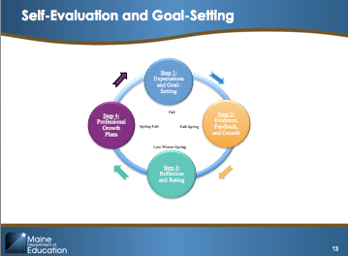Slide 13
Explain:  “Step 1 (Expectations and Goal-Setting) involves multiple activities.”  Read the activities on the slide.  “Turn to Handouts 1 and 2 in your Handout Packet. Take a few minutes to review the self-evaluation and goal-setting forms. We will review the SMART goal process for completing these forms in a moment.”  Provide a few minutes for participants to review the forms and ask questions. Participants may ask how many goals they are required to write and by what date. Be prepared to provide this information based your district’s model. | 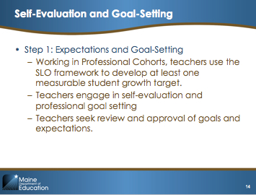Slide 14
Explain:  “By drafting your SLO, you have already completed a significant part of the process for preparing to self-evaluate and reflect. You’ve already considered your students’ needs; set student growth targets; and considered the instructional strategies, formative assessments, and instructional adjustments you will need to use to help your students meet their growth targets.  With your SLO as one source of information, your next task is to reflect and self-evaluate your professional practice against the MSFE Rubric. As part of this reflection, consider your SLO and any other evidence sources that can help inform this assessment of your own practice, such as classroom observations, feedback, student surveys, artifacts, lesson plans, and so on.  You will then use this self-reflection to set professional goals for the year.” | 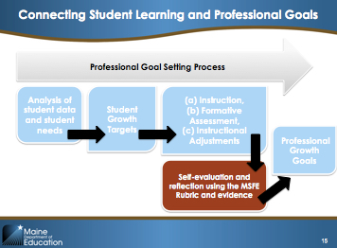Slide 15

Learning Activity 1b: Mr. Brown’s Self-Evaluation (25 minutes)

Purpose
This activity helps participants familiarize themselves with how to use evidence as part of the self-evaluation and reflection process. It also illustrates how the SLO process can inform the self-evaluation and goal-setting process.

Activity Detail
Mr. Brown is a secondary teacher. Handout 3 draws on the same information as the exemplar SLO from Module 2 (Handout 4 in this module). Handout 3 is an example that includes intentional errors, such as incorrect alignments between evidence and standard indicators and examples of weak use of evidence. For example, Mr. Brown cites several things he has proposed to do for his SLO as evidence. However, unless he did the activity last year, these cannot be used as evidence because they are proposed activities rather than completed activities.  This activity is designed to help participants recognize and correct these common errors. Note: Handout 3 only provides examples for Core Propositions 1–3. By keeping the activity focused on the instructionally focused standard indicators, participants remain centered on how the SLO process can be utilized within the reflection and self-evaluation process.  Explain:  “Recall our opening activity and the evidence statements you created for each standard indicator. You will now see an example of how evidence is used in a self-reflection. Note that this is an example for discussion, not an exemplar. Use Handout 3 to complete the following steps at your table:  - At your table, assign one or two standard indicators from Appendix M to each person.  - Scan Handout 4 (Mr. Brown’s SLO) to remind yourself of the content.  - Review Mr. Brown’s self-evaluation (Appendix M) for the standard indicator(s) you were assigned, as well as Mr. Brown’s written reflection (Appendix N).  - Use the MSFE Companion Guide to consider the following questions for your standard indicator(s):  - Are the statements of evidence specific, objective, and non-biased? If not, how would you rewrite them?  - How well does Mr. Brown’s evidence align with the identified standard indicators?  - How does Mr. Brown use his SLO to inform his reflection? What specific components does he reference?  - What other evidence or considerations might you recommend he include?  - What advice would you give Mr. Brown about strengthening his written reflection?  - Share your answers with your table members.”  After 10 minutes, prompt participants to start sharing out their answers to the questions at their tables. As tables start to share out, circulate and answer questions or help facilitate the conversation. After another 10 minutes, reconvene the whole group and ask: “Could each table share their advice for Mr. Brown?” Allow each table to share out (or as many as possible in three minutes). | 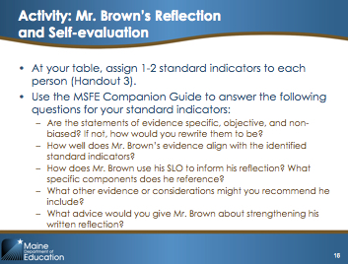Slide 16

Possible Facilitation Challenges and Solutions
Challenge | Solution(s)
Participants may struggle to identify additional evidence or considerations for Mr. Brown’s self-evaluation. | Remind participants to use reflection questions for each standard indicator in the Companion Guide. Below are some possible prompts you can use for each standard indicator (the list is not exhaustive) if needed:  - 1.1 Understanding of students: How does the Mr. Brown try to learn about students’ interests or backgrounds and use this information in instruction?  - 1.2 Application of learning theory: How does Mr. Brown help students connect learning to needs and events present in their lives and world?  - 1.3 Classroom climate: How does Mr. Brown promote collaboration among students successfully?  - 2.1 Subject knowledge: How does Mr. Brown help students make connections between each learning activity and the essential questions in the course?  - 2.2 Pedagogical content knowledge: How does Mr. Brown use student-directed learning opportunities or newer technologies, such as online video, audio, or social media.  - 2.3 Goal-focused planning: How does Mr. Brown communicate the intended learning goals to students? Does Mr. Brown detail how he facilitates cognitive engagement or higher order thinking?  - 3.1 Managing classroom routines and expectations: How does Mr. Brown invite or allow students to make independent adjustments? How does Mr. Brown identify and proactively teach social and emotional competencies?  - 3.2 Student engagement: Does Mr. Brown allow grouping based on student interest or through cooperative grouping? How does Mr. Brown create opportunities for students to connect the content with real-life situations?  - 3.3 Assessment of student progress: How does Mr. Brown provide opportunities for peer review or student choice in assessment? How does Mr. Brown provide assessments that are focused on authentic or real-world tasks?

Guiding Questions
- What does evidence-based reflection and self-evaluation look like?
- What resources can teachers use as part of the reflection and self-evaluation process?
Learning Content 2: SMARTer Goals (10 minutes)
This section helps participants understand the basic criteria for SMART goals.
Explain:  “How many people are familiar with SMART goals?”  Use participants’ responses to decide how quickly to move through this slide, or have people who raise their hands help share what they know.  “SMART goals are short-term goals (i.e., one year or less). SMART stands for...”  Direct participants to follow along with Handout 5. Read the first column. Read through the descriptions and the questions that someone could pose to ensure SMART criteria are used when developing a goal.  “Ultimately, these criteria are provided to ensure aligned and rigorous goals.” | 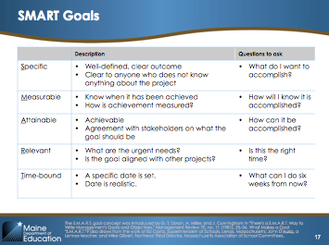Slide 17

Learning Activity 2: Mr. Brown’s Professional Goals (15 minutes)
The purpose of this activity is to allow participants to begin evaluating professional goals using the SMART goal framework. This will support their use of this framework when they draft their own professional goals.
Explain:  “Handout 6 includes Mr. Brown’s draft goals. Writing strong goals can be difficult to accomplish in one draft. Now you are going to pretend to be Mr. Brown’s evaluator. Work with an elbow partner. Look at the goals the teacher wrote and identify how the goals could be made SMARTer and then answer the questions on the SMART goals chart in Handout 5.” | 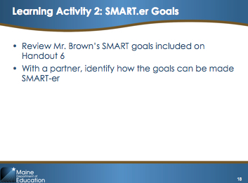Slide 18

Learning Debrief/Wrap-Up (5 minutes)
Explain:  “How did you and your partner improve Goal 1? Goal 2? Goal 3?”  Ask two or three pairs to share the ways in which they improved each goal. | 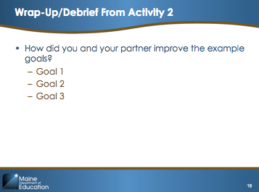Slide 19

Possible Facilitation Challenges and Solutions
Challenge | Solution(s)
In draft Goal 1, participants may not pick up on the root problem, which is that Mr. Brown has duplicated/focused on his students’ growth rather than writing a professional practice goal. | Remind participants that their professional growth goals should align with their SLO rather than duplicate it. Ask participants if the first goal is a professional practice goal (i.e., does it focus on what the teacher does as opposed to a student outcome?).
Participants may feel that they need more information to improve the SMART goals. | Tell participants that they can fill in any details that they do not have about Mr. Brown by using what they know from their own school. For example, if their school has common planning time, they can assume that Mr. Brown does too.

Guiding Questions
- What are SMART goals for professional practice?
- How can goals be improved?
The following table provides examples of how these goals can be improved. There are many other revisions that participants could generate. Use these examples if the group is reluctant to share their revised goals or if the shared goals could be strengthened.
Draft Goal | SMARTer Goal
Goal 1: My two students with low NWEA reading scores will score at level 3 on the DBQ rubric. | I will use three additional formative assessments to closely monitor the progress of my two students with low NWEA reading scores, and I will make adjustments to student groupings, instructional strategies, texts, and ongoing assessments to meet their individual needs. I will meet biweekly with our literacy coach to analyze student work and progress towards developing each literacy skill highlighted in my SLO. I will use this biweekly analysis to adjust my instruction, and by March 2015 I will develop a set of 10 new instructional strategies for improving literacy skill development with my students.
Goal 2: In an effort to support students in connecting past events to events in their lives, I will include current event discussions and opportunities for students to analyze how their personal life events connect to historical figures or events from the past. | In an effort to support students in connecting past events to events in their lives, I will include (by March 2015) five current event discussions and opportunities for students to analyze how their personal life events connect to historical figures or events of the past.
Goal 3: I will redesign the research exercise for the source document analysis activity to give students more opportunity for choice in the activity. | By February 2015, I will research possible modifications to the research exercise for the source document analysis activity. These modifications will provide students with at least three structured opportunities for choice within the activity. I will monitor the effectiveness of this new approach and identify possible improvements or modifications that may be needed for future activities.

IV. Implementing (40 minutes)

Slide 20 is the divider slide for this section.

Implementing Activity: Practicing Self-Evaluation and Goal Setting (40 minutes)
The purpose of this activity is to allow participants to begin applying the self-evaluation and goal-setting process to their own practice.
Explain:  “You have about 40 minutes to get a start on completing the self-evaluation and goal-setting process. Use Handouts 1 and 2, which we reviewed earlier. You won’t be able to complete everything today but this should give you a strong starting point. The slide lists tasks that you can work on, including:  - Completing your self-evaluation  - Drafting your goals  - Getting feedback from team members on the quality of your goals  - Refining your goals.”  Give participants 40 minutes to complete this activity. Give them time cues. For example, after 15 minutes prompt them to shift from self-evaluation to goal setting, and after 30 minutes prompt them to start exchanging feedback on at least one goal. | 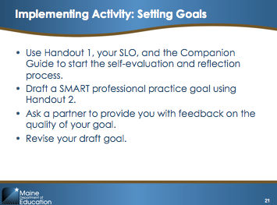Slide 21

Implementing Debrief/Wrap-Up (5 minutes)

Activity Detail
Explain:  “Would anyone like to share their goal and explain how they improved or revised it?”  Ask the volunteer to read the goal and the feedback it received. | 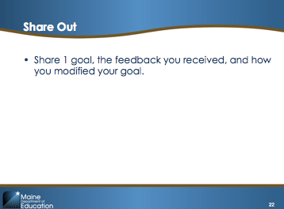Slide 22

Possible Facilitation Challenges and Solutions
Challenge | Solution(s)
Participants may seek feedback from their teammates before those individuals are finished with their own work. | Pair participants looking for feedback with others who have reached that step of the process. This will allow all individuals to move forward at their own pace.

V. Reflecting and Wrap-Up (10 minutes)

Slide 23 is the divider slide for this section.

Suggested Next Steps
Explain:  “Conduct a short reflection on what you have learned here today. Turn to Handout 7 and write down:  - Three ideas you want to remember  - Two things you learned today  - One outstanding question you have about the T-PEPG system”  Give participants about 5 minutes to complete the reflection. If participants finish early, encourage them to share their next steps with colleagues at their table. | 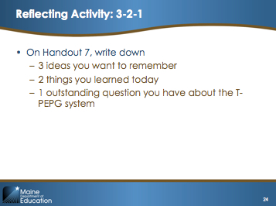Slide 24
Note: You may need to modify this slide to provide more specific information about how your district has structured the professional goal and SLO approval process.  Explain:  “After you have completed your reflection and self-evaluation, you will need to complete the following three steps:  - Complete your professional goals, including Part 2 (Implementation Planning)  - Submit your SLO for preapproval  - Submit your preapproved SLO and professional goals for final approval.”  Ask participants if they have any questions or concerns about these next steps and clarify any remaining points of confusion (e.g., due dates, roles and responsibilities, and so on).  Note: Participants may ask for guidance on filling out Part 2 (Implementation Planning), especially the second column and identifying student outcomes. Explain to participants that achievement of SLO targets is one outcome that could be discussed, but it could also be something behavioral or related to engagement, depending on the goal. | 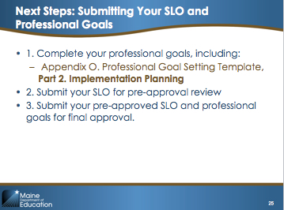Slide 25
Explain:  “Module 4 will provide details about the observation process, including the collection and organization of observation evidence and the sharing of timely, constructive feedback. All participants participate in peer observation, and the module provides information about how to make the process meaningful, collaborative, and constructive.” | 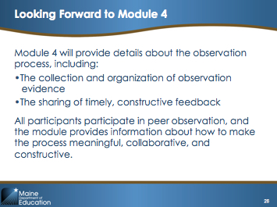Slide 26
Come to Closure:  NOTE: Enter your e-mail address on the final slide so that participants know where to send questions. | 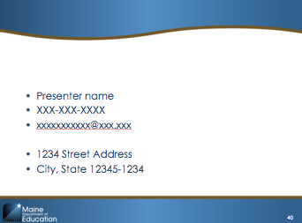 Slide 27

