Unit 1: Building Strong Communities
Week 6: How can we create positive change in our communities?
Dear Families,
As we learn about what makes a strong community, we are starting to think about what we can do to make change in our own communities. We have started thinking about a classroom project to help all children and families have access to books.
Here are some activities to do with your child this week. When you do an activity, check the box. You don’t have to do every activity and you can do any of them more than once. Remember to make time for reading, too!
Please help your child return this Family Links to school at the end of the week. We hope you enjoy learning with your child!
___________________________________________________________________________________
This week we are reading…

 | Biblioburro: A True Story from Colombia  by Jeannette Winter |  | Waiting for the Biblioburro  by Monica Brown
Both of these books are about a real person named Luis Soriano who traveled long distances on a donkey to bring books to children. Go to the library or look on your bookshelf at home to find more books about people, books, and libraries—or about anything that interests you!

Your child is practicing reading “Books” (attached). Read it together!

Reading Log
Your child can read to you, and you can read to your child.

It’s always a good idea to read a book many times. We can find something new in a book each time we read the words or look at the illustrations.
Title and Author | What do you think?

Go outside  Walk or skip around your neighborhood looking for places people can find books. Look in store windows, little libraries, donation centers… everywhere! Make a list of all the places you found books. |  |  | Talk about…  … the Book Access Project. Ask questions and share ideas about the different ways people can find and read books that interest them.
Tell a story  What if someone you know never had a book of her own? Tell a story about how she got one. Who helped her? What kind of book was it? What did she do next? |  | Read together!  at least 10 minutes every day  Record your reading on the back of this page. |  | Play with math ideas  Play Combination Partner.  The total is 8. How many combinations can we make? For example, if we have 5, how many do we need to get to 8?  5 + ? = 8 ? + 6 = 8 8 = 7 + ?  Keep going!
Explore science and engineering  Play with bubbles! Play outside, if you can, or turn on a fan inside. How do the bubbles help you understand something about the direction and speed of the wind? |  |  | Play with words; grow a reader  Our Weekly Words are resource, improve, access, and impact.  “It is important to me to have access to….”  Make a sentence with each of these words.

Child’s name ___________________________ Adult’s name ___________________________

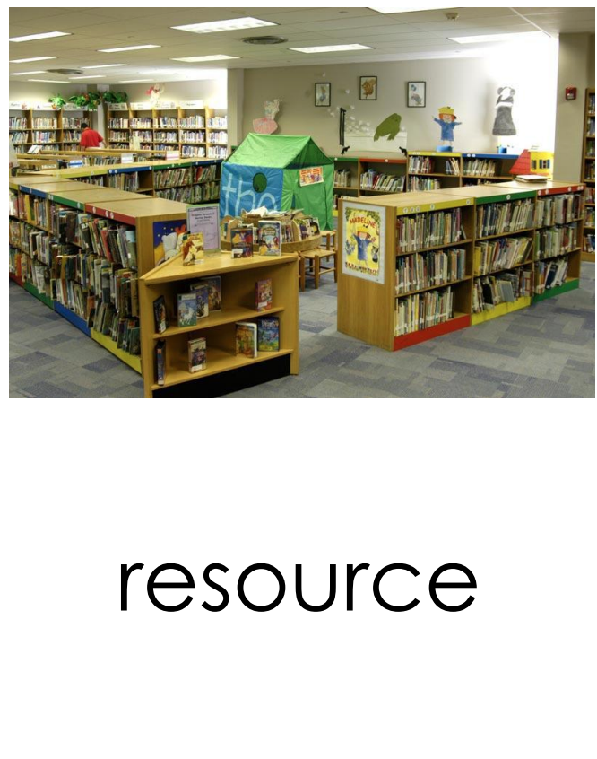  something people need | 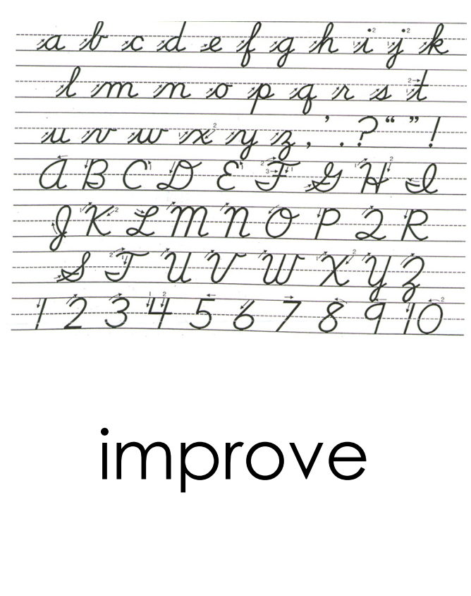  to make something better
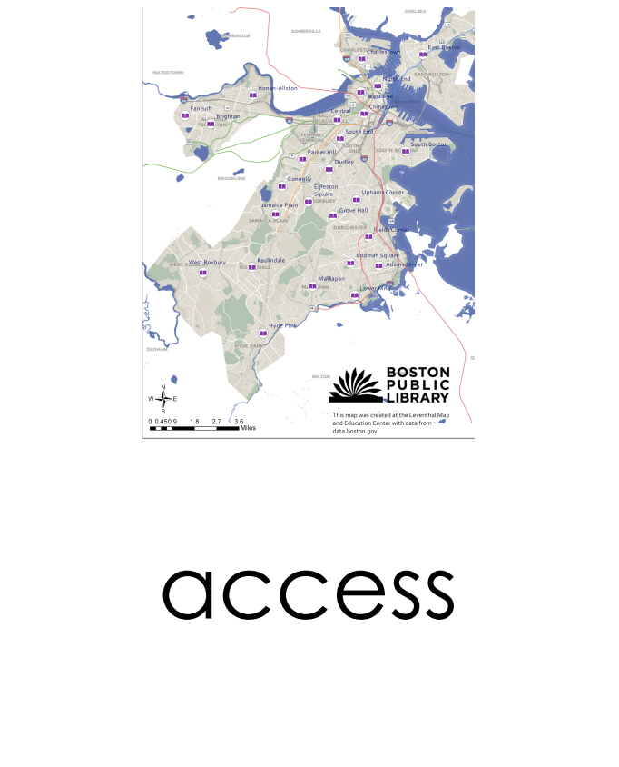  a way of being able to use or get something | 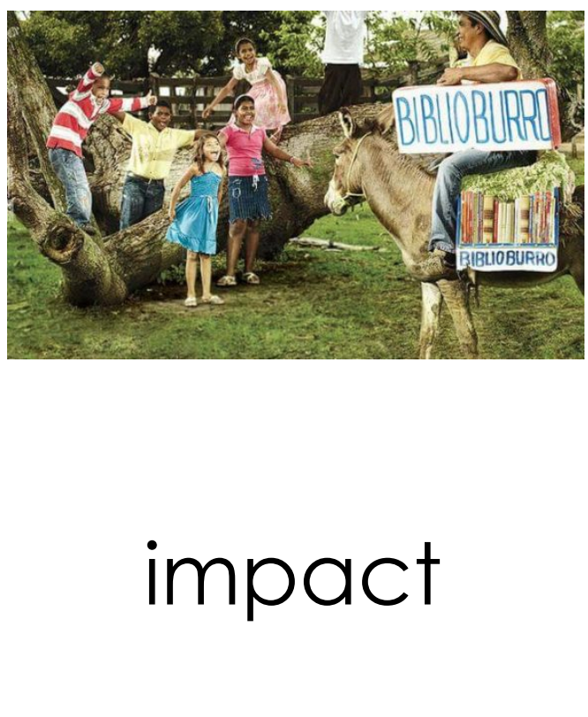  to have an effect on someone or something

Teachers need to print…
*This week’s letter (front and back)
*Vocabulary Sheet
*Books Passage

