Unit 1: Building Strong Communities
Week 5: What are the qualities of a good leader?
Dear Families,
We are continuing to think about leaders and especially about what kinds of people they are. What are they like? How do they bring their communities together in positive ways?
Here are some activities to do with your child this week. When you do an activity, check the box. You don’t have to do every activity and you can do any of them more than once. Remember to make time for reading, too!
Please help your child return this Family Links to school at the end of the week. We hope you enjoy learning with your child!

This week we are reading…
 | 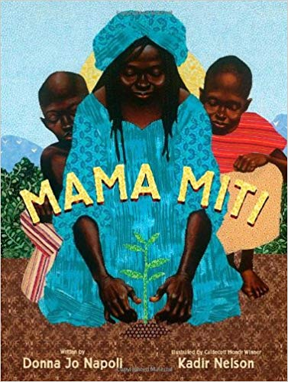 | Mama Miti: Wangari Maathai and the Trees of Kenya  by Donna Jo Napoli
Go to the library or look on your bookshelf at home to find more books about leaders who inspire others and change their communities—or about anything that interests you! Don’t forget to listen to this week's text on YouTube.
Your child is practicing reading “We’ve Got the Whole World in Our Hands” (attached). Read and sing it together!

Reading Log
Your child can read to you, and you can read to your child.

It’s always a good idea to read a book many times. We can find something new in a book each time we read the words or look at the illustrations.
Title and Author | What do you think?

Unit 1: Building Strong Communities
Week 5: What are the qualities of a good leader?
Go outside  Try to find a school leader (principal, librarian, school crosswalk guard). What can you find out about her or him? |  |  | Talk about…  … a leader you know or have heard of. What is that person like? What qualities do you think makes that person a good leader?
Tell a story  Imagine something wonderful you would like to do in your community to make a positive change. Tell a story about what you would do and how other people might help! |  | Read together!  at least 10 minutes every day  Record your reading on the back of this page. |  | Play with math ideas  Play Number Line Jumper.  Number spaces on the floor from 0 to 10, about 12 inches apart. Give a starting number and a number to jump to. For example, start at 4 and jump to 6. Ask, how many did you jump? Say and write an equation (4 + 2 = 6).
Explore science and engineering  Look out the window or go outside. What do the clouds look like? Keep a cloud journal this week. Draw a picture of the clouds you see on different days. What do you notice about them? |  |  | Play with words; grow a reader  Our Weekly Words are movement, environment, quality, and decision.  These are big, complicated words! What do you know about them?

Child’s name ___________________________ Adult’s name ___________________________

Week 5 Vocabulary Guide

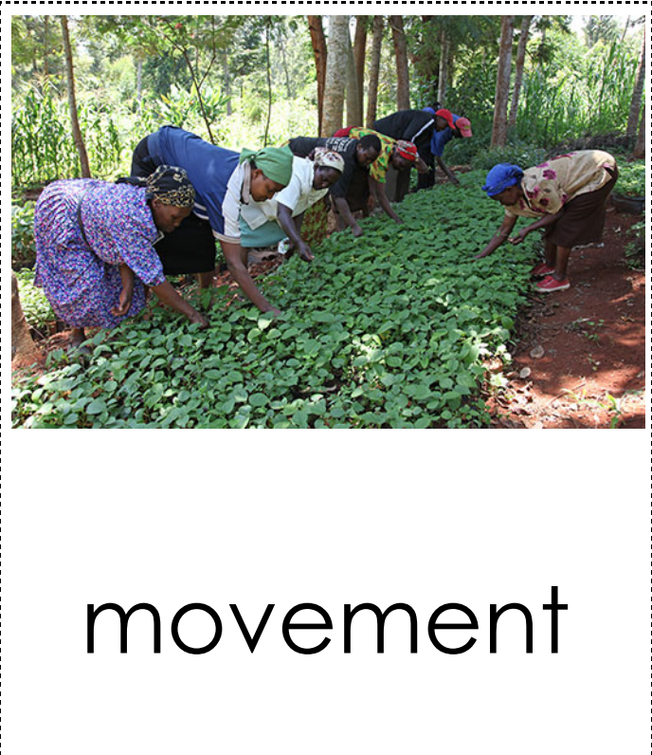  organized activities where people work together to achieve  something | 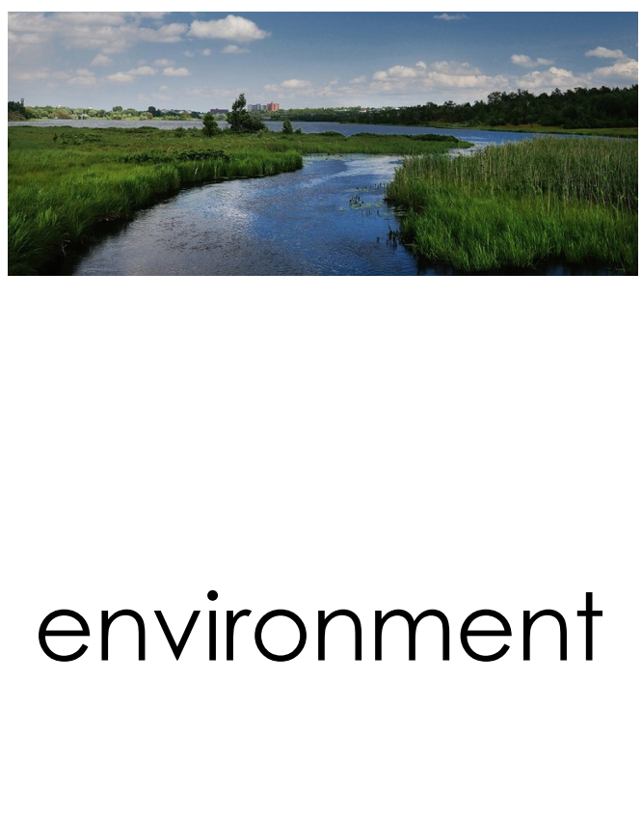  the natural world
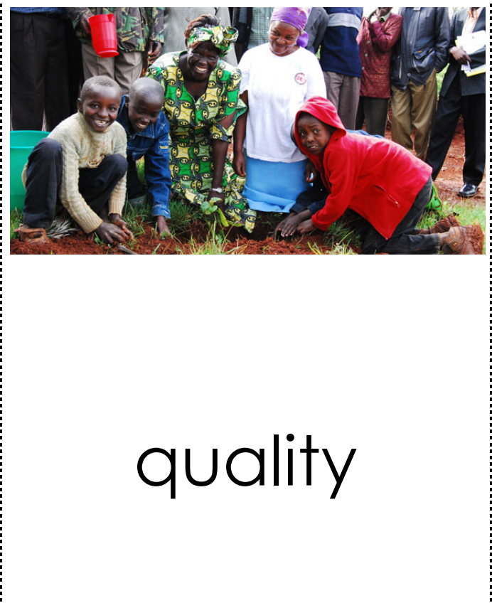  something that can be noticed as a part of a person or a thing | a choice that a person or a group makes about something

Teachers need to print…
*This week’s letter (front and back)
*Vocabulary Sheet
*The Whole World In Our Hands

