Unit 1: Building Strong Communities
Week 3: What roles and responsibilities do we have in our communities?
Dear Families,
This week we are continuing to learn about what makes our communities strong. We are thinking about what we each do as members of our communities—our roles and our responsibilities.
Here are some activities to do with your child this week. When you do an activity, check the box. You don’t have to do every activity and you can do any of them more than once. Remember to make time for reading, too!
Please help your child return this Family Links to school at the end of the week. We hope you enjoy learning with your child!
This week we are reading…
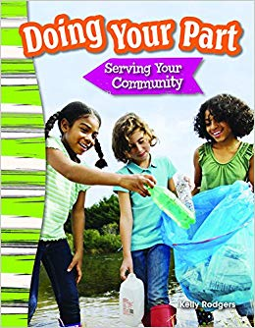 | Doing Your Part: Serving Your Community  by Kelly Rodgers | 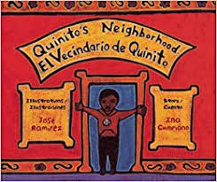 | Quinito’s Neighborhood  by Ina Cumpiano  and José Ramirez
Go to the library or look on your bookshelf at home to find more books about people’s roles and responsibilities in their communities—or about anything that interests you! Don’t forget to check out YouTube to hear these texts at home.
Your child is practicing reading “Boston Day” (attached). Read it together!

Reading Log
Your child can read to you, and you can read to your child.

It’s always a good idea to read a book many times. We can find something new in a book each time we read the words or look at the illustrations.
Title and Author | What do you think?

Unit 1: Building Strong Communities
Week 3: What roles and responsibilities do we have in our communities?
Go outside  Take a walk around the neighborhood and notice the many different jobs people do. When you come back inside, see how many of those jobs you can remember by making a list. |  |  | Talk about…  … jobs people do and why they are important in our communities. How do these jobs contribute to making our communities strong? What if no one did these jobs?
Tell a story  What job would you like to do? What would it be like to learn how to do that job?  Tell an imaginary story about an animal that goes to work for the first time and doesn’t know what to do. |  | Read together!  at least 10 minutes every day  Record your reading on the back of this page. |  | Play with math ideas  Play Number BINGO + 1.  This time, players cover the number that is called out plus one more. For example, if 7 is called, 8 is covered on the board.
Explore science and engineering  What do you notice about the sky in the morning, when you first get out of bed? What do you notice in the middle of the day, and in the evening? Fold a piece of paper into three sections and draw a picture about the sky at each time of day. |  |  | Play with words; grow a reader  Our Weekly Words are citizen, role, common good,and public space.  Make a sentence with each word.  What roles do we each have in our public spaces to build a strong community?

Child’s name ___________________________ Adult’s name ___________________________

Week 3 Vocabulary Guide

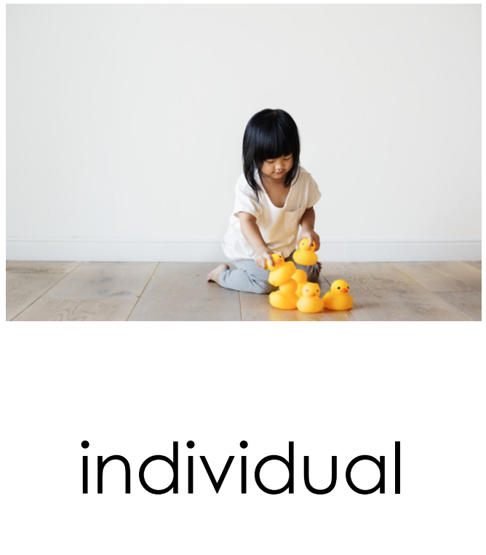  having to do with one unique person | 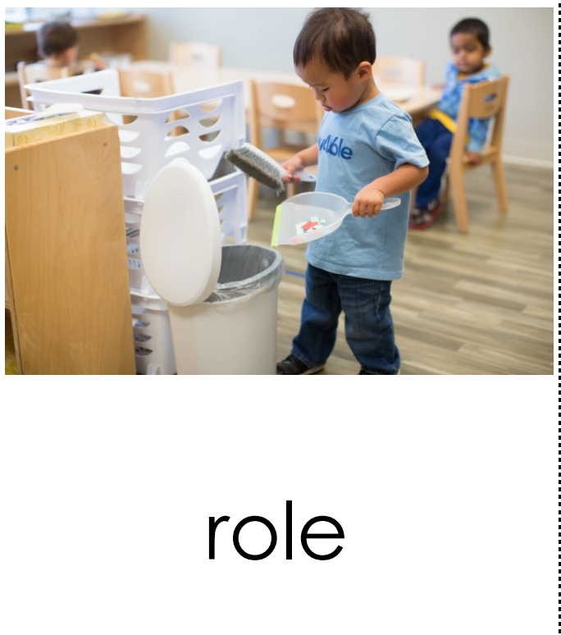  job or part someone plays
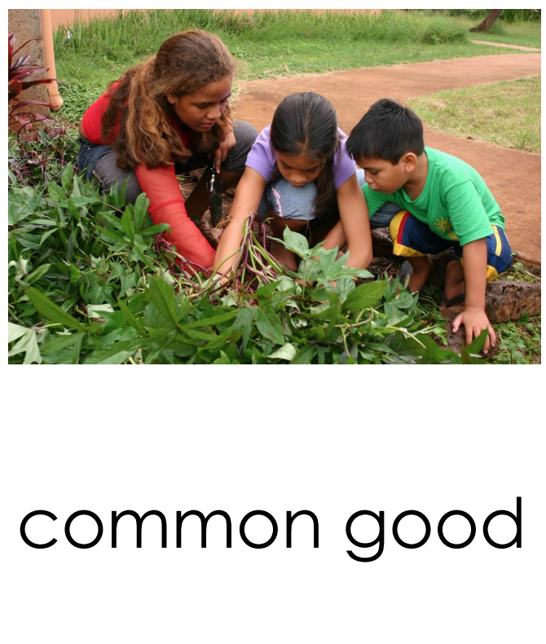  something that is good for all people | 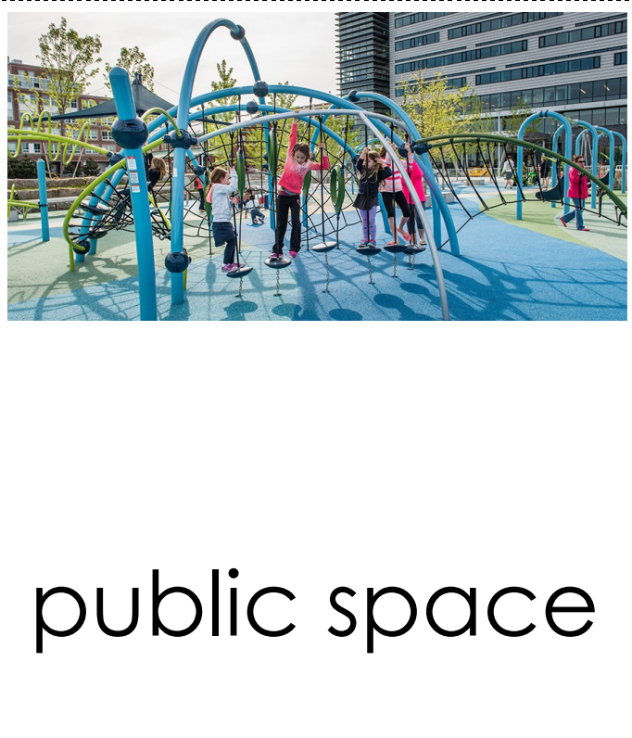  lands or buildings in a community that can be used by any member of that community

Teachers need to print:
*This week’s letter (front and back)
*Vocabulary Guide
*Boston Day
*Number Bingo +1

Children will also need a blank sheet of paper for the science and engineering activity.

