Unit 1: Building Strong Communities
Week 1: Who am I, and who are we together?
Dear Families,
Welcome to First Grade! To begin the school year, we are learning about what makes our communities strong. A community is a group of people who share a place and ideas. This week we begin our study by getting to know each other.
Here are some activities to do with your child this week. When you do an activity, check the box. You don’t have to do every activity and you can do any of them more than once. Remember to make time for reading, too!
Please help your child return this Family Links to school at the end of the week. We hope you enjoy learning with your child!
This week we are reading…
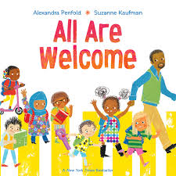 | All Are Welcome  by Alexandra Penfold and Suzanne Kaufman | 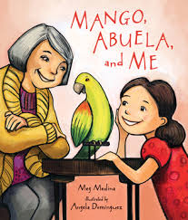 | Mango, Abuela, and Me  by Meg Medina and Angela Dominguez
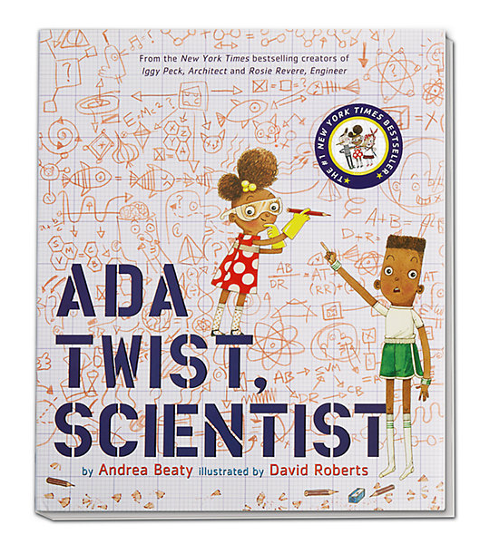 |  | Ada Twist, Scientist  by Andrea Beaty and David Roberts
Go to the library or look on your bookshelf at home to find more books about people in communities—or about anything that interests you! Don’t forget you can search these books on YouTube and listen to them at home together as well!

Reading Log
Your child can read to you, and you can read to your child.

It’s always a good idea to read a book many times. We can find something new in a book each time we read the words or look at the illustrations.
Title and Author | What do you think?

Unit 1: Building Strong Communities
Week 1: Who am I, and who are we together?
Go outside  Take a walk or a ride together around the neighborhood. Notice what people are doing to build a strong community, like saying hello and helping each other.  Try to find signs or posters about community events. What do they say? |  |  | Talk about…  … the communities you belong to. Think about your family, sports, religious communities, volunteer activities, and more.  Try to take at least 5 turns back and forth in your conversation.
Tell a story  Think about a time when something important happened in a community you are part of. Tell a short story about that time.  Then ask your child to tell a story to you. |  | Read together!  at least 10 minutes every day  Record your reading on the front page. |  | Play with math ideas  Play I Start, You Follow.  Start at 5, and ask your child to continue counting from there. Then start again from 10, 15, or another favorite number. Use items in your home to keep track of counting.
Explore science and engineering  What do scientists do? They ask questions and make observations. Inside or outside, notice something that is happening. Take turns asking questions about that! |  |  | Play with words; grow a reader  Our Weekly books are on the front page. Ask your child…  -Who were the characters in the book?  -How does the book show a community?

Child’s name ___________________________ Adult’s name ___________________________

Teachers Need to Print:
*This week’s letter (front and back)

