Essential and Guiding Questions
Essential questions reflect the unit development and planned content learning. These are developed by the teacher or team to provide an overarching common purpose for the instructional unit. The essential question should remain at a high level and present a conceptual purpose for study.
Begin by establishing a relevant goal: course objectives, program objectives, learning outcomes, multiple discipline content standards
Figure 1
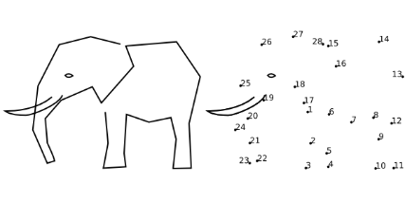
- Create big ideas – an idea is big if it helps us make sense of lots of experiences and isolated facts
  - Big ideas emphasize common characteristics of a unifying concept
  - Big ideas promote in-depth understanding
  - Big ideas apply across disciplines
- Establish essential questions that will lead students to the big idea. Is the idea big?
  - Will students be able to apply the essential question (big idea) to their lives?
  - Will students remember this big idea long after they leave your classroom?
  - Is the big idea arguable?
- Essential questions
  - Have no right or wrong answers
  - Focus student learning on the big idea
  - Promote inquiry and critical thinking
  - Engage students in real-life problem solving
Not a big idea:  Did nature influence Monet? | A big idea:  How are artists influenced?
Not a big idea:  Why are settlements developed around lakes and rivers? | A big idea:  How does habitat influence where we live?

Guiding questions are developed by students with support from a teacher, in a group, or independently. The guiding questions provide students an opportunity to makes choices about the direction of their learning.
Guiding questions help students narrow their inquiry while honoring their curiosity. Students may explore many different questions while informing their understanding of the big idea, the conceptual understandings for the study. Help students develop at least three questions to explore related to the essential question. Below is a note catcher for this activity.
Figure 2
Essential question:
Guiding questions
1
2
3

Here is an example of what it might look like in your classroom.
Figure 3
Essential question: How does history repeat itself?
Guiding questions
- What has happened before multiple times?
- Is there anything happening now that is like something that happened before?
- Why do things repeat?

These questions may lead to explore environment like storms or other natural phenomenon or may be related to health such as epidemics and pandemics. The exploration may be more social like political clashes human migration. Here is where students have a great deal of choice in how and what to learn.

