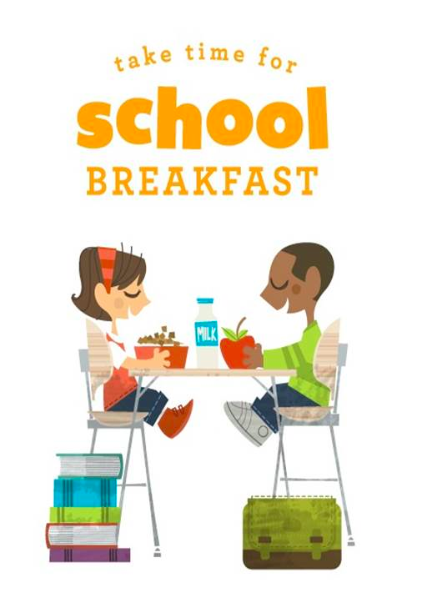
BREAKFAST AFTER THE SCHOOL BELL

TOOL KIT FOR SCHOOLS

STATE OF MAINE

129TH LEGISLATURE

FIRST REGULAR SESSION

LD 701 “AN ACT TO MODERNIZE THE NATIONAL SCHOOL LUNCH PROGRAM AND THE SCHOOL BREAKFAST PROGRAM”

This bill provides funding for schools starting an Alternative Breakfast Delivery Service Program to provide breakfast after the start of the school day. A school administrative unit with a public school in which at least 50% of students qualified for a free or reduced-price lunch during the preceding school year qualifies for funding. The department is required to develop guidelines to allocate and disburse the funding to participating schools.

BREAKFAST AFTER THE MORNING SCHOOL BELL

STUDENTS - K-5

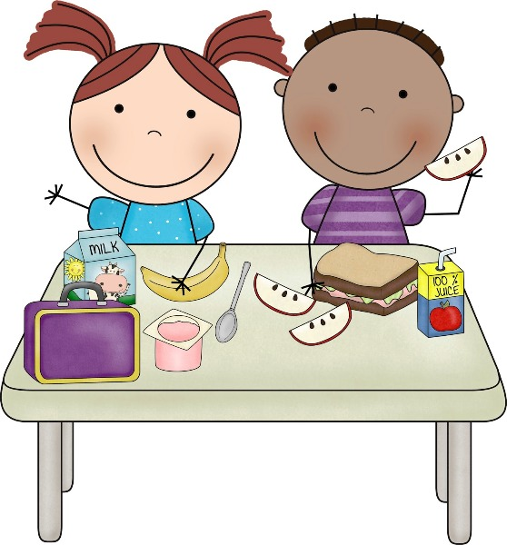

Why? To feel good and get ready for your school day

What? All kinds of yummy and healthy breakfast foods

Where? Right at your desk in your classroom with all your classmates

When? After the morning bell and you get to your classroom

Who? All students can get breakfast

STUDENTS K - 5

Why?
If you don’t eat breakfast, it can be hard to concentrate on school work. Some kids get a headache, feel sleepy, or just don’t feel well until they have something to eat. Sometimes there might not be breakfast food at home, you might not be hungry when you first wake up, or you may have to hurry to get ready for school and not have time to eat. There are lots of reasons why fueling up with a healthy breakfast gets you ready for your school day.

What?
Your school has rules that they need to follow to make sure that the meals they serve students are healthy and nutritious. There are many breakfast foods that are available to be served for breakfast. A breakfast meal will always include fruit, milk, grains and more. Some of the foods that will be offered will be cereal, juice, fresh fruit, pancakes, granola bars, yogurt, breakfast sandwiches, muffins, eggs and a whole lot more. Your school will likely have a monthly breakfast menu like your lunch menu for you to see!

Where?
When you get to school you follow your school’s rules until the starting bell rings. That might mean waiting in the cafeteria, gym, or outside until it is time to go to your classroom. Breakfast was always available to you but lots of kids don’t like sitting in the cafeteria eating breakfast while other kids are playing or socializing. With “Breakfast After the Bell” everyone goes to the classroom either with their breakfast or breakfast will come to you on a breakfast cart! Everyone will eat and start the day together!

When?
Schools have different schedules, so each might be a little different. Your school principal, teachers, and school nutrition staff will work together to get the timing worked out for you and your school.

Who?
There are lots of reasons that kids don’t eat breakfast but with “Breakfast After the Bell”, we hope to make it easier for ALL kids to get a great breakfast every day. You will do the same thing you do for lunch to get breakfast. You will enter your meal PIN, or be checked off when you get your meal.

BREAKFAST AFTER THE MORNING SCHOOL BELL

STUDENTS - 6-12

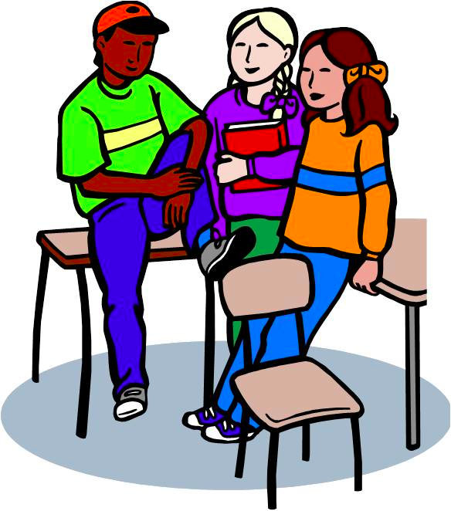

Why? To feel good and get ready for your school day

What? All kinds of tasty and healthy breakfast foods

Where? Right at your desk in your classroom with all your classmates

When? After the morning bell in your classroom. Some schools may have a “second chance” breakfast after the first period.

Who? Every student can get breakfast

STUDENTS 6-12

Why?
If you don’t eat breakfast, it can be hard to concentrate on school work. Some kids get a headache, feel sleepy, or just don’t feel well until they have something to eat. Sometimes there might not be breakfast food at home, you might not be hungry when you first wake up, or you may have to hurry to get ready for school and not have time to eat. There are lots of reasons that a nutritious breakfast is necessary for success in Middle and High School. It can improve your performance both academically and athletically.

What?
Your school has rules that they need to follow to make sure that the meals they serve students are healthy and nutritious. There are many breakfast foods that are available to be served for breakfast. A breakfast menu will always include fruit, milk, grains and more. Some of the foods offered would be cereal, juice, pancakes, granola bars, yogurt, breakfast sandwiches, muffins, eggs and a whole lot more. Your school will likely have a breakfast menu for you to see!

Where?
When you get to school you follow your school’s rules until the starting bell rings. That might be waiting in the cafeteria, gym, or outside until it is time to go to your classroom. Breakfast was always available to you but lots of kids don’t like sitting in the cafeteria eating breakfast while other kids are socializing. With the new “Breakfast After the Bell” everyone goes to the classroom either with their breakfast or breakfast comes to you! Or, some schools may do a “Second Chance” breakfast where you get breakfast after first period. Everyone will eat together and start your school day!

When?
Schools have different schedules, so each might be a little different. Your school principal, teachers, and school nutrition staff will work together to get the timing worked out for you and your school. Your school may choose to have a “Second Chance” breakfast which could happen after first period.

Who?
There are lots of reasons that kids don’t eat breakfast but with “Breakfast After the Bell”, we hope to make it easier for ALL kids to get a great breakfast every day they need it. You will do the same thing you do for lunch to get breakfast. If you pay for lunch, you will also pay for breakfast. The money will be taken out of your meal account. Some schools may accept cash at breakfast. If you get free or reduced priced meals you will get breakfast for free. Nobody will know the difference and all students can eat a healthy and yummy breakfast as part of their school day!

TESTIMONIALS

Old Town Middle School, reasons kids say they like Breakfast in the Classroom, after the bell:

“You can take your time to eat vs. rushing to finish”, Chloe, gr 6

“Not having to juggle food with moving around bags and stuff”,
Harmony, gr 6

“1. You can eat while doing your work. 2. If you’re late you can still
get breakfast”, Kylee, Lily, and Abbey, gr 7

“It’s calm so you can eat in peace and do your work”, Will and Dominic, gr 8

BREAKFAST AFTER THE MORNING SCHOOL BELL

CUSTODIANS

Why? Because many students do not get to eat before they start school.

What? Breakfast will be an easy grab n go type of meal

Where? In the classrooms at their desks

When? Usually during the first 10-15 minutes of school--your school may set a different schedule

Who? All students will be offered a breakfast

CUSTODIANS

Why?
Many families are on a tight budget or do not have the time in the morning to feed their children. Some children cannot eat early in the am. Studies have shown that students who eat a healthy breakfast have improved academic outcomes and attendance, have decreased visits to the school nurse and fewer behavior issues. Breakfast after the bell will allow students to socialize with their friends before the bell rings and avoid the stigma of eating breakfast in the cafeteria before school starts.

What?
The School Nutrition Program in your school will offer foods that are healthy and taste great. There are strict guidelines that must be followed by all schools. There are many breakfast foods that meet the guidelines. The breakfast may be served in a disposable “boat” type tray or it may be bagged and ready to go.

Where?
Whether students pick up their breakfast and head to the classroom or it is delivered to them by the School Nutrition Staff, students will eat at their desk with their classmates and teacher. The details will be worked out by the administration at your school as far as timing and where it will work best to distribute the meals.

When?
There are different models for different age groups. Older students often are offered a second chance breakfast after the bell rings--perhaps the first 10 minutes of the first or second period of the morning. The younger students will usually eat during the first 10-15 minutes after the bell in their classrooms depending on the schedule that will be set by your principal and teachers.

Who?
Breakfast is available to ALL students. The National School Breakfast Program is a federal school nutrition program just like school lunch. Maine students who are eligible for reduced price meals are also able to enjoy their breakfast for free. The State picks up the cost so that both Free and Reduced eligible students can eat for free.

HOW CAN I HELP?
Be supportive of this newest way to get meals to hungry children. Yes there may be a few bumps in the road but if everyone works together things will smooth out. There will be more trash in the classrooms. One idea was to have a separate trash bin for food items and packaging so that can be emptied daily. Teachers will be present when students are eating and can help with any spills, etc.

TESTIMONIALS
“Before the program started, I said there would be five spills a day. That first month, I don’t think there were five spills total”
Custodian, New York

“The difference in the children is well worth the little bit of effort it takes. Working together really makes all the difference in the world. It really doesn’t seem to add onto our time...just to the trash capacity.”
Todd DeVoll
Custodian, Noble Middle School
Berwick, ME.

THANKS FOR YOUR SUPPORT!

BREAKFAST AFTER THE MORNING SCHOOL BELL

PARENTS

Why? Children are ready to learn if their bodies are nourished with a healthy breakfast to start their school day.

What? School Nutrition Programs must follow strict nutritional guidelines when preparing breakfast and lunch for your children. They also work very hard to serve food that kids like.

Where? “Breakfast After the Bell” aims to let all kids eat their breakfast right at their desk in their classroom with all their classmates and their teacher.

When? The nutrition staff, the teachers, and the principal will decide what works best for kids to choose their breakfast. They will then start their school day, after the morning bell, eating at their desk while the teacher starts the day.

Who? Breakfast is provided for ALL students.

PARENTS
Why?
Whether your family has a tight budget, are too busy in the morning, or your child has a poor appetite in the morning, not all children receive the energy and nutrients to get a healthy start to the school day. Many studies have shown that students who eat a healthy breakfast have improved academic outcomes and attendance, have decreased school nurse visits, and fewer behavior disruptions. We all want the best for our kids. Breakfast after the bell will allow students to socialize with their friends before the bell rings and to avoid the stigma of eating breakfast in the cafeteria before school starts.

What?
It’s important to your school Nutrition Program that children are offered foods that are healthy and taste great. While there are strict nutritional guidelines that must be followed by all schools, there are also many breakfast foods that meet these guidelines that kids love. They include varieties of cereal, juices, fruits, muffins, eggs, pancakes, yogurt, breakfast bars, and lots more. A study of Breakfast in the Classroom was not associated with an increase in calorie intake at breakfast time or throughout the day. (*) Rather, kids that eat breakfast at school are more likely to consume diets that our adequate or exceed standards for important vitamins and minerals, and have better overall diet quality than those who eat breakfast elsewhere or skip breakfast. (*) There will likely be a breakfast menu for you to look at with your children.

Where?
Students often miss out on the morning meal at school because of being dropped off too late, not knowing about school breakfast, or choosing not to eat in the cafeteria when other kids are socializing. Breakfast after the Bell is a solution to this. Your school’s Nutrition Program, teachers, and principal will work together to find the best way to get breakfast to the classroom so all kids can eat together in their classroom, with their teacher, to start their school day. Breakfast will be a part of the school day!

When?
While there are different school breakfast models that each school will look at, the meal will be enjoyed after the start of school, and as part of the school day.

Who?
The National School Breakfast Program is a federal school nutrition program, just like school lunch. All students can participate in the breakfasts that schools serves. Meals are made affordable for all students through subsidies and reimbursements provided by the federal government. If a child gets free or reduced meals they will get free breakfast. If a child pays full price for meals they will pay full price (usually around $1.75) for breakfast which will come out of their school meal account. Students will either enter their PIN like they do at lunch, or be checked off. Typically no money passes at breakfast except perhaps at the high school level and there is no outward identification of who is free, reduced or paid. This is why it is so important to fill out the Meal Application that your children bring home at the beginning of the school year. They are also available at any time during the school year. Help us do everything we can to assure healthy meals for kids when they are at school.

HOW CAN I HELP?
- Go over the monthly breakfast menu with the kids. Talk about the menu items and help them make their choices.
- Talk about the importance of good nutrition and how it can help them do well in school.
- Be sure to submit an application to receive free and reduced meals at the beginning of the school year.

Testimonials
“Personally, this has been a Godsend to my family and others like us. I also don’t have to worry about making sure Liam gets to school early in order to take advantage of him eating breakfast at school. Most importantly, having breakfast in the classroom has ensured that my son and other students receive the nutritious food they need to grow and develop.”

--Heather, Parent from Portland

For more information and assistance with your program contact:

Christine Greenier MS RD LD
School Nutrition Program Consultant
207-852-2141 cell
csgreenier@gmail.com

Lynnette Harriman, SNS
School Nutrition Program Consultant
207-651-2958 cell
lhconsultingforsnp@gmail.com

Anna Korsen
Program Director
Full Plates Full Potential
207-653-6301
akorsen@fullplates.org

THANK YOU FOR YOUR SUPPORT!
BREAKFAST AFTER THE MORNING SCHOOL BELL

TEACHERS

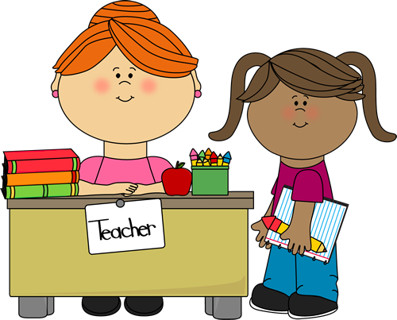

Why? Students who eat school breakfast are more likely to perform better on tests, attend more days of school, and graduate from high school.

What? A wide variety of nutritious and delicious food choices that meet USDA nutrition guidelines.

Where? Make breakfast an integral part of the school day by moving it out of the cafeteria and into the classroom.

When? One model, “breakfast in the classroom” has students eating during the first 10-15 minutes of class. In another model, “second chance breakfast”, usually seen in secondary schools, students eat after the 1st period or during a built-in break.

Who? Breakfast is available for ALL students.

TEACHERS
Why?
Participation in school breakfast programs has traditionally been very low due to barriers such as parents or busses dropping students off too late, students not knowing about school breakfast, students choosing to socialize with friends, or the stigma of sitting in the cafeteria to eat. Recognizing the connection between school breakfast and academic achievement and behavior problems, policy makers across the country are rethinking how and where breakfast is served. The goal is to close the participation gap and ensure kids have the nutrition they need to succeed. As an added benefit, many teachers and principals cite breakfast in the classroom as an opportunity to incorporate social and emotional learning for younger students into the school day. Sharing a meal together in the classroom also reduces the stigma associated with school breakfast for low-income children and provides social bonding time for students and teachers.

What?
School Nutrition Programs and food vendors work together to find breakfast foods that kids like and that meet strict USDA nutritional guidelines. These include breakfast sandwiches, pancakes, muffins, breakfast bars, cereal choices, yogurt, fruit, milk, and lots more. Your school nutrition staff will likely distribute a breakfast menu. We want kids to look forward to eating their morning meal at school with their teacher and classmates.

Where?
Whether students pick up their breakfast and head to the classroom or it is delivered to them by school nutrition staff, students will eat at their desk with their classmates and teacher.

When?
For older students, if the school opts for the model, “Second Chance Breakfast” it happens after the first period or during a built-in break where students get their meal and either eat it in their second period classroom, or if time permits, in the cafeteria. For Breakfast after the Bell, students eat during the first 10-15 minutes of class. This includes clean-up time! Depending on individual school or teacher daily schedule, this may be during morning announcements or while the teacher takes attendance, checks homework, or reviews lessons. Some teachers also use breakfast in the classroom as a means to teach valuable nutrition lessons or incorporate breakfast into reading, science, or math lessons.

Who?
Breakfast is available to ALL students. The National School Breakfast Program is a federal school nutrition program, just like school lunch. Meals are made affordable for all students through subsidies and reimbursements provided by the federal government. If a child gets free or reduced priced meals they will get free breakfast. If a child pays full price for meals they will pay full price (usually around $1.75) for breakfast. The money will come out of their school meal account. Students will either enter their PIN like they do at lunch, or be checked off. No money passes at breakfast and there is no outward identification of meal status. That is why it is important to urge the parents of your students to fill out and return the free/reduced price Meal Application that they receive at the beginning of the school year. The applications are available at any time during the school year, as well. Help to do everything you can to assure healthy meals for kids at school!
HOW CAN I HELP?
- Speak positively about, and promote, school breakfast in the classroom
- Learn the nutrition regulations programs must follow. (include copy of required components)
  - (include a couple of spec sheets on breakfast items showing whole grain and reduced sugar) - highlight healthy food options
- Learn how the reimbursable meals work (one per student, money in accounts, etc)
- Eat with the kids.

MYTHS
Breakfast after the Bell takes away from instructional time.
Some teachers report that they GAIN instructional time due to fewer behavioral disruptions, visits to the school nurse, tardiness and absenteeism. In fact Breakfast in the Classroom has been shown to increase student scores on standardized math and reading tests, particularly in vulnerable populations, proving that when students aren’t focused on hunger pangs, they can concentrate on the lessons being taught in the classroom. (*)

It places an unnecessary burden on teachers
Many teachers spend hundreds of dollars yearly of their own money to feed hungry kids in their classroom. BAB alleviates this burden. Studies show that BAB improves student’s behavior, particularly students’ level of respect and preparedness for class, which means teachers can spend more time teaching and less time disciplining students. (*)

The food is unhealthy
School breakfast is healthier than most people realize. School breakfast must provide ¼ of the RDA for many nutrients and there are tight restrictions on calories, saturated fats and sodium. Breakfast grain products are whole grain rich, milk is skim or 1% fat, juice may be offered but cannot exceed ½ cup and the other fruit servings must be either fresh, frozen, dried or canned in water or light syrup. (*)

School Breakfast-Healthier Than You Think

The Connection Between Food Insecurity, the Federal Nutrition Programs, and Student Behavior

Breakfast for Learning

The Impact of Breakfast After the Bell

Testimonials
My learners walk through the door, anxious to see what smells so good, put their things away for the day, choose their breakfast and sit with friends at the tables while they eat. I see happy learners, filling their bellies while they build relationships with their classmates. A fantastic way to begin our day!
-Jen Brown
Kindergarten Teacher
Chelsea Elementary
RSU 12

Noble Middle School, Berwick, Maine 8/2019
Initially, when I first heard about the breakfast cart, I thought it would be an interruption. I was wrong. It's not at all. It comes at exactly the same time every morning. The students are served quickly and then they head back to class. If this service was not offered, many students would simply skip breakfast. That is not a good way for a child to begin their day. There are a variety of choices offered to the students. Nothing goes to waste. Students are encouraged to take everything that is offered. If they don't like the item, they can simply give it away to a student who does. Without this service, and only having students get breakfast in the cafeteria upon arrival, many students would opt to go to the gym and hang out with their friends rather than have to eat, rather quickly, in the cafe. I'm all for the breakfast cart!

Lisa Pritchett
Math Lab Interventionist
Noble Middle School
lisa.pritchett@msad60.org
For more information and assistance with your program contact:
Christine Greenier MS RD LD
School Nutrition Program Consultant
207-852-2141 cell
csgreenier@gmail.com

Lynnette Harriman, SNS
School Nutrition Program Consultant
207-651-2958 cell
lhconsultingforsnp@gmail.com

Anna Korsen
Program Director
Full Plates Full Potential
207-653-6301
akorsen@fullplates.org
BREAKFAST AFTER THE MORNING BELL

PRINCIPALS

Why? Studies show that students who eat breakfast are more likely to perform better on tests, attendance is better, less disruption in the classrooms and graduation rates are higher

What? Breakfast will include a wide variety of nutritious food choices that not only meet USDA nutrition guidelines, but are also delicious foods that kids will eat!

Where? Breakfast will be part of the school day and available to all students by offering it in the classrooms.

When? Usually within the first 10-15 minutes of class--see list of models to make this happen

Who? Breakfast will be available to all students

PRINCIPALS
Why?
Participation in school breakfast programs has traditionally been very low due to barriers such as parents or busses dropping students off too late, students not knowing about school breakfast, students choosing to socialize with friends, or the stigma of sitting in the cafeteria to eat. Recognizing the connection between school breakfast and academic achievement and behavior problems, policy makers across the country are rethinking how and where breakfast is served. The goal is to close the participation gap and ensure kids have the nutrition they need to succeed. As an added benefit, many teachers and principals cite breakfast in the classroom as an opportunity to incorporate social and emotional learning for younger students into the school day. Sharing a meal together in the classroom also reduces the stigma associated with school breakfast for low-income children and provides social bonding time for students and teachers.

What?
School Nutrition Programs and food vendors work together to find breakfast foods that kids like and that meet strict USDA nutritional guidelines. These include breakfast sandwiches, pancakes, muffins, breakfast bars, cereal choices, yogurt, fruit, milk, and lots more. Your school nutrition staff will likely distribute a breakfast menu. We want kids to look forward to eating their morning meal at school!

Where?
Students may pick up a grab ‘n go type breakfast in the cafeteria, then head to the classroom or it may be delivered to them by School Nutrition Staff on a cart. It can also be a kiosk in the hallway that students go to on their way to class. Middle and High School students may have a different breakfast model called “Second Chance Breakfast” depending on class schedule. Students will eat at their desks with their classmates and teacher.

When?
For older students, if the school opts for the model, “Second Chance Breakfast” it happens after the first period where students get their meal and either eat it in their second period classroom, or if time permits, in the cafeteria. For Breakfast after the Bell, students eat during the first 10-15 minutes of class. Depending on individual school or teacher daily schedule, this may be during morning announcements or while the teacher takes attendance, checks homework, or reviews lessons. Some teachers also use breakfast in the classroom as a means to teach valuable nutrition lessons or incorporate breakfast into reading, science, or math lessons.

Who?
Breakfast is available to ALL students. The National School Breakfast Program is a federal school nutrition program, just like school lunch. Meals are made affordable for all students through subsidies and reimbursements provided by the federal government. If a child gets free or reduced priced meals they will get free breakfast. If a child pays full price for meals they will pay full price (usually around $1.50) for breakfast. The money will come out of their school meal account. Students will either enter their PIN like they do at lunch, or be checked off. No money passes at breakfast and there is no outward identification of meal status. That is why it is important to urge the parents of your students to fill out and return the free/reduced price Meal Application that they receive at the beginning of the school year. The applications are available at any time during the school year, as well. Help to do everything you can to assure healthy meals for kids at school!
MYTHS
Breakfast after the Bell takes away from instructional time.
Some teachers report that they GAIN instructional time due to fewer behavioral disruptions, visits to the school nurse, tardiness and absenteeism. In fact Breakfast in the Classroom has been shown to increase student scores on standardized math and reading tests, particularly in vulnerable populations, proving that when students aren’t focused on hunger pangs, they can concentrate on the lessons being taught in the classroom. (*)

It places an unnecessary burden on teachers
Many teachers spend hundreds of dollars yearly of their own money to feed hungry kids in their classroom. BAB alleviates this burden. Studies show that BAB improves student’s behavior, particularly students’ level of respect and preparedness for class, which means teachers can spend more time teaching and less time disciplining students. (*)

The food is unhealthy
School breakfast is healthier than most people realize. School breakfast must provide ¼ of the RDA for many nutrients and there are tight restrictions on calories, saturated fats and sodium. Breakfast grain products are whole grain rich, milk is skim or 1% fat, juice may be offered but cannot exceed ½ cup and the other fruit servings must be either fresh, frozen, dried or canned in water or light syrup. (*)

School Breakfast-Healthier Than You Think

HOW CAN I HELP?
- Brainstorm with faculty and staff at staff meeting to get input from them on how they think this will work.
- Promote Breakfast after the Bell with teachers and staff by stressing the positive outcomes of students when they start their school day with a nutritious breakfast.
- Visit the classrooms when children are eating to show your support.

The Connection Between Food Insecurity, the Federal Nutrition Programs, and Student Behavior

Breakfast for Learning

The Impact of Breakfast After the Bell

Testimonials:
“The Breakfast Cart is a welcoming sight at NMS. Always festively decorated and serving students with a smile! It helps to provide all students with the fuel for learning first thing in the morning.”
Melinda Luders, Vice Principal, Noble Middle School
Milinda.Luders@msad60.org

“We have students eating who never used to eat. ODR's (Office Disciplinary Referrals) are way down which I believe is because of the sense of community we encourage as students eat their breakfast. It is a great way to have students start their day with full bellies. Many of our students were arriving to school with junk food to eat for breakfast and the behavior that followed was a result of this. A challenge that we had was teacher buy in but after the first day we had all the teachers bought in as they saw the difference in their students almost immediately.”
Patricia Metta, Principal. Chelsea Elementary School

“My elementary school has been serving free breakfast for several months now, and across the board we love it. Students are able to come in and eat family-style in the lower grades, which gives them time to connect with their peers and teachers. It also gives them all an equal chance to start the day with a healthy meal. Students report that they are happy to get food at school because they didn't like to ride the bus right after eating at home. Teachers are happy that all of their students are starting the day this way as it results in happier, calmer students who can focus on their work. We are thrilled to participate in this program.”
Heather Wilson, Principal, Windsor Elementary School

For more information and assistance with your program contact:

Christine Greenier MS RD LD
School Nutrition Program Consultant
207-852-2141 cell
csgreenier@gmail.com

Lynnette Harriman, SNS
School Nutrition Program Consultant
207-651-2958 cell
lhconsultingforsnp@gmail.com

Anna Korsen
Program Director
Full Plates Full Potential
207-653-6301
akorsen@fullplates.org

BREAKFAST AFTER THE SCHOOL BELL

SCHOOL NUTRITION STAFF

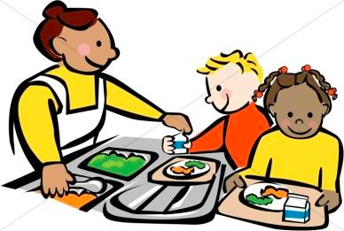

Why? Students need a healthy breakfast daily to do their best

What? A wide variety of healthy and delicious food

Where? In the classrooms, either delivered or picked up

When? Usually during the first 10-15 minutes after the bell-- Can also be a second chance type or grab n go.

Who? Breakfast is available to all students every day

SCHOOL NUTRITION STAFF
WHY?
As you already know there is a lot of room for improvement in the numbers of students who enjoy breakfast at school. Most of you have tried many different ways to increase breakfast counts. Breakfast After the Bell is aimed at helping to increase meal counts and cut down on hungry children trying to learn. We already know that studies are showing there is a connection between school breakfast and academic achievement, decreased behavior problems, fewer visits to the school nurse and increased attendance. Breakfast after the bell will allow students to socialize with their friends and still be able to eat a healthy breakfast. Many families are on a tight budget or are too busy in the mornings to get much for food for their children. Some children cannot eat first thing in the morning. Breakfast after the bell will help to get food to all the children who need it.

WHAT?
We want to offer nutritious and tasty foods to children that meet the SNP Guidelines for a healthy breakfast. Talk to other schools and your vendors to find new and exciting items to help keep students interested.

WHERE?
Many students miss out on breakfast at school because of being dropped off too late, not knowing what is available or choosing not to eat in the cafeteria. Breakfast after the Bell can help us reach those students and more. Work together with the principal and teachers to find the best way to get breakfast to the classroom so all kids can eat together with their teacher. Breakfast will be a part of the school day! It can be grab n go type meals in a bag given out from a cart as students head for the classrooms, it can be a cart that goes around to rooms, maybe a kiosk in the hallway where students can come to get their meal. What ideas do you have??

WHEN?
Timing will depend on your school’s schedule. Usually 10-15 minutes after the beginning bell for school to start. There are different school breakfast models to look at. The meal will be enjoyed by all students after the start of school--as part of the school day.

WHO?
School Nutrition Staff will be the leaders in this effort to feed more hungry children! Don’t hesitate to ask for help if you need more ideas or help with implementing this new program. There is money and resources available for you to get what you need and help get this program running smoothly. Remember that this is a great thing for our students and people will get on board once they see how easily this new change can be put in place. Let’s meet this challenge and watch the numbers go UP on our breakfast counts as we fill the needs of these hungry children.

HOW CAN I GET A PROGRAM STARTED?

- Talk to Administration--start with your Superintendent, then the principal of your school. Get support for feeding the hungry students in your school after the bell before beginning if possible. Maybe even have the principal put you on the agenda for a staff meeting so you can lay out your plans for them and answer any questions.
- Get your managers and kitchen staff on board. Some may see it as extra work. Remind them our job is to get food to as many hungry students as we can. Most of the time you won’t need extra labor--it is just a different way to serve breakfast and a rearrangement of the existing labor. It is exciting to see the counts go up.
- There are many ways to start a breakfast after the bell program at your school. Here is a list of some techniques that are used in other schools:
  - At the high school level some schools are able to open the cafeteria for 10-15 minutes after the first bell and some also let them do it again for the second period of the day...allowing students to come get breakfast that might have missed it before school.
  - “Grab n Go” type…..can be offered at the cafeteria just before the first bell rings...and continuing after the bell so that any students wanting to get a breakfast can pick it up and take it to the classroom to eat.
  - Kiosk in the hallways...a “Grab n Go” type bag or even a 5# paper boat works well for grab n go type meals. The kiosk should be located centrally to help students get served quickly and get to the classroom to eat after the bell.
  - Breakfast cart that either sits in the hallway OR one that visits classrooms after the first bell. A hand held tablet works well to enter students as they come for their breakfast. Take a look at the Breakfast Video from Noble Middle School--the link is listed below for you. They have two carts that visit at least 20 classrooms on 3 floors after the first bell.
- If you run into some opposition to your plan...one idea that has worked well in the past is to ask for permission to try a “pilot” program for 4 weeks….to work out the issues, etc...and see if the breakfast counts go up. Usually that will help you get it up and running and show some good results

Example of planning outline to get you started:
- 1. What model would work well in my school?
  - Grab and Go
  - Breakfast in the Classroom
  - Other
- 2. What equipment will I need?
  - Cart
  - POS
  - what else?
- 3. Staffing.....
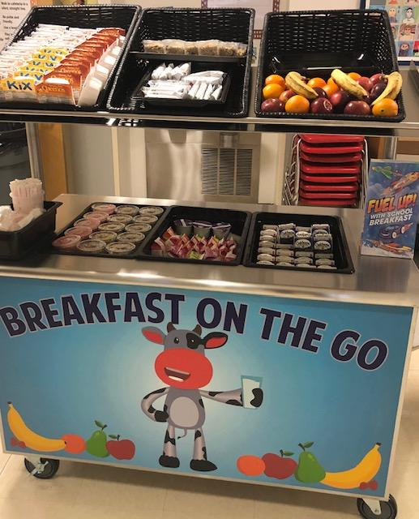
RESOURCES:
There are 4 breakfast cart videos available on the Maine Department of Education Child Nutrition Website under Breakfast Programs and then scroll down to the videos.
Noble Middle School Breakfast After the Bell Video

Funding is available to support schools switching to Breakfast After the Bell! If your school has 50% or more students eligible for free and reduced meals, you can apply for state funding here. In addition, any school can apply for Full Plates Full Potential’s Breakfast Grant. For more information contact Anna Korsen, Chris Greenier, or Lynnette Harriman.

Testimonials
“We started doing the breakfast cart here at NMS about ten years ago. Our high school had done it in the past with great success so we were hopeful we'd get good results. Our breakfast counts went from averaging around 50 to over 200. Not only do the kids love it but we've gotten great feedback from the teachers as well. They've seen the difference between trying to teach a hungry child vs a well fed child so they welcome us with open arms!”
Julie Downs, Kitchen Manager, Noble Middle School
Julie.Downs@msad60.org

“The breakfast cart we purchased through the Full Plates grant has greatly impacted our school breakfast program at Wells Elementary School. Our breakfast participation has doubled in only 3 months and the students love it!”
Christian Pasternak, School Nutrition Director, Wells-Ogunquit Consolidated School District

For more information and assistance with your program contact:
Christine Greenier MS RD LD
School Nutrition Program Consultant
207-852-2141 cell
207-862-4770 home
csgreenier@gmail.com

Lynnette Harriman, SNS
School Nutrition Program Consultant
207-651-2958 cell
207-793-8926 home
lhconsultingforsnp@gmail.com

Anna Korsen
Program Director
Full Plates Full Potential
207-653-6301
akorsen@fullplates.org
BREAKFAST AFTER THE SCHOOL BELL

BUSINESS MANAGERS

Why? Studies show that students who eat breakfast are more likely to perform better on tests, attendance is better, there is less disruption in the classrooms and graduation rates are higher

What? Students will be offered a wide variety of nutritious food choices that not only meet USDA guidelines but are delicious!

Where? Breakfast will be part of the school day and available to all students by offering it in the classrooms.

When? Usually within the first 10-15 minutes of class--see list of models to make this happen

Who? Breakfast will be available to all students

BUSINESS MANAGERS
Why? - Participation in school breakfast programs has traditionally been very low due to barriers such as parents or busses dropping students off too late, students not knowing about school breakfast, students choosing to socialize with friends, or the stigma of sitting in the cafeteria to eat. Recognizing the connection between school breakfast and academic achievement and behavior problems, policy makers across the country are rethinking how and where breakfast is served. The goal is to close the participation gap and ensure kids have the nutrition they need to succeed. As an added benefit, many teachers and principals cite breakfast in the classroom as an opportunity to incorporate social and emotional learning for younger students into the school day. Sharing a meal together in the classroom also reduces the stigma associated with school breakfast for low-income children and provides social bonding time for students and teachers. Additionally, School Nutrition Programs are reimbursed by the federal government. As numbers of students participating in the expanded school breakfast programs increase, reimbursement income can in large part, pay for the additional cost of feeding more children. Reimbursement for an income qualified free student breakfast is $2.14, reduced is $1.84, and paid is $ .31. This could potentially bring thousands of dollars to your School Nutrition Program.

What? - School Nutrition Programs and food vendors work together to find breakfast foods that kids like and that meet strict USDA nutritional guidelines. These include breakfast sandwiches, pancakes, muffins, breakfast bars, cereal choices, yogurt, fruit, milk, and lots more. Your school nutrition staff will likely distribute a breakfast menu. We want kids to look forward to eating their morning meal at school!

Where? - Students may pick up a grab ‘n go type breakfast in the cafeteria, then head to the classroom or it may be delivered to them by School Nutrition Staff on a cart. It can also be a kiosk in the hallways that students go to on their way to class. Middle and High School Students may have a different Breakfast after the Bell model. Most will eat at their desks with their classmates and teacher.

When? - For older students, if the school opts for the model, “Second Chance Breakfast” it happens after the first period where students get their meal and either eat it in their second period classroom, or if time permits, in the cafeteria. For Breakfast after the Bell, students eat during the first 10-15 minutes of class. Depending on individual school or teacher daily schedule, this may be during morning announcements or while the teacher takes attendance, checks homework, or reviews lessons. Some teachers also use breakfast in the classroom as a means to teach valuable nutrition lessons or incorporate breakfast into reading, science, or math lessons.

Who? - Breakfast is available to ALL students. The National School Breakfast Program is a federal school nutrition program, just like school lunch. Meals are made affordable for all students through subsidies and reimbursements provided by the federal government. If a child gets free or reduced priced meals they will get free breakfast. If a child pays full price for meals they will pay full price (usually around $1.50) for breakfast. The money will come out of their school meal account. Students will either enter their PIN like they do at lunch, or be checked off. No money passes at breakfast and there is no outward identification of meal status. That is why it is important to urge the parents of your students to fill out and return the free/reduced price Meal Application that they receive at the beginning of the school year. The applications are available at any time during the school year, as well. Help to do everything you can to assure healthy meals for kids at school!

HOW CAN I HELP?
Introduce at School Board meeting. Bring School Nutrition Director, students and a Champion!

Visit classrooms during breakfast.

MYTHS
School breakfast will cost your school money.
This is not true. The School Nutrition Program will receive federal reimbursement to support their breakfast program. The more kids that eat school breakfast, the more revenue the district has to make their program a success.

For more information and assistance with your program contact:

Christine Greenier MS RD LD
School Nutrition Program Consultant
207-852-2141 cell
207-862-4770 home
csgreenier@gmail.com

Lynnette Harriman, SNS
School Nutrition Program Consultant
207-651-2958 cell
207-793-8926 home
lhconsultingforsnp@gmail.com

Anna Korsen
Program Director
Full Plates Full Potential
207-653-6301
akorsen@fullplates.org

BREAKFAST AFTER THE SCHOOL BELL

SUPERINTENDENT

WHY? Studies show that students who eat breakfast are more
likely to perform better on tests, less disruption in the
classroom, better attendance and graduation rates

WHAT? Healthy breakfast food for students

WHERE? In the classrooms

WHEN? Usually within the first 10-15 minutes of class

WHO? All students can get breakfast

HOW? Grab n go, breakfast carts, Kiosks, etc.

SUPERINTENDENTS

Why? - Participation in school breakfast programs has traditionally been very low due to barriers such as parents or busses dropping students off too late, students not knowing about school breakfast, students choosing to socialize with friends, or the stigma of sitting in the cafeteria to eat. Recognizing the connection between school breakfast and academic achievement and behavior problems, policy makers across the country are rethinking how and where breakfast is served. The goal is to close the participation gap and ensure kids have the nutrition they need to succeed. As an added benefit, many teachers and principals cite breakfast in the classroom as an opportunity to incorporate social and emotional learning for younger students into the school day. Sharing a meal together in the classroom also reduces the stigma associated with school breakfast for low-income children and provides social bonding time for students and teachers. Additionally, School Nutrition Programs are reimbursed by the federal government. As numbers of students participating in the expanded school breakfast programs increase, reimbursement income can in large part, pay for the additional cost of feeding more children. Reimbursement for an income qualified free student breakfast is $2.14, reduced is $1.84, and paid is $ .31. This could potentially bring thousands of dollars to your School Nutrition Program.

What? - School Nutrition Programs and food vendors work together to find breakfast foods that kids like and that meet strict USDA nutritional guidelines. These include breakfast sandwiches, pancakes, muffins, breakfast bars, cereal choices, yogurt, fruit, milk, and lots more. Your school nutrition staff will likely distribute a breakfast menu. We want kids to look forward to eating their morning meal at school!

Where? - Students may pick up a grab ‘n go type breakfast in the cafeteria, then head to the classroom or it may be delivered to them by School Nutrition Staff on a cart. It can also be a kiosk in the hallways that students go to on their way to class. Middle and High School Students may have a different Breakfast after the Bell model. Most will eat at their desks with their classmates and teacher.

When? - For older students, if the school opts for the model, “Second Chance Breakfast” it happens after the first period where students get their meal and either eat it in their second period classroom, or if time permits, in the cafeteria. For Breakfast after the Bell, students eat during the first 10-15 minutes of class. Depending on individual school or teacher daily schedule, this may be during morning announcements or while the teacher takes attendance, checks homework, or reviews lessons. Some teachers also use breakfast in the classroom as a means to teach valuable nutrition lessons or incorporate breakfast into reading, science, or math lessons.

Who? - Breakfast is available to ALL students. The National School Breakfast Program is a federal school nutrition program, just like school lunch. Meals are made affordable for all students through subsidies and reimbursements provided by the federal government. If a child gets free or reduced priced meals they will get free breakfast. If a child pays full price for meals they will pay full price (usually around $1.50) for breakfast. The money will come out of their school meal account. Students will either enter their PIN like they do at lunch, or be checked off. No money passes at breakfast and there is no outward identification of meal status. That is why it is important to urge the parents of your students to fill out and return the free/reduced price Meal Application that they receive at the beginning of the school year. The applications are available at any time during the school year, as well. Help to do everything you can to assure healthy meals for kids at school!

HOW CAN I HELP?

Introduce at School Board meeting. Bring School Nutrition Director, students and a Champion!

Visit classrooms during breakfast

Make school breakfast an agenda item at administrative meetings. Share successes and challenges.

MYTHS
School breakfast will cost your school money.
This is not true. The School Nutrition Program will receive federal reimbursement to support their breakfast program. The more kids that eat school breakfast, the more revenue the district has to make their program a success.

The Connection Between Food Insecurity, the Federal Nutrition Programs, and Student Behavior

Breakfast for Learning

The Impact of Breakfast After the Bell

For more information and assistance with your program contact:

Christine Greenier MS RD LD
School Nutrition Program Consultant
207-852-2141 cell
207-862-4770 home
csgreenier@gmail.com

Lynnette Harriman, SNS
School Nutrition Program Consultant
207-651-2958 cell
207-793-8926 home
lhconsultingforsnp@gmail.com

Anna Korsen
Program Director
Full Plates Full Potential
207-653-6301
akorsen@fullplates.org

