15% Absenteeism Reporting Reference Guide-updated to include COVID-19
Located in NEO under Student Data tab
The login page: https://neo.maine.gov/DOE/NEO/Accounts/Account/Login

- If you DO NOT yet have a NEO login, contact your Superintendent so they may submit an Access Request Form. (Found towards the bottom of the Helpdesk Webpage)

- If you DO already have a NEO login and are having trouble, contact the Help Desk: 624-6896 or email: medms.helpdesk@maine.gov

Navigation:
1) Go to the ‘Student Data’ tab up top. (If you do not have this option, please contact your Superintendent to grant the access).
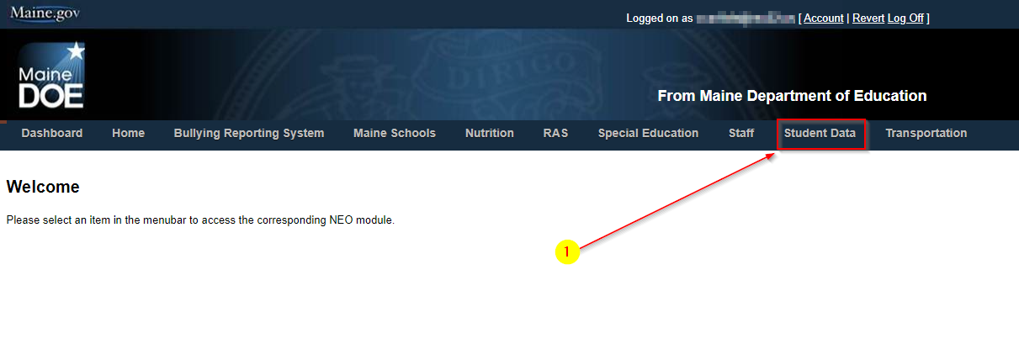
- Choose the ‘Student Health’ tab up top, or the link on the left to enter the module:
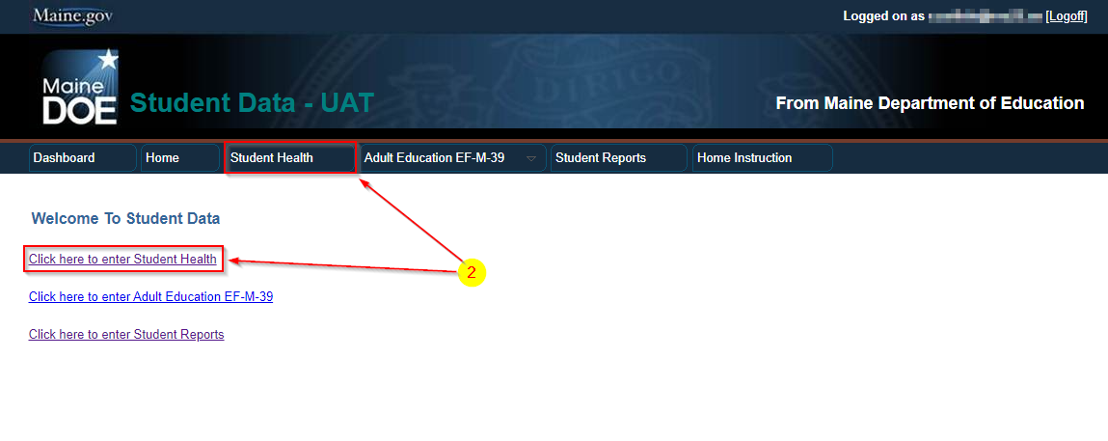
- This is the main page that explains the reporting. Use the links at the bottom to view previous school/district reports, or use the second link to Create New High Absenteeism Report:
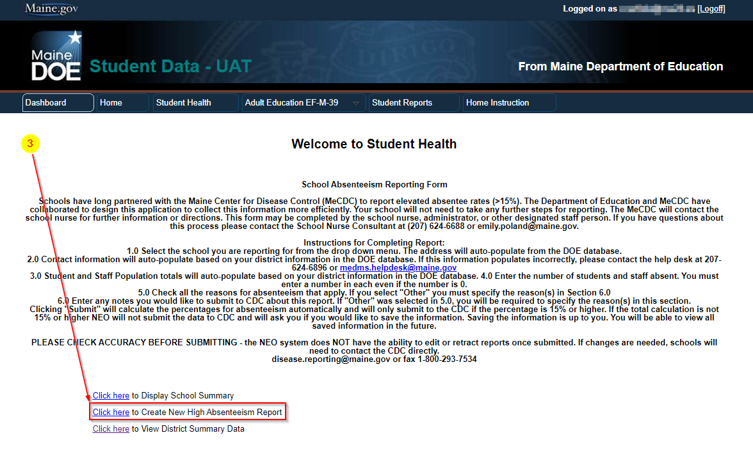

- This will load the report to be filled out (see below):

…Continued on next page

