Maine Defines School Success: Presque Isle and Bangor
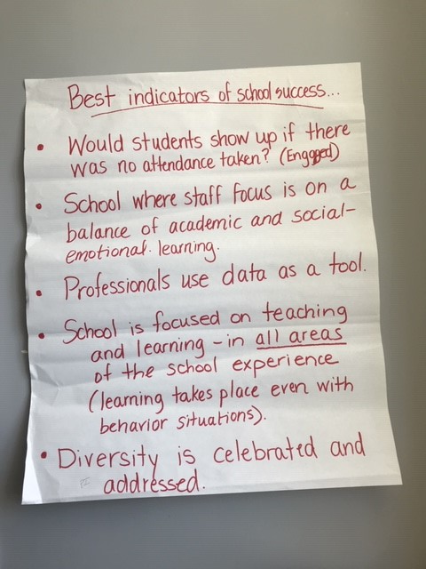
1 Presque Isle

Image 1 Presque Isle
- Best indicators of school success
  - Would students show up if there was no attendance taken? (engaged)
  - School where staff focus is on a balance of academic and social-emotional learning
  - Professionals use data as a tool
  - School is focused on training and learning – in all areas of the school experience (learning takes place even with behavioral situations)
  - Diversity is celebrated and addressed

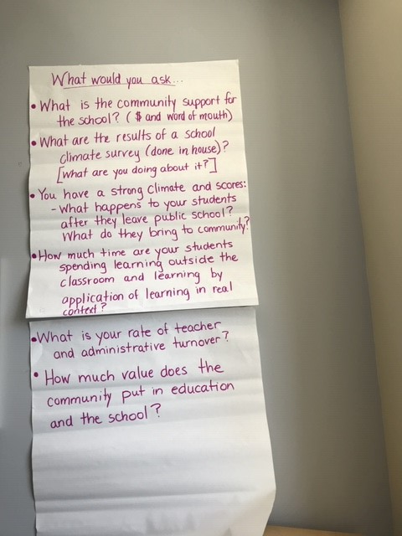
2 Presque Isle

Presque Isle

Image 2 Presque Isle
- What would you ask…
  - What is the community support for the school? (money and word of mouth)
  - What are the results of a school climate survey (done in-house)? What are you doing about it?
  - You have a strong climate and scores:
    - What happens to your students after they leave public school? What do they bring to the community?
  - How much time are your students spending learning outside the classroom and learning by application of learning in real context?
  - What is your rate of teacher and administrative turnover?
  - How much value does the community put in education and the school?

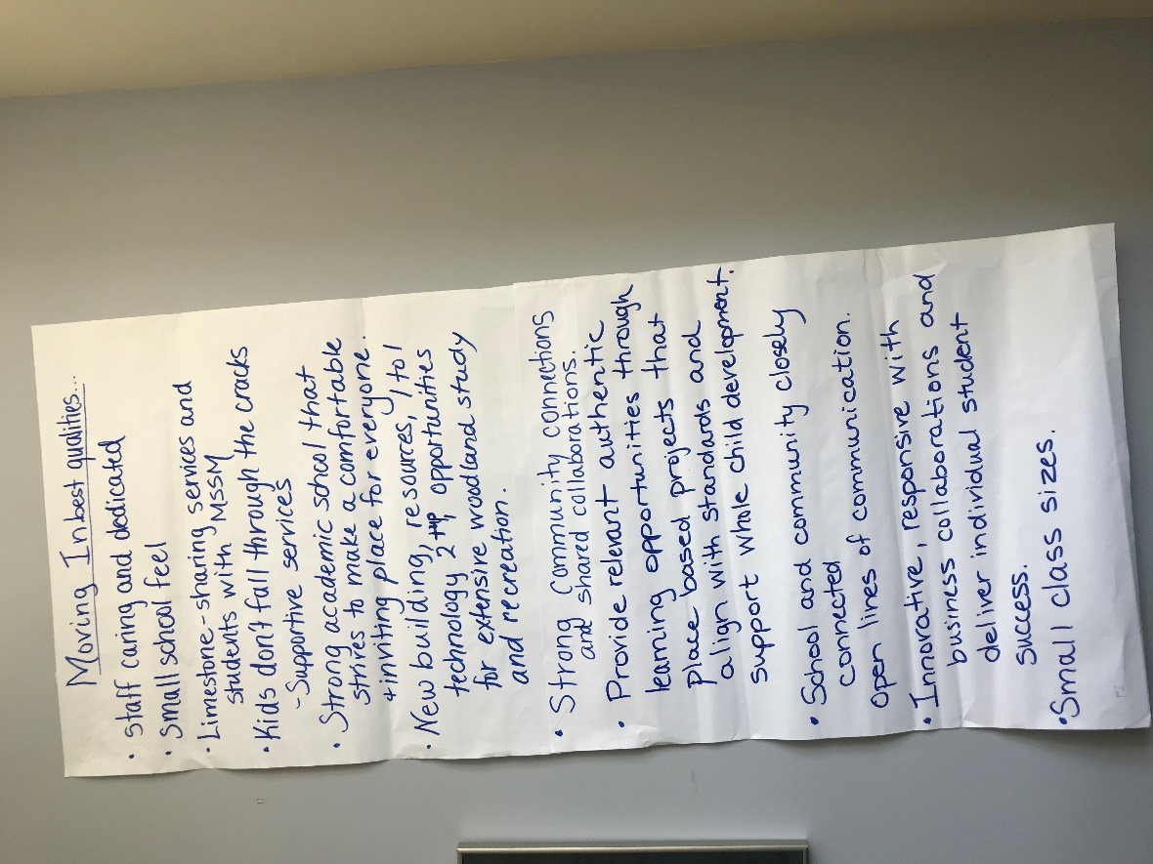
3 Presque Isle
Image 3 Presque Isle
- Moving In best qualities…
  - staff caring and dedicated
  - small school feel
  - Limestone – sharing services and students with MSSM
  - Kids don’t fall through the cracks
    - Supportive services
  - Strong academic school that strives to make a comfortable and inviting place for everyone
  - New building, resources, 1 to 1 technology 2TNP, opportunities for extensive woodland study and recreation
  - Strong community connections and shared collaborations
  - Provide relevant authentic learning opportunities through place-based projects that align with standards and support child development
  - School and community closely connected
  - Innovative, responsive with business collaborations and deliver individual student success
  - Small class sizes

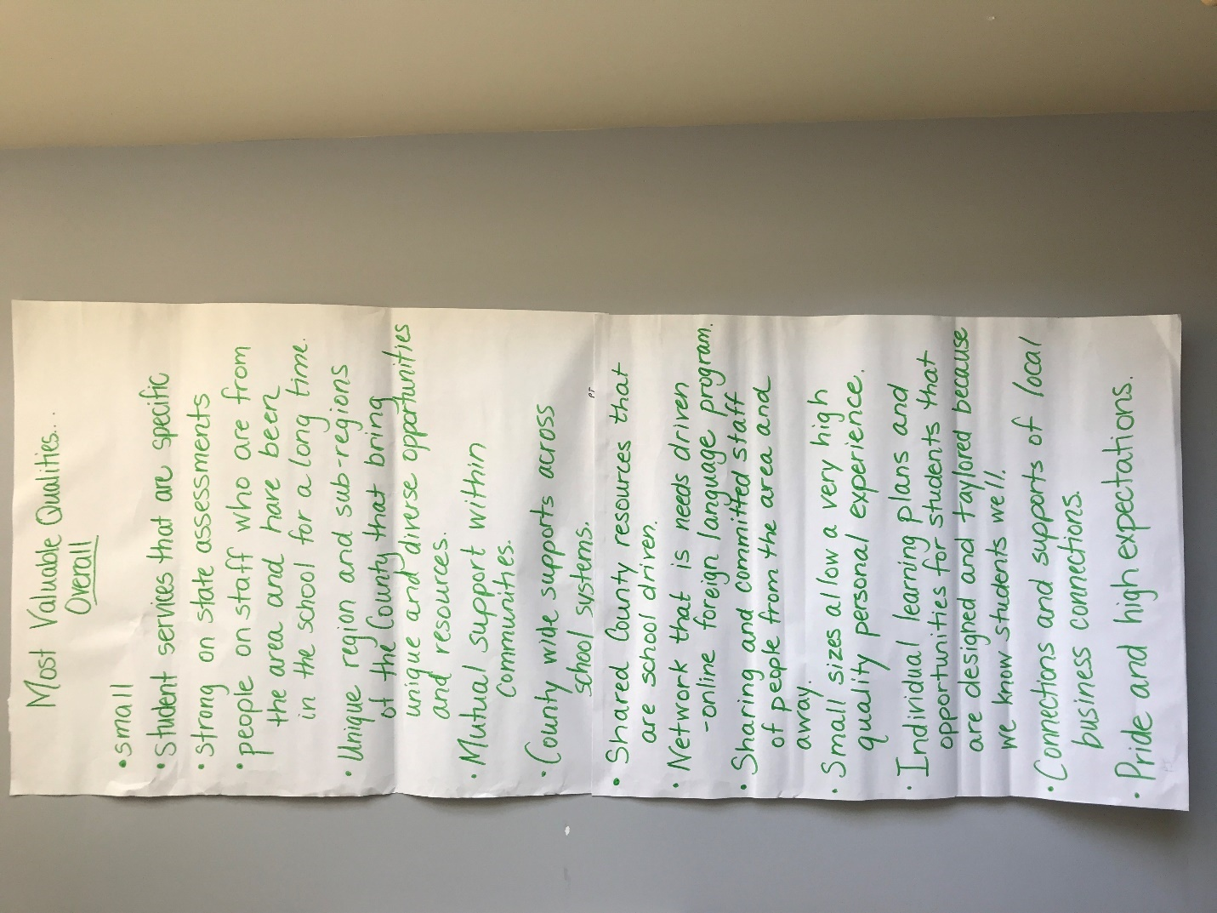

4 Presque Isle

Image 4 Presque Isle
- Most valuable qualities overall
  - Small
  - Student services that are specific
  - Strong on state assessments
  - People on staff who are from the area and have been in the school for a long time
  - Unique region and sub-regions of the country that bring unique and diverse opportunities and resources
  - Mutual support within communities
  - County wide supports across school systems
  - Shared county resources that are school-driven
  - Network that is needs-driven
    - Online foreign language program
  - Sharing and committed staff of people from the area and away
  - Small sizes allow a very high-quality personal experience
  - Individual learning plans and opportunities for students that are designed and tailored because we know students well
  - Connections and support of local business connections
  - Pride and high expectations

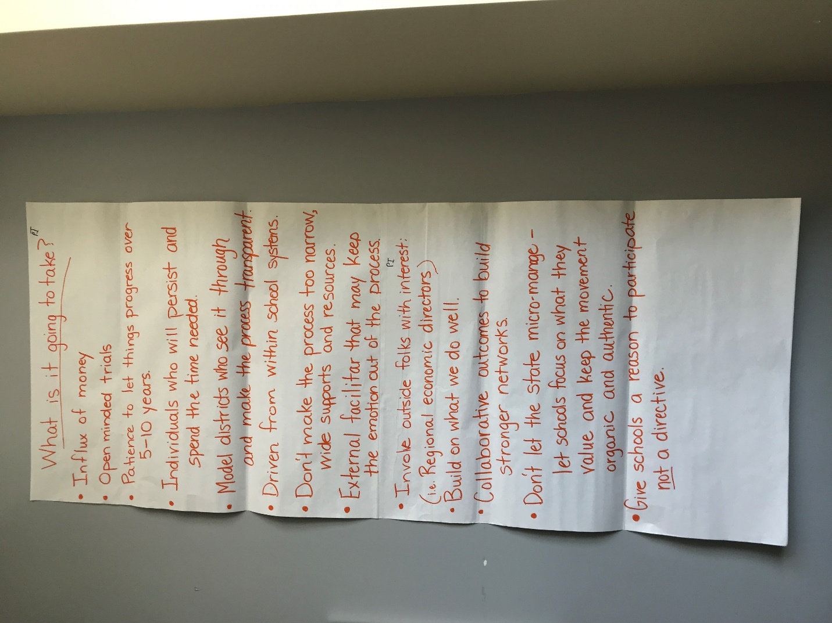

5 Presque Isle
Image 5 Presque Isle
- What is it going to take?
  - Influx of money
  - Open-minded trials
  - Patience to let things progress over 5-10 years
  - Individuals who will persist and spend the time needed
  - Model districts who see it through and make the process transparent
  - Driven from within school systems
  - Don’t make process too narrow, wide supports and resources
  - External facilitator that may keep emotions out of the process
  - Involve outside folks with interest (i.e. regional economic directors)
  - Build on what we do well
  - Collaborative outcomes to build stronger networks
  - Don’t let the state micro-manage -- let schools focus on what they value and keep the movement organic and authentic
  - Give schools a reason to participate, not a directive

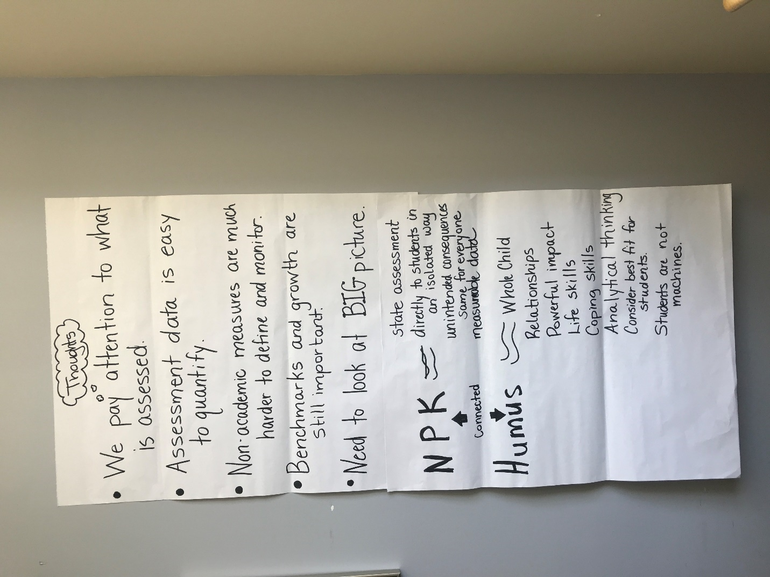

6 Presque Isle

Image 6 Presque Isle
- Thoughts (related to use of state assessments to determine the success of schools)
  - We pay attention to what is addressed
  - Assessment data is easy to quantify
  - Non-academic measures are much harder to define and monitor
  - Benchmarks and growth are still important
  - Need to look at the BIG picture
  - Analogy based on a reading NPK (nitrogen, phosphorous, potassium) = state assessment given directly to students in an isolated way; unintended consequences same for everyone; measurable data
  - NPK is connected to Humus
  - Humus = whole child, relationships, power impact, life skills, coping skills, analytical thinking, considering the best fit for students -- students are not machines

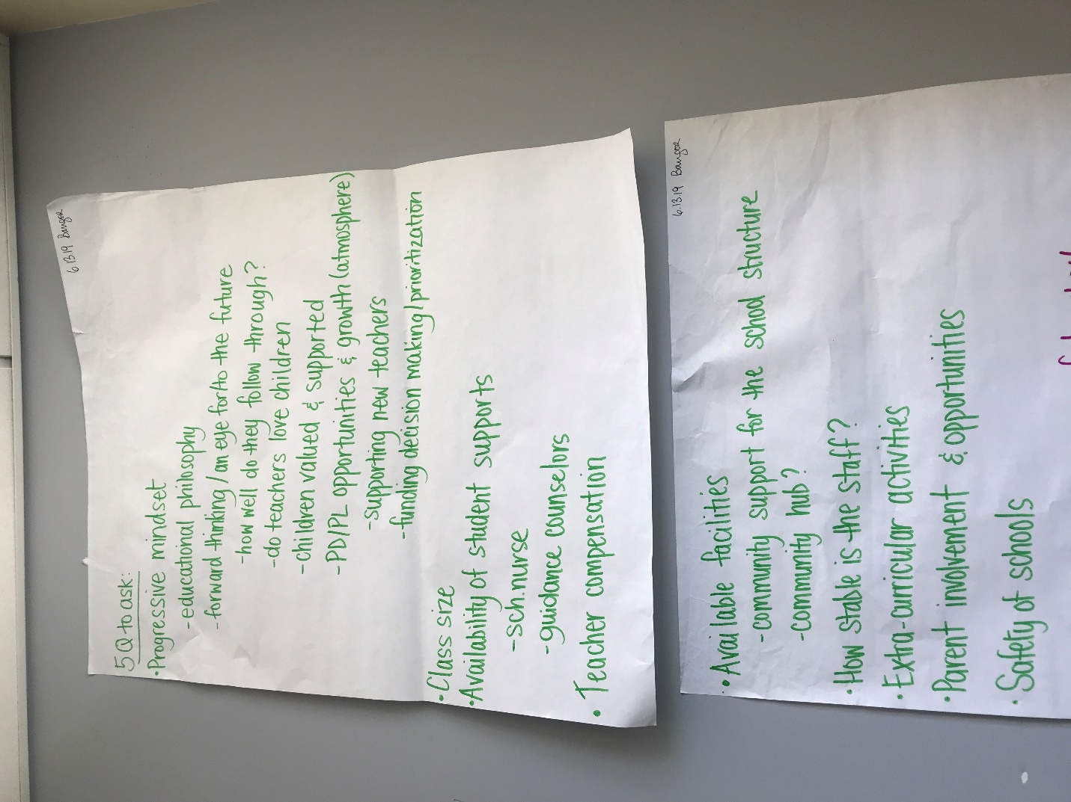

1 Bangor

Image 1 Bangor
- 5 Q to ask:
  - Progressive Mindset
    - Educational philosophy
    - Forward thinking--an eye for/to the future
      - How well do they follow through?
      - Do teachers love children?
      - Children valued & supported
      - PD/PL opportunities and growth (atmosphere)
        - Supporting new teachers
        - Funding decision making/prioritization
  - Class Size
  - Availability of student supports
    - School nurse
    - Guidance counselors
  - Teacher compensation
  - Available facilities
    - Community support for the school structure
    - Community hub?
  - How stable is the staff?
  - Extra-curricular activities
  - Parental involvement and opportunities
  - Safety of schools

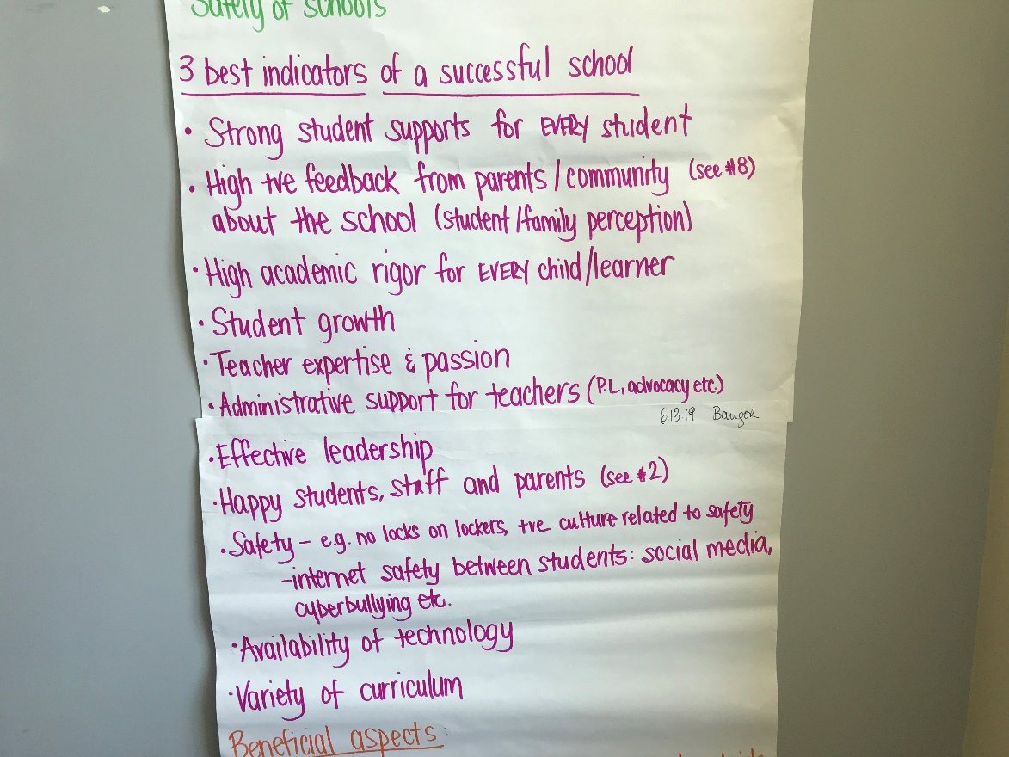
2 Bangor

Image 2 Bangor
- 3 best indicators of a successful school
  - Strong student support for every student
  - High positive feedback from parents/ community (see #8) about the school (student/family perception)
  - High academic rigor for every child/learner
  - Student growth
  - Teacher expertise and passion
  - Administrative support for teachers (P.L., advocacy, etc.)
  - Effective leadership
  - Happy students, staff, and parents (see #2)
  - Safety – e.g. no locks on lockers, the culture related to safety
    - Internet safety between students: social media, cyberbullying, etc.
  - Availability of technology
  - Variety of curriculum

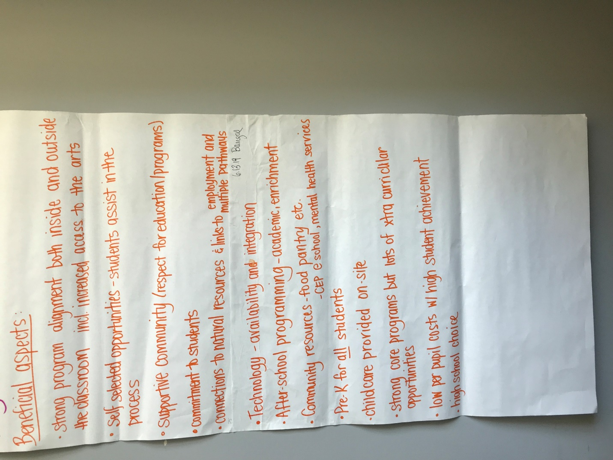

3 Bangor

Image 3 Bangor
- Beneficial aspects
  - Strong program alignment both inside and outside the classroom including increased access to the arts
  - Self-selected opportunities -- students assist in the process
  - Supportive community (respect for educational programs)
  - Commitment to students
  - Connections to natural resources and links to employment and multiple pathways
  - Technology – availability and integration
  - After-school programming – academic enrichment
  - Community resources – food pantry, etc.
    - CEP at school, mental health services
  - Pre-K for all students
  - Childcare provided on site
  - Strong core programs but lots of extra-curricular opportunities
  - Low per pupil costs with high student achievement
  - High school choice

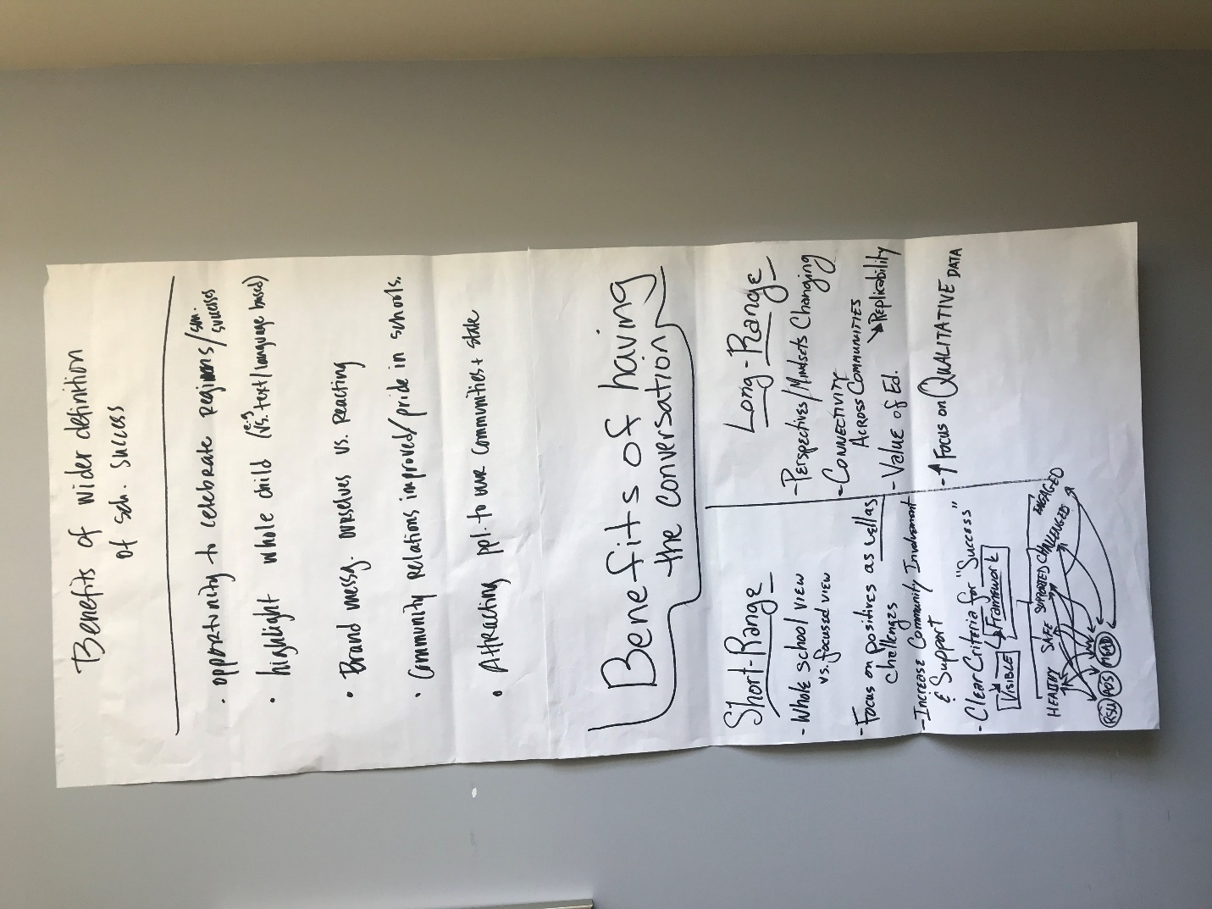

4 Bangor

Image 4 Bangor
- Benefits of wider definition of school Success
  - Opportunity to celebrate region/SAU successes
  - Highlight whole child (e.g. vs. text/language based)
  - Brand message -- Ourselves vs. reacting
  - Community relations improved/pride in our schools
  - Attracting people 6to our communities + State of Maine
Short Term | Long term
Whole school view v. focused view | Perspectives / mindsets changing
Focus on positives as well as challenges | Connectivity across communities (replicability)
Increase community involvement and support | Value of ed.
clear criteria for “success”  visible framework  l  l l l l l  healthy safe supported challenged engaged | Increased focus on qualitative data

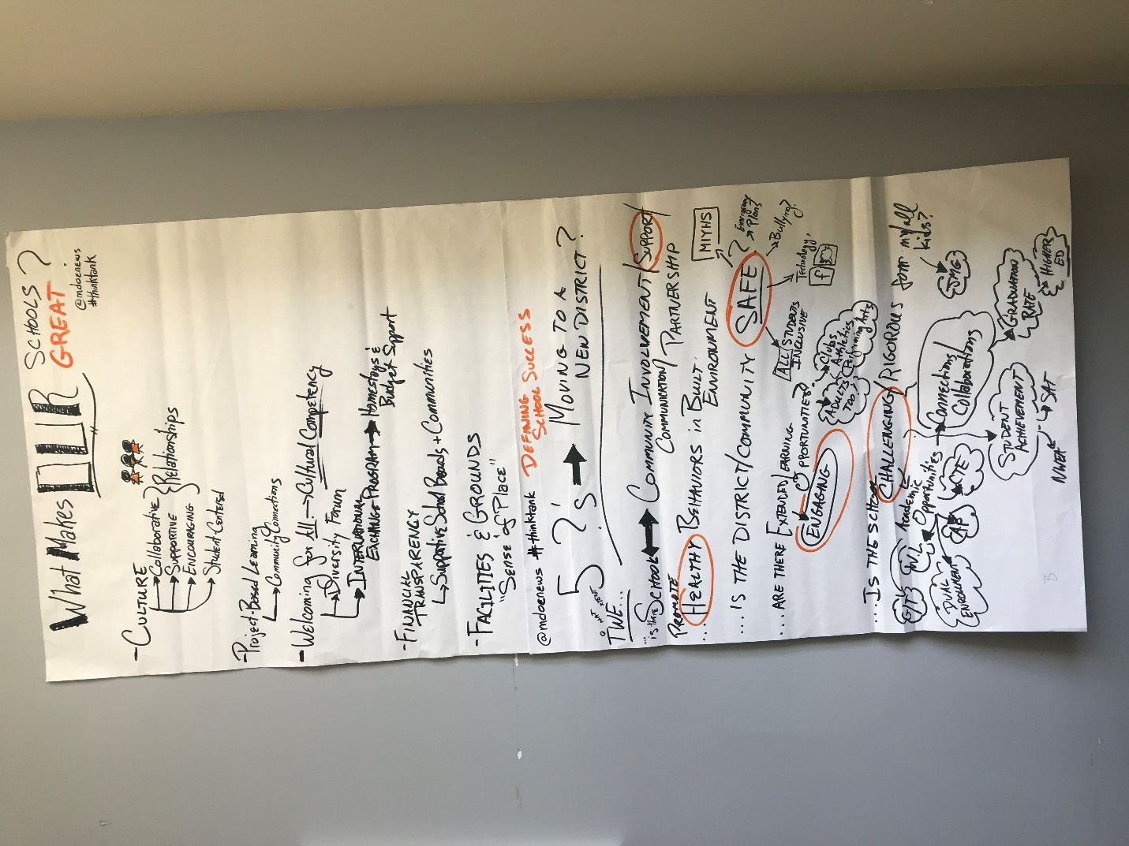

5 Bangor

Image 5 Bangor
- What makes our schools great?
  - Culture – collaborative, supportive, encouraging, student-centered
    - Relationships
  - Project- based learning
    - Community connections
  - Welcoming for all – cultural competency
    - Diversity forum
    - International exchange program – homestays and budget support
  - Financial transparency
    - Supportive school boards and communities
  - Facilities and grounds
    - “sense of place”
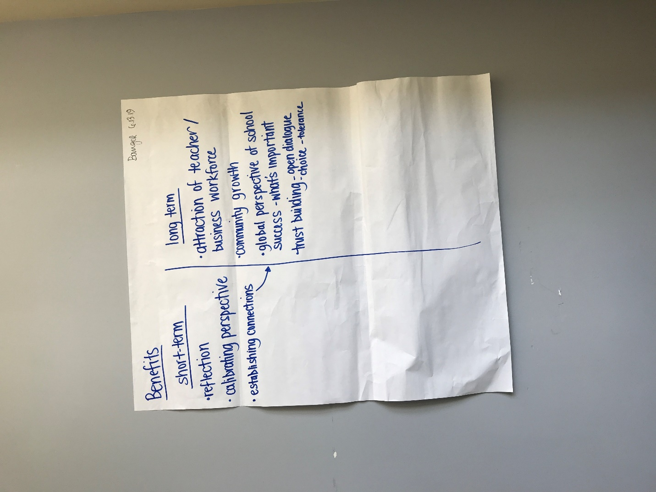
6 Bangor
Image 6 Bangor
What are the short and long term benefits of having this conversation?
Short Term | Long term
Reflection | Attraction of teacher/ business workforce
Calibrating perspective | Community growth
Establishing connections | Global perspective at school success – what’s important
Trust building – open dialogue
Choice – tolerance

