MAARS Workshop Q & A
November 2019

MAARS Workshops
November 19-21, 2019
Q & A Document

Q: One of my students scored 500 on the Math SAT. The state average is listed as 481. Why does it show the student is Below State Expectations?
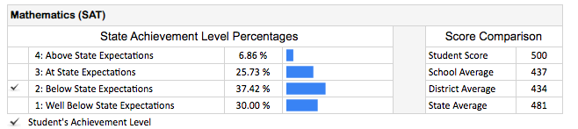
The cut scores/achievement levels for SAT are as follows:

Test | Level | Grade | Cut Scores
SAT Math | 4 | 11 | 650-800
 | 3 | 11 | 530-640
 | 2 | 11 | 420-520
 | 1 | 11 | 200-410
SAT ELA | 4 | 11 | 630-800
 | 3 | 11 | 480-620
 | 2 | 11 | 420-470
 | 1 | 11 | 200-410
A: Math score of 500 falls in the Level 2/Below range (420-520), as is the state average.

Q: When students have moved out of the district, are all districts mailing the reports to the new school or families?
- Related, is it possible to send ISRs to attending and responsible schools at time of release of ISR instead of at time of testing? My district has high school choice. I receive all 8th graders ISRs and have to coordinate with over 20 high schools to get ISRs to the correct school and student family. If DOE could use Oct enrollment to determine to what schools ISRs could be delivered in the fall, this would help a lot. Thanks for considering. (contact me, Deb Taylor, dtaylor@svrsu.org, if you want to discuss further or need me to clarify my question.)
A: The Maine DOE provides the ISRs to the responsible district to distribute to families. It is the school/district discretion as to when these are provided and which document (summary vs. comprehensive) best meets the needs for the families.
- Thank you for the feedback regarding the distribution of ISRs to the responsible districts. We will review this functionality further.

Q: For show schools, is there a way to remove outplacements from the list?
A: All schools are listed under “show schools.” This includes schools within the district and schools outside of the district but to which students attend. These are listed under the district purview as the district is the responsible district. “Outplacements” are students for whom the district is responsible as the sending district.

Q: When are we going to see a flat CSV export instead of a formatted excel file?
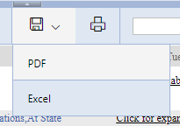
To add to this, separate tabs doesn’t help in the excel output, a column with “grade” would make more sense.
Just to give an idea of how tedious this is to download, we have to go into each assessment:
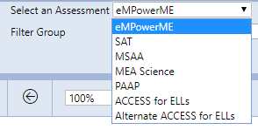
Go into each of the individual subjects:
Click on the filter at the top to select all:
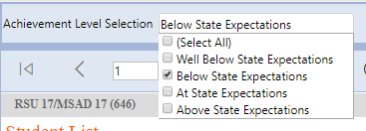
And then Click for downloadable subscores on each (and download to a non flat excel file, which we then have to edit to be able to upload to our SIS)… Dozens of menus and clicks to just get the data out for our district for assessments.

A: Thank you for the feedback. We will explore this functionality further.

Q: It would be helpful to Include the n value at the top, as well as the total N tested in this view. e.g. 41/120 etc.
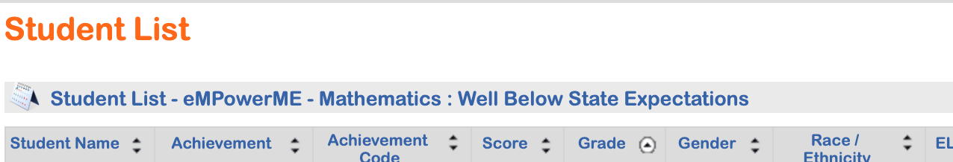
A: Thank you for the feedback. We will explore this functionality further.

Q: Why are the gender data results not comparable to the state (all) gender data results?
Similar to the other filter groups
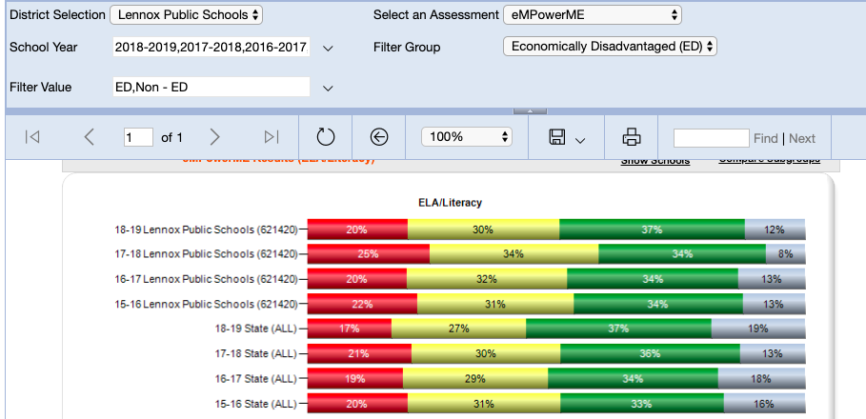
A: In production, the gender data results are comparable to the state (all) gender data results. It is our understanding that this may only apply to the training environment and districts should be able to see this in their own district view.

Q: RSU 35 - is it possible to have Rollinsford NH tuition students show up in our Marshwood Middle School data for grades 7 &8 - right now the only way we can see data is to do individual ISR searches.
Clarification from district regarding question: It is actually the opposite. Rollinsford NH students are placed at Marshwood, but they are not included in our data. Any way we could have an option to see our results both ways, with Rollinsford and without? We have 50-60 Rollinsford students in our school and we really do view them as Marshwood students.
A: If you have students from your district attending outplacement schools, including out of state schools, those students’ results will be listed as “Outplaced”.

A: In order to access the ISRs for NH students, select interactive reports -> select schools. Access to individual schools is then available.
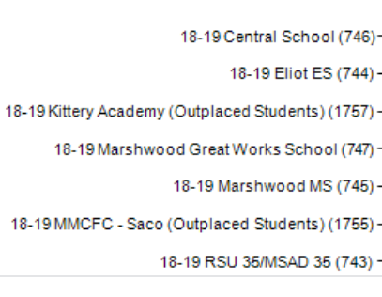
Q: Do the outplaced schools have access into MAARS to see student data and access student ISR?
A: Outplacement in-state schools (e.g. Special Purpose Private Schools, etc.) have their own MAARS logins. Out of state schools do not at this time have MAARS logins.
Printing and distribution of the ISR is the responsibility of the fiscally responsible school/district.

Q: It would be helpful if the school name was included in the student list for each student so that one could export district results and sort by school rather than having to export each school separately. Is this possible?
A: Thank you for the feedback. We will explore this functionality further.

Q: Why aren’t there released items for content areas other than Science?
A: Math and ELA/Literacy eMPowerME released items were not part of the 2018-19 Maine DOE/Cognia contract, therefore eMPowerME does not have released items for spring 2019. There are released items available from the 2018 administration. The Alternate assessment (MSAA) provides sample items within the MSAA platform and not within MAARS, and PAAP does not provide released items. MEA Science has released items which are posted to the assessment webpages each year. The 2019 SAT assessment is released in its entirety each year. There will be eMPower released items after spring 2020 administration. For elements on the assessment webpage, be sure to select the applicable assessment in order to open the accordion formatting.

Q: Are there cut scores (partially/meets/exceeds) for the subscores (ie. earth/space, matter/energy/force)? Since each is out of a different total range, it’s hard to tell if it’s a relative strength or relative weakness for any individual or for the group as a whole.
A: At this time we do not have cut scores/achievement levels for subscores.
Response: This is a really important feature to allow us to look at curricular alignment

Q: How do we see the test results - the one where it breaks down how many students answered the released test items correctly?
A: The MEA Science assessment has released items. Items can be accessed on the assessment webpages. The presenter demonstrated how to access Science released items data for the obfuscated data set listed as Lennox School District.

Q: When will the 2018-19 data be released on the public site?
A: The previous MAARS Public Site will be discontinued. The public MEA results will be posted in an ESEA Dashboard by January 1, 2020. The ESEA Dashboard contains all data elements including assessment data required to be publicly available as outlined by ESEA. Assessment only data will be published to the assessment dashboard. This will be populated early 2020.

Q. Will this new dashboard site have the same comparability features that were available on the MAARS public site? My school boards found it very useful to be able to compare student performance across schools with similar demographics. The ability of the public site to immediately create those comparisons visually was really helpful.
A: DOE is currently working on adding features to compare schools within the district to the public tableau assessment dashboard for January 2020.

Q: Is the NWEA drill down possible now or is this shared as a possibility for the future?
A: Functionality related to the upload of local data to the MAARS system has previously been available to districts/DACs. NWEA was used as an example recognizing that districts use this assessment locally to drive instructional decision making. The state summative assessment should not be utilized to drive individual student instruction at the classroom level.

Q: Can you direct me to the technical guidance for how to upload roster data onto the template? For example, what is the process for populating the template and uploading NWEA data from NWEA? What is the process for populating the template and uploading all students in 4th grade to allow us to identify those who are a “yes” for an after school program and for those who are not?
A: This information is currently being updated in the user guide manual and will be available in MAARS.

Q. If you upload rosters, is it possible to view student results by teacher? So, could I, as DAC, see student results filtered by teacher?
A: MAARS does not have that capability at this time. Thank you for this feedback. We will explore this functionality further.

Q: When can we expect the MEA Test Security Agreement Forms to be posted and the associated training videos/webinars required for signing the agreements?
A: Test Security Agreement Forms (STCs and TAs) for MEA Science & eMPowerME along with associated training videos/webinars will be posted January-February 2020. Test Security Forms for MSAA are posted. They can also be located here: https://www.maine.gov/doe/Testing_Accountability/MECAS/materials/msaa

Q: Please add feature that allows us to filter subgroups. Right now, filters and subgroups do not interact. This is a critical feature.Specific to Lewiston- we want to be able to filter our EL student groups.
A: Thank you for the feedback. We will explore the addition of this functionality further.
There are two ways to find EL student information. You can filter for sub groups here: 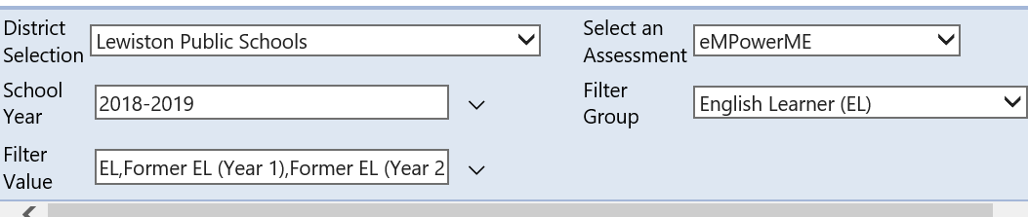
When you select any performance level in the interactive reports, a list of schools with associated students will populate listing students within that performance level. Click on the EL tab in the header row and then on a school and all of the EL students will be identified.

PLEASE increase the basic functionality to allow interactions and comparability between any sets of data we might choose to upload. For example: it would be great to be able to see spring STAR or NWEA scores alongside spring eMPowerME. Right now we have to do all this by hand (or pay a data management company to do this for us.)

Q. Can you change the rights/permissions of an existing user with the upload file?
A: Yes the DAC can make updates on an exported spreadsheet and then reupload to MAARS.

Q: Is there a way to quickly convert the # of correct responses to a %?
A: For MEA Science, there are approximately 10-12 released items (different for 5, 8, HS). Not all of the released items are right/wrong or multiple choice. There are constructed responses that receive a number of points, so there is not a released item percentage of correct responses.

Q: I notice that you have excel. Can template be uploaded in numbers? Do you need to save it as csv. File?
A: At this time, the template must be saved in an excel format.

Q: Can you direct me to the technical guidance for how to upload roster data onto the template? For example, what is the process for populating the template and uploading NWEA data from NWEA? What is the process for populating the template and uploading all students in 4th grade to allow us to identify those who are a “yes” for an after school program and for those who are not?
A: The MAARS User Admin guide is currently being updated to include documentation regarding uploading filter groups. This updated guide will be available December 9th, and is accessible from the Help menu inside the MAARS application.

Q. All the links of the production page on the left are now the same color as the screen background. Could that be fixed? As well as the white links for downloading stuff on a white background? And the profile options in the upper right corner of the screen?
A: Absolutely. The vendor was made aware of this during the presentation and has immediately addressed this during his presentation. This has been remedied.

Q: Can you PLEASE automate the uploads of classroom rosters? This would simply the district level work immensely. This would also incentivize the use of the local assessment uploading.
A: Thank you for the feedback. We will explore this functionality further.

Q. Can state averages be displayed on the district reports for easier comparisons instead of going to the Interactive Reports?
A: Thank you for the feedback. We will explore the addition of this functionality.

Q: What is the minimum n size for reporting?
A: The minimum n size for reporting is 5.

Q: District does not have a high school, all students were all tuitioned out to other districts. How do I see the data for those students?
A: As the responsible district, the district does have access to the student data for those attending high school in other districts. To view, select interactive reports. In order to see data related to outplaced students please ensure you select “show schools” in order for the schools the student attend populate. The district/school able to select the school and view the student related data. Outplaced students (students attending schools outside of the district) are then visible.

Q: Why does the ISR provided to the responsible district and not to the attending school or district?
A: The ISR is provided to the responsible district as this district is ultimately responsible for the education of the student. The attending school is able to view the ISR when viewing the school data however the ISR for an outplaced student will not be available as part of the bulk download feature. ISRs for outplaced students can be downloaded individually.

Q: For Virtual School attendees where will the data for those students be located?
A: The data for the students attending a Virtual school will be available to the responsible district. In most cases, the Virtual school is the responsible district. The data bar will indicate “Virtual School Name” (outplaced students).

Q: Does student data appear in my district if there is a Superintendent agreement?
A: No, the fiscal responsibility is no longer with the original responsible district. As this is a superintendent agreement, the responsibility for the student is now transferred to the district to which the student is attending and with whom the agreement is made.

Q: Where do we find MEA sample or released items?
A: The released and sample items can be located here.
- eMPowerME sample items found here https://maine.onlinehelp.cognia.org/sample-items/
- eMPowerME 2018 released items found here https://maine.onlinehelp.cognia.org/released-items/
- SAT released 2019 test found here https://www.maine.gov/doe/Testing_Accountability/MECAS/supports.
  - Open SAT accordion file
- 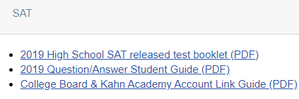
- MEA Science released items https://www.maine.gov/doe/Testing_Accountability/MECAS/supports
  - Open Science accordion file for 6-years of released item docs
  - 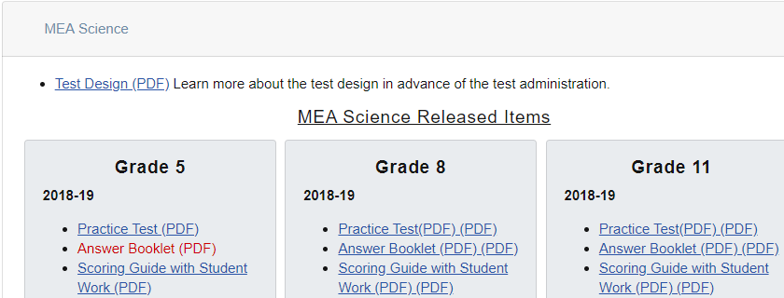
- MSAA Sample items are found here: https://www.msaaassessment.org/user

Q: If schools were reconfigured and received a new school code do we have to physically have to update the school codes in MAARS?
A: No, School A will remain in MAARS with student data related to enrollments during the 2018-2019 school year. For student data for 2019-2020, the new school lists will be populated. Please note, student data from school A will not transfer to the newly configured school B.

Q: Have cut scores for the EMPOWERME ELA and Math changed over the years?
A: eMPowerME cut scores have not changed. All MEA cut scores and achievement level descriptors can be found here: https://www.maine.gov/doe/Testing_Accountability/MECAS/results (expand MAARS Confidential accordion)
MEA Achievement Level Descriptors and Score Ranges (PDF)
MSAA cut scores did change in 2018 and have remained unchanged.

Q: How do you manage log-in for multiple districts?
A: Each district requires a separate unique name in order to create a log in. Some districts/schools address this by using the user’s first name and the school name as the last name.

Q: My understanding is that the eMPower writing results are not being used as part of students’ ELA scores, but they are included on the report. This could cause confusion for parents. Is there a letter of explanation available that we could include with test results?
A: Writing results will not be included in the students ELA/Literacy scale score. Although the ISR includes the ELA/Literacy subscores, the total raw score and the correlation between the raw score and the scaled score are not provided. Therefore a parent would not be able to determine the impact of the writing portion of the assessment to overall scale score. The Department has provided a general template letter districts may use to accompany the ISRs. This letter does not include additional information related to the removal of the writing portion of the assessment from the scale score.

Q: As an AOS, we have separate logins in MAARS for each school in the AOS because each school is a separate district. With 9 schools, this means each user that needs access to each school needs a separate login for each school. Is there any way to be able to create one login per user for the AOS as a “district” and allow users access to whichever schools they need access to?
A: Thank you for the feedback. We will explore this functionality further.

Q: My wonder is if a training like this could be video-taped and made into a digital training that could be revisited? Some of the information is hard to keep up with in real time.
A: The session Tuesday (11/19) at USM/Portland was recorded. After this week’s training we will view/edit and compile all Questions & Answers into a single document and will post to the Maine DOE assessment webpage. We will provide email communication via DACs and the MEA Listserv when the recording is available.

Q: What formats are available when exporting documents from MAARS?
A: At this time, documents when exported will be in either a PDF or Excel format.

Q: Why do I not see science information on the ISR?
A: Science data will be provided in the ISR if the student is in 5th or 8th grade or in their 3rd year of high school.
Q: What is “Download Goals”? 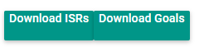
A: This is related to Maine’s Model of School Supports (accountability). As part of the model, each student group, based upon baseline data, have identified student group goals. In order for the school to be aware of these goals for the next three years, a document outlining the goals will be uploaded to the MAARS platform. These goals will not be publicly posted and will only appear in the confidential portal. Goals are reset on a three year cycle to ensure they are achievable and realistic.

Q: How do I access the cut scores and level descriptors for assessments?
A: Cut scores and level descriptors can be located at the following link: https://www.maine.gov/doe/sites/maine.gov.doe/files/inline-files/MEA_2018_ALDs%2BCut%20Scores_10-09-18.pdf
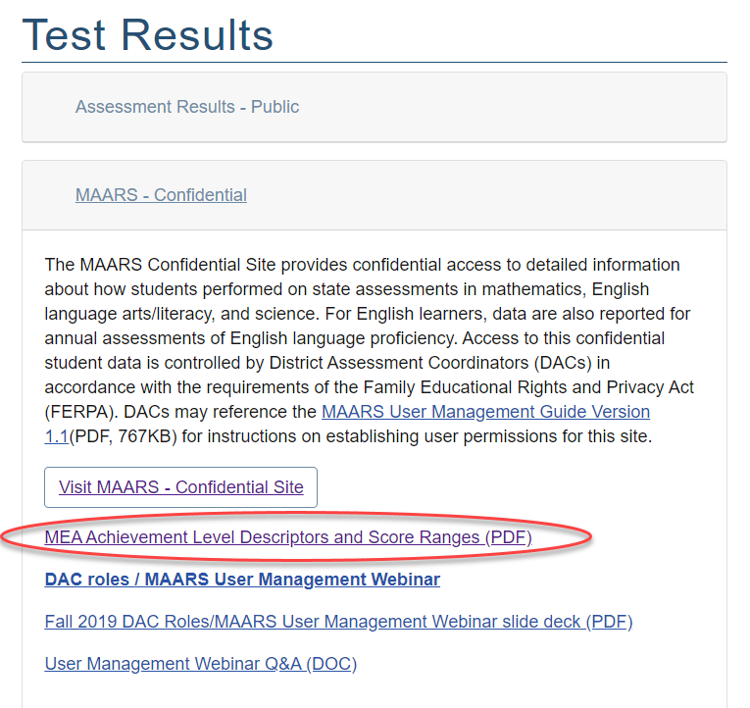
They are also located within MAARS by selecting the “+” icon at the bottom of the student list:
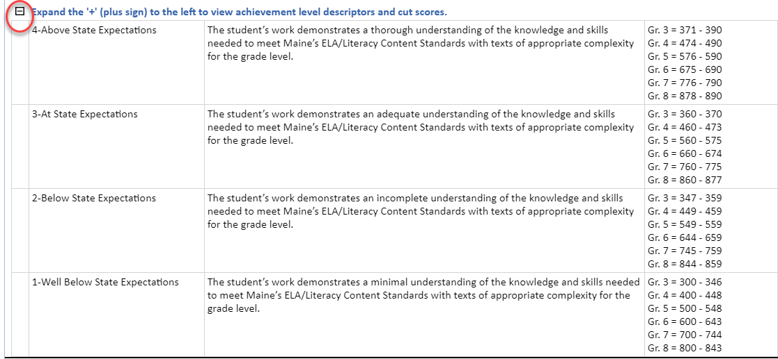

Q: Do school users have access to the help desk option?
A: FocalPointK12 will be ensuring the link and access to the help desk is available for all user configurations.

Q: Is the roster list removed annually?
A: Yes, the roster list is deleted on an annual basis to ensure compliance with FERPA. District and School users remain in place from year to year.

Q: Where do I find individual student test questions and answers? I think we looked at it earlier but I’m not sure where to find it. For example, you can see that certain students picked answer c, and others picked d.
A: Select Performance reports to return to the landing page. Select interactive reports.
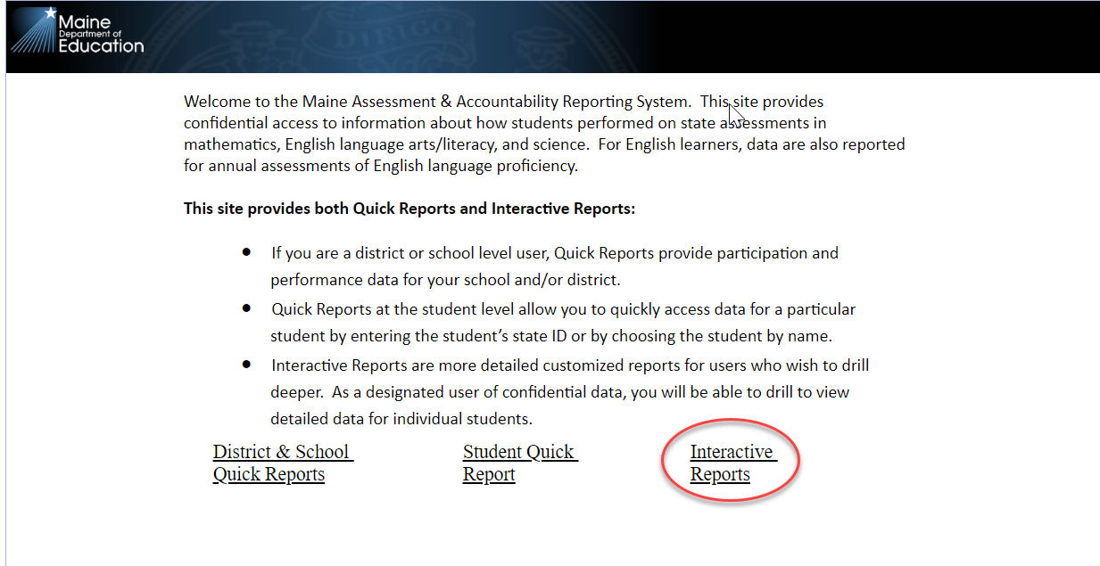
When on the next landing page select the science as the assessment -> view report.
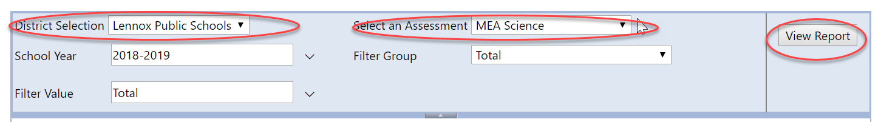
Select the achievement level
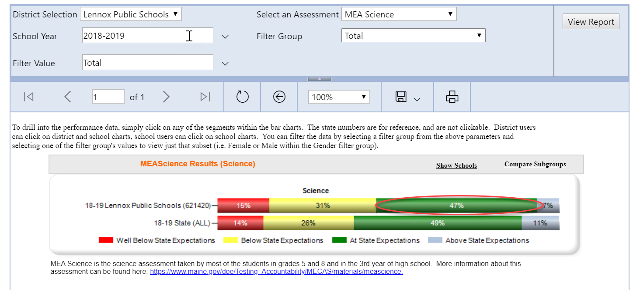
and select from the drop down all achievement levels (this will provide released items for all students across the district that participated in the science assessment. This will provide all achievement levels for all students in all schools (grades 5 & 8).
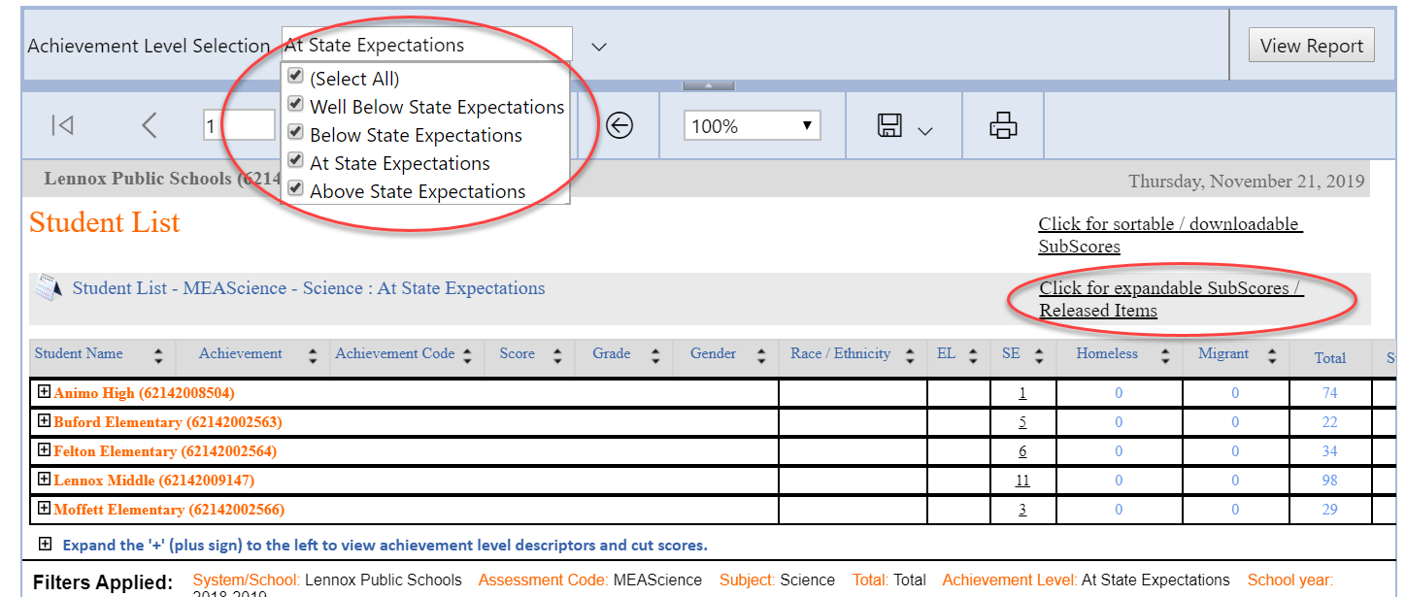
Select view subscores
Use the document map (left menu) - use the orange link with the “+” sign to review the released items.
