December [ ], 2019
Dear Families,
The Maine Department of Education recently notified all school districts of a reporting error contained within the Individual Student Reports (ISRs) provided to families. ISRs provide families information related to student performance on the state assessments. It should be noted, student data are accurate and correct. Student scale scores or applicable performance levels will not change as a result of this reporting error.
The error was in the graphic that showed performance level cut score ranges (exceeds state expectations, meets state expectations, below state expectations and well below state expectations) for the state assessments. The number range for the performance levels were not accurate, and in some cases overlapped. This may have created some confusion regarding the performance level of your student.
Attached you will find the accurate cut score ranges for reported performance levels for the eMPowerME (grades 3-8), MEA Science (grades 5, 8 and 3rd year of High School) and the SAT (3rd year of High School). The cut score ranges will assist you in reviewing your student’s score as it relates to the grade specific performance level.
We hope you find the attached information beneficial, and apologize for any additional confusion caused.
Sincerely,

[Insert name]

Mathematics : eMPowerME (grades 3-8)
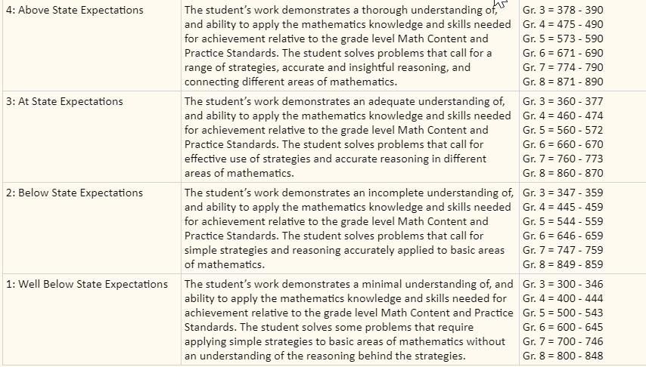
English Language Arts (ELA): eMPowerME (Grades 3-8)
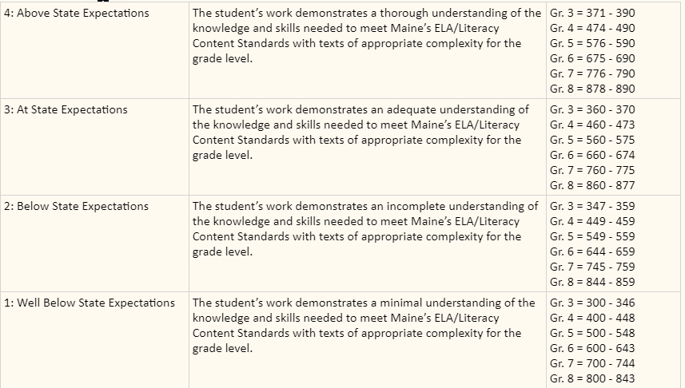
Science (Grades 5, 8 and 3rd year of High School):
