Distributing Individual Student Reports (ISRs) via Secure Email

Subscribers to School Messenger have the opportunity to utilize the Secure Document Delivery (SDD) feature in order to provide ISRs electronically simultaneously to families.

Due to personal identifiable information being present within state assessment reporting documents, it is recommended a district secure the document using the student’s state id number. This would ensure if assessment results were delivered to a wrong email address, the document and subsequent student data would remain protected.

The utilization of school messenger to electronically provide ISRs to families This process will save a district save considerable fiscal and personnel resources when compared to a print and mail approach. This process also ensures all families, not just those whom a district may traditionally mail, receive a child’s assessment results via secure email.

Part 1 – Creating a Template

School Messenger allows documents to be delivered provided they are the exact same length and have a consistently identified number on each page of the document. The secure document delivery function will read the State Student ID (SSID) printed on the front page of an ISR and send the proceeding four pages to the families associated with that SSID. Due to this process, it is important to NOT modify the Combined ISR which you have downloaded from MAARS. This also explains why all ISRs are four pages in length even if a student did not take the Science assessment, or in in the case of new English Learners, the ELA assessment.

This process requires the district to contact School Messenger to have a template created. This process may take up to four days. There is no charge beyond your SDD subscription. To save additional time, indicating the district process is based on South Portland Schools, the 2017 ISR template can be used.

Part 2 – Sending an Advance Email to Families

It is important to notify families in advance they will be receiving an email with an attached student ISR. Use School Messenger to craft a broadcast to all families of students who participated in the previous spring state assessment. This will considerably reduce the amount of questions families may have when they receive an email with an attachment that requires a password.
Log in to School Messenger and start a New Broadcast.
Use the Custom Rules feature to select students who were enrolled in assessment eligible grades in the previous school year (i.e. grades 4, 5, 6, 7, 8, 9 & 12*).

Once your recipient list has been created, determine if:
- Students are to receive the ISRs,
Families are to receive the ISRs.
If you elect to not share results directly with students click “Contacts and Guardians” and change the setting from Both to just Associated Guardians.

*Grade 12 students will represent the vast majority of 3rd year high school students who took the SAT and Science assessment.

Click Continue to advance to the Message Content screen.

Click Email and populate the To, From, Reply To, and Subject line as you would any broadcast.

Compose your message and use the Field Insert button to customize the message. The most important field is <<Inserted ID Number>> which allows guardians to receive the state ID for each of their students. It is recommended the <<First Name>><<Last Name>> fields also be used as some families will receive an advance email for more than one student.

Click Save and then click Continue.

Before the district sends the message, it is critical to UN-Check the Skip duplicate email/phone/SMS recipients’ option. If you do not, families of multiple assessment aged students will receive results for just one student.
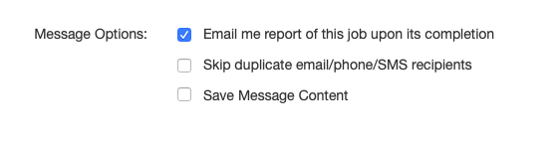

Part 3 – Uploading the ISRs

- Click on Broadcasts.
- Click SDD.
- Click Create New Document.

- Name your document.
- Select the Template that was created by School Messenger.
- Click Choose File.
- Browse to your combined ISR PDF (use Adobe to reduce the size of this PDF is necessary).
- Click Upload.
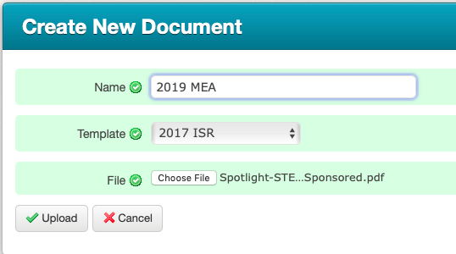

Part 4 – Configuration and Sending of ISR Emails
- Click on Broadcasts.
- Click SDD.
- Click Send Email (do not worry, this does NOT yet send the email).
- If only families and NOT both families and students are to receive the ISR email, select Associated Guardians.
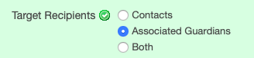

- Leave Guardian Restriction Category blank.
- Select the date and time you want the email to go out. Since these are non-emergency emails they may trickle out over a few hours.

- Change both Secure Documents fields to Inserted ID Number.
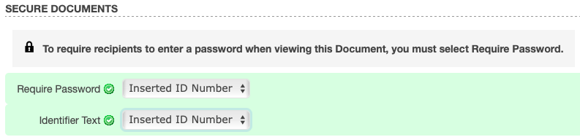

If this is not done, there will be no password needed to open the attachment.
- Populate the To, From, Reply To, and Subject line as you would any broadcast.
- Compose the message. Use the <<First Name>> <<Last Name>> field inserts as some families will receive an advance email for more than one student.
- To send ISRs click Send Now.
Need additional support? Please contact Andy Wallace at andrewtwallace72@gmail.com.

